Chue Zhang

Professor Lucci

CSC 448

**AI applied on Video Games**

Introduction

AI has become the big topic of our generation, but it has been applied for a much longer time for than people realized, specifically in the gaming field. The AI’s in video games are not necessarily self-learning robots who look to dominate the internet but more of robots who are told to do something in a certain way and to perform certain objectives. They might not even be robots but tools to help you perform better at a certain task autonomously as in the AI could take over certain controls and assist you.

Breakdown of video games

Video games have evolved so much over the past decade in terms of both visuals and in functionality, such as things like what you are allowed to do in a video game given a specific tool or a specific environment.

A really good example of the evolution of video games would be the hitboxes of characters in video games and you must be asking, “what is a hitbox”.

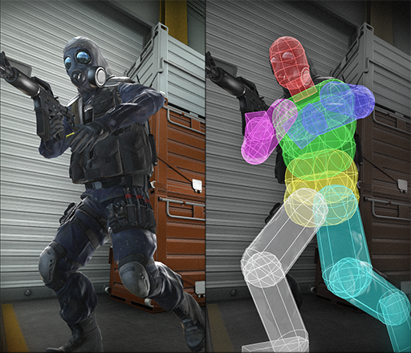A hitbox is the area in which a character can interact with different things. For instance, the picture in the right shows a mans hitbox and basically, if an enemy comes up to him and punches him in the face, he will take damage depending on which hitbox is hit. The different hitboxes are categorized by the color of the hitbox. This seems pretty standard for modern games, right? To have such a nice-looking model, that is circular so that accuracy plays a bigger role in shooting games.

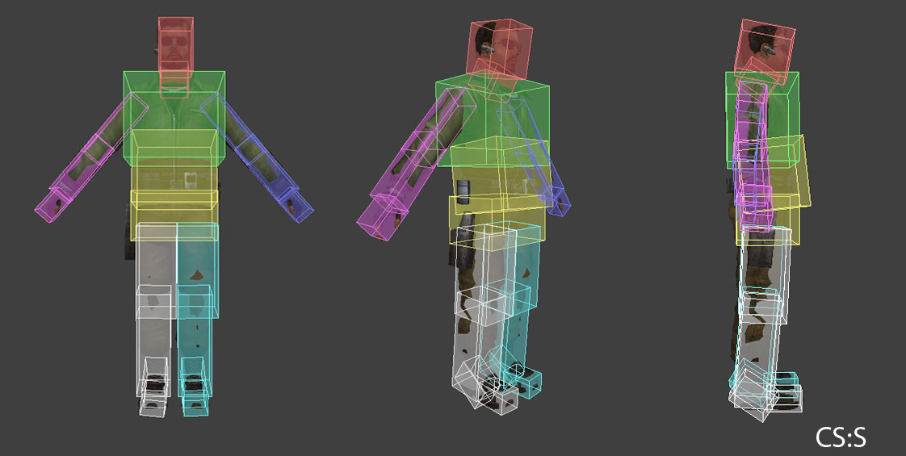

Let’s analyze the character hitbox above and what’s different. Obviously, its squarer but what’s the underlying problem of this? Someone doesn’t even have to shoot a model with a gun for it to register as a hit. Its not accurate and precise, it takes out the certain factors of skills in games that a lot of people strive for so hitbox evolution in games is very important. It might seem that I am only talking about the evolution of hit boxes but it has to be understood that hitboxes play a huge part in how games are develop since it determines the functionality of the game itself.

Furthermore, the game play of video games have certainly evolved over time where games have become far more complex as years go by such as having music games where you play to a beat or even more relaxing things such as a truck driving simulator of airplane simulator. Video games have evolved in such a way that there has been more and more realism to it such as games like “Minecraft” where the objective is to survive and you survive by building a home with other people or yourself.

**Analysis on AI being applied onto video games**

AI applied onto video game varies because the objectives of video games are different per video game even if they are of the same category. Some of the more popular candidates of applied AI onto video games would be the genre of shooting and role-playing games.

Role-playing games are games where you take on a role in a video game, say, a mage who does a lot of damage to the enemies or maybe, a farmer who makes sure that people are fed well.

Shooter games are games that have an objective of using a gun and shooting your opponent with the gun and they can also do the same thing to you.

There are different types of video games, but what about different types of Ai’s?

There are things like MMORPG’s where the players have an objective to subjugate an enemy “boss”, a powerful enemy. This “boss” enemy will have an intricate design that will dictate who it will be attacking, when to use certain things and where to use certain things. These things that I’m mentioning are more like attacks and things the boss can throw at you and it has really help pave the way for many games, designing enemies with the use of artificial intelligence

As for shooters, its common to see solo player games have AI’s all over the place where the enemies, like the “boss” enemies, will have the objective of destroying you and will do certain things at a certain place when a certain situation occurs.

This paper will be less on robots learning how to play a game from scratch and more about the AI’s that people design to challenge the players

How has AI changed gaming

The paradigm that is AI in video games is that there are so many applications for AI in video games and in modern day video games. The thing about AI is that both developers and consumers can apply AI for their own benefits and is for consumers, most of the times its easily accessible.

In the gaming community, there is a term known as “grinding” [1. Techopedia] and what it means is that players will have to dedicate a lengthy amount of time in order to achieve something, lets say for example, a player wants to get from levels 1 to level 50, in order to reach the max level, they will have to grind those levels. Why is this such an important term? Its important because this is where AI comes into place. Suppose the situation where you don’t want to go from levels 1 to level 50 because its too tedious, what can you do? Perhaps you can use a program that automates your experience in the game so that you don’t have to get those levels on your own. You’re having an AI take control of your character to do the dirty work for you.

Developers also can use AI’s as a game feature such as how Riots “League of Legends” did with their doom bots[2. League of Legends Wiki]. What Riot did was they made new bots for a game mode where 5 players were pitted against 5 bots and it was ridiculously difficult to win against. What was amazing about this experience is that not only does riot get to collect information on how players adapt to new environments but also how the bots will perform. These bots were so smart that they even knew the concept of dodging players attacks.

The bots explained above seem to be interesting but how did it change gaming? It changes gaming because it changes the ways a game can be played. This is the idea of AI’s applied on games in the first place, to automate tasks so that you can enjoy things differently. Whether the method of playing the game is intended by the developers or not, AI is used to help people enjoy the game more and also helps developers understand what players want. If a player thinks certain tasks are annoying and start using bots for it, the developers may just make it less annoying so bots can also be used by developers to innovate.

Furthermore, for Riot’s bot, it was more for a limit test for the players to see how a player might react to different environments rather than the bot. To see how what is normally done in regular games, changed to adapt to different environments is helpful for game developers to see the potential of their own game because often times when you implement, you might not know of all the possibilities so having players test everything out for you is important.

AI and business

AI and business pretty much go one and one in modern day society and that is because everyone wants to automate their experience and to gain an extra step over everyone else. The goal of games is generally to be the best at what you are doing so if you have the option to use external sources to help yourself out, why not.

Very often how AI is being used in business is, you create a bot that does tedious tasks for you in video games and you charge whoever wants the bot a monthly fee for it. A direct example would be a role-playing game called “Black Desert Online” where bots are prevalent and easy to create for the tasks available in the game. According to a seller of bots [3. Bdo.ru], the bot provides “Non-detection, Fishing, Skill Training, Gathering, make money” which are the basic goals of the game. They are extremely tedious goals, but hard work pays out and these bots are doing the hard work for you, for a certain price. These bots are also easily accessible, there was no need to look through a black market of sort to even find this, just a simple google search and many more are also available for purchase.

Often times it is also against the terms of service the game provides to apply AI in such a way but as business exists, there will be loop holes and anonymity when doing these transactions so it is hard to shutdown such operations. In addition, it is role-playing games that suffer the most from these types of AI applications because it dilutes their player base and gives advantages to people who want to not play fairly. When people notice that playing fair is no longer something viable and only people who use such tools are viable, the player base dwindles, and games tend to die out. That’s why many games have to do their best to try to mitigate the number of bots in their games.

Of course, when dealing with bots and business there are often ethical issues related to whether or not it should exist. Reiter’s [4. BDO bot maker sued] article where possible legal actions may have taken place over the creator of a bot, show how the creator of the bot does not think he is doing anything illegal and that the person issuing the court action is just a person who hates the bot because it provides an advantage over players who play normally.

But on the brighter side of the spectrum, we have AI’s in video games being promoted as content and this is huge in games that have “boss” enemies. Generally, these enemies will be super tough to defeat and require insane amounts of strategy and this is the fun that people strive for. To be tested to their limits and to see what will sate their curious minds and the thing is, developers know that many people strive for this rush, so they are constantly trying to make different designs for boss battles. To get a better spectrum of a company being successful at doing this would be Square Enix where they had a net sale of 42 billion yen [6. Mmos.com] because of one of their popular games “Final Fantasy XIV” Which explicitly has challenge boss battles for the players and constantly piques the players interest with different types of mechanics

Issues encountered with AI’s in video games

The common issue that is brought up often with AI in video games is that are the players “bots” fair or not. The general consensus is that bots are not fair and should be completely removed from the game, but the problem is how do you remove something like that. It is hard to recognize a bot from a regular player if concealed properly as the bot that I talked about earlier [3. Bdo.ru] even has a feature that helps them not get detected. As stated previously, there is an ethical dilemma that is brought up to the bot’s developer regarding whether or not it is legal and should be done. They know it makes people have ill-feelings, but the person needs to generate a stream of income for themselves. One person argues that they are not having a fair game whereas the other may argue that he needs to sell the bot in order to keep a roof over his head. The developers of the games on the other hand do not care, its either they ruin one person or they ruin the experience of many people and many times, the developers choose to ruin the one person because that person is making them lose revenue. Another common ethical dilemma faced by the people using the bots is, “is my own enjoyment worth more than the enjoyment of many others”. Would you rather ruin the experience for hundreds of others so that you can have fun or will you just try to play the game normally and try to have fun with the hundred others. A report from Hart [5. Human side of cheats] quotes someone who uses something akin to bots in video games “its simple really: it makes me laugh”. This also summarizes the ethical dilemma as “do you want to be the only one enjoying the game or have the other people you are playing with to enjoy game”. A possible ethical dilemma that developers face while dealing with these bots is whether or not their game is fair enough. The fact that players have to employ the use of bots to get enjoyment in their game could have many meanings and it could mean that things are too tedious. So the ethical decision they need to make in removing the bot is, “Should I change feature X in the game so players have an easier time and remove the essence of the game? Or keep it”. Keeping true to the values of the games or change it for the sake of the players is a problem that game developers may face when trying to balance features in a game. Of course, people will always find a reason to cheat in any game, so it doesn’t always have to mean that developers have to change a feature. Furthermore, they could also try to compensate with the players in order to keep the values of the games while making it slightly easier. The ethical dilemma generally comes when players don’t agree with the decisions made in a game which tends to be a worst-case scenario.

**Conclusion**

To conclude on this report, AI has changed gaming in more ways than one and has effect on things such as business and ethical dilemmas. AI has been innovated so much as games have evolved over the years and will continue to develop. The takeaway from AI’s in games is that it helps in the development to games in the sense that it forces developers to innovate on their security systems and innovate on their games gameplay as shown in Riots case.

Sources

[1.] <https://www.techopedia.com/definition/27527/grinding>

[2.] <https://leagueoflegends.fandom.com/wiki/Doom_Bots>

[3.] <https://bdo.r23.ru/>

[4.] <https://medium.com/@BlackDesertOnline/bdo-bot-maker-sued-f979052b59ad>

[5.] <https://egmnow.com/the-human-side-of-those-who-cheat-at-and-hack-games/>

[6.]<https://mmos.com/news/square-enix-reports-2020-earnings-mmo-division-reports-record-high-revenues-and-profits>