**PREDICATE LOGIC**

Member(Joe)

Member(Sally)

Member(Bill)

Member(Ellen)

Married(Joe, Sally)

Brother(Bill, Ellen)

**∀** x, **∀** y ( Married(x, y) ) ^ ( Member(x) v (Member(y)) => Members(x) ^ Member(y)

Last_Meeting(Joe)

**PROLOG CODE**

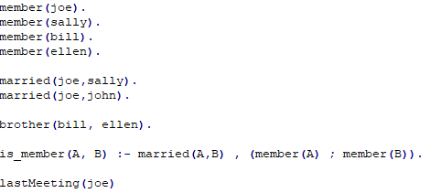

** THE LAST MEETING OF THE CLUB WAS AT SALLY’S HOUSE

Sally and Joe ARE married but we do not know if they are living together so a clause needed to be added is.



** ELLEN IS NOT MARRIED

We know that Joe and Sally are married and that for every member that is married, their spouse is also a member. Under this relation, we know that Bill is not married to anyone otherwise they’d be in the club and Ellen isn’t married because another member would be in the club. The only way Ellen would be married is if she married her brother which I’m not sure if this should be a thing

Member = Joe, Sally, Bill, Ellen [4]

Married = (Joe, Sally) [1]

Siblings = (Bill, Ellen) [1]

If Ellen was married then there would be a 5th member which there is not, only way for Ellen to be married is by sweet home Alabama with bill