Chue Zhang, 23398187

Professor Zaid Al- Mashhadani

Assignment 1 Report

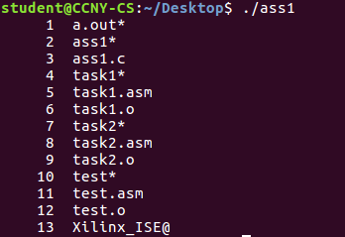

1. The exec() function that I used was execlp and the reason that I used this was because I needed to use ls and nl, execlp lets me do that in code.

2. I used 2 forks since there were only 2 children processes to work with.

3. only 1 pipe was needed since I was pumping output from child one to two, I wasn’t working with transferring more than one piece of info at once.

4. I used wait(NULL) and I used it twice because there were 2 children processes that I was working with