Chue Zhang

Professor Zaid-Al-Mashadani

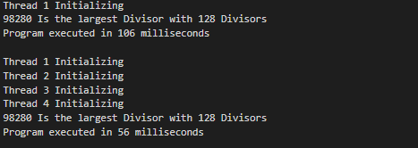

1) It took 106 ms for my program to run with 1 thread

2) My system can only run 4 threads simultaneously

3) It took 56 ms for my program to run with 4 threads

4) I used task parallelization for this program because I broke the total number of 100k down to the amount of threads I was using then ran each of those functions at the same time not having to worry about data being overwritten by each other.