Chue Zhang

Professor Zaid-Al-Mashhadani

**Without Lock**

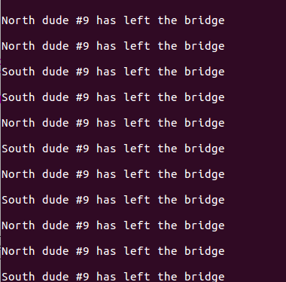

**With Lock**

\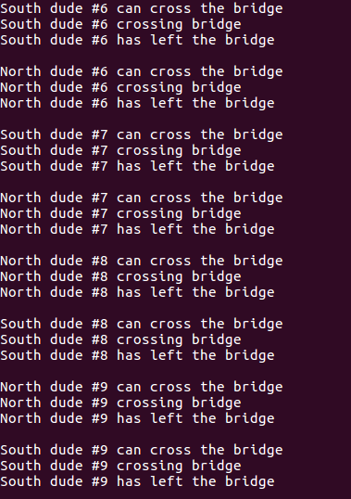

1. I am using a mutex lock

2. There are an equal number of north and south, so we forked about 20 processes in total. However, there is a weird bug that sometimes when running the program, some of the processes will be skipped out. The Screenshot outputs are the best case scenario however, it took a few times to run before successful