Lab Report : VHDL with LPM

Chue Zhang

Csc343 Fall 2021

Professor Gertner

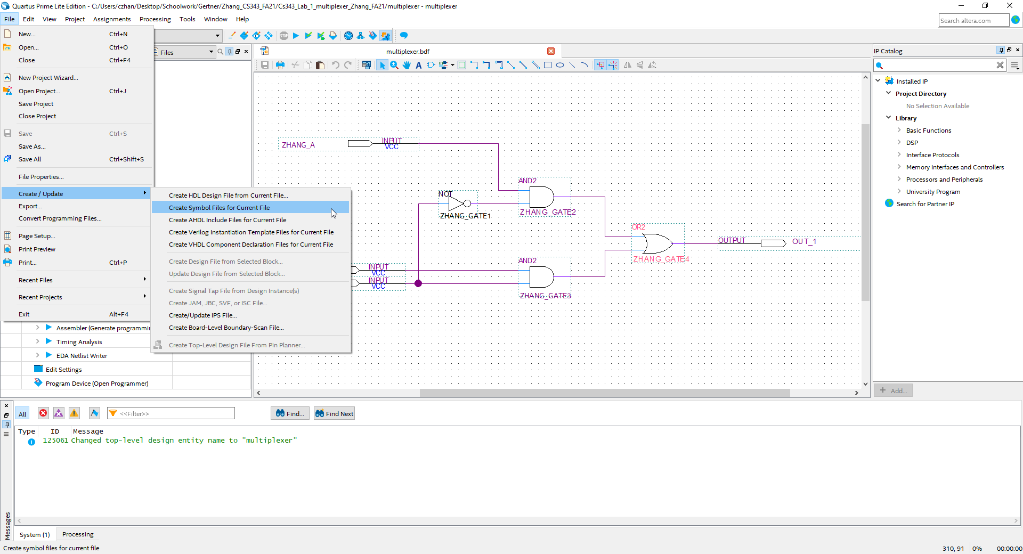

With the 2:1 Mux previously created, I go to the file 🡪 create HDL design File for Current File and a popup should show up

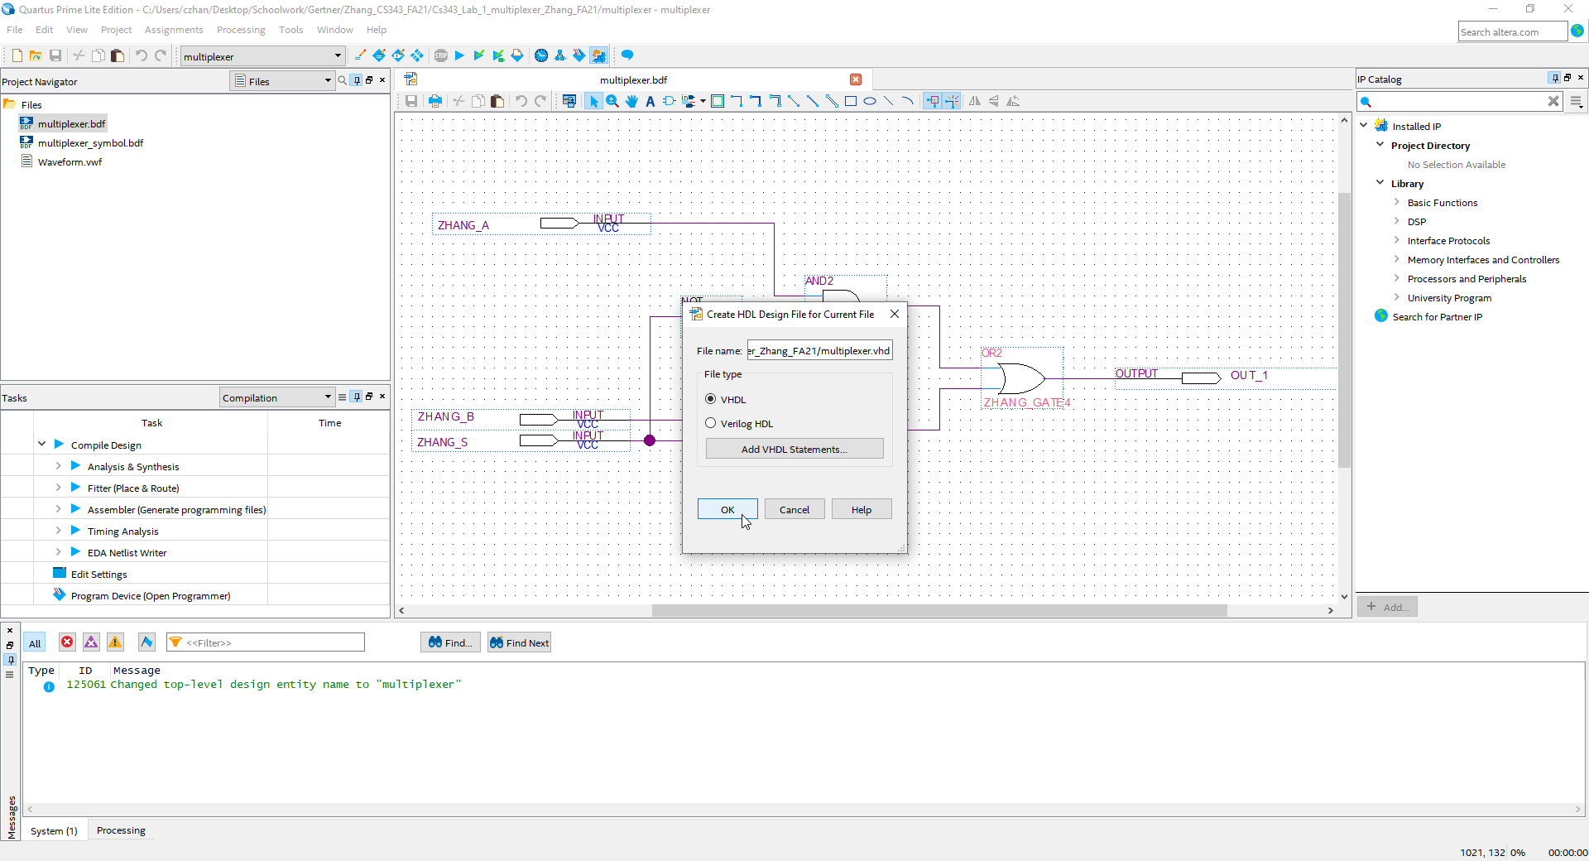

Make sure that the file type is in VHDL not in Verilog and press OK

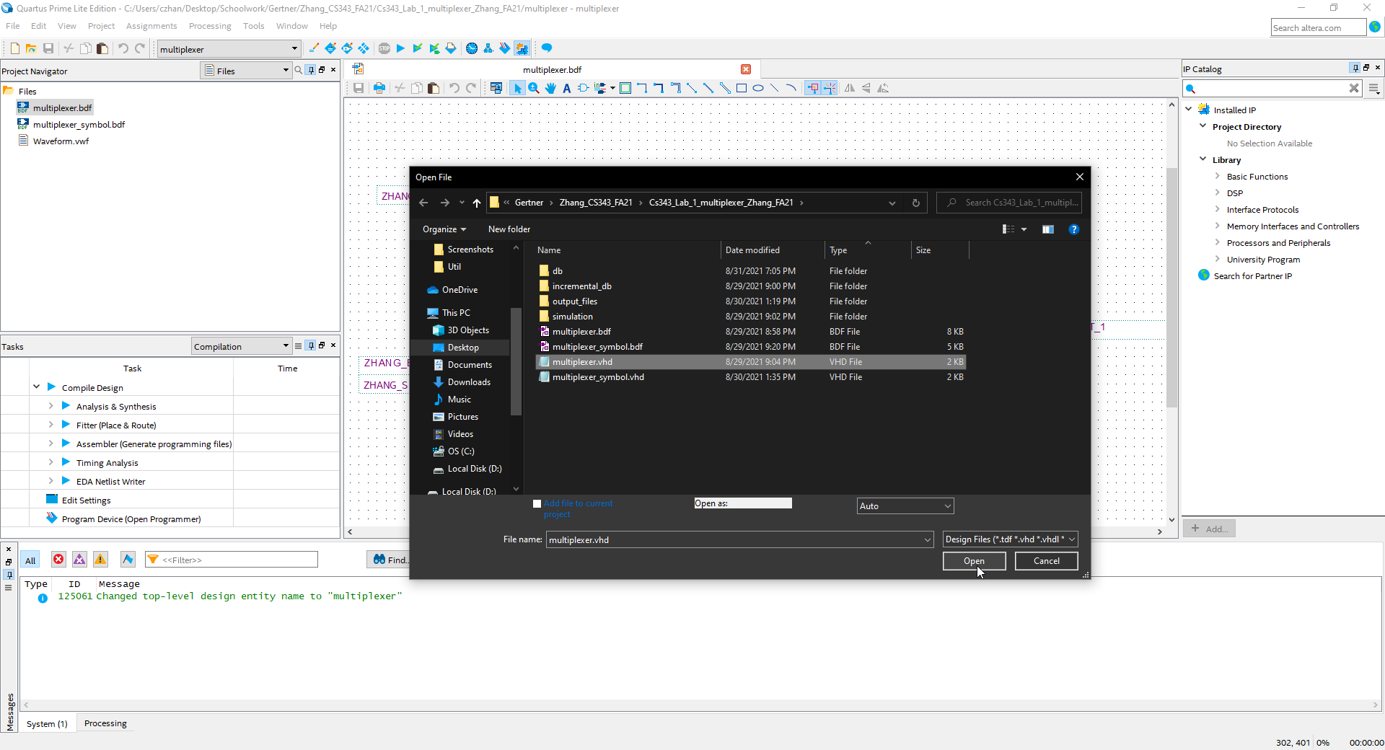

I now add the VHDL file of the design into the files

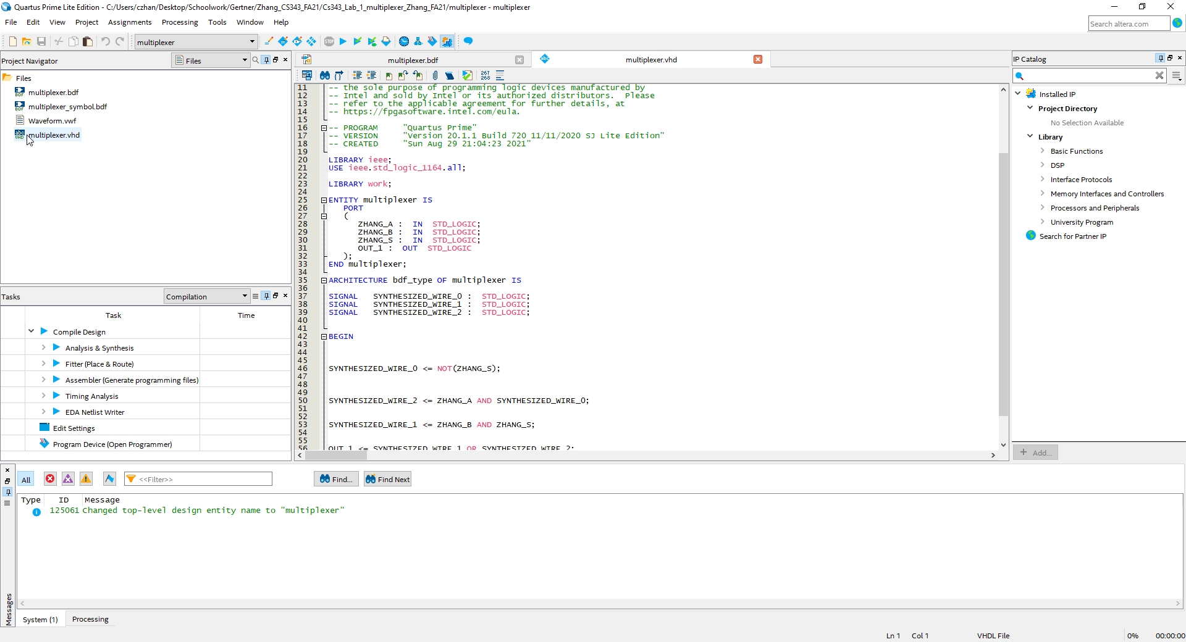

I now set the VHDL file to top level while showcasing some of the code

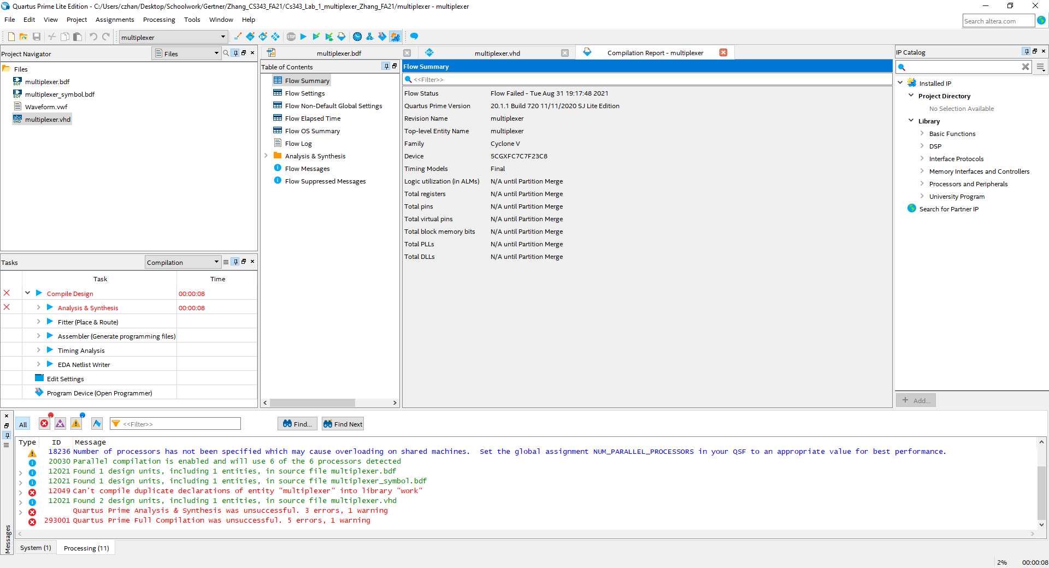

I try to compile but come to an error

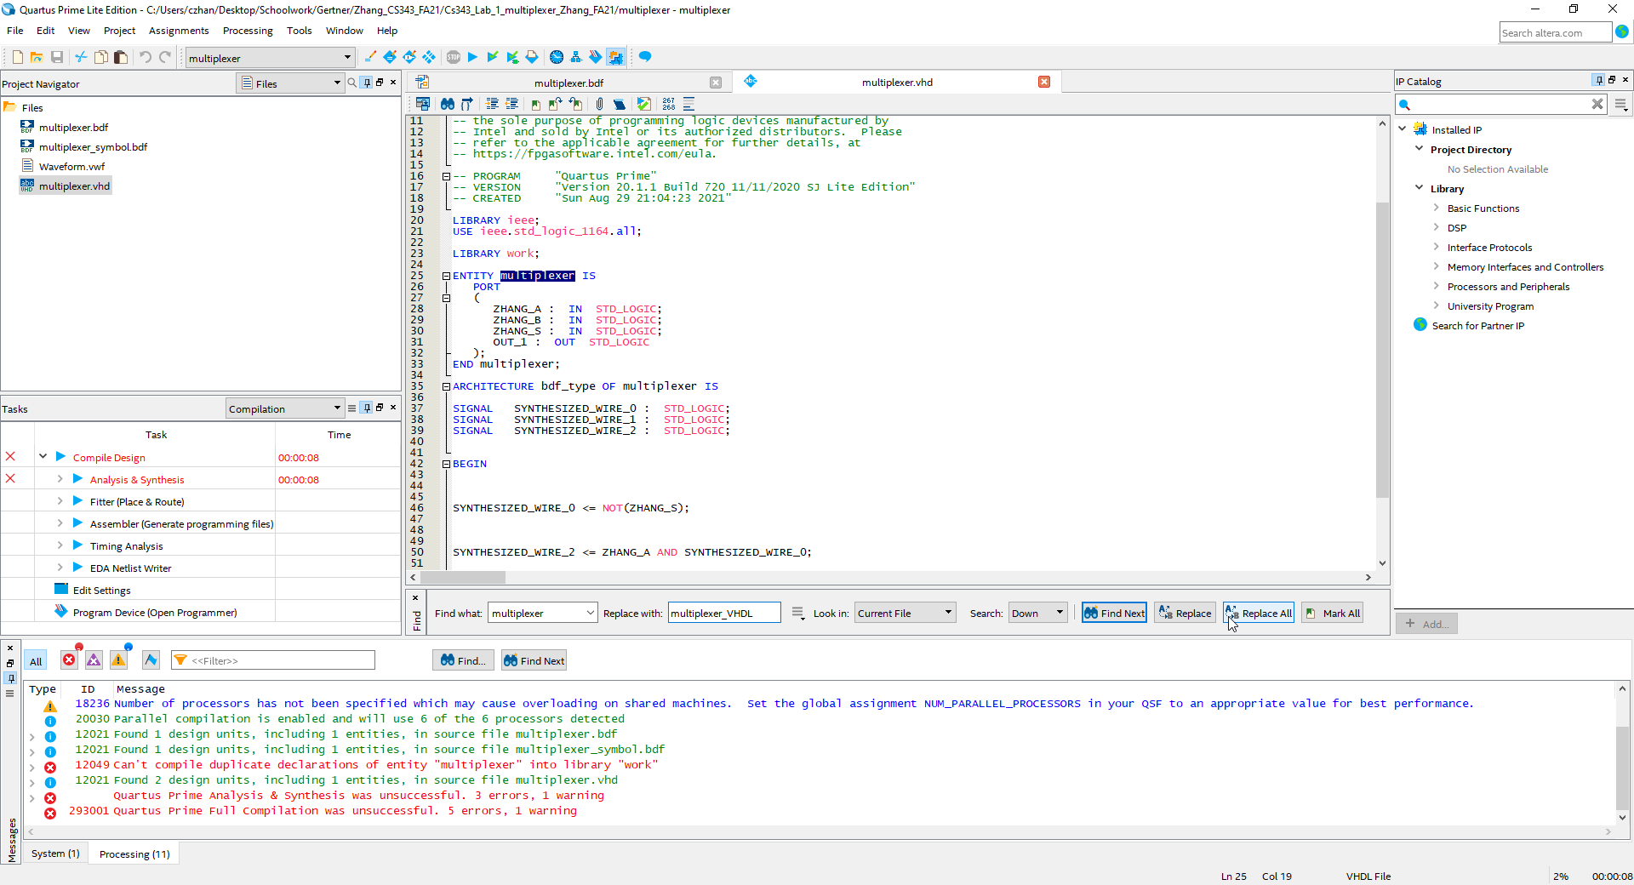

I change the highlighted multiplexer text to multiplexer_VHDL and save the VHDL file under the new corrected name

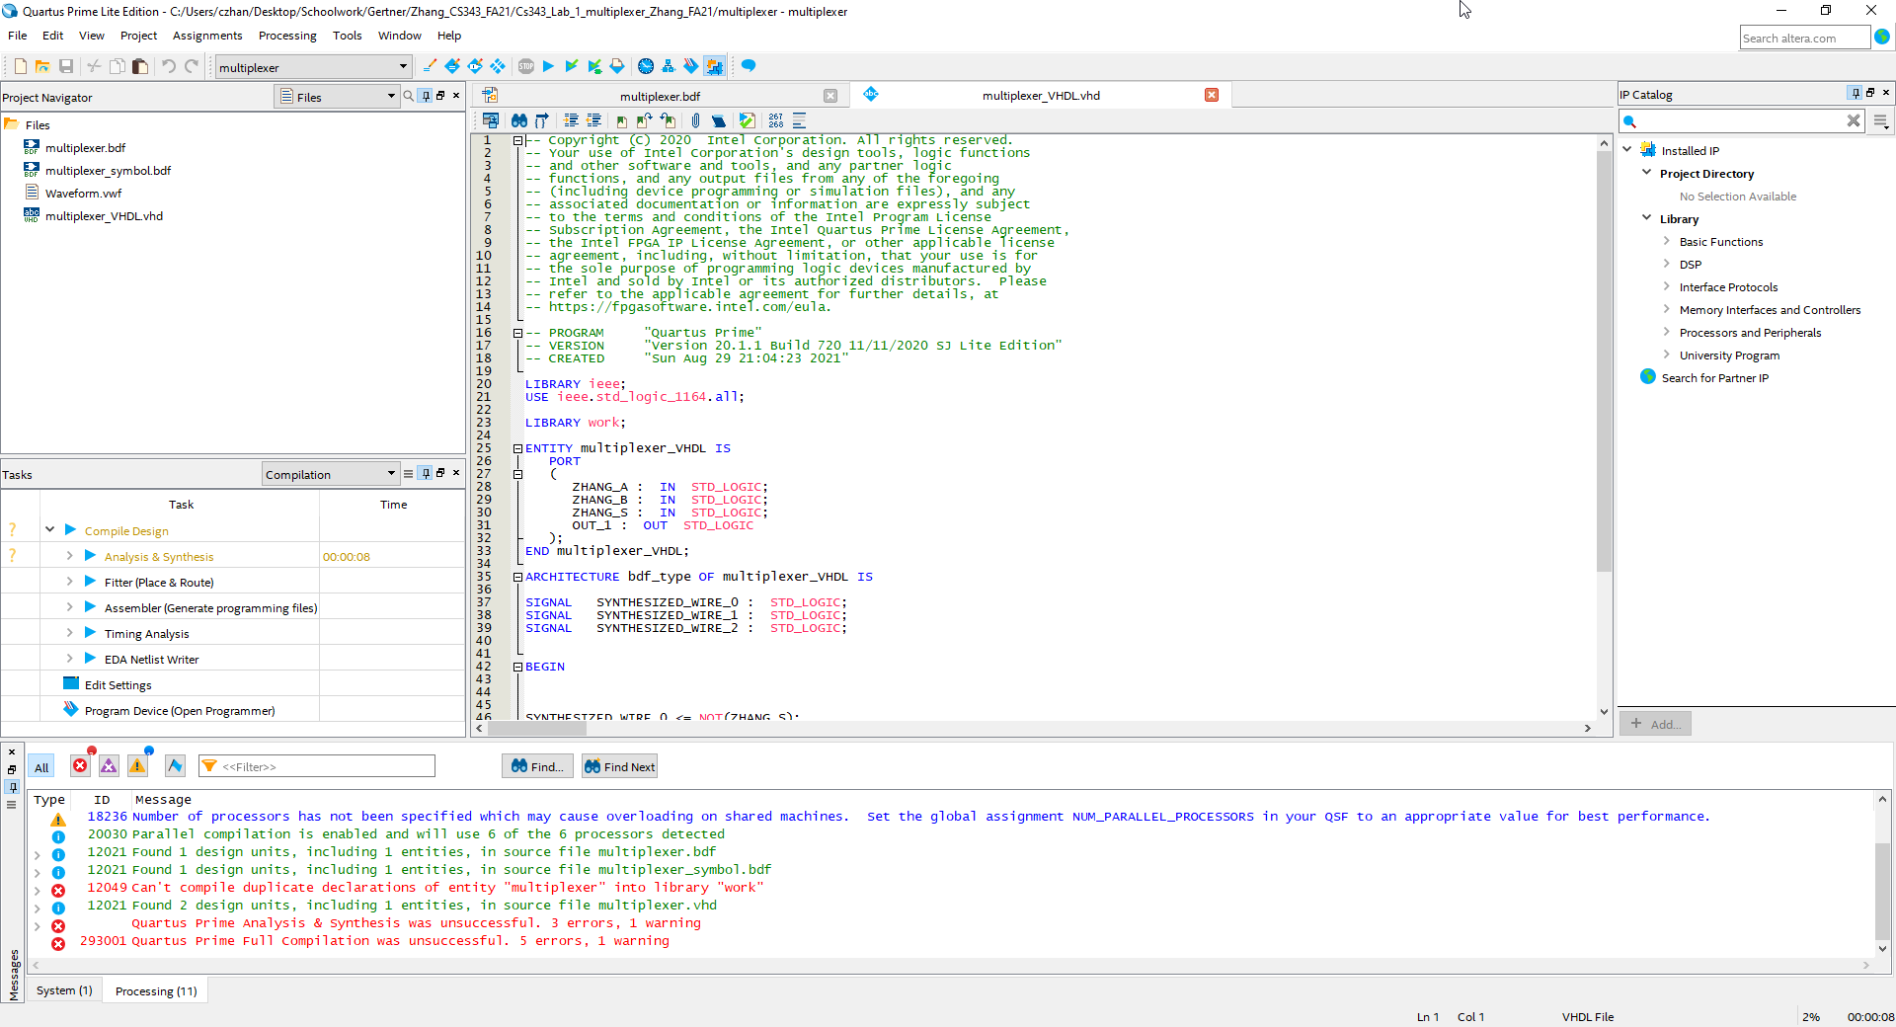

Here is the corrected code that I will then save with a different name according to what I renamed the code to

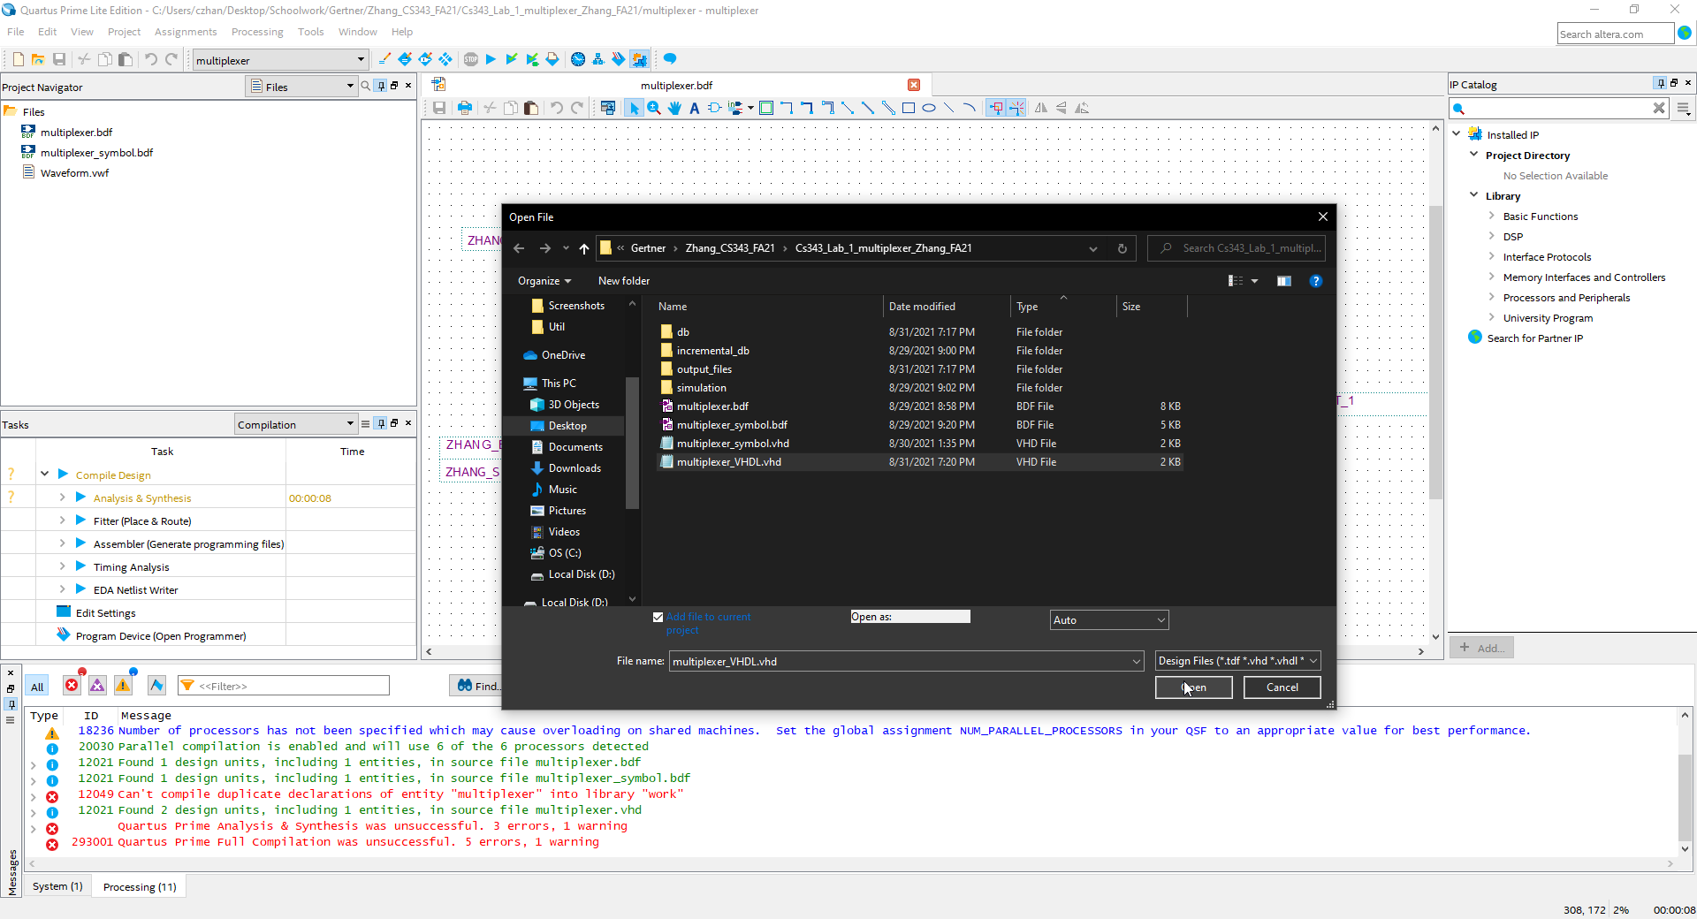

I re-add the vhdl file

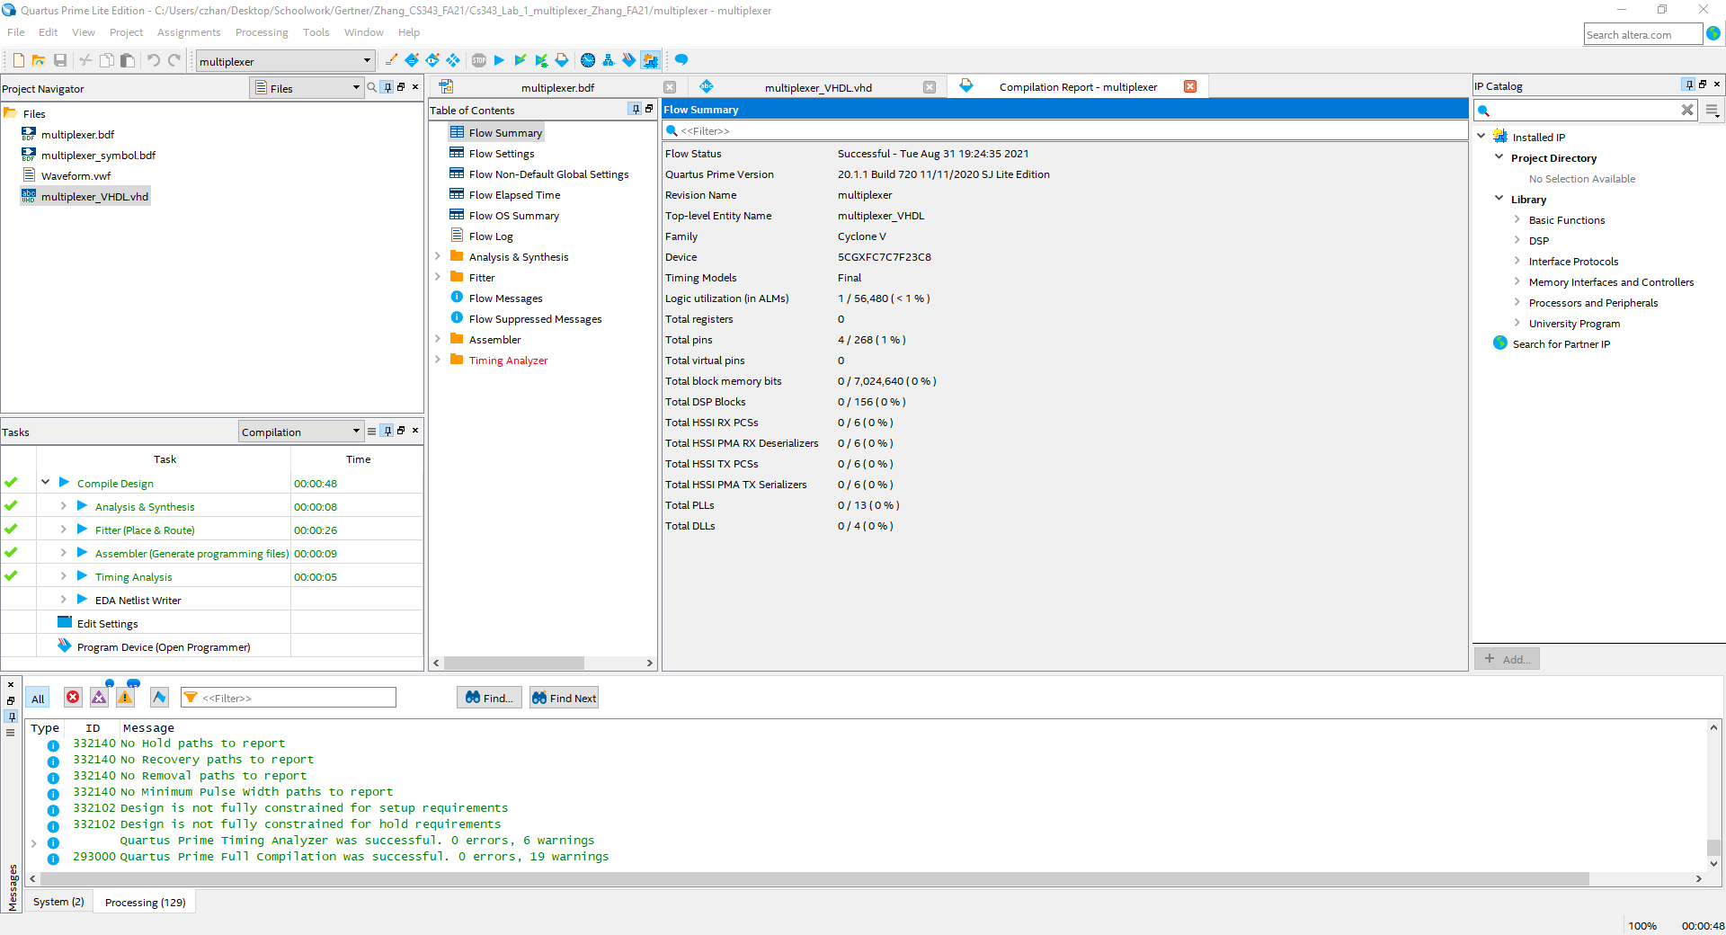

I compile with success

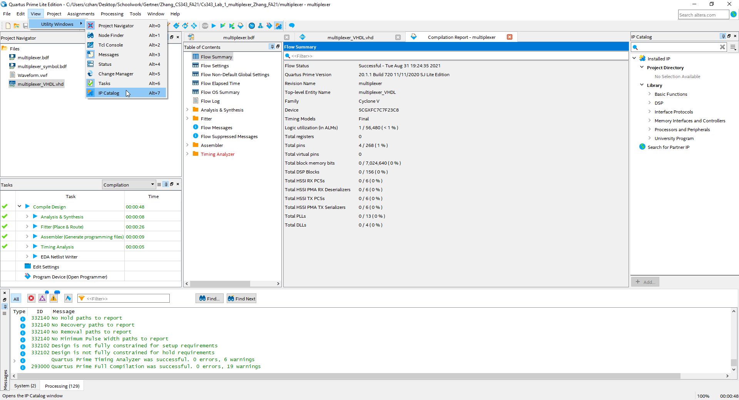

Here I ensure that the IP catalog is checked out and is available for me to use

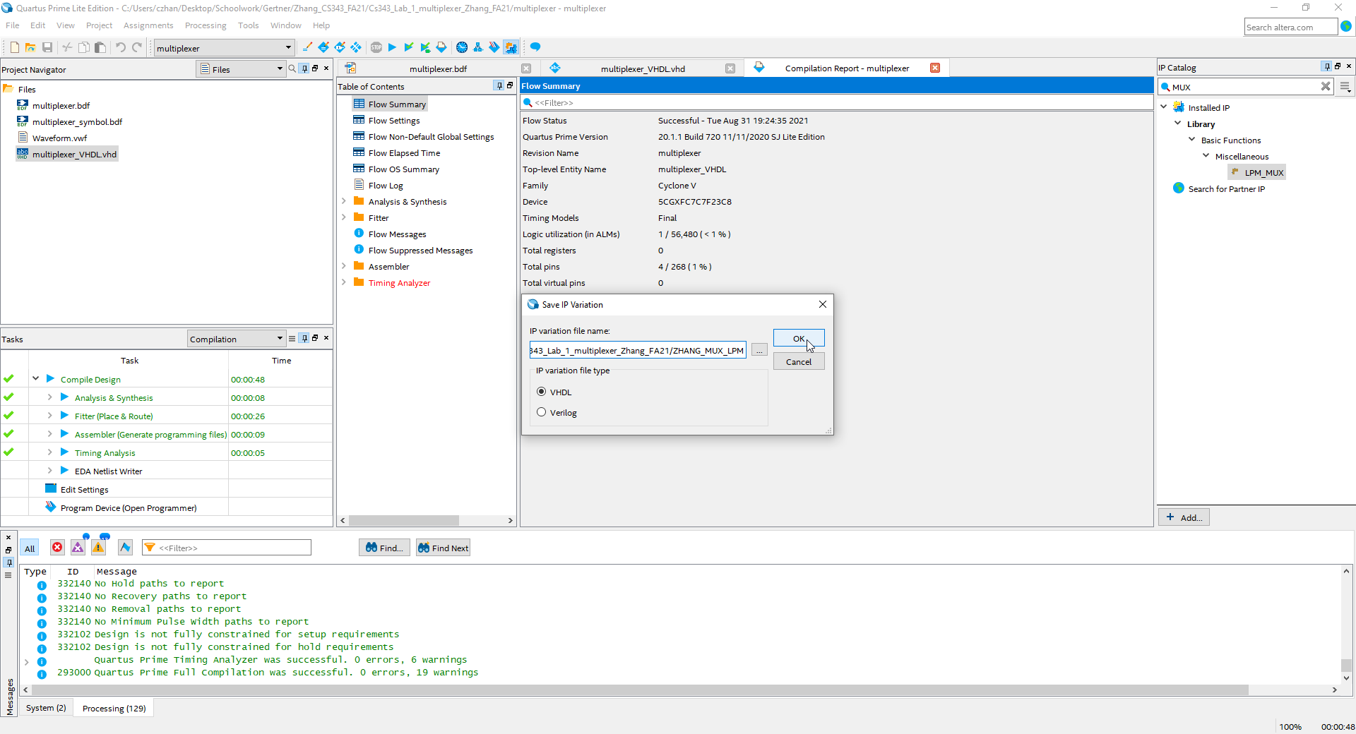

In the right where the IP catalog is, I type in MUX and a drop down showing LPM_MUX shows up. I double click and press OK

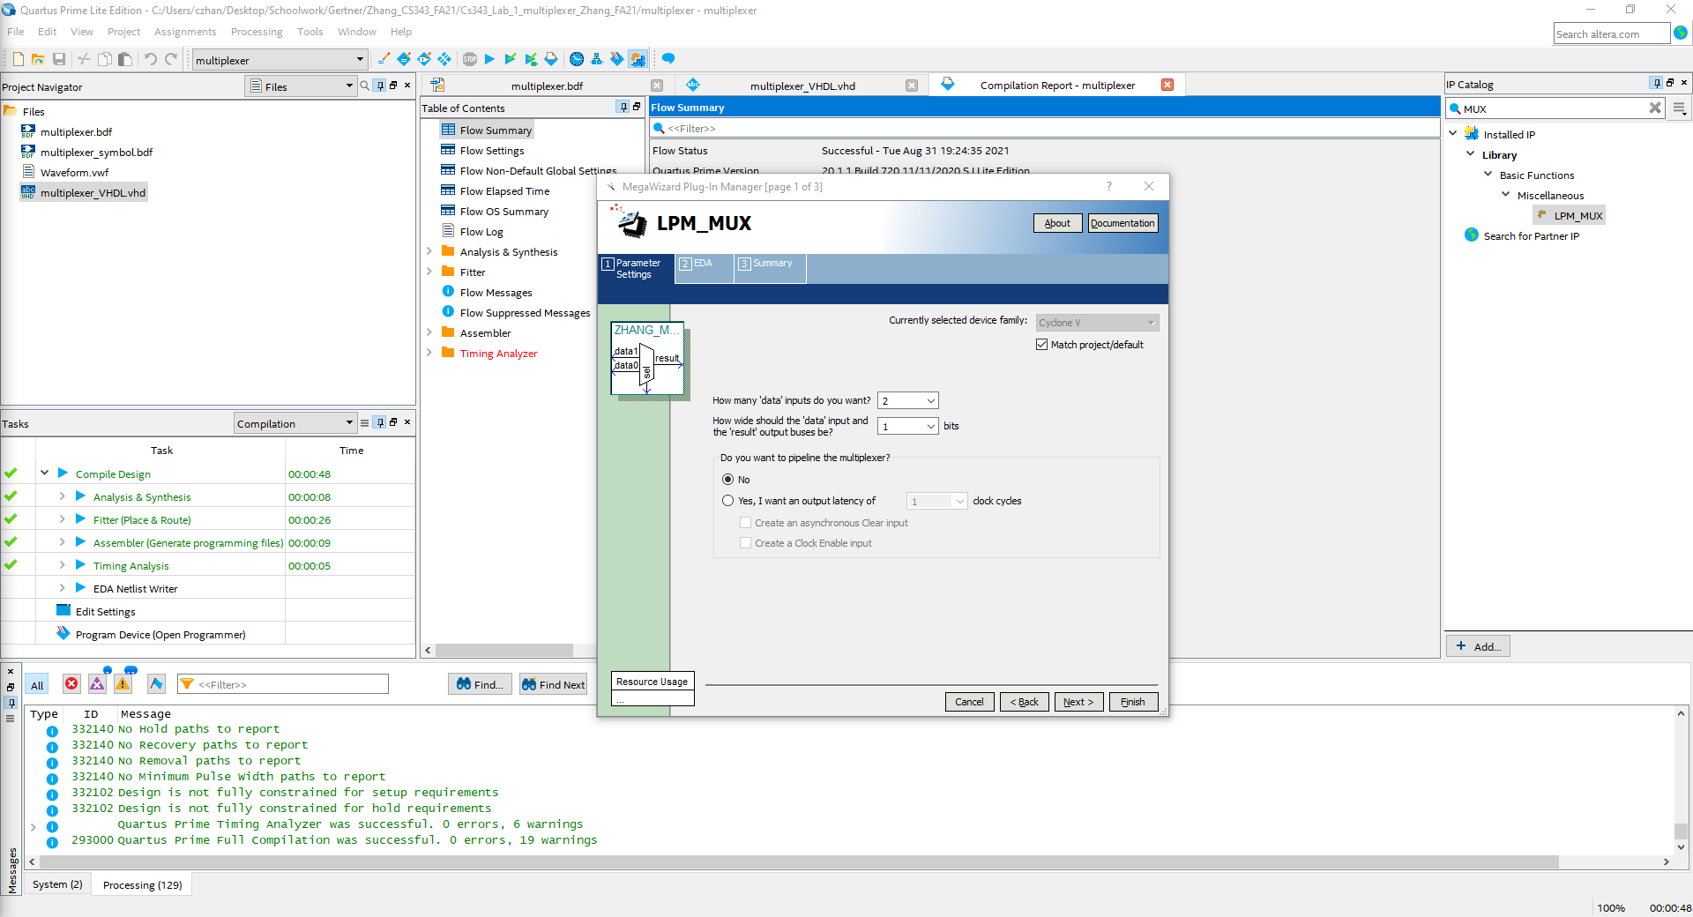

A pop up shows, I press next until I can no longer press next, then I press finish

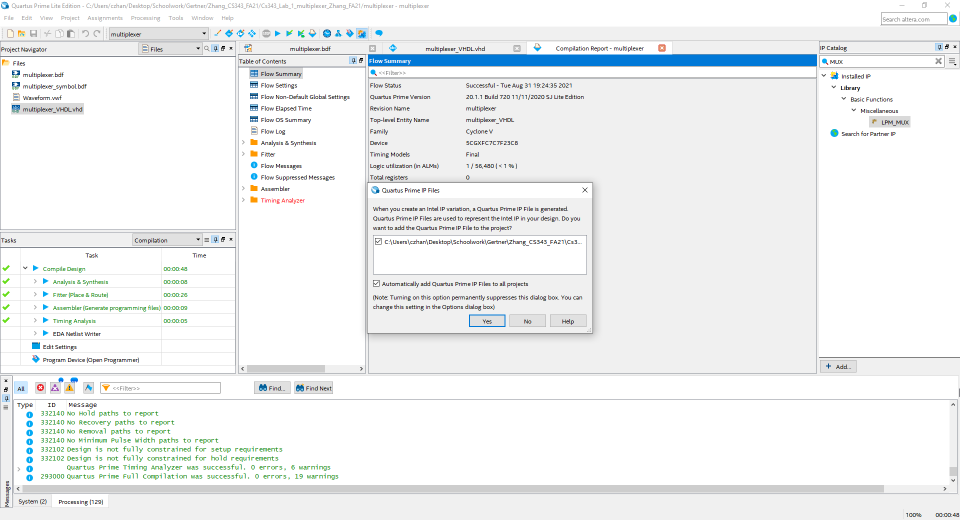

A pop up shows up and I check the box that says “automatically add quartus prime IP files to all projects” and press Yes

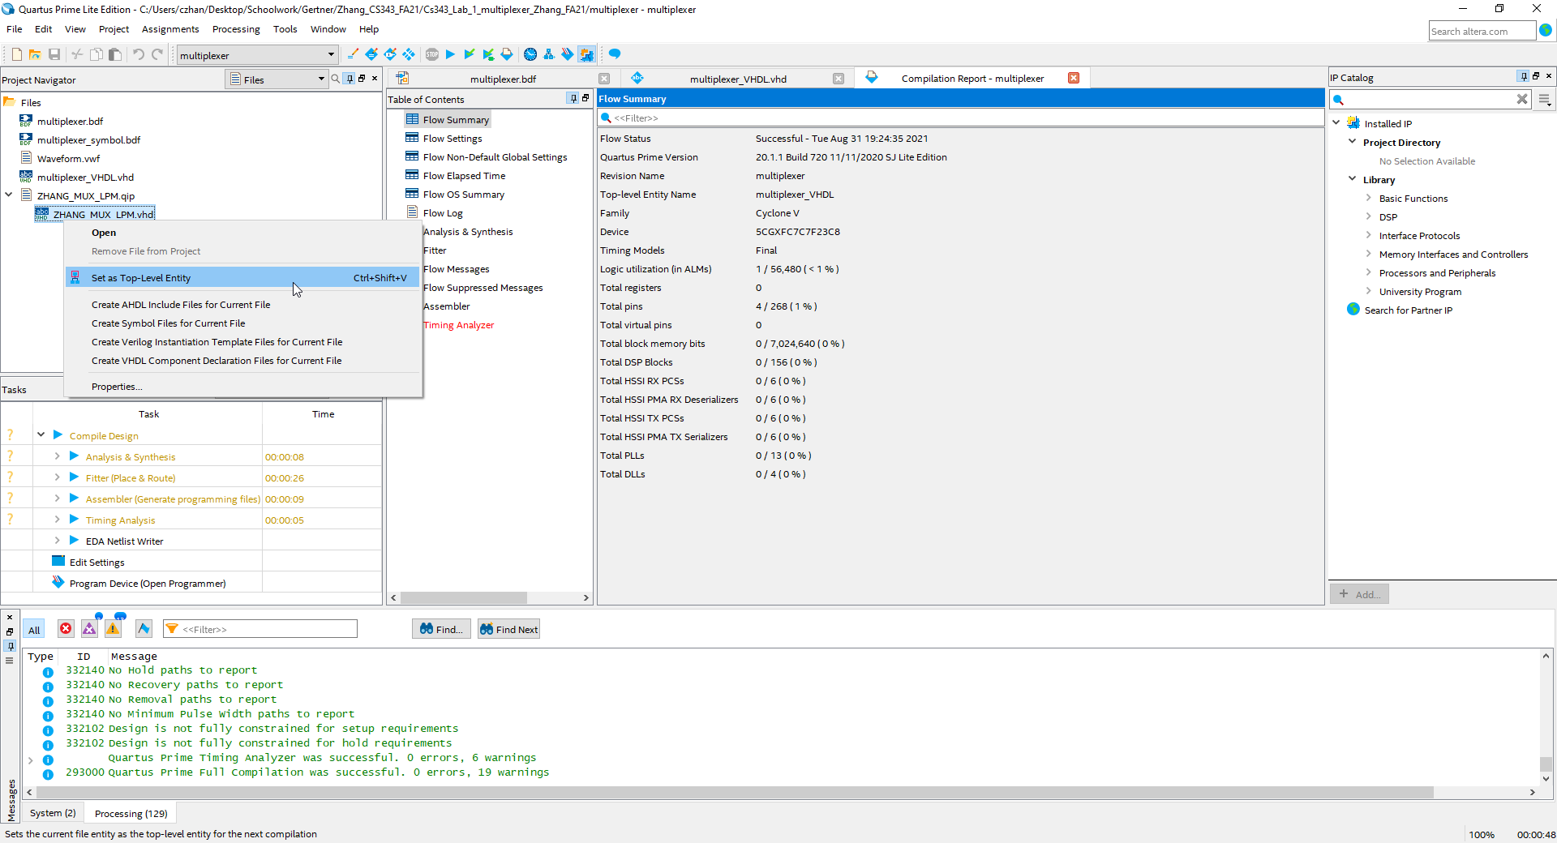

I set the new VHDL file as top level entity

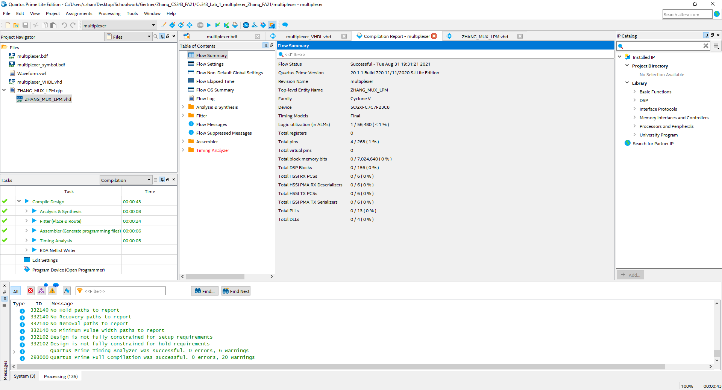

I compile with no erro

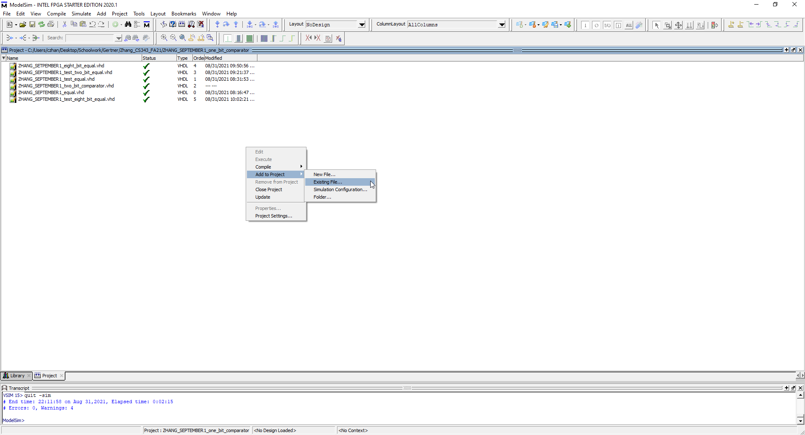

In ModelSim, I right click 🡪 Add to project 🡪 Existing file.. 🡪 and select the vhdl files necessary

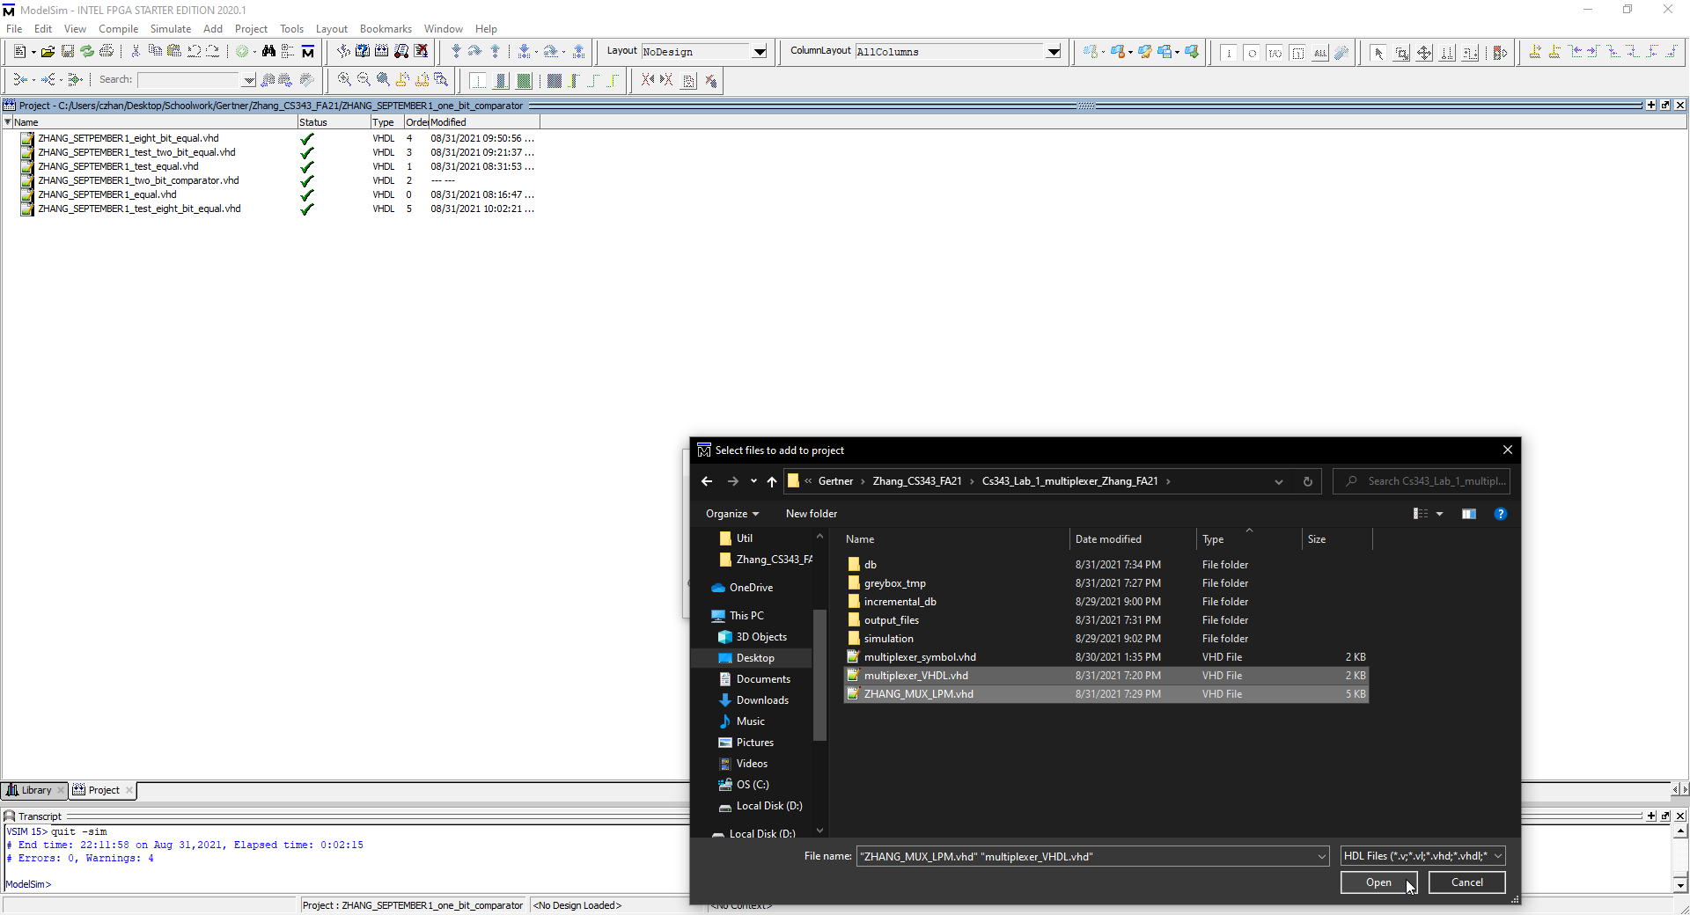

Here I am selecting the LPM MUX vhdl and the VHDL from my mux design

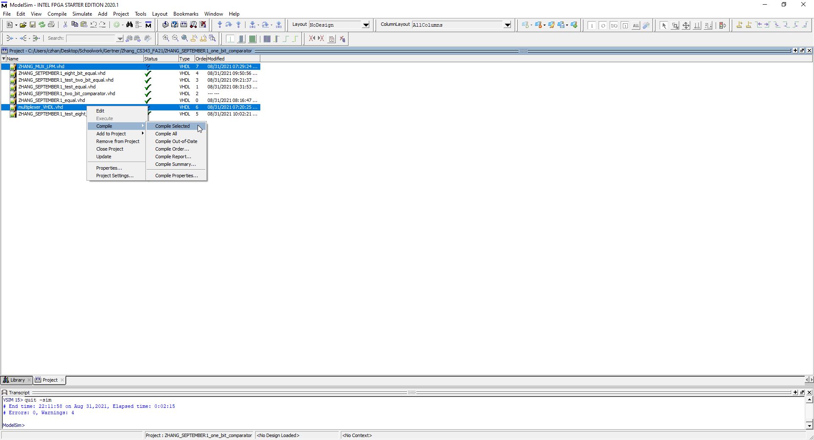

To ensure that they are correct, I compile both files by selecting both files 🡪 right click 🡪 compile 🡪 compile selected

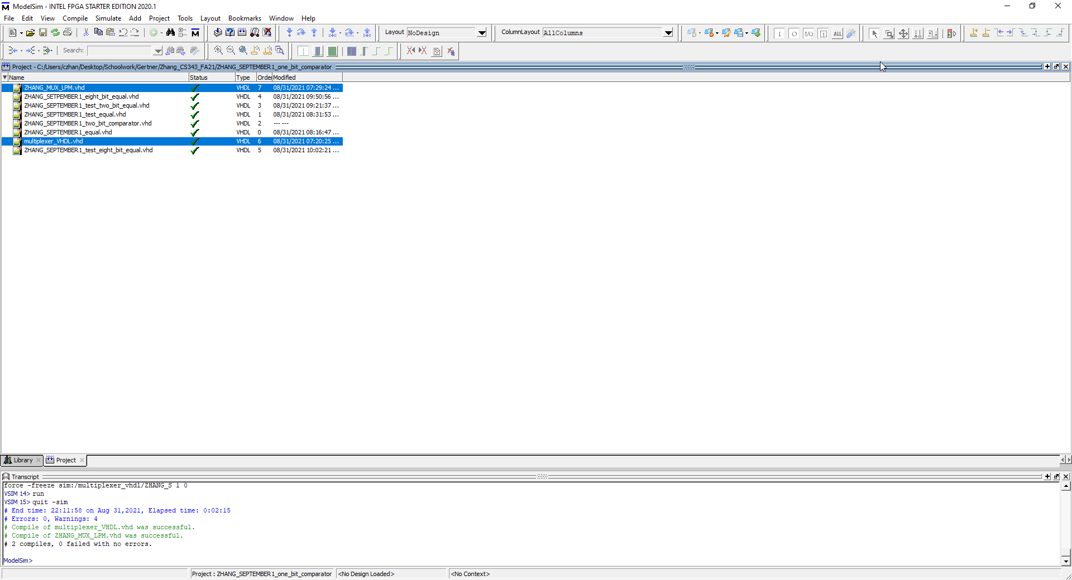

I have successfully compiled with no errors

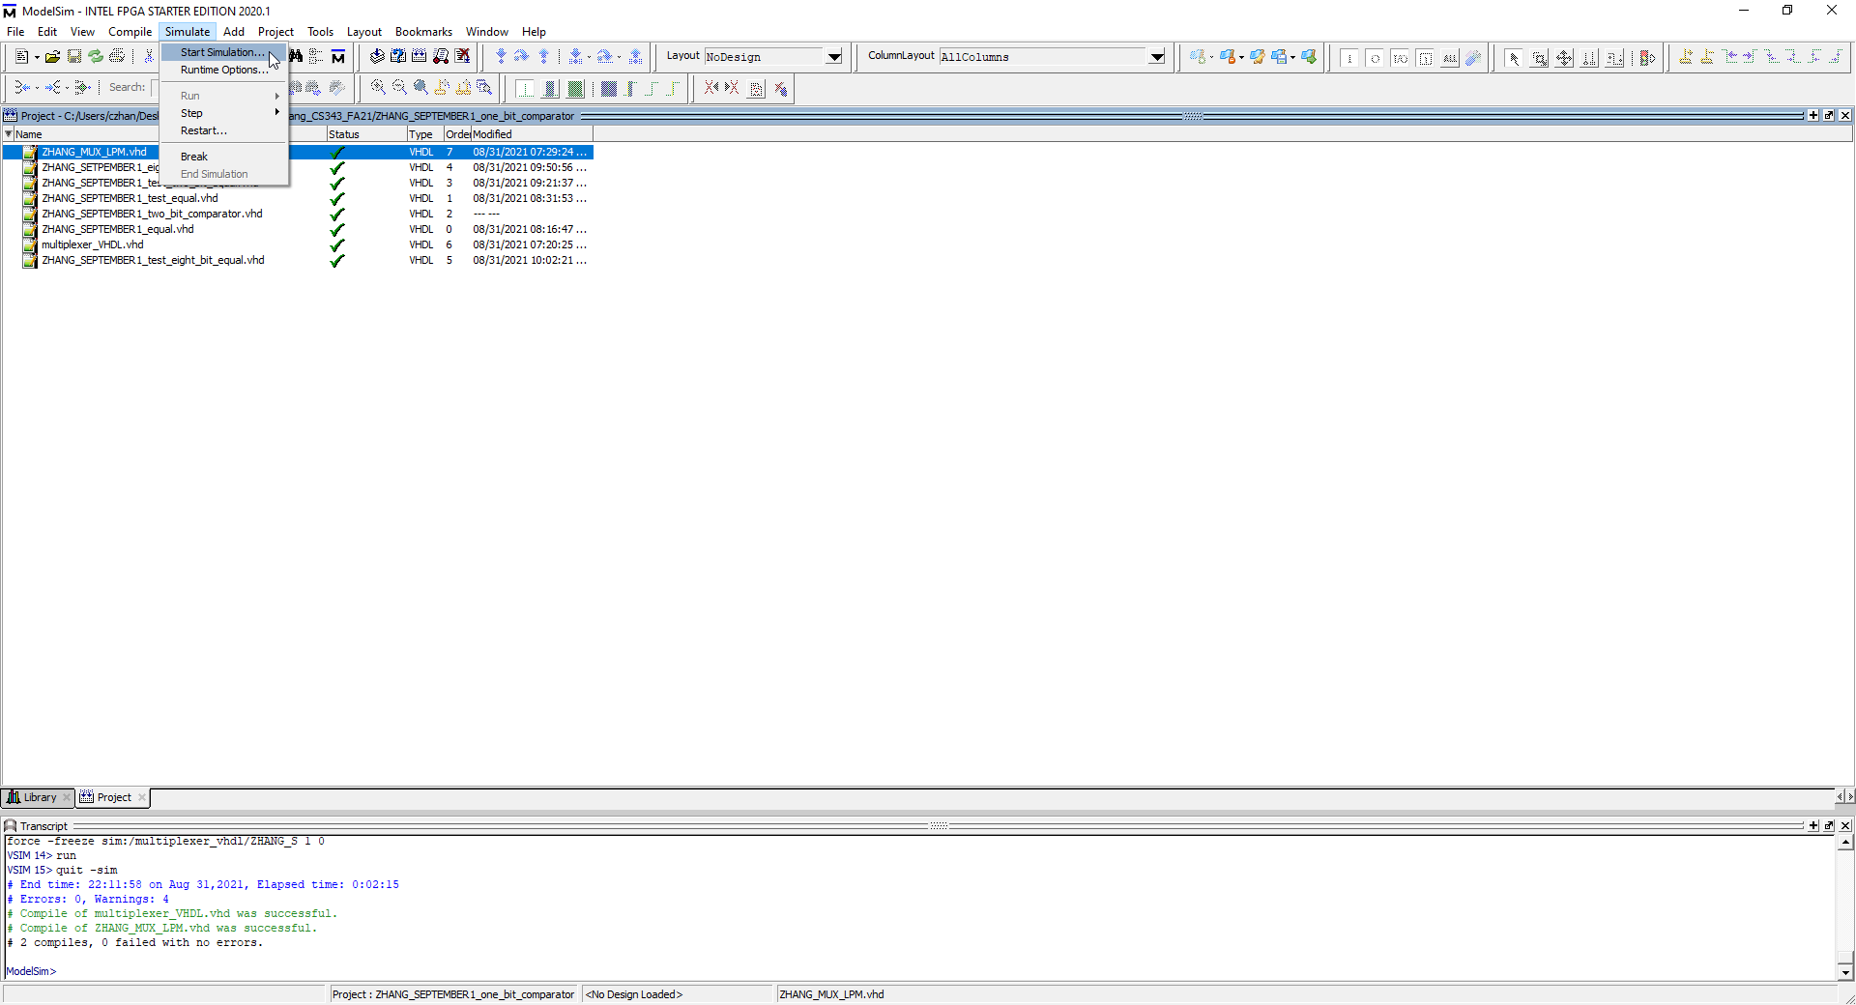

I will now proceed with simulations so on simulations 🡪 I press start simulation

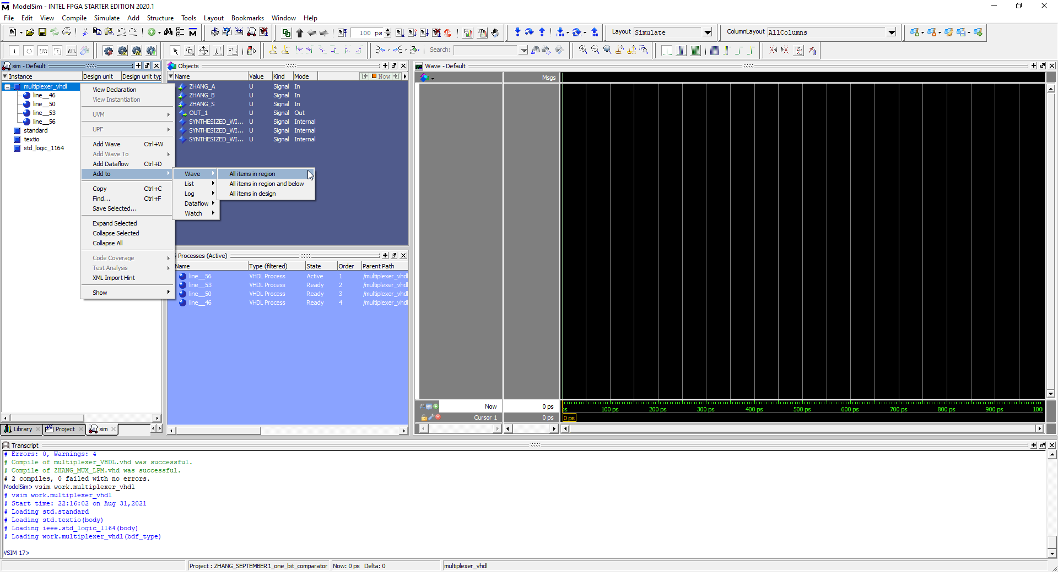

I right click the vhdl with the items in it and right click 🡪 add to 🡪 wave 🡪 add items in region

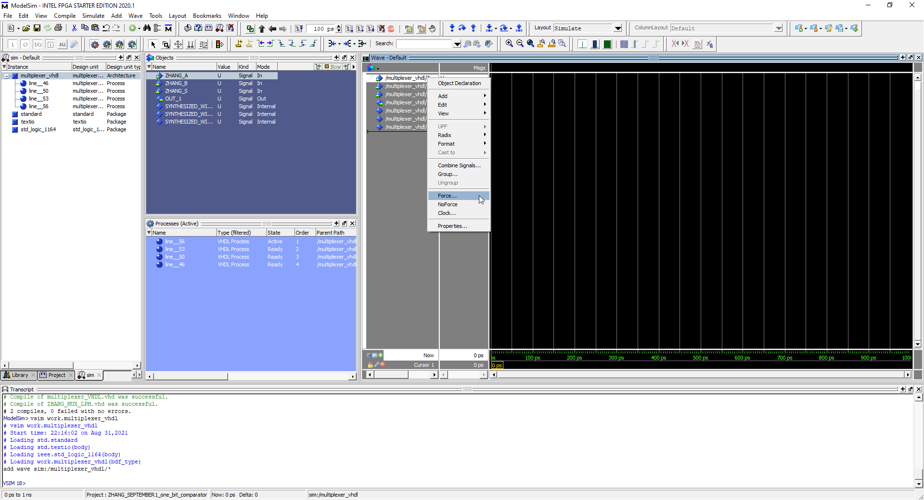

This adds all the files that I want to simulate in and then I right click ZHANG_A input and press force

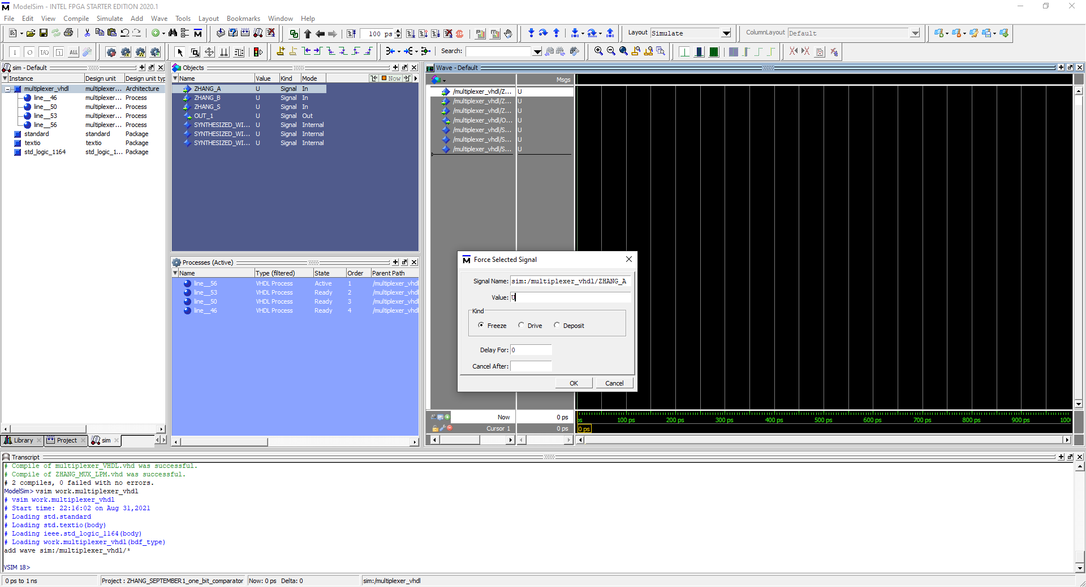

This gives me a popup menu where I can set values. For ZHANG_A I set values to 0 and for ZHANG_B and ZHANG_S I set values to 1

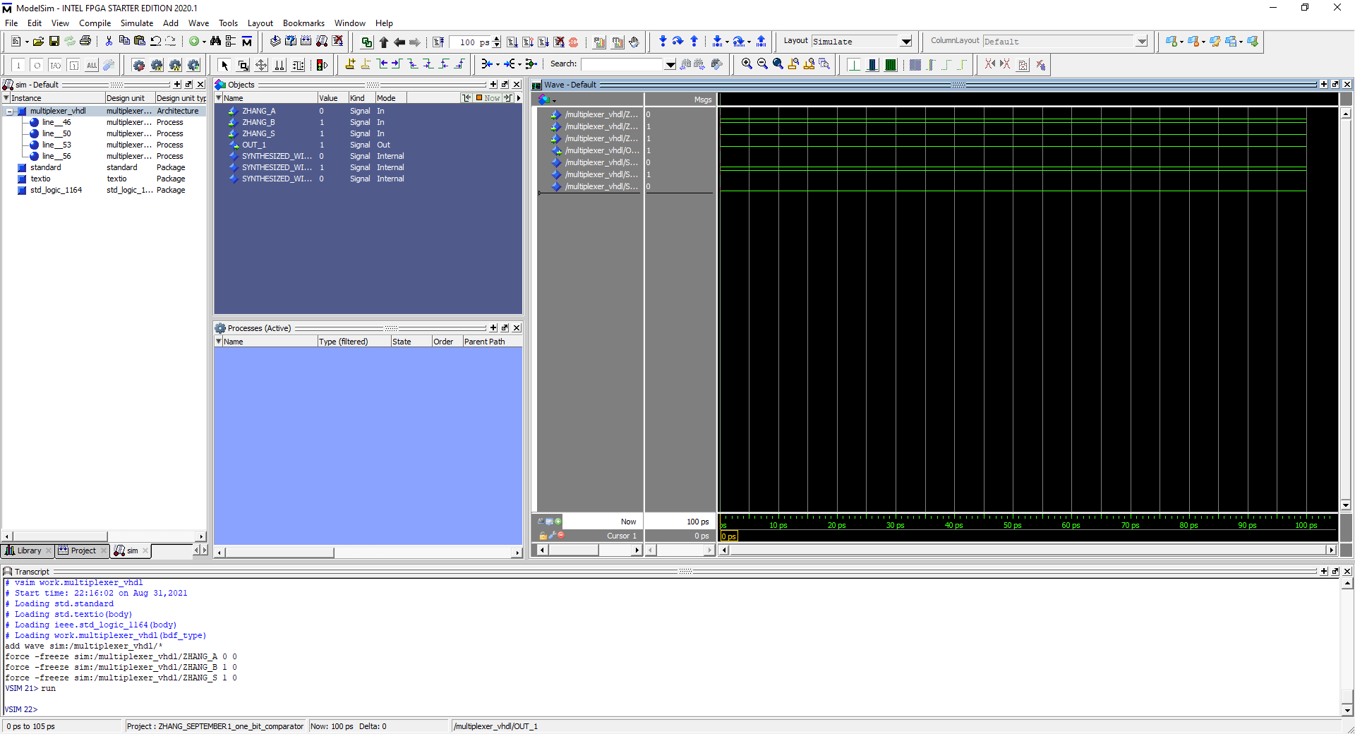

I then run the simulation and this is the output for my design’s, VHDL file. No errors

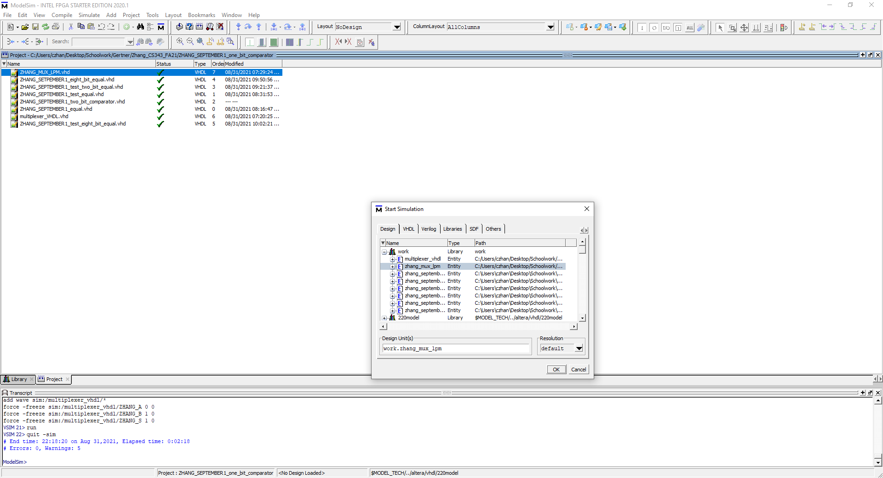

I follow the same steps as what I did for the previous VHDL file but instead, it is for the LPM MUX VHDL file

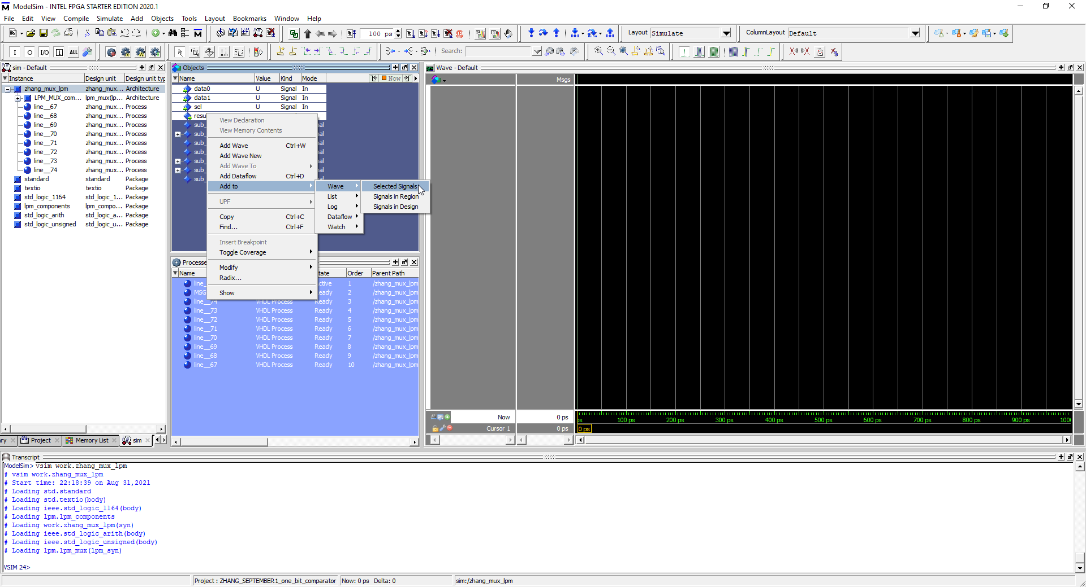

Like before, I add what I want to simulate however, I am only selecting the values necessary to be simulated with

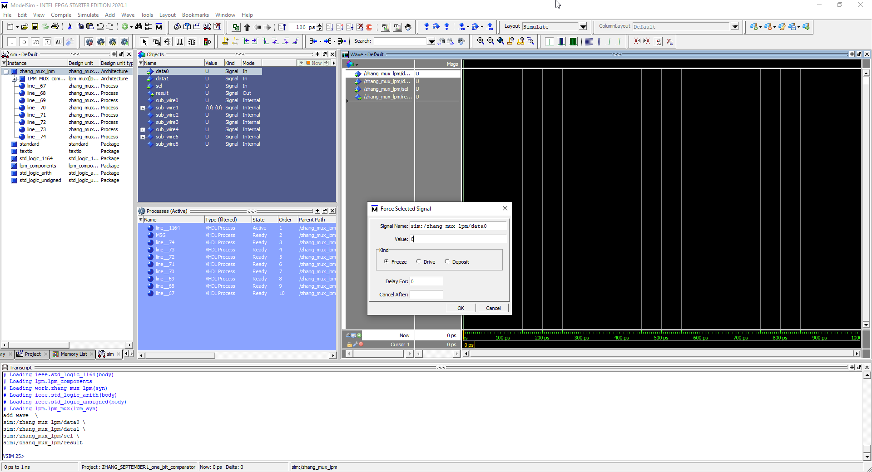

Like before, I right click on the inputs and I press force. Again will I set the values of data0 to “0” and data1 and sel to “1”

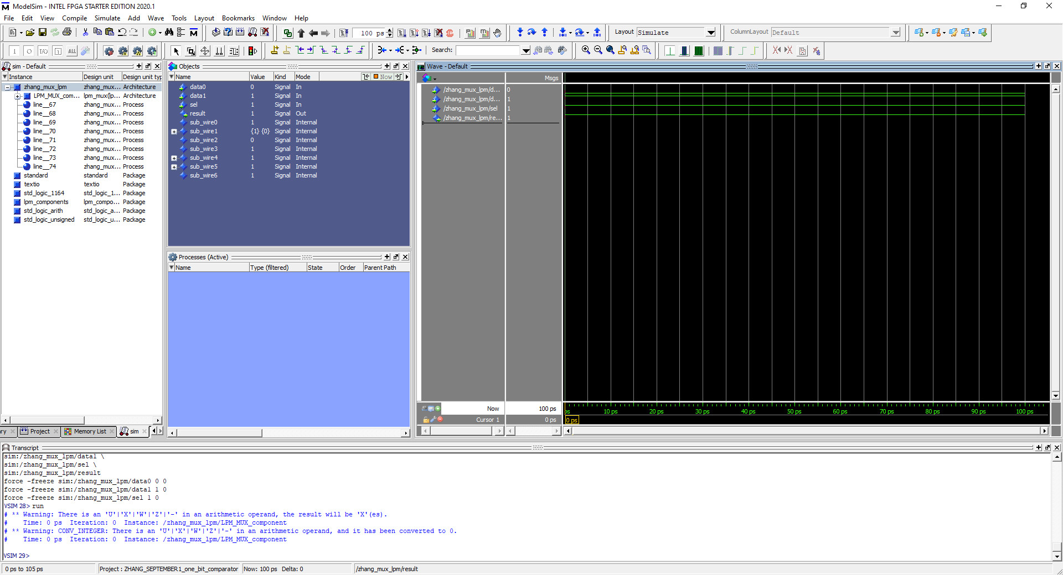

This is the output of the waveform. No errors

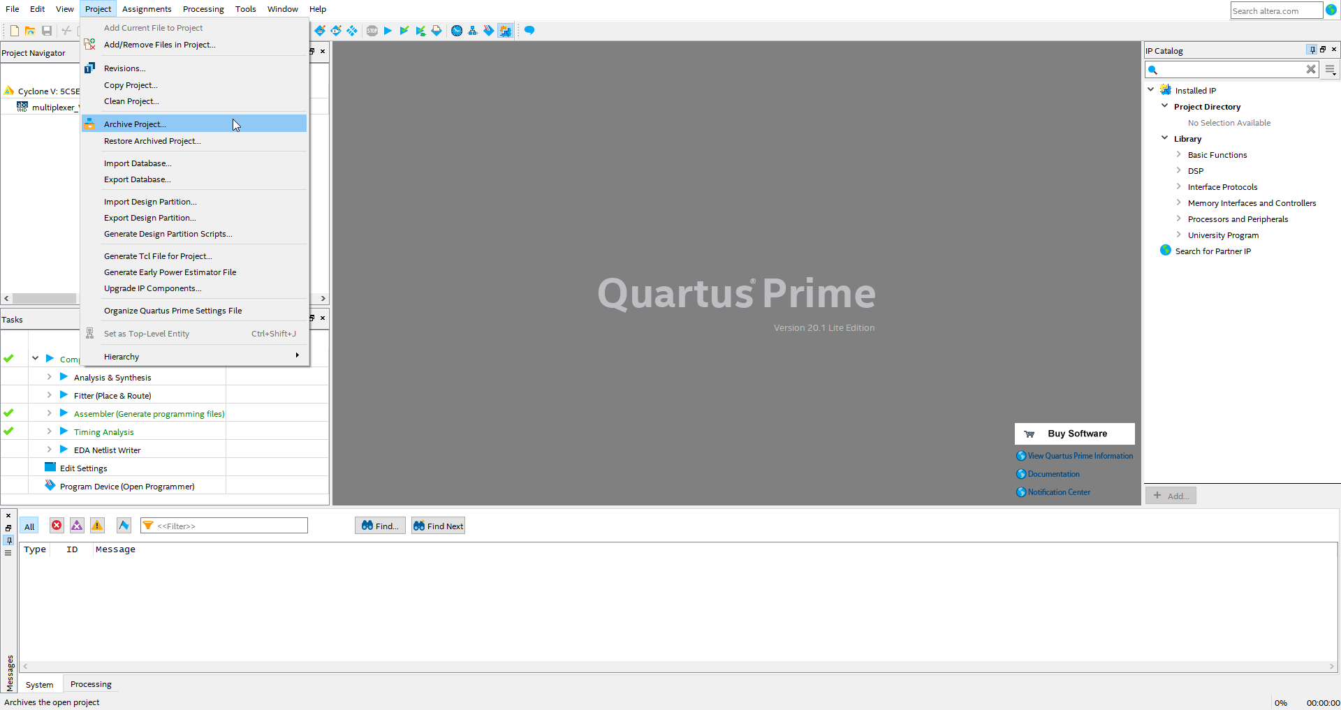

To archive a project, click on project 🡪 archive project

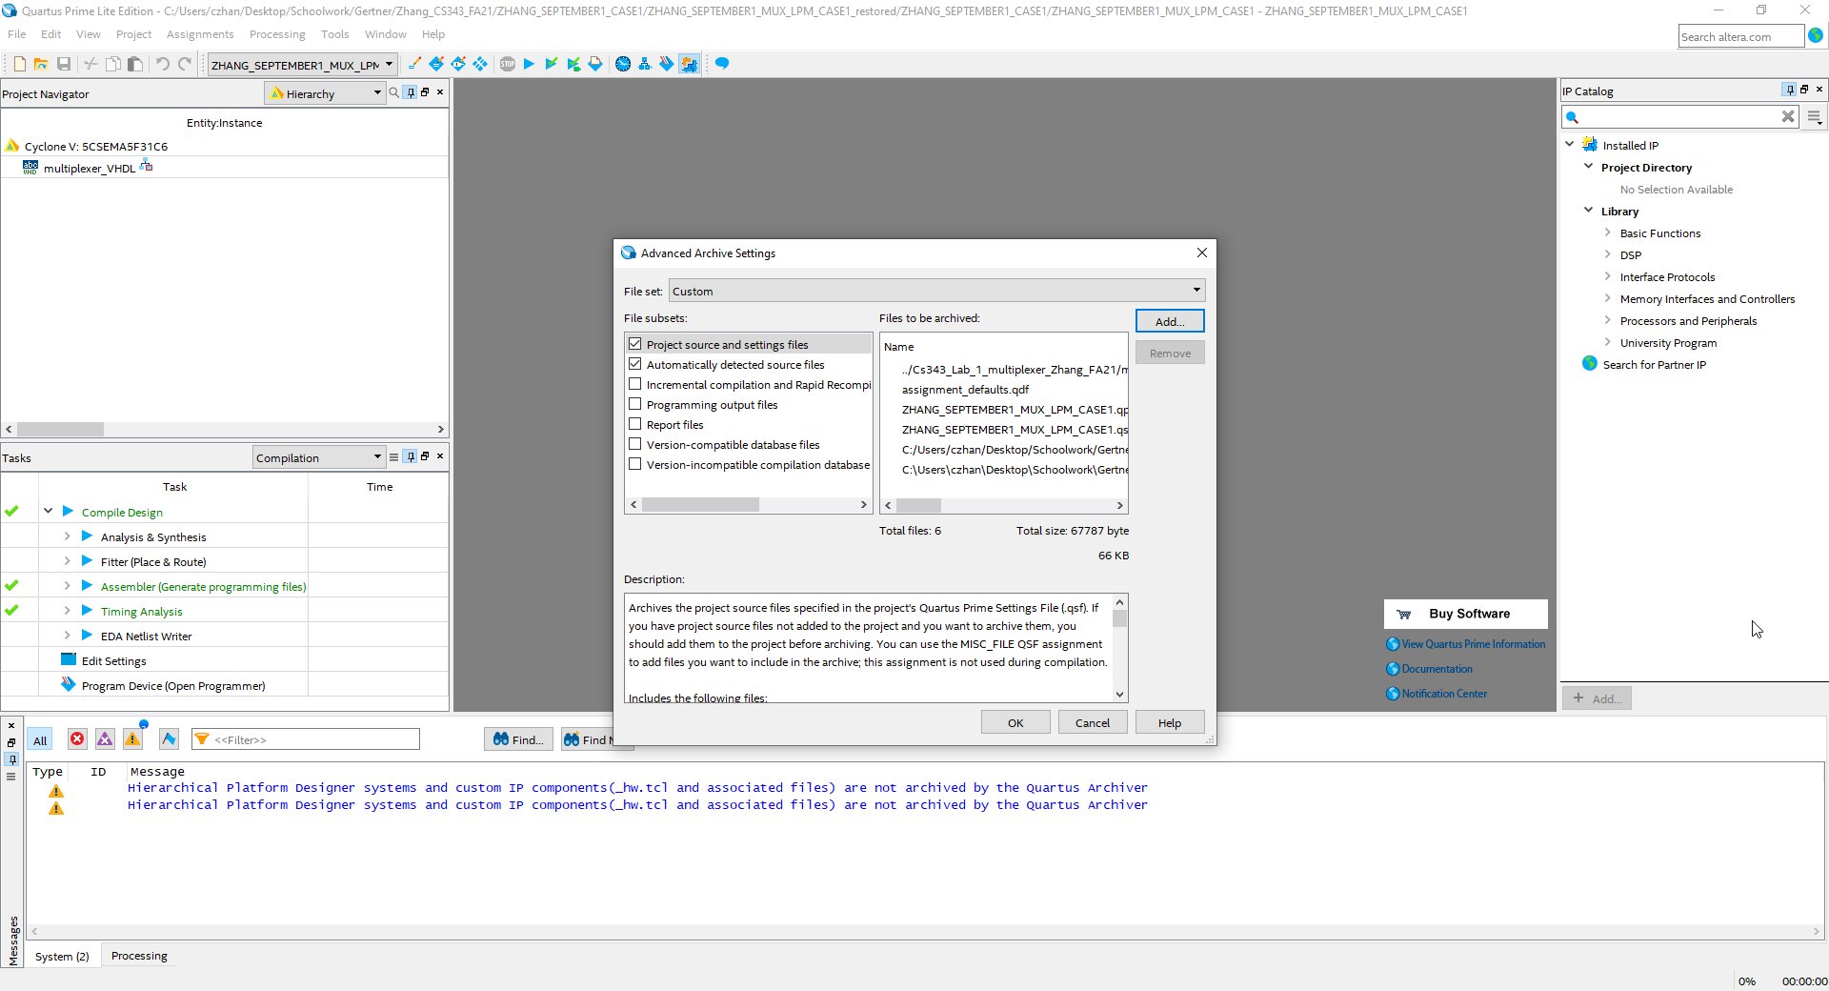

To add a README.TXT to the archive, press advanced 🡪 then the image above should show. Press add then add the respective file you wish to add in.

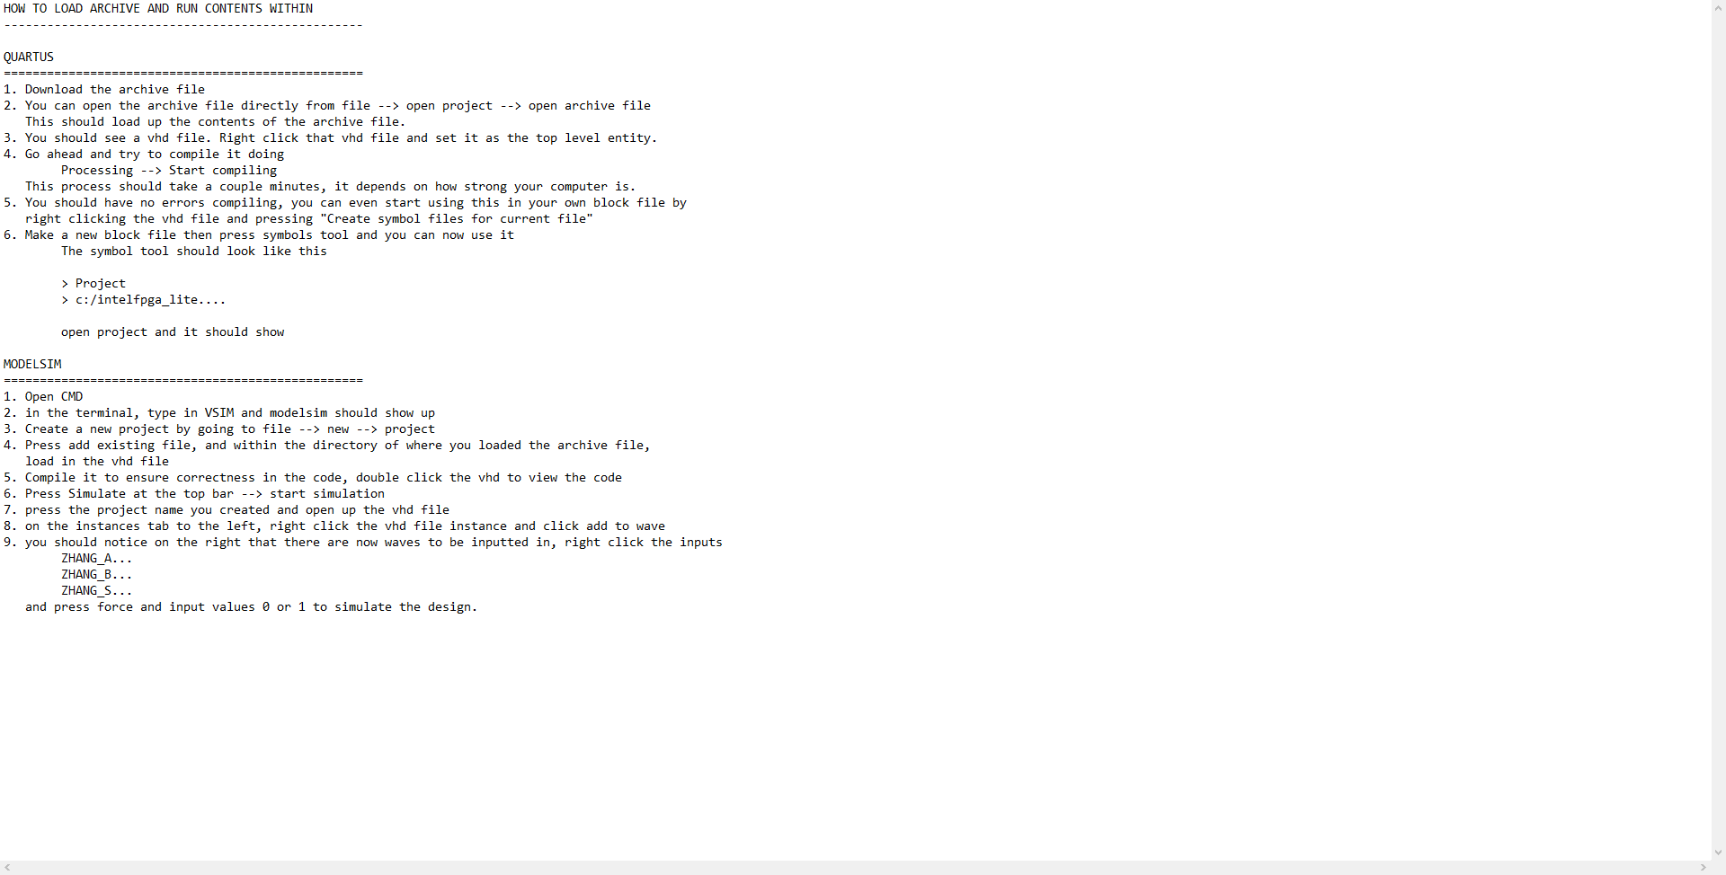

This is the readme file that I will be including in, complete the archive by pressing ok

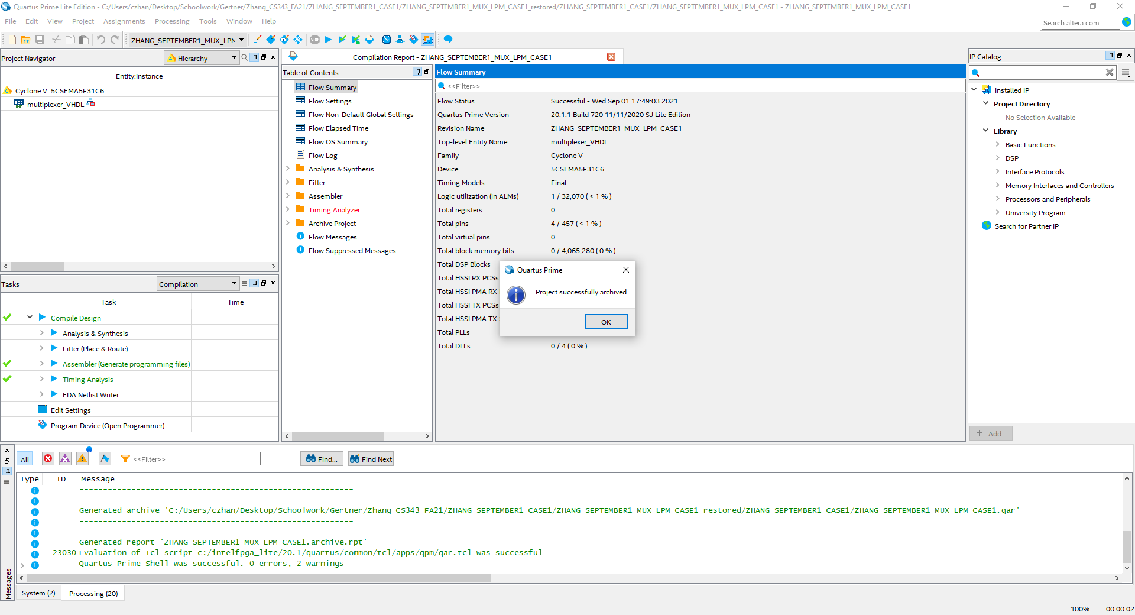

Once the archived has been successfully created, a popup like this should show. Also refer to the green text below for success.