Lab: 3 Port Adder/Subtractor

Chue Zhang

Csc343 Fall 2021

Professor Gertner

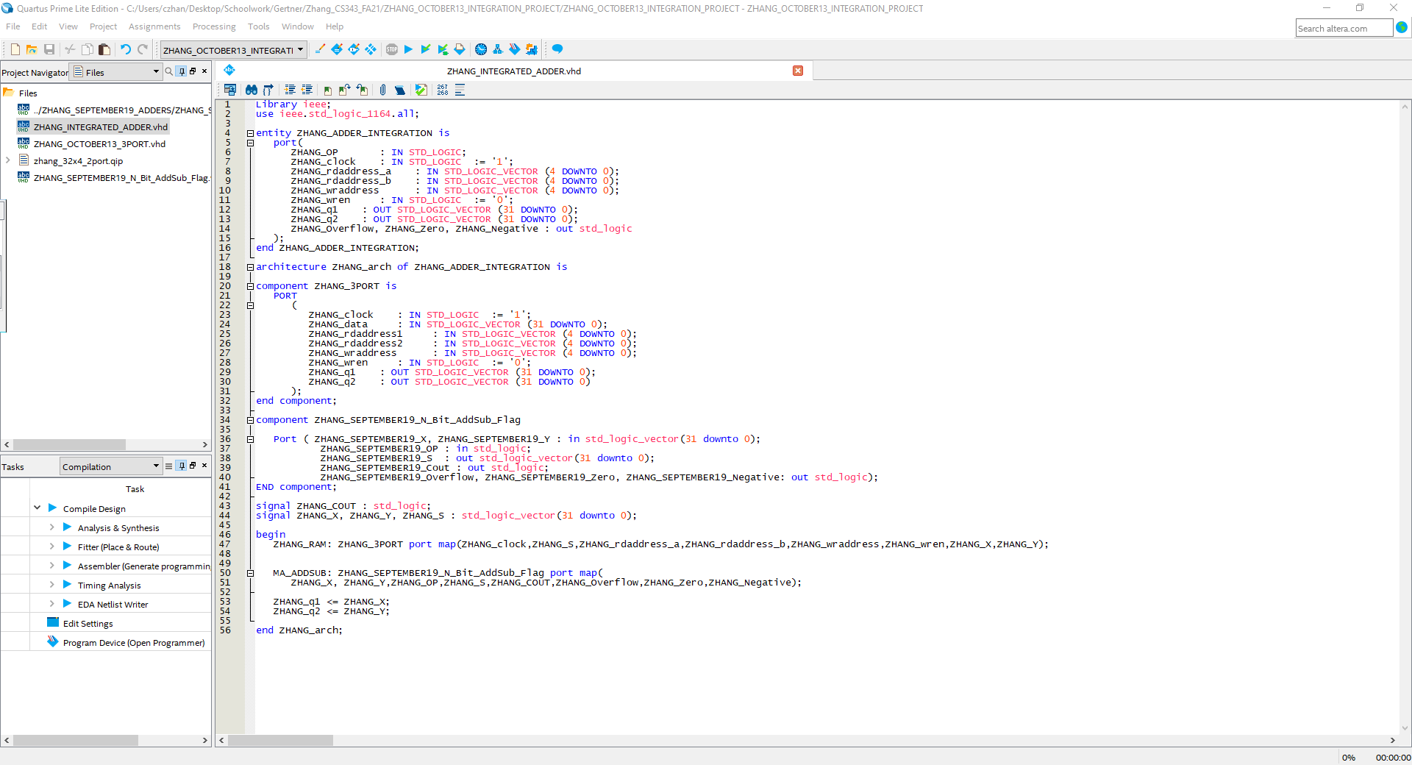

Code of main file that contains imported file of 3 port LPM, N bit adder/sub and the usage of them

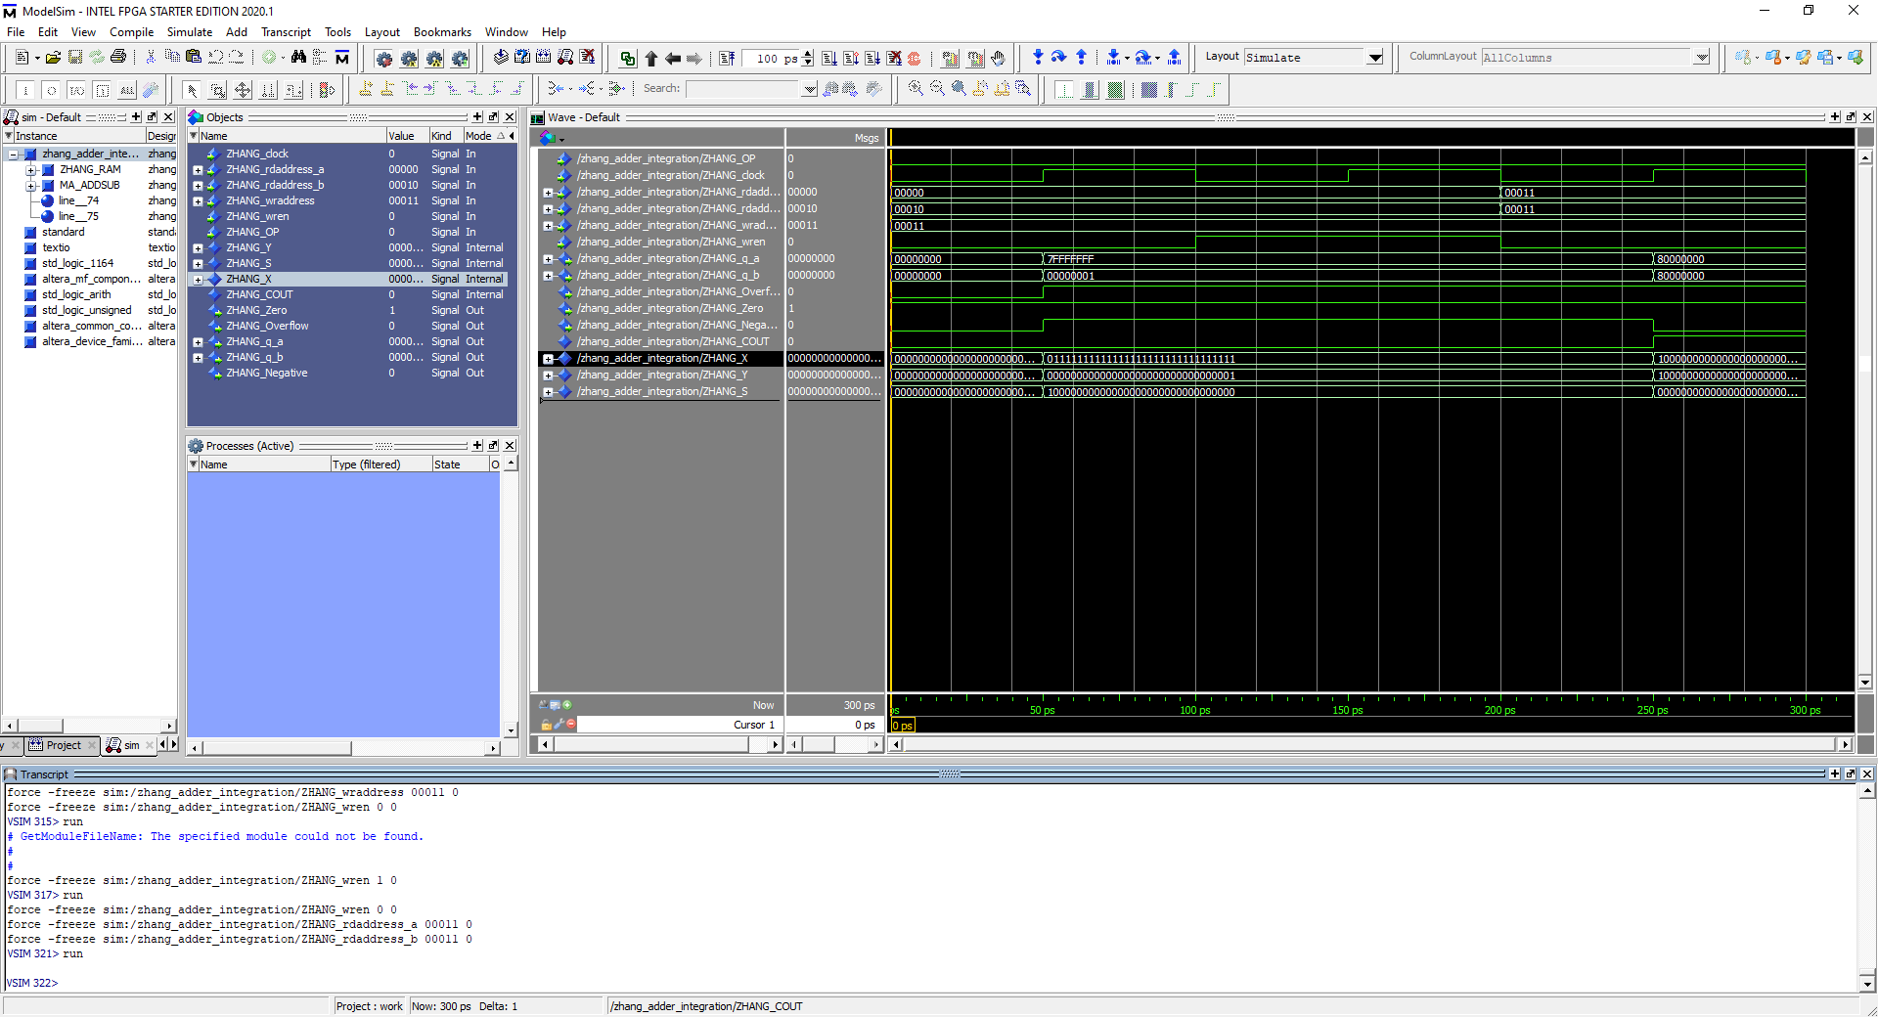

Most Postive + 1, reading first address in MIF and the 3rd address in MIF then writing onto the 4th address with newly computed value

Most Positive - 1, reading first address in MIF and the 3rd address in MIF then writing onto the 4th address with newly computed value

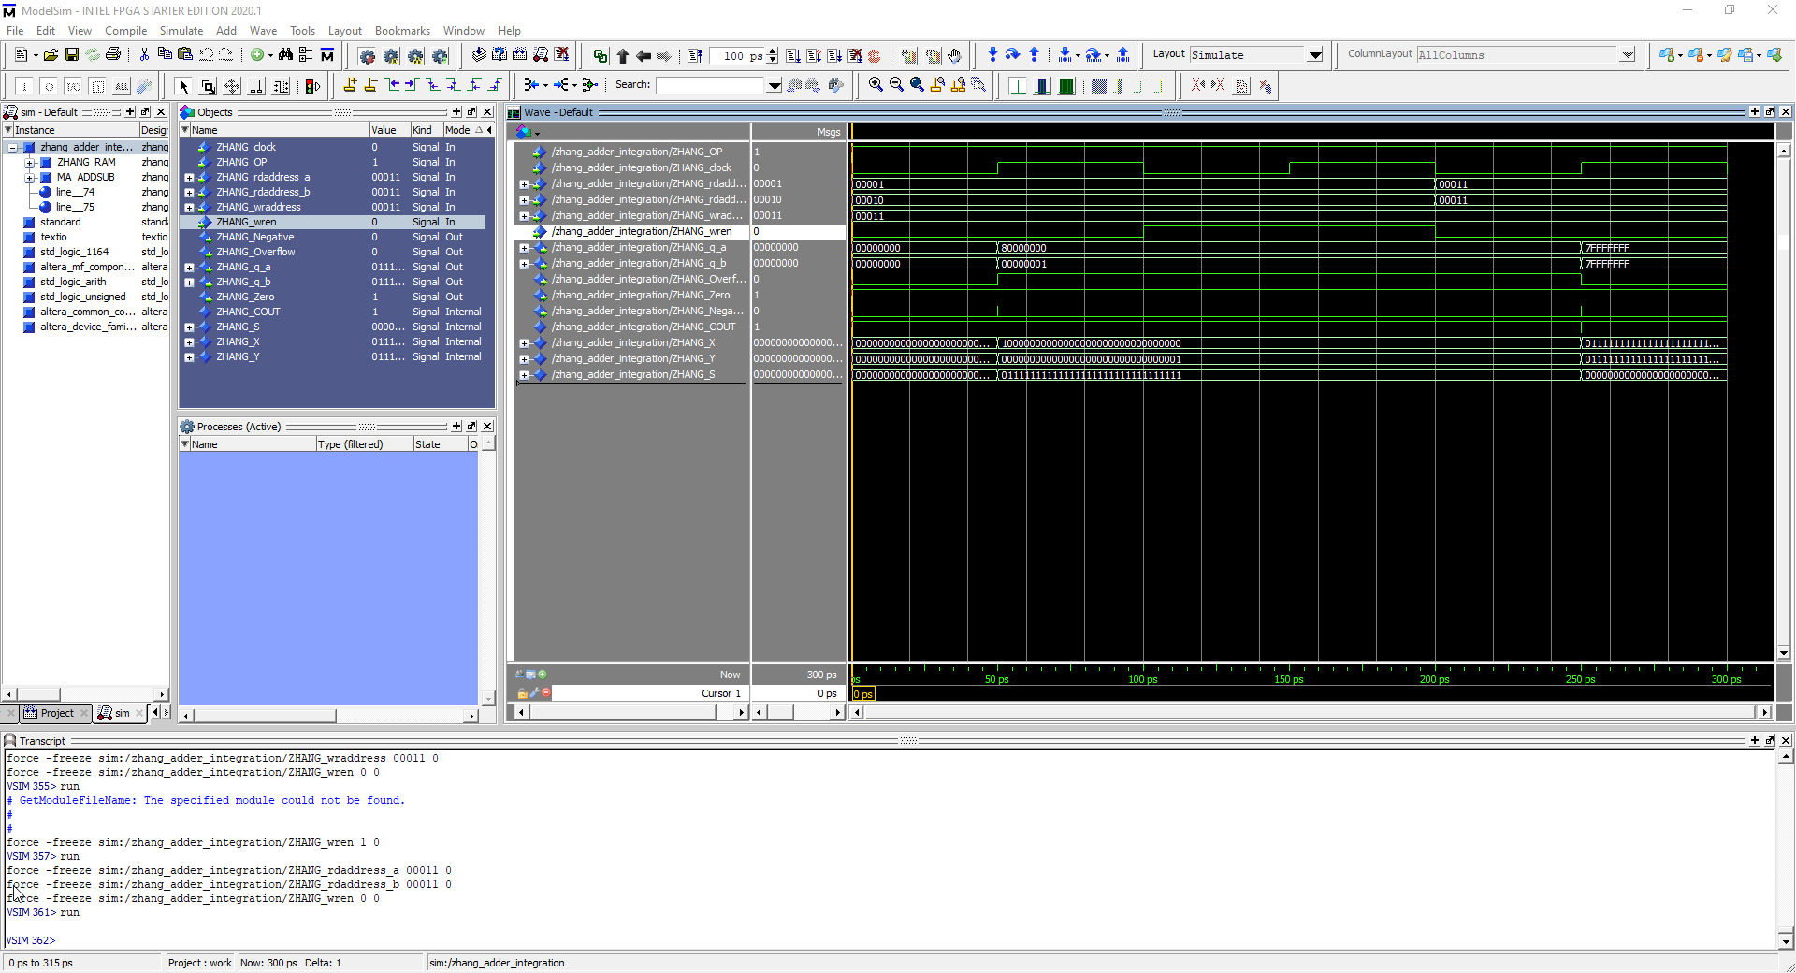

Most negative – 1, reading 2nd address in MIF and the 3rd address in MIF then writing onto the 4th address with newly computed value

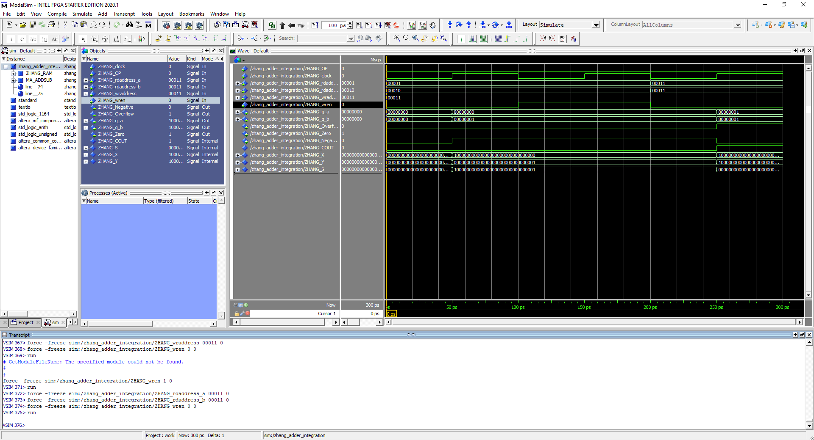

Most negative + 1, reading first address in MIF and the 3rd address in MIF then writing onto the 4th address with newly computed value

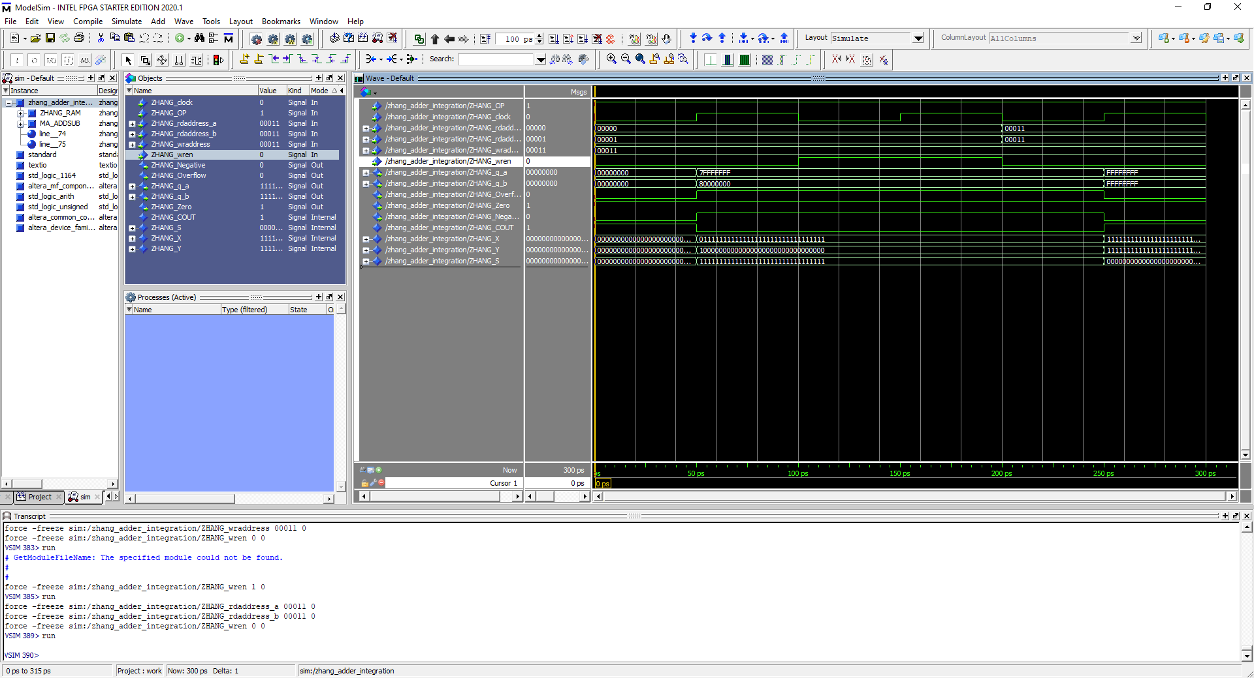

Most positive – most negative, reading 1st address in MIF and the 2nd address in MIF then writing onto the 4th address with newly computed value

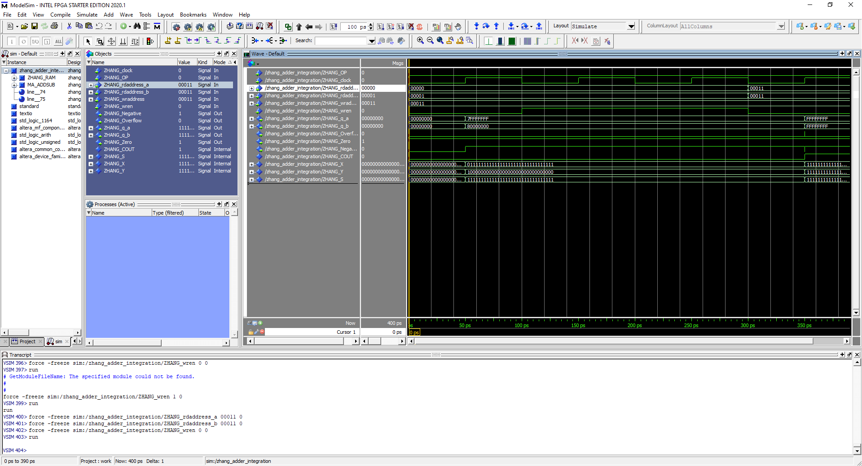

Most positive + Most negative, reading 1st address in MIF and the 2nd address in MIF then writing onto the 4th address with newly computed value

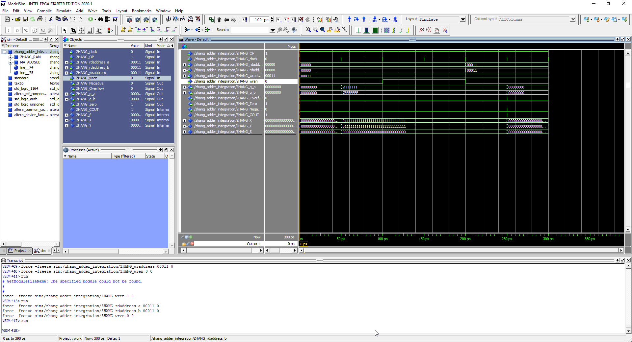

Most positive – Most positive, reading 1st address in MIF and the 1st address in MIF then writing onto the 4th address with newly computed value.