ZHANG_CHUE

BONUS TASK

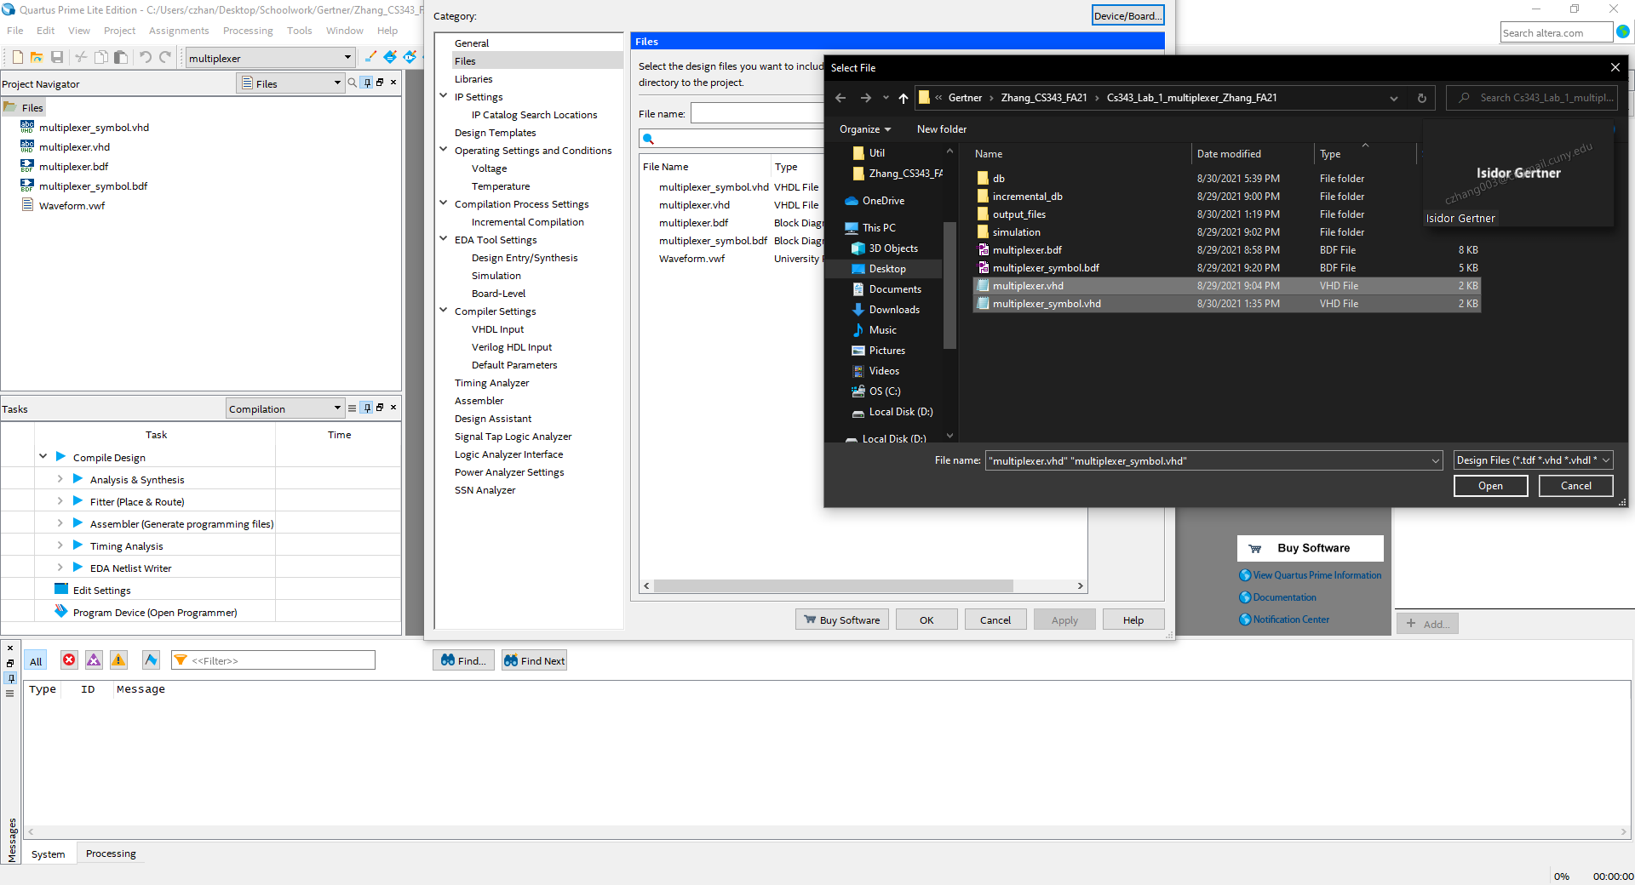

I created a new project where I included the MUX symbol and the Top-level design vhdl files. In the figure above, what is showcased is the inclusion of both vhd file into the new project. 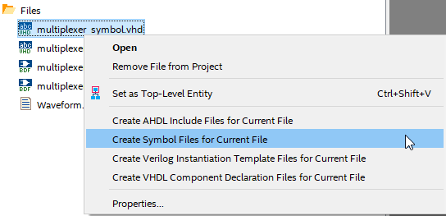

Next, I right click the vhd files and press “Create Symbol Files for Current File” and this step applies to both vhd file. What happens here is that we are now able to use the symbols in the project

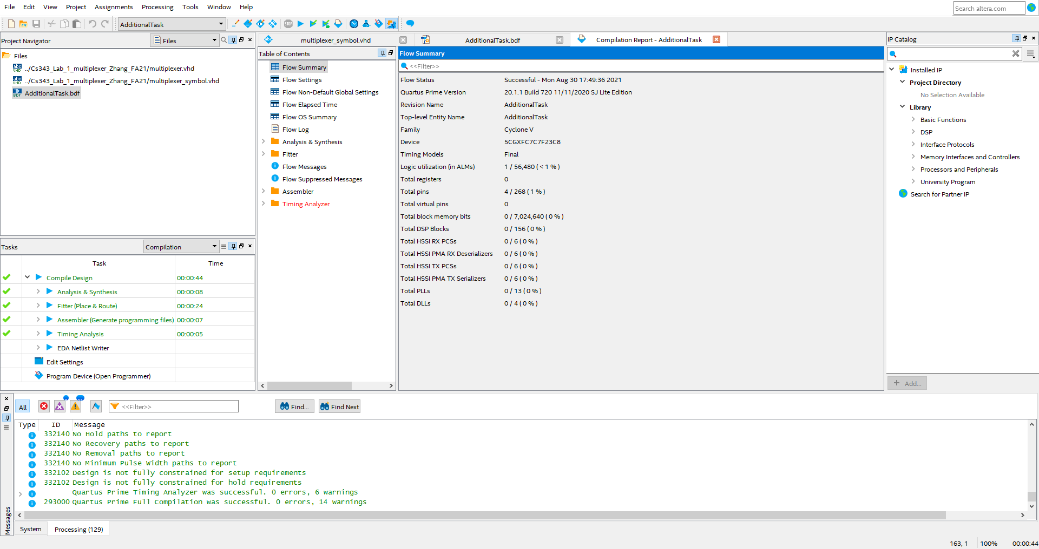

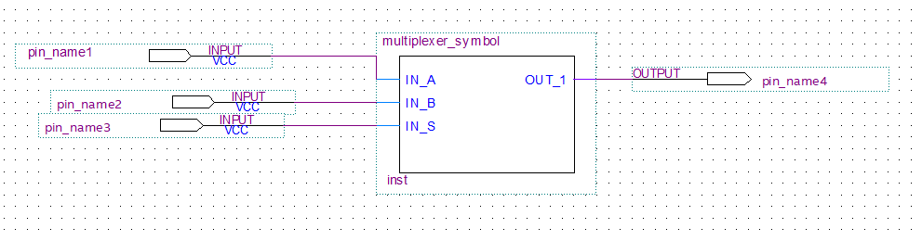

The figure above showcases a successful compilation of the bdf file that includes the MUX symbol

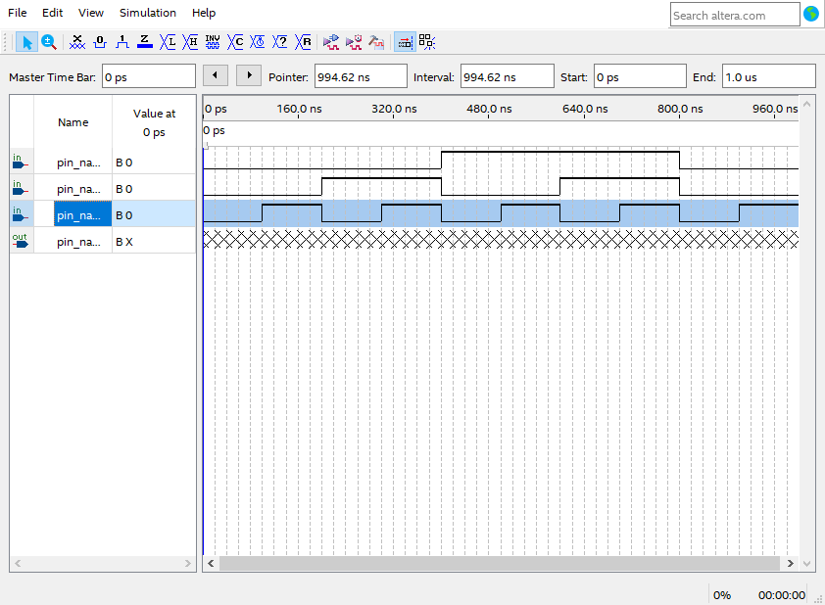

In this screenshot, I am just setting the input values so that we can test for correctness

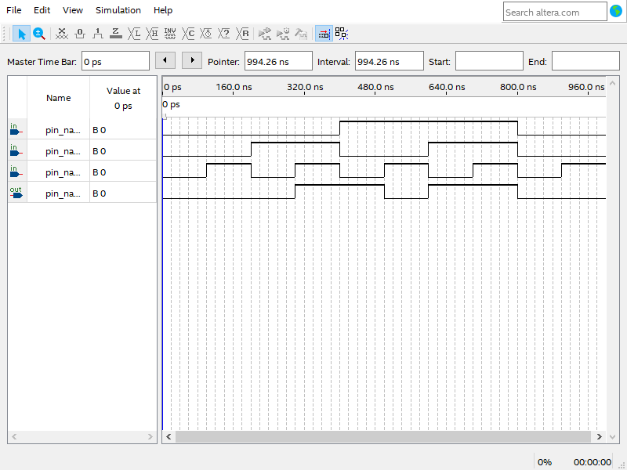

This is the output