**Computer Science**

**CSc 342 Performance time 12:00-1:40 PM Oct 4, 2021 Please submit as DM to instructor by 1:40 PM on Slack**

**Quiz No.1**

October 4, 2021 **Please write your Last Name on every page:**

**NO CORRECTIONS ARE ALLOWED IN ANSWER CELLS!!!!!**

You may use the back page for computations. YOU DO NOT NEED TO SIGN IN ON ZOOM FOR THIS QUIZ Please answer all questions. **Not all questions are of equal difficulty. Please review the entire quiz first and then budget your time carefully.**

Please hand write and sign statements affirming that you will not cheat:

*“I will neither give nor receive unauthorized assistance on this exam. I will use only one computing device to perform this test”*

Please hand write and sign here:

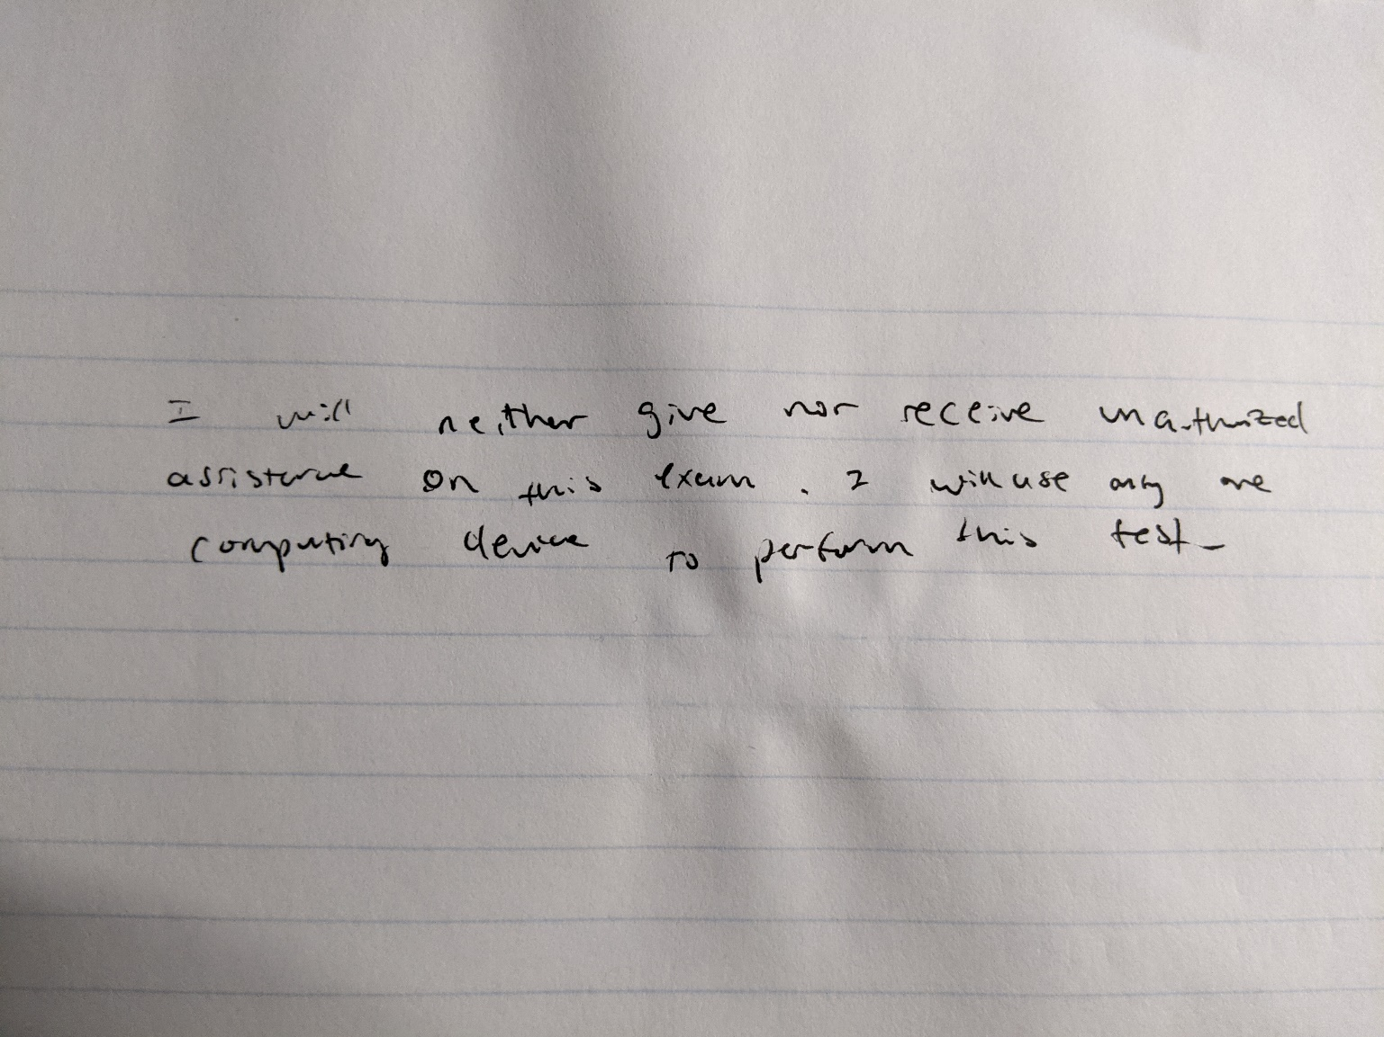

1. [10 points] For **each 8 BIT** binary pattern shown in the table below please write corresponding values of the following interpretations: **UNSIGNED INT, SIGNED INT, UNSIGNED Fixed Point, SIGNED Fixed Point.**

Each correctly answered column is **2.5** points. ***FIXED POINT IS LOCATED TWO POSITIONS FROM THE RIGHT!* MOST SIGNIFICANT BIT IS 7. LEAST SIGNIFICANT BIT IS 0.**

|  |  |  |  |  |
| --- | --- | --- | --- | --- |
| ***76543210*** | **UNSIGNED INT** | **SIGNED INT** | **UNSIGNED**  **Fixed Point** | **SIGNED**  **Fixed Point** |
| 10000000 | 128 | -128 | 32 + 0 = 32 | -32 + 0 = -32 |
| 10000011 | 131 | -125 | 32 + ½ + ¼ = 131/4 | -32 + ½ + ¼ = -125/4 |
| 10000001 | 129 | -127 | 32 + ¼ = 129/4 | -32 + ¼ = -127/4 |
| 01000001 | 65 | 65 | 16 + ¼ = 65/4 | 16 + ¼ = 65/4 |
| 01111111 | 127 | 127 | 31 + ½ + ¼ = 127/4 | 31 + ½ + ¼ = 127/4 |
| 11111111 | 255 | -1 | 63 + ½ + ¼ = 255/4 | -1 + ½ + ¼ = -1/4 |
| 11111100 | 252 | -4 | 63 + 0 = 63 | -1 |
| 00000000 | 0 | 0 | 0 | 0 |
| 01111110 | 126 | 126 | 31 + ½ = 63/2 | 32 + ½ = 63/2 |
| 10001110 | 142 | -114 | 35 + ½ = 71/2 | -28 – ½ = -57/2 |
| 00010011 | 19 | +19 | 4+= | +4+=+ |

1. [10 points] What is the most negative number (largest absolute value negative) that can be represented using 16 bit signed integer representation? Please circle around over all the correct ones: -32768, -65536, -16384, -32767, NONE

-2^(16-1) = -2^15 = -32768 therefore -32768 only.

1. [ 10 points]Please subtract two number in Hex. Then convert each operand to binary and perform the same operation in binary, then repeat BASE 10. The signed integers are represented using two’s complement.

|  |  |  |
| --- | --- | --- |
| 0x0E | 0000 1110 | 14 |
| - | - | - |
| 0xFF | 1111 1111 | -1 |

Result: 0x0F 0000 1111b dec: 15

0 = 0000, E = 1110, F = 1111

FF = 1111 1111 = 2’s complement = 0000 0001 = -1

0E = 0000 1110 = 14

14 = 0000 1111 = 0F

1. **[20 points]**

Determine the **MINIMAL** number of **bit**s required to represent **-*127.75*** *using:*

|  |
| --- |
| 56 bits |

# **4.1 (5 points)** ASCII code (please write the number of bits in the cell)

Each character is represented as an 8 bit character therefore 7 x 8 = 56 bits

**4.2** **(5 points)** Binary Fixed Point representation 10 bits *(please write the number of bits in the cell)* And the corresponding binary Fixed Point representation here.

0 0 1 0 0 0 0 0 0 0 0 1 0

(1*-2^7) + (0 x 2^6) + (0 x 2^5) + (0 x 2^4) + (0 x 2^3) + (0 x 2^2) + (0 x 2^1) + (0 x 2^0) + 0/2 + ¼ = -127.5

# **4.3 (5 points)** **Take the result from you answer in 4.2 and shift fixed point by 2 positions to the RIGHT. Please write down the resulting signed decimal value,**

And the corresponding binary Fixed Point representation here.

1

0

0

0

0

0

0

0

0

1

0

0

0

(1*2^-9) + (1*2^0) = -511

1. 4**(5 points)** Please write down the signed rational number stored in the 9-bit word below:

1.00000001 so 1x2^0 + 2^-8 = 257/256

Fixed Point:

1

0

0

0

0

0

0

0

1

$$Reference for Q5-Q8$$

$${\left(-1\right)}^{s}×\left(1+F\right)×2^{E-Bias}$$

With Bias = 127

1. [ 10 points] Please determine if single precision floating point representation given below is ***NAN,or +Infinity,Infinity, or a valid number*** floating point : The top row shows the bit index. ***PLEASE JUSTIFY your ANSWER and SHOW your*** work! Just the final result will not count as a correct answer.

|  |  |  |  |  |  |  |  |  |  |  |  |  |  |  |  |  |  |  |  |  |  |  |  |  |  |  |  |  |  |  |  |
| --- | --- | --- | --- | --- | --- | --- | --- | --- | --- | --- | --- | --- | --- | --- | --- | --- | --- | --- | --- | --- | --- | --- | --- | --- | --- | --- | --- | --- | --- | --- | --- |
| 3  1 | 3  0 | 2  9 | 2  8 | 2  7 | 2  6 | 3  5 | 2  4 | 2  3 | 2  2 | 2  1 | 2  0 | 1  9 | 1  8 | 1  7 | 1  6 | 1  5 | 1  4 | 1  3 | 1  2 | 1  1 | 1  0 | 9 | 8 | 7 | 6 | 5 | 4 | 3 | 2 | 1 | 0 |
| **0** | **1** | **0** | **0** | **0** | **0** | **0** | **0** | **1** | **1** | **1** | **0** | **0** | **0** | **0** | **0** | **0** | **0** | **0** | **0** | **0** | **0** | **0** | **0** | **0** | **0** | **0** | **0** | **0** | **0** | **0** | **0** |

E = 1000 0001 = 129

${\left(-1\right)}^{0}×\left(1+\frac{1}{2}+\frac{1}{4}\right)×2^{129-127}$ = 7.0

1. [ 10 points] Please determine the decimal value (scientific notation) of the single precision floating point representation given below: The top row shows the bit index. ***PLEASE SHOW your*** work! Just the final result will not count as correct answer. ***If it represents NAN, or Infinity, or zero please state this and justify.***

|  |  |  |  |  |  |  |  |  |  |  |  |  |  |  |  |  |  |  |  |  |  |  |  |  |  |  |  |  |  |  |  |
| --- | --- | --- | --- | --- | --- | --- | --- | --- | --- | --- | --- | --- | --- | --- | --- | --- | --- | --- | --- | --- | --- | --- | --- | --- | --- | --- | --- | --- | --- | --- | --- |
| 3  1 | 3  0 | 2  9 | 2  8 | 2  7 | 2  6 | 3  5 | 2  4 | 2  3 | 2  2 | 2  1 | 2  0 | 1  9 | 1  8 | 1  7 | 1  6 | 1  5 | 1  4 | 1  3 | 1  2 | 1  1 | 1  0 | 9 | 8 | 7 | 6 | 5 | 4 | 3 | 2 | 1 | 0 |
| **1** | **1** | **0** | **0** | **0** | **0** | **1** | **0** | **1** | **1** | **1** | **1** | **1** | **1** | **1** | **1** | **1** | **0** | **0** | **0** | **0** | **0** | **0** | **0** | **0** | **0** | **0** | **0** | **0** | **0** | **0** | **0** |

E = 10000101 = 131

$${\left(-1\right)}^{1}×\left(1+\frac{1}{2}+\frac{1}{4}+\frac{1}{8}+\frac{1}{16}+\frac{1}{32}+\frac{1}{64}+\frac{1}{128}+\frac{1}{256}\right)×2^{133-127}= -127.75$$

1. [ 5 points] Please determine the decimal value (scientific notation) of the single precision floating point representation given below: The top row shows the bit index. ***PLEASE SHOW your*** work! Just the final result will not count as correct answer. ***If it represents NAN, or Infinity, or zero please state this and justify.***

|  |  |  |  |  |  |  |  |  |  |  |  |  |  |  |  |  |  |  |  |  |  |  |  |  |  |  |  |  |  |  |  |
| --- | --- | --- | --- | --- | --- | --- | --- | --- | --- | --- | --- | --- | --- | --- | --- | --- | --- | --- | --- | --- | --- | --- | --- | --- | --- | --- | --- | --- | --- | --- | --- |
| 3  1 | 3  0 | 2  9 | 2  8 | 2  7 | 2  6 | 3  5 | 2  4 | 2  3 | 2  2 | 2  1 | 2  0 | 1  9 | 1  8 | 1  7 | 1  6 | 1  5 | 1  4 | 1  3 | 1  2 | 1  1 | 1  0 | 9 | 8 | 7 | 6 | 5 | 4 | 3 | 2 | 1 | 0 |
| **0** | **0** | **0** | **0** | **0** | **0** | **0** | **0** | **0** | **0** | **0** | **0** | **0** | **0** | **0** | **0** | **0** | **0** | **0** | **0** | **0** | **0** | **0** | **0** | **0** | **0** | **0** | **0** | **0** | **0** | **0** | **0** |

**All values are 0 therefore this is zero. There is no E and there is no mantissa**

1. [ 5 points] Please determine the decimal value (scientific notation) of the single precision floating point representation given below: The top row shows the bit index. ***PLEASE SHOW your*** work! Just the final result will not count as correct answer. If it represents NAN, or Infinity, or zero please state this and justify.

|  |  |  |  |  |  |  |  |  |  |  |  |  |  |  |  |  |  |  |  |  |  |  |  |  |  |  |  |  |  |  |  |
| --- | --- | --- | --- | --- | --- | --- | --- | --- | --- | --- | --- | --- | --- | --- | --- | --- | --- | --- | --- | --- | --- | --- | --- | --- | --- | --- | --- | --- | --- | --- | --- |
| 3  1 | 3  0 | 2  9 | 2  8 | 2  7 | 2  6 | 3  5 | 2  4 | 2  3 | 2  2 | 2  1 | 2  0 | 1  9 | 1  8 | 1  7 | 1  6 | 1  5 | 1  4 | 1  3 | 1  2 | 1  1 | 1  0 | 9 | 8 | 7 | 6 | 5 | 4 | 3 | 2 | 1 | 0 |
| **1** | **1** | **1** | **1** | **1** | **1** | **1** | **1** | **1** | **1** | **1** | **1** | **1** | **1** | **1** | **1** | **1** | **1** | **1** | **1** | **1** | **1** | **1** | **1** | **1** | **1** | **1** | **1** | **1** | **1** | **1** | **1** |

**The value is NaN as NaN maintains a form S111 1111……..1111 and above showcases this**

***In EACH Questions 10.1-10.4 you are given SIGNED Integers stored in 32 BIT Registers. (Not 33-BIT Register ).***

***Please write decimal, and binary operands and the results. For each question you have to write the result and* overflow or No overflow. You may override ‘0’ with ‘1’.**

**10.1**  **(5 points)** What is the result (hexadecimal, decimal and binary) of the following addition:

0x0000000E = 0000 1110 = 14

+

0xFFFFFFFF = 1111 1111…. 1111 (2’s complement) = -1

HEX: 0x0000000D Decimal: +13 Binary:0000 0000 0000 0000 0000 0000 0000 1101

**No overflow, 13 IS WITHIN BOUNDS OF 2^32-1**

------------------------------------------------------------------------------------------------------------------------------------------------------- **10.2 (5 points)** What is the result (hexadecimal, decimal and binary) of the following subtraction: 0x7FFFFFFF = 0111 1111 1111 1111 1111 1111 1111 1111 = 2147483647

-

0xFFFFFFFF = 0000 0001 (2’s complement = -1

HEX: 0x8000000000 Decimal**:-2147483648**  Binary: 0000 0000 0000 0000 0000 0000 0000 000 0001

**Yes Overflow because this number exceeds the bounds of 2^31-1 (2^31-1 = +2147483647 and 2147483647 + 1 = 2147483648 which is 1 above)**

-------------------------------------------------------------------------------------------------------------------------------------------------------

**10.3 (5 points)** What is the result(hexadecimal, decimal and binary) of the following subtraction:

0x80000000 = 1000 0000 0000 0000 0000 0000 0000 0000 = -2147483648

-

0xFFFFFFFF = 1111 1111 1111 1111 1111 1111 1111 1111 = -1

HEX: 0x80000001 Decimal: -2147483647 Binary: 1000 0000 0000 0000 0000 0000 0000 0000 0001

**No overflow, NUMBER IS THE LARGEST NEGATIVE NUMBER IN 2^31-1**

----------------------------------------------------------------------------------------------------------------------------------------------------- **10.4 (5 points)** What is the result(hexadecimal, decimal and binary) of the following addition:

0X7FFFFFFF = 0111 1111 1111 1111 1111 1111 1111 1111 = 2147483647

**+**

0XFFFFFFFF = 0000 0001 (2’s complement = -1

HEX: **0X7FFFFFFFE Decimal:** 2147483646 **Binary: 0111 1111 1111 1111 1111 1111 1111 1110**

**NO OVERFLOW BECAUSE WITHIN BOUNDS OF 2^31-1**

Please write your result in the following form:

|  |
| --- |
| OVEREFLOW |

0x80000000

+

|  |  |  |
| --- | --- | --- |
|  | 0xFFFFFFFF |  |
| HEX: | 0x7FFFFFFF |  |

Decimal:+231-1 Binary: **01111111111111111111111111111111**