**Computer Science**

**C.Sc. 342**

**Quiz No.3**

**July 20, 2021**

**START TIME: 12:00 PM JULY 20,2021, you can start the test earlier if you have time.**

**END Time: 2:40 PM July 20, 2021, you can take a break, and continue from 3:30 PM and submit completed test to me on Slack by 4:30 PM, July 20, 2021.**

**Please write your Last Name on every page:**

**NO CORRECTIONS ARE ALLOWED IN ANSWER CELLS!!!!!**

You may use the back page for computations.

Please answer all questions. **Not all questions are of equal difficulty.**

**Please review the entire quiz first and then budget your time carefully.**

Please hand write and sign statements affirming that you will not cheat:

*“I will neither give nor receive unauthorized assistance on this exam. I will use only one computing device to perform this test”*

Please hand write and sign here: Tanvir Youhana

This quiz has 8 pages.

|  |  |  |
| --- | --- | --- |
| Question | Your Grade | Max Grade |
| 1.1 |  | 5 |
| 1.2 |  | 10 |
| 1.3 |  | 10 |
| 1.4 |  | 10 |
| 2.1 |  | 5 |
| 2.2 |  | 5 |
| 2.3 |  | 10 |
| 2.4 |  | 10 |
| 3.1.1 |  | 5 |
| 3.1.2 |  | 5 |
| 3.1.3 |  | 5 |
| 3.2.1 |  | 5 |
| 3.2.2 |  | 5 |
| 3.2.3 |  | 5 |
| 3.3 |  | 5 |

Total: 100

**Question 1.**

A student, while debugging his program, unintentionally displayed partially corrupted DISSASSEMBLY windows in MS Visual Studio Debug environment.

He was able to display correctly Register window, and two Memory windows.

His task was to determine addresses of variables in the expression **result = LocalInt + StatInt** in Memory at the instance of the snapshot.

He is not allowed to restart the debug session.

Can you help him to answer the following questions:

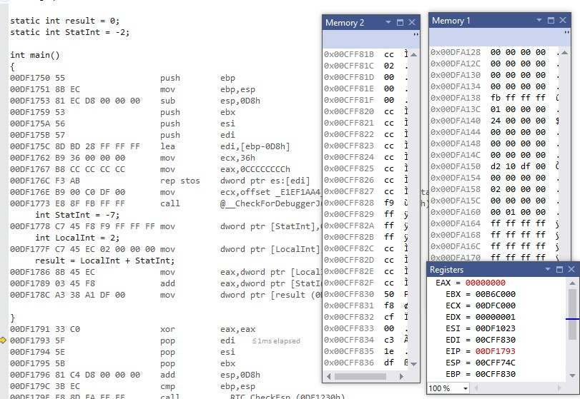

**1.1** [5 points] What is the address of the instruction that will be executed next instance?

**Answer:** The address of the next instruction to be executed is the address of the register EIP, which is **0x00DF1793**. The yellow arrow marker also tells us the address of the next executed instruction, as we can see in the figure.

**1.2** [10 points] Can you determine the address of variable **StatInt** in the expression? **YES or NO.**

*Please circle around your answer***. IF** *No is your answer, then go to the next question* **ELSE** *Please compute the address of variable* ***StatInt*** *in memory , and determine the value of variable StatInt you can read from memory:*

*Address of* ***StatInt*** *is ……. Value of* ***StatInt*** *in memory is Please justify your answers.*

**Answer:** From the figure we see that machine code of StatInt is C7 45 F8 F9 FF FF FF. We see that after the first three hex values we see that **F9 FF FF FF** is seen being stored in memory window 2. This tells us that the address next to the F9 is the address where the variable StatInt is stored. That address is **0x00CFF828.**

**1.3** [10points] Can you determine the address of variable **LocalInt** in the expression? **YES or NO.**

*Please circle around your answer***. IF** *No is your answer, then go to the next question* **ELSE** *Please compute the address of variable* ***LocalInt*** *in memory , and determine the value of variable* ***LocalInt*** *you can read from memory:*

*Address of* ***LocalInt*** *is …….*

*Value of* ***LocalInt*** *in memory is….*

*Please justify your answers.*

**Answer:** We can see from the figure that the machine code for LocalInt variable is C7 45 EC 02 00 00 00. The hex values **02 00 00 00** can be seen stored in memory 2 window at address **0x00CFF81C.**

**1.4** [10 points] Can you determine the address of variable **result** in the expression? **YES or NO.**

*Please circle around your answer***. IF** *No is your answer, then go to the next question* **ELSE** *Please compute the address of variable* **result** *in memory , and determine the value of variable* **result** *you can read from memory:*

*Address of* **result** *is ……. Value of* **result** *in memory is Please justify your answers.*

**Answer:** When we add -7 and 2 together we get -5. **-5** in hex value is **FB FF FF FF**. We see this value in memory window 1 being stored at the address **0x00DFA138.**

**Question 2.**

*A student compiled his C code using compiler:*

"GCC: (GNU) 4.8.5 20150623 (Red Hat 4.8.5-11)"

Target processor: x64, i7

***Figure 1. Dump of assembly code in GDB:***

(gdb) disassemble

Dump of assembler code for function main:

0x00000000004004ed <+0>: push %rbp

0x00000000004004ee <+1>: mov %rsp,%rbp

=> 0x00000000004004f1 <+4>: movl $0xffffffff,-0x4(%rbp)

0x00000000004004f8 <+11>: movl $0x7ffffff,-0x8(%rbp) 0x00000000004004ff <+18>: movl $0x8000000,-0xc(%rbp)

|  |  |
| --- | --- |
| 0x0000000000400506 <+25>: | movl $0x0,-0x10(%rbp) |
| 0x000000000040050d <+32>: | mov -0x8(%rbp),%eax |
| 0x0000000000400510 <+35>: | mov -0x4(%rbp),%edx |
| 0x0000000000400513 <+38>: | add %edx,%eax |
| 0x0000000000400515 <+40>: | mov %eax,-0x10(%rbp) |
| 0x0000000000400518 <+43>: | mov 0x200b0e(%rip),%eax |
| 0x000000000040051e <+49>: | mov -0x8(%rbp),%edx |
| 0x0000000000400521 <+52>: | sub %eax,%edx |
| 0x0000000000400523 <+54>: | mov %edx,%eax |
| 0x0000000000400525 <+56>: | mov %eax,-0x14(%rbp) |
| 0x0000000000400528 <+59>: | mov $0x0,%eax |
| 0x000000000040052d <+64>: | pop %rbp |
| 0x000000000040052e <+65>: | retq |

End of assembler dump.

***Question 2.1*** [5 points] Do you have enough information to determine the content of register %eax after executing instruction at offset +40 in the dump of assembly code shown in Figure 1.?

**Answer: Yes**, we do have enough information to determine the contents of register %eax. We see that from the disassembly, that first two values are stored into the stack with offsets from the base pointer. These values are 0xffffffff and 0x7ffffff are stored onto the stack and then the value is copied from the stack into registers %eax and %edx. These values are then added together and the answer is stored into register %eax. The value is 0x7fffffe.

***Question 2.2*** [5 points] Please compute the address of the static variable referenced in this dump of assembly code show in Figure 1.?

**Answer:**  To calculate the address of the static variable we have to add the offset of 0x200b0e to the base address to the register %rip. This will give us the address of the static variable.

***Question 2.3*** [10 points] In GDB environment you typed the following commands:

(gdb) x $rbp - 4

0x7fffffffdcac: 0xffffffff

(gdb) x $rbp - 8

0x7fffffffdca8: 0x07ffffff

Can you determine the content of register %rbp. ***YES or NO***?

**If** ***No*** go to next question **ELSE** Please determine the content of register *%rbp.*

**Answer:** The answer is no because the contents of %rbp always changes.

***Question 2.4*** [10 points] Shown below partial stack memory for dump of assembly code shown in Figure 1?

|  |  |  |  |  |  |  |  |
| --- | --- | --- | --- | --- | --- | --- | --- |
| 0x7fffffffdca4: 0x00 | 0x00 | 0x00 | 0x08 | 0xff | 0xff | 0xff | 0x07 |
| 0x7fffffffdcac: 0xff | 0xff | 0xff | 0xff | 0x00 | 0x00 | 0x00 | 0x00 |
| 0x7fffffffdcb4: 0x00 | 0x00 | 0x00 | 0x00 | 0x35 | 0xcb | 0xa3 | 0xf7 |

Please determine the value of variable on stack at offset -12 decimal from base pointer %rbp. Use the value for Register %rbp you obtained in question 2.3.

**Answer:** From the partial stack memory we see that the value of the variable on the stack at offset -12 is 0x80000000 because from question 2.3 we see that the value 0x07ffffff has an offset of -8 from the base pointer and if we add another 4, we get an offset of -12 from the base pointer. This means that the first 4 values of the first line starting with address 0x7fffffffdca4 is an offset of -12 from the base pointer.

**Question 3.**

*A student wrote MIPS assembly program and executed it in MARS simulator.*

.data

array1: .word -1,0x7fffffff,0x10000080,0x80000010

.text

main:

la $t1,array1

# create Frame pointer

add $fp,$zero,$sp

#Store the address of the first element on stack using frame pointer

sw $t1,0($fp) #allocate memory on Stack for 6 integers  addi $sp,$sp,-24

#load **FIRST** element from array1[0] to register $s0  lw $s0,0($t1)

#**push $s0 (NO PUSH!)**i.e. store register $s0 on #top of the stack

sw $s0,0($sp)

#load **SECOND** element from array1[1] to register $s0  lw $s0,4($t1) #create new top of the stack  addi $sp,$sp,-4  sw $s0,0($sp)

#

#load third element from array1[2] to register $s0

lw $s0,8($t1)

#create new top of the stack

# addi $sp,$sp,-4 sw $s0,0(sp)

#load forth element from array1[3] to register $s0

lw $s0,12($t1)

# #create new top of the stack addi $sp,$sp,-4

# sw $s0,0($sp)

After execution of the program in MARS simulator, he displayed the following memory windows and register file:

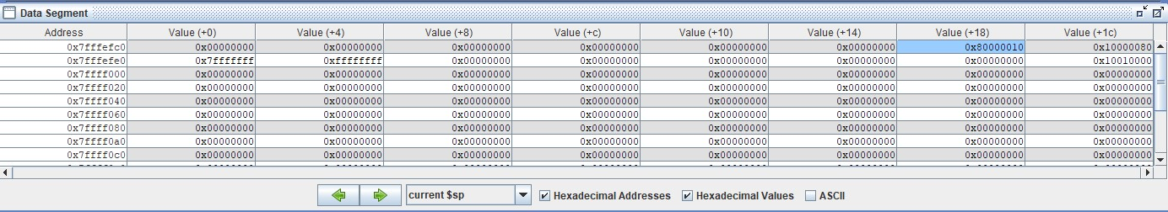

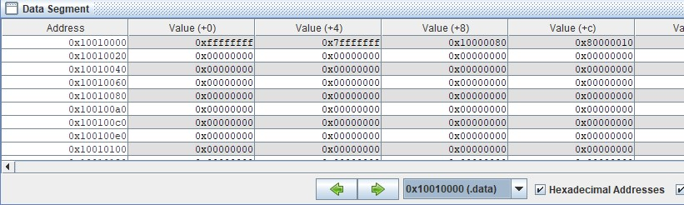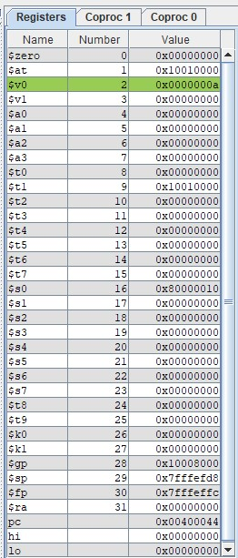

**Figure 2. Register file and memory windows in MARS simulator.**

Based on the information displayed in **Figure 2.** memory windows and register file above, please answer the following questions

3.1.1 [5 points] What is the address of an integer that was **first** pushed on to stack?

**Answer:** The address of the first integer that is pushed onto the stack is **0x7fffefe0+0x4=** **0x7fffefe4.** When we look at the current stack, we see that the last value in the stack is actually the first value that is pushed onto the stack. This is because in a stack everything is piled on top of each other. So, the first thing is always is at the bottom of the stack.

3.1.2 [5 points] What is the value in Hex and signed decimal of an integer that was **first** pushed on to stack?

**Answer:** The value of the hex value of the first integer that is pushed onto the stack is 0xffffffff and the signed decimal value is -1. This is the last value seen on the current stack window.

3.1.3 [5 points] What is the offset from FRAME POINTER to an integer that was **first** pushed on to stack?

**Answer:** The offset of the first integer that is pushed on to the stack from the frame pointer is

**0x7fffeffc - 0x7fffefe4 = 0x18**

3.2.1 [5 points] What is the address of an integer that was **Last** pushed on to stack?

**Answer:** The address of the last integer pushed onto the stack is the first value we see on the current sp window. This is because the last value that is always pushed onto a stack is always the value on the top of the stack. We see that the address is:

**0x7fffefc0+ 0x18** = **0x7fffefd8.**

3.2.2 [5 points] What is the value in Hex and signed decimal of an integer that was **Last** pushed on to stack?

**Answer:**  The hex value in as seen on the current $sp window is **0x80000010**.

The signed decimal value for this integer is= **-2147483632**

3.2.3 [5 points] What is the offset from FRAME POINTER to an integer that was **Last** pushed on to stack?

**Answer:** The offset from the frame pointer to the last integer is:

**0x7fffeffc – 0x7fffefd8= 0x24**

3.3 [5 points] Based on the data shown Figure 2.,Can you determine if Frame pointer points to an **address** *or a* **value?** Please circle around your answer. Please explain.

**Answer:** Based on the data shown in figure 2, we can see that frame pointer is a pointer that points to the starting address of the stack. We should originally see that the stack pointer and the frame pointer will have the same starting address, however, as data is pushed onto the stack , the stack pointer address changes, but the frame pointer address remains the same from first running the code till the end of the code. We see that the address stored in the frame pointer is 0x7fffeffc.