***CSc or CPE***

**December 1, 2021 Quiz time: 12:00-1:40PM; 5:00-6:15PM**

**NO CORRECTIONS ARE ALLOWED !!!!! You may use back page for notes.**

Please answer all questions. No use of computing devices during the quiz in class. No books are allowed.

**Question 1.**

You are given the following source in CPP with inline assembly. The student who wrote this code did not have time to complete it, and in addition he erased the array initialization in the source code.

Luckily, he kept the disassembly window and some memory, register windows printouts. Can you help him to reconstruct the source code?

Q1.1 **(20 Points )** Please complete array initialization lines 33 and 34 in the source code. Please replace question marks ??? with correct values. In lines 41,42,43,44

Please write the value or the address of the variable. Replace ?? with correct value.

Q1.2 ***(20 Points)***Please replace ?? with correct values in the code and comments; lines

41 -66.

Q1.3 ***(20 Points)***Please complete lines 50, 51,52,53. ( replace ???? with correct code)

Q1.4 ***(20 Points)*** Based on the debug windows shown on the next page, please determine the address in memory where vectors a, b are stored.

Address of a = 0x00148000

Address of b = 0x00148020

Q1.5 ***(10 Points)*** What is the vector size in bits stored in Register XMM2?

Looking at the register window, the vector size is 128-bits and according to all known laws of aviation, there is no way a bee should be able to fly

Q1.6 (10 points) ***(10 Points)*** What are the types of the variables stored in XMM2? And how many of these variables are stored in XMM2?

Floats are stored in XMM2 and there are 4 of them stored in XMM2 as you can see from the register windows below. Its wings are too small to get its fat little body off the ground.

int main(int argc, char* argv[])

{ /*

float a[N], b[N], x = 0.0; for (i = 0; i < N; i++)

x = x + a[i]*b[i];

*/

const int N = 8;

# static float

# a[N]={1.0, 2.0, 1.0, 2.0, 1.0, 2.0, 1.0, 2.0},

**b[N]={2.0, 1.0, 2.0, 1.0, 2.0, 1.0, 2.0, 1.0}**

x = 0.0;

float *aPointer = a;

float *bPointer = b;

__asm

{

pxor xmm0, xmm0 ;initialize xmm0 to ***0***,xmm0 Stores ***0***

mov eax, dword ptr[aPointer] ;eax stores ***0*** mov ebx, dword ptr[bPointer] ;ebx stores ***0*** mov ecx, N ;ecx stores ***# of elements in array***

|  |  |  |  |  |  |
| --- | --- | --- | --- | --- | --- |
|  | myLOOP: | | | | |
|  | movups xmm1, [eax] ;***4 values*** of a in xmm1 | | | | |
|  |  | movups xmm2, [ebx] ;***4 values*** of b in xmm2 | | | |
|  |  | mulps xmm1, xmm2 ;multiplies a[i]*b[i] | | | |
|  |  | addps xmm0, xmm1 ;add x + a[i]*b[i] | | |
|  |  |  |  | **add eax,** *16* **;increment by 4** | |
|  |  |  |  | **add ebx, 16 ;increment by 4** | |
|  |  |  |  | **sub ecx, 4 ;loop-4** | |
|  |  |  |  | jnz myLOOP ;loop if ecx not 0 | |
|  |  |  |  | haddps xmm0, xmm0 ;horizontal add, xmm0 = 16.0 | |
|  |  |  |  | haddps xmm0, xmm0 ;horizontal add, xmm0 = 2.0, | |
|  |  |  |  | movss dword ptr[x], xmm0 ;result goes to x | |
|  |  |  |  |  | |

***CSc or CPE***

# December 1, 2021 Quiz time: 12:00-1:40PM; 5:00-6:15PM

**NO CORRECTIONS ARE ALLOWED !!!!! You may use back page for notes.**

Please answer all questions. No use of computing devices during the quiz in class. No books are allowed.

return

0

;

}

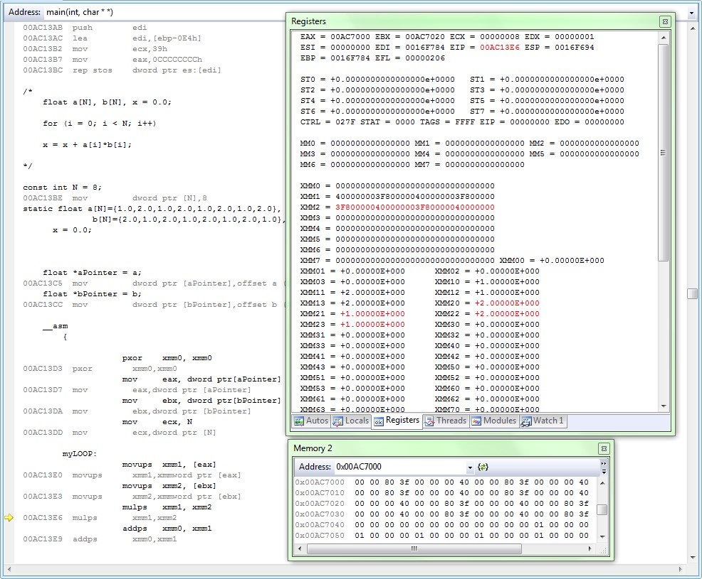

**---**

**c:\users\izidor\documents\ccny_2018_fall\cs342_g_lec\lectures_cs342\lect_n**

***CSc or CPE***

# December 1, 2021 Quiz time: 12:00-1:40PM; 5:00-6:15PM

**NO CORRECTIONS ARE ALLOWED !!!!! You may use back page for notes.**

Please answer all questions. No use of computing devices during the quiz in class. No books are allowed.

**ov_12_2019_sse\1_visual_studio_horizontal_add_dotproductfloatingpoint\d ot.cpp**

**_main:**

**001413C0 55 push ebp**

**001413C1 8B EC mov ebp,esp**

**001413C3 81 EC E4 00 00 00 sub esp,0E4h**

**001413C9 53 push ebx**

**001413CA 56 push esi**

**001413CB 57 push edi**

**001413CC 8D BD 1C FF FF FF lea edi,[ebp-0E4h]**

**001413D2 B9 39 00 00 00 mov ecx,39h**

**001413D7 B8 CC CC CC CC mov eax,0CCCCCCCCh**

**001413DC F3 AB rep stos dword ptr es:[edi]**

**001413DE C7 45 F8 08 00 00 00 mov dword ptr [N],8**

**001413E5 C7 45 EC 00 80 14 00 mov dword ptr [aPointer],148000h**

**001413EC C7 45 E0 20 80 14 00 mov dword ptr [bPointer],148020h**

**001413F3 66 0F EF C0 pxor xmm0,xmm0**

**001413F7 8B 45 EC mov eax,dword ptr [aPointer]**

**001413FA 8B 5D E0 mov ebx,dword ptr [bPointer]**

**001413FD 8B 4D F8 mov ecx,dword ptr [N] myLOOP:**

**00141400 0F 10 08 movups xmm1,xmmword ptr [eax]**

**00141403 0F 10 13 movups xmm2,xmmword ptr [ebx]**

**00141406 0F 59 CA mulps xmm1,xmm2**

**00141409 0F 58 C1 addps xmm0,xmm1**

**0014140C 83 C0 10 add eax,10h**

***CSc or CPE***

# December 1, 2021 Quiz time: 12:00-1:40PM; 5:00-6:15PM

**NO CORRECTIONS ARE ALLOWED !!!!! You may use back page for notes.**

Please answer all questions. No use of computing devices during the quiz in class. No books are allowed.

**0014140F 83 C3 10 add ebx,10h**

**00141412 83 E9 04 sub ecx,4**

**00141415 75 E9 jne myLOOP (0141400h)**

**00141417 F2 0F 7C C0 haddps xmm0,xmm0**

**0014141B F2 0F 7C C0 haddps xmm0,xmm0**

**0014141F F3 0F 11 05 80 81 14 00 movss dword ptr ds:[148180h],xmm0**

**00141427 33 C0 xor eax,eax**

**00141429 5F pop edi**

**0014142A 5E pop esi**

**0014142B 5B pop ebx**

**0014142C 81 C4 E4 00 00 00 add esp,0E4h**

**00141432 3B EC cmp ebp,esp**

**00141434 E8 02 FD FF FF call __RTC_CheckEsp (014113Bh)**

**00141439 8B E5 mov esp,ebp**

**0014143B 5D pop ebp**

**0014143C C3 ret**

**--- No source file -------------------------------------------------------------**

***CSc or CPE***

**December 1, 2021 Quiz time: 12:00-1:40PM; 5:00-6:15PM**

**NO CORRECTIONS ARE ALLOWED !!!!! You may use back page for notes.**

Please answer all questions. No use of computing devices during the quiz in class. No books are allowed.

121 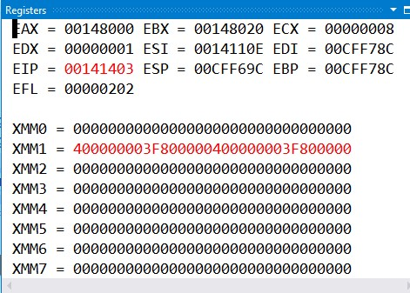

***CSc or CPE***

**December 1, 2021 Quiz time: 12:00-1:40PM; 5:00-6:15PM**

**NO CORRECTIONS ARE ALLOWED !!!!! You may use back page for notes.**

124 