**Intel College Excellence Program   
Project Synopsis**

***“Stopwatch”***

|  |  |  |  |
| --- | --- | --- | --- |
| **Team member’s detail** | | | |
| **S.No.** | **Participant Name** | **Mobile No.** | **Email ID** |
| 1 | Chukka Chaitanya | 6304922273 | ***Chaitanyachukka03@gmail.com*** |
| **Faculty(college) mentor detail** | | | |
| **S.No.** | **Mentor Name** | **Mobile No.** | **Email ID** |
| 1 | Dr. Praveen Malik | 97194377711 | ***Praveen.23314@lpu.co.in*** |
| **College/University Name** | | | |
| ***LOVELY PROFESSIONAL UNIVERSITY*** | | | |

**BACKGROUND**

The IC 4033 is a versatile BCD counter integrated circuit widely employed in electronic circuits for time-related applications, such as digital clocks, timers, and stopwatches. With its four decades of BCD output, the IC 4033 facilitates accurate timekeeping and display functions. Typically used in conjunction with 7-segment displays, the IC 4033 can be configured to count in either up or down modes, offering flexibility in design. Its ease of use and compatibility with crystal oscillators make it a popular choice for hobbyists and engineers alike seeking to implement precise timekeeping functions in their electronic projects.

In the realm of electronic design and simulation, Proteus serves as an invaluable tool for bringing theoretical circuitry to life in a virtual environment. Offering a user-friendly interface and a vast library of electronic components, including the IC 4033, Proteus allows engineers and hobbyists to design, simulate, and test their circuits before moving to physical implementation. This capability not only accelerates the development process but also provides a platform for comprehensive troubleshooting and optimization, ensuring the reliability and functionality of the electronic systems being designed.

**PROBLEM IDENTIFICATION**

The use of the IC 4011, a quad NAND gate IC, in a stopwatch circuit poses challenges due to its primary function as a logic gate, which is not inherently suited for timing applications. Potential issues may arise from incorrect IC selection, circuit wiring errors, power supply fluctuations, clock signal problems, and timing/frequency inaccuracies. The IC 4011's unsuitability for stopwatch functionality underscores the importance of choosing an IC specifically designed for timing applications, such as a counter or timer IC, to ensure accurate and reliable stopwatch operation. Careful consideration of circuit design, wiring, and component selection is essential for troubleshooting and resolving these challenges in a stopwatch circuit using the IC 4011.

**PROPOSED SOLUTION**

To address the challenges encountered in the stopwatch circuit using the IC 4011, a suitable alternative is the integration of the IC 4033, a 4-digit BCD counter. By replacing the IC 4011 with the IC 4033, which is specifically designed for counting and timing applications, the circuit gains enhanced functionality. The IC 4033 simplifies the design process, offering BCD outputs that can be directly interfaced with 7-segment displays for clear time representation. Additionally, the IC 4033 provides versatile counting modes and stable clock input, ensuring accurate timekeeping. This solution not only rectifies the mismatched IC issue but also brings the stopwatch circuit in line with its intended timing functionality.

Moreover, incorporating the IC 4033 into the stopwatch circuit offers compatibility with standard timing configurations and facilitates seamless integration into the overall electronic system. The robust features of the IC 4033, combined with its ease of use, make it an ideal replacement for the IC 4011 in stopwatch applications, ensuring precise time measurement and overcoming the inherent limitations associated with using a logic gate IC for timing purposes.

**HARDWARE & SOFWARE REQUIREMENTS**

1. 7 segment display
2. 555 IC
3. 4033 IC
4. Push Button
5. Capacitor
6. Resistor

**BLOCK DIAGRAM & DESCRIPTION**

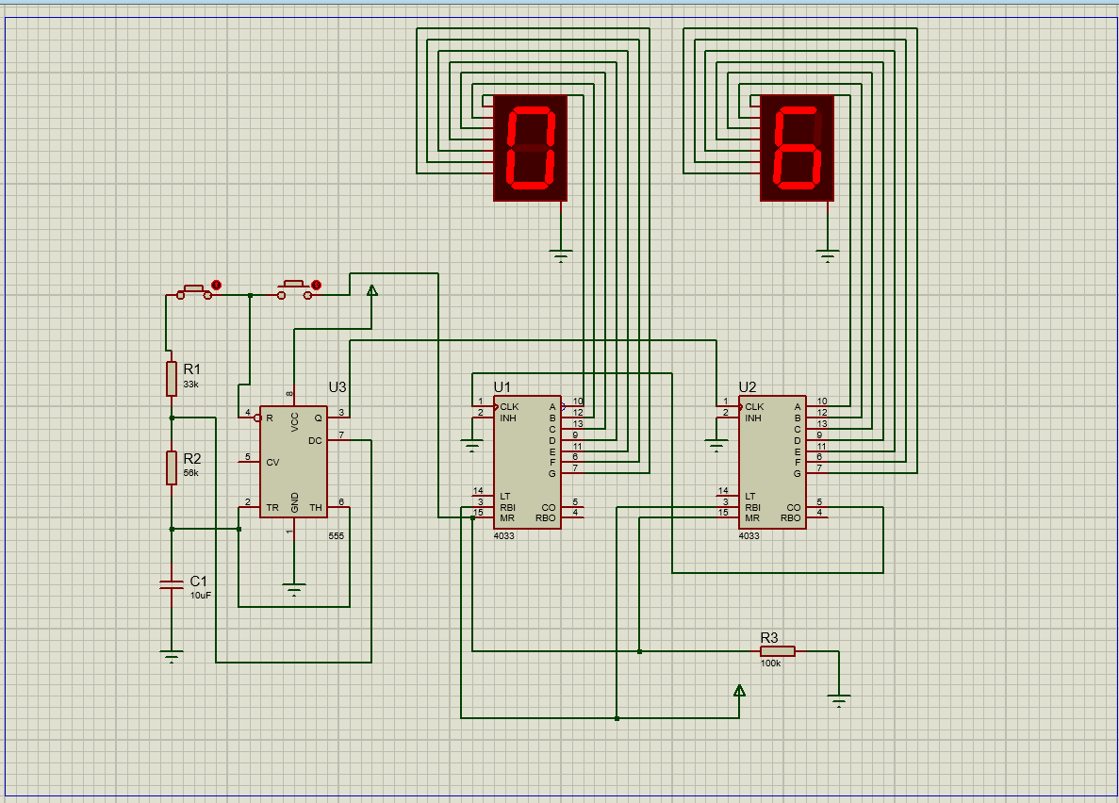

The project involves creating a stopwatch circuit utilizing the IC 4033, a 4-digit BCD counter, in conjunction with other electronic components. The IC 4033 serves as the core element for timekeeping, offering four decades of BCD outputs that facilitate accurate counting. These BCD outputs are then connected to 7-segment displays, providing a clear visual representation of the elapsed time. The stopwatch is designed to be versatile, with start, stop, and reset functionalities implemented through push buttons. The circuit incorporates a crystal oscillator for precise timing, and careful consideration is given to power supply stability to ensure reliable operation. In the Proteus simulation environment, the circuit is tested and optimized before potential physical implementation. The IC 4033's features, such as counting modes and clock input stability, make it an ideal choice for constructing a functional and accurate stopwatch.

This stopwatch project not only showcases the practical application of the IC 4033 in timekeeping but also highlights the importance of systematic circuit design and simulation. Through the integration of the IC 4033 and other supporting components, the project aims to provide a reliable and versatile electronic stopwatch solution suitable for various time-related applications, from personal productivity tools to precise timing in scientific experiments or athletic training sessions.

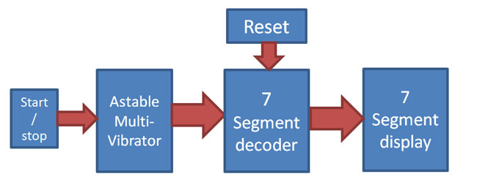

**FUTURE SCOPE**

The stopwatch project, based on the IC 4033, can advance through the integration of wireless connectivity, such as Bluetooth, for remote control. Data logging features for recording and analyzing timing data offer insights into performance trends, while a dedicated mobile app could enhance user interaction. Exploring advanced timing mechanisms like stable crystal oscillators or GPS synchronization can improve overall accuracy, crucial for precision-demanding applications. Implementing power-saving features boosts energy efficiency, extending battery life for practical, extended use. Considering commercialization opportunities and mass production could broaden the project's impact through partnerships with fitness equipment manufacturers or sports training facilities.

The future scope of the stopwatch project entails refining user interfaces with touchscreen displays for intuitive operation. The incorporation of IoT could enable seamless integration with other smart devices, enhancing home automation capabilities. Multi-functional timer modes, including countdown and interval timers, could diversify the stopwatch's applications. Prioritizing energy efficiency with low-power modes would contribute to prolonged battery life, ensuring practicality in various settings. Commercialization efforts could involve collaboration with educational institutions, reaching a wider audience and addressing diverse market needs.

**CONCLUSION**

In conclusion, the stopwatch project utilizing the IC 4033 not only demonstrates the practical application of electronic components in timekeeping but also holds significant potential for future enhancements. The integration of wireless connectivity, data logging, and a dedicated mobile app could elevate user experience and expand the project's utility. Exploring advanced timing mechanisms and improving energy efficiency enhances accuracy and prolongs battery life. The project's adaptability for various applications, from personal fitness to professional settings, underscores its versatility. Future endeavors, including commercialization and mass production, offer avenues for broader impact and collaboration with industry stakeholders. The journey from a basic stopwatch circuit to a sophisticated timing solution showcases the dynamic possibilities within the realm of electronic design and innovation.

**REFERENCES**

https://github.com/Chukka003/IntelFiceProject