**Intel College Excellence Program   
Project Synopsis**

**“Wireless Home Automation”**

|  |  |  |  |
| --- | --- | --- | --- |
| **Team member’s detail** | | | |
| **S. No.** | **Participant Name** | **Mobile No.** | **Email ID** |
| 1 | Chukka Chaitanya | 6304922273 | ***Chaitanyachukka03@gmail.com*** |
| **Faculty(college) mentor detail** | | | |
| **S. No.** | **Mentor Name** | **Mobile No.** | **Email ID** |
| 1 | Dr. Shelej Khera | 9466731632 | ***shelej.22390@lpu.co.in*** |
| **College/University Name** | | | |
| ***Lovely Professional University*** | | | |

**BACKGROUND**

In today's world, wireless home automation has emerged as a transformative force, integrating IoT technology to redefine how we interact with and manage our living spaces. Traditional home systems, lacking real-time monitoring and intelligent control, are being replaced by dynamic ecosystems tailored to meet the evolving needs of modern homeowners. Energy efficiency stands as a cornerstone of this transformation, with smart thermostats, lighting controls, and energy monitoring systems enabling users to optimize resource usage and reduce waste. Enhanced security features, including smart locks, surveillance cameras, and motion sensors, offer unparalleled peace of mind through remote monitoring and proactive threat detection. Automation of routine tasks streamlines daily life, while predictive maintenance and remote diagnostics minimize operational costs and extend the lifespan of household appliances. Seamless connectivity, facilitated by smartphone apps and voice commands, empowers homeowners to manage their homes effortlessly from anywhere in the world. As technology continues to evolve, wireless home automation systems remain at the forefront of innovation, offering a comprehensive solution that seamlessly integrates efficiency, security, and convenience into the fabric of modern living. Moreover, the adaptability of these systems allows for personalized experiences, with adaptive settings that cater to the unique preferences of each household member. By leveraging data analytics and machine learning algorithms, wireless home automation continuously refines its capabilities, ensuring optimal performance and user satisfaction. Ultimately, these systems not only enhance the functionality of homes but also pave the way for a smarter, more sustainable future.

**PROBLEM IDENTIFICATION**

Recognizing common challenges faced by homeowners. High utility bills due to inefficient energy usage and concerns about home security and intrusions are primary issues. The hassle of manual tasks and routines, along with costly repairs and maintenance issues, also pose significant challenges. Environmental impact and sustainability concerns are increasingly pressing, as are inconveniences related to managing multiple devices and systems. Difficulty in monitoring and controlling home systems remotely and adjusting settings based on changing needs adds to homeowner frustrations. Inefficient resource usage, safety concerns, and limited accessibility further compound the challenges.

Managing multiple properties remotely and vulnerability to natural disasters or emergencies are also significant concerns. Inconsistencies in temperature and comfort levels, inadequate lighting control, and challenges in managing household appliances efficiently are common grievances. Lack of awareness about energy usage patterns, risk of property damage due to leaks or flooding, and issues with ventilation and indoor air quality contribute to homeowner stress. Additionally, difficulties in pest control, coordinating family schedules, and ensuring privacy and data security in connected environments are notable challenges. Integrating different smart devices seamlessly and customizing the home environment present further obstacles. Staying updated with evolving technology and compatibility issues adds to the complexity of addressing these problems.

**PROPOSED SOLUTION**

**Energy Efficiency:**

Implementing Bluetooth Arduino-based home automation can significantly reduce energy consumption. Often, we inadvertently leave lights, fans, and other devices on, unnecessarily wasting energy. However, with Bluetooth connectivity directly integrated, we can conveniently control these devices from our smartphones. Compared to other costly devices, Bluetooth and other sensors consume minimal electricity, making them a cost-effective and efficient solution for home automation.

**Security Enhancement:**

Utilizing Bluetooth Arduino-enabled smart locks for keyless entry and remote access, integrating DHT sensors for environmental monitoring, and implementing relay-controlled surveillance cameras with motion detection for real-time security alerts can greatly enhance our house security. Without incurring any extra cost, we can directly control these devices using our Bluetooth-enabled smartphone.

**Convenience Optimization:**

Integrate Bluetooth Arduino-powered smart assistants for voice-activated control, utilize DHT sensors in smart thermostats for automatic temperature adjustment, and incorporate relay-based remote control of smart appliances and lighting fixtures via smartphone apps.

**Sustainability Promotion:**

Integrating Bluetooth Arduino allows us to design our home with relays for water motors and attach DHT sensors to our air conditioning units. This setup ensures that the AC or fan activates only when the room temperature rises above a set threshold, promoting environmental safety by reducing the need for constant AC usage and minimizing the release of harmful emissions.

**COMPONENTS REQUIRED**

If we want to implement the Wireless Home Automation these are the components required:

1. Arduino Uno

2. Relay

3. DHT11

4. Relay

5. LED

6.Flame Sensor

**7.**HC-05

**DESCRIPTION**

**1. Arduino Uno:**

- The Arduino Uno is a microcontroller board based on the ATmega328P chip. It features digital and analog input/output pins, making it ideal for interfacing with various sensors and actuators. With its 14 digital pins (of which 6 provide PWM output) and 6 analog inputs, the Uno serves as the brain of many DIY electronics projects, including home automation systems.

**2. Relay:**

- A relay is an electrically operated switch that allows a low-power signal to control a high-power circuit. It consists of an electromagnet that moves an armature to open or close electrical contacts. In home automation, relays are commonly used to control appliances, lights, and motors by switching their power supply on or off based on signals from the Arduino or other control systems.

**3. DHT11:**

- The DHT11 is a basic digital temperature and humidity sensor. It uses a capacitive humidity sensor and a thermistor to measure the surrounding air's relative humidity and temperature, respectively. The DHT11 communicates with the Arduino via a single-wire digital interface, providing accurate humidity and temperature readings for environmental monitoring and control applications.

**4.Relay:**

Relays are electromechanical switches that control high-power devices with low-power signals. They operate using electromagnetic coils to open or close circuits, making them vital in automation, industrial machinery, and automotive applications.

**5.Flame Sensor:**

Flame sensors detect flames through infrared radiation or ultraviolet light, crucial for fire detection systems. They trigger alarms, activate fire suppression systems, or shut off fuel supplies, offering various types like infrared detectors, ultraviolet detectors, and flame ionization detectors.

**6.HC-05:**

HC-05 is a Bluetooth module facilitating wireless communication between devices. Equipped with a serial port profile (SPP), it enables transparent serial data transmission, making it popular in home automation, robotics, wearables, and IoT projects.

**7. LED (Light-Emitting Diode):**

- An LED is a semiconductor light source that emits light when an electric current passes through it. LEDs are highly efficient, durable, and available in various colors and sizes. In home automation projects, LEDs are used as indicators to signal system status, sensor readings, or activation of certain functions. They are typically connected to the Arduino's digital output pins and can be controlled to provide visual feedback to users.

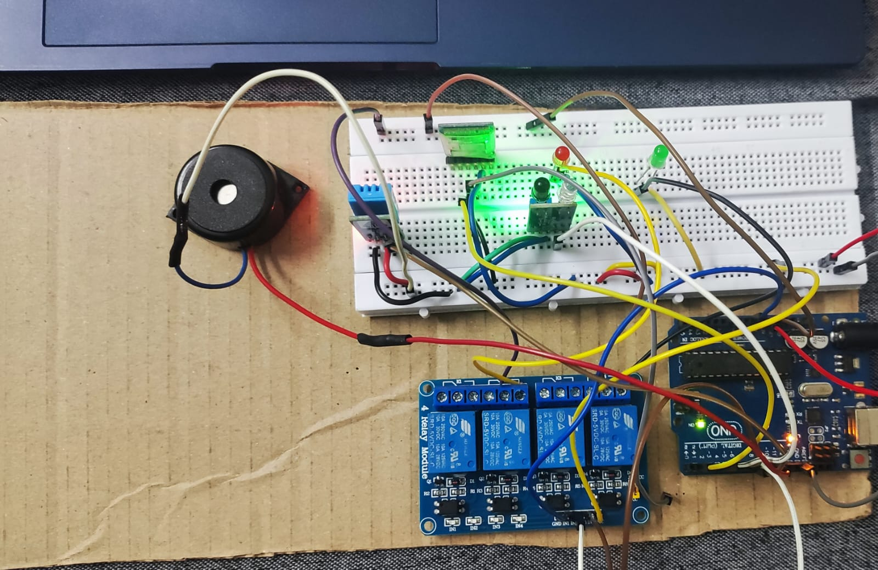**CIRCUIT**

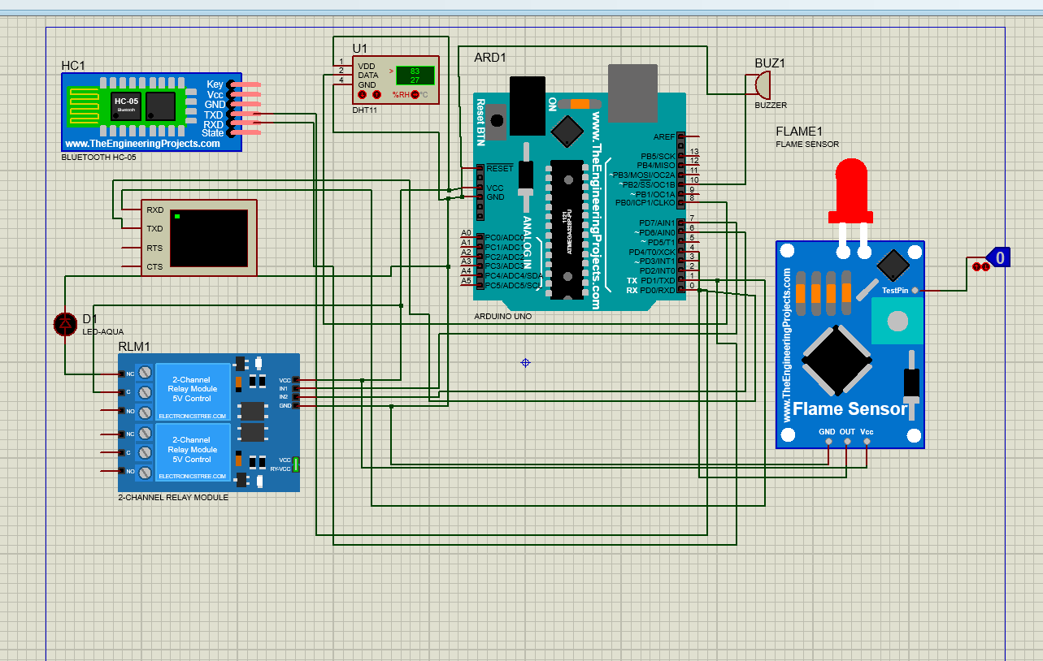

**PROGRAM**

#include <dht.h>

dht DHT;

char val;

char val2;

void setup() {

Serial.begin(9600);

pinMode(7, OUTPUT);

pinMode(6, OUTPUT);

pinMode(4, INPUT);

pinMode(10, OUTPUT);

Serial.begin(9600);

digitalWrite(7, HIGH);

digitalWrite(6, HIGH);

digitalWrite(10, LOW);

}

void loop() {

if (val == '1') {

digitalWrite(7, LOW);

Serial.println("Light On");

} else if (val == '2') {

digitalWrite(7, HIGH);

Serial.println("Light Off");

} else if (val == '3') {

digitalWrite(6, LOW);

Serial.println("Fan On");

} else if (val == '4') {

digitalWrite(6, HIGH);

Serial.println("Fan Off");

}

int readData = DHT.read11(8);

float t = DHT.temperature;

float h = DHT.humidity;

Serial.print("Temperature = ");

Serial.print(t);

Serial.print("°C | ");

Serial.print("Humidity = ");

Serial.print(h);

Serial.println("% ");

Serial.println("");

int flameValue = digitalRead(4);

if (flameValue == LOW) {

Serial.println("Flame detected!");

digitalWrite(10, HIGH);

} else

digitalWrite(10, LOW);

}

if (Serial.available()) {

val = Serial.read(); val2 = Serial.read(); } delay(1500); }

**FLOWCHART**

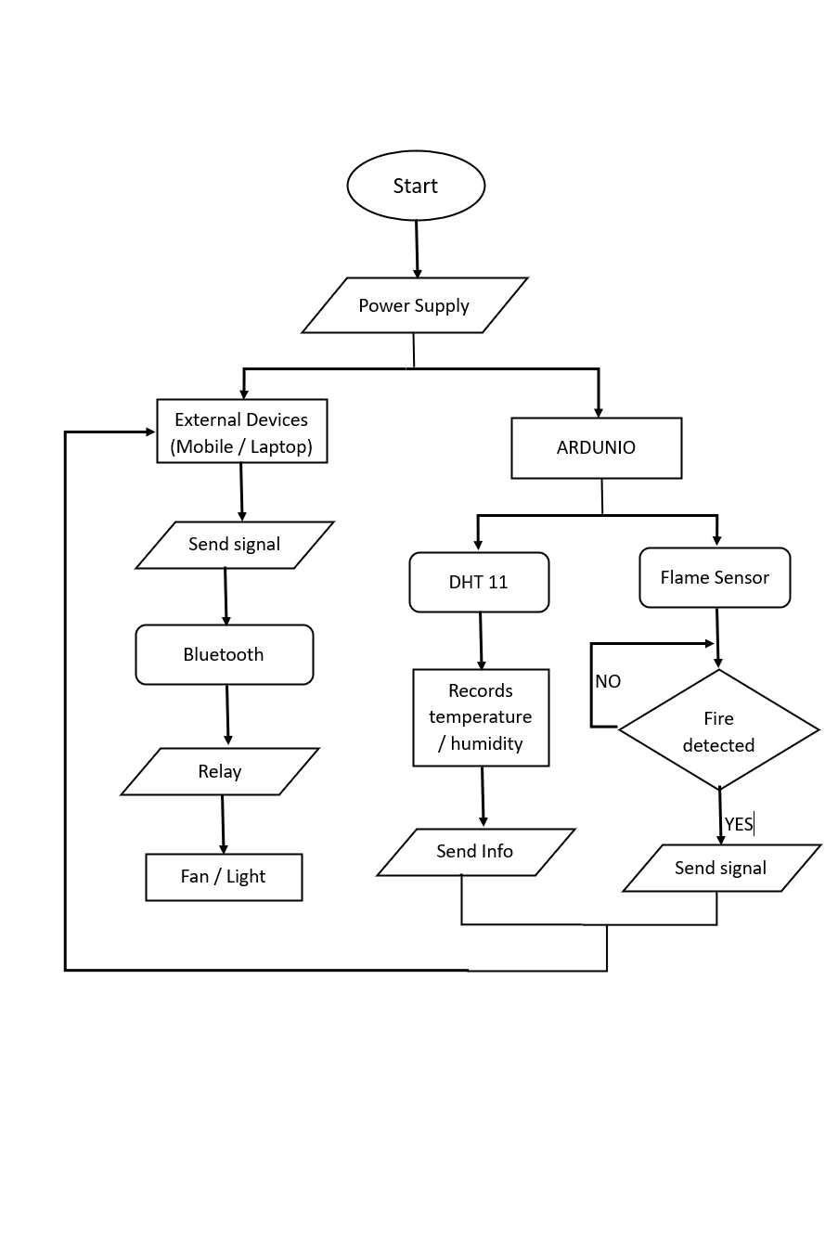

**FUTURE SCOPE**

In the future of wireless home automation, the convergence of Raspberry Pi, ESP, and other emerging technologies will redefine how we interact with our living spaces. Raspberry Pi, with its versatile computing capabilities, will serve as the central hub for home automation, orchestrating the interaction between various smart devices. ESP8266 and ESP32 modules will enable seamless connectivity between sensors, actuators, and the Raspberry Pi, creating a robust and interconnected network. Advanced sensors, including LiDAR and radar, will provide precise environmental data, while AI algorithms running on Raspberry Pi will enable predictive analytics for proactive automation. Blockchain integration will ensure security and privacy in data exchange between devices, while augmented reality interfaces will offer immersive user experiences. Energy harvesting technologies will power self-sustaining smart devices, reducing reliance on external power sources. Through these innovations, future wireless home automation systems will prioritize efficiency, security, and user-centric design, enhancing comfort and convenience for occupants.

**CONCLUSION**

In conclusion, the integration of IoT technology into wireless home automation systems presents a transformative opportunity to enhance energy efficiency, security, convenience, and cost savings for homeowners. By leveraging real-time monitoring, intelligent control, and seamless connectivity, these systems empower users to optimize energy usage, safeguard their property, simplify daily routines, and reduce operational expenses. With smart devices and sensors, homeowners can make informed decisions about their energy consumption, mitigate security risks, and enjoy personalized experiences tailored to their preferences. Furthermore, predictive maintenance and remote diagnostics capabilities contribute to prolonging the lifespan of household appliances and systems, ultimately delivering long-term value and sustainability. As the demand for smart home solutions continues to grow, wireless home automation powered by IoT technology stands poised to redefine modern living, offering a seamless blend of efficiency, security, and convenience in today's connected world.

**REFERENCES**

Github link:

https://github.com/Chukka003/Intel_Fice_4thsem.git