**Intel College Excellence Program   
Project Synopsis**

**“Plex Media Server”**

|  |  |  |  |
| --- | --- | --- | --- |
| **Team member’s detail** | | | |
| **S. No.** | **Participant Name** | **Mobile No.** | **Email ID** |
| 1 | Chukka Chaitanya | 6304922273 | ***Chaitanyachukka03@gmail.com*** |
| **Faculty(college) mentor detail** | | | |
| **S. No.** | **Mentor Name** | **Mobile No.** | **Email ID** |
| 1 | Dr. Shelej Khera | 9466731632 | ***shelej.22390@lpu.co.in*** |
| **College/University Name** | | | |
| ***Lovely Professional University*** | | | |

**BACKGROUND**

In today's digital era, Plex Media Server has revolutionized home entertainment by offering a centralized solution for storing, organizing, and streaming media. Traditional systems that required manual control are being replaced by Plex, which allows users to stream content across devices like smartphones and smart TVs with ease. The platform optimizes media efficiency by automatically organizing libraries, fetching metadata, and presenting a clean interface, enhancing the user experience. Security features such as encryption, customizable access, and parental controls ensure that content is protected and manageable for families. Plex also automates media management tasks like organizing new content, updating libraries, and transcoding media for optimal playback on different devices, providing a streamlined experience. Predictive maintenance features, including server health monitoring and storage checks, help maintain smooth performance and reduce downtime. Plex integrates seamlessly with smart home systems and voice commands, enabling users to manage their media hands-free or remotely. As technology advances, Plex’s adaptability and machine learning capabilities continue to enhance playback quality and personalization, delivering a smarter, more connected media experience. Ultimately, Plex not only simplifies home entertainment but also offers a customizable, secure, and user-friendly solution for managing media in the modern age.

**PROBLEM IDENTIFICATION**

People often face challenges when managing their digital media libraries and accessing content seamlessly across devices. The inefficiencies in organizing large media collections—such as movies, music, and TV shows—often result in cluttered libraries, missing metadata, and poorly categorized content. Additionally, streaming media remotely outside the home network can be problematic due to bandwidth limitations, incorrect network configurations, or firewall restrictions, leading to frequent buffering or interrupted playback. Compatibility issues across different devices, such as smartphones, smart TVs, and tablets, can make media access inconsistent, particularly when dealing with various media formats that require transcoding. Performance optimization is another challenge; inefficient use of network and server resources leads to lag during playback, particularly when multiple users are streaming simultaneously. Security risks also arise when remote access is enabled, requiring careful management of access permissions to prevent unauthorized use or data breaches. As media libraries expand, storage constraints become a significant concern, especially when users lack the technical expertise to scale their storage solutions effectively. Keeping the server software up to date and maintaining optimal performance is a constant burden, especially for users unfamiliar with technical maintenance. Power consumption and energy efficiency concerns also emerge as users leave their servers running 24/7, raising sustainability issues. Customization options, such as creating personalized media experiences, are often limited, and integrating the server with other smart home devices or systems, like voice assistants, presents its own set of compatibility challenges. Multi-user management also adds complexity, particularly for families wanting to set restrictions or create individual profiles for different members. The need for an efficient backup solution is crucial, as users often neglect to safeguard their media against data loss from hardware failures or natural disasters. Integrating a media server with a smart home environment brings additional concerns around privacy, security, and data management, especially in today’s connected ecosystem. Finally, staying updated with evolving technology and ensuring all components are compatible further complicates managing a home media server, making it difficult for users to enjoy their digital content seamlessly and securely.

**PROPOSED SOLUTION**

**Efficient Media Management and Optimization**

Plex Media Server excels at organizing and managing digital media libraries efficiently. It automatically fetches metadata for movies, TV shows, and music, ensuring users have accurate information and attractive artwork. This eliminates the hassle of manual organization and supports a variety of media formats, enabling smooth playback across devices without the need for additional transcoding tools. Users can quickly search and access their favorite content, making the media consumption experience seamless and enjoyable.

**Remote Access and Seamless Streaming**

Plex enables secure remote access to media libraries, allowing users to stream their content from anywhere. This feature mitigates common streaming issues such as buffering and network congestion by optimizing streaming quality based on the user's current network conditions. Additionally, Plex Pass users benefit from offline media sync, which allows them to download content for offline viewing. This ensures users can enjoy their media library regardless of their location or internet connectivity.

**Enhanced Security and User Management**

Plex prioritizes security by implementing robust access protocols that ensure only authorized users can access the server remotely. It offers advanced user management features, enabling the creation of individual profiles tailored to different family members, with personalized media preferences and viewing restrictions. This functionality helps maintain a family-friendly environment, while real-time activity monitoring provides notifications of any unauthorized access attempts, enhancing overall media security.

**Resource Optimization and Scalability**

Plex is designed to optimize hardware resources efficiently, allowing multiple users to stream content simultaneously without straining the server. By utilizing hardware acceleration and configuring transcoding settings, Plex minimizes CPU usage while ensuring smooth playback. The platform also offers scalability by allowing users to expand their storage solutions through NAS devices or external hard drives, accommodating growing media libraries without running into space limitations. This adaptability makes Plex a sustainable choice for long-term media management**.**

**Setup Essentials**

**Hardware Requirements:**

1. Server Machine
2. Network Equipment
3. Backup Storage (Optional)

**Software Requirements:**

1. Operating System
2. Plex Media Server Application
3. Media Files
4. Plex Account
5. Supported Codecs (Optional)

**DESCRIPTION**

**Plex Media Server**

This guide walks you through the process of installing Plex Media Server on Ubuntu, setting up media folders, and ensuring proper permissions for both Plex and the user.

**Table of Contents**

1. Prerequisites

2. Step 1: System Update

3. Step 2: Install Required Packages

4. Step 3: Add Plex Repository and Key

5. Step 4: Install Plex Media Server

6. Step 5: Start and Enable Plex Service

7. Step 6: Set Up Media Directory

8. Step 7: Configure Permissions

9. Step 8: Mount Media Folder to Plex Directory

10. Step 9: Make Bind Permanent

11. Step 10: Adjust Permissions for Media Access

12. Step 11: Finalize and Restart Plex Service

13. Step 12: Access Plex Web Interface

14. Step 13: Plex Dashboard and Media Library Setup

15. Step 14: Share Media with Friends via Plex

16. Conclusion

**Prerequisites:**

**Before starting, ensure you have:**

- Ubuntu system (20.04 or later recommended)

- Sudo privileges

- Stable internet connection

**Step 1: System Update:**

Make sure your system is up to date before installing Plex.

> sudo apt update && sudo apt upgrade -y

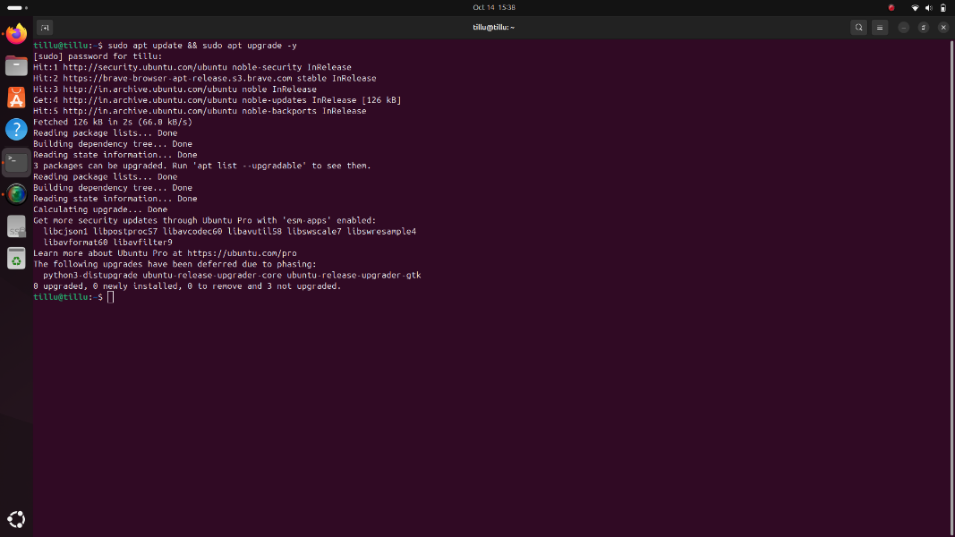

**Step 2: Install Required Packages:**

Install the dependencies that Plex requires:

> sudo apt install dirmngr ca-certificates software-properties-common apt-transport-https curl -y

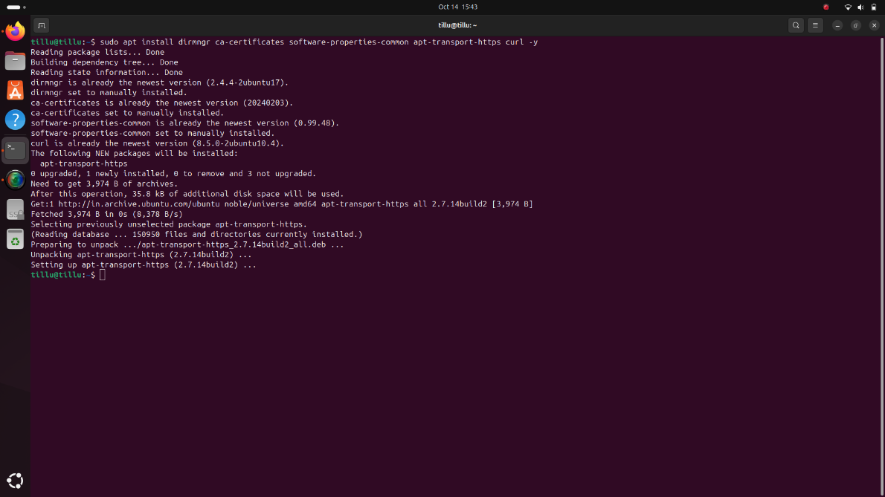

**Step 3: Add Plex Repository and Key:**

Add the GPG Key

To ensure that the packages from Plex are trusted, download the GPG key and add it to your keyring:

> curl -fsSL https://downloads.plex.tv/plex-keys/PlexSign.key | sudo gpg --dearmor | sudo tee /usr/share/keyrings/plex.gpg

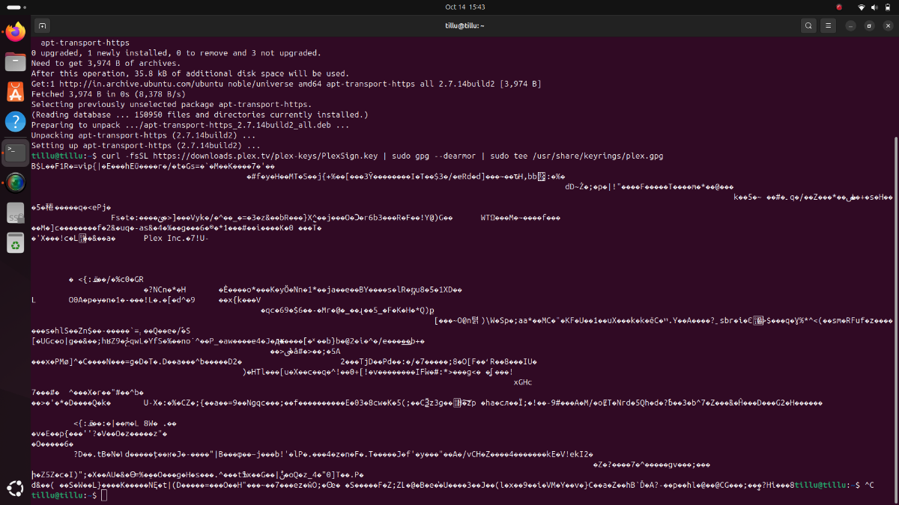

Add the Plex Repository

Add the Plex repository to your APT sources list:

> echo deb [signed-by=/usr/share/keyrings/plex.gpg] https://downloads.plex.tv/repo/deb public main | sudo tee /etc/apt/sources.list.d/plexmediaserver.list

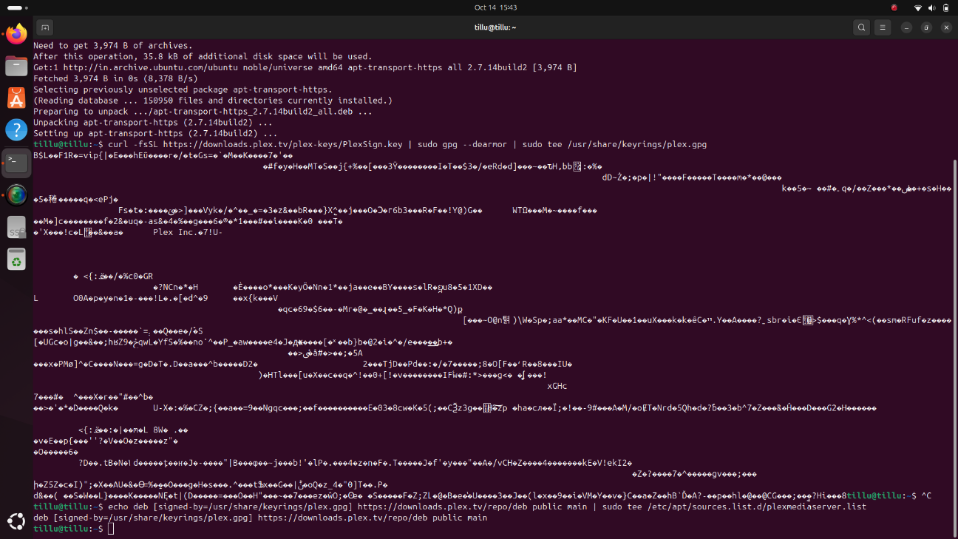

Update the Package List

Update your package list to include the new Plex repository:

> sudo apt update

**Step 4: Install Plex Media Server**

Now that the repository is added, you can install Plex Media Server using the APT package manager:

> sudo apt install plexmediaserver

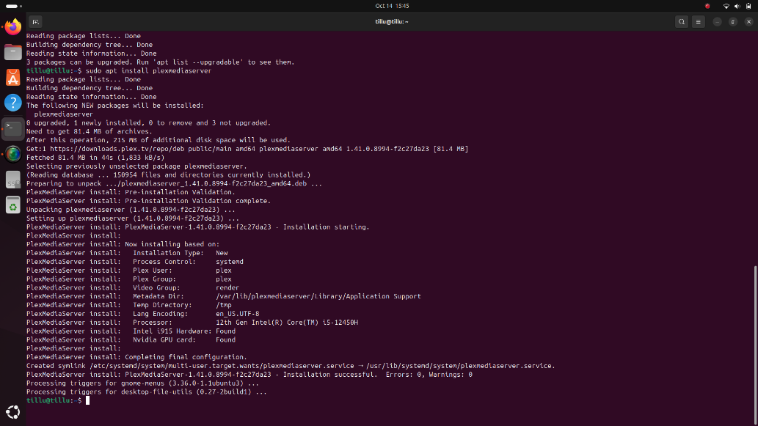

**Step 5: Start and Enable Plex Service**

After the installation is complete, start the Plex Media Server service and enable it to run on system boot:

Start the Plex Service:

> sudo systemctl start plexmediaserver

Enable Plex to Start on Boot:

> sudo systemctl enable plexmediaserver

**Step 6: Set Up Media Directory**

Create a directory in your home folder to store your media files for Plex:

> mkdir /home/tillu/plexmedia

**Step 7: Configure Permissions**

Set the appropriate ownership and permissions for the media directory:

Change Ownership:

> sudo chown -R plex:plex /home/tillu/plexmedia

Set Permissions:

> sudo chmod 755 /home/tillu/plexmedia

**Step 8: Mount Media Folder to Plex Directory**

To allow Plex to access your media files, mount the media folder into the Plex directory:

Create the Plex Media Directory:

> sudo mkdir /var/lib/plexmediaserver/plexmedia

Mount the Media Folder:

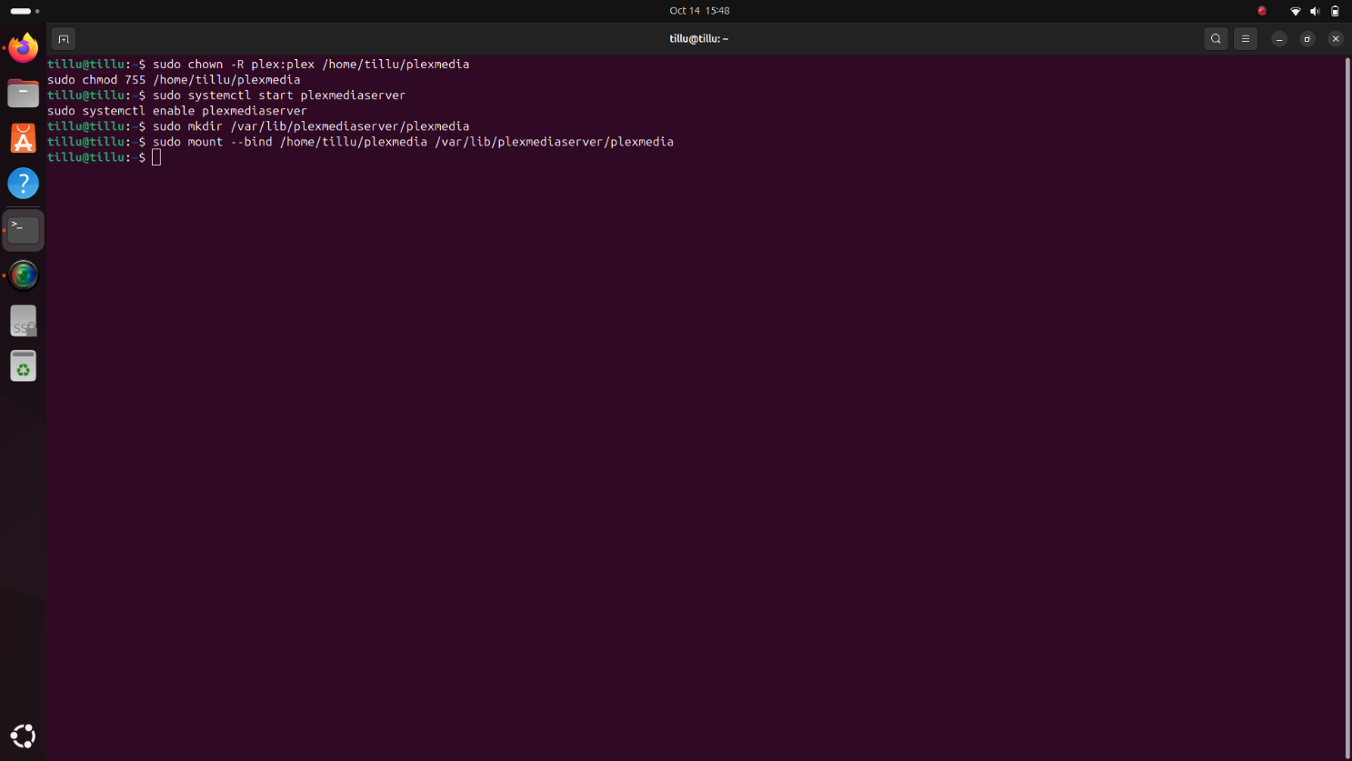> sudo mount --bind /home/tillu/plexmedia /var/lib/plexmediaserver/plexmedia

**Step 9: Make Bind Permanent**

To ensure that the bind mount persists after a reboot, edit the fstab file:

Edit the fstab File:

> sudo nano /etc/fstab

Add the Following Line:

> /home/tillu/plexmedia /var/lib/plexmediaserver/plexmedia none bind 0 0

**Step 10: Adjust Permissions for Media Access**

To ensure both the Plex service and your user can manage the media files:

Change Ownership Back to the User:

> sudo chown -R tillu:tillu /home/tillu/plexmedia

Add the User to the Plex Group:

> sudo usermod -aG tillu plex

Set Directory Permissions:

> sudo chmod -R 775 /home/tillu/plexmedia

**Step 11: Finalize and Restart Plex Service**

After configuring the permissions, restart the Plex Media Server:

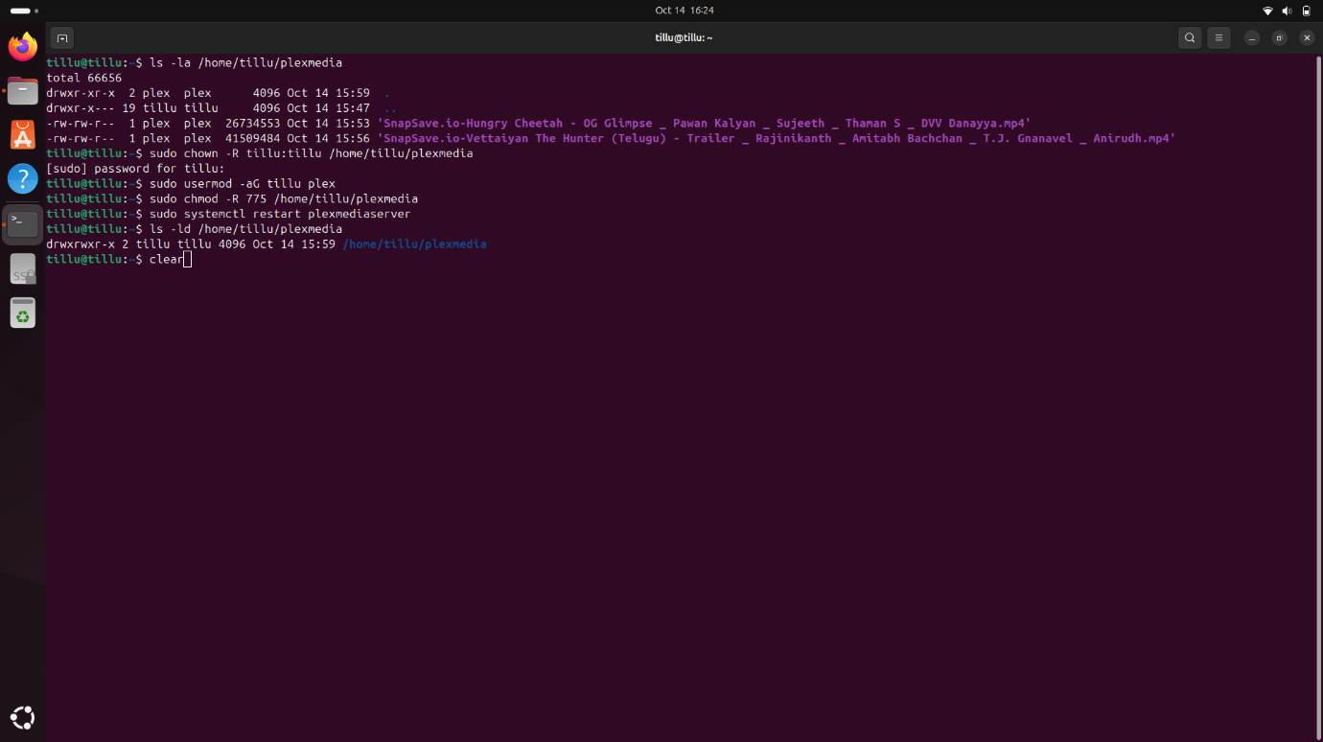> sudo systemctl restart plexmediaserver

Verify Folder Permissions:

> ls -ld /home/tillu/plexmedia

**The output should be: drwxrwxr-x 2 tillu tillu 4096 Oct 14 10:15 /home/tillu/plexmedia**

**Step 12: Access Plex Web Interface**

Once Plex Media Server is installed and running, access the Plex Web interface by navigating to:

> http://<your-server-ip>:32400/web

Replace `<your-server-ip>` with the IP address of the machine where Plex Media Server is installed (e.g.`http://172.26.144.64:32400/web`)

**Login Screen Example:**

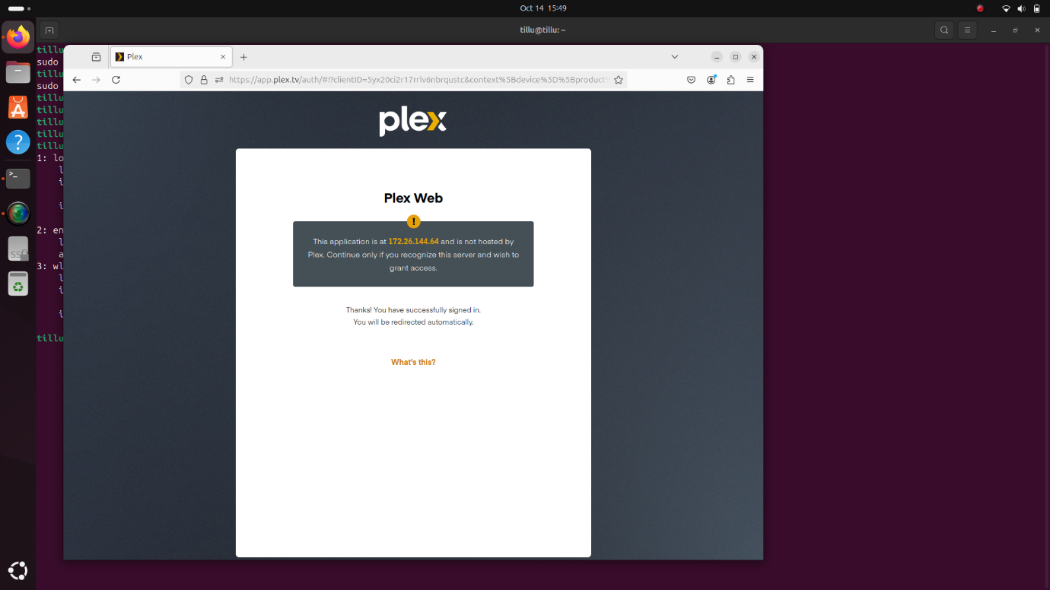

**Step 13: Plex Dashboard and Media Library Setup**

After logging in, configure your media libraries:

1. Click on “Add Library.”

2. Select the type of media (e.g., Movies, Music, TV Shows).

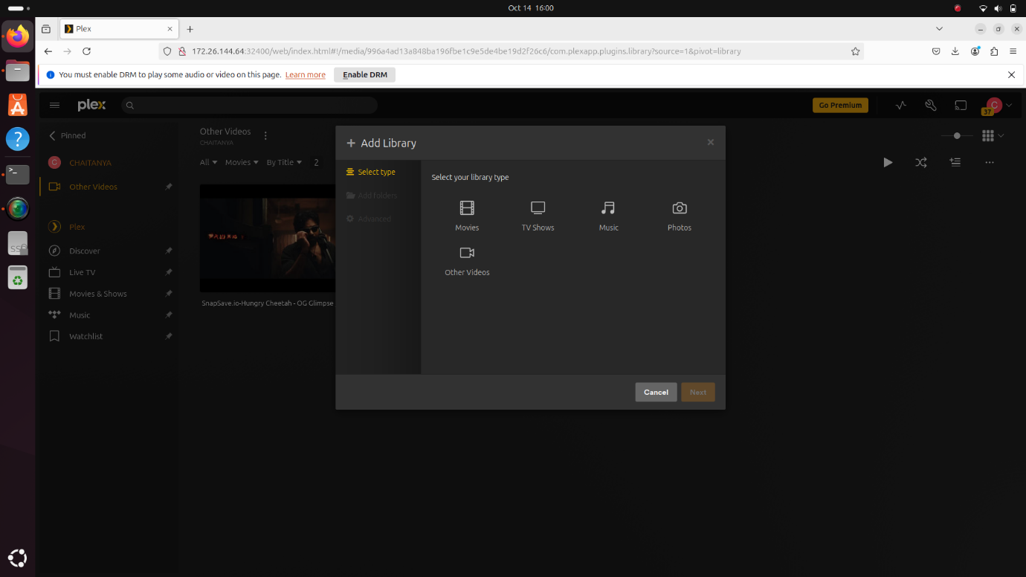

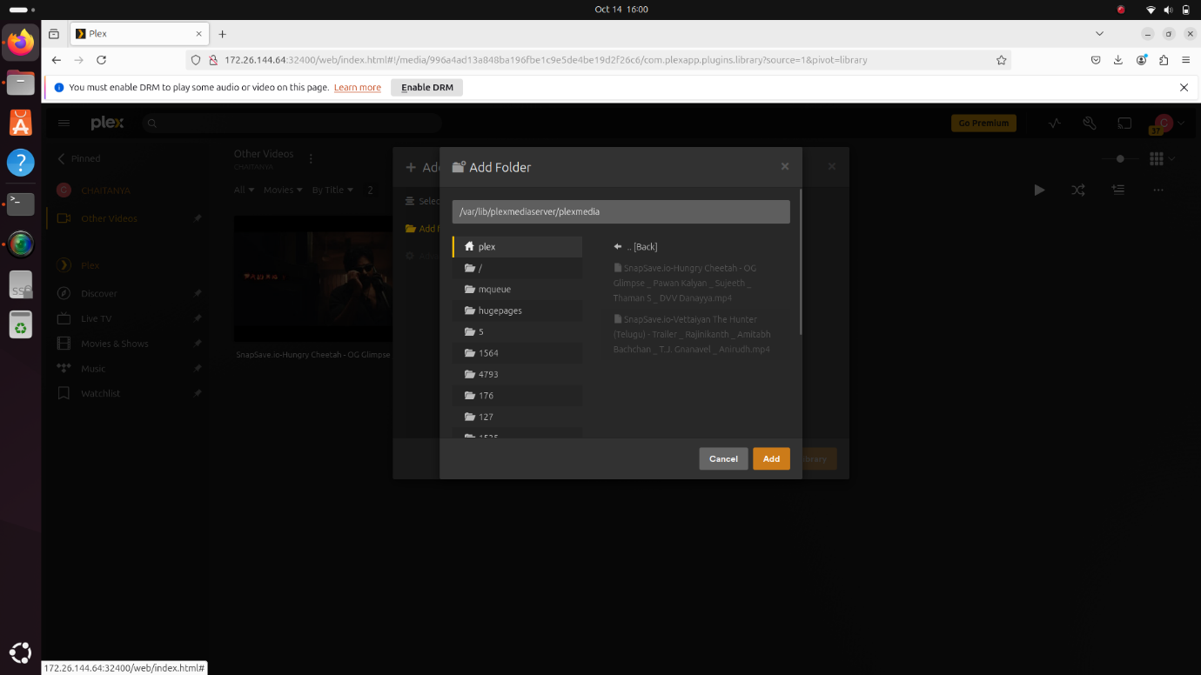3. Browse for the media directory (`/home/tillu/plexmedia`).

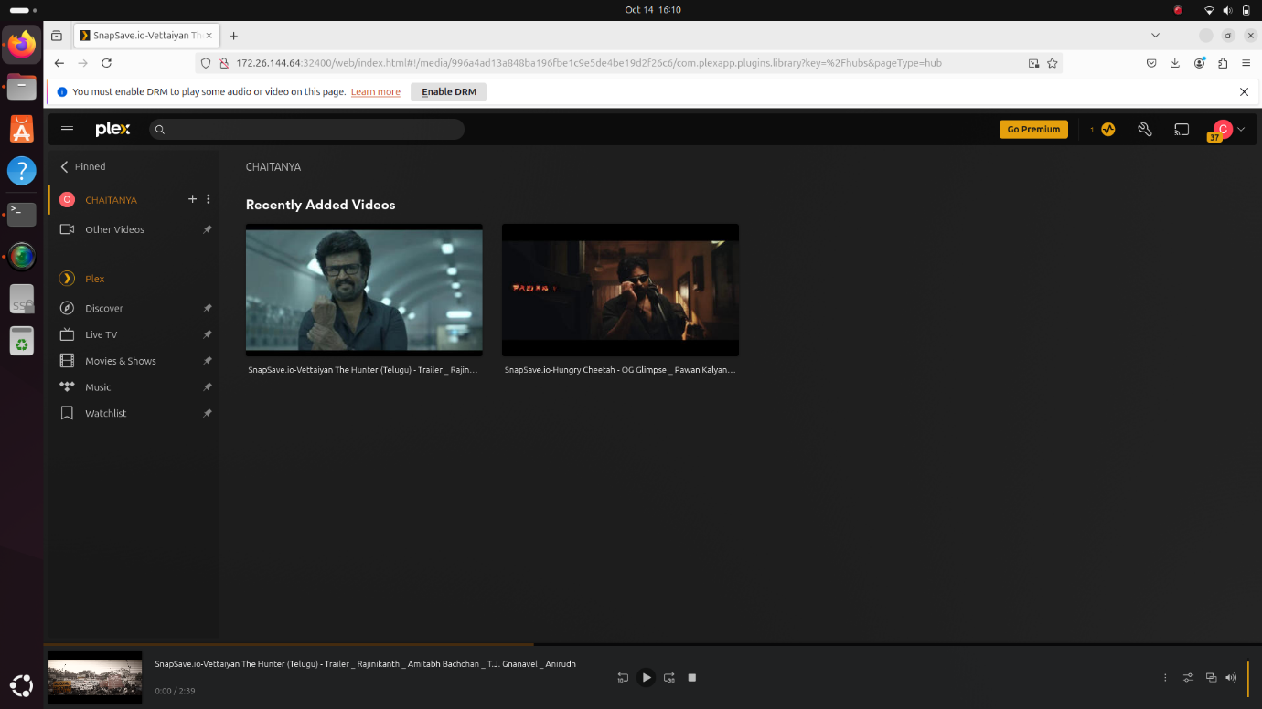4. Click “Add Library” to start scanning.

Plex will begin indexing your media files and fetching metadata.

**Step 14: Share Media with Friends via Plex**

To share your media libraries with friends, follow these steps:

1. Go to your Plex Web Interface.

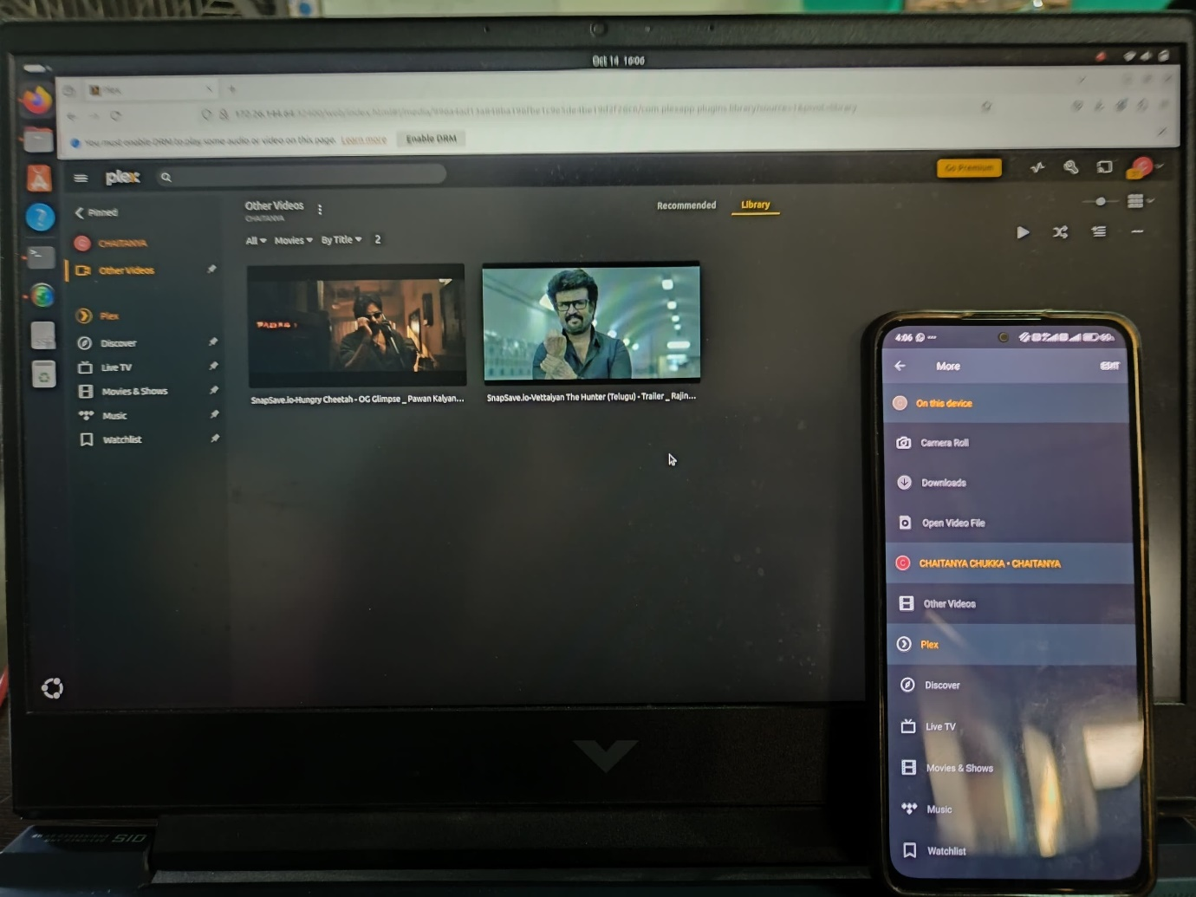2. Select a media file and click on “Watch Together.”

3. Choose a friend from the list and click “Invite.”

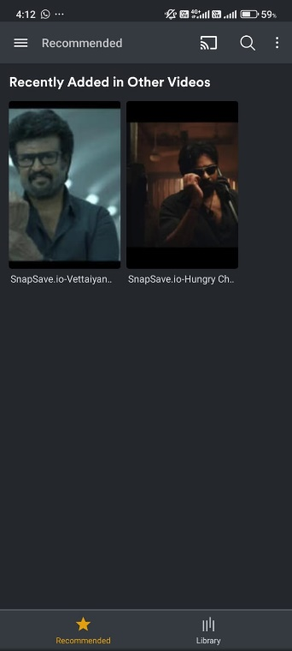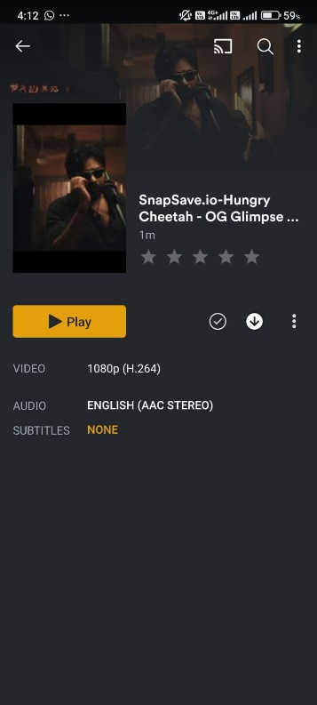4. Your friend can now watch the content on their Plex account.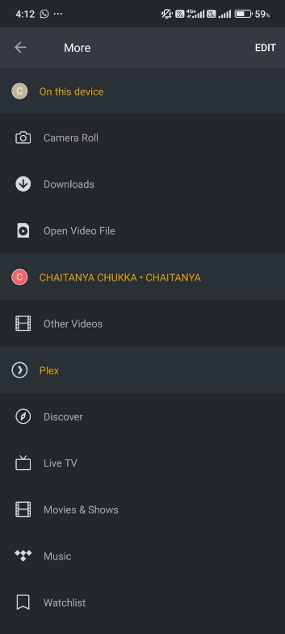

**FUTURE SCOPE**

In the future, Plex Media Server will evolve with advancements in artificial intelligence, cloud integration, and improved connectivity. AI will enable smarter content recommendations, personalized media experiences, and automated metadata management. Cloud solutions will offer hybrid storage, combining local and remote resources for seamless media access. As internet speeds and 5G technology improve, Plex will support effortless 4K and 8K streaming, with AI-driven transcoding optimizing playback across different devices. Enhanced security features, possibly using blockchain, will ensure secure media access and data privacy. The integration of voice assistants will make server control more intuitive, while sustainability features like energy-saving modes will reduce server power consumption. Overall, Plex will become more intelligent, efficient, and user-friendly, adapting to the growing demand for flexible and secure media streaming.

**CONCLUSION**

In conclusion, setting up Plex Media Server offers a powerful and flexible solution for managing and streaming media libraries across multiple devices. By organizing content like movies, TV shows, and music, Plex ensures an enhanced user experience with automated metadata fetching, media categorization, and seamless access from anywhere. Through proper configuration, users can leverage the platform’s ability to stream high-quality media remotely, with built-in transcoding that optimizes playback based on network conditions and device capabilities. With additional features such as user profile management, parental controls, and secure remote access, Plex offers a personalized experience for each user while maintaining strict control over content access. The ability to scale storage through NAS devices or cloud integration ensures that users can expand their libraries without compromising performance. Moreover, Plex Media Server supports multiple platforms, including smartphones, smart TVs, and gaming consoles, ensuring compatibility with various devices. By setting up permission structures and maintaining server performance through regular updates, Plex delivers a robust solution for media enthusiasts. As streaming and media consumption continue to evolve, Plex stands out as a versatile and user-friendly tool, capable of adapting to new technologies and meeting the needs of modern media consumers. With its ever-expanding features and support for advanced media formats, Plex remains a leading choice for those seeking an all-in-one media server platform that balances ease of use, performance, and security.

**REFERENCES**

Github link:

<https://github.com/Chukka003/intel_fice_5thsem>