1. Introduction
https://www.kickstarter.com/projects/wivenai/wiven-ai-the-ai-that-makes-any-erp-intuitive?ref=discovery&term=AI&total_hits=2583&category_id=51
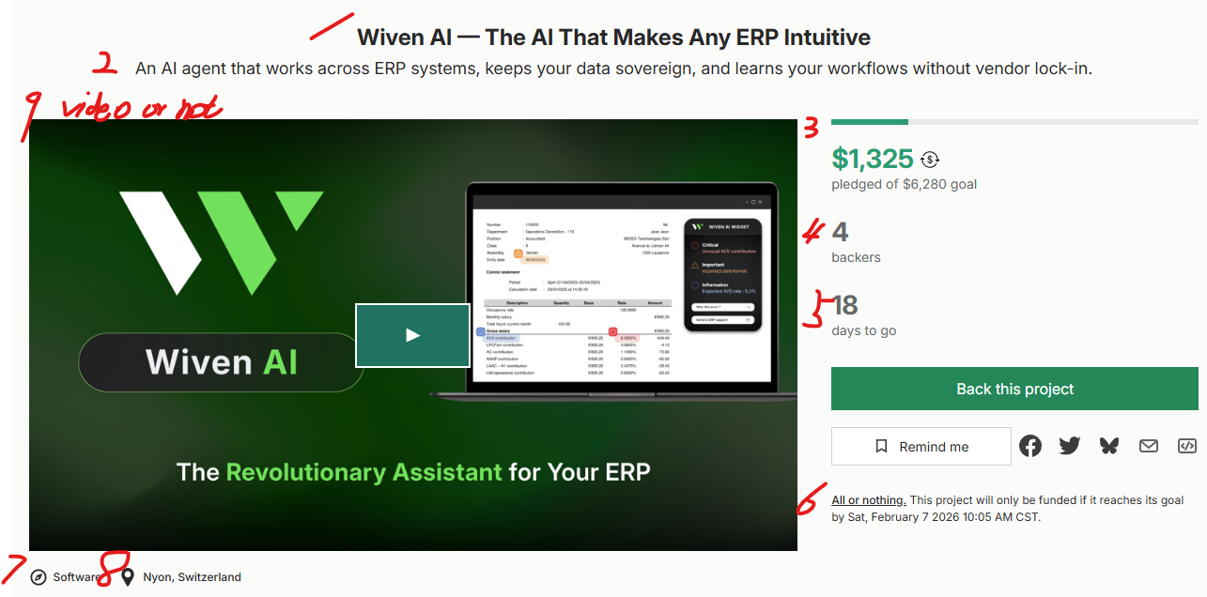

2. Count number
FAQ 0
For example, variable comments, value 7, meaning 7 comments.
Comments 7
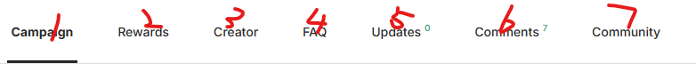

3. Campaign page (Count No (all items no and AI no)+Content)
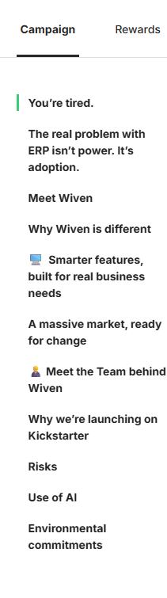

4. Content analysis (all text)
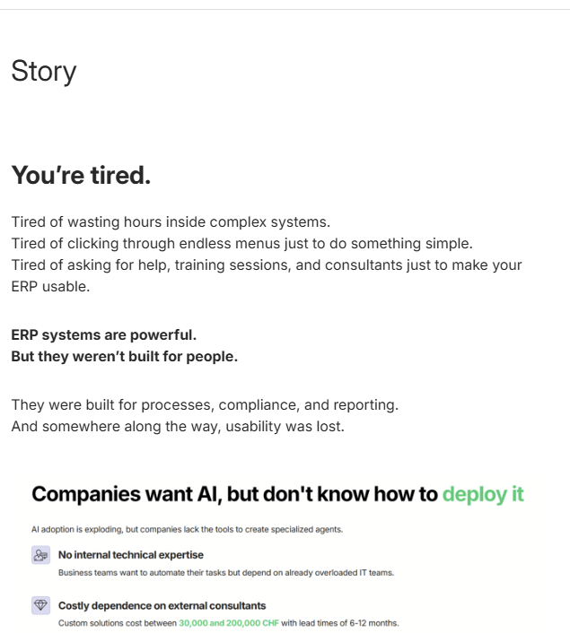

5.Rewards
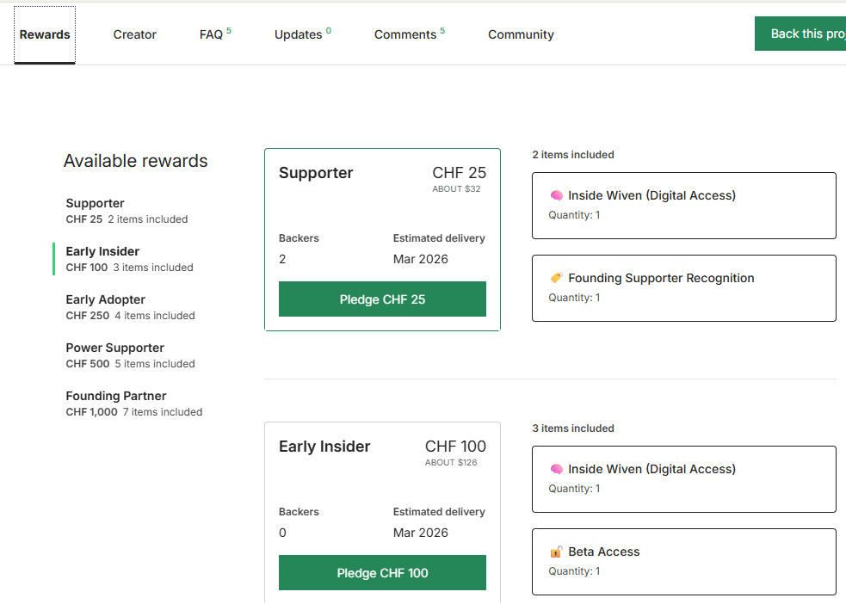

6. Creator
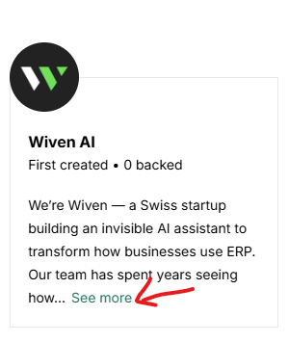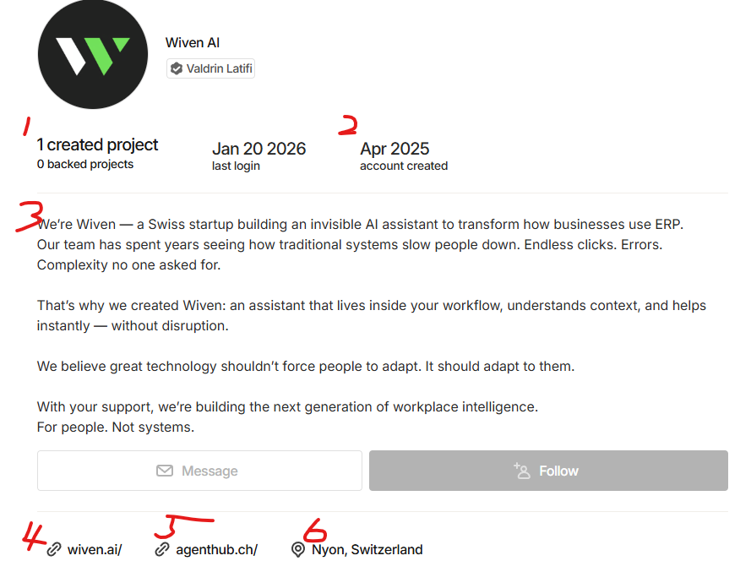

7. FAQ (NO+Title)
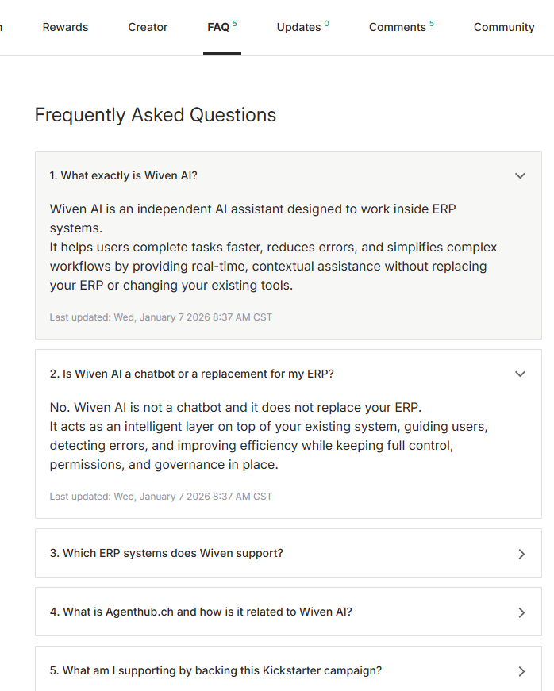
8=

