**Tower Craft – The Marching Mushrooms**

Game Design Document

By Team Double Check

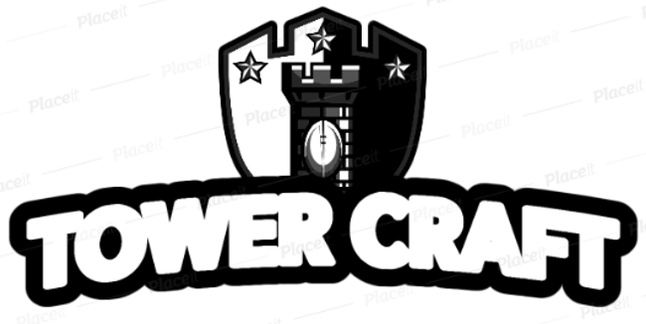

GAM150S19KR

Spring 2019

**Producer**

Jeesoo Kim

**Lead Designer**

Chulseung Lee

**Technical Director**

Sangmin Kim

**Test Manager**

Minseok Sung

***CONCEPTS***

HIGH CONCEPT…………………………………………………4

SUMMARY………………………………………………………4

GAME FLOW………………………………………………….…5

Splash Screens…………………………………………………5

Title Screen…………………………………………………….5

Game Play…...…………………………………………………5

GAME MECHANICS………………………………………….…7

Enemy Movement………..………….…………………………7

Auto Attack System……………………………………………7

Re-Attempt System………………….…………………………7

GAME CHARACTER……………………………………………7

Tower…………………………………………………………..7

Enemy (Mushroom)……………………………………………7

GAME RESOURCES….………………………………………….8

Upgrade Shop………………………………………………….8

GAME ENVIRONMENTS……………………………………….8

Path……………………………………………………………8

Castle………………………………………………………….8

Money………………………………………………...……….8

GAME CONTROLS……...……………………………………….9

VISUAL DESIGN…...…...…………………………………...…10

AUDIO DESIGN…….…...……………………………………...10

BEHAVIOR DESIGNS…..……………………………………...11

PHYSICS DESIGNS…...……………………………………..…12

# High Concept

“Tower Craft – The Marching Mushrooms” is a 2D tower defense game where the user defends the castle with various towers from the approaching army of mushrooms.

## Summary

An army of vicious mushrooms are marching towards the castle in order to take over the human race. There is no way to stop them other than to defeat all incoming mushrooms.

Protect the castle by installing towers and fire at the marching mushrooms. Be careful, the mushrooms are getting stronger as the war continues. But do not worry, stronger towers are ready to go.

There is no right way to win the war, build many small towers or build few strong towers. Man vs Mushroom, who will be the winner?

## Game Flow

*Splash Screen*

When the game begins, a short screen of the Digipen Logo and the team logo will be presented.

*Title Screen*

The title screen will have mushrooms coming towards a castle as a background. In the title screen, user can choose play, option (sound, full screen), how-to-play, credit and quit.

*Game Play*

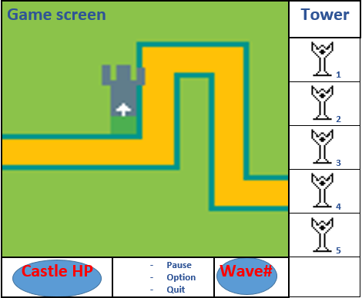

In the game play, user can see the play session, statistics (HP, enemy information), and the upgrade shop in a single screen. During the game play, a line of enemy is considered as a single round. Every round, the enemy gets stronger, so the user must reinforce its defense line by using the upgrade ship placing on the right side of the screen. As the user defeats each enemy unit, they earn money to purchase stronger towers or upgrade a built one. As the user gain more money and power, they will be able to clear the final round.

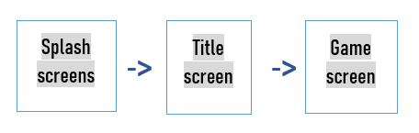

## Game Mechanics

*Enemy Movement*

Enemies move in one direction and can only walk through a given path. All enemies head towards the castle and cannot be stopped unless their health hits 0.

*Auto Attack System*

If an enemy approaches within the attack range of the tower, the tower automatically starts firing at the enemy. The tower attacks the first enemy to come into the range, and does not attack other enemies in the range unless the previous enemy gets killed or leaves the attack range.

*Re-Attempt System*

If the player fails to protect the castle, and loses the round, they can start from the beginning of the round.

*How to Win / Lose*

## Player can win the game by clearing the last round of the game. Player loses if the HP of the castle becomes 0.

## Game Character

*Tower*

Tower is our main character. It is the only way to defeat incoming enemies.

*Mushroom*

Each enemy unit has armor, health, and speed stats. Armor reduces the damage done by the tower. The health indicates the life of the mushroom that can be reduced by attacking. Speed is how fast the enemy moves towards the castle.

## Game Resources

*Upgrade Shop*

Player can upgrade towers or purchase stronger towers in the shop.

## Game Environments

*Path*

Path is the designated road for the enemy to march which leads to the castle. Path cannot be blocked with towers.

*Castle*

Castle is the ultimate goal which the player must protect. Castle has a health bar that reduces every time the enemy achieves to touch it. If the health reaches 0, player loses the game.

*Money*

Every time a player kills an enemy, they gain certain amount of money. Money can be used to purchase new towers or upgrade them.

## Game Controls

Every control in the game could be done with the mouse.

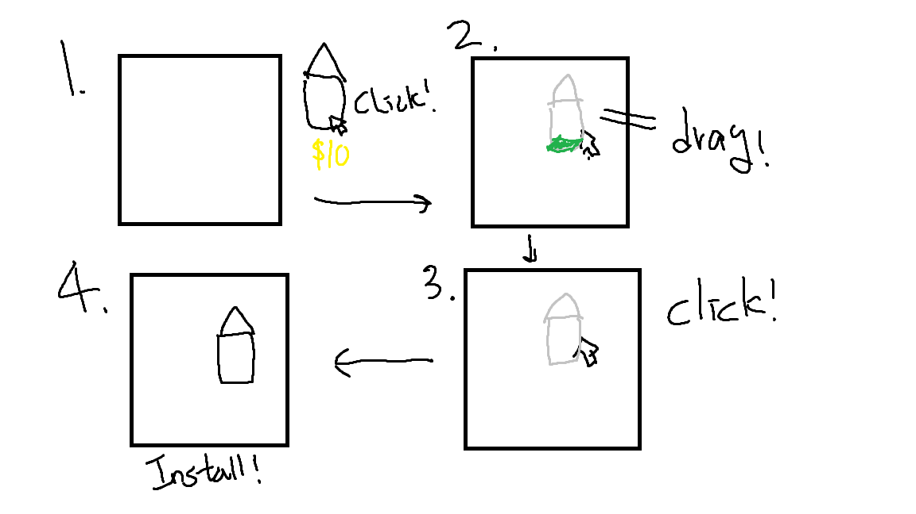

## Visual Design

*Background*

Our game background has a path that the enemy passes. Beside the path, there will be towers and at the end of the path stands the castle.

*Tower*

Firing at enemies

Upgrading(Change appearance)

*Enemy (Mushroom)*

Marching

Getting hit by a tower attack

Crashing into the castle

*Castle*

Castle will be expressed with a health bar

## Audio Design

There will be background music that plays constantly during the game play.

*Button & Level Change*

Whenever a button is clicked and when the level is changed, it will make a sound.

*Gameplay*

In gameplay, to make game experience more intense, there will be various kinds of sound effects.

- When mushrooms die

- When tower is upgraded

- When tower is built

- When the tower fires

## Behavior Design

*Enemy move*

Enemy will move in a fixed path. The enemy will have path-finding system (Enemy will be able to calculate the shortest way towards the destination). If the enemy reaches a curve, it will automatically find the next direction and move toward the path.

*Tower attack*

If the enemy comes in the tower's attack range, tower will attack the front most enemy.

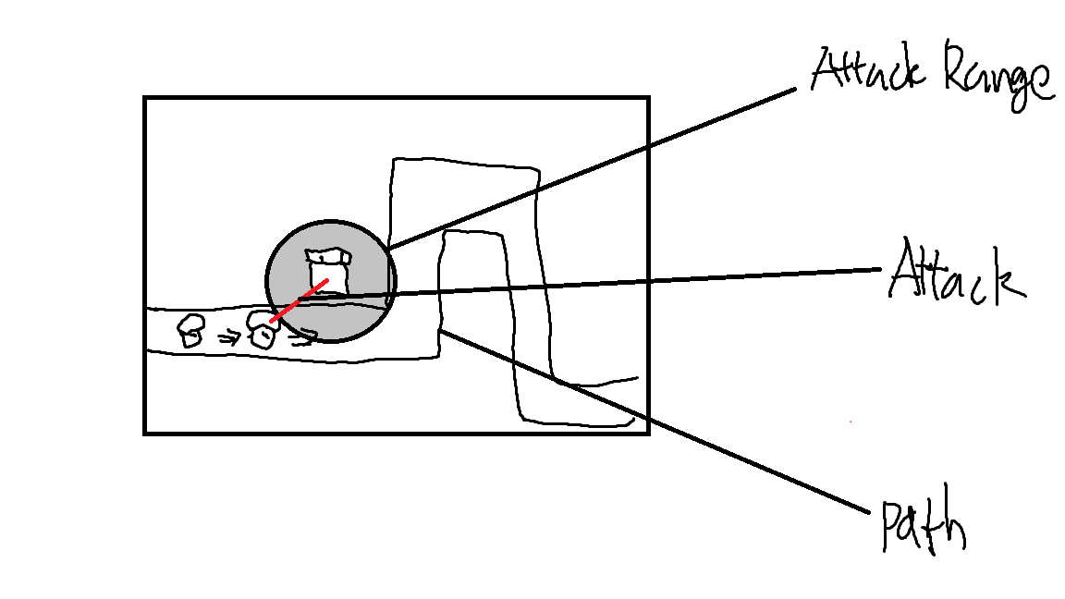

## Physics Design

*Firing Towards Enemy*

The firing direction of the tower will head towards the location of the enemy it is attacking.

*Collision*

Every attack, enemy will have a collision box. If both box is on collision, the arrow will disappear, enemy's HP will reduce.