## 가로선

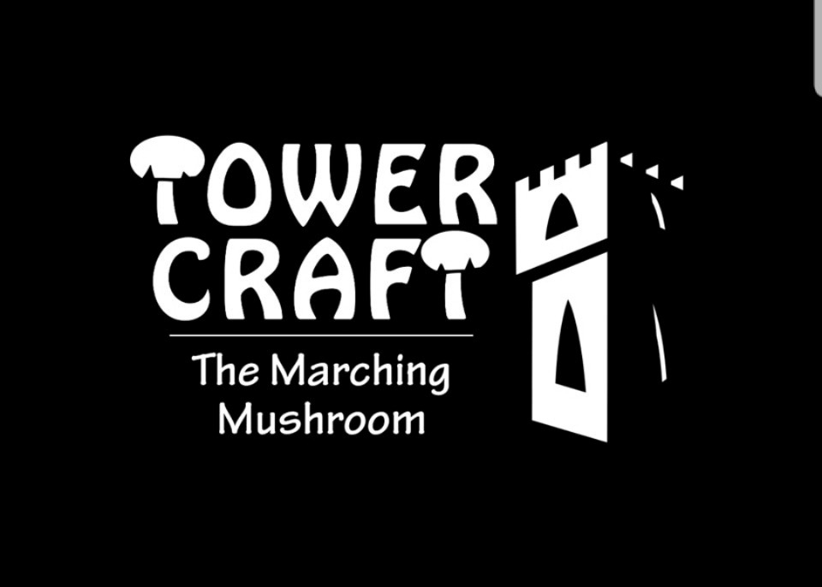

Tower Craft - The Marching Mushroom

Release Plan Document

**─**

**GAM150 - Spring 2019**

**Team Double Check**

Producer - Jeesoo Kim

Tech Director - Sangmin Kim

Lead Designer - Chulseung Lee

Test Manager - Minseok Sung

# Release 1 : Prototype

In the prototype release stage, the main goal is to show the core mechanics of the game and prove that the gameplay is promising.

# *Must Have Features*

* Tower Installation (L) : To click on a tower button from the menu and place it on the game map.
* Range Attack (XL) : To make the tower automatically shoot at passing-by enemies when it comes within the shooting range that is displayed on each tower.
* Enemy Generation (L) : Generate a wave of enemies on the game screen.

# *Should Have Features*

* Castle (S) : Castle is the health of the user that gets reduced when the enemy succeeds to arrive to. Protecting the castle is the goal of the game.
* Game Map (S) : Create path for the enemy to approach to the castle.

# *Nice to Have Features*

* Game Menu (S) : A basic menu that has start and quit.

# Release 2 : Alpha

In the alpha release, all gameplay functionality will be implemented and some assets partially. In this stage, game features could be added or dropped.

# *Must Have Features*

* Tower Variety (L) : To give a large set of choices, create various types of towers that could be installed.
* Leveling System (L) : Make the gameplay more challenging as the game proceeds. Generate more and stronger enemies after each wave.
* Gold System (M) : Everytime an enemy is killed, user collects money that can be used to install additional towers.
* Game Map (S) : Create path for the enemy to approach to the castle.

# *Should Have Features*

* Game Menu (S) : Have a complete version of menu screen for quit, options, and restart.

# *Nice to Have Features*

* Background Music (S) : To have background music playing while the gameplay.
* Shooting Effects (S) : Everytime the tower shoots, have a visual effect to make the action more realistic.

# Release 3 : Beta

All game features and assets should be complete in the beta release. In this stage, game is polished to increase the game experience.

# *Must Have Features*

* Game Interface (M) : A proper interface and distinguished tower selection & game map sections during the gameplay screen.

# *Should Have Features*

* Tower Design (S) : Enhance tower looks and its shooting motion.
* Enemy Appearance (M) : Enemies with high quality designs.

# *Nice to Have Features*

* Enemy Death Sound (S) : Have sound effects when enemy dies.
* Game Over & Game Clear Screen (S) : Displays game over and game clear screens.
* Mouse Click Sound (S) : When any button is clicked by the mouse, a simple sound plays.

# Release 4 : Final

The Final release stage is to have the completed version of the game. All features and assets are implemented and the game is ready to submit.

# *Must Have Features*

* How To Play (S) : To introduce how to play the game and show the basic controls.

# *Should Have Features*

* Score (M) : To keep a score of the user and have a score menu that saves high scores along with the user name.

# *Nice to Have Features*

* Story Screen (S) : Have a simple story flow screen display in every 3-4 rounds.