Description

Intended User

Features

User Interface Mocks

Main Activity(Commercial Selected)

Main Activity(Free Selected)

Main Activity(Help Selected)

Commercial service list(under specific category)

Commercial service detail page

Upload a commercial service

Upload a free service(or seek help)

Home screen widget

Key Considerations

How will your app handle data persistence?

Describe any edge or corner cases in the UX.

Describe any libraries you’ll be using and share your reasoning for including them.

Describe how you will implement Google Play Services or other external services.

Next Steps: Required Tasks

Task 1: Project Setup

Task 2: Implement UI for Each Activity and Fragment

Task 3: Implement Data Model for Firebase Realtime Database

Task 4: Implement Google Play Services

Task 5: Implement business logic and UI control

Task 6:Test

**GitHub Username**: CarlosYang

CNSY--services in my language

# Description

CNSY is a service sharing and seeking platform which uses your most comfortable language. It’s not only the platform supporting your language, but also the service provider using your language. So you can enjoy much more amazing services and don’t need to worry about language barrier.

The CN in my app whole name CNSY stands for Chinese. Although I want to support as many languages as I can, it’s hard to accomplish it in a short time. So I will firstly support Chinese which is my native language. Because I saw many Chinese people here who can’t use English well spend much time searching Chinese services like Chinese restaurants. It motivates me to build an platform to gather such information for them.

I want to make it clear that it’s not the function of the app to supply any kinds of commercial translation assistance. This app doesn’t aim to be a translation agency. All information in the app is from users, reviewed by users and handled by users. The app itself is just a platform to make these happen.

It means that the users who want to share these services with others should upload it through the app. They can also leave comments and rate to help others making a right decision.

And they can search for the service they want and contact with the service providers to make a deal. If you are glad to offer some unprofitable help like hitchhiking, you can also post it in the app. And if you get some troubles and want to seek help, you can create a post and wait for help. In a word, It’s a tool for those people who want to help themselves and other people to enjoy life.

# Intended User

Currently support Chinese language:

* People who feel comfortable using Chinese and want to get some services from Chinese.
* People who are glad to share these services they discovered with others
* People who want to offer some unprofitable help
* People who are seeking help
* Sellers who offer Chinese language support

(*Note: services above must meet specific language requirement)

# Features

* Store service data on the cloud
* Display different service lists
* Sort and search services
* Comment and rate
* Upload a new service with both photo and text.
* Get current location and show specific location on the map
* Share

# User Interface Mocks

(*Note: Following mock pages use English which is just for you as a reviewer convenience. I will replace all of them with Chinese in actual development ,but I will also leave a reviewer entry in my app with English support so that you can review it without language trouble. After that I will close this special entry)

## Main Activity(Commercial Selected)



1

This is the home page of app. There are three first-level categories which are commercial, free and help. I will describe their meanings in each mock-up page. Commercial tag means the services under it are profitable. I have listed eight child categories of commercial. You can drill each child category. I will explain each label on the picture.

1. You can select different district like Brooklyn or even whole New York and search what you want.
2. Three main categories
3. Eight child categories of commercial, you can scroll horizontally to discover more
4. Random recommended service list within all child categories
5. Add a new related service(Here is a commercial service)
6. Commercial item design

## Main Activity(Free Selected)

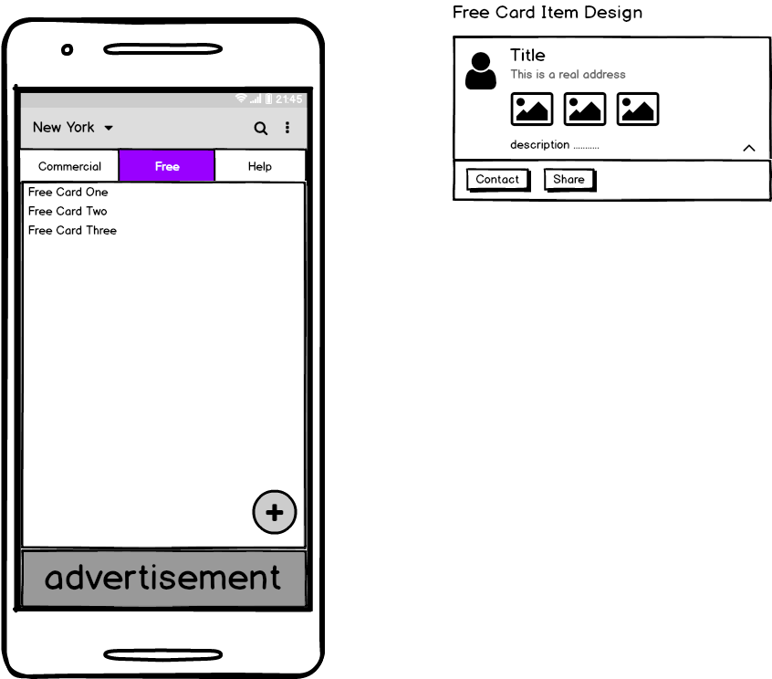

If you want to find some warm-hearted helps which are not be charged like hitchhiking, you can find them under free tag. All services found here are non-profit. And if you want to offer a warm-hearted help to others, you can create it here.

.

## Main Activity(Help Selected)

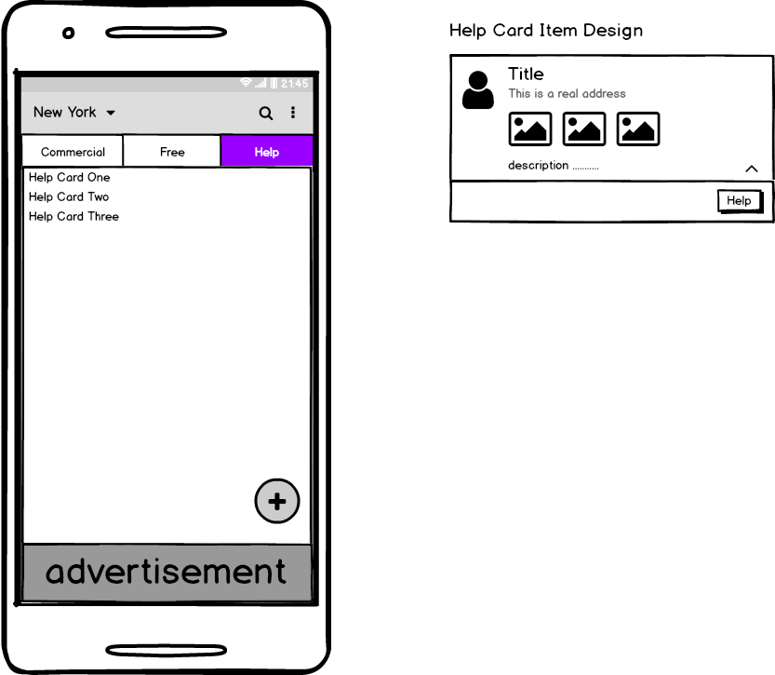

If you want to help others who are in trouble, you can see their troubles in this help page. If you are able to help them to solve it, you can contact them. And if you get some troubles which can’t be solved by yourself, you can also create a new post here to seek help.

## Commercial service list(under specific category)

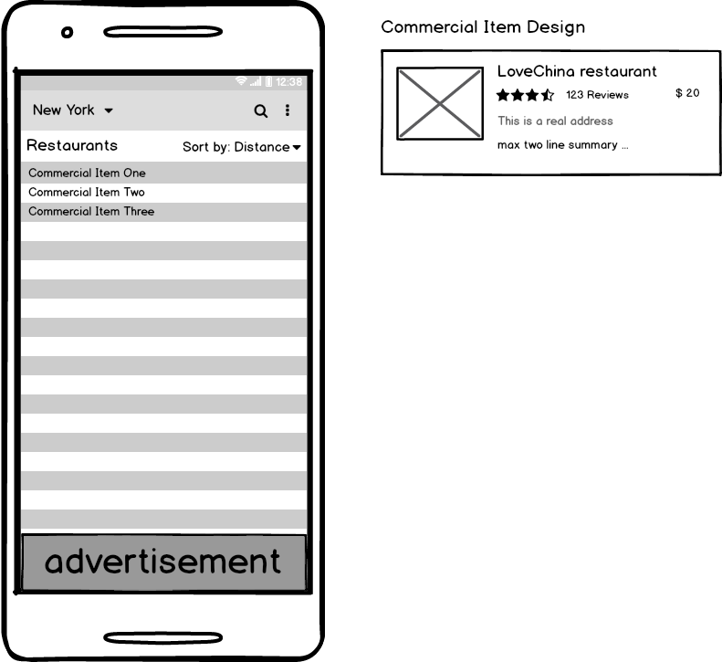

If you choose a specific child category of commercial services such as restaurants, you can see a list of all restaurants in your selected district in this page. You can also sort them by distance or customer rate.

## Commercial service detail page

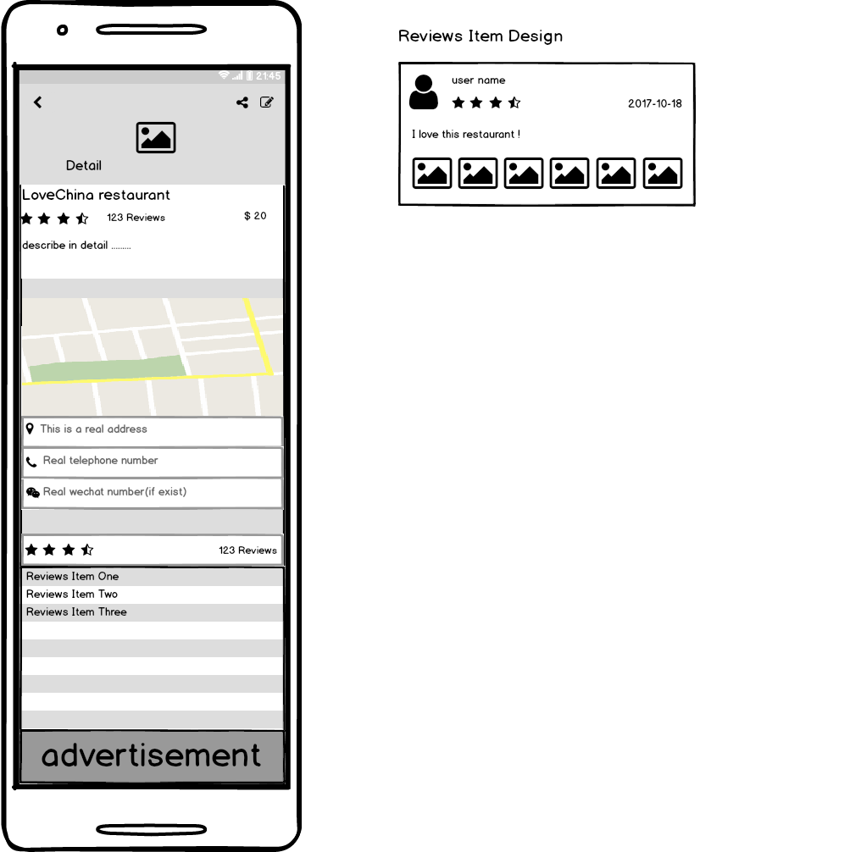

If you click each commercial service item, you will see this detail page which includes service basic description, location, contact information and customer reviews

## Upload a commercial service

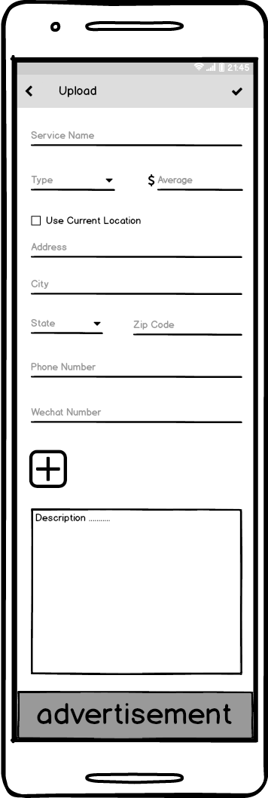

Upload a commercial service, you can add photos and use current location

## Upload a free service(or seek help)

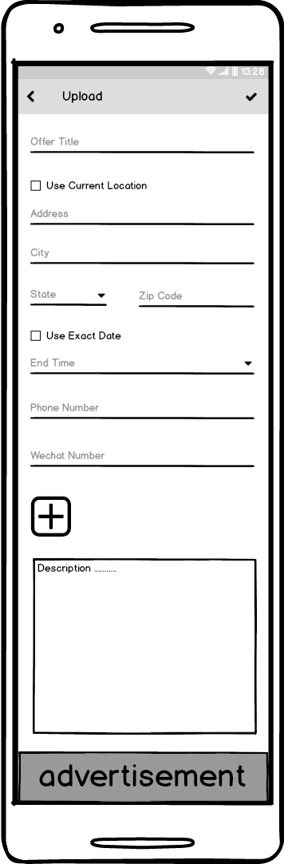

Upload a free service or create a new post to seek help. If the end time is exceeded, it will be invalid.

## Home screen widget

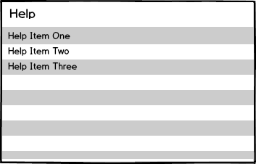

The widget will show the list under the selected tag. For example, if you select help tag in the main activity, the widget will show the help list.

# Key Considerations

### How will your app handle data persistence?

I will use Firebase Realtime Database to store data.

### Describe any edge or corner cases in the UX.

In upload page, if you set end time earlier than now, you will receive a reminder. If you both write down your detail address and check using current position checkbox, your current position will be used. You should leave at least one contact info (either phone or wechat) to commit successfully.

### Describe any libraries you’ll be using and share your reasoning for including them.

Glide to handle image displaying .ButterKnife to handle view injection . Gson to handle json serialization. Rxjava to handle some complex Asynchronous Tasks. Timber to log.

### Describe how you will implement Google Play Services or other external services.

* I will use maps to show the location of service provider on the map.
* I will use Admob to display test ads on the bottom of page.
* I will use Firebase Realtime Database to store services data.
* I will use location to get current location when uploading a new service.

# Next Steps: Required Tasks

## Task 1: Project Setup

* Set up Google Play service
* Set up Firebase
* Configure other libraries
* Configure home screen widget

## Task 2: Implement UI for Each Activity and Fragment

* Build UI for MainActivity
* Build UI for commercial、free、and help fragment
* Build UI for commercial item、free card item、help card item
* Build UI for commercial detail page and review item
* Build UI for three kinds of upload pages
* Build UI for some dialogs
* Build UI for home screen widget

## Task 3: Implement Data Model for Firebase Realtime Database

* Create commercial list model
* Create free card list model
* Create help card list model
* Create reviews list model

## Task 4: Implement Google Play Services

* Implement Firebase Realtime Database for service data storing, sorting and searching, use intentservice to fetch data and use asynctask to search.
* Implement Google map for showing the provider’s location
* Implement Location for uploading your location
* Implement Admob

## Task 5: Implement business logic and UI control

* Complete mainActivity and three child fragment
* Complete commercial detail page
* Complete three kinds of add page
* Complete each dialog
* Complete home screen widget

## Task 6:Test

* Test main activity
* Test detail activity
* Test all add activity