Methodology
This section outlines the methodology adopted in the study and describes the systematic approach used to analyse healthcare claims data and address the research objectives. The study follows the Cross-Industry Standard Process for Data Mining (CRISP-DM) framework, which provides a structured methodology for conducting data analytics and machine learning projects. The CRISP-DM framework consists of a series of interconnected phases that guide the research process from problem definition to model deployment and evaluation. According to Shimaoka et al. (2024), CRISP-DM is a flexible and widely adopted framework that can be applied across various domains, making it suitable for healthcare analytics research. By following this framework, the study ensures a logical and comprehensive approach to understanding and predicting medical scheme claim outcomes.

3.1 Business Understanding
Business Understanding is the first phase of the CRISP-DM framework and focuses on defining the research problem, objectives, and project requirements. This phase involves developing a clear understanding of the business context and translating the identical problem into specific analytical goals. In the context of this study, the primary challenge is the occurrence of claim payment delays and claim rejections within South Africa’s private healthcare financing system. These issues can negatively affect healthcare providers, medical bureaus, and medical schemes by increasing administrative costs, reducing operational efficiency, and creating financial uncertainty.

The objective of this study is to identify the factors that influence healthcare claim outcomes and to develop predictive models capable of estimating payment duration and predicting claim rejection. By generating data-driven insights, the study aims to support improved decision-making, enhance claims processing efficiency and contribute to the overall effectiveness of healthcare financing systems in South Africa. The business understanding phase therefore establishes the foundation for the subsequent stages of data collection, preparation, modelling, and evaluation.

3.1.1 Definition of the business problem
In South Africa’s private healthcare sector, medical schemes reimburse healthcare providers for services provided to insured patients. However, inefficiencies in claims processing system often result in payment delays and claim rejections. The key business problem is the limited understanding of the factors that influence these outcomes, which hinders stakeholders’ ability to proactively identify inefficiencies and implement data-driven strategies to improve the accuracy, efficiency, and timeliness of claims processing.
3.1.2 Project Objectives
The primary objective of this study is to apply predictive analytics to enhance the understanding of medical scheme claims processing and support decision-making within South Africa’s private healthcare sector. The specific objectives are to:
- Analyse historical medical claims data to identify patterns and trends in payment durations and claim outcomes.
- Develop predictive models to estimate the likelihood of claim delays and rejections.
- Identify and assess the key factors that influence claims processing outcomes.
- Promote data-driven decision-making within the healthcare claims processing environment in South Africa.

3.1.3 Success Criteria
The success of this project will be measured through model performance, business relevance, and practical impact. From a technical perspective, the predictive models should achieve acceptable performance, including a ROC-AUC of at least 0.70, a low misclassification rate, and a strong Gini coefficient indicating good discriminatory ability.

3.2 Data Understanding
This section provides an overview of the dataset used in the study. It describes the source, size, and structure of the dataset, as well as the type of information it contains. Furthermore, it includes an examination of the dataset variable to understand their definitions, data type, and relevance to the research objectives. The purpose of this phase is to gain a comprehensive understanding of the data and assess its suitability for subsequent analysis and predictive modelling.

3.2.1 Descriptive of Dataset
The dataset used in this study was obtained from the medical bureau LA Health and contains information on medical claims submitted to medical schemes for reimbursement. The dataset comprises 50 000 observations and 3 variables, with each observation representing an individual medical claim. The data includes both categorical and numerical variables that capture various aspects of the claim process. Overall, the dataset provides detailed records of medical claims submitted for reimbursement and serves as the basis for the analysis and predictive modelling conducted in this study.

3.2.2 Data Source and Key Variables

- Debtors’ status – State whether a claim is paid, outstanding or rejected.
- Invoice Date - The date on which the invoice was created by the service provider.
- Capture Date – The date on which the invoice was entered or recorded into the system.
- Scheme & Option – Identifies the medical aid provider and plan type.
- Contracted / non contracted – Indicates provider agreement with the scheme.
- Total Turnover, Total Cashflow, Total Outstanding – Financial measures of claim performance

3.2.3 Identification of Variables

Table 1 Identification of variables
Administrative Variables | Date Variables | Clinical Variables | Patient Variables | Medical Scheme Variables | Financial Variables | Outcome Variables
Invoice number | Invoice Date | Primary ICD10 | Age Bracket | Scheme | Total Turnover | Debtor Status
Entity Name | Capture Date | ICD10 Description | Gender | Option | Total Cashflow | Possible PMB calculated
Medical Aid Number | Earliest Capture Date |  | Service centre | Administrator | Total Outstanding | contracted/non-contracted
 | Latest Capture Date |  |  |  | Total Journals
Source: Authors own

3.2.4 Initial exploration of the data
Initial data exploration involves a preliminary assessment of the dataset to understand its structure, content, and overall quality. This process includes examining data types, identifying missing values and observing basic patterns and trends within the data. The purpose of this stage is to develop a general understanding of the dataset and identify any potential issues that may need to be addressed before conducting further analysis or predictive modelling.

3.2.5 Duplicate records
The initial assessment of the dataset identified no duplicate rows, suggesting that the data collection and entry process include controls to minimize redundancy. However, the absence of fully duplicated records does not necessarily guarantee the uniqueness of key identifiers, such as invoice numbers. Therefore, it remains important to examine fields that are expected to contain unique values to determine whether any repeated entries exist, as such occurrences could affect the accuracy and reliability of transaction-level analyses.

3.2.6 Missing Values
A substantial proportion of missing values was identified across several variables in the dataset, with particularly high levels observed in Patient Date of Birth and Total Journals, the latter containing an exceptionally large amount of missing data. Incomplete values were also found in various financial and doctor related variables. The missing data points may affect the quality of the analysis by reducing data completeness and introducing potential bias. The extent of missingness suggests that some variables may need to be excluded from the analysis, while others may require appropriate imputation techniques to preserve their analytical value and ensure reliable modelling outcomes.

Table 2: Identification and Percentage Distribution of Missing Values in the LA Health Dataset
Variable Identification | Missing Count | Total Count | %Missing
Patient Variable
1. Service centre | 775 | 50000 | 1.55%
2. Gender | 472 | 50000 | 0.94%
Clinical Variables
1. Primary ICD10 | 1347 | 50000 | 2.69%
2. ICD10 Description | 1347 | 50000 | 2.69%
Financial Variables
1. Total Turnover | 1095 | 50000 | 2.19%
2. Total Cashflow | 3312 | 50000 | 6.62%
3. Total Journals | 46093 | 50000 | 92.19%
Source: Authors own

Table 2 illustrates the level of missing data across variables using counts and percentages. Most variables have low missing values, indicating complete data. However, some financial variables, such as Total Cashflow, have higher missingness, which may affect analysis reliability and model performance. The Total Journals variable has extremely high missing data (92.19%) and may need to be excluded or imputed to prevent negative impacts on model accuracy.
3.2.7 Data Consistency Issues
The dataset may contain inconsistencies within categorical variables, including variations in the recording of gender, service centres, and doctor names. For instance, differences in formatting, spelling or naming conventions for the same category can result in inaccurate grouping and aggregation during analysis. Such inconsistencies can compromise data quality and reliability, making it necessary to standardize categorical values to ensure accurate analysis, reporting and interpretation of results.
3.2.8 Outliers and Data quality issues
The financial variables in the dataset, such as total turnover and outstanding amounts, may include outliers. These outliers could be extremely high values or potentially incorrect entries, such as negative amounts where they are not expected. Outliers can skew statistical measures like averages and totals, making it crucial to recognize and evaluate them before proceeding with analysis.
Figure 1 Financial Variables
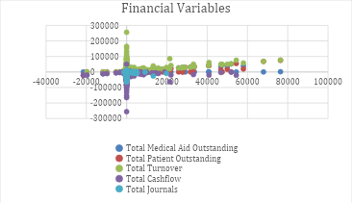
Source: Excel Microsoft
Figure 1 presents a scatter plot of key financial variables, including total turnover, outstanding amounts, cashflow, and journals. The distribution of points shows that most values cluster around a central range, but there are several extreme values that lie far from the main group, indicating the presence of outliers. Some variables also display negative values where they may not typically be expected, suggesting potential data entry errors or inconsistencies. These outliers and anomalies can distort overall trends and statistical measures, highlighting the need for careful data cleaning and validation before analysis.

3.2.9 Data Integrity Checks
Data integrity checks were conducted to verify the accuracy and consistency of the dataset. These checks involved assessing the logical relationships between variables to identify potential errors or inconsistencies. For example, patients ages were compared against their recorded dates of birth to ensure consistency, while invoice dates were examined to confirm that they preceded with capture dates. Such validations help improve data quality and ensure that the dataset is suitable for meaningful analysis.

3.3 Data Preparation
This section describes the procedures undertaken to prepare the dataset for analysis and predictive modelling. The data preparation phase includes data cleaning, the treatment of missing values, the correction of inconsistencies and identification and handling of outliers. The objective of this phase is to transform raw data into a clean, consistent, and reliable dataset that is suitable for accurate analysis and model development.
3.3.1 Data Cleaning and Handling Missing Values.
This research applies data preparation using Microsoft Excel, RStudio, and SAS Enterprise Miner to ensure that the dataset is accurate, consistent, and suitable for analysis. Excel is used for initial inspection of the dataset, including identifying errors, sorting, filtering, and detecting inconsistencies. Advanced data cleaning and transformation are performed in RStudio, where variables such as Gender are standardized to consistent categories (e.g., F for Female and M for Male).
Missing values are addressed through a combination of imputation and data removal, depending on the extent of missingness. Variables with excessive missing data, such as Total Journals, Total Turnover, and Posted Billing Group, are removed to maintain data quality and integrity. In cases where missing values are manageable, appropriate imputation techniques are applied to preserve useful information. Records with unreliable or unrepairable missing data are excluded to ensure the reliability of the final dataset used for modelling.
3.3.2 Feature Engineering
Feature engineering was performed to create new variables and transform existing variables into formats suitable for predictive modelling. New variables such as Processing Delays and the binary target variable Delay Status were created to measure healthcare claim processing delays. Processing Delays was calculated using the difference between the invoice date and capture date, while DelayStatus classified claims as delayed (1) or non-delayed (0). In addition, categorical variables were transformed into numerical and binary formats to improve model performance and predictive accuracy.
3.3.3 Correlation and Associations
At this stage, correlations and associations among predictor variables are examined to identify potential multicollinearity and remove redundant variables before model development. For numerical variables, the Pearson correlation coefficient is used to measure the strength and direction of linear relationship between variables. Strong correlations, typically greater than 0.8 or less than -0.8 suggest that the variables contain similar information. In such cases, one of the highly correlated variables may be removed to reduce redundancy, improve model performance, and enhance the interpretability of the results.
Figure 2 Correlation Matrix of Financial Variables in the LA Health Dataset
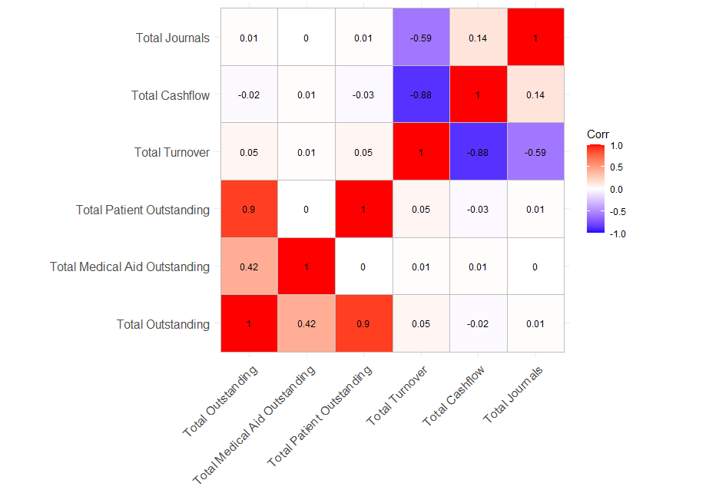
Source: R Programming
Figure 2 shows strong multicollinearity among some predictors, meaning certain variables provide overlapping information. Highly correlated pairs should not be included together in the model, so one variable from each pair should be removed to reduce redundancy and improve model stability.
3.3.4 Descriptive Analysis
This study performs variable selection to ensure that only relevant variables are included in the analysis and modelling process. Variables that do not contribute meaningful predictive information, such as unique identifiers are removed from the dataset. In addition, statistical techniques, including correlation analysis, are used to evaluate relationships between variables and identify redundant predictors. This process helps reduce complexity, improve model performance, and ensure that the dataset is suitable for accurate and reliable predictive modelling.
3.3.5 Data Partitioning
Data partitioning involves dividing the LA Health dataset into separate subsets for model training and evaluation. In this study, the dataset is split inti a training set (70%) and a validation set (30%). The training set is used to develop the predictive models, while the validation set is used to assess model performance on previously unseen data. This approach helps evaluate the model’s predictive accuracy, reduce the risk of overfitting, and ensure that the model can generalize effectively when predicting claim payment delays or claim rejections.

