SECRETARY’S MINUTES
Title of Paper: Multicab Stop Time Monitoring System using AI Based Camera Detection
Name of Proponents:
Michael Angelo Angeles
Elton John Muralla
Jesse Pepito
Zurich Cabanelez
Type of Defense: ( ) Proposal Defense ( ✓ ) System Defense ( ) Final Defense
Number of Rounds: ( ✓ ) 1st ( ) 2nd ( ) 3rd
Date/Time & Venue: April 15, 2026 || 2:00pm || IT Faculty Room
Adviser: Peter Joseph G. Rabanes
Panel Chair/REC: Dr. Rozanne Tuesday G. Flores Panel Members:
Anna Rose C. Tan
Roanne Zoe Cayanan
Secretary: Czarissa Louise A. Navidad
Name of Panel |  | COMMENTS/SUGGESTIONS
Dr. Rozanne Tuesday G. Flores | • | Expand locations for testing, use locations with more frequent traffic. | Location  Sayre Highway - Fortich St., Malaybalay City
 | • | Reports should not be static. Allow generation of custom dates. | 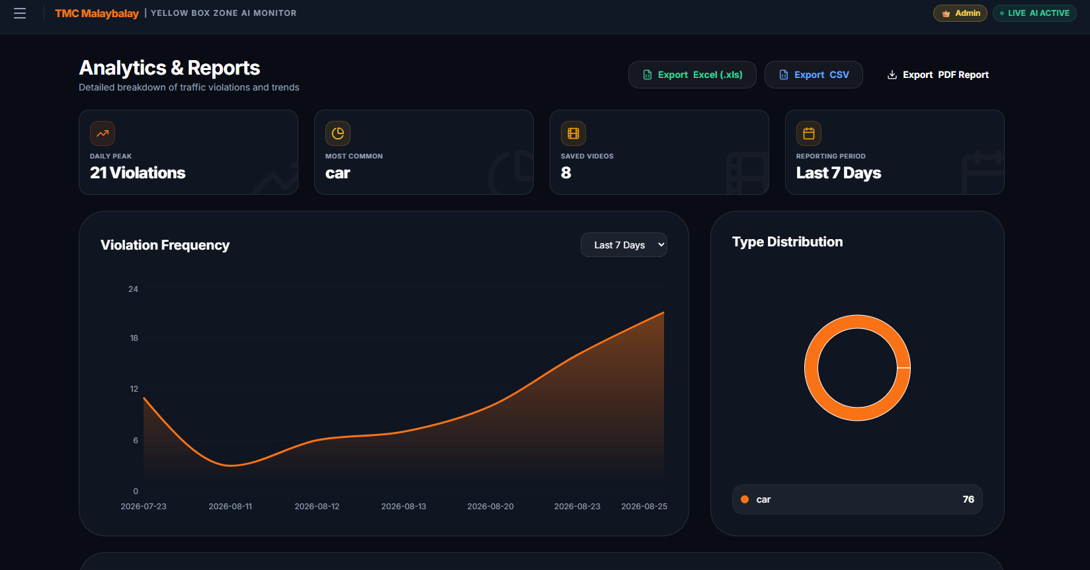
 | • | Improve report generation file. Make sure it can be used by the client (TMC). Headers, signatories, etc. | 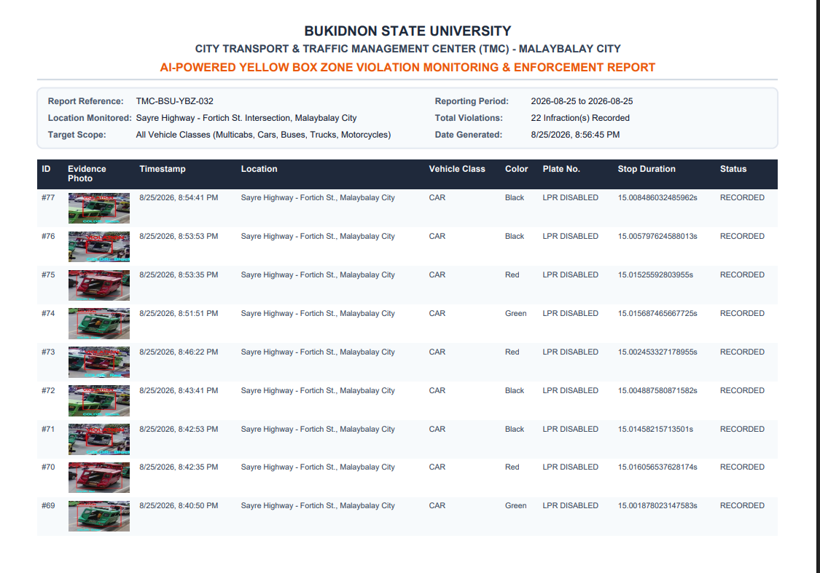
 | • | Make sure the data that’s being recorded is useful and valuable.  E.g. Location, Timestamp, Plate Number, Make/Color of Vehicle (picture, if possible). | 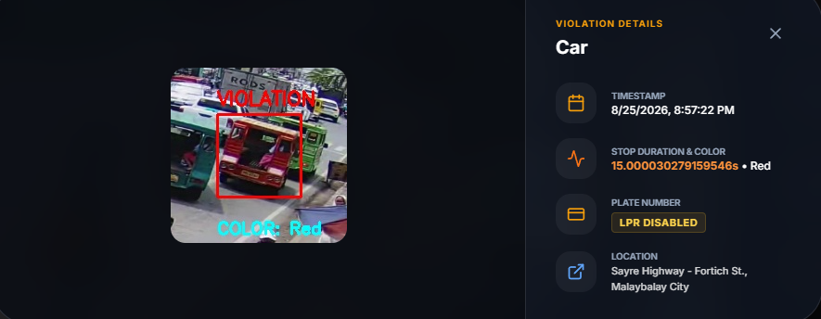
 | • | Data is very lacking. Test using more videos. | Still Working on it
 | • | Purchase your own camera for testing so that you can record the Plate Number as well. | Camera available
 | • | Add a Login functionality. Improve dashboard UI. | 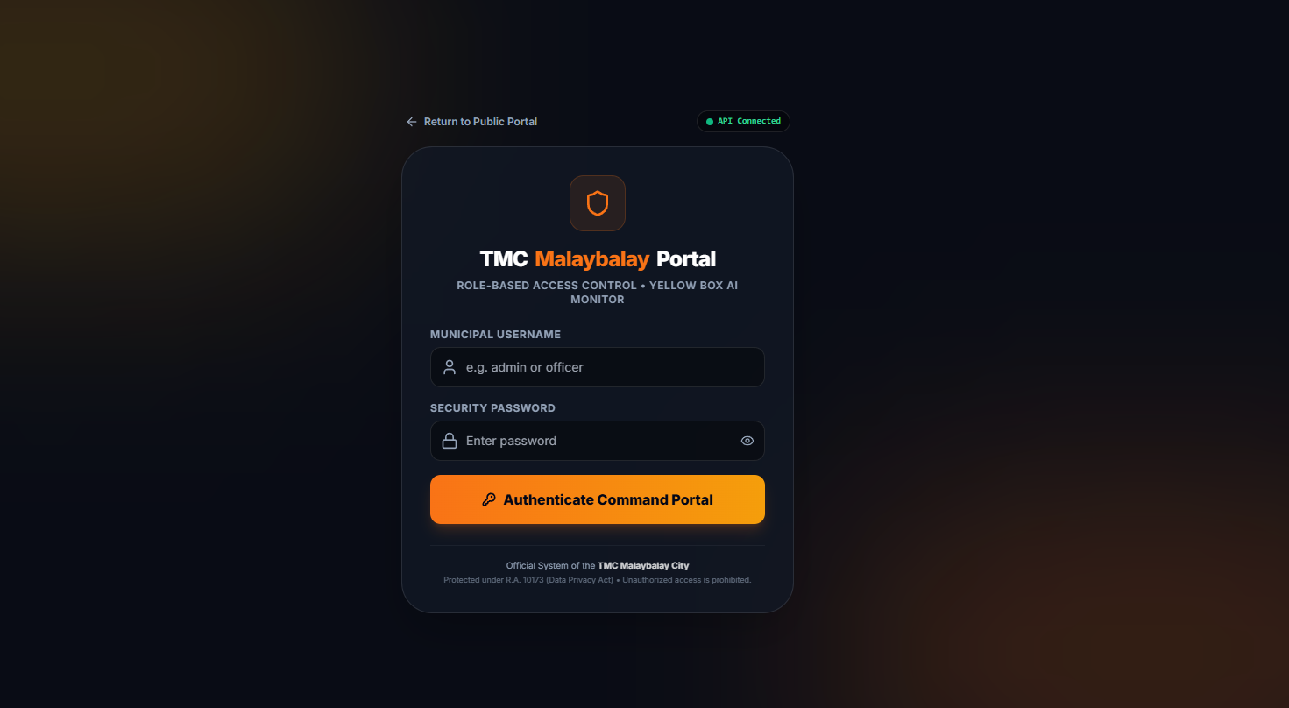
 | • | Upon entering the yellowbox, system should capture the plate number of the multicab. If a violation occurred, then store the plate number in the database. If no violation occurred, disregard the captured plate number. | When the vehicles enters the yellow box, the system should capture its plate number. If a violation occurs, the plate number will be stored in the database; otherwise, it will be disregarded.  However, plate detection is currently difficult because the camera is too far, the video quality is low, and the camera angle affects EasyOCR's ability to recognize the plate accurately.

Name of Panel |  | COMMENTS/SUGGESTIONS
Anna Rose C. Tan | • | Improve dashboard UI. | 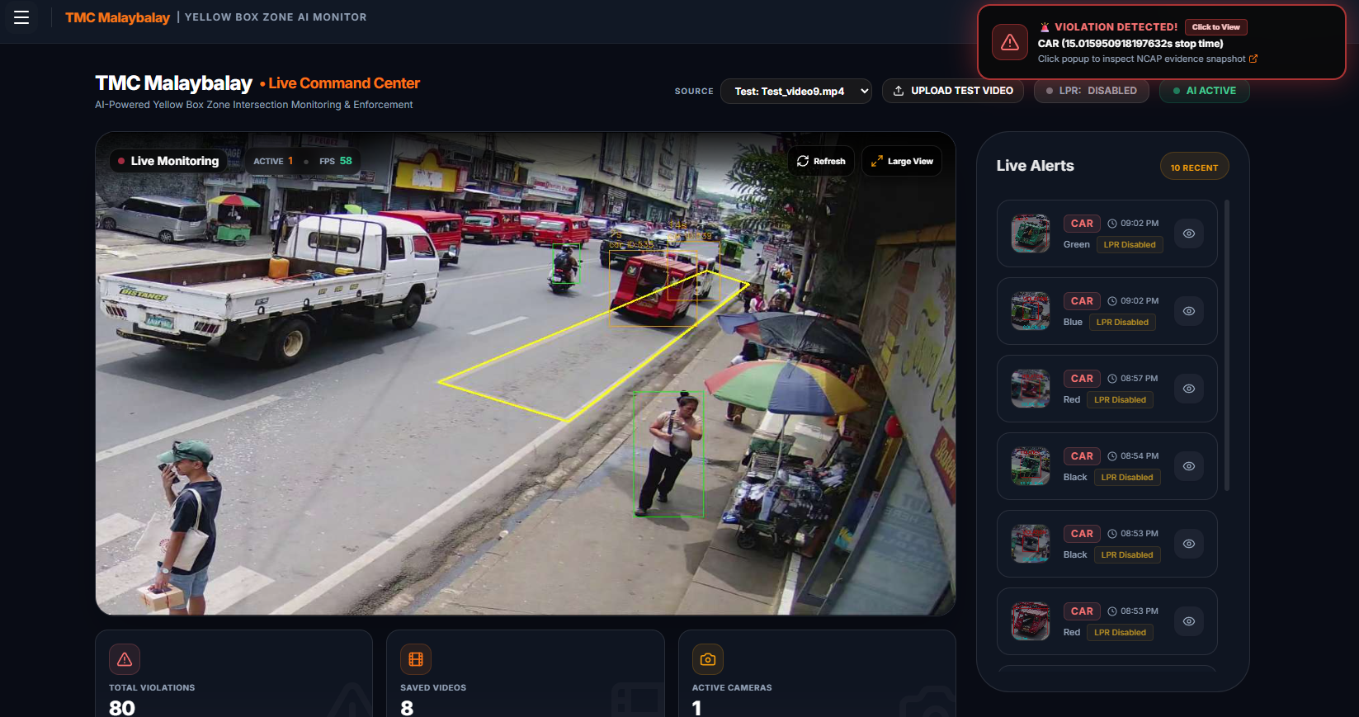
 | •  • | TMC dashboard should have a notification every time a violation is detected. | 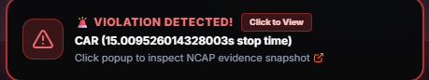

Name of Panel |  | COMMENTS/SUGGESTIONS
Roanne Zoe Cayanan | • | Improve device demo specs for next time. | 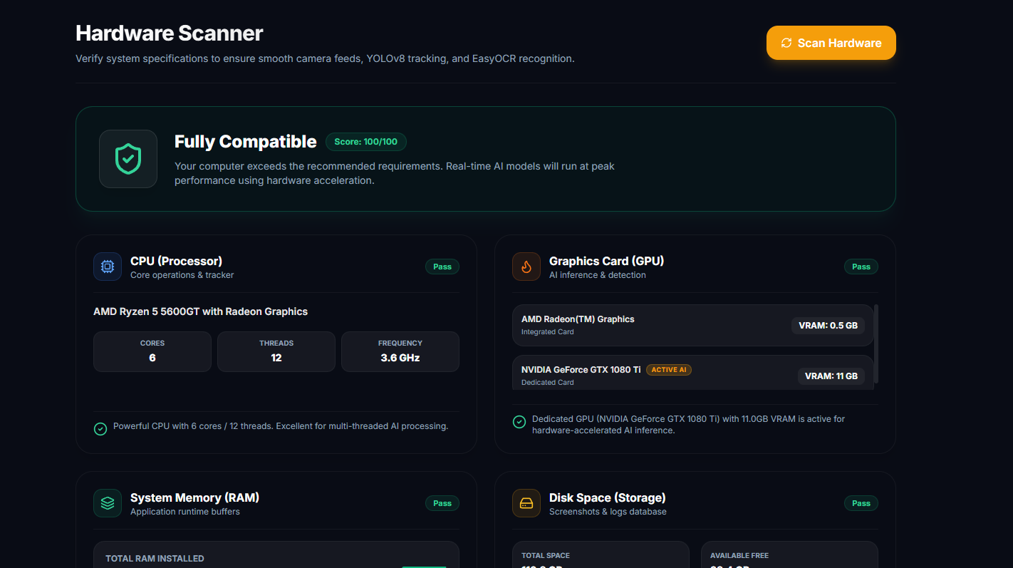
 | • | Identification of other vehicle types is not important here. | We have implemented a hardware scanner for the system so the user can know if the device can handle the project
 | • | Improve dashboard design. | 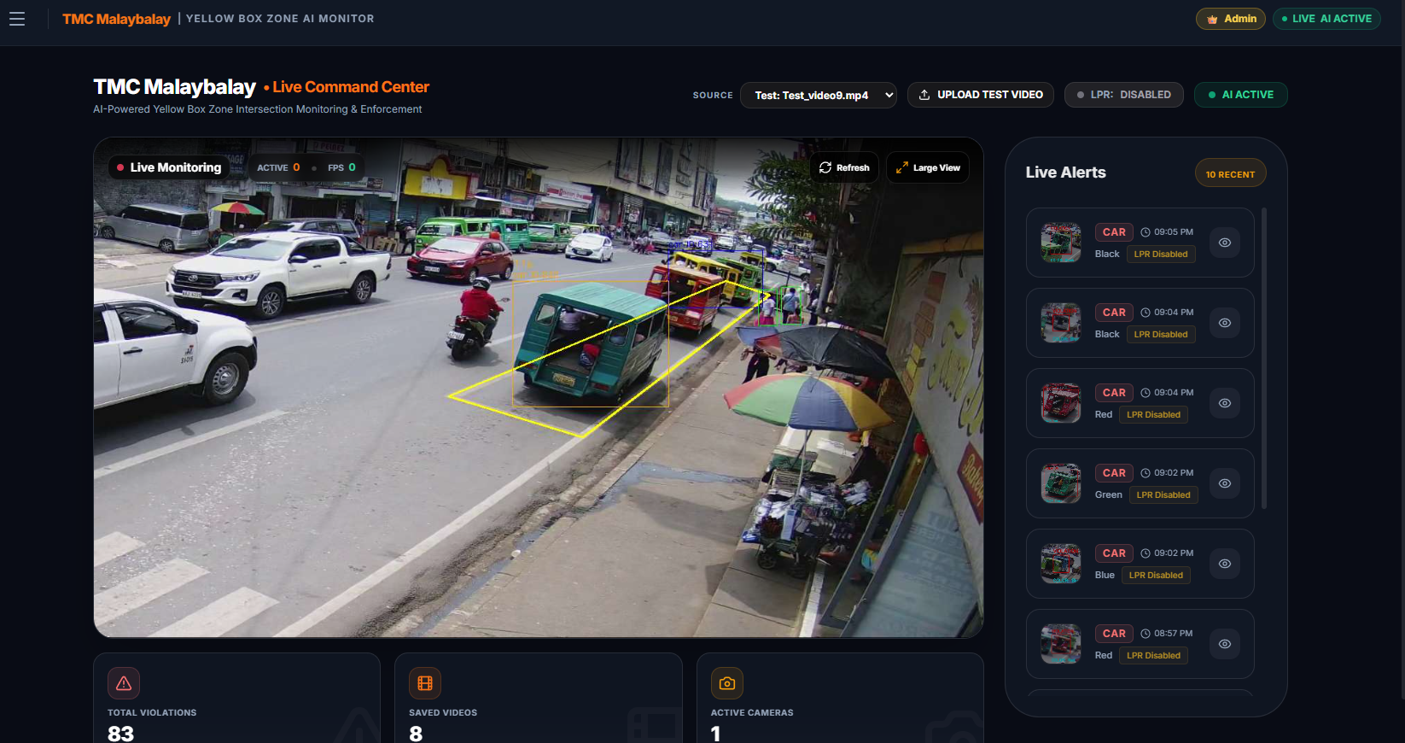
Name of Client | COMMENTS/SUGGESTIONS
Overall recommendation:
• Make sure to demo your system to your client and have them evaluate. Take pictures during demonstration and take notes of their comments.
Panel Verdict:
( ) Approved with Minor Revision
( ✓ ) Approved with Major Revision
( ) Rejected
Czarissa Louise A. Navidad
Signature over Printed Name of Secretary

