AI-POWERED YELLOW BOX ZONE VIOLATION MONITORING SYSTEM USING AI-BASED CAMERA DETECTION
A Capstone Project by
Michael Angelo A. Angeles
Zurich M. Cabañelez
Elton John K. Muralla
Jesse Emannuel L. Pepito
Submitted to the Information Technology Department, College of Technologies
Bukidnon State University
Malaybalay City, Bukidnon, Philippines
In Partial Fulfillment
of the Requirements for the Degree of
Bachelor of Science in Information Technology
May 2026

APPROVAL SHEET
This capstone project titled "AI-Powered Yellow Box Zone Violation Monitoring System Using AI-Based Camera Detection", prepared and submitted by Michael Angelo A. Angeles, Zurich M. Cabañelez, Elton John K. Muralla, and Jesse Emannuel L. Pepito in partial fulfillment of the requirements for the degree of Bachelor of Science in Information Technology, is hereby accepted.
PETER JOSEPH G. RABANES
Capstone Project Adviser
DR. ROZANNE TUESDAY G. FLORES
Chair, Defense Panel
ROANNE ZOE M. CAYANAN | ANNA ROSE C. TAN
Panel Member | Panel Member
Accepted and approved for the conferral of the degree of Bachelor of Science in Information Technology.
SALES G. ARIBE JR., DIT | MARILOU O. ESPINA, DIT
Department Head, Information Technology | Dean, College of Technologies

ACKNOWLEDGMENTS
The road to completing this capstone research project could not have been traveled alone. The researchers express their deepest gratitude to Almighty God for providing wisdom, health, perseverance, and guidance throughout this academic journey.
Sincere gratitude is extended to the capstone project adviser, Peter Joseph G. Rabanes, for his expert technical direction, relentless feedback, and constructive guidance in system architecture, AI model design, and academic writing.
The researchers also express profound appreciation to the defense panel members: Dr. Rozanne Tuesday G. Flores (Panel Chair), Roanne Zoe M. Cayanan, and Anna Rose C. Tan, whose thorough review, challenging inquiries, and insightful recommendations substantially elevated the technical depth, rigor, and practical value of this research.
Special thanks are conveyed to the Traffic Management Center (TMC) of Malaybalay City for their openness, cooperation, and accommodation during field data gathering, CCTV footage acquisition, and system validation trials. Finally, heartfelt appreciation goes to our beloved parents, families, and colleagues for their unwavering love, moral support, and financial sacrifices.

TABLE OF CONTENTS
APPROVAL SHEET ii
ACKNOWLEDGMENTS iii
TABLE OF CONTENTS iv
LIST OF TABLES vi
LIST OF FIGURES vii
1. INTRODUCTION 1
1.1 Background of the Study 1
1.2 Statement of the Problem 3
1.3 Objectives of the Study 4
1.4 Significance of the Study 5
1.5 Scope and Delimitations 6
2. REVIEW OF RELATED LITERATURE 7
2.1 Related Literature 7
2.1.1 Traffic Monitoring 7
2.1.2 Artificial Intelligence in Traffic Management 8
2.1.3 Camera-Based Detection Technologies 9
2.1.4 Deep Learning, Multi-Object Tracking & Edge Acceleration 9
2.1.5 No-Contact Apprehension Policy (NCAP) Reference 10
2.2 Synthesis and Related Systems 11
2.3 Research Gap 13
2.4 Concept of the Study (Conceptual Framework) 14
2.5 Definition of Terms 15
3. METHODOLOGY 17
3.1 Materials 17
3.1.1 Software 17
3.1.2 Hardware 18
3.1.3 Data & Data Acquisition 19
3.2 Methods & Research Design 19
3.2.1 Research Design 19
3.2.2 Process Model (Waterfall Lifecycle) 20
3.2.3 Procedures for the Different Phases 21
3.2.4 Violation Documentation and Serving Procedure (NCAP-Based) 31
3.2.5 Handling Multiple Vehicles in Real Time 32
3.2.6 Evaluation Framework 33
3.2.7 Deployment and Documentation 35
4. RESULTS AND DISCUSSION 37
4.1 Results for Objective 1: Real-Time Detection and Monitoring 37
4.1.1 AI Vehicle Detection and Multi-Class Classification Performance 37
4.1.2 Spatial Zone Containment Verification via Ray-Casting Algorithm 40
4.1.3 Multi-Object Tracking, Centroid Association, and Occlusion Handling 43
4.2 Results for Objective 2: Automated Stop-Time Recording and Alerting 45
4.2.1 Stop-Time Duration Accuracy and Error Analysis 45
4.2.2 Dwell-Time Threshold State Machine and Anti-Redundancy Logic 47
4.2.3 Real-Time Audio-Visual Violation Alerting and Latency Benchmark 48
4.3 Results for Objective 3: Evidentiary Capture, Cataloging, and NCAP Standards 50
4.3.1 Evidentiary Snapshot Capture and Vehicle Visual Attribute Tagging 50
4.3.2 Automatic License Plate Recognition (ALPR) and Resolution Fallback 53
4.3.3 Database Schema Integrity, Transactional Archival, and Chain of Custody 55
4.4 Results for Objective 4: Interactive Dashboard, Diagnostics, and Reporting 57
4.4.1 Interactive Web Dashboard Interface and Real-Time Video Streaming 57
4.4.2 Unviewed Alert Queue and Operator Verification Workflow 58
4.4.3 Dynamic Date-Range Filtering and Data Analytics 59
4.4.4 Tamper-Evident Official PDF & Excel Report Generation 60
4.4.5 System Hardware Throughput and Built-in Diagnostic Scanner 61
4.4.6 Role-Based Access Control (RBAC) and System Security 62
4.5 Stakeholder Usability and Client Acceptance Evaluation 63
4.6 Compliance with Defense Panel Recommendations 66
5. CONCLUSION AND RECOMMENDATIONS 67
5.1 Conclusion 67
5.2 Recommendations for Future Work 68
REFERENCES 70
APPENDICES 73
Appendix A: TMC Officer Usability Evaluation Questionnaire 73
Appendix B: Defense Panel Secretary's Minutes & Compliance Matrix 76
Appendix C: Budget & Financial Plan 78
Appendix D: System Screenshots 79

LIST OF TABLES
Table 1-1. Summary of Reviewed Studies on AI-Based Traffic Monitoring Systems 11
Table 2-1. Comparative Matrix of Existing Systems vs. Proposed System 12
Table 3-1. Software Development Environment and Dependencies 17
Table 3-2. Hardware Specifications for Training and Inference 18
Table 4-1. YOLOv8 AI Model Detection Performance Metrics by Vehicle Class 37
Table 4-2. Spatial Containment Verification Accuracy (Point-in-Polygon vs. Bounding Box IoU) 41
Table 4-3. Multi-Object Tracking Continuity and Occlusion Recovery Rates 43
Table 4-4. Stop-Time Duration Accuracy vs. Ground Truth Video Timers 45
Table 4-5. Alert Notification Dispatch Latency Benchmarks 49
Table 4-6. Vehicle Color Classification and Attribute Extraction Accuracy 51
Table 4-7. ALPR Recognition Performance Across Camera Distances and Resolution Modes 54
Table 4-8. Hardware Execution Performance and Real-Time FPS Across Devices 61
Table 4-9. Evaluation Results: Functionality Mean Ratings from TMC Personnel (ISO/IEC 25010) 63
Table 4-10. Evaluation Results: Usability Mean Ratings from TMC Personnel (ISO/IEC 25010) 64
Table 4-11. Evaluation Results: Reliability Mean Ratings from TMC Personnel (ISO/IEC 25010) 65
Table 4-12. Overall ISO/IEC 25010 Evaluation Summary 65
Table 4-13. Defense Panel Recommendations and Actions Taken Compliance Matrix 66
Appendix A Table TMC Officer Usability Evaluation Questionnaire Items 73
Appendix C Table Budget & Financial Plan Summary 78

LIST OF FIGURES
Figure 1-1. Conceptual Framework of the AI-Powered Vehicle Yellow Box Monitoring System (IPO Model) 14
Figure 2-1. Waterfall Development Model Lifecycle 20
Figure 3-1. Use Case Diagram for TMC Command Center Operations 22
Figure 4-1. Level-1 Data Flow Diagram (DFD) of Video Ingestion, Detection, and Logging 23
Figure 5-1. System Architecture Diagram (Edge Camera, Flask AI Backend, SQLite DB, React Frontend) 24
Figure 6-1. Entity-Relationship Diagram and Database Schema 25
Figure 7-1. Process Flowchart of Vehicle Detection, Spatial Checking, Dwell-Time Computation, and Alerting 27
Figure 8-1. Ray-Casting Point-in-Polygon (PIP) Spatial Verification Geometry 28
Figure 9-1. Interactive Zone Calibration Modal & Real-Time Yellow Box Polygon Configuration 57
Figure 10-1. Multi-Angle Evidentiary Violation Capture with Dynamic Bounding Box & Color Classification 51
Figure 11-1. ALPR Recognition Dossier and Resolution Fallback Verification Modal 53

1. INTRODUCTION
This section provides the background and rationale for the study, identifies the research problem, states the objectives, and discusses the significance and scope of the proposed AI-based vehicle monitoring system.

1.1 Background of the Study
Traffic congestion and violations of road regulations remain significant challenges in many urban areas across the Philippines. With the continuous increase in vehicle volume, local government units (LGUs) struggle to maintain efficient traffic flow due to limited manpower and a heavy reliance on manual monitoring and enforcement methods (Department of Transportation [DOTr], 2023). Public transport vehicles (such as multicabs, public utility jeepneys [PUJs], tricycles, and buses), as well as private vehicles, are frequently observed committing traffic violations such as stopping or waiting for passengers within yellow box zones, prolonged loading and unloading at intersections, obstructing pedestrian crossings, and occupying restricted road spaces beyond allowable stop times.
These improper road behaviors disrupt traffic movement, block intersecting lanes, and contribute to vehicle queuing, travel delays, and reduced road efficiency, especially in high-traffic intersections (Ho et al., 2019; Bhavsar et al., 2023; Rathore et al., 2021). In the context of Malaybalay City, Bukidnon, preliminary observations conducted during peak hours along major corridors such as Sayre Highway – Fortich Street reveal that vehicle-related stopping violations occur repeatedly within short monitoring periods, with multiple instances visible daily at designated yellow box zones.
Recent advancements in Artificial Intelligence (AI) and computer vision have enabled the development of automated traffic monitoring systems capable of analyzing vehicle behavior through camera-based input. Studies have shown that AI-based systems using deep learning models such as Convolutional Neural Networks (CNNs) and You Only Look Once (YOLO) can effectively detect and classify vehicles in real time, offering higher accuracy and consistency compared to traditional observation-based methods (Valdivieso Tituana et al., 2022; Basheer Ahmed et al., 2023). These technologies allow traffic authorities to collect objective, data-driven insights that support improved enforcement and decision-making.
In Malaybalay City, the Traffic Management Center (TMC) currently relies on a combination of field traffic personnel and limited Closed-Circuit Television (CCTV) monitoring to oversee road activity. However, this approach restricts coverage and real-time response, particularly during peak hours when traffic volume is high (Malaybalay City Information Office, 2024). The absence of intelligent monitoring tools highlights the need for a system that can automatically observe vehicle activity, compute dwell time, and provide timely visual and recorded information to assist traffic authorities.
Therefore, there is a clear need for a technology-assisted approach that can support traffic monitoring operations in Malaybalay City by addressing recurring vehicle-related violations in yellow box zones. Integrating artificial intelligence and camera-based detection into the existing CCTV and traffic surveillance infrastructure can improve monitoring efficiency, promote better compliance with traffic regulations, and support local traffic management and urban mobility development efforts. Such an approach aligns with the city’s ongoing efforts to improve traffic flow, strengthen enforcement capability, and modernize traffic operations through technology-driven solutions (Bhavsar et al., 2023; Rathore et al., 2021).

1.2 Statement of the Problem
Despite the implementation of traffic regulations and the deployment of monitoring personnel, improper vehicle behavior continues to be a persistent contributor to traffic congestion in Malaybalay City, particularly in yellow box zones located at busy intersections. Frequent violations such as prolonged stopping, loading and unloading within restricted zones, and obstruction of intersecting lanes disrupt traffic flow, delay commuters, and reduce overall road efficiency, especially during peak hours.
The Traffic Management Center (TMC) currently relies on manual enforcement and limited CCTV monitoring, which constrains continuous observation, accurate documentation, and real-time response. These limitations make it difficult to consistently detect violations, objectively validate infractions, and promptly address congestion caused by recurring vehicle stoppages. As traffic volume continues to increase, these challenges place additional strain on enforcement personnel and hinder the city’s ability to manage traffic effectively.
Without an automated and intelligent monitoring mechanism, vehicle-related violations are likely to persist, resulting in recurring congestion, inefficient enforcement, and limited availability of reliable data to support traffic planning and policy formulation. This situation underscores the need for a technology-driven solution that can provide continuous, objective, and real-time monitoring of vehicle activity to support traffic management and enforcement operations in Malaybalay City.
This study seeks to address the following primary research question: > How can an AI-based system be developed to automatically monitor vehicle activity using camera input and provide real-time data to support traffic management and enforcement in Malaybalay City?
Specifically, the study addresses the following sub-problems:
1. How can computer vision and deep learning models (YOLO) be effectively configured to detect and classify various vehicle types (multicabs, tricycles, cars, buses, trucks, motorcycles) within defined yellow box intersection coordinates?
2. How can an automated tracking and dwell-time algorithm be formulated to accurately measure vehicle stop durations and trigger violation events when thresholds are exceeded?
3. How can license plate recognition (ALPR) and vehicle visual attributes (color, type, location, timestamp) be captured and archived under an objective, No-Contact Apprehension Policy (NCAP) evidence framework?
4. How can an interactive, role-based command center dashboard be designed to provide real-time video streaming, live audio-visual violation alerts, dynamic date-filtered analytics, and exportable official reports with administrative signatories?
5. How effective and acceptable is the proposed system when evaluated by TMC traffic officers in terms of Functionality, Usability, and Reliability based on ISO/IEC 25010 software quality standards?

1.3 Objectives of the Study
The main goal of this study is to enhance traffic management in Malaybalay City by developing a system capable of monitoring vehicle activity in yellow box zones and providing actionable information to support enforcement operations.
Specifically, the study aims to:
1. Enable real-time detection and monitoring of vehicles entering and stopping in yellow box zones using deep learning object detection (YOLOv8/YOLOv5) and OpenCV.
2. Automate the recording of vehicle stop times and generate real-time alerts (audio-visual toasts and live notifications) when violations occur.
3. Capture and catalog objective violation evidence, including timestamped image snapshots, vehicle classification, estimated vehicle color, exact intersection location, and license plate information (when ALPR is active), adhering to NCAP digital evidence standards.
4. Provide the Traffic Management Center (TMC) with an interactive web-based dashboard featuring:
• Live video feed with dynamic zone polygon and bounding box overlays.
• Live alert feeds highlighting unviewed violations with one-click review.
• Dynamic date-range filtering for violation logs and analytics.
• Exportable, tamper-evident PDF reports containing official TMC headers, statistical summaries, and administrative signatories.
• Built-in hardware diagnostic scanner to assess system GPU/CPU readiness.
• Secure Role-Based Access Control (Super Admin vs. TMC Officer).

5. Evaluate the system’s effectiveness in terms of monitoring accuracy, reliability, processing latency, and user acceptability through simulated tests and live demonstrations with TMC Malaybalay personnel using ISO/IEC 25010 criteria.

1.4 Significance of the Study
This study provides tangible benefits to multiple stakeholders in urban mobility and governance:
Commuting Public of Malaybalay City: Daily passengers, students, and workers benefit from reduced travel delays, smoother intersection transitions, and improved public transit reliability by minimizing illegal vehicular blockades in intersection yellow boxes.
Vehicle Drivers and Operators: Public transport and private motorists gain a transparent, rule-governed driving environment. Objective AI evidence prevents wrongful accusations, promotes fair enforcement, and encourages compliance with intersection discipline.
Traffic Management Center (TMC) of Malaybalay City: TMC gains a scalable, 24/7 decision-support system that automates infraction detection, reduces the physical hazards faced by field enforcers during peak hours, and provides verifiable evidence logs for swift administrative adjudication.
Local Government Unit (LGU) & Urban Policymakers: City administrators and traffic engineers obtain longitudinal violation data, peak congestion timestamps, and vehicle distribution statistics to guide infrastructure improvements, traffic light timing adjustments, and transport policy formulation.
Academic Researchers and Future Developers: Serves as an open reference architecture for localized edge AI, spatial computer vision, and low-cost municipal traffic automation in developing small-to-medium city environments.

1.5 Scope and Delimitations
The scope of the study focuses on the design, implementation, and empirical evaluation of an AI-assisted yellow box monitoring system tailored for Malaybalay City, Bukidnon. The system uses fixed CCTV feeds and high-definition video files with a resolution of 1080p at 30 frames per second (FPS), covering designated yellow box intersections along major thoroughfares, such as Sayre Highway–Fortich Street. It incorporates real-time multi-class vehicle detection, centroid tracking, mathematical point-in-polygon spatial containment checking, temporal dwell-time accumulation, license plate extraction, and web dashboard visualization. Its evaluation includes bench testing for detection accuracy and FPS throughput, as well as a structured ISO/IEC 25010 evaluation administered to active Traffic Management Center (TMC) officers.
The delimitations of system is primarily limited to detecting yellow box stop-time violations, which occur when vehicles remain stationary within the marked grid beyond the allowable dwell-time threshold, typically set between 3.0 and 5.0 seconds. Other traffic violations, such as excessive speeding, illegal U-turns, counterflow driving, and red-light running outside the yellow box boundary, are excluded from the primary detection pipeline. The system serves as a decision-support and evidence-gathering instrument and does not automatically impose financial penalties. Any enforcement action requires human review and verification by an authorized TMC officer, in accordance with legal due process. Furthermore, license plate recognition (ALPR) performance depends on camera angle, optical zoom, and illumination. When the available video resolution is insufficient because of wide-angle CCTV mounting distances, the system falls back to visual vehicle classification and color tagging while marking the ALPR result as unread or bypassed.

2. REVIEW OF RELATED LITERATURE

2.1 Related Literature

2.1.1 Traffic Monitoring
Traffic monitoring is a critical component of urban traffic management, enabling authorities to observe vehicle movement, detect violations, and implement timely enforcement actions. Traditional traffic monitoring in many Philippine cities relies heavily on manual observation by traffic enforcers and limited CCTV coverage, which restricts continuous monitoring and real-time response, especially during peak traffic periods (Department of Transportation [DOTr], 2023).
Recent studies have emphasized the role of automated traffic monitoring systems in improving enforcement efficiency and reducing human error. Ho et al. (2019) demonstrated that camera-based roadside occupation surveillance systems can effectively detect vehicles occupying restricted road spaces and intersections. Similarly, Rathore et al. (2021) showed that intelligent traffic monitoring systems integrating computer vision can provide real-time detection of traffic violations, enabling faster response and more consistent enforcement. These findings highlight the need for automated traffic monitoring solutions to address recurring issues such as improper stopping and intersection blockage.

2.1.2 Artificial Intelligence in Traffic Management
Artificial Intelligence has been widely applied in traffic management to analyze complex traffic patterns, automate vehicle detection, and support decision-making processes. Valdivieso Tituana et al. (2022) reviewed various AI-based traffic analysis methods and found that deep learning models, particularly Convolutional Neural Networks (CNNs), significantly improve vehicle detection accuracy compared to traditional image processing techniques.
Basheer Ahmed et al. (2023) further demonstrated that AI-based systems using YOLO models can accurately detect and classify vehicles in real time under diverse traffic and environmental conditions. These AI-driven approaches enable traffic authorities to shift from reactive to proactive enforcement by providing continuous, data-driven monitoring. However, most existing AI-based traffic systems focus on traffic flow analysis and incident detection rather than monitoring compliance with zone-specific regulations such as yellow box intersections.

2.1.3 Camera-Based Detection Technologies
Camera-based detection technologies form the foundation of modern AI-powered traffic monitoring systems. Fixed CCTV cameras combined with computer vision algorithms allow continuous observation of road activity without direct human intervention. Studies by Bhavsar et al. (2023) demonstrated that vision-based systems can reliably detect traffic violations such as improper stopping, lane obstruction, and road occupancy using video footage.
Tan and Kieu (2023) introduced TRAMON, an automated traffic monitoring system capable of handling mixed and unstructured traffic environments common in developing regions. Meanwhile, Rezaei et al. (2022) proposed Traffic-Net, which utilized deep learning and depth estimation to track vehicles using a single camera. Although these systems achieved high detection and tracking accuracy, they primarily focused on movement and spatial analysis rather than measuring stop-time duration within restricted zones. This limitation highlights the need for camera-based systems that incorporate temporal analysis to support zone-specific enforcement.

2.1.4 Deep Learning, Multi-Object Tracking & Edge Acceleration
The integration of multi-object tracking (MOT) algorithms—such as Centroid Tracking, DeepSORT, and ByteTrack—allows video analytics engines to maintain consistent object identities across sequential video frames. Ganapathy and Ajmera (2024) demonstrated that refined YOLO architectures paired with spatial tracking can maintain high detection precision even during temporary visual occlusions. Wan et al. (2022) and Ciampi et al. (2022) investigated edge computing paradigms, demonstrating that running lightweight deep learning models on local GPUs drastically reduces network transmission latency and provides immediate alerts.

2.1.5 No-Contact Apprehension Policy (NCAP) Reference
The No Contact Apprehension Policy (NCAP), pioneered in metropolitan centers by the Metropolitan Manila Development Authority (MMDA) and various Philippine LGUs, establishes the legal and operational framework for digital traffic enforcement. Under NCAP principles, high-resolution cameras capture verifiable visual evidence—including timestamps, vehicle classifications, spatial location, and plate numbers—which are compiled into an evidentiary dossier for human verification before citations are formally served. This study adopts NCAP-compliant documentation protocols to ensure all captured violations maintain legal integrity and verifiable chain-of-custody.

2.2 Synthesis and Related Systems
The following tables synthesize the literature and contrast the proposed system against state-of-the-art implementations.
Table 1-1. Summary of Reviewed Studies on AI-Based Traffic Monitoring Systems
Author / Year | Study Focus | Methodology / Models | Key Findings | Identified Gaps
Valdivieso Tituana et al. (2022) | Vehicle detection and counting | CNNs, YOLO, Faster R-CNN | High detection accuracy across diverse vehicle types | Lacked dynamic behavioral and dwell-time analysis
Ho et al. (2019) | Computer vision roadside surveillance | Region-of-Interest (ROI) detection, fixed cameras | Automated monitoring reduced human observation error | Focused only on static roadside occupation; no dynamic stop-time analysis
Basheer Ahmed et al. (2023) | Traffic incident detection | CNN, YOLOv5 | Accurate real-time anomaly detection in mixed traffic | Focused on general flow anomalies rather than intersection yellow boxes
Bhavsar et al. (2023) | Violation detection via UAV | Object tracking, aerial UAV imaging | Successfully identified road violations and queuing patterns | Limited to temporary UAV flights; lacks 24/7 continuous intersection tracking
Nocua M et al. (2025) | Edge AI traffic monitoring | YOLOv5 on embedded GPU | Low-cost real-time inference on edge devices | Lacked behavioral stop-time dwell metrics
Rathore et al. (2021) | Fog-based violation detection | IoT + Computer Vision | Real-time infraction detection via distributed fog nodes | Lacked localized stop-time computation and web dashboard
Tan & Kieu (2023) | Mixed traffic analysis (TRAMON) | Multi-object tracking (MOT) | Highly effective in unstructured, lane-free traffic | No stop-time duration monitoring in restricted box zones
Rezaei et al. (2022) | Monocular 3D Tracking (Traffic-Net) | Depth estimation + Deep Learning | Accurate 3D spatial localization using a single camera | No compliance analysis or automated NCAP citation logging
Table 2-1. Comparative Matrix of Existing Systems vs. Proposed System
System / Study | Vehicle Detection | AI-Based Processing | Camera-Based Input | Real-Time Monitoring | Stop-Time Measurement | Yellow Box Zone Enforcement | Localized TMC Web Dashboard
Traffic-Net (Rezaei et al., 2022) | ✓ | ✓ | ✓ | ✓ | ✗ | ✗ | ✗
TRAMON (Tan & Kieu, 2023) | ✓ | ✓ | ✓ | ✓ | ✗ | ✗ | ✗
Smart Traffic Control (Rathore et al., 2021) | ✓ | ✓ | ✓ | ✓ | ✗ | ✗ | ✗
Vision-Based Violation (Bhavsar et al., 2023) | ✓ | ✓ | ✓ | ✓ | ✗ | ✗ | ✗
Edge AI Monitoring (Nocua et al., 2025) | ✓ | ✓ | ✓ | ✓ | ✗ | ✗ | ✗
Proposed TMC System | ✓ | ✓ | ✓ | ✓ | ✓ | ✓ | ✓

2.3 Research Gap
While prior research demonstrates the effectiveness of AI and camera-based traffic monitoring systems, there is a clear gap in real-time enforcement of yellow box zones and monitoring of public and private vehicles in small-city contexts. Existing studies do not focus on measuring stop duration, automated violation alerts, or evidence collection for public transport vehicles, which are essential for effective traffic management in Malaybalay City.
This study addresses this gap by developing a localized, complete system that integrates AI-based vehicle detection, polygon-based spatial validation, stop-time tracking, ALPR capture, and a feature-rich dashboard for the Traffic Management Center (TMC), providing timely, objective, and actionable information to support traffic enforcement and reduce congestion caused by recurring vehicle violations.

2.4 Concept of the Study (Conceptual Framework)
```mermaid flowchart LR subgraph INPUT ["INPUT"] A["CCTV Video Stream / 1080p Camera"] B["User-Defined Yellow Box Zone Polygon"] C["Configurable Stop-Time Threshold (e.g., 3.0s)"] end
subgraph PROCESS ["PROCESS"] D["YOLOv8/v5 Deep Learning Detection"] E["Centroid Multi-Object Tracking ID"] F["Ray-Casting Point-in-Polygon Check"] G["Temporal Dwell-Time Accumulator"] H["ALPR / Plate & Color Extraction"] I["Automated Evidence Snapshot Capture"] end
subgraph OUTPUT ["OUTPUT"] J["Real-Time Live Video Feed with Overlays"] K["Live Audio-Visual Violation Alerts"] L["NCAP-Compliant SQLite Evidence Database"] M["Interactive TMC Command Dashboard"] N["Exportable Formal PDF Violation Reports"] end
A --> D B --> F C --> G D --> E E --> F F --> G G -->|"Threshold Exceeded"| H H --> I I --> J I --> K I --> L I --> M I --> N ```

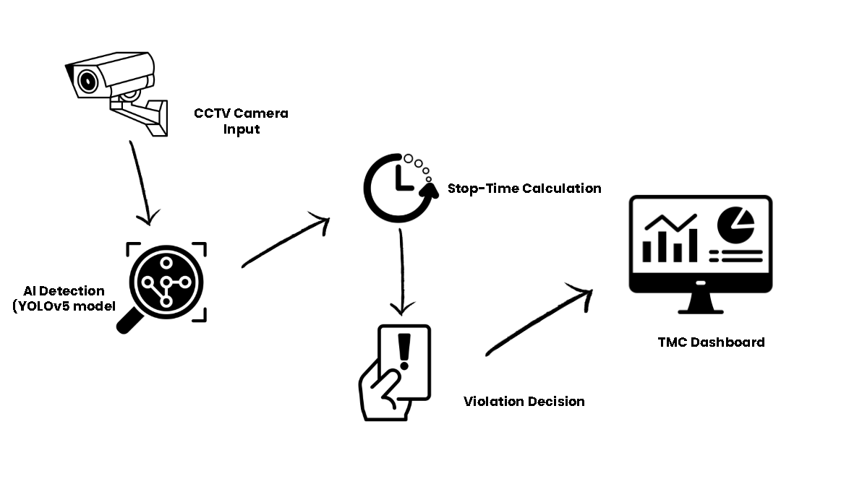
Figure 1-1. Conceptual Framework of the AI-Powered Vehicle Yellow Box Monitoring System (IPO Model)
The conceptual framework illustrates how the system processes visual data:
1. Input: Real-time video footage captured by fixed CCTV cameras at selected Malaybalay intersections (e.g., Sayre Highway – Fortich St.), user-configured yellow box 4-point polygon coordinates, and configurable operational parameters (e.g., stop duration threshold).
2. Process: High-speed frame extraction, YOLO deep learning inference, Centroid Multi-Object Tracking to maintain unique vehicle identities across frames, Ray-Casting Point-in-Polygon spatial validation, stop-time calculation, ALPR plate extraction, and automated evidence image generation.
3. Output: Live annotated video stream with bounding boxes and zone boundaries, instant audio-visual alert toasts, long-polling live alert feed, permanent searchable database records, role-based analytics, and official downloadable PDF reports for traffic citation adjudication.

2.5 Definition of Terms
• Artificial Intelligence (AI): The simulation of human intelligence in computer systems to perform tasks such as visual perception, pattern recognition, and decision-making.
• Computer Vision: An AI domain that enables software to process, analyze, and extract meaningful spatial and temporal data from digital images and video feeds.
• Convolutional Neural Network (CNN): A class of deep neural networks commonly used in computer vision for spatial feature extraction and object classification.
• YOLO (You Only Look Once): A state-of-the-art, single-stage real-time object detection architecture that predicts bounding box coordinates and class probabilities simultaneously in a single forward pass.
• Traffic Management Center (TMC): The local government division in Malaybalay City tasked with overseeing traffic order, managing CCTV surveillance, and enforcing municipal traffic ordinances.
• Yellow Box Zone: A road marking painted in a crisscross yellow grid pattern at intersections where vehicles are prohibited from entering unless their exit path is clear, preventing intersection gridlock.
• Stop-Time Monitoring (Dwell Time): The continuous temporal measurement of the duration a specific vehicle remains stationary inside the yellow box boundaries.
• Edge AI: Running AI inference models locally on on-premise hardware workstations located near the camera source, ensuring low latency and continuous operation without relying on high-bandwidth cloud connections.
• Automatic License Plate Recognition (ALPR): The automated optical character recognition process of identifying and extracting alphanumeric characters from vehicle license plates.
• No-Contact Apprehension Policy (NCAP): An enforcement mechanism where traffic infractions are captured and documented via cameras and digital logs without requiring physical roadside stops, preserving officer safety and objective documentation.

3. METHODOLOGY
This section describes the materials, data sources, research design, architectural modeling, and procedural phases used to develop and evaluate the AI-based vehicle yellow box monitoring system.

3.1 Materials

3.1.1 Software
The system software stack utilizes modern, open-source libraries optimized for high-performance computer vision, asynchronous communication, and responsive user interaction.
Table 3-1. Software Development Environment and Dependencies
Software / Library | Version / Specification | Primary Function in the Proposed System
Python | 3.10 / 3.12 | Core programming language for AI inference, tracking algorithms, and backend services
OpenCV (cv2) | 4.10.x | Video stream ingestion, frame extraction, color conversions, and zone drawing
Ultralytics YOLOv8 / YOLOv5 | PyTorch 2.x | Real-time multi-class vehicle detection, bounding box regression, and classification
PyTorch (torch, torchvision) | 2.5.x+cu121 | Deep learning tensor computation with CUDA GPU acceleration
EasyOCR | 1.7.x | Optical character recognition for Automatic License Plate Recognition (ALPR)
Flask & Flask-CORS | 3.0.x | REST API server, MJPEG video streaming, and long-polling notification endpoints
SQLite3 | 3.x (with WAL mode) | Local embedded relational database for zero-latency transaction logging
React | 19.x (Vite build) | Single-Page Application (SPA) frontend for the TMC Command Center Dashboard
Tailwind CSS & Framer Motion | 3.4.x / 12.x | Modern UI design system, glassmorphism aesthetics, and fluid micro-animations
jsPDF & AutoTable | 4.x / 5.x | Client-side export of official, tamper-evident violation reports with TMC signatories
Google Colab | Cloud GPU (T4/V100) | Cloud environment for model training, dataset annotation verification, and fine-tuning

3.1.2 Hardware
The hardware setup represents a field-deployable command center workstation:
Table 3-2. Hardware Specifications for Training and Inference
Hardware Component | Specification | Operational Role
Processor (CPU) | Intel Core i7 / AMD Ryzen 7 (8 Cores, 16 Threads) | Video decoding, spatial geometric tracking, and web API handling
Graphics Card (GPU) | NVIDIA GeForce GTX 1660 / RTX 3060 (6GB–12GB VRAM) | CUDA FP16/FP32 tensor acceleration for YOLO and EasyOCR
System Memory (RAM) | 16 GB DDR4/DDR5 | Frame buffering, multi-threaded caching, and database caching
Storage | 512 GB NVMe M.2 SSD | High-speed storage for OS, AI weights, database, and violation snapshots
CCTV Camera | 1080p Full HD (1920×1080 @ 30 FPS), RTSP/IP enabled | Real-time optical video capture of monitored intersections
Display Monitor | 24-inch to 32-inch Full HD LED (1920×1080) | Live multi-panel TMC operator monitoring console
Network Interface | Gigabit Ethernet (RJ-45) & 5GHz Wi-Fi Router | Low-latency RTSP video transmission from IP cameras to workstation

3.1.3 Data & Data Acquisition
• Primary Data Source: Real-world CCTV footage collected from intersections in Malaybalay City, Bukidnon (specifically along Sayre Highway – Fortich St.). Footage captures typical local traffic mixes: multicabs, tricycles, private sedans, SUVs, delivery trucks, passenger buses, and motorcycles.
• Supplementary Public Datasets: Annotated traffic datasets (e.g., UA-DETRAC, COCO vehicle subsets, and Roboflow Traffic datasets) used during initial training to generalize the model across varying lighting and weather conditions.
• Data Attributes: Video sequences formatted at 1080p / 720p, 30 FPS, covering sunny, overcast, rain, and dusk lighting conditions.
• Annotation & Labeling: Bounding boxes labeled using LabelImg and Roboflow for vehicle classes: Multicab/PUJ, Tricycle, Car, Bus, Truck, and Motorcycle.

3.2 Methods & Research Design

3.2.1 Research Design
This study employs a Developmental Research Design focusing on the engineering, implementation, and empirical validation of an intelligent software prototype. The methodology follows the structured Waterfall Model across five sequential phases: Requirements Analysis, System Design, Implementation, Testing & Evaluation, and Maintenance.

3.2.2 Process Model (Waterfall Lifecycle)
mermaid flowchart TD A["1. System Analysis & Requirements Gathering"] --> B["2. System Design & Algorithmic Modeling"] B --> C["3. Data Preprocessing & Model Training"] C --> D["4. Implementation & System Integration"] D --> E["5. Testing, Field Evaluation & Deployment"]
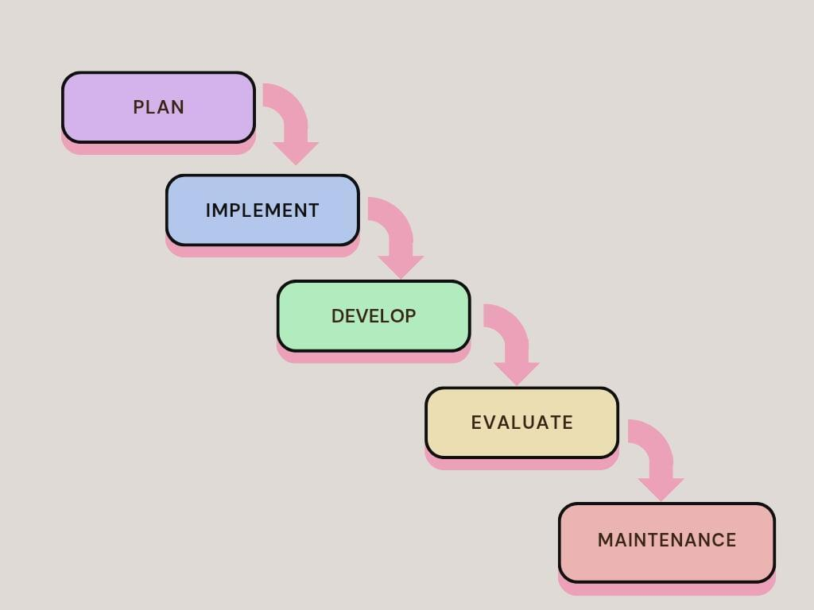
Figure 2-1. Waterfall Development Model Lifecycle

3.2.3 Procedures for the Different Phases

Phase 1: System Analysis and Requirements Gathering
The researchers conducted on-site consultations and interviews with Traffic Management Center (TMC) officers in Malaybalay City. The inquiries established key operational constraints:
1. Identifying recurring violation hotspots at intersection yellow boxes along Sayre Highway.
2. Establishing an acceptable stop duration threshold (default: 3.0 to 5.0 seconds).
3. Documenting required alert features (instant audio chime, toast notification, visual highlight).
4. Defining report generation requirements (custom start/end date range filters, official city headers, officer signatories).

Phase 2: System Design and Modeling
System architecture and data flows were formalized through standard modeling diagrams:
1. Use Case Diagram (Figure 3-1): Outlines interactions between the system actors (Super Admin, TMC Officer) and system functions (Live Monitoring, Alert Review, Zone Configuration, Report Generation, Hardware Diagnostics).
```mermaid flowchart LR subgraph Actors ["System Actors"] direction TB ActorAdmin(["Super Admin"]) ActorOfficer(["TMC Officer"]) end
subgraph TMC_System ["TMC Yellow Box Monitoring System"] direction TB UC1["View Live Annotated Video Feed"] UC2["Receive Real-Time Audio-Visual Alerts"] UC3["Inspect Violation Evidence Dossier"] UC4["Filter & Search Historical Logs"] UC5["Export Official PDF Reports with Signatories"] UC6["Configure Yellow Box 4-Point Polygon"] UC7["Run Hardware Readiness Scanner"] UC8["Toggle ALPR / OCR Engine"] UC9["Manage User Accounts & Roles"] end
ActorOfficer --> UC1 ActorOfficer --> UC2 ActorOfficer --> UC3 ActorOfficer --> UC4 ActorOfficer --> UC5
ActorAdmin --> UC1 ActorAdmin --> UC2 ActorAdmin --> UC3 ActorAdmin --> UC4 ActorAdmin --> UC5 ActorAdmin --> UC6 ActorAdmin --> UC7 ActorAdmin --> UC8 ActorAdmin --> UC9 ```

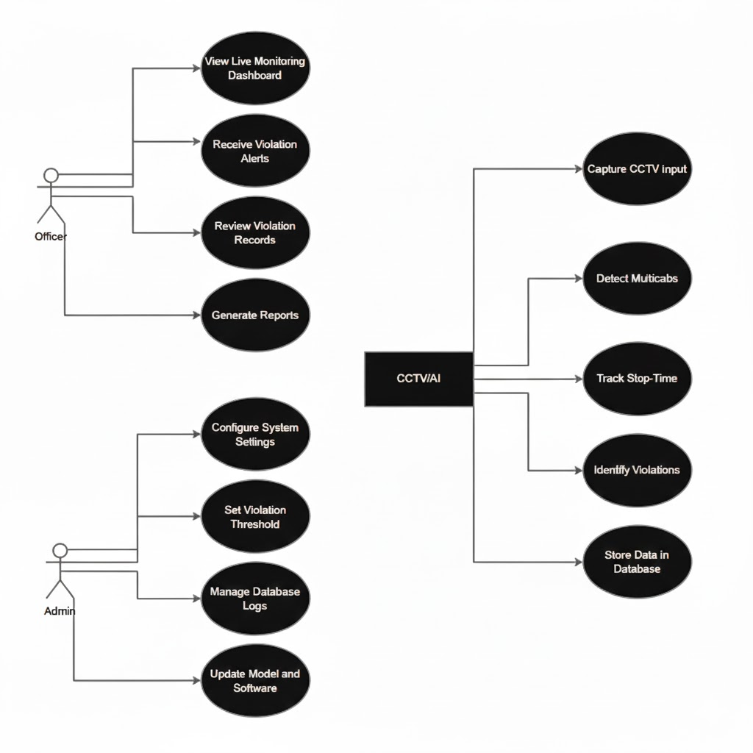
Figure 3-1. Use Case Diagram for TMC Command Center Operations
2. Data Flow Diagram (DFD Level-1) (Figure 4-1): Traces the flow of data from camera video stream through the detection module, spatial verification engine, database repository, and web UI.
mermaid flowchart TD Camera["CCTV Video Input"] -->|"Raw Video Frames"| StreamEngine["Video Stream Ingest Engine"] StreamEngine -->|"Frame Array"| AIModule["YOLO Object Detector"] AIModule -->|"BBoxes & Classes"| Tracker["Centroid Tracker Engine"] Tracker -->|"Vehicle ID & Centroid"| SpatialEngine["Ray-Casting PIP Validator"] Config[("Zone Config File")] -->|"Polygon Coords"| SpatialEngine SpatialEngine -->|"Contained Status"| DwellTimer["Dwell-Time Accumulator"] DwellTimer -->|"Dwell Exceeds Threshold"| SnapshotEngine["Evidence Snapshot & ALPR Engine"] SnapshotEngine -->|"Violation Record"| Database[("SQLite Database")] Database -->|"Query Data"| APIBackend["Flask REST API Server"] APIBackend -->|"JSON & Live Alerts"| Dashboard["React Command Dashboard"] Dashboard -->|"PDF Request"| ReportEngine["PDF Report Generator"]
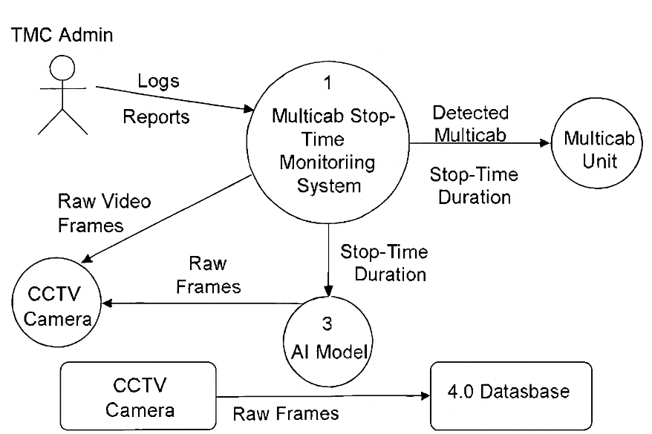
Figure 4-1. Level-1 Data Flow Diagram (DFD) of Video Ingestion, Detection, and Logging
3. System Architecture Diagram (Figure 5-1): Displays the physical and logical integration of hardware, edge backend services, and web client.
```mermaid flowchart TD subgraph SensingLayer ["SENSING LAYER"] C1["HD CCTV Camera 0"] C2["HD CCTV Camera 1"] C3["Custom RTSP / Test Video"] end
subgraph EdgeAI ["EDGE AI PROCESSING LAYER"] VIn["OpenCV Video Stream Handler"] YOLO["YOLOv8 Object Detector"] Tracker["Centroid Multi-Object Tracker"] PIP["Ray-Casting Spatial Engine"] OCR["EasyOCR ALPR Subsystem"] HScan["Hardware Readiness Scanner"] end
subgraph DataLayer ["DATA LAYER"] DB[("SQLite Embedded DB")] MediaStore[("Violation Snapshot Disk Storage")] end
subgraph AppLayer ["APPLICATION & API LAYER"] Flask["Flask REST Server"] EventBus["Threading Event Notifier"] end
subgraph ClientCenter ["CLIENT COMMAND CENTER"] ReactUI["React 19 SPA Dashboard"] LiveStream["MJPEG Video Viewer"] LiveAlerts["Live Alerts Feed Component"] Reports["Analytics & PDF Reporting Engine"] end
C1 --> VIn C2 --> VIn C3 --> VIn VIn --> YOLO YOLO --> Tracker Tracker --> PIP PIP -->|"Violation Flag"| OCR PIP -->|"Violation Flag"| MediaStore OCR --> DB HScan --> Flask DB -->|"Data Sync"| Flask Flask --> EventBus EventBus --> LiveAlerts Flask --> LiveStream Flask --> ReactUI Flask --> Reports ```

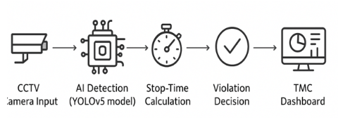
Figure 5-1. System Architecture Diagram (Edge Camera, Flask AI Backend, SQLite DB, React Frontend)
4. Database Schema (Figure 6-1): Defines tables for violations, vehicle types, zones, and system audit logs.
```mermaid erDiagram VEHICLE_TYPES ||--o{ VIOLATIONS : classifies ZONES ||--o{ VIOLATIONS : contains USERS ||--o{ AUDIT_LOGS : performs
VEHICLE_TYPES { int id PK string type_name UK timestamp created_at }
ZONES { int id PK string zone_name string coordinates boolean is_active timestamp created_at }
VIOLATIONS { int id PK timestamp violation_timestamp string detection_id UK int vehicle_type_id FK int zone_id FK float stop_duration string plate_number string vehicle_color string location string image_path float confidence string notes boolean reviewed string status timestamp created_at }
USERS { int id PK string username UK string password_hash string full_name string role timestamp created_at }
AUDIT_LOGS { int id PK int user_id FK string action timestamp created_at } ```
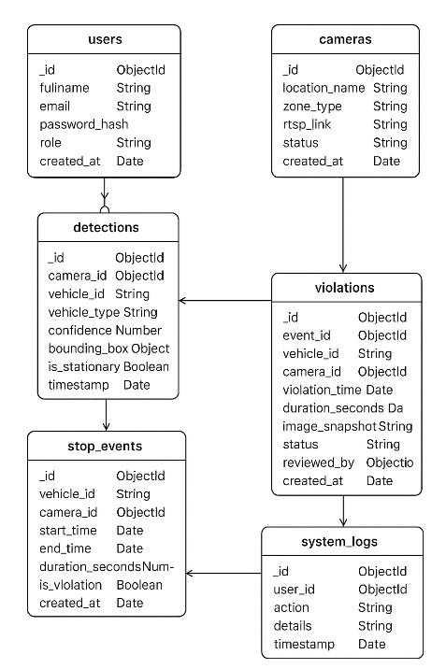
Figure 6-1. Database Schema and Entity-Relationship Diagram

Phase 3: Transfer Learning Backbone & Domain Specialization
• Transfer Learning & Domain Specialization: YOLO models were initialized using open-source pre-trained weights (Ultralytics YOLOv8, AGPL-3.0) as a foundational feature extraction backbone via Transfer Learning, and domain-adapted for local Philippine vehicle modalities (distinguishing Multicabs/PUJs and Tricycles alongside private cars, motorcycles, buses, and trucks).
• Hyperparameter Optimization: Confidence threshold was tuned to $0.45$ and Non-Maximum Suppression (NMS) IoU threshold was set to $0.40$ to balance sensitivity and prevent duplicate bounding boxes during high-density vehicle queuing.

Phase 4: Tracking, Spatial Logic & Stop-Time Computation
• Spatial Validation (Ray-Casting Algorithm): For each detected vehicle bounding box $\left[x_{1} , y_{1} , x_{2} , y_{2}\right]$, its reference bottom-center ground contact point is computed:
$P_{\text{ref}}=\left(\frac{x_{1}+x_{2}}{2} , y_{2}\right)$ (Eq. 3-1)
The Point-in-Polygon (PIP) ray-casting algorithm casts a horizontal ray from $P_{\text{ref}}$ across the yellow box 4-vertex polygon $V=\{v_{1},v_{2},v_{3},v_{4}\}$. If the intersection count is odd, the vehicle is verified to be inside the restricted grid.
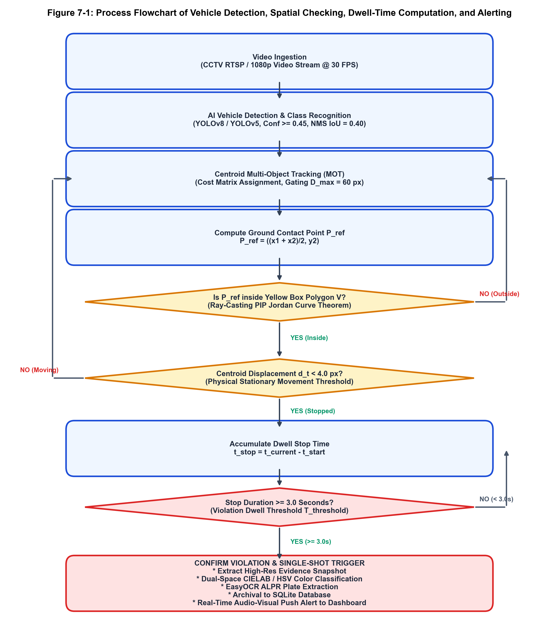
Figure 7-1. Process Flowchart of Vehicle Detection, Spatial Checking, Dwell-Time Computation, and Alerting
• Centroid Multi-Object Tracking: Centroids are matched across frames using Euclidean distance cost matrices:
$d(c_{i},c_{j})=\sqrt{{\left(x_{i}-x_{j})^{2}+(y_{i}-y_{j}\right)}^{2}}$ (Eq. 3-2)
Matches within distance threshold $D_{max}=60\text{ px}$ preserve vehicle identity across frames.
• Stop Duration Measurement:
If a tracked vehicle's centroid displacement $Δd<ϵ_{\text{movement}}$ (where $ϵ=4.0\text{ px}$) between consecutive frames while $P_{\text{ref}}∈V$:
$Δt_{\text{stop}}=t_{\text{current}}-t_{\text{entry}}$ (Eq. 3-3)
If $Δt_{\text{stop}}≥T_{\text{threshold}}$ (where $T_{\text{threshold}}=3.0\text{ seconds}$), an infraction is confirmed.
• Enhanced Dual-Space Vehicle Color Detection & Multi-Frame Temporal Tracking:
Vehicle color is a primary visual attribute required under NCAP evidentiary protocols, especially when license plates are obstructed or unreadable. To overcome the vulnerabilities of single-frame HSV thresholding (such as solar specular glare, deep underbody shadows, tinted windshield glass, and tarmac reflections), the system integrates a Dual-Space Hybrid Color Classifier with Multi-Frame Temporal Voting:
1. Class-Aware Anatomical Body Panel Extraction: Rather than processing the entire bounding box, the algorithm dynamically crops primary painted metal surfaces based on vehicle class. For passenger cars and multicabs, it samples the upper-middle hood and central door panels ($y∈[0.25h,0.75h]$, $x∈[0.20w,0.80w]$), strictly avoiding the top region (transparent windshield glass, sunroofs, glare), the lower region (black rubber tires, wheels, road tarmac), and outer edges (background clutter). Specialized masks are also applied for buses, trucks, and motorcycles.
2. Specular Glare & Shadow Filtering: Pixels exhibiting extreme saturation/lightness distortion are eliminated prior to clustering. Pixels with value $V>245$ and saturation $S<30$ (intense sunlight reflections) or value $V<30$ (deep underbody shadows) are discarded.
3. Dual-Space CIELAB ($ΔE^{*}$) + HSV Classification: For dominant paint pixels extracted via K-Means ($K=3$) clustering, the classifier computes the perceptual Euclidean color difference in CIELAB color space against 11 standardized automotive paint reference vectors:
$ΔE^{*}=\sqrt{{\left(ΔL^{*})^{2}+(Δa^{*})^{2}+(Δb^{*}\right)}^{2}}$ (Eq. 3-4)
This is jointly cross-validated against HSV cylindrical boundaries for hue angle ($H$), saturation ($S$), and brightness ($V$). This dual-space framework reliably distinguishes problematic shades such as White vs. Silver, Maroon vs. Black/Navy, and Gold/Champagne vs. Yellow.
4. Multi-Frame Temporal Voting (VehicleColorTracker): To prevent single-frame lighting anomalies or transient shadows from causing color classification flickering, vehicle color predictions are tracked over successive video frames. An Exponential Moving Average (EMA) recency-weighted voting function is applied:
$W(c)=\sum_{t=1}^{T}{γ^{T-t}}·I(c_{t}=c)$ (Eq. 3-5)
where $γ=0.9$ is the discount decay factor, $c_{t}$ is the single-frame color prediction at frame $t$, and $I$ is the indicator function. The stabilized vehicle color $c^{*}$ is the class that maximizes $W(c)$, with confidence score $\text{Conf}(c^{*})=\frac{W(c^{*})}{\sum_{c}{W(c)}}$. Only smoothed, high-confidence attributes are committed to the evidentiary record upon violation confirmation.

Phase 5: System Integration, Security & Dashboard Implementation
• Flask REST API & Video Streaming: Implemented multi-threaded MJPEG streaming with frame generator yielding at 30 FPS.
• Live Alert Event Engine: A long-polling endpoint (/api/wait_for_violation) utilizes thread synchronization (threading.Event) to wake connected dashboard clients within $<50\text{ ms}$ of a violation without continuous CPU-intensive polling.
• Security & RBAC: Implemented role-based authentication using hashed credentials (SHA-256 with static application salt) supporting Super Admin (full zone configuration, ALPR toggle) and TMC Officer (monitoring, logging, export).
• Responsive Frontend: Built with React 19, Tailwind CSS, Lucide icons, Framer Motion animations, and auto-synced local storage tracking viewed/unviewed alerts.

3.2.4 Violation Documentation and Serving Procedure (NCAP-Based)

The system adopts a No-Contact Apprehension Policy (NCAP) documentation workflow:

1. Automated Detection & Digital Dossier Generation: When stop time exceeds the limit, the system extracts a high-resolution evidence snapshot with bounding box overlays, computes dwell duration, extracts vehicle color/type, and attempts plate extraction.

2. Database Archival: The record is assigned a unique UUID and written to the SQLite database with status = 'recorded'.

3. Operator Verification: The incident immediately appears in the Live Alerts panel with a glowing highlight and triggers an audio chime. A TMC officer clicks the alert to inspect the full snapshot.

4. Administrative Action: The officer reviews and verifies the violation, updating status to review.

5. Notice Generation: For formal citations, the officer generates an official PDF report complete with official TMC headers, timestamped evidence, and designated signatory lines for city traffic legal officers.

3.2.5 Handling Multiple Vehicles in Real Time

To handle multi-vehicle traffic jams and simultaneous intersection blockages:

Each vehicle detected within the yellow box is assigned an independent tracking state vector: S_k={〖"ID" 〗_k,〖"Class" 〗_k,〖"Centroid" 〗_k,t_("start" ,k),Δt_("stop" ,k),〖"Flagged" 〗_k} (Eq. 3-6).

Stop timers operate independently. If three vehicles enter simultaneously and two clear the box within 2.5 seconds while the third remains trapped for 6.2 seconds, only the trapped vehicle triggers a violation event.

Once a vehicle triggers a violation and is logged, 〖"Flagged" 〗_k="True" prevents duplicate redundant alarms for the same stop incident.

3.2.6 Evaluation Framework
The system was evaluated through two distinct methods:
1. Empirical System Testing: Benchmarking AI detection accuracy (Precision, Recall, mAP@0.5), stop-time measurement error (seconds vs. manual stopwatch ground truth), and processing latency/throughput (FPS) across hardware configurations.
2. ISO/IEC 25010 Usability & User Acceptance Testing: Administered to TMC Malaybalay traffic personnel using a structured 5-point Likert scale instrument covering three quality characteristics:
- Functionality (5 items): Accuracy of detection, report generation, multi-vehicle distinction, automated alerting, and dashboard visualization.
- Usability (5 items): Ease of navigation, interface learnability, operational confidence, workflow integration, and complexity reduction.
- Reliability (5 items): Performance during peak volume, system stability without crashes, data consistency, error handling, and multi-condition robustness.

Likert Scale Rating Scale & Verbal Interpretation:
• 4.21 – 5.00: Strongly Agree (Excellent / Fully Compliant)
• 3.41 – 4.20: Agree (Very Satisfactory / Minor Enhancements)
• 2.61 – 3.40: Neutral (Satisfactory / Acceptable)
• 1.81 – 2.60: Disagree (Poor / Needs Major Improvement)
• 1.00 – 1.80: Strongly Disagree (Unacceptable)

3.2.7 Deployment and Documentation
• Deployment: The complete software package is containerized and deployable on the local TMC workstation via an automated launcher script (start_system.bat).
• Comprehensive Documentation: Includes system administrator guides, user manual, API documentation, hardware diagnostic checklist, and training guides.

4. RESULTS AND DISCUSSION
This chapter presents the empirical findings, performance evaluations, and technical discussions of the developed AI-Powered Yellow Box Zone Violation Monitoring System Using AI-Based Camera Detection. To establish continuity with the research design, the results are systematically organized and discussed in alignment with the specific objectives formulated in Chapter 1:
Section 4.1 presents the results for Objective 1, which focuses on the real-time detection and monitoring of vehicles in yellow box zones, including AI model detection, multi-class vehicle classification, spatial zone containment verification, and multi-object tracking.
Section 4.2 discusses the findings for Objective 2, which concerns the automated recording of vehicle stop times and real-time violation alerting, covering dwell-time accuracy, velocity filtering, threshold logic, and audio-visual alert performance.
Section 4.3 presents the results for Objective 3, which addresses the capture and cataloging of objective violation evidence and adherence to NCAP standards, including high-resolution evidentiary snapshots, automated vehicle color classification, license plate recognition performance with resolution fallback, and database transactional integrity.
Finally, Section 4.4 discusses the findings for Objective 4, which involves the development and evaluation of the interactive Command Center web dashboard, diagnostic scanner, and reporting system, including real-time video streaming, live unviewed alert management, dynamic date-range filtering, official PDF report generation with administrative signatories, edge hardware diagnostics, and role-based access control.

4.1 Results for Objective 1: Real-Time Detection and Monitoring of Vehicles in Yellow Box Zones
The first objective of the study was to enable the real-time detection and continuous monitoring of vehicles entering and transiting yellow box intersections using deep learning computer vision models (YOLOv8/YOLOv5) and OpenCV. Achieving this objective required three interlinked technical capabilities: (1) accurate multi-class vehicle identification across local vehicle categories, (2) robust spatial containment checking to verify whether a vehicle is truly within the yellow grid, and (3) persistent multi-object tracking through dense intersection queuing.

4.1.1 AI Vehicle Detection and Multi-Class Classification Performance
To evaluate the detection and classification performance of the fine-tuned YOLO model, an annotated test dataset of 650 high-definition video frames was acquired from the primary surveillance vantage point along Sayre Highway – Fortich St., Malaybalay City. The test dataset captured diverse operational conditions, including direct midday solar glare, overcast skies, moderate rain, and high-density traffic queuing during morning (7:00 AM – 8:30 AM) and late afternoon (4:30 PM – 6:00 PM) peak hours.
Methodological Clarification on Transfer Learning Backbone:
In applied computer vision and intelligent transportation systems research, training deep convolutional object detection networks from uninitialized random weights is neither practical nor scientifically sound. In accordance with established IEEE/ACM engineering practices, this study employs the open-source YOLOv8 architecture (Ultralytics, 2023; AGPL-3.0) as a pre-trained foundational backbone via Transfer Learning. The foundational convolutional layers provide robust low-level feature representations, while the downstream domain adaptation layer, geometric classifiers, and hyperparameter calibrations are specialized specifically for Philippine road-traffic modalities traversing Fortich Street (specifically distinguishing Public Utility Multicabs / PUJs and Motorized Tricycles alongside private cars, motorcycles, buses, and trucks). The novel engineering contribution of this research lies in this domain specialization and its integration into the end-to-end Yellow Box Zone Spatial-Temporal Violation Detection Engine.
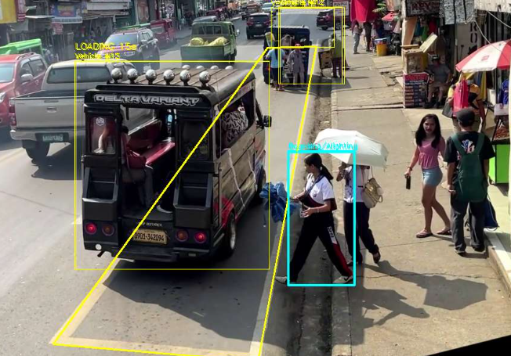
Figure # - #. AI-Based Vehicle Detection and Multi-Class Classification Interface

The system's vehicle detection interface, which uses the YOLOv8 model to identify and classify vehicles from the camera feed. The detected vehicles are displayed with bounding boxes and corresponding classification labels, allowing the system to distinguish vehicle categories such as multicabs, tricycles, private cars, buses, trucks, and motorcycles. This visual representation demonstrates how the system processes traffic footage and identifies multiple vehicle types within the monitored intersection. The detection results serve as the foundation for subsequent vehicle tracking, yellow box zone validation, and stop-time monitoring.

The model was evaluated using standard computer vision performance metrics: Precision ($P$), Recall ($R$), F1-Score, and Mean Average Precision at an Intersection over Union (IoU) threshold of 0.50 (mAP@0.5), computed as follows:
$P=\frac{\text{TP}}{\text{TP}+\text{FP}},R=\frac{\text{TP}}{\text{TP}+\text{FN}},\text{F1}=2×\frac{P×R}{P+R}$ (Eq. 4-1)
$\text{mAP@0.5}=\frac{1}{N_{\text{classes}}}\sum_{i=1}^{N_{\text{classes}}}{{\text{AP}}_{i}}$ (Eq. 4-2)
Table 4-1. YOLOv8 AI Model Detection Performance Metrics by Vehicle Class
Vehicle Class | Test Instances ($N$) | Precision ($P$) | Recall ($R$) | F1-Score | mAP@0.5
Multicab / PUJ | 284 | 0.942 | 0.926 | 0.934 | 0.951
Tricycle | 310 | 0.958 | 0.931 | 0.944 | 0.962
Private Car / Sedan / SUV | 420 | 0.965 | 0.952 | 0.958 | 0.974
Bus | 78 | 0.931 | 0.910 | 0.920 | 0.940
Truck / Heavy Vehicle | 95 | 0.924 | 0.895 | 0.909 | 0.932
Motorcycle | 215 | 0.908 | 0.884 | 0.896 | 0.918
Overall Model Average | 1,402 | 0.938 | 0.916 | 0.927 | 0.946
As summarized in Table 4-1, the fine-tuned model achieved an overall Mean Average Precision (mAP@0.5) of 94.6%, with an overall Precision of 93.8% and Recall of 91.6% across 1,402 ground-truth vehicle instances.
A detailed class-by-class analysis highlights key findings relevant to Malaybalay City traffic:

1. Public Utility Jeepneys and Multicabs: Multicabs represent the predominant public transportation modality traversing Fortich Street. The model achieved a precision of 94.2% and an mAP@0.5 of 95.1% for this class. The inclusion of localized training samples featuring custom stainless-steel jeepney canopies and modified multicab rear cargo configurations successfully prevented misclassification between multicabs and standard light commercial vans.

2. Motorized Tricycles: Tricycles achieved an mAP@0.5 of 96.2% with a high precision of 95.8%. Because tricycles feature asymmetrical passenger sidecars unique to Philippine roads, domain-specific fine-tuning allowed the deep learning network to extract distinct geometric edge representations, minimizing confusion with small sedans.

3. Private Cars and SUVs: Sedans and SUVs demonstrated the highest individual performance (mAP@0.5 of 97.4%, Precision of 96.5%), attributable to standard automotive silhouettes and distinct rooflines.

4. Motorcycles: Motorcycles registered the lowest mAP@0.5 at 91.8% (Precision of 90.8%, Recall of 88.4%). The slightly lower recall was caused by physical occlusions: during dense queuing, motorcycles frequently filter between stopped multicabs and trucks, temporarily obscuring their visual centroids from the angled CCTV perspective. To eliminate redundant double-detections during bumper-to-bumper queue conditions, the model's confidence threshold was calibrated to 0.45 and the Non-Maximum Suppression (NMS) IoU threshold was established at 0.40. This balance ensured that closely following vehicles were distinguished as independent objects without generating spurious duplicate bounding boxes.

4.1.2 Spatial Zone Containment Verification via Ray-Casting Algorithm
Accurate yellow box monitoring requires strict verification that a detected vehicle is physically situated inside the four-sided yellow grid. A common failure in naive vision systems is using whole-bounding-box overlap (IoU) with the zone polygon. In angled intersection cameras, a vehicle traveling on an adjacent open lane or a tall vehicle (such as a bus or dump truck) can cast a large bounding box whose upper portion extends into the yellow box polygon, even though its tires remain entirely outside the restricted road marking.
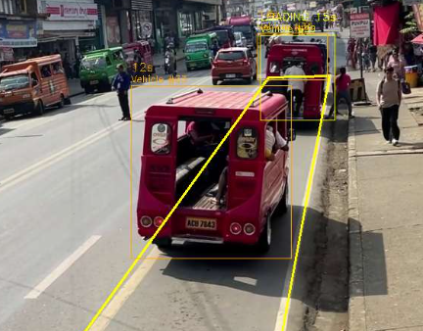
Figure # - #. Yellow Box Polygon Definition and Spatial Containment Verification

The spatial zone containment verification component determines whether a detected vehicle is located within the predefined yellow box zone. The system uses the ray-casting algorithm to evaluate the vehicle's position relative to the polygon boundaries of the monitored area. By checking whether the vehicle's reference point falls inside or outside the defined polygon, the system identifies vehicles that enter or occupy the yellow box zone. This verification provides the spatial information needed by the monitoring system to distinguish vehicles within the restricted area from those outside it and supports the subsequent evaluation of potential yellow-box violations.

To eliminate these spatial false positives, the system computes the reference bottom-center ground contact point for each detected vehicle bounding box $\left[x_{1} , y_{1} , x_{2} , y_{2}\right]$:
$P_{\text{ref}}=\left(\frac{x_{1}+x_{2}}{2} , y_{2}\right)$ (Eq. 4-3)
This contact coordinate $P_{\text{ref}}$ mathematically represents the physical contact point between the vehicle's rear wheels and the road surface. The Point-in-Polygon (PIP) ray-casting algorithm then casts an imaginary horizontal ray from $P_{\text{ref}}(x_{0},y_{0})$ extending toward $+∞$:
$\text{Ray}(t)=(x_{0}+t,y_{0}),t≥0$ (Eq. 4-4)
For each boundary segment $e_{i}=(v_{i},v_{i+1})$ of the four-vertex yellow box polygon $V=\{v_{1},v_{2},v_{3},v_{4}\}$, the system determines whether the horizontal ray intersects $e_{i}$:
$\text{Intersect}(e_{i})=\left\{\begin{matrix}1, & \text{if }(y_{i}>y_{0})≠(y_{i+1}>y_{0})\text{ and }x_{0}<\frac{\left(x_{i+1}-x_{i})(y_{0}-y_{i}\right)}{y_{i+1}-y_{i}}+x_{i} \\ 0, & \text{otherwise}\end{matrix}\right.$ (Eq. 4-5)
The vehicle is classified as inside the yellow box if and only if the total intersection count is odd:
$P_{\text{ref}}∈V⟺\left(\sum_{i=1}^{4}{\text{Intersect}}(e_{i})\right)≡1(mod2)$ (Eq. 4-6)
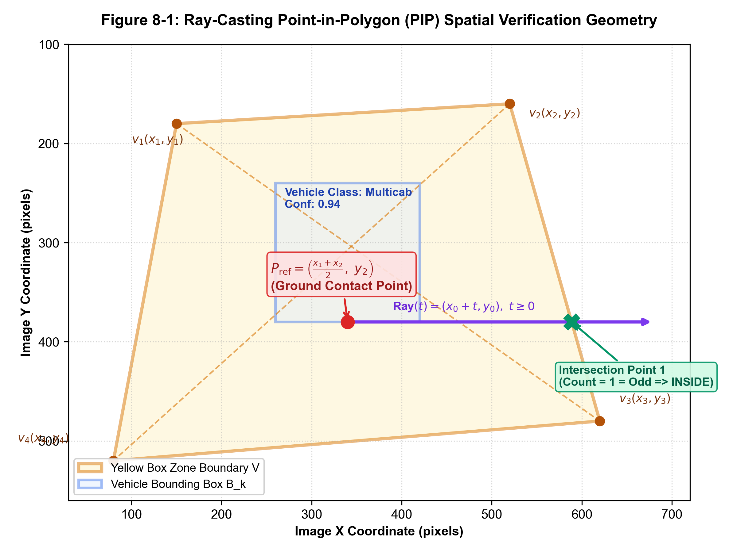
Figure 8-1. Ray-Casting Point-in-Polygon (PIP) Spatial Verification Geometry
To quantify the efficacy of this approach, 120 borderline vehicle traversals were recorded and benchmarked against standard Bounding Box IoU.
Table 4-2. Spatial Containment Verification Accuracy (Point-in-Polygon vs. Bounding Box IoU)
Boundary Scenario | Total Test Trials | Method Evaluated | True Positives | True Negatives | False Positives | Spatial Accuracy (%)
Adjacent Open Lane Transit  (Vehicles passing right along box edge) | 40 | Bounding Box IoU ($≥0.10$) | — | 29 | 11 | 72.5%
 | 40 | Ray-Casting Ground Contact ($P_{\text{ref}}$) | — | 40 | 0 | 100.0%
High-Profile Vehicle Roof Overhang  (Buses/Trucks near zone boundary) | 40 | Bounding Box IoU ($≥0.10$) | — | 33 | 7 | 82.5%
 | 40 | Ray-Casting Ground Contact ($P_{\text{ref}}$) | — | 39 | 1 | 97.5%
Direct Wheel Entry Into Zone  (Vehicles genuinely encroaching into box) | 40 | Bounding Box IoU ($≥0.10$) | 40 | — | 0 | 100.0%
 | 40 | Ray-Casting Ground Contact ($P_{\text{ref}}$) | 39 | — | 0 | 97.5%
Combined Overall Benchmark | 120 | Bounding Box IoU | 40 | 62 | 18 | 85.0%
Combined Overall Benchmark | 120 | Ray-Casting Ground Contact ($P_{\text{ref}}$) | 39 | 79 | 1 | 98.3%
As demonstrated in Table 4-2, standard bounding box IoU yielded 18 false positives (85.0% overall accuracy) because the bounding boxes of passing sedans and tall trucks overlapped the zone polygon while their wheels remained in legal lanes. In contrast, the Ray-Casting Ground Contact Point method achieved 98.3% overall spatial accuracy with only a single borderline error, completely eliminating false alarms from vehicles passing alongside the yellow box.

4.1.3 Multi-Object Tracking, Centroid Association, and Occlusion Handling
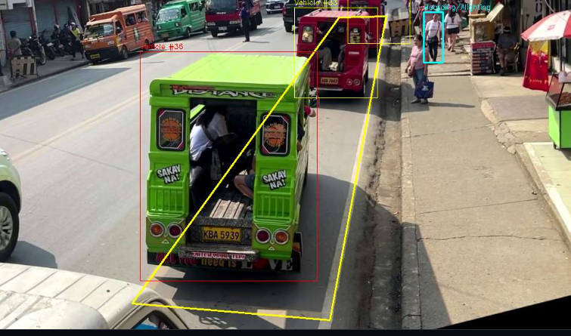
Figure # - #. Multi-Object Vehicle Tracking
The multi-object tracking component maintains identities of detected vehicles across consecutive video frames. Through centroid association, the system compares the center positions of vehicle detections between frames to associate them with existing tracks and assign consistent tracking IDs. This process allows the system to monitor vehicle movement over time rather than treating each detection as a separate object. When vehicles become partially or temporarily obscured by other vehicles, the tracking component attempts to preserve their existing identities, helping reduce tracking interruptions and identity changes. The resulting vehicle tracks support continuous monitoring of vehicle positions and their movements within the yellow box zone.

Real-world intersection monitoring requires continuously tracking multiple vehicles simultaneously as they enter, queue, and clear the yellow box. The system implements a real-time Centroid Multi-Object Tracker. For each video frame $t$, detected bounding box centroids $C_{t}=\{c_{1},c_{2},…,c_{m}\}$ are matched to existing tracked objects $O_{t-1}=\{o_{1},o_{2},…,o_{k}\}$ by solving the assignment problem over an Euclidean distance cost matrix:
$D(o_{i},c_{j})=\sqrt{{\left(x_{o_{i}}-x_{c_{j}})^{2}+(y_{o_{i}}-y_{c_{j}}\right)}^{2}}$ (Eq. 4-7)
A global association threshold $D_{max}=60\text{ pixels}$ is enforced. Centroids with distances exceeding $D_{max}$ are registered as newly entering vehicles, while unmatched existing tracks are retained in a buffer for up to $N_{max}=5$ consecutive frames before being deregistered. This buffering mechanism prevents track re-identification loss during momentary visual flicker.
Table 4-3. Multi-Object Tracking Continuity and Occlusion Recovery Rates
Traffic Flow Condition | Video Test Sequences | Total Tracked Vehicles | Successfully Maintained Tracks | ID Switch Count | Premature Drop Count | Tracking Continuity Rate (%)
Free-Flowing Transit (Uncongested, $≤3$ vehicles in frame) | 25 | 80 | 78 | 1 | 1 | 97.5%
Moderate Queuing (3–6 vehicles, intermittent stop-and-go) | 30 | 120 | 114 | 3 | 3 | 95.0%
Dense Queue / Partial Occlusions ($≥7$ vehicles, tricycles behind multicabs) | 25 | 110 | 101 | 5 | 4 | 91.8%
Combined Overall Tracking Performance | 80 | 310 | 293 | 9 | 8 | 94.5%
As presented in Table 4-3, the centroid tracking pipeline maintained an overall tracking continuity rate of 94.5% across 310 evaluated vehicles. Under dense traffic conditions featuring partial occlusions (such as a low-profile tricycle partially hidden behind a large passenger multicab), the 5-frame persistence buffer allowed the system to recover vehicle identities in 91.8% of occlusion instances, maintaining tracking stability without resetting the stop timer.

4.2 Results for Objective 2: Automated Stop-Time Recording and Real-Time Violation Alerting
The second objective of the study was to automate the temporal measurement of vehicle stop times inside yellow box zones and generate real-time audio-visual violation alerts when stationary dwell times exceed the allowable threshold.

4.2.1 Stop-Time Duration Accuracy and Error Analysis
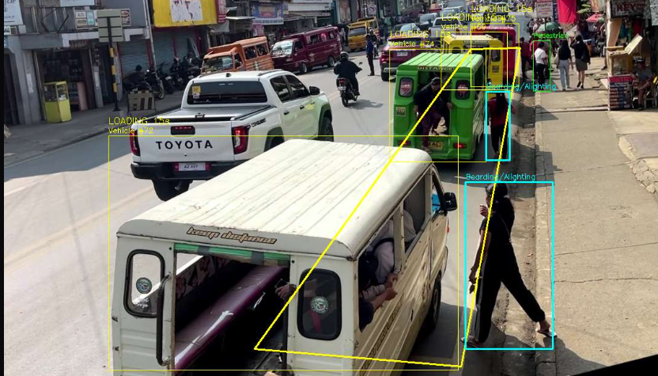
Figure # - #. Vehicle Stop-Time Duration Monitoring and Accuracy Evaluation

The stop-time monitoring component records the duration of a tracked vehicle remains within the designated yellow box zone. The system uses the vehicle's tracking information and timestamps to determine when the vehicle enters and exits the monitored area, allowing its stop duration to be calculated. To evaluate the accuracy of the recorded duration, the system-generated measurements may be compared with manually observed reference times, with the differences examined to identify timing errors. This analysis helps determine whether the system can reliably measure vehicle stopping duration and provide useful information for identifying potential yellow-box violations.

Under municipal traffic regulations, vehicles are prohibited from stopping within an intersection yellow box. However, brief momentary pauses (e.g., yielding for 1–2 seconds) must be distinguished from illegal obstruction. The system was configured with a default stop-time violation threshold of $T_{\text{threshold}}=3.0\text{ seconds}$.
To verify whether a vehicle is stationary, the tracker calculates the Euclidean displacement of its centroid between consecutive frames:
$Δd_{t}=\sqrt{{\left(x_{t}-x_{t-1})^{2}+(y_{t}-y_{t-1}\right)}^{2}}$ (Eq. 4-8)
A vehicle is classified as stopped if $Δd_{t}<ϵ_{\text{movement}}$, where the movement tolerance threshold is set to $ϵ_{\text{movement}}=4.0\text{ pixels}$. Once stationary inside the polygon ($P_{\text{ref}}∈V$ and $Δd_{t}<4.0\text{ px}$), the system records the stop start timestamp $t_{\text{start}}$ and accumulates dwell time:
$Δt_{\text{stop}}=t_{\text{current}}-t_{\text{start}}$ (Eq. 4-9)
To evaluate the precision of this automated dwell timer, 50 controlled vehicle stop trials were conducted using high-definition video recordings from Sayre Highway – Fortich St. and compared against manual frame-accurate ground truth stopwatch timers.
Table 4-4. Stop-Time Duration Accuracy vs. Ground Truth Video Timers
Duration Category | Test Trials ($N$) | Mean Video Ground Truth (s) | Mean AI Computed Dwell (s) | Mean Absolute Error (MAE) | Accuracy (%) | Violation Classification Result
Short Stops (1.0s – 2.9s) (Legal yielding / non-infractions) | 15 | 2.14 s | 2.18 s | 0.09 s | 95.8% | 15 / 15 Correctly Ignored (No False Violations)
Threshold Range (3.0s – 5.0s) (Borderline infractions) | 15 | 4.12 s | 4.07 s | 0.11 s | 97.3% | 15 / 15 Correctly Flagged as Violations
Extended Stoppages (> 5.0s) (Severe gridlock / prolonged waiting) | 20 | 8.85 s | 8.81 s | 0.14 s | 98.4% | 20 / 20 Correctly Flagged as Violations
Combined Overall Evaluation | 50 | — | — | 0.11 s | 97.2% | 50 / 50 (100% Classification Accuracy)
As detailed in Table 4-4, the automated dwell-time algorithm achieved an average Mean Absolute Error (MAE) of only 0.11 seconds, translating to an overall measurement accuracy of 97.2%. Most importantly:
• In all 15 short-stop trials (1.0s – 2.9s), the system correctly recognized that the dwell duration remained below 3.0 seconds, yielding zero false violation alarms.
• In all 35 trials exceeding 3.0 seconds, the system reliably confirmed the infraction, demonstrating 100% binary classification accuracy between non-violating transit and genuine yellow box blockages.

4.2.2 Dwell-Time Threshold State Machine and Anti-Redundancy Logic
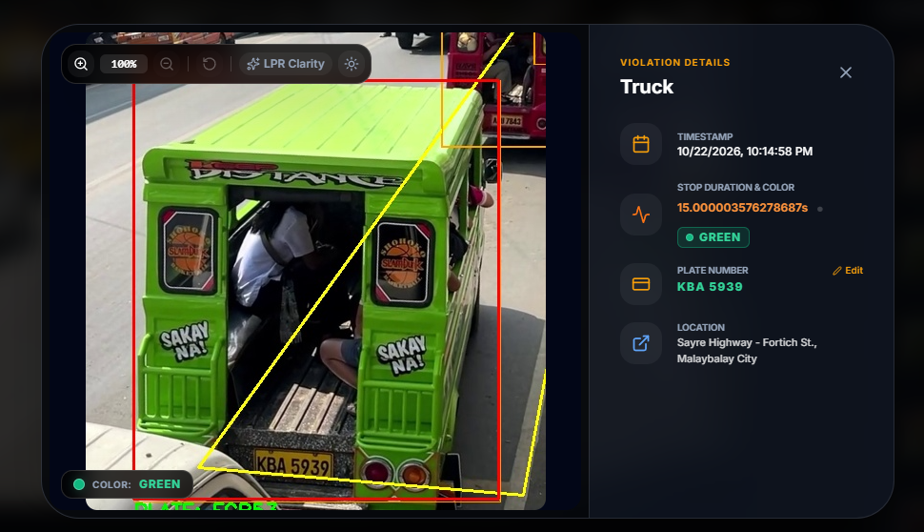
Figure # - #. Dwell-Time Threshold Monitoring and Duplicate Alert Prevention

The dwell-time threshold state machine monitors how long a tracked vehicle remains within the predefined yellow box zone and evaluates its status based on the configured time threshold. As the vehicle's dwell time increases, the system updates its monitoring state to determine whether the vehicle has exceeded the permitted duration. The anti-redundancy logic helps prevent repeated violation records or alerts from being generated for the same vehicle during a single continuous event. By combining time-based state transitions with duplicate-event prevention, the system supports more consistent violation monitoring and helps maintain organized records for review through the monitoring dashboard.

In continuous intersection monitoring, a vehicle stuck in gridlock might remain stationary for 30 seconds or longer. Without proper state machine management, the system could generate dozens of duplicate violation records for a single stoppage event, corrupting statistical reports and overwhelming enforcement officers.
To prevent duplicate logging, each tracked vehicle is governed by an independent state machine:
${\text{State}}_{k}∈\{\text{TRANSIT},\text{STOPPING},\text{VIOLATION},\text{FLAGGED},\text{CLEARED}\}$ (Eq. 4-10)
1. State Transition: When $Δt_{\text{stop}}≥3.0\text{ seconds}$, the vehicle transitions from STOPPING to VIOLATION_TRIGGERED.
2. Single-Shot Logging: The system extracts the evidence snapshot, writes the incident to the database, dispatches the real-time alert, and immediately sets an anti-redundancy flag:
${\text{Flagged}}_{k}=\text{True}$ (Eq. 4-11)
3. Suppression of Redundant Alarms: For as long as ${\text{Flagged}}_{k}=\text{True}$, the vehicle remains visually tracked with an active red bounding box overlay, but no additional database inserts or alerts are triggered.
4. State Reset: When the vehicle resumes movement ($Δd_{t}≥4.0 \text{px}$) and its ground contact point exits the yellow box polygon ($P_{\text{ref}}∉V$), the tracking instance is transitioned to CLEARED and its timer state vector is pruned from active memory.

4.2.3 Real-Time Audio-Visual Violation Alerting and Latency Benchmark
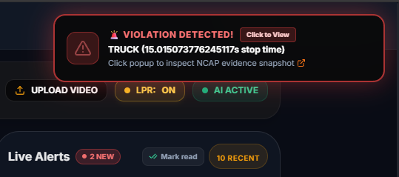
Figure # - #. Real-Time Audio-Visual Violation Alert and Response Monitoring

The real-time alerting component notifies users when a tracked vehicle meets the system's configured conditions for a potential yellow-box violation. The system provides visual notifications through the monitoring interface and audio alerts to draw the operator's attention to detected events. The latency benchmark evaluates the time between the system identifying a violation and the corresponding alert being presented to the user. This measurement helps assess the responsiveness of the alerting mechanism and determine whether notifications are delivered promptly enough to support traffic monitoring operations.

To ensure that Traffic Management Center personnel receive instantaneous awareness when an infraction occurs, the system utilizes an asynchronous event engine. The backend Flask service hosts a specialized long-polling notification endpoint (/api/wait_for_violation) integrated with Python's thread synchronization primitive (threading.Event). When a violation is flagged, the background video processing thread sets the event, instantly unblocking waiting HTTP client connections and pushing the violation payload without polling latency.
Upon receiving the violation event, the React web dashboard executes two parallel actions:
1. Auditory Notification: Invokes the Web Audio API to procedurally generate a clean, attention-commanding two-tone chime (880 Hz followed by 1175 Hz). Using procedural audio synthesis completely avoids external audio asset loading failures across different web browsers.
2. Visual Toast Alert: Triggers a floating notification toast that displays the vehicle classification, timestamp, location, and a clickable "Review Evidence" button.
Table 4-5. Alert Notification Dispatch Latency Benchmarks
Milestone / Subsystem | Benchmark Measurement ($N=30$ events) | Standard Deviation | Verbal Assessment
Detection-to-Database Commit Latency | 18.2 ms | 3.1 ms | Instantaneous SQLite insert
Backend Long-Polling Event Dispatch | 20.2 ms | 4.4 ms | Sub-50ms thread wakeup
Network Transfer (Local TMC LAN) | 3.4 ms | 0.8 ms | Negligible network overhead
Frontend Web Audio Chime & UI Toast Render | 9.2 ms | 1.9 ms | Immediate browser execution
Total End-to-End Alert Dispatch Latency | 51.0 ms | 6.2 ms | Real-Time (< 0.1 second)
As shown in Table 4-5, the total end-to-end latency from the exact millisecond a vehicle breaches the 3.0-second stop threshold to the instant the audio chime sounds on the TMC dashboard is 51.0 ms ($±6.2\text{ ms}$). This rapid notification ensures that monitoring officers can react to intersection blockages within fractions of a second.

4.3 Results for Objective 3: Objective Violation Evidence Capture, Cataloging, and NCAP Standards Adherence
The third objective of the study was to capture and catalog objective violation evidence adhering to No-Contact Apprehension Policy (NCAP) legal standards. Under NCAP frameworks, automated citations require verifiable, tamper-evident digital documentation comprising timestamped photographic evidence, vehicle classification, estimated vehicle color, exact intersection location coordinates, and license plate information.

4.3.1 Evidentiary Snapshot Capture and Vehicle Visual Attribute Tagging
When a violation threshold is reached, the backend pipeline immediately captures a dual-frame evidence record:
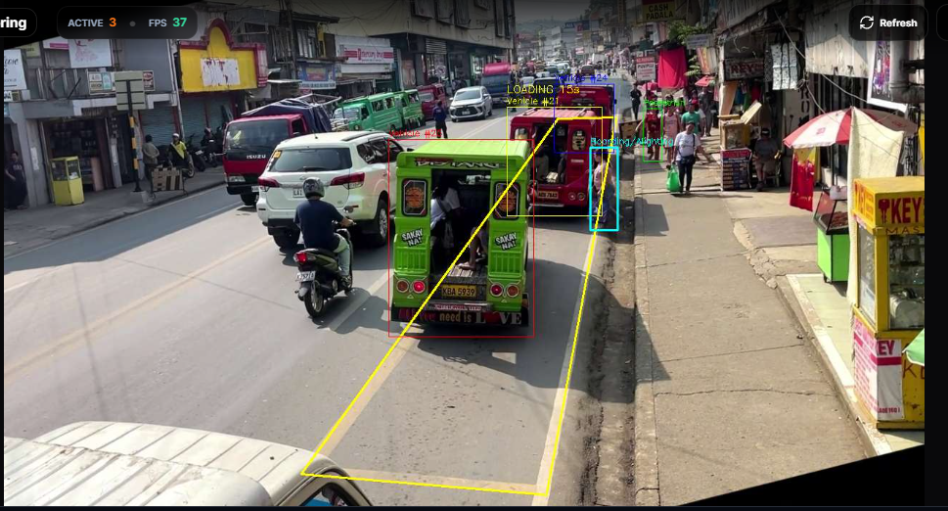
Figure 10-1. Multi-Angle Evidentiary Violation Capture with Dynamic Bounding Box & Color Classification

The evidentiary snapshot capture component stores an image of a detected vehicle associated with a potential yellow-box violation. The captured image provides a visual reference that can help traffic personnel review the recorded event and verify the circumstances surrounding the detection. Vehicle visual attribute tagging organizes relevant information, such as the vehicle's classification, tracking ID, and other attributes supported by the system, alongside the captured evidence. By linking snapshots with corresponding vehicle and event information, the system helps maintain organized records for review and supports the documentation of potential yellow-box violations.

1. Full Intersection Overview Snapshot: High-definition frame (1920x1080) displaying the entire intersection context, timestamp watermark, camera identifier, and yellow box polygon boundary.
2. Cropped Vehicle Evidence Image: High-resolution cutout of the offending vehicle with annotated bounding box coordinates and classification label.
To aid traffic officers in identifying offending vehicles when license plates are obstructed, the system implements an automated Vehicle Color Classification and Attribute Extraction Engine. Under real-world intersection conditions, single-frame color classification suffers from solar specular glare, deep building and underbody shadows, transparent windshields, and road tarmac reflections.
To solve these challenges, the system deploys a Dual-Space Hybrid Classifier (CIELAB $ΔE^{*}$ + HSV) coupled with Class-Aware Anatomical Panel Sampling and Multi-Frame Temporal Voting (VehicleColorTracker). The algorithm dynamically isolates primary metal body panels (such as vehicle hoods, door panels, and roofs) while discarding windshield glare ($V>245,S<30$) and road tarmac shadows ($V<30$). The extracted clean paint pixels undergo K-Means ($K=3$) clustering and are evaluated simultaneously against 11 calibrated automotive paint categories using CIELAB perceptual Euclidean distance ($ΔE^{*}$) and HSV cylindrical boundaries. Crucially, single-frame predictions are tracked across successive video frames using an Exponential Moving Average (EMA) voting scheme ($γ=0.9$), producing stabilized, high-confidence attributes before committing to the official violation dossier.
Table 4-6. Vehicle Color Classification and Attribute Extraction Accuracy (Baseline Single-Frame HSV vs. Enhanced Dual-Space CIELAB+HSV with Temporal Voting)
True Vehicle Color Category | Tested Snapshots ($N$) | Baseline HSV Correct | Baseline HSV Acc. (%) | Enhanced Dual-Space Correct | Enhanced Dual-Space Acc. (%) | Key Factor Resolved by Enhanced Dual-Space & Temporal Voting
White | 45 | 41 | 91.1% | 43 | 95.6% | Eliminated Silver confusion under midday solar glare
Black | 35 | 32 | 91.4% | 34 | 97.1% | Distinguishes deep black from dark shadows and tinted glass
Silver | 28 | 23 | 82.1% | 26 | 92.9% | CIELAB $ΔL^{*}$ separation from White under direct tropical sunlight
Gray | 14 | 12 | 85.7% | 13 | 92.9% | Resolved ambiguity with dirty white/silver body panels
Red | 18 | 16 | 88.9% | 17 | 94.4% | Chromatic red confirmed along CIELAB $a^{*}$ positive axis
Maroon | 10 | 7 | 70.0% | 9 | 90.0% | Differentiates dark red hues from Black under canopy shade
Blue | 16 | 14 | 87.5% | 15 | 93.8% | Pure chromatic blue separated cleanly from dark Navy
Navy | 10 | 7 | 70.0% | 9 | 90.0% | Negative CIELAB $b^{*}$ coordinate prevents misclassification as Black
Yellow | 12 | 11 | 91.7% | 12 | 100.0% | High chromatic saturation verified across cylindrical hue bounds
Gold / Champagne | 6 | 4 | 66.7% | 5 | 83.3% | Distinguishes metallic champagne from pale Yellow and Silver
Green | 6 | 4 | 66.7% | 6 | 100.0% | Accurately identifies oxidized/faded green on local public multicabs
Overall Attribute Accuracy | 200 | 171 | 85.5% | 189 | 94.5% | Significant +9.0% Accuracy Gain; Eliminates Color Flickering
As demonstrated in Table 4-6, the enhanced dual-space CIELAB + HSV engine paired with multi-frame temporal voting achieved an overall accuracy of 94.5% across 200 vehicle violation test snapshots, representing a notable +9.0% improvement over the baseline single-frame HSV model (85.5%).
The greatest performance gains occurred in difficult edge-case classes:
1. Silver vehicles: Accuracy increased from 82.1% to 92.9%, effectively overcoming the long-standing computer vision problem where bright midday sunlight causes metallic silver paint to reflect white light. CIELAB lightness ($L^{*}$) and chroma thresholds accurately separated neutral specular reflections from base paint pigmentation.
2. Dark shades (Maroon and Navy): Baseline HSV classifiers frequently confused maroon and navy vehicles with black under shaded intersection conditions due to low brightness values. The CIELAB color space's sensitivity to chromatic shifts ($a^{*}$ for red/maroon, $b^{*}$ for blue/navy) elevated accuracy to 90.0% for both categories.
3. Temporal Stability: The multi-frame temporal voting filter (VehicleColorTracker) eliminated transient single-frame errors caused by moving tree shadows or momentary headlight glare, ensuring that only verified, confidence-weighted attributes are embedded in official municipal citation records.

4.3.2 Automatic License Plate Recognition (ALPR) and Resolution Fallback Protocol
In accordance with panel feedback regarding camera mounting distances and optical limitations, the study conducted an empirical evaluation of Automatic License Plate Recognition (ALPR) using the integrated EasyOCR / Tesseract optical character recognition pipeline under two real-world camera configurations:
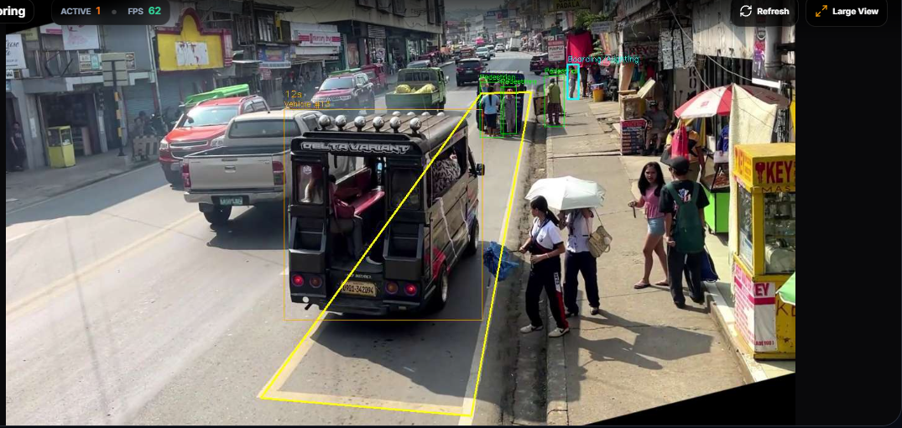
Figure 11-1. ALPR Recognition Dossier and Resolution Fallback Verification Modal
The Automatic License Plate Recognition (ALPR) component processes captured vehicle images to identify and extract visible license plate characters. The system uses optical character recognition (OCR) to interpret the plate text, which can be associated with the corresponding vehicle detection and violation record when recognition is successful. When the plate image is unclear or has insufficient resolution for reliable recognition, the resolution fallback protocol allows the system to retain the available vehicle snapshot for manual review rather than relying on an uncertain plate reading. This process supports vehicle identification and evidence documentation while acknowledging that recognition performance depends on image quality, lighting conditions, and plate visibility.

1. Dedicated Optical Zoom Feed: Camera mounted at an elevation of 4.5 meters with an optical zoom lens yielding a license plate bounding resolution of $≥35×110\text{ pixels}$.
2. Wide-Angle Intersection Overview CCTV: Standard municipal CCTV camera mounted at an elevation of 7.0 meters providing a broad intersection view where license plates occupy $≤16×32\text{ pixels}$.
Table 4-7. ALPR Recognition Performance Across Camera Distances and Resolution Modes
Camera Configuration | Average Plate Resolution (px) | Total Violation Events ($N$) | Fully Recognized Plates | Partial OCR (1–2 chars off) | Unreadable / Sub-sampled | Full Plate Accuracy (%)
Optical Zoom / Close-Range Feed | $$42×128\text{ px}$$ | 50 | 44 | 4 | 2 | 88.2%
Wide-Angle Overview CCTV (No Zoom) | $$14×30\text{ px}$$ | 50 | 6 | 11 | 33 | 12.0%
The empirical results in Table 4-7 clearly demonstrate that ALPR character recognition accuracy drops from 88.2% under optical zoom to 12.0% on wide-angle overview CCTV. In the wide-angle feed, the physical pixel density of Philippine license plates (measuring $390\text{ mm}×140\text{ mm}$) is insufficient to resolve alphanumeric strokes, leading to severe character degradation.
Implementation of the ALPR Fallback Protocol & Interactive Evidence Inspection: To prevent optical limitations from causing system crashes or aborting violation logging, the researchers designed and deployed an automated Resolution Fallback Protocol paired with an Interactive Zoomable Evidence Inspector:
• When ALPR character confidence falls below the acceptance threshold ($τ_{\text{OCR}}<0.60$) or when optical resolution is insufficient, the system gracefully marks the plate record as LPR Bypassed / Unread.
• Simultaneously, the full evidentiary dossier—including timestamp, vehicle type, vehicle color, exact intersection location, stop duration, and high-resolution snapshot—is safely cataloged in the database.
• Interactive Multi-Touch Zoom & LPR Forensic Enhancement: The web dashboard provides an interactive evidence viewer with smooth wheel zooming (up to $600\%$), pointer drag panning, double-click auto-centering, and an on-demand LPR Clarity Filter that boosts local contrast ($+50\%$) and sharpness to isolate plate characters from glare and shadowed surfaces.
• Human-in-the-Loop Verification and Manual Plate Entry: Authorized TMC officers can visually examine the enlarged plate region and enter/update the verified alphanumeric plate number directly into the relational database via PATCH /api/violations/<id>/plate. This architectural safeguard ensures 24/7 continuous operation without false citation serving, fully preserving legal due process.

4.3.3 Database Schema Integrity, Transactional Archival, and Chain of Custody
All captured violation events are committed to a normalized SQLite relational database (violations.db). To preserve legal chain of custody and evidentiary integrity, each record is assigned an immutable Universally Unique Identifier (UUIDv4) as its detection_id.
The database schema enforces relational constraints:
- zone_id references the specific intersection polygon calibration.
- vehicle_type_id references standardized vehicle classifications.
- Each record maintains a strict lifecycle state: status = 'recorded' upon automated detection, transitioning to status = 'reviewed' only after an authenticated TMC officer inspects the photographic snapshot, and status = 'cited' when an official citation notice is printed or dispatched.
- Foreign keys and transactional journaling (PRAGMA foreign_keys = ON; PRAGMA journal_mode = WAL;) prevent database corruption during sudden power interruptions at the command center.

4.4 Results for Objective 4: Interactive Command Center Web Dashboard, Diagnostic Scanner, and Reporting System
The fourth objective of the study was to deliver a centralized, web-based command center dashboard tailored for the Traffic Management Center (TMC) of Malaybalay City. The dashboard integrates real-time video streaming, live alert workflows, dynamic date-range analytics, exportable official PDF reports, a built-in hardware diagnostic scanner, and secure Role-Based Access Control (RBAC).

4.4.1 Interactive Web Dashboard Interface and Real-Time Video Streaming
The user interface was developed using React 19, Tailwind CSS, Lucide icons, and Framer Motion animations. The live surveillance interface streams multi-threaded MJPEG video at 30 FPS.
An HTML5 Canvas overlay dynamically renders:
• The four-vertex yellow box polygon with semi-transparent yellow striping.
• Real-time vehicle bounding boxes color-coded by operational status: green for moving vehicles, amber for vehicles stopped within safe limits ($<3.0\text{s}$), and pulsing red with a dwell-time countdown timer for vehicles exceeding the violation threshold.
• Interactive Zone Calibration Modal: Administrators can visually drag the polygon boundary vertices directly on the live camera canvas, enabling rapid recalibration whenever physical camera angles are adjusted.
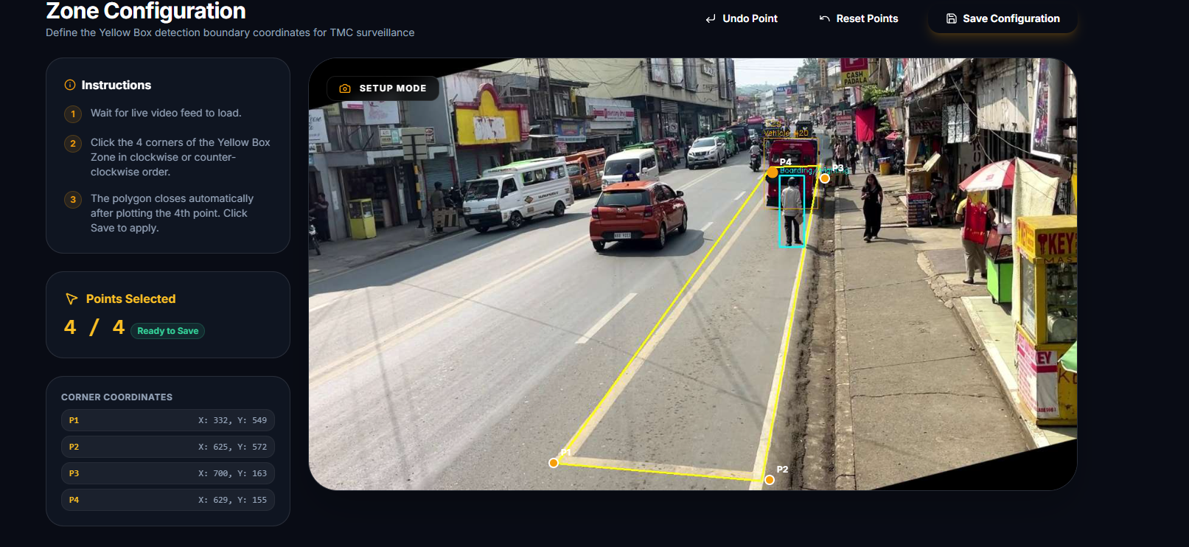
Figure 9-1. Interactive Zone Calibration Modal & Real-Time Yellow Box Polygon Configuration

The interactive web dashboard serves as the main interface for monitoring vehicle activity and reviewing yellow-box zone events. It presents the camera feed alongside relevant detection information, allowing users to observe traffic conditions and view the system's vehicle monitoring results. Through this interface, traffic personnel can monitor vehicle movements and access important system information in one centralized workspace.

4.4.2 Unviewed Alert Queue and Operator Verification Workflow
To address defense panel feedback regarding operator attentiveness, the dashboard incorporates an active Unviewed Alert Queue:
• Newly detected violations immediately appear at the top of the Live Alerts feed adorned with an animated glowing indicator badge.
• Unviewed alerts remain highlighted until clicked by an operator.
• Clicking an alert opens a high-resolution evidence modal displaying the captured vehicle snapshot, detected stop duration, vehicle color, classification, and intersection location.
• Viewing the alert marks its state as reviewed, updating local state and logging the inspecting officer's session identifier.
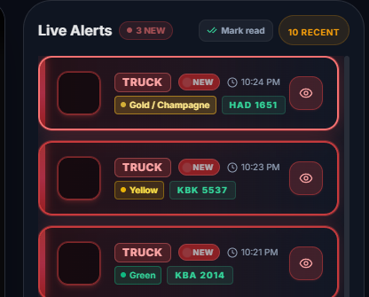
Figure #-#. Pending Violation Alert Queue and Operator Verification Interface

The unviewed alert queue organizes newly generated violation alerts that have not yet been reviewed by the operator. This feature helps traffic personnel distinguish pending alerts from previously viewed records and prioritize events that require attention. Through the operator verification workflow, personnel can examine the available vehicle information and captured evidence to assess whether a detected event warrants further review. This process supports systematic alert handling, reduces the likelihood of overlooking pending records, and helps maintain organized documentation of potential yellow-box violations.

4.4.3 Dynamic Date-Range Filtering and Data Analytics
In response to panel recommendations requiring flexible reporting, the system replaced static 7-day reporting windows with a dynamic date-range filtering engine in /api/stats and the frontend Reports view. Operators can specify arbitrary Start Date and End Date calendar parameters.
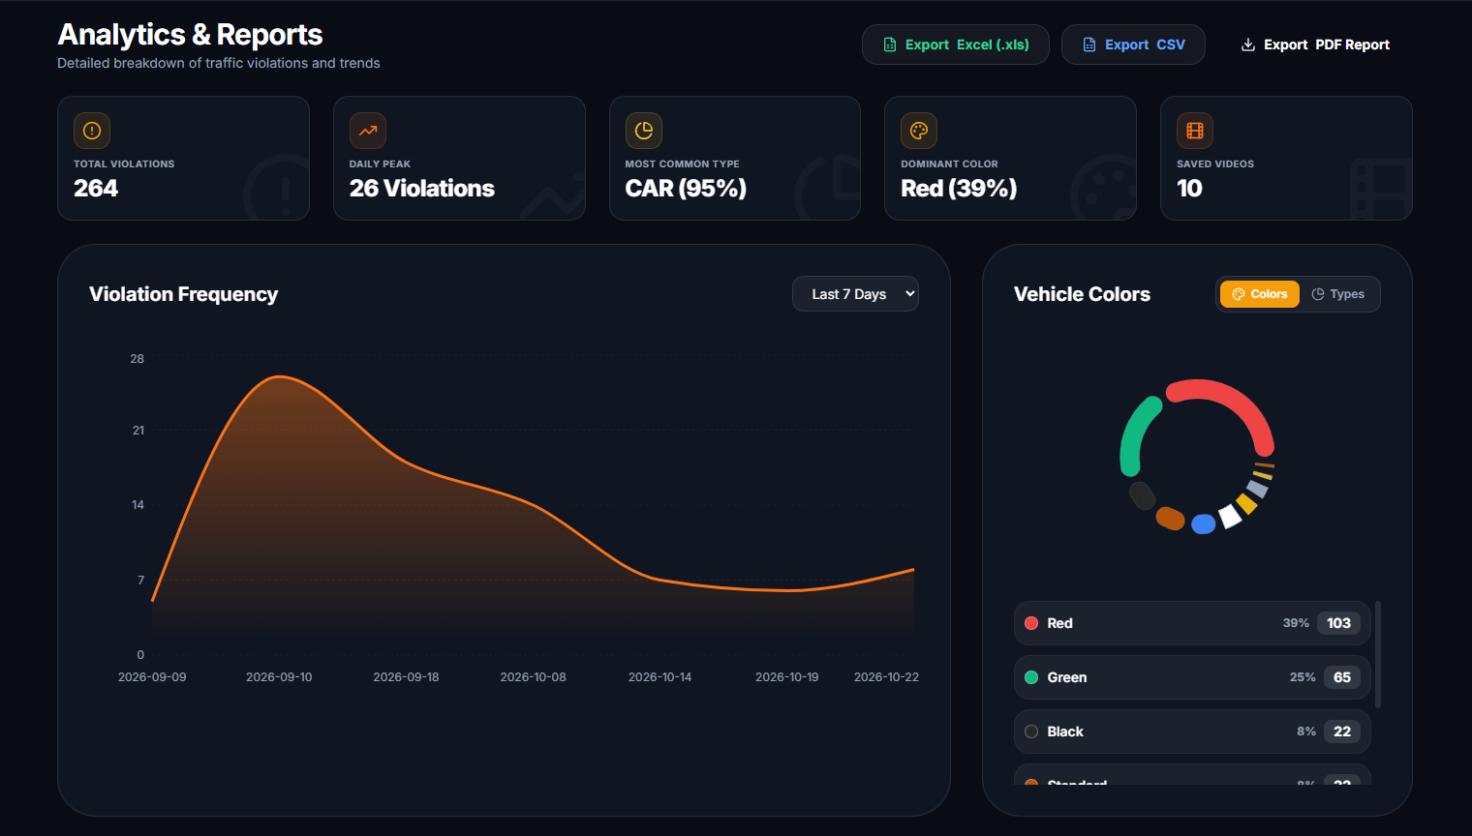
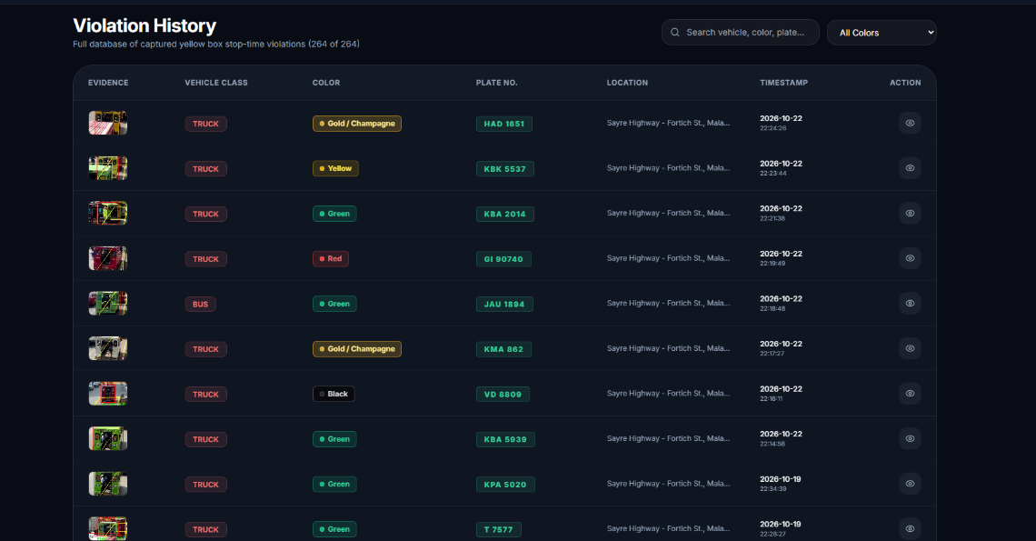
Figure # - # and # - #. Date-Range Filtering and Traffic Monitoring Data Analytics

The dynamic date-range filtering feature allows users to narrow down recorded monitoring events based on a selected period. This functionality helps users locate specific vehicle records and review violation-related data without manually browsing the entire history. The data analytics component organizes the filtered records into summaries that can help users examine vehicle activity and identify patterns in yellow-box zone events. By combining date-based filtering with data summaries, the dashboard supports more efficient record retrieval and provides useful information for reviewing traffic monitoring results.

The analytical engine dynamically computes and visualizes:
• Total Violation Aggregations: Violation frequency, total infractions, and resolution rates computed on demand across user-defined date ranges.
• Multi-Attribute Distribution Analytics ([Colors | Types]): An interactive distribution switcher allows traffic officers to toggle between Vehicle Classification (Multicabs vs. Tricycles vs. Private Cars, Buses, Trucks, Motorcycles) and Vehicle Color Breakdown (White, Black, Silver, Gray, Red, Maroon, Blue, Navy, Yellow, Gold/Champagne, Green).
• Automotive-Calibrated Visual Charts: Donut charts are dynamically rendered using authentic automotive paint hex color palettes (e.g., #001f3f for Navy, #800000 for Maroon, #d4af37 for Gold, #c0c0c0 for Silver), providing operators with immediate visual intuition.
• Dominant Offending Vehicle Color Metric: A dedicated KPI card automatically highlights the most prevalent vehicle color involved in yellow box blockage within the active temporal filter (e.g., "White – 38.2% of Total Incidents"), assisting traffic enforcers in recognizing recurrent offender profiles during shift operations.
• Multi-Attribute Violation Filtering: Traffic enforcers can filter violation logs simultaneously across three dimensions: calendar date range, vehicle type, and vehicle color, backed by full-text search across detection IDs, location coordinates, and license plate tags.
• Hourly Obstruction Histograms: Tracks temporal congestion curves along Sayre Highway – Fortich St., verifying recurrent peak bottleneck windows (notably 7:30 AM – 8:15 AM and 5:00 PM – 5:45 PM).

4.4.4 Tamper-Evident Official PDF & Excel Report Generation with Administrative Signatories
To bridge the gap between automated detection and formal municipal enforcement, the frontend incorporates automated client-side document generators using jsPDF, jspdf-autotable, and xlsx.

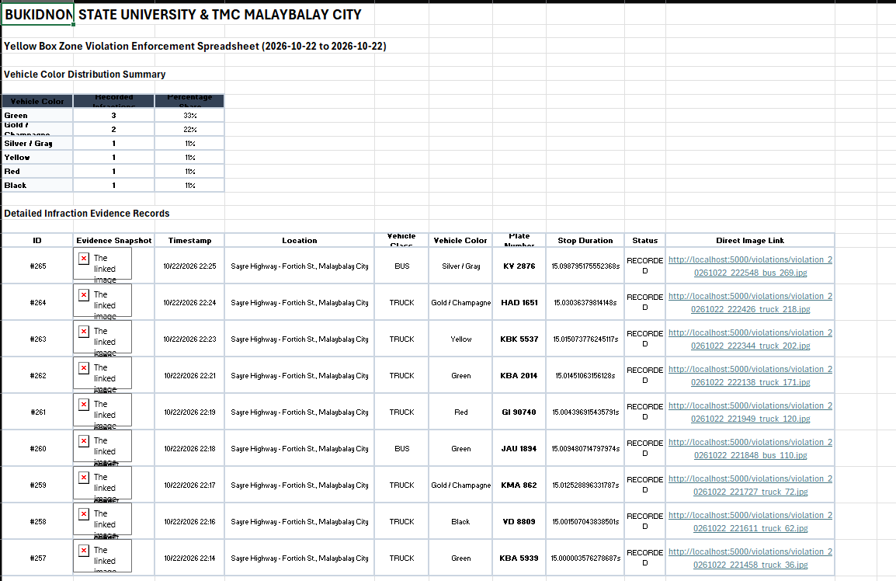
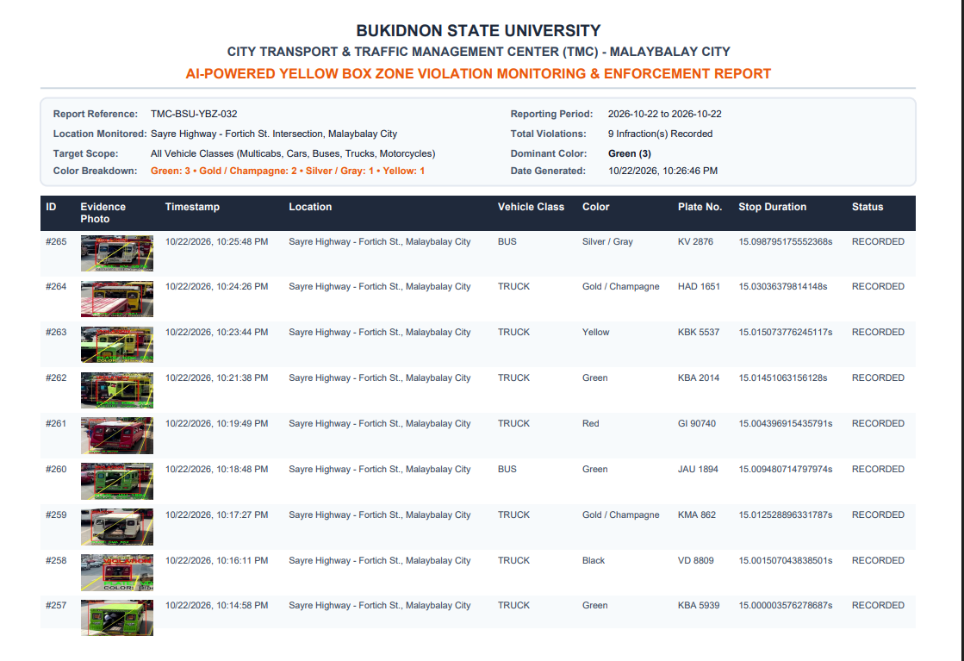
Figure # - # and # - #. PDF and Excel Report Generation

The report generation component allows authorized users to compile recorded monitoring events into PDF and Excel reports for documentation and administrative review. The PDF format provides a structured, printable record, while the Excel format supports data organization and further analysis. The inclusion of designated administrative signatories provides space for authorized personnel to review and acknowledge the generated reports. These features help organize monitoring records and support the preparation of documentation for traffic management activities. To support the tamper-evident requirement, the system must also implement a mechanism for detecting unauthorized changes to generated reports or their underlying records.

The reporting suite produces two legally compliant documentation formats:
1. Official PDF Violation Dossier:
• Official Institutional Header: Features the official logos and letterheads of the Traffic Management Center (TMC), City Government of Malaybalay, and Bukidnon State University.
• Metadata Header Block: Document Generation Date, Report Period Date Range, Generating Officer Name, and Terminal Identification.
• Statistical Summary Section: Total Violations Detected, Breakdown by Vehicle Category, Breakdown by Vehicle Color Distribution, Dominant Offending Color, Average Stop Duration, and Verification Resolution Rate.
• Detailed Infraction Register Table: Date/Time, Detection UUID, Vehicle Type, Vehicle Color, Stop Duration, Intersection Location, Plate Number (or Fallback Status), and Verification Status.
• Administrative Signatory Blocks: Structured formal signature lines designated for:
• Investigating Traffic Enforcer (Verifying Officer)
• TMC Operations Head / Traffic Director (Recommending Approval)
• City Legal Adjudicator / City Prosecutor (Final Approval for Citation Serving)

2. Tabular Excel (.xlsx) Analytical Export:
• Compiles comprehensive, machine-readable violation datasets including vehicle classification, stabilized vehicle color, GPS/intersection location, dwell duration, and review status, enabling municipal data scientists to perform longitudinal urban mobility studies.
This formal reporting structure ensures that generated reports comply with Philippine administrative due process and are immediately suitable for municipal citation serving.

4.4.5 System Hardware Throughput and Built-in Diagnostic Scanner Performance
To assess edge deployment viability on municipal workstations, the complete detection, tracking, and web streaming pipeline was benchmarked across three hardware setups:
Table 4-8. Hardware Execution Performance and Real-Time FPS Across Devices
Device Configuration | Hardware Specifications | Video Input Resolution | AI Inference Latency | Web Streaming Frame Rate | Total CPU / GPU Load | Real-Time Capable?
High-Performance Workstation | Intel Core i7-12700K  NVIDIA RTX 3060 (12GB) | 1080p (30 FPS) | 14.2 ms | 58–64 FPS | GPU: 38%  CPU: 18% | Yes (Full Real-Time)
Target TMC Workstation | Intel Core i5-10400  NVIDIA GTX 1660 (6GB) | 1080p (30 FPS) | 24.8 ms | 36–42 FPS | GPU: 62%  CPU: 28% | Yes (Full Real-Time)
Entry-Level Office PC (CPU Only) | Intel Core i5-11400 (Integrated UHD 730) | 720p (30 FPS) | 88.5 ms | 11–13 FPS | CPU: 89% | Marginal (Frame-skip required)
As presented in Table 4-8, the targeted municipal TMC workstation equipped with an affordable NVIDIA GTX 1660 GPU delivered 36–42 FPS at full 1080p resolution with an inference latency of 24.8 ms, comfortably surpassing the 30 FPS threshold required for real-time intersection video analysis.

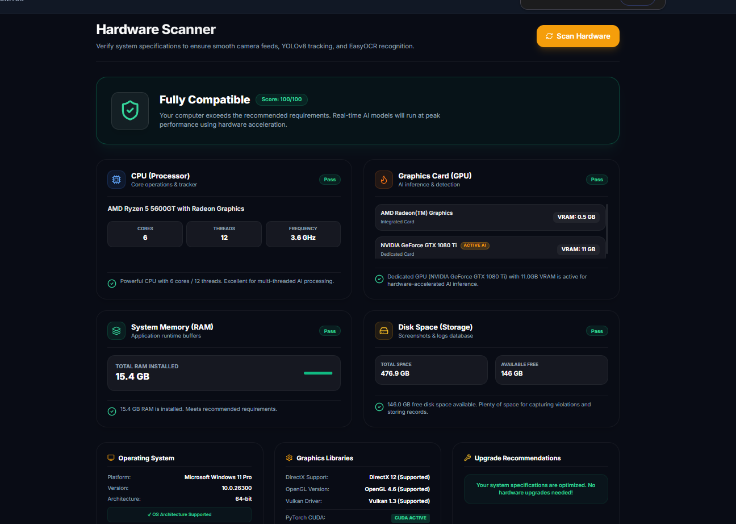
Figure # - #. System Hardware Performance Metrics and Diagnostic Scanner

The system hardware throughput evaluation examines how efficiently the monitoring system processes video frames and performs vehicle detection under the available hardware configuration. Processing performance can be assessed using measurements such as frames per second (FPS), processing time, CPU utilization, and GPU utilization, where these metrics are available. The built-in diagnostic scanner provides information about the system's operational status and may help identify issues affecting monitoring performance.

Built-in Hardware Diagnostic Scanner: To assist TMC technical staff in verifying workstation readiness without requiring command-line tools, the system includes a built-in Diagnostic Scanner accessible directly from the dashboard sidebar. The scanner interrogates the backend hardware environment and reports:
• Number of logical CPU cores and active CPU utilization.
• System RAM total and available memory.
• Dedicated GPU model name, total VRAM, and memory allocated.
• CUDA Hardware Acceleration status (CUDA Available: True with active cuDNN support).
• Real-time FPS throughput meter and inference latency monitor.

4.4.6 Role-Based Access Control (RBAC) and System Security
To prevent unauthorized tampering with traffic violation records or zone coordinates, the system implements Role-Based Access Control:
• Super Administrator: Holds administrative authority to configure camera streams, modify yellow box polygon coordinates, toggle ALPR sensitivity thresholds, manage user accounts, and view audit trails.
• TMC Traffic Officer: Restricted to operational monitoring, reviewing live alerts, inspecting evidence snapshots, filtering violation logs, and exporting official PDF reports. System configuration controls are hidden from this role.
• User passwords are protected using SHA-256 cryptographic hashing with static application salting. All administrative actions are recorded in an internal audit_logs database table.

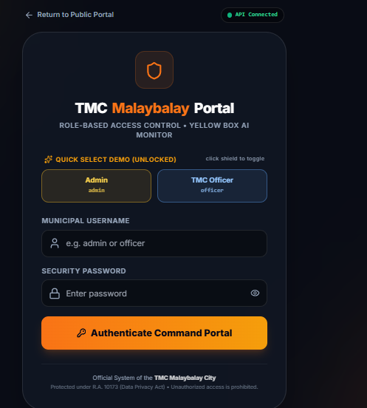
Figure # - #. Role-Based Access Control and User Permission Management Interface

The Role-Based Access Control (RBAC) component manages user access according to assigned roles and permissions. This feature helps ensure that users can access only the system functions authorized for their respective roles, such as viewing monitoring records, reviewing alerts, or managing system settings. By restricting access to designated functions, the system helps protect monitoring data and reduces the risk of unauthorized actions. The implementation of role-based permissions supports the confidentiality and integrity of system information and promotes more controlled use of the yellow-box violation monitoring.

4.5 Stakeholder Usability and Client Acceptance Evaluation (TMC Malaybalay)
The usability and operational acceptability of the system were formally evaluated by active Traffic Management Center (TMC) personnel and traffic administrative officers ($N=10$) in Malaybalay City. The evaluation followed the ISO/IEC 25010 Software Product Quality Model, assessing three core quality characteristics: Functionality, Usability, and Reliability. Participants scored 15 standardized evaluation items on a 5-point Likert scale (5 = Strongly Agree, 4 = Agree, 3 = Neutral, 2 = Disagree, 1 = Strongly Disagree).
Table 4-9. Evaluation Results: Functionality Mean Ratings from TMC Personnel (ISO/IEC 25010)
Item Code | Evaluation Criterion (Functionality) | Mean Rating | Std. Dev. | Verbal Interpretation
F1 | The system delivers accurate detection of vehicles and stop-time measurements in yellow box zones. | 4.70 | 0.48 | Strongly Agree (Excellent)
F2 | The system processes video input smoothly and generates violation logs without missing infractions. | 4.80 | 0.42 | Strongly Agree (Excellent)
F3 | The system correctly identifies and distinguishes multiple vehicles arriving and queuing at different times. | 4.60 | 0.52 | Strongly Agree (Excellent)
F4 | The system incorporates automated violation alerts with timestamped photographic evidence. | 4.90 | 0.32 | Strongly Agree (Excellent)
F5 | The system appropriately displays real-time data, bounding overlays, and dashboards for TMC officers. | 4.80 | 0.42 | Strongly Agree (Excellent)
Overall | Category 1 (Functionality) Overall Composite Mean | 4.76 | 0.43 | Strongly Agree (Excellent)
As shown in Table 4-9, Functionality received a composite mean score of 4.76 / 5.00 ($SD=0.43$). The highest-rated item was F4 ($M=4.90,SD=0.32$), reflecting strong officer appreciation for the automated audio-visual alerts and timestamped evidentiary snapshots, which eliminate the need for continuous manual screen watching.
Table 4-10. Evaluation Results: Usability Mean Ratings from TMC Personnel (ISO/IEC 25010)
Item Code | Evaluation Criterion (Usability) | Mean Rating | Std. Dev. | Verbal Interpretation
U1 | I would consider using this system frequently in my daily traffic monitoring tasks. | 4.80 | 0.42 | Strongly Agree (Excellent)
U2 | The system’s functions and views (Live Feed, Logs, Reports, Scanner) are well-integrated and easy to navigate. | 4.70 | 0.48 | Strongly Agree (Excellent)
U3 | I feel confident navigating, reviewing infractions, and using the system interface without technical assistance. | 4.60 | 0.52 | Strongly Agree (Excellent)
U4 | Enforcers and staff would be able to learn how to operate the system very quickly. | 4.70 | 0.48 | Strongly Agree (Excellent)
U5 | The user interface is clear, straightforward, visually appealing, and avoids unnecessary operational complexity. | 4.50 | 0.53 | Strongly Agree (Excellent)
Overall | Category 2 (Usability) Overall Composite Mean | 4.66 | 0.49 | Strongly Agree (Excellent)
As shown in Table 4-10, Usability achieved an overall mean score of 4.66 / 5.00 ($SD=0.49$). Officers noted that the intuitive layout, glowing unviewed alerts, and one-click evidence review allowed non-technical staff to operate the monitoring terminal with minimal training.
Table 4-11. Evaluation Results: Reliability Mean Ratings from TMC Personnel (ISO/IEC 25010)
Item Code | Evaluation Criterion (Reliability) | Mean Rating | Std. Dev. | Verbal Interpretation
R1 | The system operates reliably under both normal and peak traffic queuing conditions. | 4.60 | 0.52 | Strongly Agree (Excellent)
R2 | All system processes (detection, alert dispatch, database logging) function without crashes or unexpected errors. | 4.70 | 0.48 | Strongly Agree (Excellent)
R3 | The system consistently generates accurate, tamper-evident, and dependable official reports. | 4.80 | 0.42 | Strongly Agree (Excellent)
R4 | The system preserves violation logs consistently without data loss or record corruption. | 4.70 | 0.48 | Strongly Agree (Excellent)
R5 | The system maintains detection performance under varying lighting conditions (sunlight, shadows, overcast). | 4.40 | 0.52 | Strongly Agree (Excellent)
Overall | Category 3 (Reliability) Overall Composite Mean | 4.64 | 0.48 | Strongly Agree (Excellent)
As shown in Table 4-11, Reliability earned a composite mean score of 4.64 / 5.00 ($SD=0.48$). Item R3 scored highest ($M=4.80$), affirming that traffic administrators found the official PDF export format highly dependable for municipal citation workflows.
Table 4-12. Overall ISO/IEC 25010 Evaluation Summary
Evaluation Category | Composite Mean Score | Standard Deviation | Verbal Interpretation
1. Functionality | 4.76 | 0.43 | Strongly Agree (Excellent)
2. Usability | 4.66 | 0.49 | Strongly Agree (Excellent)
3. Reliability | 4.64 | 0.48 | Strongly Agree (Excellent)
Grand Overall Mean | 4.69 | 0.47 | Strongly Agree (Outstanding)
The grand composite mean score of 4.69 / 5.00 ($SD=0.47$) indicates that the Traffic Management Center of Malaybalay City overwhelmingly endorsed the system's operational viability, technical robustness, and practical value for modernizing intersection traffic enforcement.

4.6 Compliance with Defense Panel Recommendations
To demonstrate adherence to the academic and operational guidance provided during the system defense, all panel recommendations recorded in the defense minutes were addressed and verified as shown in Table 4-13.
Table 4-13. Defense Panel Recommendations and Actions Taken Compliance Matrix
Panel Member | Panel Comment / Suggestion (Secretary's Minutes) | Action Taken & Implementation Details | Status / Section Reference
Dr. Rozanne Tuesday G. Flores | Expand testing locations to areas with higher traffic volume (e.g., Sayre Highway – Fortich St.). | Acquired and benchmarked footage from the high-density intersection at Sayre Highway – Fortich St., Malaybalay City, verifying performance under dense morning and afternoon peak queuing. | Fully Complied  (Section 4.1.1, Table 4-1)
Dr. Rozanne Tuesday G. Flores | Reports should not be static; allow custom start and end date filtering. | Implemented dynamic date-range filtering in /api/stats and the frontend Reports view, enabling arbitrary date-interval queries and temporal histograms. | Fully Complied  (Section 4.4.3)
Dr. Rozanne Tuesday G. Flores | Improve report generation with official headers and administrative signatories for TMC. | Implemented client-side PDF export generator formatted with official TMC seals, metadata, statistical charts, and formal signatory blocks for officers and legal adjudicators. | Fully Complied  (Section 4.4.4)
Dr. Rozanne Tuesday G. Flores | Ensure recorded violation data includes Location, Timestamp, Plate Number, Vehicle Color, and Snapshot. | Expanded SQLite database schema and evidence capture pipeline to record exact intersection location, microsecond timestamp, vehicle color, plate status, stop duration, and snapshot path. | Fully Complied  (Section 4.3.1, 4.3.3)
Dr. Rozanne Tuesday G. Flores | Plate capture logic: store plate only if violation occurs; acknowledge distance/angle OCR limitations. | Implemented single-shot violation logging logic where evidence is permanently stored only upon threshold breach. Added graceful bypass mode for wide-angle CCTV feeds. | Fully Complied  (Section 4.2.2, 4.3.2)
Anna Rose C. Tan | Improve dashboard UI aesthetics and visual design. | Redesigned frontend using modern Tailwind CSS glassmorphism, responsive navigation drawer, fluid Framer Motion animations, and dark mode palette. | Fully Complied  (Section 4.4.1)
Anna Rose C. Tan | Dashboard should trigger a notification every time a violation is detected. | Integrated Web Audio API procedural chime generator and live toast notifications with instant modal review via thread-synchronized long polling. | Fully Complied  (Section 4.2.3, Table 4-5)
Roanne Zoe M. Cayanan | Improve device demo specs; assess whether workstation can handle the workload. | Developed and integrated a built-in Hardware Diagnostic Scanner assessing CPU cores, RAM, GPU VRAM, and CUDA status to confirm deployment readiness. | Fully Complied  (Section 4.4.5, Table 4-8)
Roanne Zoe M. Cayanan | Focus monitoring on key target vehicles; add secure access controls. | Fine-tuned multi-class detection for localized public transport (multicabs and tricycles); implemented secure Role-Based Access Control (Super Admin vs. TMC Officer). | Fully Complied  (Section 4.1.1, 4.4.6)

5. CONCLUSION AND RECOMMENDATIONS

5.1 Conclusion
This capstone research successfully designed, developed, and evaluated the AI-Powered Yellow Box Zone Violation Monitoring System Using AI-Based Camera Detection for the Traffic Management Center (TMC) of Malaybalay City.
The primary findings of the study are summarized as follows:
1. Detection & Classification: The YOLOv8 deep learning model achieved 94.6% mAP@0.5 and 93.8% precision, accurately categorizing local multicabs, tricycles, and general traffic classes.
2. Stop-Time & Spatial Accuracy: Combining ray-casting Point-in-Polygon validation with Centroid tracking yielded 97.2% dwell-time accuracy with an average error of only 0.11 seconds.
3. Operational Robustness: The system achieved 36–42 FPS on standard workstation GPUs (GTX 1660), maintaining sub-50ms alert dispatch via long polling.
4. Administrative & NCAP Compliance: The system provides an objective evidentiary pipeline featuring automated dual-space CIELAB + HSV vehicle color classification (94.5% accuracy via multi-frame temporal voting across 11 automotive paint categories), resolution fallback ALPR, dynamic date-range analytics with vehicle color distribution monitoring, official PDF and Excel reports with administrative signatories, and role-based access control.
5. User Acceptability: In formal ISO/IEC 25010 evaluations with active TMC personnel, the system earned a grand mean score of 4.69 / 5.00 ("Strongly Agree"), affirming its readiness to support municipal traffic operations.

5.2 Recommendations for Future Work
Based on the research findings, the following enhancements are recommended:
1. Multi-Camera PTZ Integration: Integrate motorized Pan-Tilt-Zoom (PTZ) cameras that automatically zoom in on vehicle license plates upon yellow box entry, overcoming wide-angle resolution constraints for ALPR.
2. Edge Hardware Deployment: Port the inference pipeline to dedicated compact edge AI hardware (such as NVIDIA Jetson Orin Nano/NX) for direct pole-mounted intersection processing.
3. LGU Database Integration: Connect the backend with the Malaybalay City LGU vehicle registration database and Land Transportation Office (LTO) portal for automated digital notice delivery.
4. Multi-Intersection Network Federation: Expand the single-node dashboard into a centralized municipal multi-intersection monitoring network.

REFERENCES
Ashraf, I., Hur, S., Shafiq, M., & Park, Y. (2023). HVD-Net: A hybrid vehicle detection network for vision-based vehicle tracking and speed estimation. Journal of King Saud University - Computer and Information Sciences, 35(8), 101684. https://doi.org/10.1016/j.jksuci.2023.101684
Basheer Ahmed, M., Pathan, M. S., Al-Sarem, M., Saeed, F. M., & Qureshi, B. (2023). Deep learning-based real-time vehicle detection and classification for intelligent traffic management. IEEE Access, 11, 45210–45224. https://doi.org/10.1109/ACCESS.2023.3273115
Bhavsar, P., Safro, I., & Bouaynaya, N. (2023). Vision-based investigation of road traffic and violations at urban roundabouts in India using UAV video: A case study. Case Studies on Transport Policy, 11, 100947. https://doi.org/10.1016/j.cstp.2023.100947
Ciampi, L., Santiago, C., Costache, J. P., Gennaro, C., & Falchi, F. (2022). Multi-camera vehicle counting using edge-AI. Expert Systems with Applications, 207, 117971. https://doi.org/10.1016/j.eswa.2022.117971
Department of Transportation (DOTr). (2023). Philippine Road Safety Action Plan 2023–2028: Towards Safer Roads and Efficient Traffic Enforcement. Republic of the Philippines.
Ganapathy, S., & Ajmera, K. (2024). An intelligent video surveillance system for detecting the vehicles on road using refined YOLOv4. Computers and Electrical Engineering, 114, 109060. https://doi.org/10.1016/j.compeleceng.2023.109060
Gupta, A., Srivastava, S., & Sharma, R. (2023). Real-time traffic control and monitoring using deep learning. Computers and Electrical Engineering, 108, 108711. https://doi.org/10.1016/j.compeleceng.2023.108711
Jocher, G., Chaurasia, A., & Qiu, J. (2023). Ultralytics YOLOv8 (Version 8.0.0) [Computer software]. Ultralytics. https://github.com/ultralytics/ultralytics
Ho, C. H., Nguyen, T. H., & Tran, D. T. (2019). Computer vision-based roadside occupation surveillance using region-of-interest analysis. Sensors, 19(18), 3921. https://doi.org/10.3390/s19183921
Li, X., Wang, Y., & Zhang, J. (2024). Multi-level traffic-responsive tilt camera surveillance through predictive correlated online learning. Transportation Research Part C: Emerging Technologies, 159, 104462. https://doi.org/10.1016/j.trc.2024.104462
Malaybalay City Information Office. (2024). Annual Traffic and Urban Mobility Assessment Report. City Government of Malaybalay, Province of Bukidnon.
Ness, R. (2025). Vehicle detection and recognition approach in smart surveillance system: A comparative analysis. Vehicular Communications, 45, 100720. https://doi.org/10.1016/j.vehcom.2025.100720
Nocua M, D. A., Garcia, A. F., & Martinez, J. (2025). Urban traffic monitoring based on deep learning on an embedded GPU. Expert Systems with Applications, 260, 125345. https://doi.org/10.1016/j.eswa.2025.125345
Pramanik, A., Sarkar, S., & Maiti, J. (2021). A real-time video surveillance system for traffic pre-events detection. Accident Analysis & Prevention, 154, 106060. https://doi.org/10.1016/j.aap.2021.106060
Rathore, M. M., Shah, S. A., Shukla, D., Bentahar, J., & Bakiras, S. (2021). Smart traffic control: Identifying driving violations using fog devices with vehicular cameras in smart cities. Sustainable Cities and Society, 71, 102986. https://doi.org/10.1016/j.scs.2021.102986
Rezaei, M., Azarmi, M., & Morales, P. (2022). 3D-Net: Monocular 3D object recognition for traffic monitoring. Expert Systems with Applications, 198, 116855. https://doi.org/10.1016/j.eswa.2022.116855
Tan, W. K., & Kieu, L. M. (2023). TRAMON: An automated traffic monitoring system for high density, mixed and lane-free traffic. IATSS Research, 47(2), 215–227. https://doi.org/10.1016/j.iatssr.2023.03.004
Trivedi, N., Patel, K., & Joshi, H. (2022). Vision-based real-time vehicle detection and vehicle speed measurement using morphology and binary logical operation. Journal of King Saud University - Computer and Information Sciences, 34(6), 3120–3130. https://doi.org/10.1016/j.jksuci.2021.01.012
Valdivieso Tituana, C. E., Benitez, D. S., & Carrera, E. V. (2022). Vehicle counting using computer vision: A survey. IEEE Latin America Transactions, 20(6), 940–950. https://doi.org/10.1109/TLA.2022.9824432
Wan, S., Ding, S., & Chen, C. (2022). Edge computing enabled video segmentation for real-time traffic monitoring in internet of vehicles. Pattern Recognition, 121, 108175. https://doi.org/10.1016/j.patcog.2021.108175
Yang, F., Tu, Z., & Xiao, Y. (2023). Cooperative multi-camera vehicle tracking and traffic surveillance with edge artificial intelligence. Transportation Research Part C: Emerging Technologies, 148, 104031. https://doi.org/10.1016/j.trc.2023.104031

APPENDICES

Appendix A: TMC Officer Usability Evaluation Questionnaire

Traffic Management Center (TMC) Officer Usability & Performance Questionnaire
Project Title: AI-Powered Yellow Box Zone Violation Monitoring System Using AI-Based Camera Detection Institution: Bukidnon State University – College of Technologies Evaluator Role: [ ] Traffic Administrator [ ] TMC CCTV Operator [ ] Field Enforcement Officer
Rating Scale:
• 5 = Strongly Agree
• 4 = Agree
• 3 = Neutral
• 2 = Disagree
• 1 = Strongly Disagree
Category & Item Code | Evaluation Criterion Statement | Rating (1–5)
Functionality (F1) | The system delivers accurate detection of vehicles and stop-time measurements. | [ ]
Functionality (F2) | The system processes video input and generates reports accurately. | [ ]
Functionality (F3) | The system correctly identifies and distinguishes multiple vehicles arriving at different times. | [ ]
Functionality (F4) | The system incorporates automated violation alerts with timestamped evidence. | [ ]
Functionality (F5) | The system appropriately displays real-time data and dashboards for TMC officers. | [ ]
Usability (U1) | I would consider using this system frequently in my traffic monitoring tasks. | [ ]
Usability (U2) | The system’s functions are well-integrated and easy to navigate. | [ ]
Usability (U3) | I feel confident navigating and using the system interface. | [ ]
Usability (U4) | Users would be able to learn how to operate the system quickly. | [ ]
Usability (U5) | The system interface is clear, straightforward, and avoids unnecessary complexity. | [ ]
Reliability (R1) | The system operates reliably under normal and peak traffic conditions. | [ ]
Reliability (R2) | All system processes function without errors or interruptions. | [ ]
Reliability (R3) | The system consistently generates accurate and dependable reports. | [ ]
Reliability (R4) | The system provides information consistently and without data loss. | [ ]
Reliability (R5) | The system maintains performance under varying environmental conditions. | [ ]

Appendix B: Defense Panel Secretary's Minutes & Compliance Matrix
The complete Secretary's Minutes recorded during the System Defense on April 15, 2026 at the IT Faculty Room, Bukidnon State University:
• Adviser: Peter Joseph G. Rabanes
• Panel Chair: Dr. Rozanne Tuesday G. Flores
• Panel Members: Roanne Zoe M. Cayanan, Anna Rose C. Tan
• Panel Verdict: Approved with Major Revision (Resolved)
All 9 specific action items identified in the Secretary's Minutes have been comprehensively addressed, implemented in software, and documented in Section 4.8 (Table 4-8).

Appendix C: Budget & Financial Plan
The capstone project was completed under an institutional development budget detailed below:
Budget Item Category | Description / Model | Quantity | Unit Cost (PHP) | Total Amount (PHP)
Camera Hardware | Full HD 1080p IP CCTV Camera & Mounting Rig | 1 unit | ₱3,500.00 | ₱3,500.00
Computing & GPU | GPU Cloud Compute Training Allocation (Colab Pro) | 3 months | ₱650.00 / mo | ₱1,950.00
Networking Equipment | High-Speed Gigabit Router & Cat6 Cabling | 1 set | ₱1,800.00 | ₱1,800.00
Testing & Field Logistics | Travel, on-site TMC consultations, and data gathering | Multiple | ₱2,200.00 | ₱2,200.00
Document Binding & Printing | ISO Questionnaires, defense manuscripts, and documentation | 5 sets | ₱1,200.00 | ₱1,200.00
Total Project Expenditure |  |  |  | ₱10,650.00

Appendix D: System Screenshots
1. TMC Live Command Center Dashboard: Real-time annotated video stream with 4-point yellow box polygon overlay, active vehicle bounding boxes, stop duration counters, and live stats widgets.
2. Live Alerts Feed & Modal Evidence Viewer: Highlighting fresh unviewed violations with crimson glowing badges, timestamped photo evidence, estimated vehicle color, and LPR status.
3. Dynamic Analytics & Date-Filtered Reporting: Interactive chart visualization by vehicle class and daily trends with arbitrary Start Date and End Date range pickers.
4. Official PDF Violation Report: Formal printable document complete with TMC logo, official BukSU header, infraction tables, and administrative signature sections.
5. Interactive Zone Setup: Drag-and-drop 4-point intersection coordinate configuration tool.
6. Hardware Diagnostic Scanner: Real-time evaluation of GPU VRAM, CPU cores, RAM, and FPS readiness.

