Hotel Management System

**Software Requirements Specification**

Version 1.0

Danang, Feb2025

**TABLE OF CONTENTS**

**TABLE OF CONTENTS** 2

1. DOCUMENT HISTORY 4

2. REFERENCE DOCUMENTS 4

3. INTRODUCTION 4

3.1 Purpose 5

3.2 In Scope 5

4. REQUIREMENT 5

5. OVERVIEW 6

5.1 Actors 5

5.2 System Use Case Diagram 6

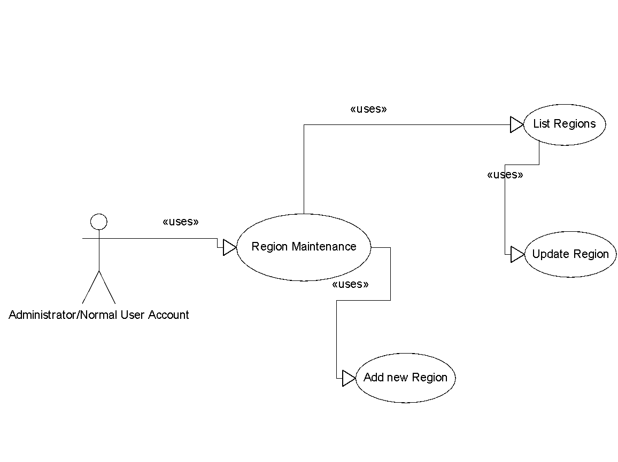

5.3 System Pages Flow 6

6. SCREEN DESIGN 13

7. Data Structure 18

7.1 Entity Diagram 18

7.2 Database 18

8. NON-FUNCTIONAL REQUIREMENTS AND OTHERS 25

Performance 25

Security 25

Design Constraints 25

Standards Compliance 26

Reliability 26

Availability 26

Maintainability 26

Portability 26

9. APPENDIX

# **DOCUMENT HISTORY**

| **Date** | **Summary of Changes** | **Version** |
| --- | --- | --- |
| 10/02/2025 | Software Requirement Specification for Hotel management system | v1.0 |
|  |  |  |
|  |  |  |

# 

# **REFERENCE DOCUMENTS**

| **Document Name** | **Description** |
| --- | --- |
|  |  |
|  |  |
|  |  |
|  |  |
|  |  |
|  |  |
|  |  |

# 

# **INTRODUCTION**

The following subsections of the Software Requirements Specifications (SRS) document provide an overview of the entire SRS.

## ***Purpose***

* This Software Requirements Specification (SRS) defines the requirements for the Hotel Management System (HMS). It ensures a clear understanding of the system's functionality for both developers and hotel staff. The SRS serves as a foundation for design, development, and testing. Developers will use it to build the system, while hotel staff can review it to ensure their needs are met.

## ***In Scope***

* The intended software product is a Hotel Management System designed to streamline key hotel operations through automation. It comprises three primary subsystems: the Reservation and Booking System, which monitors reservations and room availability; the Tracking and Selling Food System, which manages charges to the current room; and the General Management Services and Automated Tasks System, which generates operational audit reports and allows for the modification of subsystem data. Detailed functionality of these subsystems will be elaborated in section 2-Overall Description. The system will cater to two types of end users: hotel staff, specifically customer service representatives, and hotel managers. Both user groups will have access to the Reservation and Booking System and the Food Tracking and Selling System, while access to the General Management System will be limited to management personnel. The primary goal of the Hotel Management System is to effectively manage a hotel with a capacity of 100 rooms, addressing the challenges posed by manual management processes. By automating various tasks, the system aims to significantly ease the daily responsibilities of hotel management, ensuring efficient service delivery to customers. It is essential that the system is user-friendly, facilitates error recovery, and ultimately achieves high levels of user satisfaction.

# **REQUIREMENT**

***4.1 Purpose***

+ Customer management

+ Booking Room and reject Room management

+ Room status’s management

+ Service management

+ Expense management

+ Staff management

***4.2 Requirement specification***

***4.2.1 The organization of hotel***

Department with the highest power is the board of directors, the board of directors includes many people divided by three main tasks: Room and other services, financial management, security and maintenance. Room management and other services management includes the following departments: Reception, Room department, bar, kitchen, service rooms (such as laundry, sauna ...). The financial management includes: Department of Finance and Planning, Administration and General Affairs. Maintenance protection includes: guard and maintenance rooms.

***4.2.2 Booking room flow***

***4.2.2.1 Booking***

When a customer books a room, in many ways, by phone or direct apparently, the Reception will check rooms for the customer's requirement (on room type and price). If hotel has the room that customer requires, the receptionist will take to receive reservation procedure by obtaining the necessary information of customers, including:

- Customer name

- Nationality

- Phone number

- How many room needed and room category

- Payment method

- Check In date

- Check Out date

Receptionists also ask customers with information assurance (usually prepay a portion of cash or certain reputation, due to referral or patrons). The bill will be sent to the customer. If the reservation time is too long, the previous overbooking reservations due date, the hotel will get back to the hotel again to check to make sure other viewers also demand reservation again and again to update the booking status. Based on the list above that guests booking a day Reception will predict the booking department a relative number of rooms to be prepared to welcome visitors through the preparation with the following contents:

- The total amount of customers

- Room price

- The amount of room

- The customer per room

***4.2.2.2 Receive Room***

When a customer receive room, the receptionist write their information with the following field

**With International customer**

- RoomID

- Customer name

- Nationality

- Birthday

- Passport

- Visa number

- The name of the tourist company

- Arrive date

- Leave date

**With local customer**

- Customer name

- Birthday

- Identity number

- Countryside

- Arrive date

- Leave date

If a customer is a walk-in guest, the receptionist can hold customer prepay-money and hold until payment. If this amount of money is too large, the receptionist will give it to the financial department. After that Reception will store information about visitors, give it to the Room department by sending the contract to the chamber room. The contract includes the following information:

- The amount of people and gender

- Nationality

- Receive date

- Leave date

- Room number

- Room price

- Service

- Check out date

***4.2.2.3 Leaving at hotel***

During staying at the hotel, all requirements for physical facilities of the hotel will be reported directly to the Receptionist, the loan services that will be recorded by the receptionist to remind visitors to pay when checking out. When guests want to switch rooms, the receptionist shall have procedures for customers then report back to the housekeeping department to update the customer information. If customers use other services of the hotel and want to share the amounts paid upon check out, guests must sign a agreement as follows:

- Customer name

- Company name

- Tax code

- Service name

- Price/Service

- Total

***4.2.3 Service management***

***4.2.3.1 Restaurant service***

- Customers order meal

- Expose bill for customers

- Customers choose payment method

***4.2.3.2 Bar service***

As the same at Restaurant service

***4.2.3.3 Laundry service***

Only for clients staying in the hotel.

- Customer requests the assistance to launder

- Once done, Housekeeping department gives customer an invoice confirmation

- Customer Pay the fee when check out

***4.2.4 Staff management***

***4.2.4.1 Room and Service management***

+ Confirm the reservation.

+ Check in for customers.

+ Payment check, transferred to the financial department.

+ Receiving complaints and answering questions, resolving customer requirements.

+ Regularly check the rooms, responsible for preparing equipment in the room.

+ Provide other services such as dining, entertainment, laundry, transportation, ...

***4.2.4.2 Finance management***

+ Financial management, renting payments and other services.

+ Management of employee salaries.

***4.2.4.3 Security and maintenance***

+ Hotel security guard.

+ Maintenance and replacement (if necessary) of the equipment in the room.

***4.2.5 Staff management***

+ Staff name

+ Staff code

+ Department

+ Salary

+ Shift

# **OVERVIEW**

## ***Actors***

+ Customer

+ Manager

## ***System Use Case Diagram***

## 

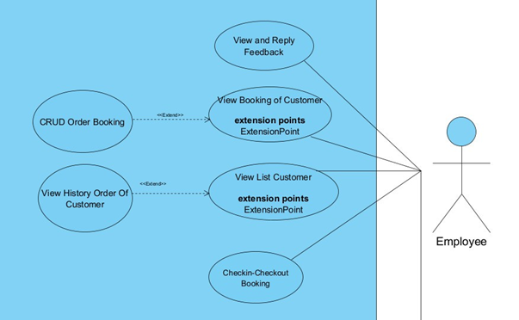

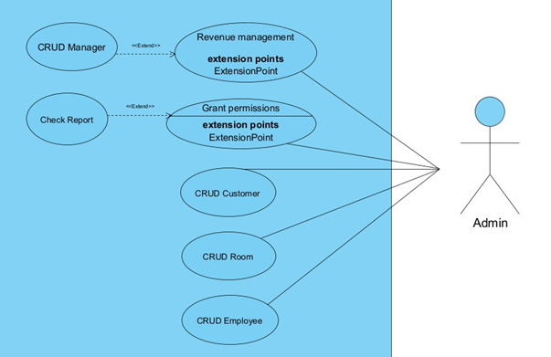

## ***System Pages Flow***

***5.3.1 Management flow***

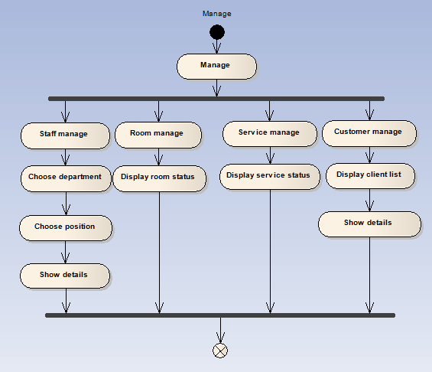

***5.3.2 Booking room flow***

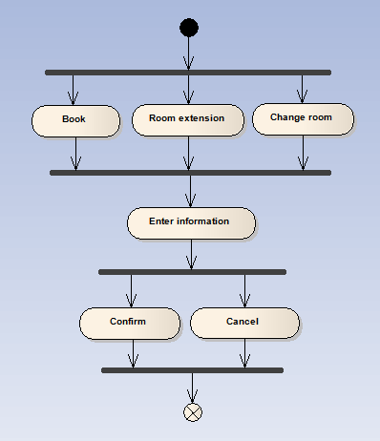

***5.3.3 Service providing flow***

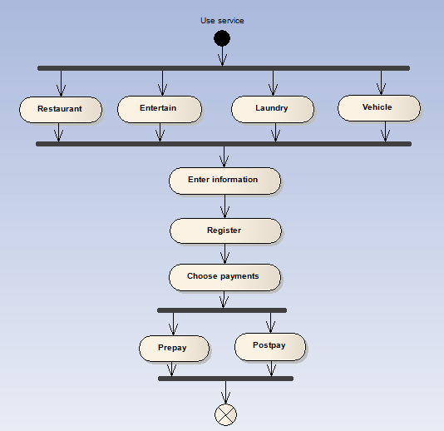

# **SCREEN DESIGN**

**+ Login**

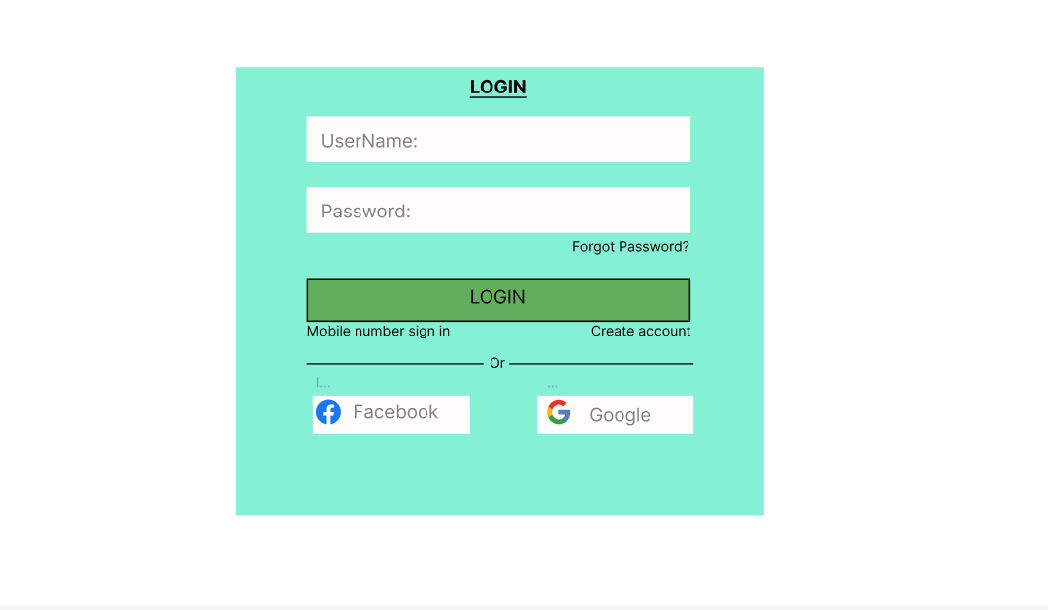  
  
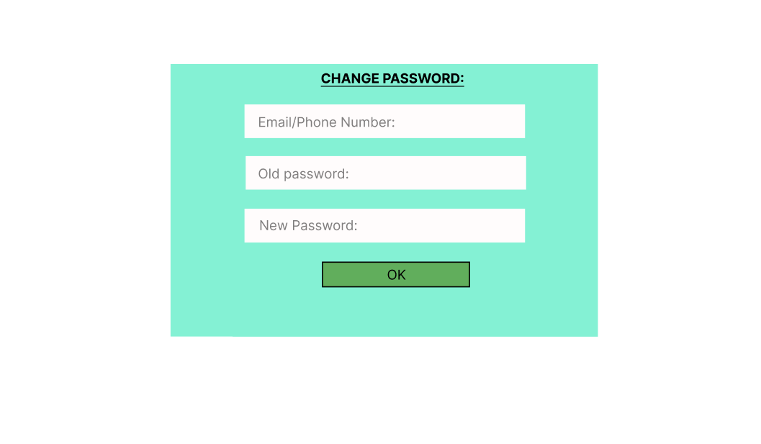

| **Screen** | Login screen | | | |
| --- | --- | --- | --- | --- |
| **Description** | Input your user name and password to login your account. If you do not have any account, you can click the “Create account” to create a new account or click to Forget password to reset password. | | | |
| **Screen Access** | Defaut | | | |
| **Screen Content** | | | | |
| **Item** | | **Type** | **Data** | **Description** |
| Email | | Textbox | Export From Database | Input your email |
| Password | | Textbox | Export From Database | Input your password. |
| Login | | Button |  | Click to login. If the username or password is wrong, return the message “Wrong username or password”. You must retype and try again. |
| Create Account | | Link |  | Redirect to “Create account” page. |
| Forget Password | | Link |  | Redirect to “Forget password” page. |

**+ Create new account layout**

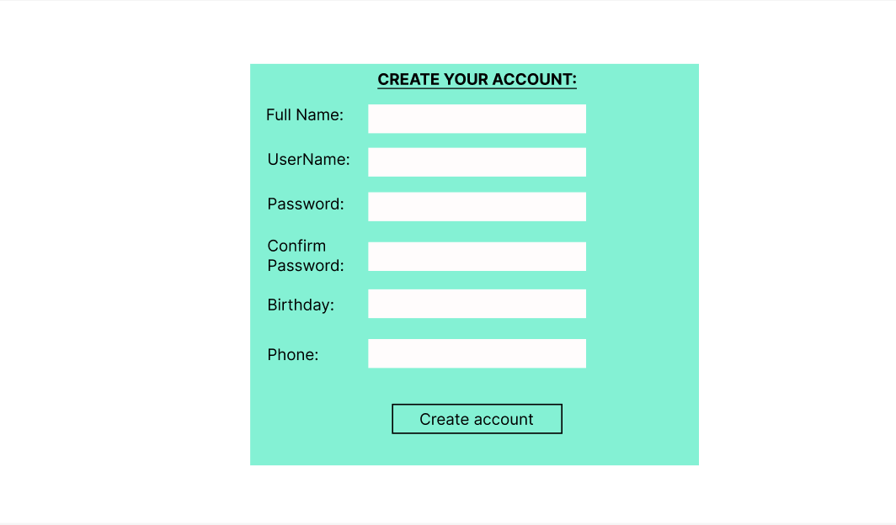

| **Screen** | Create account | | | |
| --- | --- | --- | --- | --- |
| **Description** | | Create an account page. From the login screen, click create account link to view this layout. After inserting your information, click Create Account to register a new account. | | |
| **Screen Access** | | User click on create account from login layout. | | |
| **Screen Content** | | | | |
| **Item** | | **Type** | **Data** | **Description** |
| Name | | textbox | Insert your full name | Type text |
| Email | | textbox | Insert your email. | Type text. |
| Password | | textbox | Insert your register password. | Type text |
| Confirm Password | | textbox |  | Retype password |
| Birthday | | Textbox (dd/mm/yyyy) | Insert your birthday | Type your birthday. |
| Phone | | Textbox (number) | Insert your phone number | Insert your cell phone |
| Create Account | | button |  | Click to create an account. If there is an empty field, you have to complete it to continue. |

**+ Forget password**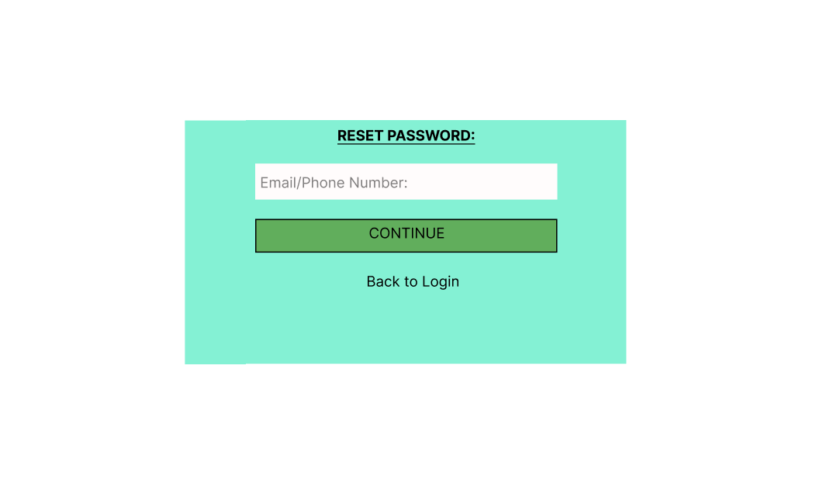

| **Screen** | Forget password | | | |
| --- | --- | --- | --- | --- |
| **Description** | | Forget password page. From the login screen, click forgot password link to view this layout. | | |
| **Screen Access** | | User click on forgot password from login layout. | | |
| **Screen Content** | | | | |
| **Item** | | **Type** | **Data** | **Description** |
| Email/Phone number | | textbox |  | Type your Email or phone number |
| Continue | | Button |  | Click to proceed with resetting password |
| Back to Login | | link |  | Click to cancel and return to login screen. |

**+ Booking room**

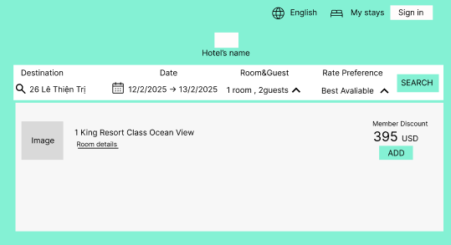

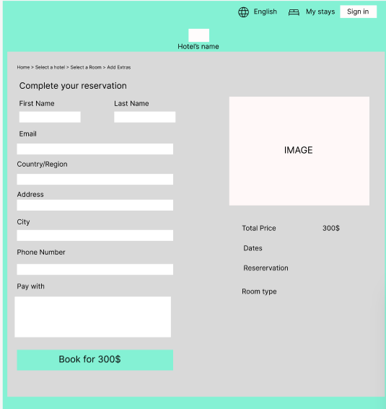

| **Screen** | Book | | | |
| --- | --- | --- | --- | --- |
| **Description** | | Describe how and what to do when you are booking room by your account on Hotel’s website | | |
| **Screen Access** | | Click Book from the Book menu | | |
| **Screen Content** | | | | |
| **Item** | | **Type** | **Data** | **Description** |
| Hotel’s icon | | Image box |  | Show image of the hotel. |
| Hotel’s name | | Label |  | Show name of the hotel. |
| Log out | | Button |  | Click the Logout button to log out of the account. |
| Category room | | Radio check |  | Show 3 kinds of room for you to choose one. |
| Start day | | Textbox |  | Insert check in date |
| End day | | Textbox |  | Insert check out date |
| Amount of room | | Number |  | Insert number of rooms you want to reserve. |
| Ok | | button |  | Click Ok to complete the reservation. |
| Cancel | | button |  | Cancel the booking room session. |

|  |  | | | |
| --- | --- | --- | --- | --- |
|  | |  | | |
|  | |  | | |
|  | | | | |
|  | |  |  |  |
|  | |  |  |  |
|  | |  |  |  |

**+ Booking (edit)**

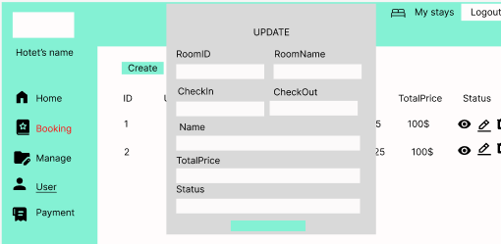

| **Screen** | Edit | | | |
| --- | --- | --- | --- | --- |
| **Description** | | Edit reservation information. Click save or cancel to finish | | |
| **Screen Access** | | Click edit item from Book menu | | |
| **Screen Content** | | | | |
| **Item** | | **Type** | **Data** | **Description** |
| Category room | | Radio checkbox |  | Show 3 kinds of rooms to choose. You can choose one of them |
| Start day | | Textbox |  | Insert check in date |
| End day | | Textbox |  | Insert check out date |
| Amount of room | | Number |  | Insert number of rooms you want to reserve |
| Save | | Button |  | Click it to Save and update reservation information. |
| Cancel | | button |  | Click this to cancel the update and return to unsaved data. |

**+ Booking (Cancel)**

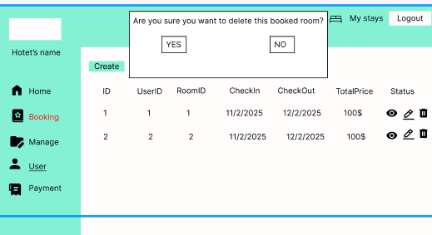

| **Screen** | Cancel | | | |
| --- | --- | --- | --- | --- |
| **Description** | | View and cancel reservation. | | |
| **Screen Access** | | Click cancel item from Book menu | | |
| **Screen Content** | | | | |
| **Item** | | **Type** | **Data** | **Description** |
| Table | | table | Export from database | Listing information about reservations of current user. |
| Cancel | | Button |  | Click here if you want to Cancel your reservation. When clicking Cancel button, a dialog box will open to confirm your decision. |

---------------------------------Pending (service need reworking)-----------------------------------------------

**+ Manage Staff**

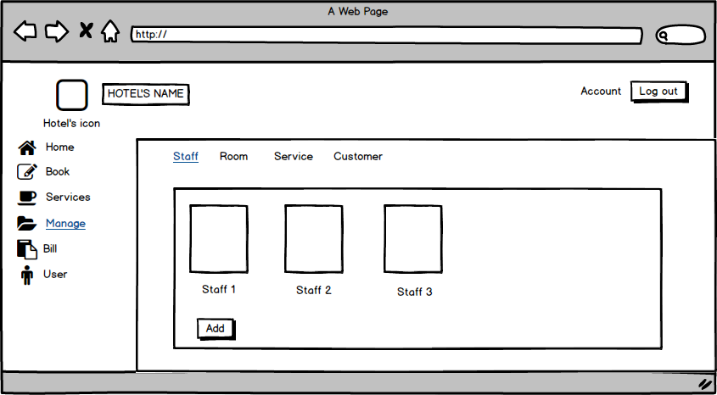

| **Screen** | Manage Staff | | | | |
| --- | --- | --- | --- | --- | --- |
| **Description** | | Displays a list Staff and add Staff. | | | |
| **Screen Access** | | Users click on add to add Staff | | | |
| **Screen Content** | | | | | |
| **Item** | | **Type** | **Data** | **Description** | |
| Staff 1 | | Text | information of Staff 1 | * Display information of Staff 1 | |
| Staff 2 | | Text | information of Staff 2 | * Display information of Staff 2 | |
| Staff 3 | | Text | information of Staff 3 | * Display information of Staff 3 | |
| Add | | Button |  | * User click on button to add Staff | |
| **Screen Actions** | | | | | |
| **Action Name** | | **Description** | | **Success** | **Failure** |
| Add | | User click on button to add Staff | | Display list of Staff. |  |

**+ Manage Staff (Add Staff)**

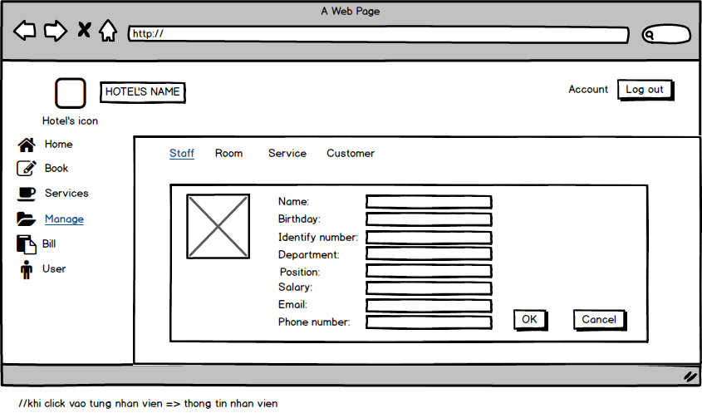

| **Screen** | Add Staff | | | | |
| --- | --- | --- | --- | --- | --- |
| **Description** | | Add Staff: Name, birthday, Email …… | | | |
| **Screen Access** | | Add information of Staff | | | |
| **Screen Content** | | | | | |
| **Item** | | **Type** | **Data** | **Description** | |
| Name | | Textbox | Name off staff | * User enter name | |
| Birthday | | Date | Dd/mm/yy | * User enter your birthday | |
| Identify number | | Number(15) | Number | * User enter Identify number | |
| Department | | Text | Department of staff | * User enter department | |
| Position | | Text | Position | * User enter your position | |
| Salary | | Number | Salary | * User enter your Salary | |
| Email | | text | email | * User enter your Email | |
| Phone Number | | Number | Phone number | * User enter your phone number | |
| Ok | | button |  | * User click to add | |
| Cancel | | button |  | * User click to cancel | |
| **Screen Actions** | | | | | |
| **Action Name** | | **Description** | | **Success** | **Failure** |
| Ok | | User click Ok to agree add information off staff. | | Display messgage “Ok”. | Display messgage “Failed”. |
| Cancel | | User click cancel to not agree add information off staff. | |  |  |

**+ Manage Staff (Edit Staff)**

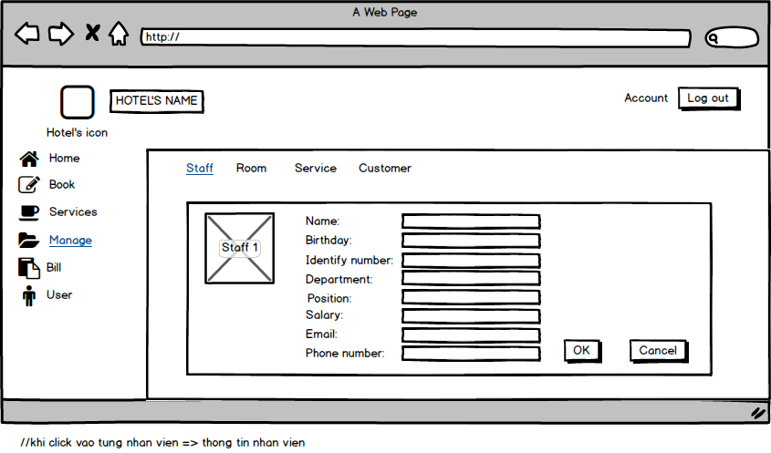

| **Screen** | Edit Staff | | | | |
| --- | --- | --- | --- | --- | --- |
| **Description** | | Edit Staff: Name, birthday, Email …… | | | |
| **Screen Access** | | Edit information of Staff | | | |
| **Screen Content** | | | | | |
| **Item** | | **Type** | **Data** | **Description** | |
| Name | | Textbox | Name off staff | * User enter name | |
| Birthday | | Date | Dd/mm/yy | * User enter your birthday | |
| Identify number | | Number(15) | Number | * User enter Identify number | |
| Department | | Text | Department of staff | * User enter department | |
| Position | | Text | Position | * User enter your position | |
| Salary | | Number | Salary | * User enter your Salary | |
| Email | | text | email | * User enter your Email | |
| Phone Number | | Number | Phone number | * User enter your phone number | |
| Ok | | Button |  | * User click to edit | |
| Cancel | | Button |  | * User click to cancel | |
| **Screen Actions** | | | | | |
| **Action Name** | | **Description** | | **Success** | **Failure** |
| Ok | | User click Ok to agree edit information off staff. | | Display messgage “Ok”. | Display messgage “Failed”. |
| Cancel | | User click Ok to not edit information off staff. | |  |  |

**+ Manage Staff (View Staff)**

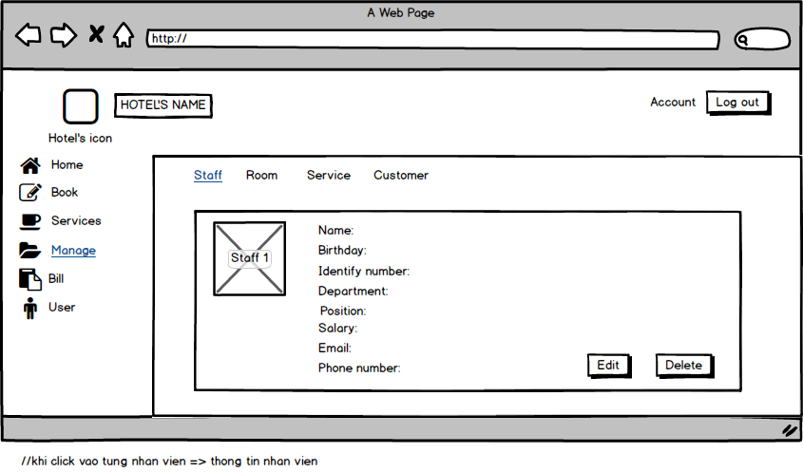

| **Screen** | View Staff | | | | |
| --- | --- | --- | --- | --- | --- |
| **Description** | | View Staff: Name, birthday, Email …… | | | |
| **Screen Access** | | View information of Staff | | | |
| **Screen Content** | | | | | |
| **Item** | | **Type** | **Data** | **Description** | |
| Name | | Textfield | Name off staff | * Displays name | |
| Birthday | | Date | Dd/mm/yy | * Displays birthday | |
| Identify number | | Number(15) | Number | * Displays Identify number | |
| Department | | Text | Department of staff | * Displays department | |
| Position | | Text | Position | * Displays position | |
| Salary | | Number | Salary | * Displays Salary | |
| Email | | Text | email | * Displays Email | |
| Phone Number | | Number | Phone number | * Displays phone number | |
| Edit | | Button |  | * User click to edit | |
| Delete | | Button |  | * User click to delete | |
| **Screen Actions** | | | | | |
| **Action Name** | | **Description** | | **Success** | **Failure** |
| Edit | | User click Edit to edit. | |  |  |
| Delete | | User click delete to delete | |  |  |

**+ Manage Staff (Delete Staff)**

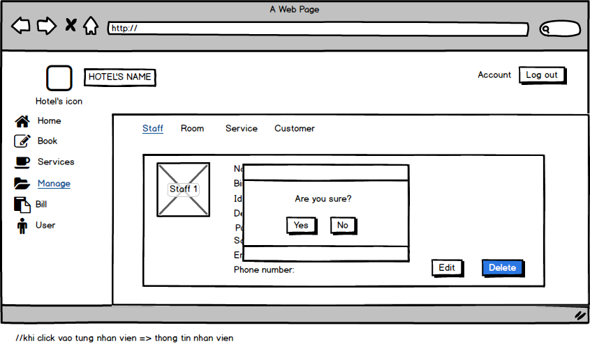

| **Screen** | Delete Staff | | | | |
| --- | --- | --- | --- | --- | --- |
| **Description** | | Delete Staff: Name, birthday, Email …… | | | |
| **Screen Access** | | Delete information of Staff | | | |
| **Screen Content** | | | | | |
| **Item** | | **Type** | **Data** | **Description** | |
| Name | | Textfield | Name off staff | * Displays name | |
| Birthday | | Date | Dd/mm/yy | * Displays birthday | |
| Identify number | | Number(15) | Number | * Displays Identify number | |
| Department | | Text | Department of staff | * Displays department | |
| Position | | Text | Position | * Displays position | |
| Salary | | Number | Salary | * Displays Salary | |
| Email | | Text | email | * Displays Email | |
| Phone Number | | Number | Phone number | * Displays phone number | |
| Yes | | Button |  | * User click to delete staff | |
| No | | Button |  | * User click to not delete staff | |
| **Screen Actions** | | | | | |
| **Action Name** | | **Description** | | **Success** | **Failure** |
| Yes | | User click to delete staff | | Display message “delete success”. |  |
| No | | User click to not delete staff | |  |  |

**+ Manage Room**

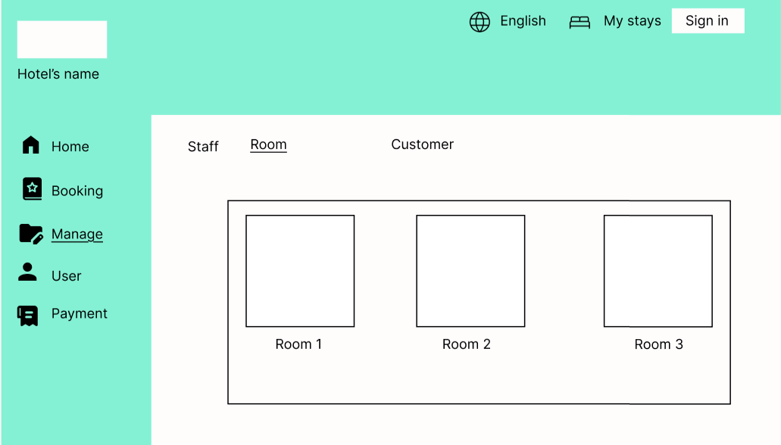

| **Screen** | Manage Room | |
| --- | --- | --- |
| **Description** | | Displays Room list and information |
| **Screen Access** | | View Room list and information |

**+ Manage Room (Add Room)**

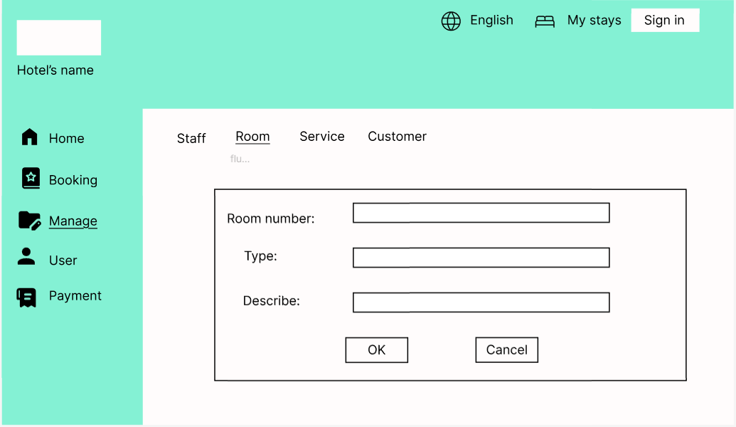

| **Screen** | Add Room | | | | |
| --- | --- | --- | --- | --- | --- |
| **Description** | | Add Room: Room number, type, Describe | | | |
| **Screen Access** | | Add information of Room | | | |
| **Screen Content** | | | | | |
| **Item** | | **Type** | **Data** | **Description** | |
| Room number | | Number | number | * enter room number | |
| Type | | Text | Text | * enter type of room | |
| Describe | | Text | Text | * enter room description | |
| Ok | | Button |  | * confirm create room | |
| Cancel | | Button |  | * cancel action | |
| **Screen Actions** | | | | | |
| **Action Name** | | **Description** | | **Success** | **Failure** |
| Ok | | User click Ok to agree add room | | Display message “Create room successfully”. | Display messgage “Failed to create room”. |
| Cancel | | User click cancel to cancel | |  |  |

**+ Manage Room (View Room)**

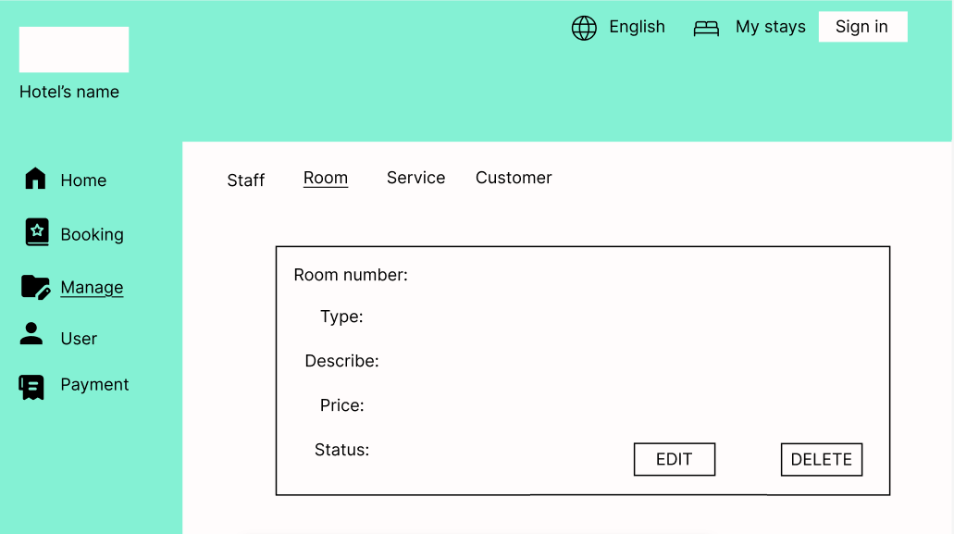

| **Screen** | View Room | | | | |
| --- | --- | --- | --- | --- | --- |
| **Description** | | View room: Room number, type, Describe, status, price | | | |
| **Screen Access** | | View information of Room | | | |
| **Screen Content** | | | | | |
| **Item** | | **Type** | **Data** | **Description** | |
| Room number | | Number | number | * Display number of room | |
| Type | | Text | Text | * Display type of room | |
| Describe | | Text | Text | * Display room description | |
| Status | | Text | Text | * Displays status of room | |
| Price | | Number | Number | * Displays price of room | |
| Edit | | Button |  | * Click to edit | |
| Delete | | Button |  | * Click to delete | |
| **Screen Actions** | | | | | |
| **Action Name** | | **Description** | | **Success** | **Failure** |
| Edit | | User click Edit to edit. | |  |  |
| Delete | | User click delete to delete | |  |  |

**+ Manage Room (Edit Room)**

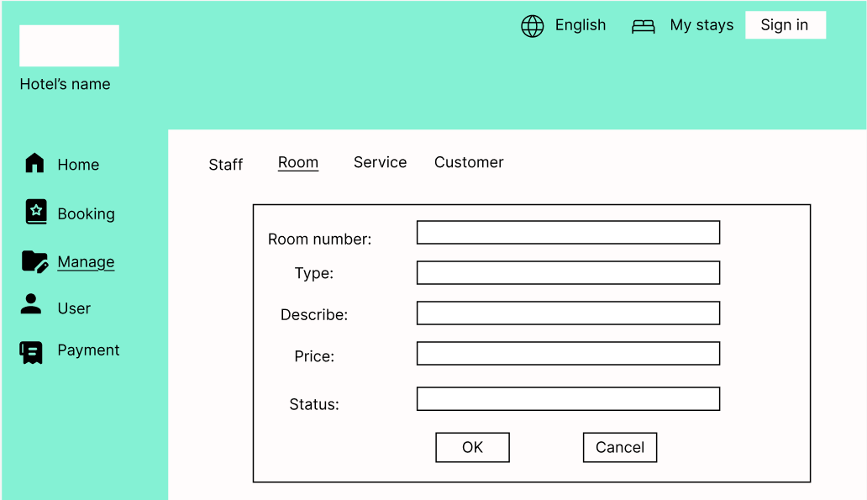

| **Screen** | Edit Room | | | | |
| --- | --- | --- | --- | --- | --- |
| **Description** | | Edit Room: Room number, type, Describe, status, price | | | |
| **Screen Access** | | Edit information of room | | | |
| **Screen Content** | | | | | |
| **Item** | | **Type** | **Data** | **Description** | |
| Room number | | Textbox | number | * enter room number | |
| Type | | Textbox | Text | * enter type of room | |
| Describe | | Textbox | Text | * enter room description | |
| Status | | Textbox | Text | * enter status of room | |
| Price | | Textbox | Number | * enter price of room | |
| Ok | | Button |  | * Click to edit | |
| Cancel | | Button |  | * Click to cancel | |
| **Screen Actions** | | | | | |
| **Action Name** | | **Description** | | **Success** | **Failure** |
| Ok | | User click Ok to agree edit information off room. | | Display messgage “Ok”. | Display messgage “Failed”. |
| Cancel | | User click Ok to not edit information off room. | |  |  |

**+ Manage Room (Delete Room)**

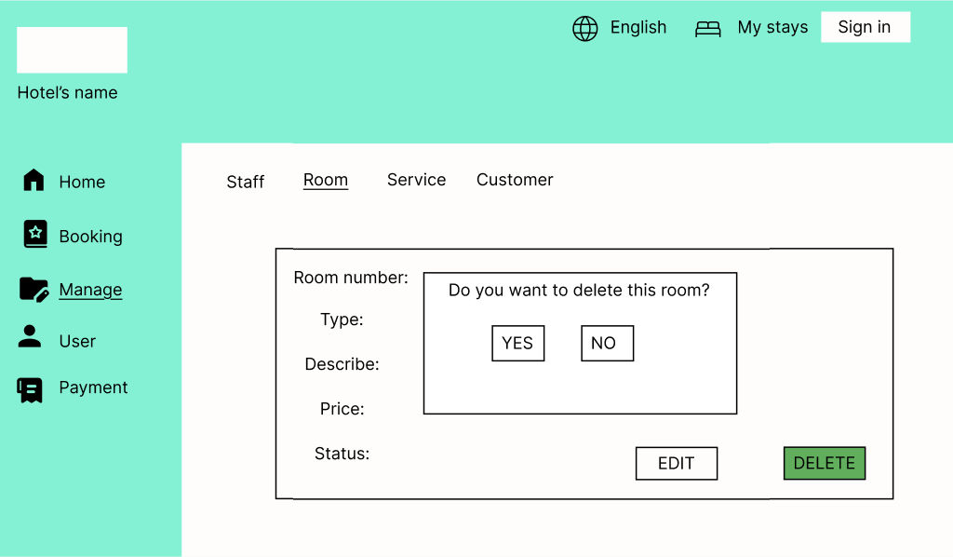

| **Screen** | Delete Room | | | | |
| --- | --- | --- | --- | --- | --- |
| **Description** | | Delete room: Room number, type, Describe, status, price | | | |
| **Screen Access** | | Delete information of room | | | |
| **Screen Content** | | | | | |
| **Item** | | **Type** | **Data** | **Description** | |
| Room number | | Textbox | number | * display room number | |
| Type | | Textbox | Text | * display type of room | |
| Describe | | Textbox | Text | * display room description | |
| Status | | Textbox | Text | * display status of room | |
| Price | | Textbox | Number | * display price of room | |
| Yes | | Button |  | Click to confirm delete room | |
| No | | Button |  | * Click to cancel room deletion | |
| **Screen Actions** | | | | | |
| **Action Name** | | **Description** | | **Success** | **Failure** |
| Yes | | User click to delete room | | Display message “delete successfully”. |  |
| No | | User click to not delete room | |  |  |

**+ Manage Service**

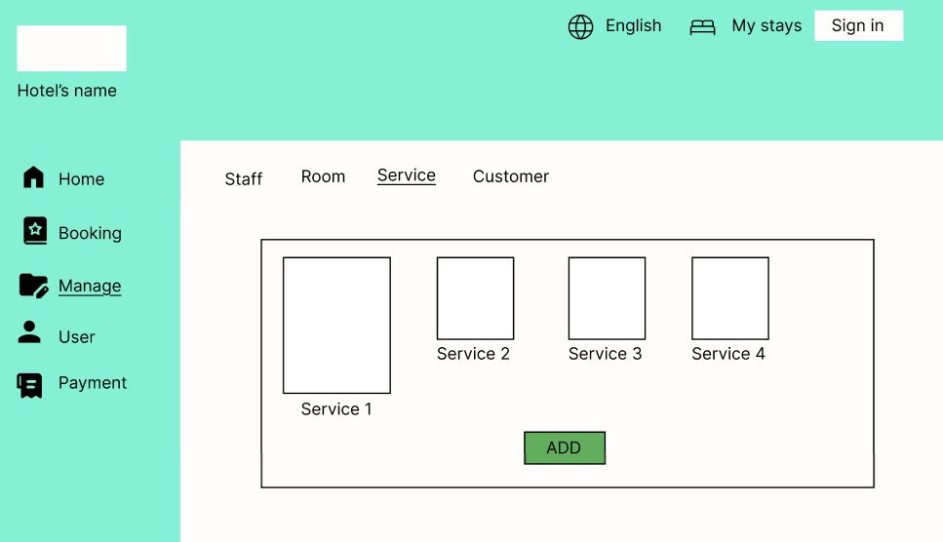

| **Screen** | Manage Service | | | | | |
| --- | --- | --- | --- | --- | --- | --- |
| **Description** | | Displays Service list and information for all the service of the Hotel. | | | | |
| **Screen Access** | | Click item Service on the menu Manage. | | | | |
| **Screen Content** | | | | | | |
| **Item** | | **Type** | **Data** | | **Description** | |
| Service | | link |  | | Service’s name, link to Service information. | |
| Table List | | table |  | | Display list of services. Including information and image about each service. | |
| Add | | Button |  | | Add new Service | |
| **Screen Actions** | | | | | | |
| **Action Name** | | **Description** | | **Success** | | **Failure** |
| show service | | Show the information of all the service. | |  | |  |
| Add | | To add new service | | Show add service layout for you to input new service information. | | No action. |

**+ Manage Service (Add Service)**

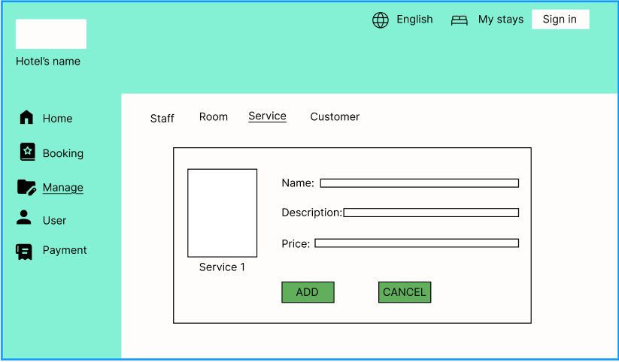

| **Screen** | Add new Service | | | | | |
| --- | --- | --- | --- | --- | --- | --- |
| **Description** | | Screen to add new service to hotel. | | | | |
| **Screen Access** | | Click Add button from service manage screen. | | | | |
| **Screen Content** | | | | | | |
| **Item** | | **Type** | **Data** | | **Description** | |
| Image | | Image |  | | Insert image for the Service | |
| Name | | textbx (text) |  | | Insert service name. | |
| Describe | | textbox (text) |  | | Insert service description | |
| Price | | textbox (text) |  | | Input service cost. | |
| OK | | Button |  | | Click confirm adding service. | |
| Cancel | | Button |  | | Cancel adding service. | |
| **Screen Actions** | | | | | | |
| **Action Name** | | **Description** | | **Success** | | **Failure** |
| Input information | | Input text | |  | |  |
| Click OK button | | Click on the OK button | | Add the service into service manage. | | No action, the service will not be added. |
| Click Cancel | | Click on the Cancel button | | Return to service manage screen. | | No action. |

**+ Manage Service (View Service)**

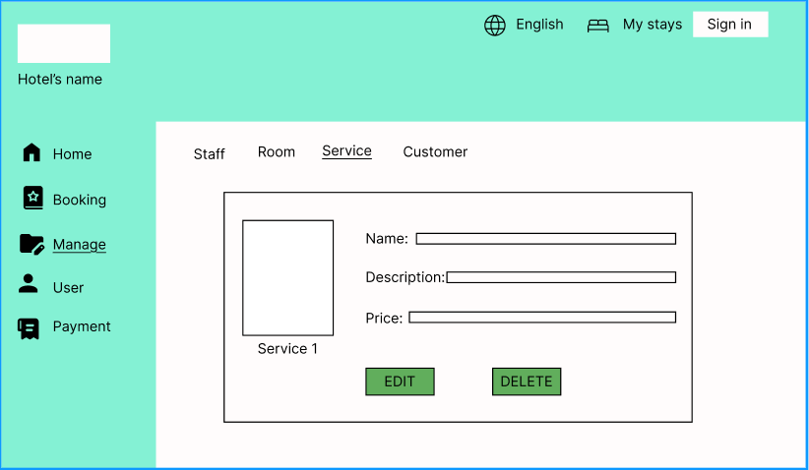

| **Screen** | View Service | | | | | |
| --- | --- | --- | --- | --- | --- | --- |
| **Description** | | Displays the service detailed information | | | | |
| **Screen Access** | | Click service name (link). | | | | |
| **Screen Content** | | | | | | |
| **Item** | | **Type** | **Data** | | **Description** | |
| Image | | Image |  | | Display image for the Service | |
| Name | | Label (text) |  | | Display the service name. | |
| Describe | | Label (text) |  | | Display service description. | |
| Price | | Label (text) |  | | Display service input. | |
| Edit | | Button |  | | Go to edit screen to change the information for the service. | |
| Delete | | Button |  | | Delete the service. | |
| **Screen Actions** | | | | | | |
| **Action Name** | | **Description** | | **Success** | | **Failure** |
| Click Edit button | | Click on the Edit button to change service name, service cost or service description. | | Show the Edit screen for you to change the information. | | No action. |
| Click delete | | Click on the delete button. | | Show a message box to check your decide. | | No action. |

**+ Manage Service (Edit Service)**

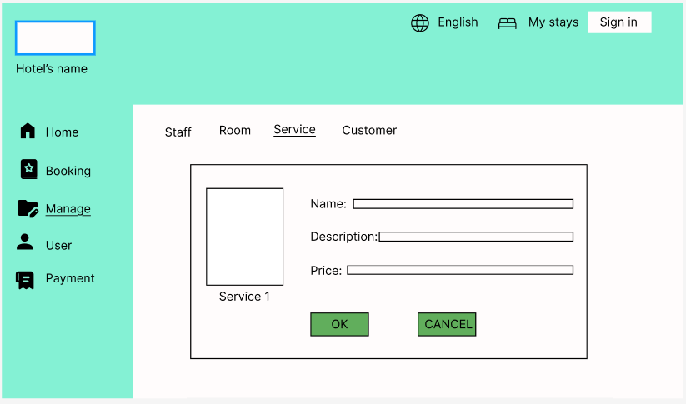

| **Screen** | Edit Screen | | | | | |
| --- | --- | --- | --- | --- | --- | --- |
| **Description** | | Edit the information of the service. | | | | |
| **Screen Access** | | Click Edit button from View service screen. | | | | |
| **Screen Content** | | | | | | |
| **Item** | | **Type** | **Data** | | **Description** | |
| Image | | Image |  | | Change image for the Service | |
| Name | | Textbox (text) |  | | Insert service name | |
| Describe | | Textbox (text) |  | | Insert service description | |
| Price | | Textbox (text) |  | | Insert service price | |
| OK | | Button |  | | Confirm change. | |
| Cancel | | Button |  | | Cancel changes. | |
| **Screen Actions** | | | | | | |
| **Action Name** | | **Description** | | **Success** | | **Failure** |
| Change text | | Retype new text into the textbox. | |  | |  |
| Click OK button | | Click on the OK button to do change service name, service cost or service description. | | Update and show the change in service manage screen. | | No action. |
| Click Cancel | | Click on the Cancel button. | | Show a message box to check your decide. | | No action. |

**+ Manage Service (Delete Service)**

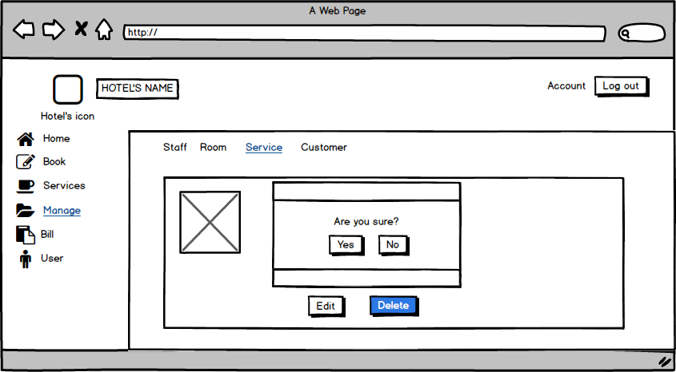

| **Screen** | Edit Screen | | | | | |
| --- | --- | --- | --- | --- | --- | --- |
| **Description** | | Delete chosen service. | | | | |
| **Screen Access** | | Click Delete button from View service screen. | | | | |
| **Screen Content** | | | | | | |
| **Item** | | **Type** | **Data** | | **Description** | |
| Image | | Image |  | | Display image for the Service | |
| Messabox | |  | OS | | Show a messagebox with a text “Are you sure” | |
| Yes | | Button |  | | Confirm deletion. | |
| No | | button |  | | Cancel action. | |
| **Screen Actions** | | | | | | |
| **Action Name** | | **Description** | | **Success** | | **Failure** |
| Show messbox | | A message box will show with the text. | | Show the text | | No action. |
| Click Yes button | | Click on the Yes button to confirm the service will be delete. | | update and no see the service into service manage screen. The message box disappear. | | The service still in the service manage screen. |
| Click No | | Click on the No button. | | Show a message box to check your decide. The message box disappear. | | No action. |

**+ Manage Customer**

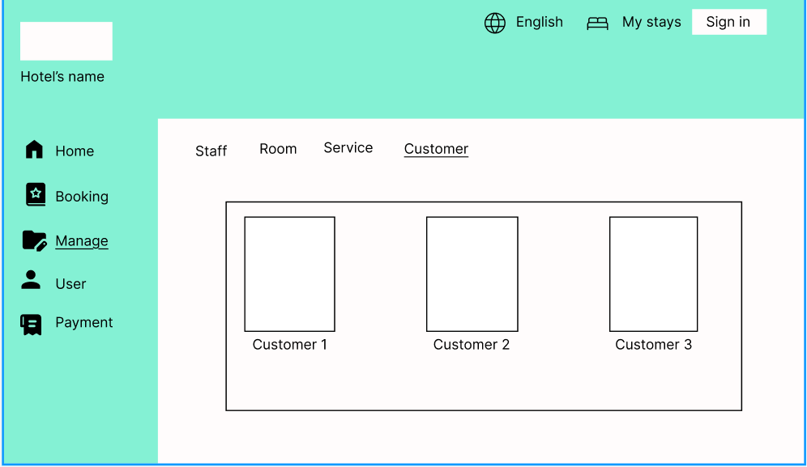

| **Screen** | Manage Customer | | | |
| --- | --- | --- | --- | --- |
| **Description** | | Show the customer information ( image and name) | | |
| **Screen Access** | | Click iteam Customer on the menu Manage. | | |
| **Screen Content** | | | | |
| **Item** | | **Type** | **Data** | **Description** |
| Image | | Image |  | Image for the Service |
| Customer1 | | link | Customer’s name | Link to Customer’s information. |

**+ Manage Customer (Add Customer)**

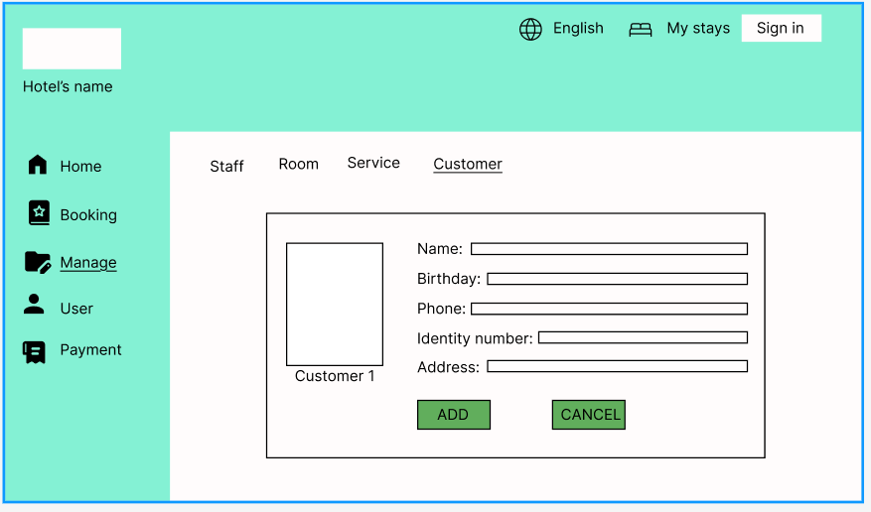

**+ Manage Customer (View Customer)**

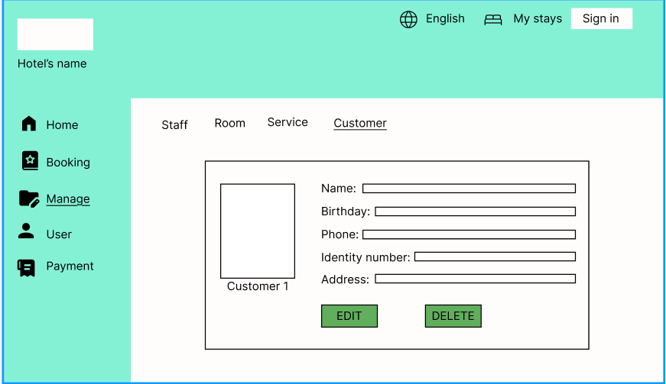

| **Screen** | View Customer | | | | | |
| --- | --- | --- | --- | --- | --- | --- |
| **Description** | | Show the customer information . | | | | |
| **Screen Access** | | Click Customer name (link) From customer manage. | | | | |
| **Screen Content** | | | | | | |
| **Item** | | **Type** | **Data** | | **Description** | |
| Image | | Image |  | | Image for the Service | |
| Name Customer | | Label (text) |  | | Display Name Customer | |
| Birthday | | Label (text) |  | | Display customer birthday. | |
| Phone number | | Label (text) |  | | Display phone number | |
| Email | | Label (text) |  | | Display Email | |
| address | | Label |  | | Display customer address. | |
| Edit | | Button |  | | Edit Customer information | |
| Delete | | Buton |  | | Delete Customer | |
| **Screen Actions** | | | | | | |
| **Action Name** | | **Description** | | **Success** | | **Failure** |
| Click Edit button | | Click on Edit button to edit customer information. | | Show Edit customer Screen | | No action. |
| Click Delete button | | Click on the delete button to delete customer. | | The customer will be delete from Customer manage screen. | | No action. |

**+ Manage Customer (Edit Customer)**

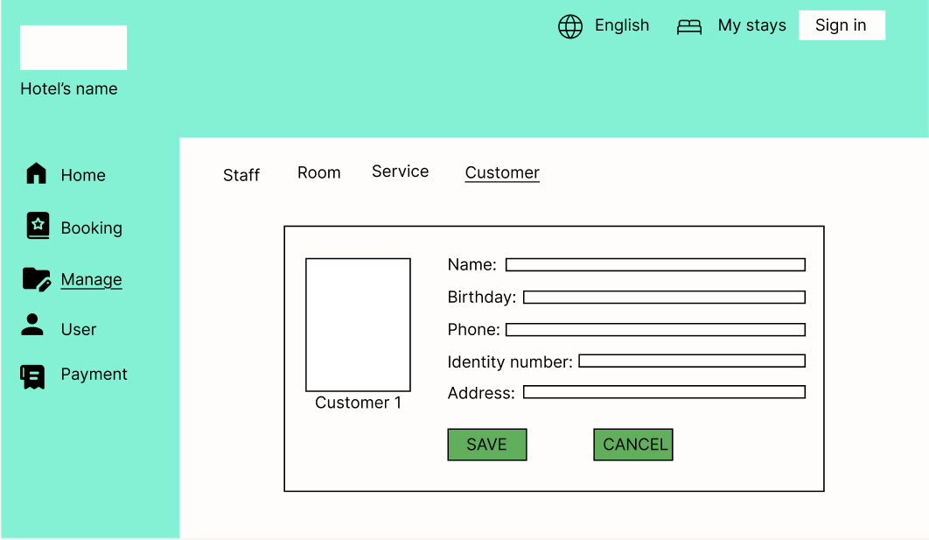

| **Screen** | Edit Customer Screen. | | | | | |
| --- | --- | --- | --- | --- | --- | --- |
| **Description** | | Show the customer information, and the textbox for change. | | | | |
| **Screen Access** | | Click Edit button from Customer View Screen. | | | | |
| **Screen Content** | | | | | | |
| **Item** | | **Type** | **Data** | | **Description** | |
| Image | | Image |  | | Display Image, Edit image | |
| Name Customer | | TextBox (text) |  | | Edit Name here | |
| Birthday | | TextBox (text) |  | | Edit customer birthday. | |
| Phone number | | TextBox (text) |  | | Edit phone number | |
| Email | | TextBox (text) |  | | Show Email | |
| address | | TextBox (text) |  | | Edit customer address. | |
| Save | | Button |  | | To save and update Customer information | |
| Cancel | | Buton |  | | Exit and return to customer view screen | |
| **Screen Actions** | | | | | | |
| **Action Name** | | **Description** | | **Success** | | **Failure** |
| Click Save button | | Click on save button to save customer information. | | Update customer information on customer manage. | | No action. |
| Click Cancel button | | Click on the Canel button to exit. | | Return View Customer Screen. | | No action. |

**+ Manage Customer (Delete Customer)**

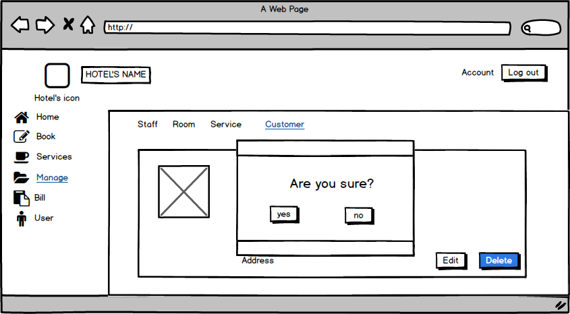

| **Screen** | Edit Customer Screen. | | | | | |
| --- | --- | --- | --- | --- | --- | --- |
| **Description** | | Show the customer information, and the textbox for change. | | | | |
| **Screen Access** | | Click Delete button from Customer View Screen. | | | | |
| **Screen Content** | | | | | | |
| **Item** | | **Type** | **Data** | | **Description** | |
| Image | | Image |  | | Display Image, Edit image | |
| Message box | |  |  | | Display message box | |
| Yes | | Button |  | | Confirm deletion. | |
| No | | Buton |  | | Cancel and return to customer view screen | |
| **Screen Actions** | | | | | | |
| **Action Name** | | **Description** | | **Success** | | **Failure** |
| Click Yes button | | Click on Yes button . | | The customer information will be deleted. | | No action. |
| Click No button | | Click on the No button | | Return View Customer Screen. | | No action. |

**+ Bill**

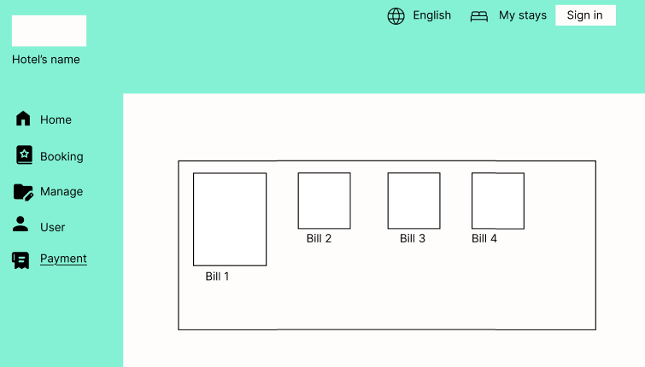

| **Screen** | Bill | | | | | |
| --- | --- | --- | --- | --- | --- | --- |
| **Description** | | Displays list of bills. | | | | |
| **Screen Access** | | Click item Payment. | | | | |
| **Screen Content** | | | | | | |
| **Item** | | **Type** | **Data** | | **Description** | |
| Bill | | link |  | | Link to detailed bill information. | |
| Table List | | table |  | | Display list of bills. | |
| **Screen Actions** | | | | | | |
| **Action Name** | | **Description** | | **Success** | | **Failure** |
| show bills | | Show the information of all the bills. | |  | |  |

**+ Bill (User’s bill)**

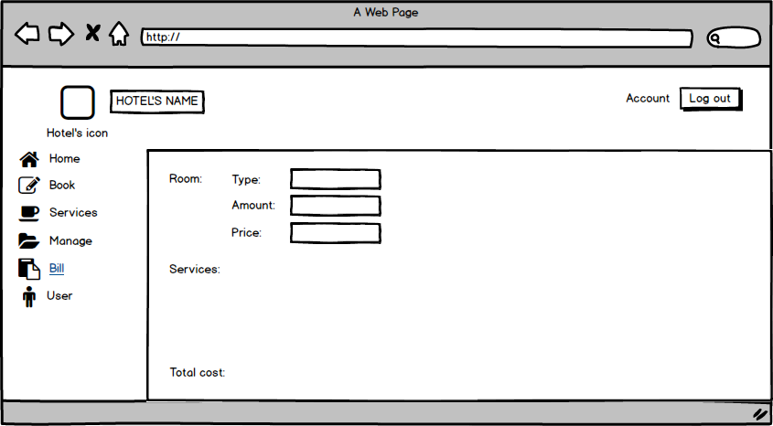

| **Screen** | Bill | | | |
| --- | --- | --- | --- | --- |
| **Description** | | Display information about type, amount, price of room and total cost. | | |
| **Screen Access** | | View information | | |
| **Screen Content** | | | | |
| **Item** | | **Type** | **Data** | **Description** |
| Type (Room) | | Text field | Type of room | * Display information about type of room |
| Amount (Room) | | Number | Number of room | * Display room number |
| Price (Room) | | Number | Price | * Display Price |
| Services | | Text field | Service list | * Display Service list |
| Total cost | | Number | Total cost | * Display Total cost |

**+ User**

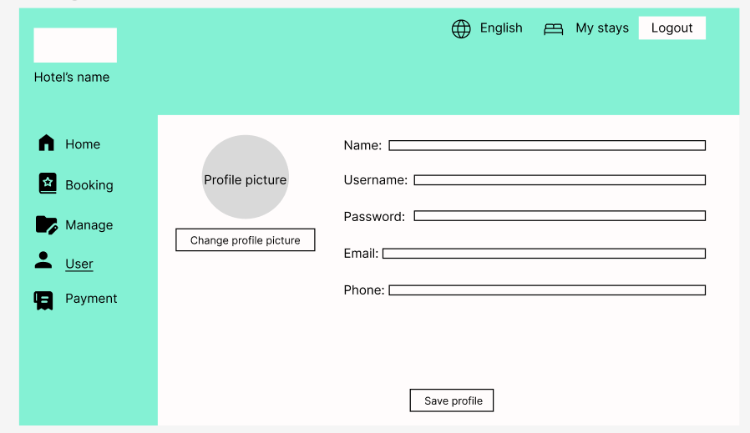

| **Screen** | User | | | |
| --- | --- | --- | --- | --- |
| **Description** | | View, edit user profile | | |
| **Screen Access** | | Click User menu | | |
| **Screen Content** | | | | |
| **Item** | | **Type** | **Data** | **Description** |
| name | | Text field | Export from database | * Display full name * Type in the text box to change full name |
| Email | | Tex field | Export from database | * Display registered email * Type in the text box to change email |
| Username | | Tex field | Export from database | * Display username. * Type in the text box to change username |
| phone | | Tex field | Export from database | * Display phone number * Type in the text box to change phone number |
| password | | Text box | Insert old password | * Display password in *** |
| Profile picture | | Image | Export from database | * Display profile picture |
| Change profile picture button | | Button | - | * Click to choose new profile picture |
| Save profile | | button | - | * Click to save profile. |

# **DATA STRUCTURE**

## ***Entity diagram***

* 1. 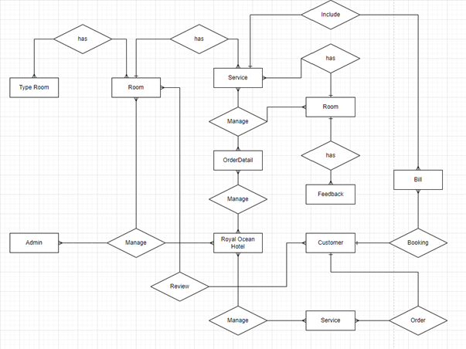

## ***Database***

* 1. 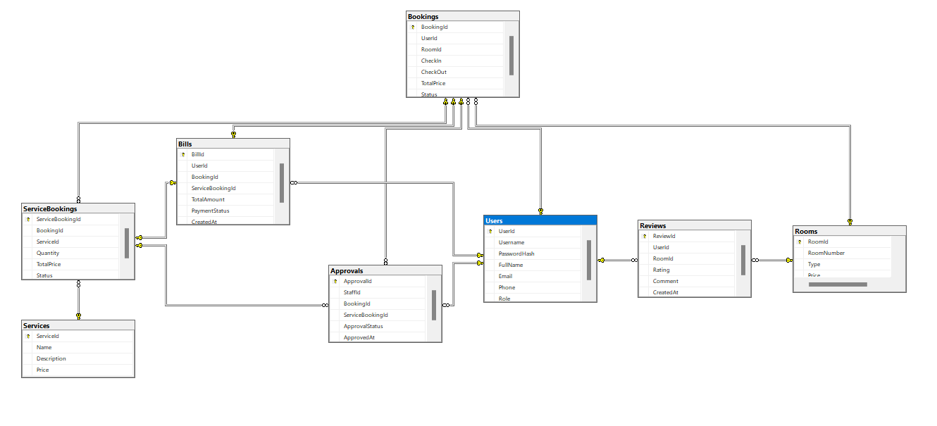

Null = Yes: allow empty value.

Null = No: disallow empty value.

PK: primary key.

FK: foreign key.

Int: 4-byte integer type.

Char: character type.

Money: monetary data types 8 bytes.

DateTime: date data type 8 bytes.

Nvarchar: Unicode data type.

| User | | | | |
| --- | --- | --- | --- | --- |
| Field name | Data type | Null | Key | Note |
| UserId | Int(4) | No | PK |  |
| Username | Nvarchar(20) | No | FK |  |
| PasswordHash | Nvarchar(20) | No |  |  |
| FullName | Nvarchar(20) | No |  |  |
| Email  Phone | Nvarchar(70)  Nvarchar(20) | No  No |  |  |
| Role | Nvarchar(20) | No |  |  |

| Room | | | | |
| --- | --- | --- | --- | --- |
| Field name | Data type | Null | Key | Note |
| RoomId | Int(4) | No | PK |  |
| RoomNumber | Nvarchar(20) | No |  |  |
| Price | Float | No |  | Price(VND) |
| Status | Nvarchar(20) | No |  |  |

| SERVICE | | | | |
| --- | --- | --- | --- | --- |
| Field name | Data type | Null | Key | Note |
| Name | Int(4) | No |  |  |
| ServiceID | Int(4) | No | PK |  |
| Price | Float | No |  | Price(VND) |
|  |  |  |  |  |

| ServiceBooking | | | | |
| --- | --- | --- | --- | --- |
| Field name | Data type | Null | Key | Note |
| ServiceBookingId | Int(4) | No | PK |  |
| BookingId | Int(4) | No | FK |  |
| ServiceId | Int(4) | No | FK |  |
| Quantity | Int(4) | No |  |  |
| TotalPrice | Float | No |  |  |
| Status | Nvarchar(20) | No |  |  |
|  |  |  |  |  |

| Booking | | | | |
| --- | --- | --- | --- | --- |
| Field name | Data type | Null | Key | Note |
| BookingId | Int(4) | No | PK |  |
| UserId | Int(4) | No | FK |  |
| RoomId | Int(4) | No | FK |  |
| Gender | Char(1) | No |  | O: male  X: female |
| CheckIn | DateTime(8) | No |  |  |
| CheckOut | DateTime(8) | No |  |  |
| TotalPrice | Float | No |  |  |
| Status | Nvarchar(20) | Yes |  |  |

| Review | | | | |
| --- | --- | --- | --- | --- |
| Field name | Data type | Null | Key | Note |
| ReviewId | Int(4) | No | PK |  |
| UserId | Int(4) | No | FK |  |
| RoomId | Int(4) | No | FK |  |
| Rating | Int(5) | No |  |  |
| Comment | Nvarchar(70) | No |  |  |

| Bill | | | | |
| --- | --- | --- | --- | --- |
| Field name | Data type | Null | Key | Note |
| BillId | Int(4) | No | PK |  |
| UserId | Int(4) | No | FK |  |
| BookingId | Int(4) | No | FK |  |
| ServiceBookingId | Int(4) | No | FK |  |
| TotalAmount | Float | No |  | Price(VND) |
| PaymentStatus | Nvarchar(20) | No |  |  |

| Approval | | | | |
| --- | --- | --- | --- | --- |
| Field name | Data type | Null | Key | Note |
| ApprovalId | Int(4) | No | PK |  |
| StaffId | Int(4) | No | FK |  |
| BookingId | Int(4) | No | FK |  |
| ServiceBookingId | Int(4) | No | FK |  |
| ApprovalStatus | Nvarchar(20) | No |  |  |
|  |  |  |  |  |

|  | | | | |
| --- | --- | --- | --- | --- |
|  |  |  |  |  |
|  |  |  |  |  |
|  |  |  |  |  |
|  |  |  |  |  |
|  |  |  |  |  |

# **NON-FUNCTIONAL REQUIREMENTS AND OTHERS**

Performance

| **No.** | **Requirement** |
| --- | --- |
| 1. | The load time for user interface screens shall take no longer than two seconds. |
| 2. | The log in information shall be verified within five seconds. |
| 3. | Queries shall return results within five seconds. |

Security

| **No.** | **Requirement** |
| --- | --- |
| 1. | Customer Service Representatives and Managers will be able to log in to the Hotel Management System. |
| 2. | Customer Service Representatives will have access to the Reservation/Booking and Food subsystems |
| 3. | Managers will have access to the Management subsystem as well as the Reservation/Booking and Food subsystems |
| 4. | Access to the various subsystems will be protected by a user login screen that requires a username and password |

Design Constraints

| **No.** | **Requirement** |
| --- | --- |
| 1. | The Hotel Management System shall be a stand-alone system running in a Windows environment. |
| 2. | The system shall be developed using PHP and an MySQL database. |

Standards Compliance

| **No.** | **Requirement** |
| --- | --- |
| 1. | There shall be consistency in variable names within the system. The graphical user interface shall have a consistent look and feel. |

Reliability

| **No.** | **Requirement** |
| --- | --- |
| 1. | Specify the factors required to establish the required reliability of the software system at time of delivery |

Availability

| **No.** | **Requirement** |
| --- | --- |
| 1. | The system shall be available during normal hotel operating hours. |

Maintainability

| **No.** | **Requirement** |
| --- | --- |
| 1. | The Hotel Management System is being developed in PHP. PHP is an object oriented programming language and shall be easy to maintain. |

Portability

| **No.** | **Requirement** |
| --- | --- |
| 1. | The Hotel Management System shall run in any Microsoft Windows environment that contains the MySQL database |

# 