FPT UNIVERSITY
COMMUNICATION SYSTEMS — COS201
PROJECT REPORT
BPSK MODULATOR AND
DEMODULATOR USING VERILOG HDL
Digital Communication • Top-down RTL Design • Golden Model Verification

Member 1: Lam Quoc Trung
Member 2: Than Ngoc Tan Hoang
Member 3: Le Cuong Thinh
Member 4: Le Ngo Hoang Nguyen
Lecturer: Pham The Vinh
Ho Chi Minh City — 01 November 2026

ABSTRACT
This report presents the top-down design and functional verification of a digital Binary Phase Shift Keying (BPSK) communication system implemented in Verilog HDL. The modulator converts each input bit into eight signed 16-bit carrier samples. A deterministic digital channel can invert a selected symbol, the correlator-based demodulator reconstructs the received bit, and a BER counter matches transmitted and received bits to count errors. An independent Python Golden Model produces reference vectors used by a self-checking Verilog testbench.
The integrated design was compiled and simulated in ModelSim Intel FPGA Edition 2020.1 on 01 November 2026. All 17 defined end-to-end test cases passed, with zero simulator errors and zero warnings. The Python Golden Model was used to verify the transmitted samples, received samples, recovered bits, and BER counters. Separate Modulator verification confirmed the correct eight-sample carrier waveforms for bits 0 and 1. Demodulator verification also passed two 16-bit scenarios: a clean transmission with BER = 0% and a controlled one-symbol inversion with BER = 6.25%.
7.2 Demodulator — No-Error ScenarioScope: functional RTL simulation of a deterministic sign-inversion channel, rather than an AWGN or real-RF transmission environment. Physical FPGA or ASIC implementation is outside this project’s verified scope.

1. INTRODUCTION AND OBJECTIVES
Binary Phase Shift Keying (BPSK) represents binary data with two carrier phases separated by 180 degrees. This project implements the corresponding digital sign inversion using a finite carrier lookup table (LUT), demonstrating the complete development path from system specification to Verilog RTL, integration, and Golden Model comparison.
- Implement the Modulator → Channel → Demodulator → BER Counter communication chain.
- Represent one input bit with eight signed 16-bit carrier samples.
- Use self-checking testbenches instead of relying only on visual waveform inspection.
- Report the number of compared bits and mismatches; calculate BER = error_bits / total_bits after simulation.

2. TOP-DOWN DESIGN METHODOLOGY AND ARCHITECTURE
The top-down process starts with the system requirements, partitions the communication path into functional blocks, specifies each interface and timing contract, implements Verilog modules separately, integrates them at bpsk_top, and finally checks the complete RTL against independent Python reference data.
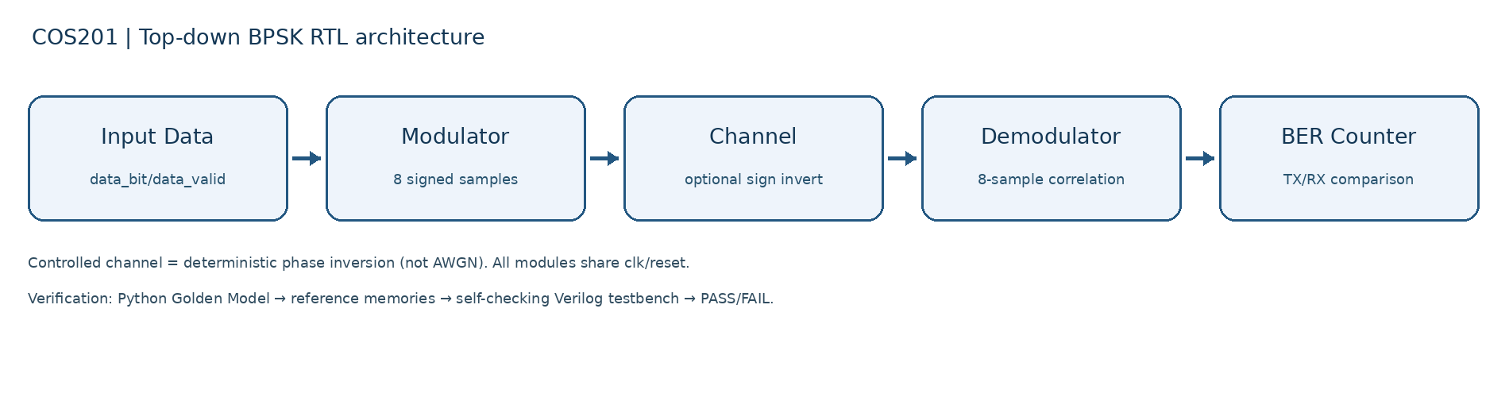
Figure 1. Top-down architecture of the digital BPSK communication chain.
Data flow: dDemodulatorata_bit and data_valid → bpsk_modulator → tx_sample and tx_sample_valid → channel → rx_sample and rx_sample_valid → bpsk_demodulator → recovered_bit and bit_valid. The BER counter receives the original transmitted bits and decoded bits, matches them in order, and outputs total_bits and error_bits. All stages share clk and active-high reset.

3. SYSTEM SPECIFICATION AND INTERFACES
Property | Value / specification
Modulation | BPSK; bit 0 = +carrier; bit 1 = -carrier
Carrier LUT | [0,707,1000,707,0,-707,-1000,-707]
Samples / symbol | 8 valid samples per input bit
Sample width | 16-bit signed
Clock / Reset | Rising-edge clock; active-high reset
Channel | Pass-through or inversion of the selected BPSK symbol
Demodulation | 8-sample correlation; negative result → bit 1
Output BER | 32-bit total_bits and error_bits counters

Input timing contract: a one-cycle data_valid pulse is permitted only when the modulator is idle. The interface does not expose ready and does not buffer new input bits while the modulator produces eight samples. The registered channel stage delays samples and sample_valid by one clock; bit_valid is asserted after the eighth valid received sample.

4. DETAILED RTL DESIGN

4.1 BPSK Modulator — rtl/bpsk_modulator.v
The eight-entry carrier is c[k] = [0, 707, 1000, 707, 0, −707, −1000, −707]. For input bit b, sample x[k] = (−1)^b × c[k] for k = 0…7. The active flag and three-bit sample counter sequence the eight valid samples. A one-cycle sample_valid pulse accompanies each output sample.

4.2 Digital Channel — rtl/channel.v
The channel is a registered data/valid stage. When error_enable is asserted and symbol_cnt equals error_symbol_index, the selected symbol’s samples are sign-inverted, r[k] = −x[k]; otherwise r[k] = x[k]. A three-bit sample counter identifies the eight samples and an eight-bit symbol counter identifies the selected symbol, wrapping after 256 symbols.

4.3 Correlation-Based Demodulator — rtl/bpsk_demodulator.v
The demodulator multiplies each signed received sample by the same reference carrier and accumulates D = Σ r[k] × c[k] for k = 0…7. At the eighth valid sample, recovered_bit is set to 1 if D < 0 and 0 otherwise; bit_valid is asserted for one clock. The correlation accumulator is signed and reset after every complete symbol.

4.4 BER Counter — rtl/ber_counter.v
The BER counter uses a 16-entry FIFO to preserve transmitted-bit order while waiting for their decoded counterparts. On a valid received bit and nonempty FIFO, it compares the oldest transmitted bit with the recovered bit. Every comparison increments total_bits; every mismatch also increments error_bits. Floating-point division is intentionally performed outside the RTL: BER = error_bits / total_bits.

4.5 Top-Level Integration — rtl/bpsk_top.v
The top-level module connects the four functional blocks. Inputs are clk, reset, data_bit, data_valid, error_enable, and error_symbol_index[7:0]. Outputs are recovered_bit, bit_valid, total_bits[31:0], and error_bits[31:0]. TX and RX samples are available as internal top-level signals for verification.

5. PYTHON GOLDEN MODEL AND VERILOG TESTBENCH
The independent reference model, model/golden_model.py, computes integer-valued BPSK modulation, optional symbol sign inversion, correlation-based recovery, and expected bit errors. It generates the reproducible memory files under model/reference/, including vectors.mem, golden_tx_samples.mem, golden_rx_samples.mem, golden_rx_bits.mem, and per-case configurations.
The self-checking SystemVerilog testbench, tb/tb_bpsk_system.v, reads these memories and compares RTL TX samples, channel RX samples, recovered bits, valid signal timing, and BER counters with expected values. A mismatch produces FAIL output. Separate unit testbenches are included for the channel and BER counter.

6. GOLDEN MODEL COMPARISON RESULTS
The results below are taken from the integrated ModelSim simulation executed on 01 November 2026, using the five team RTL modules and the official reference memories. The tested scenarios are representative functional tests and do not prove exhaustive correctness for every possible input or timing pattern.
ID | Test case | Bits | Errors | Result
0 | first_bit_one | 8 | 0 | PASS
1 | all_zero | 8 | 0 | PASS
2 | all_one | 8 | 0 | PASS
3 | alternating | 8 | 0 | PASS
4 | pattern_A5 | 8 | 0 | PASS
5 | pattern_B2 | 8 | 0 | PASS
6 | error_middle | 8 | 1 | PASS
7 | error_first | 8 | 1 | PASS
8 | error_last | 8 | 1 | PASS
9 | error_outside | 8 | 0 | PASS
10 | random_100 | 100 | 0 | PASS
11 | random_100_error | 100 | 1 | PASS
12 | gapped_input | 8 | 1 | PASS
13 | reset_mid_symbol | 2 | 0 | PASS
14 | index_255 | 256 | 1 | PASS
15 | fifo_wrap_300 | 300 | 0 | PASS
16 | idle_no_input | 0 | 0 | PASS

The simulator reported “TEST PASS: 17 cases; scope=team_rtl”, followed by “Errors: 0, Warnings: 0”. The run ended at simulation time 72,160 ns. The cases cover correct transmission, selected single-symbol inversions, out-of-range error selection, random 100-bit streams, spaced input, mid-symbol reset, the 255th symbol, 300-bit FIFO/wrap behavior, and an idle case. A single run with multiple deliberately corrupted symbols has not been separately demonstrated in the end-to-end tests.
An independent Python Golden Model (model/golden_model.py) generates reference data for the BPSK communication system, including expected transmitted samples, received samples, recovered bits, and bit error counts.
The self-checking Verilog Testbench (tb/tb_bpsk_system.v) compares the actual RTL outputs against the Golden Model reference data. The verification checks four major components:
- TX Samples: The Modulator output must match the expected BPSK carrier samples.
- RX Samples: The Channel output must match the expected received samples after controlled error injection.
- Recovered Bits: The Demodulator decisions must match the expected recovered bits.
- BER Counters: The total bit count and error bit count must match the expected values.
The integrated system was simulated using ModelSim Intel FPGA Edition 2020.1 on November 1, 2026.
Verification Result: 17/17 test cases PASSED, with 0 simulator errors and 0 warnings.
These results confirm that the Verilog RTL implementation agrees with the Python Golden Model for all 17 defined verification scenarios.

7. WAVEFORMS AND MODULE-LEVEL EVIDENCE

7.1 Modulator — 8-Sample Comparison for Bits 0 and 1
Member 1 supplied modulator_results.csv with two PASS rows for input bits 0 and 1; each row reports eight valid samples with zero mismatches. The attached modulator_trace.csv samples agree with the carrier LUT and its sign inversion. Figure 2 illustrates both sample sequences.
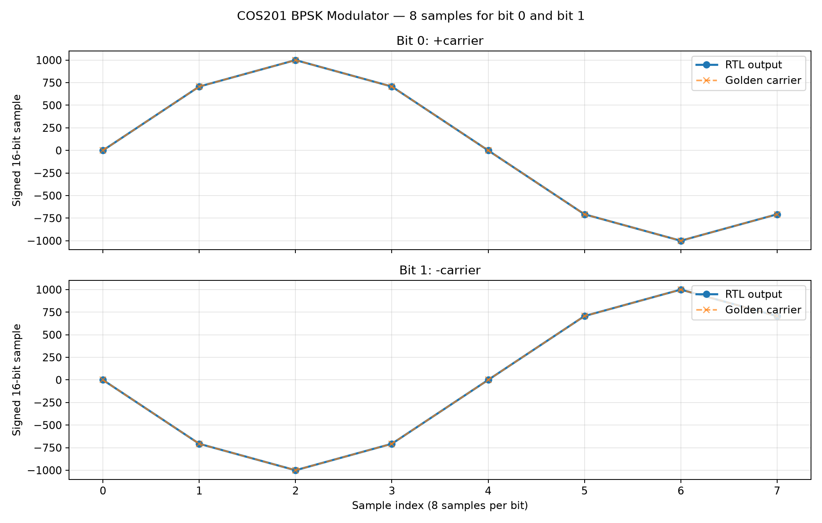
Figure 2. Transmitted BPSK carrier samples for bit 0 and bit 1.

7.2 Demodulator — Clean and Single-Error Verification
The BPSK Demodulator was verified using two scenarios, each containing 16 transmitted bits and 128 received samples.
Scenario 0 — No Error: All 16 recovered bits matched the transmitted bits, resulting in BER = 0/16 = 0%.
Scenario 1 — One Bit Error: Symbol index 3 was intentionally inverted. The demodulator recovered 15 correct bits and one incorrect bit, resulting in BER = 1/16 = 6.25%.
Both scenarios passed with zero RTL mismatches against the expected demodulation decisions. The demodulator uses correlation-based detection: a nonnegative correlation indicates bit 0, while a negative correlation indicates bit 1.
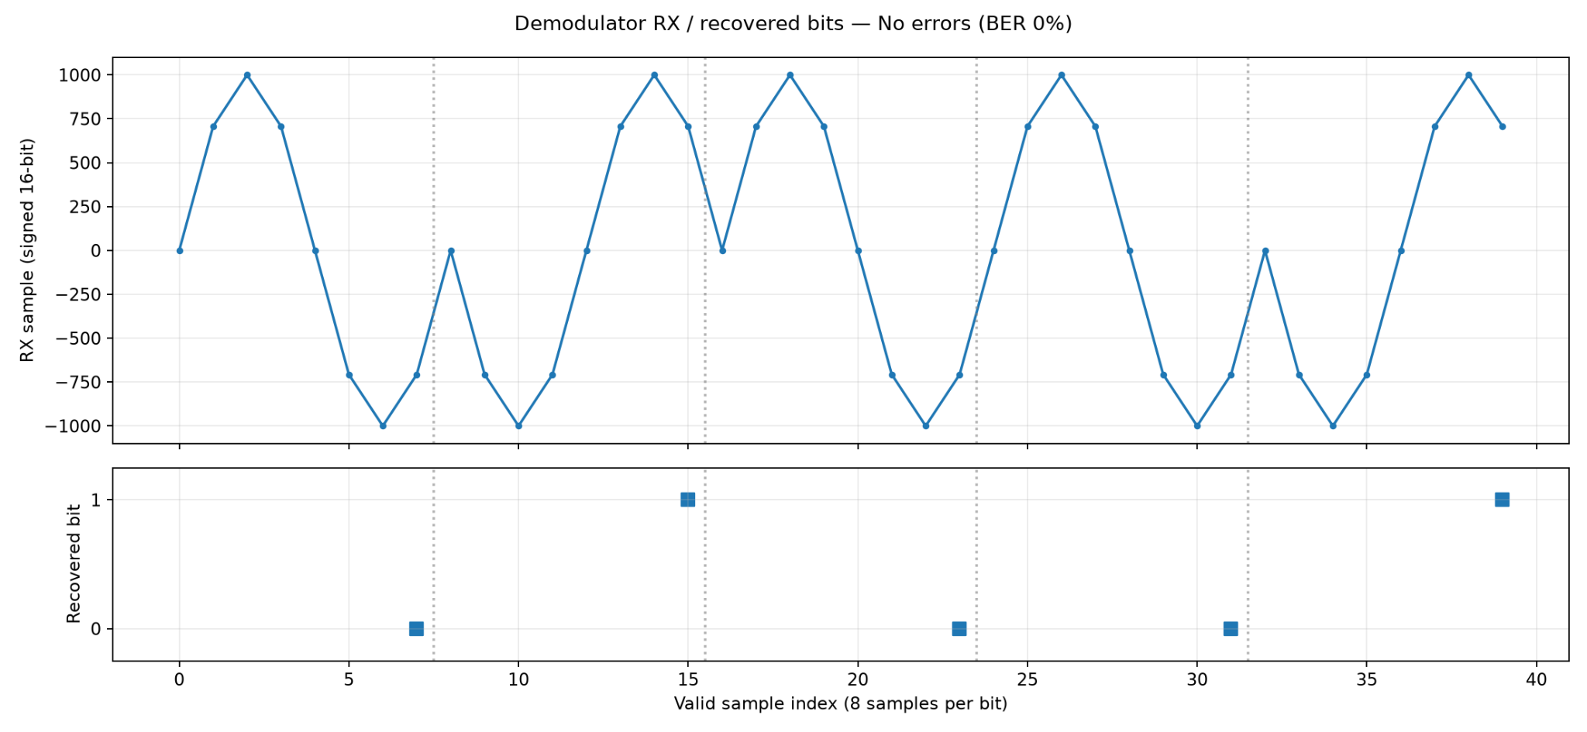
Figure 3. Representative no-error demodulator simulation waveform.
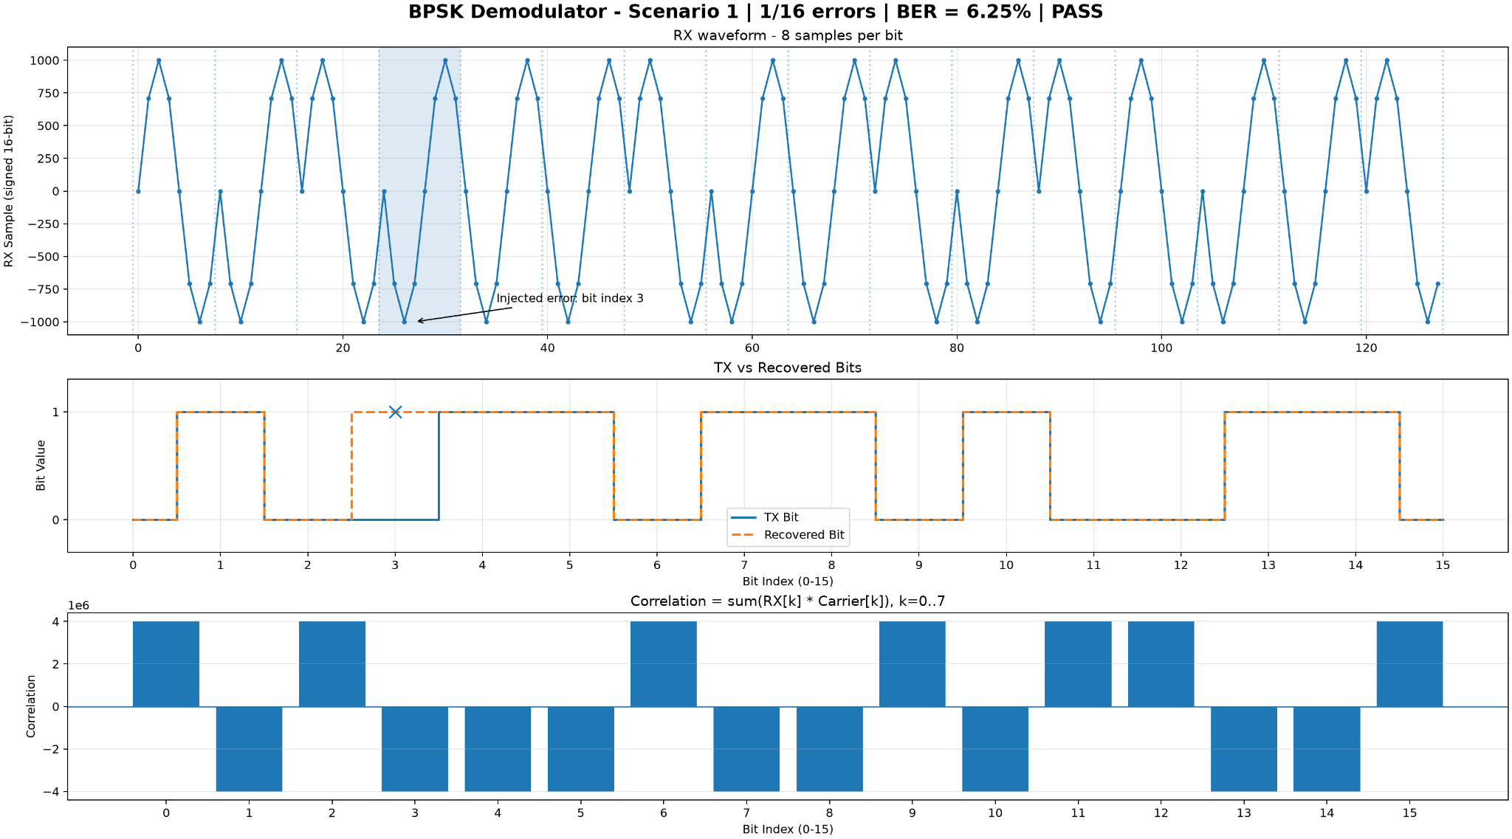
Figure 4. BPSK demodulator verification with one inverted symbol at index 3. The recovered sequence contains 1 bit error out of 16 bits, corresponding to BER = 6.25%.

Verification note: Both standalone demodulator scenarios were verified using the submitted simulation results. The clean scenario passed with 0 errors out of 16 bits (BER = 0%), while the controlled single-error scenario passed with 1 error out of 16 bits (BER = 6.25%). These results complement the integrated system verification, in which all 17 test cases passed against the Python Golden Model reference.

8. LIMITATIONS AND FUTURE WORK
- The digital channel performs deterministic sign inversion rather than modeling AWGN or real communication noise.
- The receiver assumes a known reference carrier and aligned samples; it has no carrier or timing recovery, PLL, or Costas loop.
- The modulator ignores new data_valid pulses while busy and provides no input-ready handshake.
- The channel symbol index wraps after 256 symbols, and the BER matching FIFO contains 16 entries.
- The reported findings concern RTL simulation; FPGA deployment, synthesis timing, and hardware performance have not been validated.

9. CONCLUSION
The project implemented a complete digital BPSK transmit–channel–receive chain in Verilog HDL using a top-down workflow. Individual module designs were integrated into bpsk_top and verified with an independent Python Golden Model and a self-checking testbench. The documented ModelSim run on 01 November 2026 passed all 17 defined end-to-end scenarios without reported errors or warnings. The architecture, module interfaces, design limitations, and reproducible verification instructions provide a foundation for later AWGN-channel and FPGA extensions.

APPENDIX A — REPRODUCING THE MODELSIM TESTS
From the repository root in Windows PowerShell, with ModelSim/QuestaSim available on PATH:
New-Item -ItemType Directory -Force simulation/results | Out-Null
vlog -sv +incdir+. rtl/bpsk_modulator.v rtl/channel.v rtl/bpsk_demodulator.v rtl/ber_counter.v rtl/bpsk_top.v tb/tb_bpsk_system.v
vsim -c tb_bpsk_system -do "run -all; quit -f"
An alternative Icarus Verilog flow is available through python run_tests.py, provided Python 3, iverilog, and vvp are installed. This separate runner was not independently verified by the ModelSim log above.

APPENDIX B — REPOSITORY REFERENCES
- docs/block_diagram.md
- docs/system_specification.md
- docs/interface_specification.md
- docs/channel_design.md
- docs/ber_design.md
- docs/task_tracking.md
- model/golden_model.py
- tb/tb_bpsk_system.v
- rtl/bpsk_top.v
GitHub repository: https://github.com/Chun241006/BPSK-Verilog-Communication-System

COS201 — VISUAL DESIGN AND VERIFICATION SUPPLEMENT
Illustrated RTL architecture, actual module-level design, independent Python Golden Model and verified simulation evidence. Add this supplement to the existing final report without replacing group details or previous edits.

SUPPLEMENT A — TOP-DOWN AND DETAILED RTL DESIGN

A.1 Top-down architecture and signal interfaces
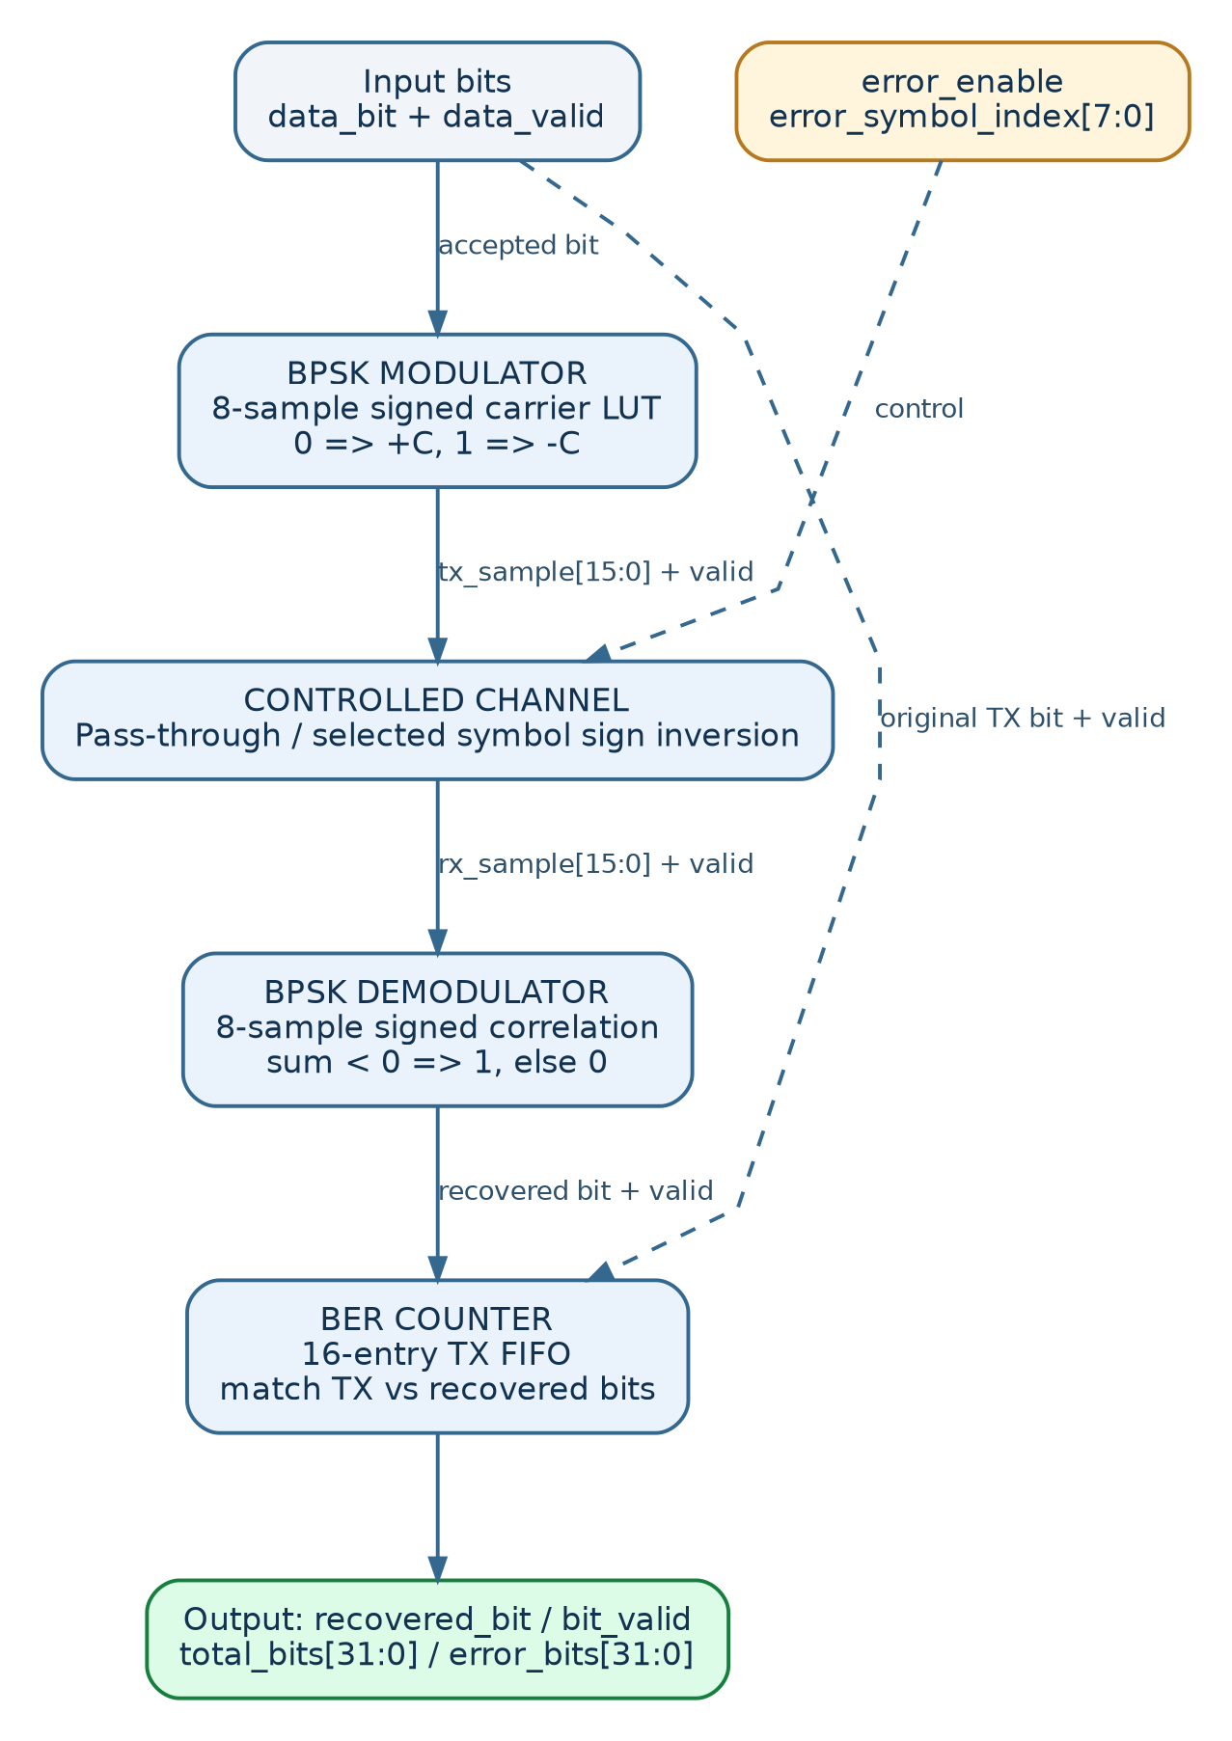
Figure A1. Top-down RTL data path, control signals and BER monitoring.
The four processing modules are instantiated in rtl/bpsk_top.v. All modules share clk and active-high reset. Internal sample buses are signed 16-bit values; the top-level exposes recovered_bit, bit_valid and 32-bit total/error counters. The BER counter also stores the original transmitted bits in a 16-entry FIFO.
Digital scope: carrier values come from an eight-sample lookup table; the channel applies deterministic sign inversion. The design does not implement analog RF, AWGN, carrier recovery or FPGA deployment.

A.2 Modulator and Channel — implementation details
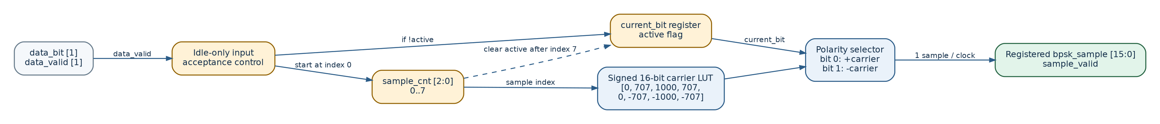
Figure A2. BPSK Modulator RTL: 8-entry carrier LUT, active flag, sample counter and polarity selection.
Modulator: data_valid is accepted only while active=0. The controller emits eight signed samples (indices 0–7) per input bit. Bit 0 selects +carrier; bit 1 selects −carrier. sample_valid accompanies every output sample.
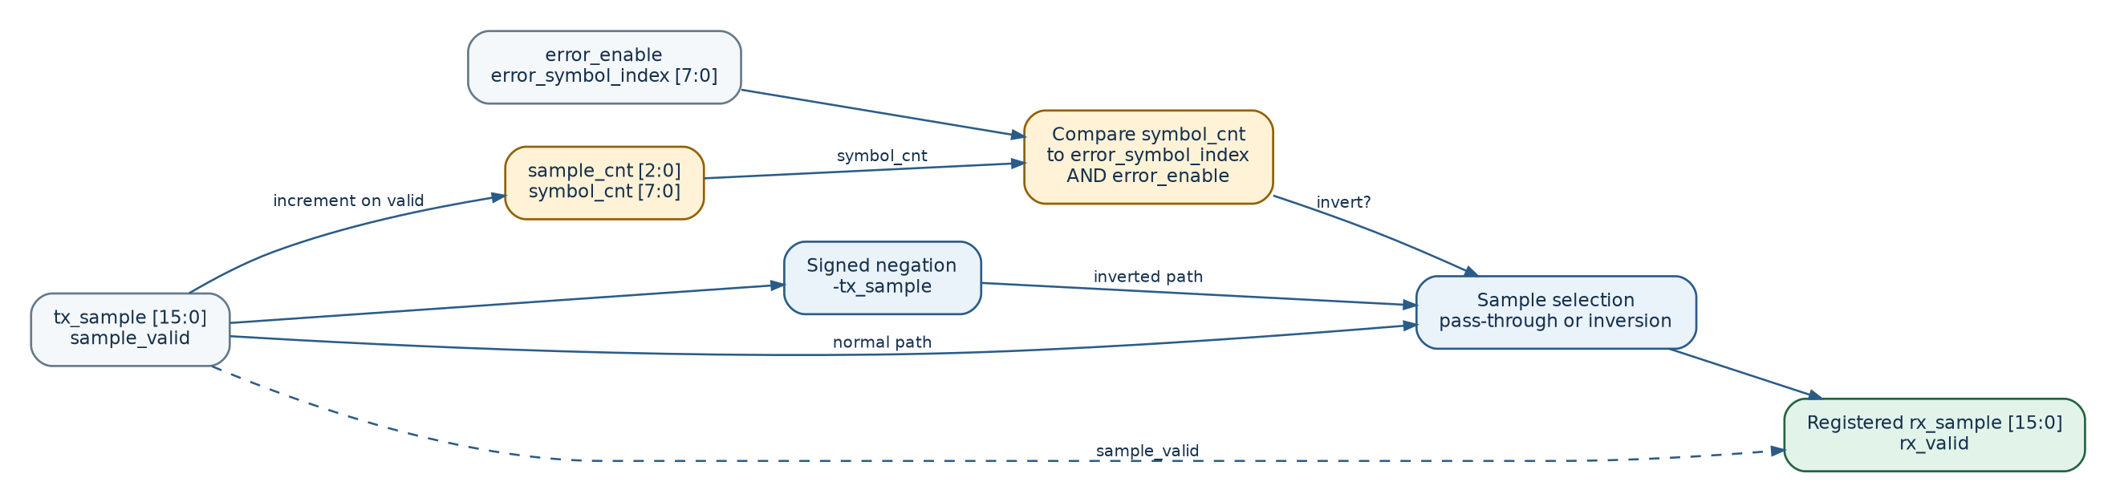
Figure A3. Controlled Channel RTL: symbol selection, conditional sample inversion and registered RX output.
Channel: sample_cnt advances on valid samples and symbol_cnt increments once per group of eight. When error_enable=1 and symbol_cnt matches error_symbol_index, the valid samples are negated; otherwise they pass unchanged. rx_sample and rx_valid are registered together.

A.3 Demodulator — signed correlation detector
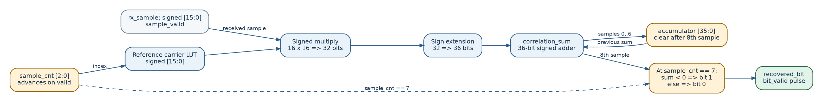
Figure A4. RTL Demodulator: signed multiplication, sign extension, 36-bit accumulation and 8th-sample hard decision.
At valid sample index k, the demodulator multiplies RX[k] by C[k] using signed 16×16 multiplication, sign-extends the product to 36 bits, then accumulates the result. At k=7, the current correlation sum determines the recovered bit. bit_valid pulses for one cycle.
C = [0, 707, 1000, 707, 0, −707, −1000, −707]. Decision: recovered_bit = 1 if Σ(RX[k]×C[k]) < 0; otherwise 0. For an ideal clean symbol, the correlation magnitude is 3,999,396.

A.4 BER Counter — matching received and transmitted bits
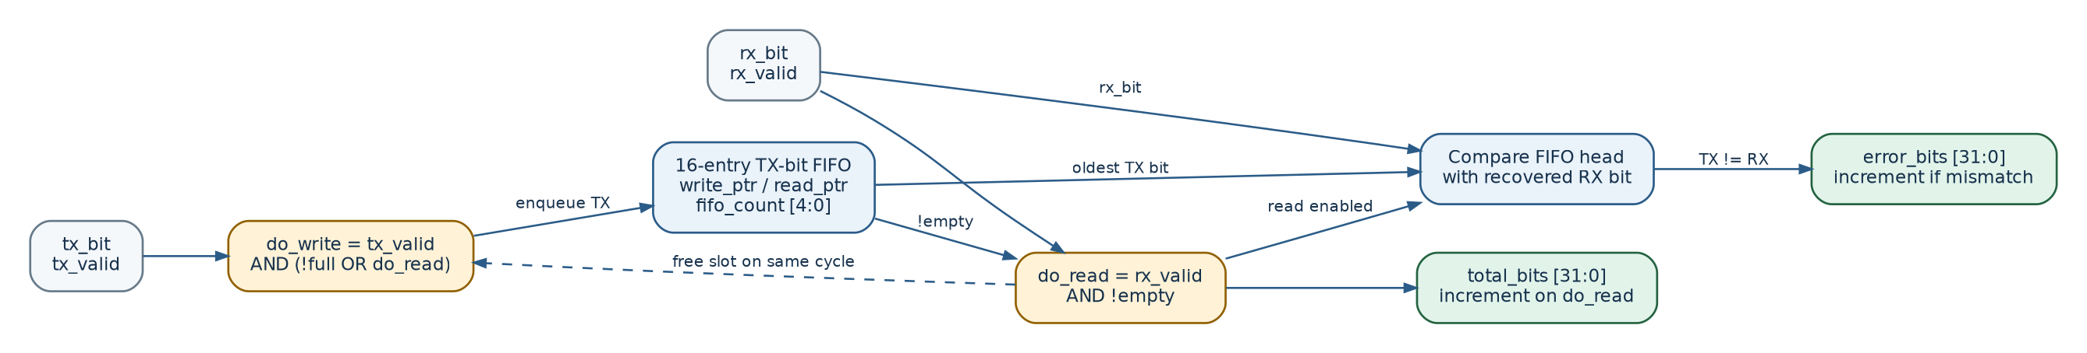
Figure A5. BER Counter RTL: 16-entry TX FIFO, bit comparator, total count and error count.
The FIFO stores transmitted bits until the corresponding recovered bits arrive. A successful dequeue increments total_bits; if the FIFO head differs from the recovered bit, error_bits also increments. BER = error_bits / total_bits is calculated outside the RTL. The current input contract requires data_valid only when the Modulator is idle.

SUPPLEMENT B — GOLDEN MODEL AND VERIFICATION

B.1 Independent Python Golden Model
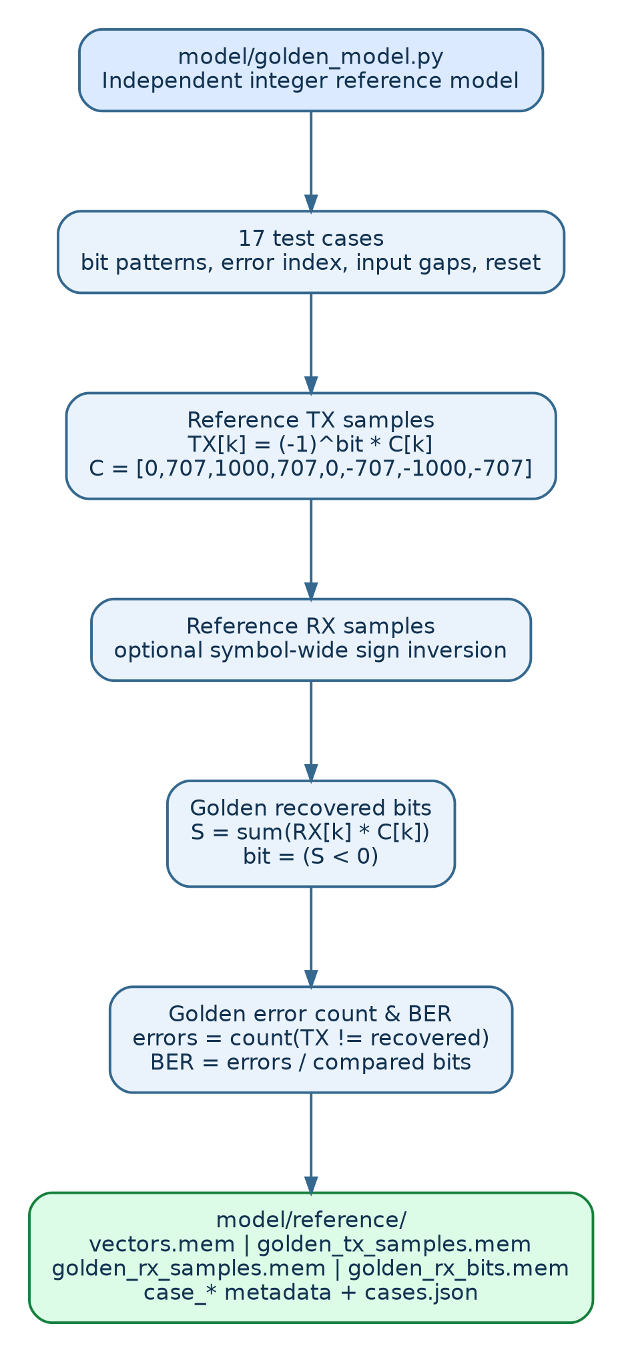
Figure B1. Golden Model computation and reference-memory generation in model/golden_model.py.
The independent integer Python model creates 17 defined test cases. For each case it maps TX bits to eight carrier samples, optionally negates the selected symbol, correlates the RX samples against the same eight-value reference carrier and derives expected recovered bits and bit errors. It generates memory files under model/reference/ for the SystemVerilog scoreboard.
Files used by the testbench include vectors.mem, golden_tx_samples.mem, golden_rx_samples.mem, golden_rx_bits.mem and case_* scenario metadata. The Python reference model is NOT part of the synthesizable Verilog datapath.

B.2 Golden Model vs. RTL comparison
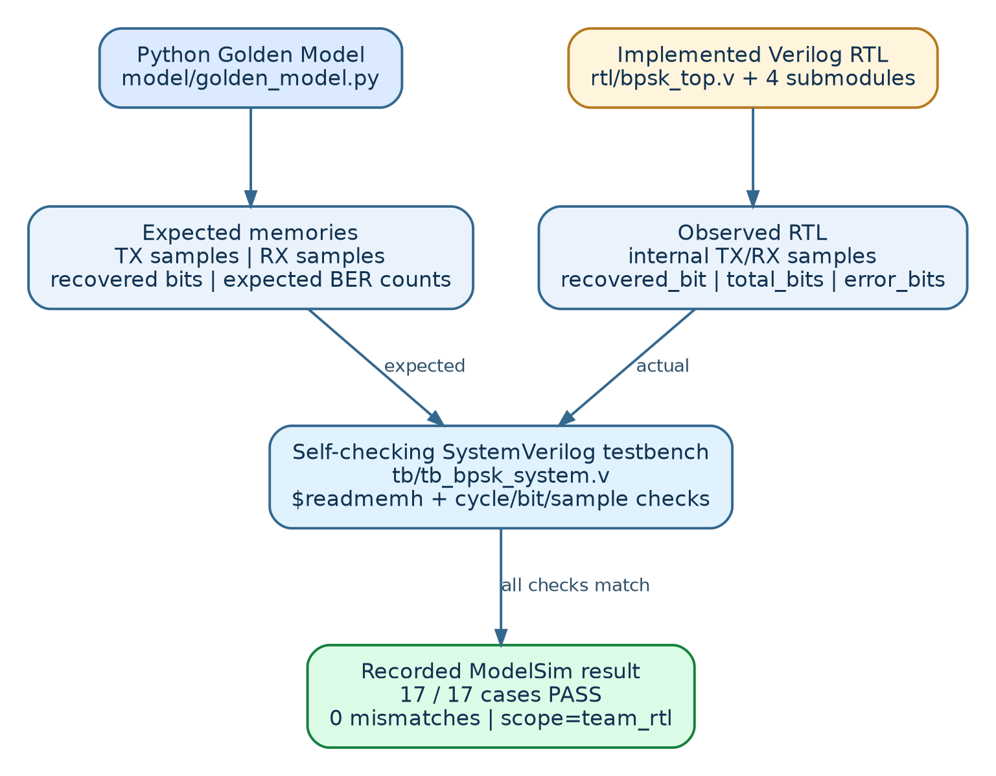
Figure B2. Independent reference values compared against the actual top-level RTL by tb/tb_bpsk_system.v.
The self-checking testbench reads Golden Model outputs using $readmemh. It checks actual TX samples, RX samples, recovered bits, total_bits and error_bits; also validates the Channel valid alignment and selected reset/idle conditions. PASS is reported only when the defined comparisons match.
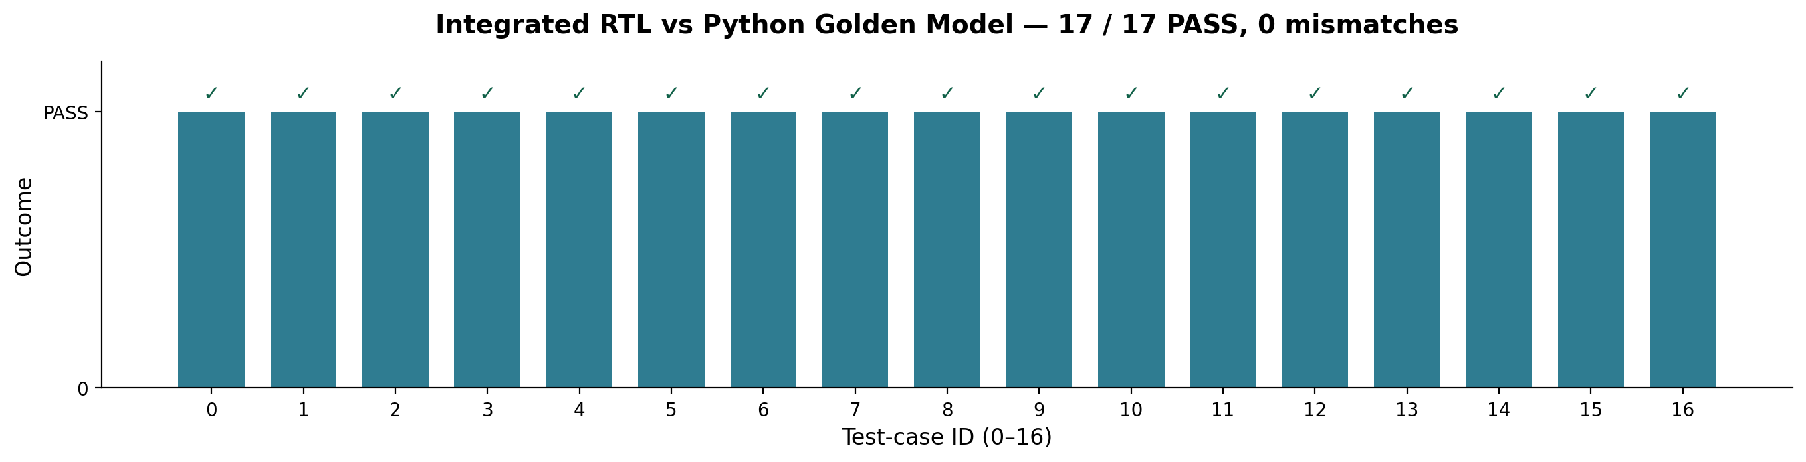
Figure B3. Recorded ModelSim end-to-end results: all 17 cases PASS with zero mismatches (scope=team_rtl).
Evidence: docs/results/system_integration/test_results.txt, test_results.csv and sample_trace.csv. The recorded ModelSim Intel FPGA Edition 2020.1 run on 01 November 2026 reported 17/17 PASS, 0 mismatches, 0 simulator errors and 0 warnings. Verification is not exhaustive for arbitrary input timing or simultaneous multi-symbol errors.

B.3 Standalone Demodulator error demonstration
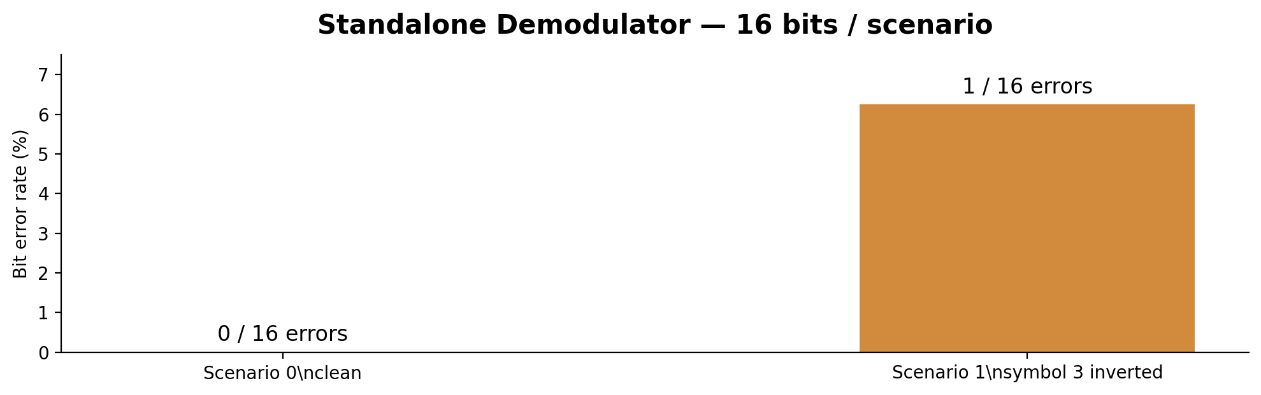
Figure B4. Two 16-bit demodulator scenarios: clean (BER 0%) and one inverted symbol at bit index 3 (BER 6.25%).
Scenario 0: all 16 recovered bits match the transmitted sequence. Scenario 1: the controlled channel inverts the 8 received samples of symbol index 3; the corresponding bit flips, producing 1 error out of 16 bits. Both standalone scenarios reported zero RTL decision mismatches against their reference received-signal decisions.
Note: correlation bars in the standalone plots are recomputed mathematically from recorded RX samples, not direct snapshots of the RTL correlation register. The 16-bit evidence complements the separate 17-case integrated Golden Model comparison.

