FPT UNIVERSITY
HO CHI MINH CITY
FINAL PROJECT REPORT
DESIGN AND VERIFICATION OF A 3-BAND DIGITAL AUDIO EQUALIZER USING VERILOG HDL
Digital Signal Processing (DGT302)
Simulation-Based Design, Golden Model and RTL Verification
November 2026

TABLE OF CONTENTS
Abstract | 3
Chapter 1. Introduction | 3
Chapter 2. Mathematical Background and Worked Example | 3
Chapter 3. Top-down System Design | 5
Chapter 4. DSP Design | 7
Chapter 5. Golden Model | 11
Chapter 6. RTL Implementation | 14
Chapter 7. Verification | 17
Chapter 8. Results and Discussion | 22
Chapter 9. Conclusion | 25
References | 25

Abstract
This project presents the design and verification of a three-band digital audio equalizer using Verilog HDL.
The system uses three parallel 31-tap FIR filters to process Bass, Mid, and Treble frequency bands. The filters are designed using a Hamming window at a sampling rate of 48 kHz.
Each frequency band has an independent gain control. The filtered signals are combined through a mixer and limited to signed 16-bit output values using saturation.
A Python Golden Model is developed to generate reference output samples using fixed-point arithmetic. A Verilog Testbench then compares the RTL results against these reference values.
The original ModelSim simulation completed 2021 output comparisons with zero mismatches. An additional gain verification testbench completed 7070 comparisons across seven fixed gain configurations, also with zero mismatches.
Together, the two simulation runs provide 9091 recorded comparisons with no mismatches.
The results demonstrate correct fixed-point processing for the tested inputs. However, the 31-tap filters have limited frequency separation, particularly between the Bass and Mid bands.

Chapter 1. Introduction

1.1 Background
A digital audio equalizer adjusts the frequency characteristics of an audio signal.

1.2 Project Objectives
- Design a 3-band digital audio equalizer.
- Implement DSP algorithms using Verilog HDL.
- Develop a Python Golden Model.
- Verify RTL using a Testbench.
- Compare RTL and Golden Model results.

1.3 Project Scope
Simulation-based design and verification. No physical FPGA hardware is required.

Chapter 2. Mathematical Background and Worked Example

2.1 FIR Filter Equation
The equalizer uses three 31-tap FIR filters for Bass, Mid, and Treble frequency bands.
The FIR equation is:
$$y[n]=\sum_{k=0}^{30}{h}[k]x[n−k]$$
Here, x[n] is the input sample, h[k] is the filter coefficient, and y[n] is the filtered output [1].

2.2 Hamming Window
A Hamming window is used when designing the 31-tap FIR coefficients.
$$w[k]=0.54−0.46cos\left(\frac{2πk}{30}\right)$$
The sampling rate is 48 kHz.
The three filters are designed with these cutoff frequencies:
- Bass: Low-pass, 200 Hz
- Mid: Band-pass, 250-3800 Hz
- Treble: High-pass, 4000 Hz

2.3 Fixed-Point Arithmetic
The filter coefficients use signed Q1.15 format.
$$h_{Q}[k]={sat}_{16}\left(round(h[k]×2^{15})\right)$$
The FIR accumulator is calculated using integer coefficients:
$$A[n]=\sum_{k=0}^{30}{x}[n−k]h_{Q}[k]$$
The RTL uses a signed 37-bit accumulator.
The output is obtained by arithmetic right shift and 16-bit saturation:
$$y_{FIR}[n]={sat}_{16}\left(\left\lfloor \frac{A[n]}{2^{15}}\right\rfloor \right)$$
Saturation limits the result to the signed 16-bit range of -32768 to 32767.

2.4 Gain Control and Mixer
Each band has an independent Q8.8 gain.
$$y_{g}[n]={sat}_{16}\left(\left\lfloor \frac{y_{FIR}[n]×G_{Q}}{2^{8}}\right\rfloor \right)$$
A gain value of 256 represents unity gain (1.0).
The three band outputs are added using an 18-bit signed mixer:
$$M[n]=y_{b,g}[n]+y_{m,g}[n]+y_{t,g}[n]$$
The final output is:
$$y_{out}[n]={sat}_{16}(M[n])$$

2.5 Worked Calculation Example
This example uses actual data from the project.
At sample index 52:
- Current input x[52] = 515 (0x0203).
- Previous input x[51] = 257 (0x0101).
The earlier samples in the 31-tap history are zero, so only two products contribute to each FIR accumulator.
Step 1: Bass FIR
The first two Bass coefficients are 158 and 178.
$$A_{b}=515(158)+257(178)$$
$$A_{b}=81370+45746=127116$$
After shifting by 15 bits:
$$y_{b}=\left\lfloor \frac{127116}{32768}\right\rfloor =3$$
Step 2: Mid FIR
The first two Mid coefficients are 28 and 14.
$$A_{m}=515(28)+257(14)$$
$$A_{m}=14420+3598=18018$$
$$y_{m}=\left\lfloor \frac{18018}{32768}\right\rfloor =0$$
Step 3: Treble FIR
The first two Treble coefficients are -56 and -58.
$$A_{t}=515(−56)+257(−58)$$
$$A_{t}=−28840−14906=−43746$$
$$y_{t}=\left\lfloor \frac{−43746}{32768}\right\rfloor =−2$$
For negative values, the arithmetic right shift rounds toward negative infinity.
Step 4: Gain Control
The three gains are set to 256 (unity gain).
$$y_{b,g}=\left\lfloor \frac{3×256}{256}\right\rfloor =3$$
$$y_{m,g}=\left\lfloor \frac{0×256}{256}\right\rfloor =0$$
$$y_{t,g}=\left\lfloor \frac{−2×256}{256}\right\rfloor =−2$$
Step 5: Mixer and Final Saturation
$$M=3+0−2=1$$
Since the value is within the signed 16-bit range, no saturation is needed.
$$\boxed{y_{out}[52]=1=0x0001}$$
The calculated result matches sample index 52 in data/expected_output.mem.
This example follows the same fixed-point operations used by the Python Golden Model and the Verilog RTL.

Chapter 3. Top-down System Design

3.1 System Overview
The project implements a three-band digital audio equalizer using Verilog HDL.
The system processes signed 16-bit audio samples through three parallel FIR filters:
- Bass: Low-pass filter
- Mid: Band-pass filter
- Treble: High-pass filter
Each filter output passes through a separate gain control block.
The three signals are then combined by a mixer. The final output is limited to the signed 16-bit range using saturation.
The design is verified through simulation. No physical FPGA implementation is included.

3.2 System Architecture
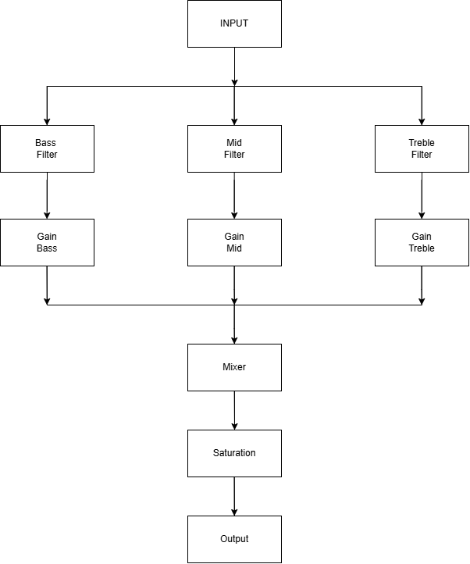
Top-level architecture of the 3-band audio equalizer
The top-level module is audio_equalizer_top.
The input audio sample is sent to all three FIR filters at the same time.
Each filter uses 31 taps and reads its coefficients from a separate memory file.
The main processing path is:
Audio Input -> FIR Filters -> Gain Control -> Mixer -> Output Saturation -> Audio Output
The Bass, Mid, and Treble filters operate in parallel.
The gain blocks use signed Q8.8 values. The mixer uses an 18-bit signed sum. The final saturation block produces a signed 16-bit output.
The system architecture diagram is stored in the docs/ directory.

3.3 Top-Level Interface
The top-level module receives:
- clk: System clock
- rst: Synchronous active-high reset
- valid_in: Input valid signal
- sample_in: Signed 16-bit audio sample
- gain_bass_q8_8: Bass gain
- gain_mid_q8_8: Mid gain
- gain_treble_q8_8: Treble gain
The outputs are:
- sample_out: Signed 16-bit audio sample
- valid_out: Output valid signal
The three FIR filters register their outputs on the rising edge of the clock.
The top-level valid output is the AND of the three filter valid signals.
Gain control, mixing, and final saturation are combinational operations.

3.4 Design Parameters
Parameter | Value
Sampling rate | 48 kHz
Audio input/output | Signed 16-bit
Frequency bands | 3
FIR taps | 31 per filter
Window | Hamming
Coefficient format | Signed Q1.15
Gain format | Signed Q8.8
FIR accumulator | 37-bit signed
Mixer output | 18-bit signed
Final output | 16-bit signed
The cutoff frequencies are:
- Bass: 200 Hz
- Mid: 250-3800 Hz
- Treble: 4000 Hz
The frequency responses depend on the actual quantized filter coefficients.

Chapter 4. DSP Design

4.1 FIR Filter Design
The project uses three FIR filters to process different frequency ranges of an audio signal.
The filters are designed in Python using scipy.signal.firwin with a Hamming window [2].
The sampling rate is 48 kHz, and each filter contains 31 taps.
The coefficients are symmetric, giving the filters a linear-phase response.
The same coefficients are used in the Python Golden Model and the Verilog RTL.

4.2 Bass Low-Pass Filter
The Bass filter is designed as a low-pass FIR filter with a nominal cutoff frequency of 200 Hz.
Its purpose is to keep low-frequency components while reducing higher-frequency components.
The coefficients are stored in:
dsp/coefficients/bass_coeff.mem
Because the filter has only 31 taps, its transition band is relatively wide.

4.3 Mid Band-Pass Filter
The Mid filter is designed as a band-pass FIR filter with nominal cutoff frequencies of 250 Hz and 3800 Hz.
Its coefficients are stored in:
dsp/coefficients/mid_coeff.mem
The current filter does not strongly reject very low frequencies. This limitation comes from using a short 31-tap FIR at 48 kHz.

4.4 Treble High-Pass Filter
The Treble filter is designed as a high-pass FIR filter with a nominal cutoff of 4000 Hz.
Its purpose is to preserve higher-frequency components and reduce low-frequency components.
Its coefficients are stored in:
dsp/coefficients/treble_coeff.mem

4.5 Coefficient Generation
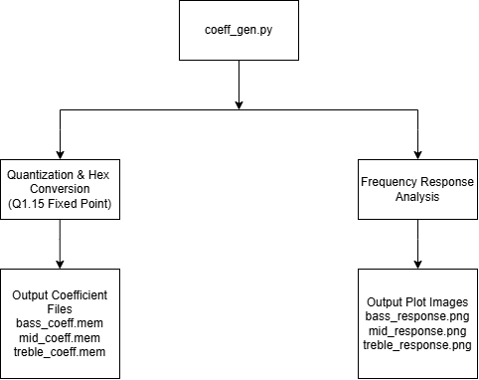
DSP coefficient generation and frequency response flow
The coefficients are generated by:
dsp/coeff_gen.py
The script performs the following operations:
- Set the sampling rate and filter parameters.
- Generate the three FIR coefficient arrays.
- Quantize each coefficient into Q1.15.
- Save the coefficients in hexadecimal format.
- Generate frequency response plots.
Each coefficient file contains 31 signed 16-bit hexadecimal values.

4.6 Fixed-Point Implementation
The Verilog FIR filters use signed 16-bit samples and Q1.15 coefficients.
Each multiplication produces a signed 32-bit result.
The products are added using a signed 37-bit accumulator.
After accumulation, the result is shifted right by 15 bits and saturated to 16 bits.
The detailed equations and calculation example are presented in Chapter 2.

4.7 Frequency Response Analysis
The frequency responses are calculated using scipy.signal.freqz in Python [3].
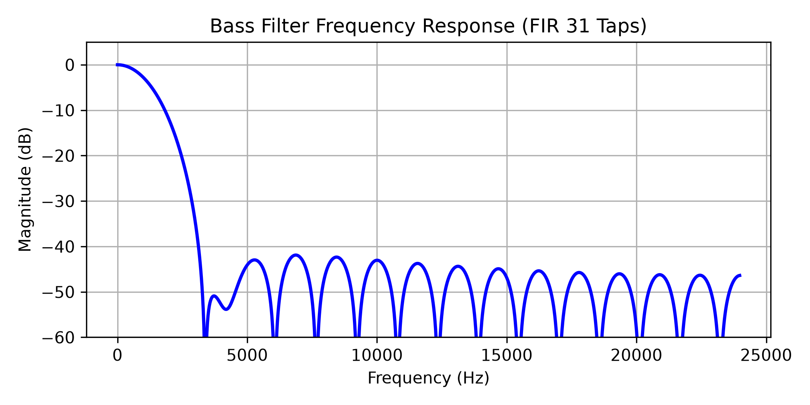
Bass FIR frequency response
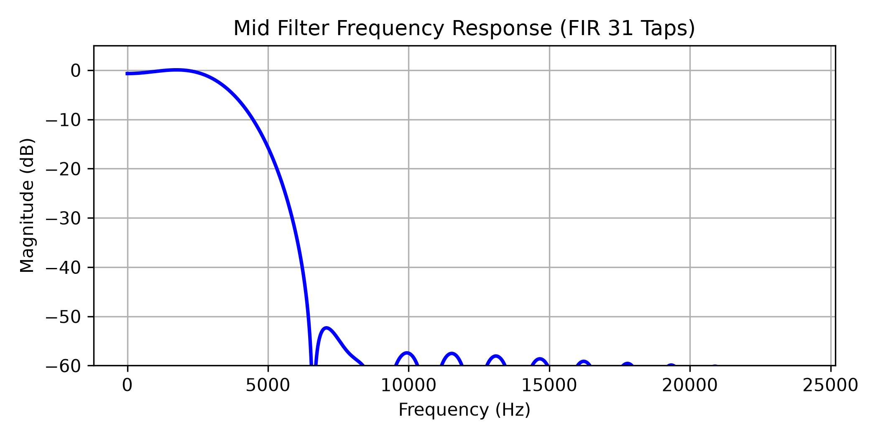
Mid FIR frequency response
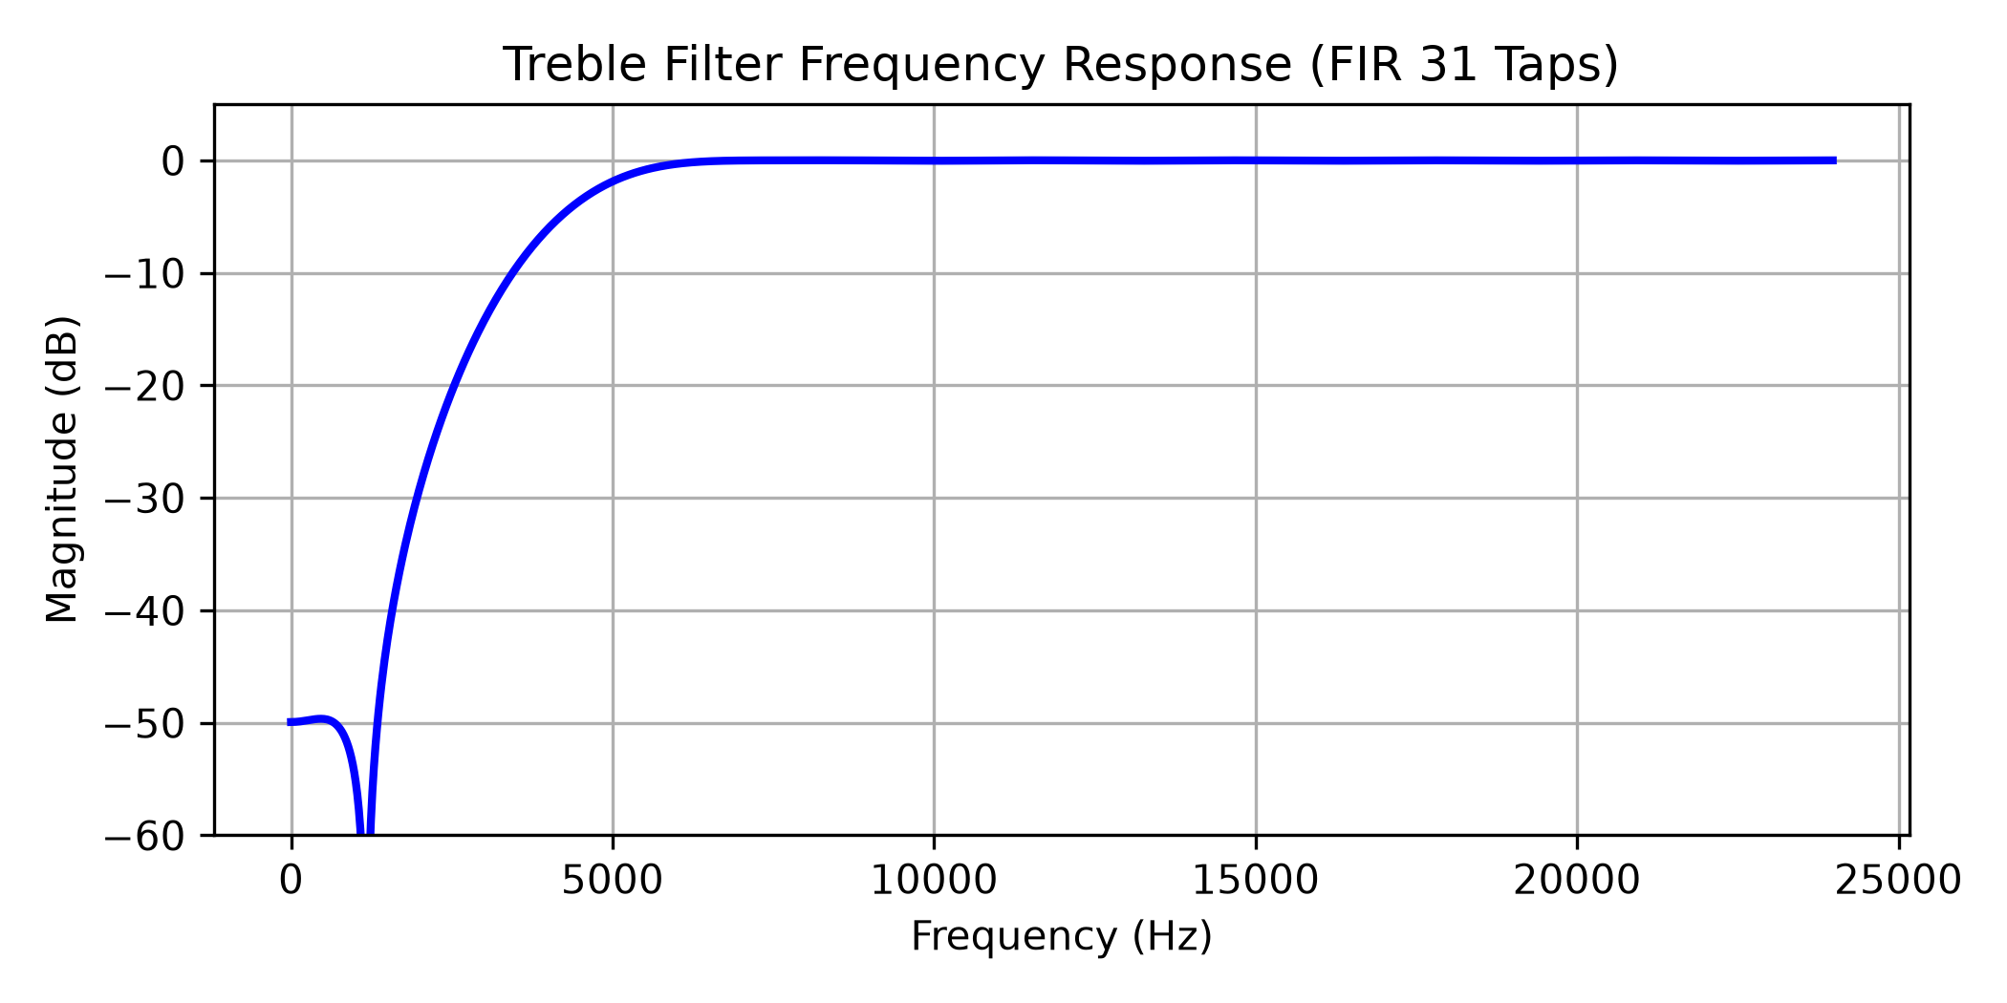
Treble FIR frequency response
The generated frequency response plots are:
- dsp/plots/bass_response.png
- dsp/plots/mid_response.png
- dsp/plots/treble_response.png
The plots are generated from the floating-point FIR coefficients before Q1.15 quantization.
An additional calculation using the stored Q1.15 coefficients gives these approximate responses:
Frequency | Bass | Mid | Treble
0 Hz | 0.00 dB | -0.68 dB | -49.97 dB
1 kHz | -2.81 dB | -0.24 dB | -55.19 dB
4 kHz | -52.79 dB | -6.36 dB | -6.05 dB
The results show that the three filters operate differently across the frequency range.
However, the Bass and Mid responses overlap at low frequencies. The Mid filter also provides little attenuation at DC.
This is a limitation of the selected 31-tap design and should be considered when evaluating audio equalization quality.
The project focuses on the FIR implementation and bit-exact verification in Verilog, rather than high-performance audio filtering.

Chapter 5. Golden Model

5.1 Purpose of the Golden Model
The Python Golden Model is used as a reference for checking the Verilog implementation.
It performs the same fixed-point calculations as the RTL, including FIR filtering, gain control, mixing, and saturation.
The model is implemented in:
dsp/golden_model.py
Its main output is expected_output.mem. The Verilog Testbench reads this file and compares it with the actual RTL output.
The Golden Model does not simulate clock cycles or hardware timing. It calculates the expected value for each accepted sample.

5.2 Input Data and Coefficients
The model reads input samples from:
data/input_samples.mem
Each sample is stored as a 16-bit hexadecimal number. The model converts the hexadecimal values into signed integers.
For example:
- 0001 represents 1.
- FFFF represents -1.
- 8000 represents -32768.
- 7FFF represents 32767.
The model also loads three coefficient files:
- dsp/coefficients/bass_coeff.mem
- dsp/coefficients/mid_coeff.mem
- dsp/coefficients/treble_coeff.mem
Each file contains 31 signed Q1.15 coefficients.
Using the same coefficient files ensures that the Python model and RTL use identical quantized filter parameters.

5.3 Golden Model Processing
The model uses a 31-element sample history, initially filled with zeros.
For every input sample, the following operations are performed.
Step 1: Update sample history
The newest sample is inserted at the beginning of the history array.
The oldest sample is removed.
In Python:
shift_reg = [x] + shift_reg[:-1]
Step 2: FIR calculations
The model calculates a separate multiply-accumulate result for each band.
For example, the Bass accumulator is:
acc_b = sum(
shift_reg[i] * hb[i]
for i in range(num_taps)
)
The Mid and Treble accumulators use their own coefficient arrays.
All three filters use the same input history.
Step 3: Fixed-point scaling
Each FIR accumulator is shifted right by 15 bits and saturated to signed 16-bit.
For example:
yb = saturate16(acc_b >> 15)
Python’s right shift on negative integers matches the arithmetic right-shift behavior required by the signed RTL calculation.
Step 4: Gain control
The model converts gain values into signed Q8.8 integers.
For unity gain:
gb_int = 256
gm_int = 256
gt_int = 256
The gain operation multiplies the FIR result by the gain integer, shifts the product right by 8 bits, and applies 16-bit saturation.
For example:
yb_g = saturate16((yb * gb_int) >> 8)
The same operation is used for the Mid and Treble bands.
Step 5: Mixing
The three gain-adjusted outputs are added:
mixed_18bit = yb_g + ym_g + yt_g
The result is limited to the signed 16-bit range:
final_out = saturate16(mixed_18bit)
Step 6: Store output
The final integer is converted to a 16-bit hexadecimal value and added to the output list.
The process repeats for every input sample.

5.4 Reference Output Generation
The current input file contains 1010 samples.
The Golden Model generates one expected output for each input sample.
The generated values are written to:
data/expected_output.mem
The default configuration uses unity gain for all three bands:
- Bass gain = 1.0
- Mid gain = 1.0
- Treble gain = 1.0
In Q8.8 format, each gain is represented by the integer value 256.
The example in Chapter 2 uses sample index 52 from these files.
The calculated result is:
- Bass output: 3
- Mid output: 0
- Treble output: -2
- Final output: 1 (0001 in hexadecimal)
This matches the stored reference output.

5.5 Comparison with RTL
The Golden Model provides expected output values before Verilog simulation.
The Testbench reads the input and expected output files and drives the RTL design.
After each valid input sample, the Testbench checks valid_out and compares the RTL output against the reference value.
A mismatch is recorded when the output is invalid or differs from the expected 16-bit value.
The saved ModelSim results show:
Test | Comparisons | Mismatches
Continuous input | 1010 | 0
Input with valid gaps | 1010 | 0
Reset recovery | 1 | 0
Total | 2021 | 0
All comparisons passed with unity gains.
The Python model does not explicitly handle reset signals or idle clock cycles. These timing behaviors are tested by the Verilog Testbench.
These original results confirm matching fixed-point outputs for the tested unity-gain data. Chapter 7 describes additional fixed-gain verification; dynamic gain changes and exhaustive input combinations remain untested.

Chapter 6. RTL Implementation

6.1 RTL Module Structure
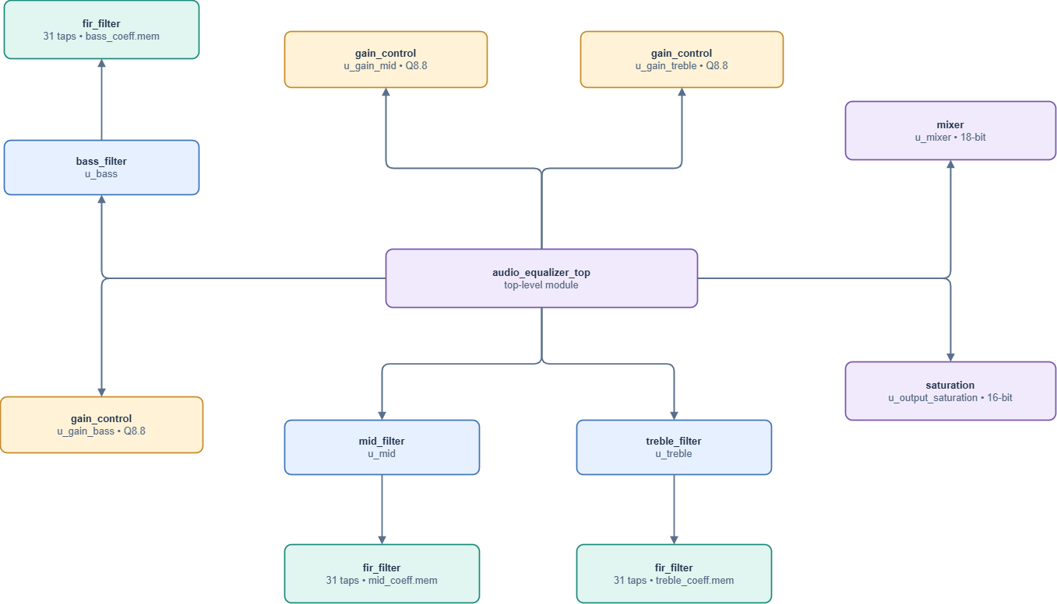
RTL module hierarchy
The audio equalizer is implemented using eight Verilog modules.
Module | Function
audio_equalizer_top | Connects the complete system
fir_filter | Performs FIR filtering
bass_filter | Bass filter wrapper
mid_filter | Mid filter wrapper
treble_filter | Treble filter wrapper
gain_control | Applies Q8.8 gain
mixer | Adds the three band outputs
saturation | Limits the final output to 16 bits
The three filter wrappers use the same fir_filter module with different coefficient files.
This allows the FIR implementation to be reused for all three frequency bands.

6.2 FIR Filter Implementation
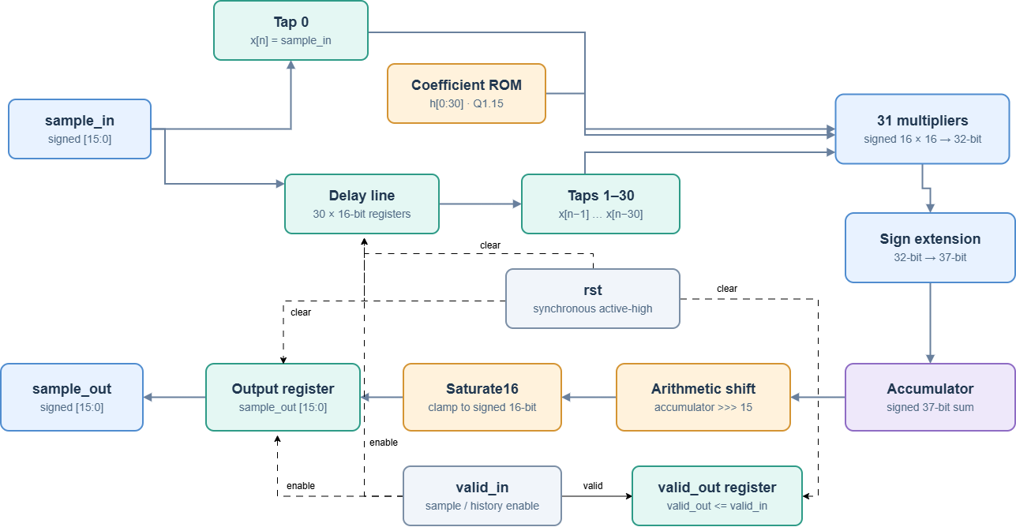
FIR internal datapath
The main FIR module is located in rtl/fir_filter.v.
Each filter contains 31 taps and processes signed 16-bit input samples.
The coefficients are stored in a memory array and loaded using $readmemh.
The FIR datapath contains:
- A delay line storing 30 previous valid samples.
- 31 signed multiplications.
- A signed 37-bit accumulator.
- An arithmetic right shift by 15 bits.
- A 16-bit saturation function.
- Output and valid registers.
Each multiplication produces a signed 32-bit result. The products are sign-extended before being added to the accumulator.
The arithmetic calculation is combinational. The filtered result is stored in sample_out on a rising clock edge when valid_in is high.
When valid_in is low, the delay line and registered sample output keep their values.
When rst is high, the delay line, sample output register, and valid flag are cleared on the next rising clock edge.

6.3 Gain Control
The gain module is implemented in rtl/gain_control.v.
Each frequency band has a separate instance of the same gain control module.
The module accepts:
- A signed 16-bit filtered sample.
- A signed 16-bit Q8.8 gain value.
The multiplication produces a signed 32-bit result. It is shifted right by 8 bits and saturated to signed 16-bit.
A gain value of 256 represents 1.0.
Gain control is combinational and does not introduce an additional registered stage.

6.4 Mixer and Output Saturation
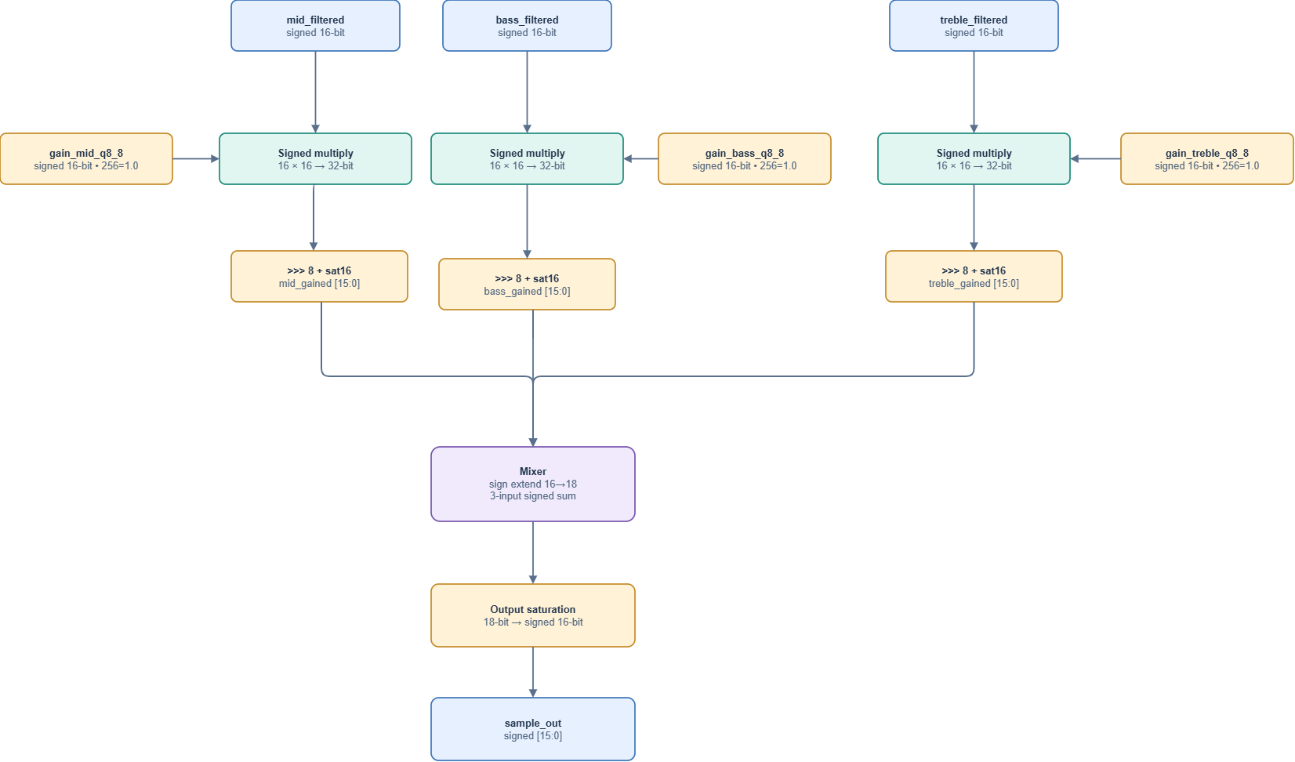
Gain, mixer and saturation datapath
The mixer is implemented in rtl/mixer.v.
It receives the three signed 16-bit gain-adjusted outputs.
Each input is sign-extended to 18 bits before addition.
The mixer produces a signed 18-bit result, which is passed to rtl/saturation.v.
The saturation module limits the output to:
- Maximum: 32767
- Minimum: -32768
If the mixed value exceeds these limits, the output is clipped to the corresponding boundary.
Otherwise, the signed value is preserved.

6.5 Top-Level Integration
The top-level module is rtl/audio_equalizer_top.v.
It instantiates three FIR filter wrappers, three gain control blocks, one mixer, and one output saturation block.
The same sample_in signal is connected to all three FIR filters.
Each filter uses a separate coefficient file:
- Bass: bass_coeff.mem
- Mid: mid_coeff.mem
- Treble: treble_coeff.mem
The three FIR valid signals are combined using an AND operation:
valid_out = valid_bass & valid_mid & valid_treble
Because the FIR filters share the same clock, reset, and input valid signal, their registered valid outputs are aligned.
The gain, mixer, and final saturation stages are combinational.
A valid output sample is available after the rising edge that accepts a valid input, once the registered and combinational signals have settled.
The system uses a synchronous active-high reset and does not require physical FPGA hardware for the current project.

6.6 RTL Simulation
The integrated RTL was simulated using ModelSim Intel FPGA Edition 2020.1.
The Testbench supplies input audio samples and checks the corresponding output values against the Python Golden Model.
The saved simulation log reports:
- Continuous input: 1010 samples, 0 errors.
- Input with valid gaps: 1010 samples, 0 errors.
- Reset recovery: 1 comparison, 0 errors.
- Total: 2021 comparisons, 0 errors.
The overall simulation result is PASS.
These results apply to the tested unity-gain configuration.
The detailed verification process and simulation evidence are presented in Chapter 7.

Chapter 7. Verification

7.1 Testbench Architecture
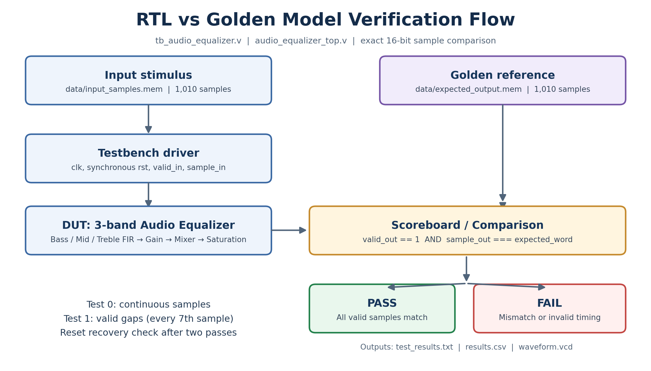
RTL and Golden Model verification flow
The Verilog Testbench is implemented in tb/tb_audio_equalizer.v.
Its purpose is to verify the RTL output against the Python Golden Model.
The Testbench includes:
- Clock and reset generation.
- Input sample reading.
- Expected output reading.
- DUT input control.
- Output comparison.
- Error counting and result logging.
The Testbench instantiates the top-level module audio_equalizer_top.
Input samples are read from:
data/input_samples.mem
Expected outputs are read from:
data/expected_output.mem
The expected values are generated by the Python Golden Model before RTL simulation.
In the original testbench, all three gain inputs are set to 256, representing unity gain in Q8.8 format. A separate testbench verifies seven other fixed gain configurations.

7.2 Verification Test Plan
The original testbench uses three main verification scenarios.
Test 0: Continuous Input
The Testbench sends 1010 consecutive valid input samples to the DUT.
Each output is compared with the corresponding Golden Model value.
This test checks the FIR calculations, gain processing, mixing, and saturation for the supplied input data.
Test 1: Input with Valid Gaps
The Testbench uses the same 1010 samples but inserts invalid clock cycles before selected input samples.
An invalid cycle is inserted before every seventh sample index, starting at index 0.
During these cycles, valid_in is low.
The Testbench checks that valid_out is also low.
The output values for subsequent valid samples are compared with the same Golden Model reference.
This checks that invalid cycles do not advance the FIR sample history.
Test 2: Reset Recovery
After the two input tests, the Testbench asserts the synchronous reset while valid_in is high.
It checks that valid_out is low and the registered output is cleared.
The Testbench then releases reset, sends the first input sample again, and compares the resulting output with its expected value.

7.3 RTL and Golden Model Comparison
The Testbench drives input signals on falling clock edges.
The DUT processes valid input samples on rising clock edges.
The Testbench checks the results 1 ns after each rising edge, allowing the registered outputs and combinational logic to settle.
The simulation clock period is 10 ns.
This is the Testbench clock period, not the 48 kHz audio sampling frequency used during FIR coefficient design.
A comparison passes when:
- valid_out is high for an accepted sample.
- sample_out matches the expected signed 16-bit reference word.
The Testbench uses exact 16-bit comparisons rather than an error tolerance.
During invalid cycles, it checks that valid_out is low.
The comparison results are saved in:
- simulation/results/results.csv
- simulation/results/test_results.txt
The CSV file contains the results for the 2020 valid samples in Tests 0 and 1. The additional reset-recovery comparison is included in the summary log.

7.4 Waveform Analysis
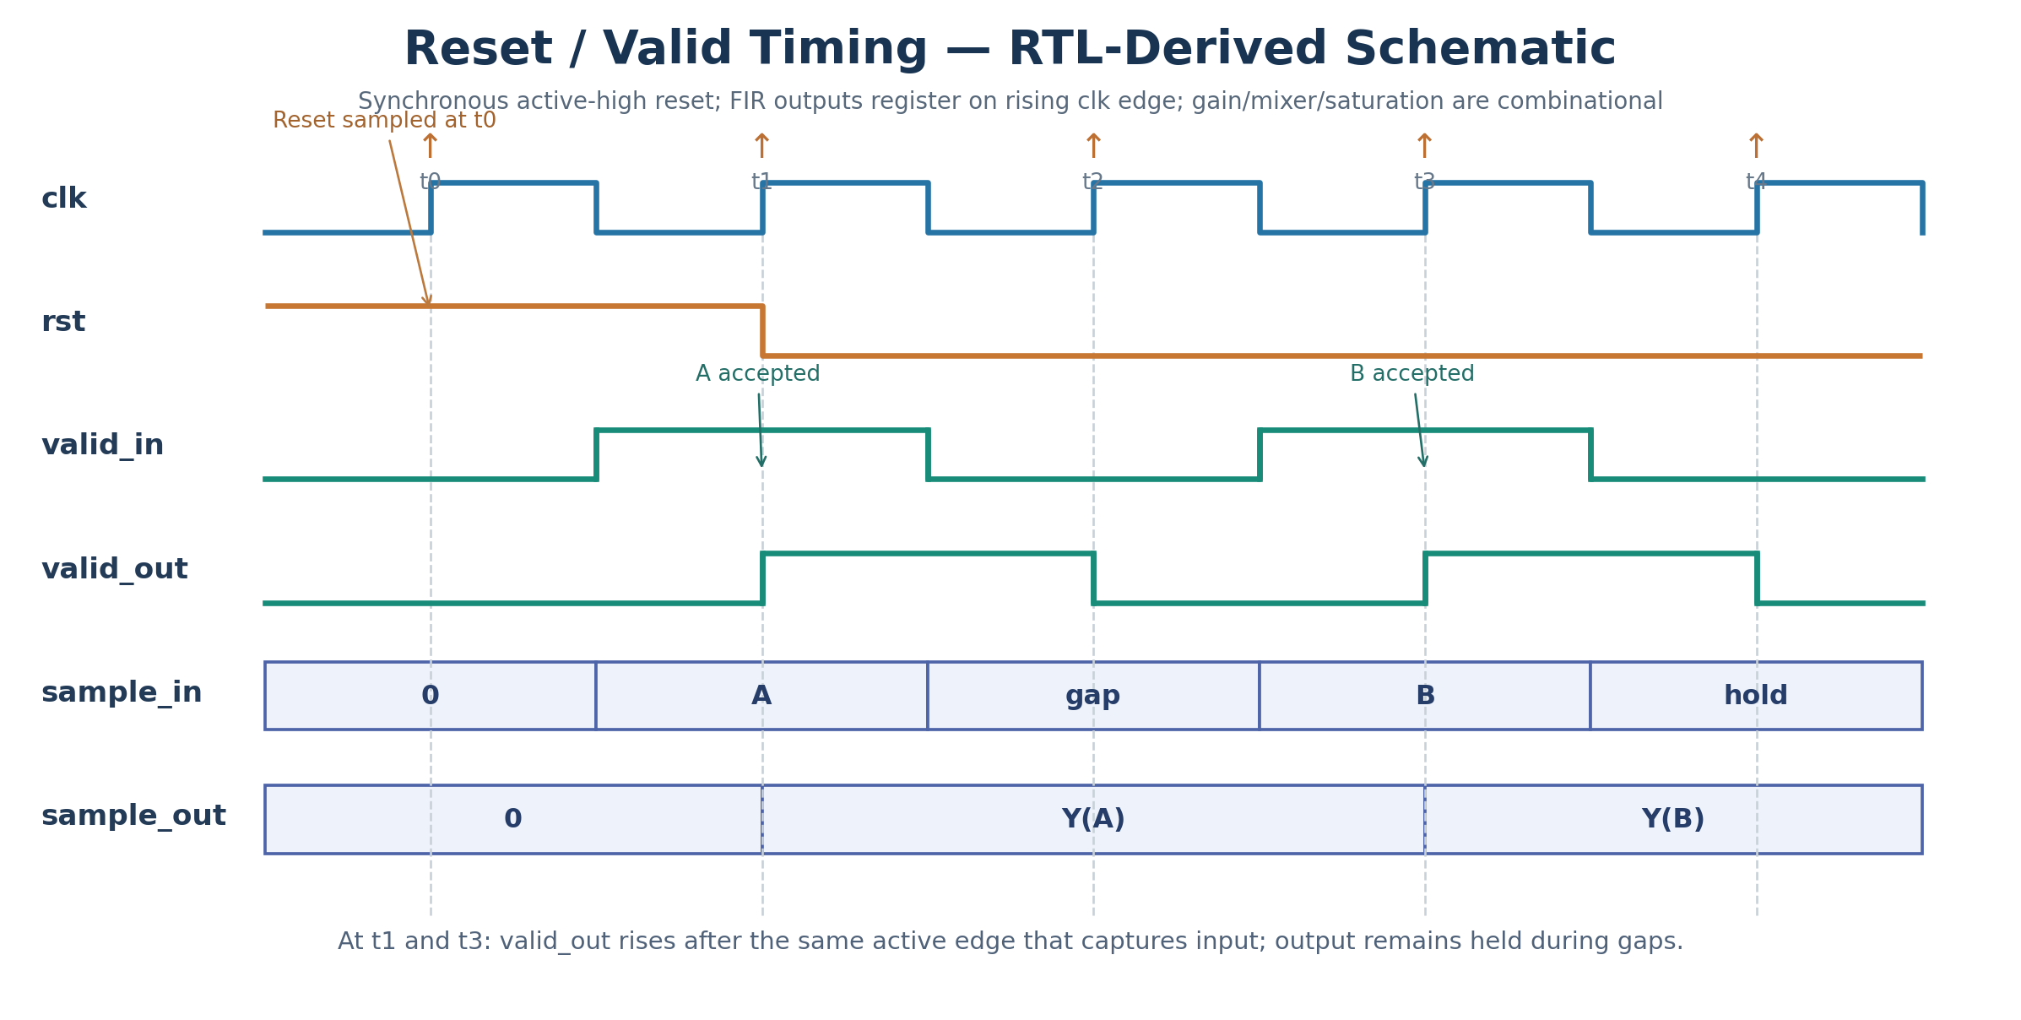
RTL reset and valid timing schematic
The diagram above illustrates the expected RTL reset and valid timing behavior. It is a timing schematic, not a ModelSim waveform capture.
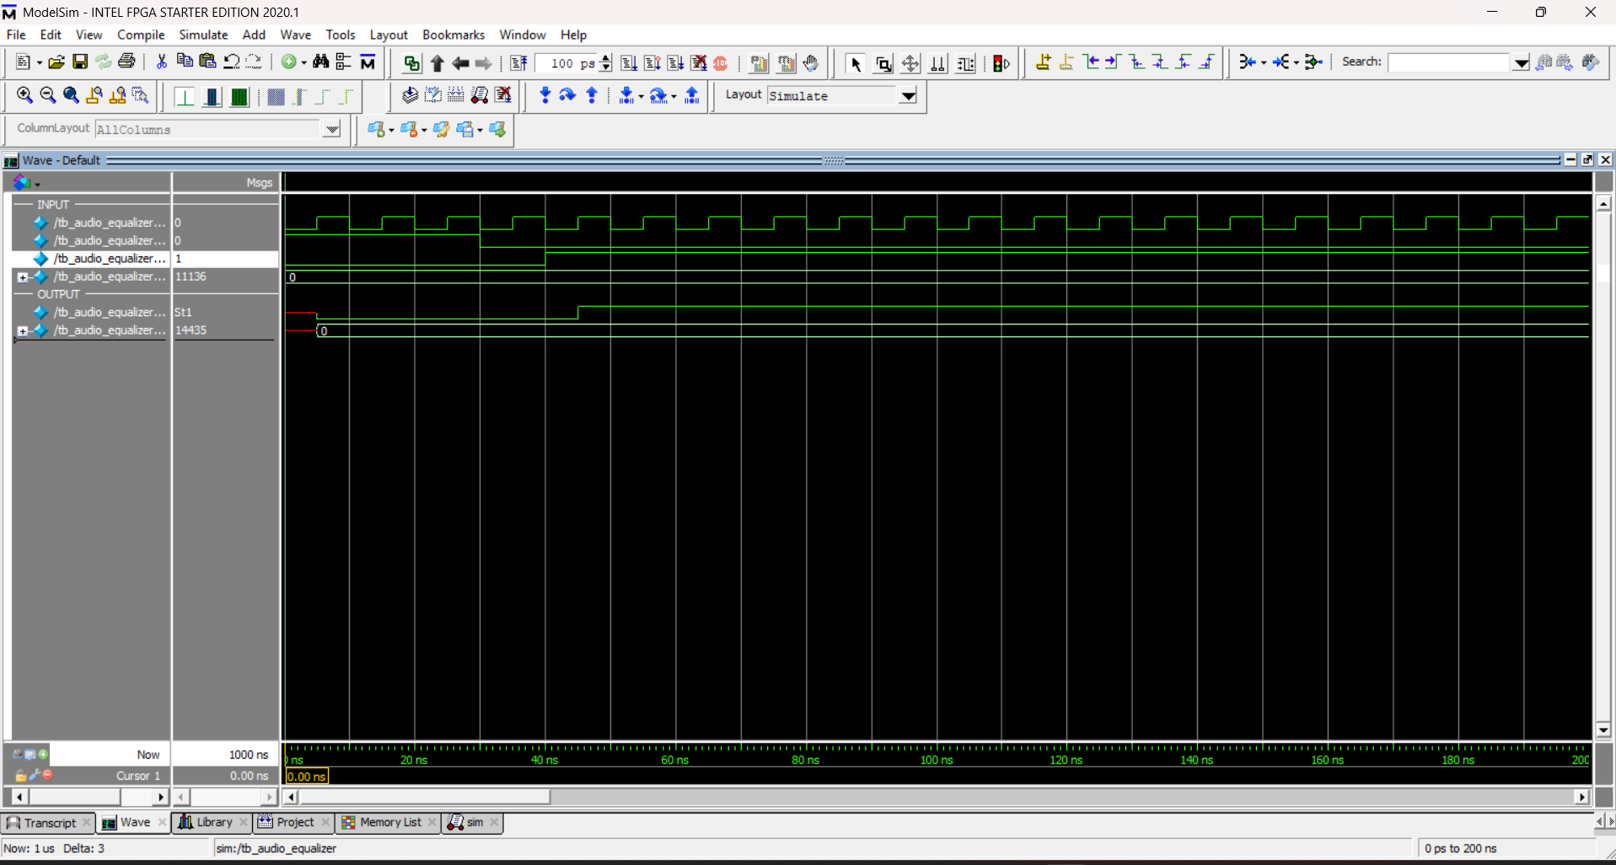
RTL simulation waveform - continuous input
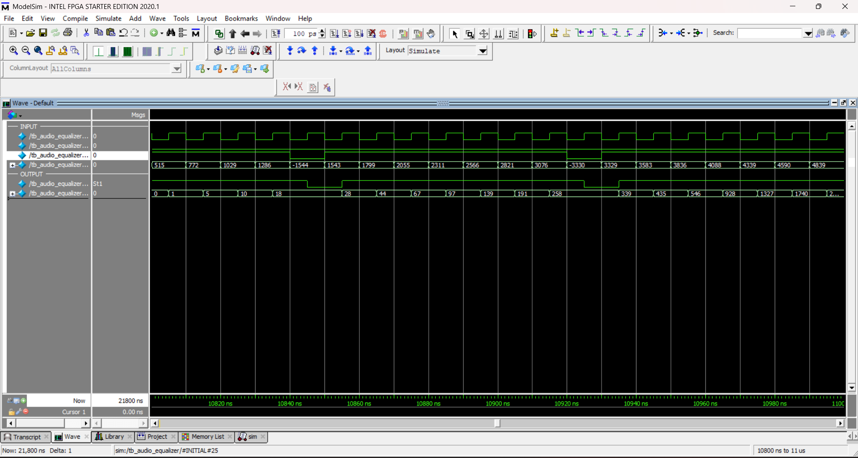
RTL simulation waveform - valid gaps
The project includes saved ModelSim waveform screenshots:
- docs/images/waveform_continuous.png
- docs/images/waveform_valid_gaps.png
The continuous-input waveform is used to observe the normal sample flow.
The valid-gap waveform shows the behavior when input samples are separated by invalid clock cycles.
The relevant signals include:
- clk
- rst
- valid_in
- sample_in
- valid_out
- sample_out
The FIR output registers update when a valid sample is accepted.
During invalid cycles, the FIR history and registered filtered samples are held, while the output valid signal is low.
The gain, mixer, and final saturation blocks are combinational.
Therefore, the final output should only be treated as valid when valid_out = 1.

7.5 Verification Results
The saved RTL simulation was performed using ModelSim Intel FPGA Edition 2020.1.
The recorded results are:
Test | Comparisons | Errors | Result
Continuous input | 1010 | 0 | PASS
Input with valid gaps | 1010 | 0 | PASS
Reset recovery | 1 | 0 | PASS
Total | 2021 | 0 | PASS
The simulation console reports:
TEST 0: samples=1010 errors=0
TEST 1: samples=1010 errors=0
SUMMARY compared=2021 errors=0
OVERALL PASS
The recorded simulation completed without reported errors or warnings.
All 2021 compared output samples matched the Golden Model reference for the tested configuration.

7.5.1 Additional Gain Verification Results
A separate Gain Verification Testbench was executed using ModelSim Intel FPGA Edition 2020.1 on November 7, 2026.
Seven fixed gain configurations were tested against the Python Golden Model:
Gain vectors (Bass, Mid, Treble) are expressed as signed Q8.8 integers: Bass only (256, 0, 0); Mid only (0, 256, 0); Treble only (0, 0, 256); Mute all (0, 0, 0); Fractional gains (128, 384, 64); Negative Bass gain (-256, 256, 256); High gains (768, 512, 384).
Gain Configuration | Comparisons | Errors | Result
Bass only | 1010 | 0 | PASS
Mid only | 1010 | 0 | PASS
Treble only | 1010 | 0 | PASS
Mute all | 1010 | 0 | PASS
Fractional gains | 1010 | 0 | PASS
Negative Bass gain | 1010 | 0 | PASS
High gains | 1010 | 0 | PASS
Total | 7070 | 0 | PASS
The ModelSim console reported:
GAIN SUMMARY compared=7070 errors=0
GAIN VERIFICATION PASS
Together with the original 2021 comparisons, the project now has 9091 recorded comparisons without mismatches.
The new testbench is tb/tb_gain_verification.v, and its results are stored in simulation/results/gain_test_results.txt.

7.6 Verification Limitations
The original testbench verifies continuous samples, valid gaps, and reset recovery using unity gain.
The additional Gain Verification Testbench covers seven fixed gain configurations, including isolated frequency bands, mute, fractional gains, negative Bass gain, and high gains.
However, the current verification does not exhaustively cover all possible input and gain combinations. Gain changes during active sample processing have not been tested separately.
The recorded PASS results confirm numerical agreement between the RTL and Python Golden Model for the tested configurations. They do not establish complete functional coverage or physical FPGA implementation.

Chapter 8. Results and Discussion

8.1 FIR Filter Results
The project generated three FIR filters using the Hamming window method.
Each filter contains 31 coefficients stored in signed Q1.15 format.
The frequency response plots are saved in:
- dsp/plots/bass_response.png
- dsp/plots/mid_response.png
- dsp/plots/treble_response.png
The Bass filter mainly responds to lower frequencies, while the Treble filter responds to higher frequencies.
The Mid filter was designed for the frequency range from 250 Hz to 3800 Hz.
However, the calculated response from the stored Q1.15 coefficients shows that the Mid filter does not strongly reject very low frequencies.
At DC, its magnitude is approximately -0.68 dB.
This happens because 31 taps are not enough to produce a narrow transition band at these low cutoff frequencies.
The filter design is suitable for studying FIR implementation, but its frequency separation is limited.

8.2 Golden Model Results
The Python Golden Model processed 1010 input samples using the three FIR filters, Q8.8 gains, mixing, and saturation.
All three gains were set to unity (256).
The model generated 1010 expected samples in data/expected_output.mem.
An independent integer calculation using the stored coefficients matched all 1010 expected samples.
The worked example in Chapter 2 also matched the stored output at sample index 52.

8.3 RTL Verification Results
The integrated Verilog design was simulated using ModelSim Intel FPGA Edition 2020.1.
The saved results are:
Test | Comparisons | Errors | Result
Continuous input | 1010 | 0 | PASS
Valid gaps | 1010 | 0 | PASS
Reset recovery | 1 | 0 | PASS
Total | 2021 | 0 | PASS
No mismatches were reported.
The results show that the RTL and Python Golden Model produce the same fixed-point outputs for the tested samples.
The valid-gap test also checks that the FIR history advances only when a valid sample is accepted.
The reset-recovery test confirms that the stored filter history is cleared by reset.
An additional ModelSim gain verification run on November 7, 2026 completed 7070 comparisons across seven fixed gain configurations, with zero mismatches.
Combined with the original 2021 comparisons, the recorded RTL verification evidence includes 9091 comparisons with zero mismatches.
These results support the correctness of the fixed-point gain control, per-band saturation, and mixing behavior for the tested configurations.

8.4 Saturation Behavior
The equalizer uses saturation after FIR filtering, gain control, and final mixing.
The final mixer combines the three gain-adjusted band outputs.
If the result exceeds the signed 16-bit range, it is limited to 32767 or -32768.
The current input data includes values that cause final output saturation.
For example, at sample index 146, an independent integer calculation gives a mixer sum of 32911.
The final output is therefore:
32767 (0x7FFF)
This agrees with the stored Golden Model reference value.
Saturation prevents output wraparound, although clipping can still introduce distortion in a real audio application.

8.5 Project Limitations
The project has several limitations.
First, the three 31-tap FIR filters do not provide sharp frequency separation. The Bass and Mid responses overlap at lower frequencies.
Second, although seven fixed gain configurations have now passed RTL verification, dynamic gain changes during active sample processing and exhaustive boundary-value combinations have not been separately tested.
Third, the design has only been tested through RTL simulation. It has not been implemented on physical FPGA hardware.
The project also does not include a real audio input/output interface.

8.6 Discussion
The main goal of this project is to design and verify a three-band digital audio equalizer using Verilog HDL.
The RTL implementation and Python reference model use the same fixed-point arithmetic rules and filter coefficients.
The recorded simulation runs show successful output matching for the tested configurations.
The results demonstrate the implementation of FIR filtering, gain control, mixing, saturation, and sample-valid handling.
Better frequency separation and broader verification coverage would be useful improvements in future versions.

Chapter 9. Conclusion
This project designed and verified a three-band digital audio equalizer using Verilog HDL.
The system consists of three 31-tap FIR filters for Bass, Mid, and Treble frequency bands. Each band has an independent Q8.8 gain control. The filtered signals are combined using a mixer and limited to signed 16-bit output values.
A Python Golden Model was developed to generate reference outputs using the same fixed-point arithmetic as the RTL.
The Verilog design was tested using ModelSim Intel FPGA Edition 2020.1.
The original verification completed 2021 comparisons with zero mismatches, covering continuous input, valid gaps, and reset recovery.
The additional gain verification completed 7070 comparisons with zero mismatches across seven fixed gain configurations.
In total, the recorded verification includes 9091 output comparisons without mismatches.
The project demonstrates FIR filtering, fixed-point arithmetic, gain control, mixing, saturation, and RTL verification.
However, the 31-tap filters have limited frequency separation, especially between the Bass and Mid bands. The Testbench also does not cover all possible gain settings.
Future improvements could include longer FIR filters, dynamic gain-change verification, more extensive boundary-value tests, and implementation on an FPGA board.
Overall, the project achieved its main simulation and verification objectives for the tested configurations.

References
[1] A. V. Oppenheim and R. W. Schafer, Discrete-Time Signal Processing, 3rd Edition, Pearson, 2010.
[2] SciPy Documentation, “scipy.signal.firwin - FIR filter design using the window method.” https://docs.scipy.org/doc/scipy/reference/generated/scipy.signal.firwin.html
[3] SciPy Documentation, “scipy.signal.freqz - Compute the frequency response of a digital filter.” https://docs.scipy.org/doc/scipy/reference/generated/scipy.signal.freqz.html

