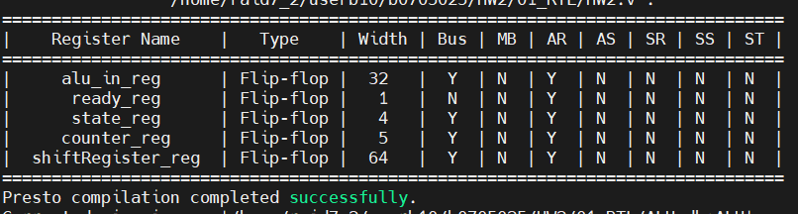

In the picture, all sequential registers are flip-flops, no latches.