**CS 457/557 -- Winter Quarter 2021**

**Project #1**

**Step- and Blended-edged Elliptical Dots**

**Name: Chun-Yu Chen**

**E-mail:** [**chench6@oregonstate.edu**](mailto:chench6@oregonstate.edu)

* 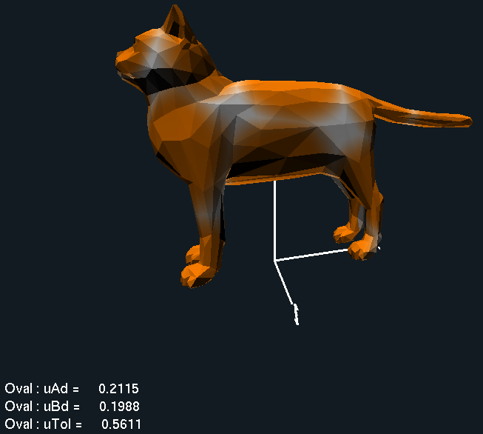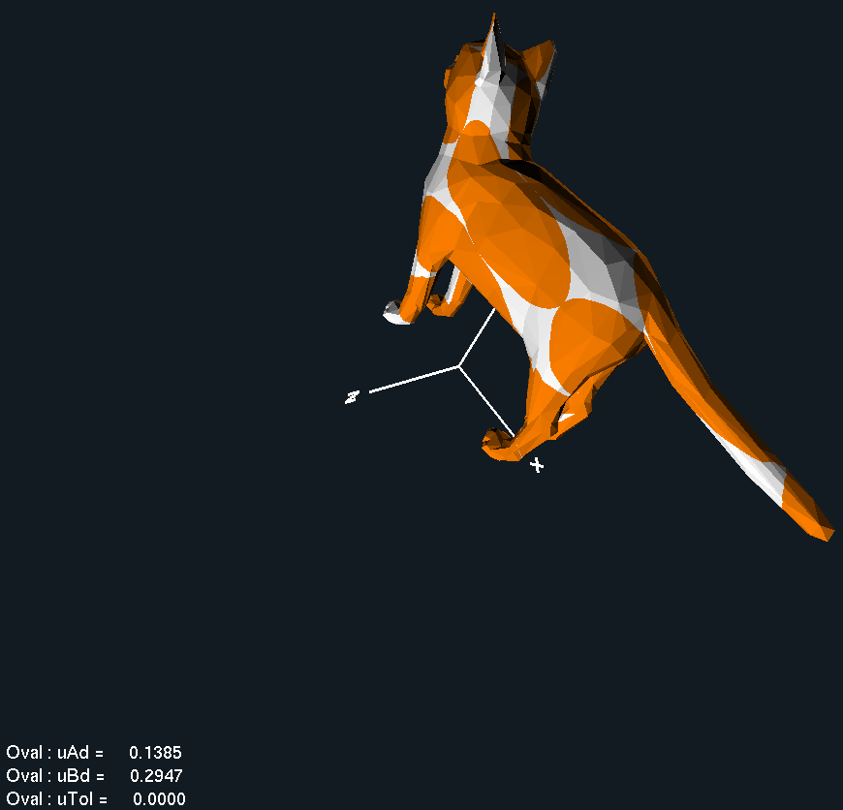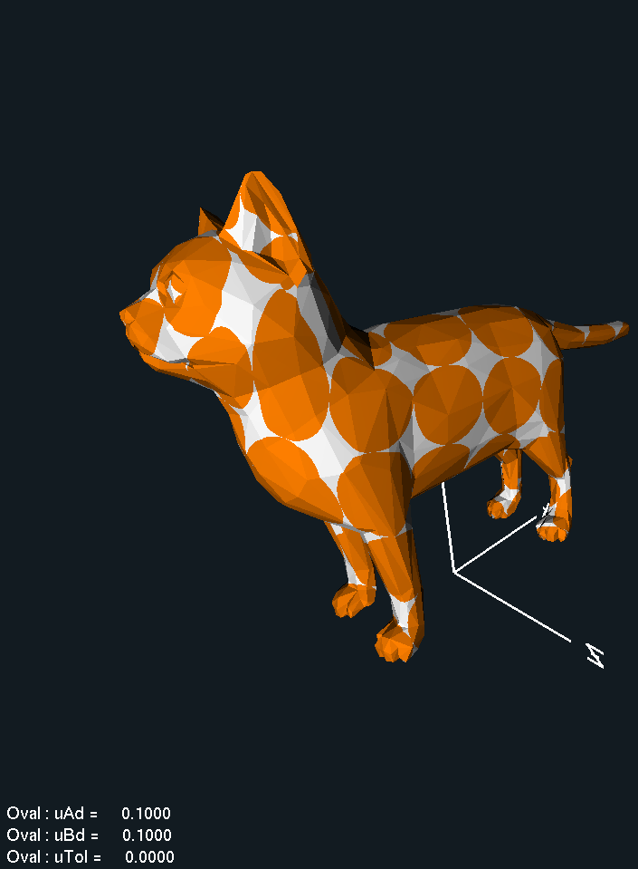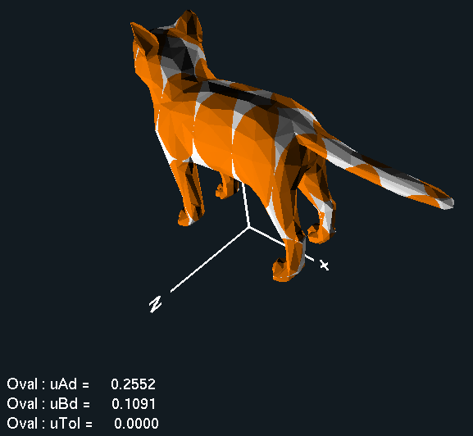**Screen shots from program:**
* **Video record:** [**https://youtu.be/VdnhE1S-JFc**](https://youtu.be/VdnhE1S-JFc)