**CS 457/557 -- Winter Quarter 2021**

**Project #3**

**Displacement Mapping, Bump Mapping, and Lighting**

**Name: Chun-Yu Chen**

**E-mail:** [**chench6@oregonstate.edu**](mailto:chench6@oregonstate.edu)

* **What I did and explaining why it worked this way:**

1. Set the Normal vector, Light vector, Eye vector as vNs, vLs, vEs.
2. Insert and get the value of gl_Vertex then makes z axis equal to uK * (1-vert.y) * sin( 2.*PI*vert.x/uP ). Then it will simultaneously change the relevant variable like vLs and vEs.
3. Use the concept of Noise to calculate two value angx, angy. Then, put angx, angy, and vNs into the function “RotateNormal” to get the latest value of normal. Then, the latest value of normal can be used to get the new value diffuse and specular.

* 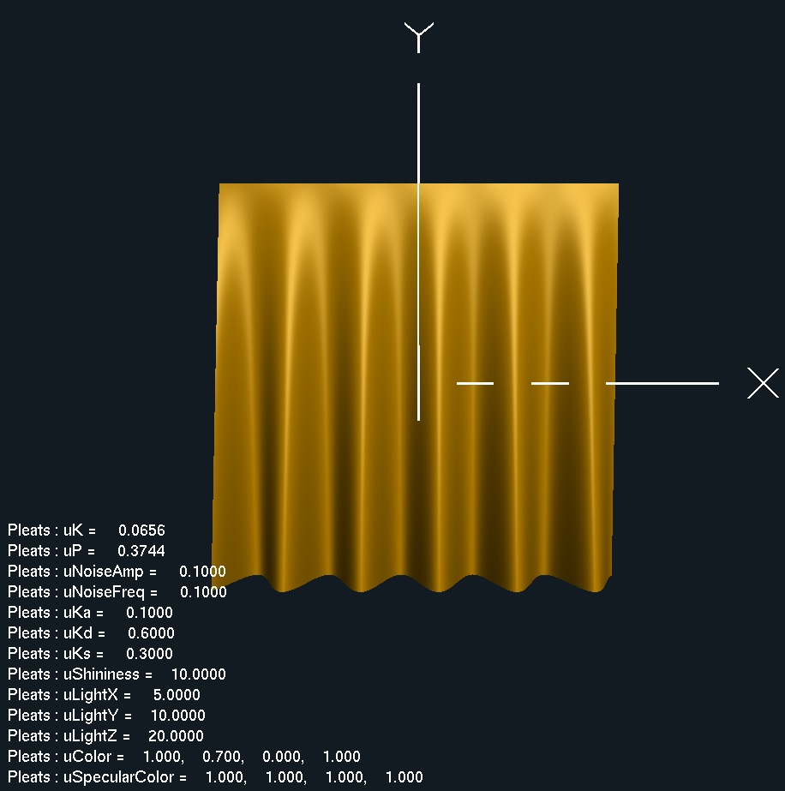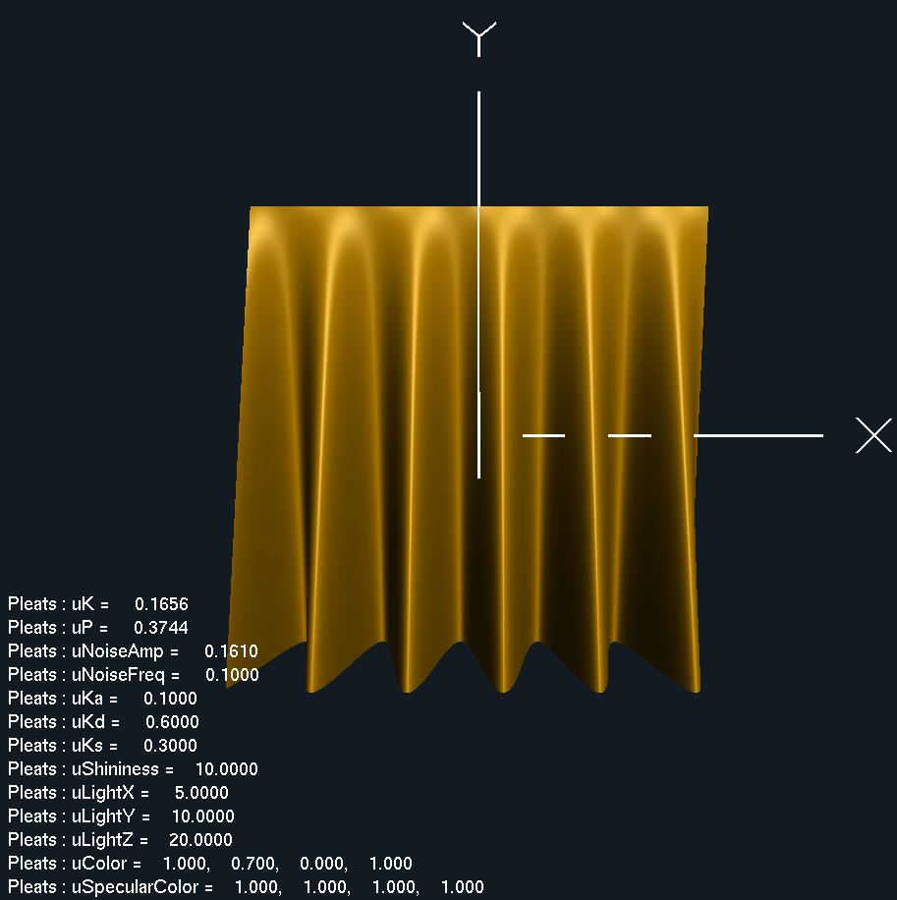**Screen shots from program:**

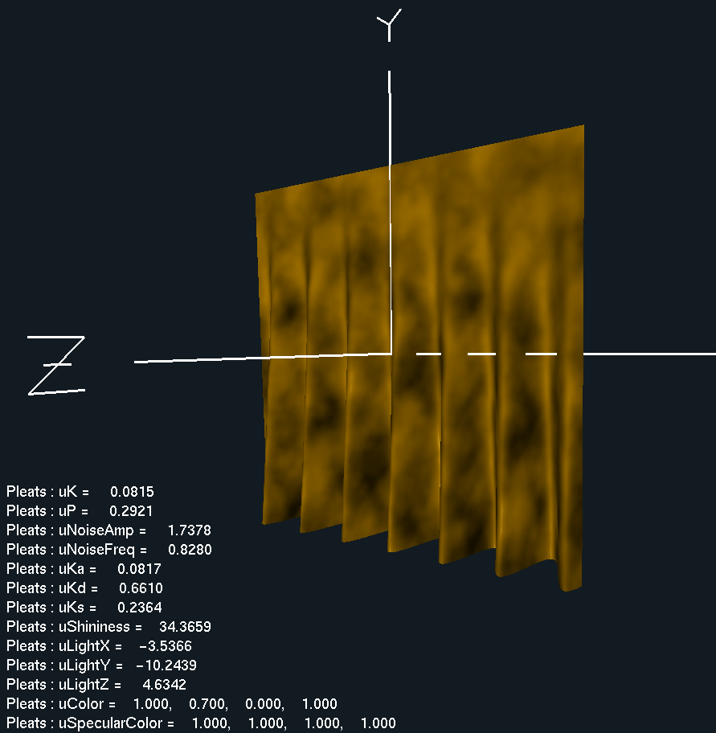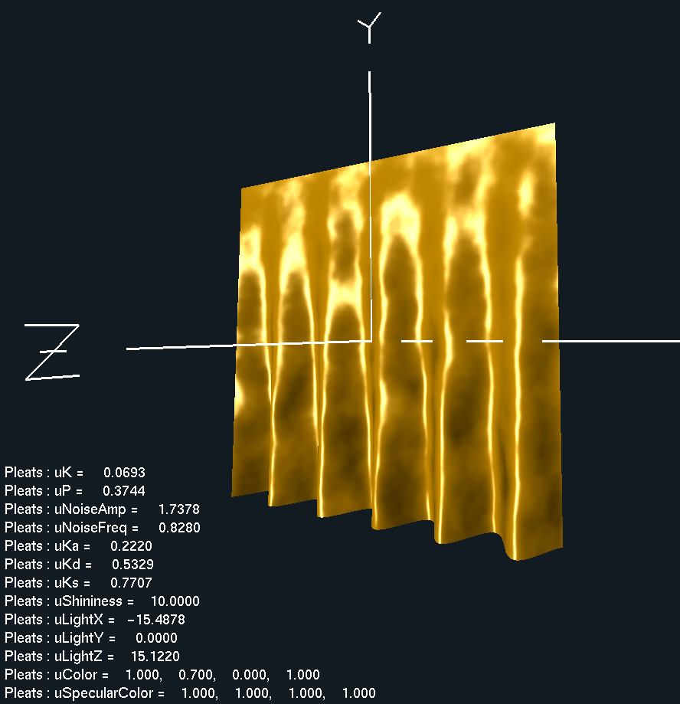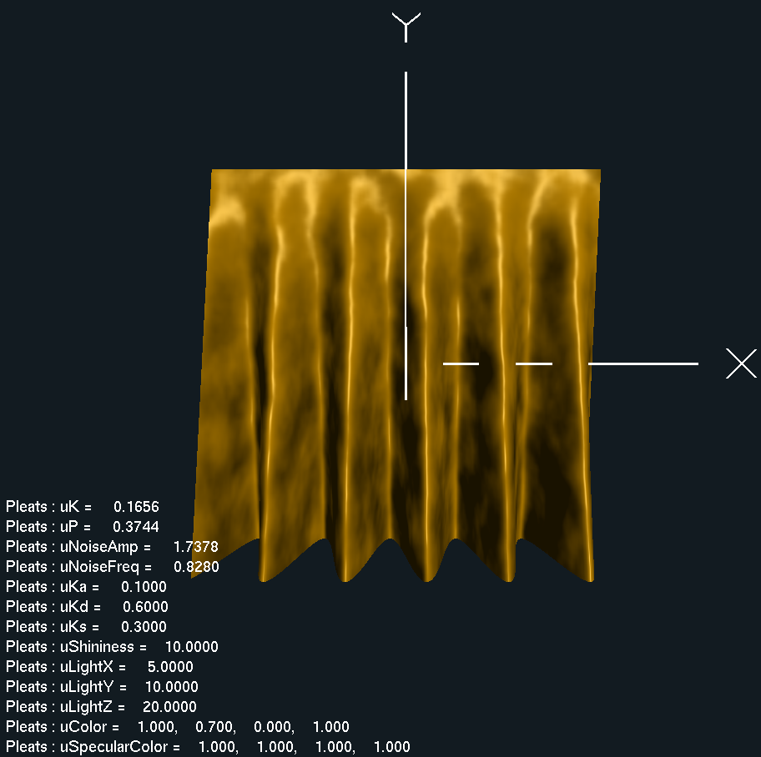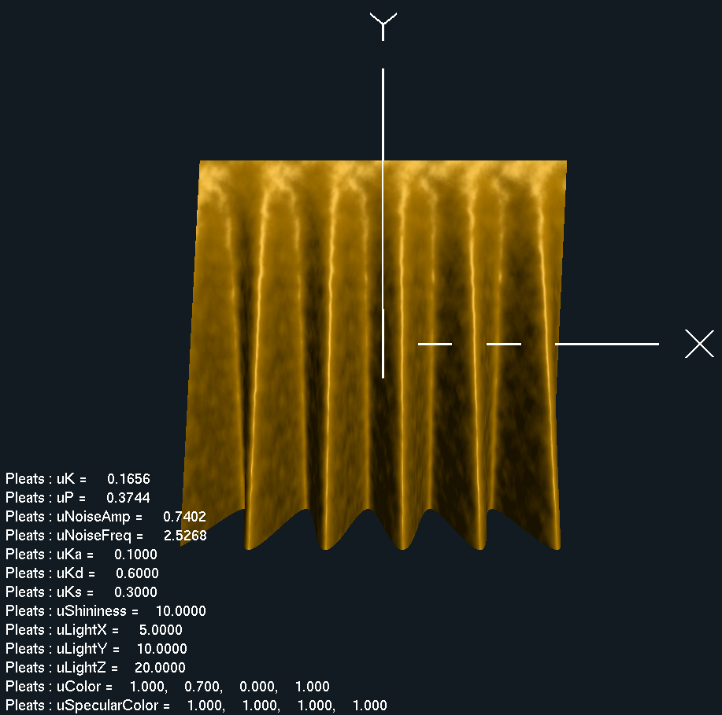

* **Demo video link:** [**https://youtu.be/xaFxr4iLMns**](https://youtu.be/xaFxr4iLMns)