**CS 457/557 -- Winter Quarter 2021**

**Project #6**

**The Cat Menagerie**

**Name: Chun-Yu Chen**

**E-mail:** [**chench6@oregonstate.edu**](mailto:chench6@oregonstate.edu)

* Screen shots from program:

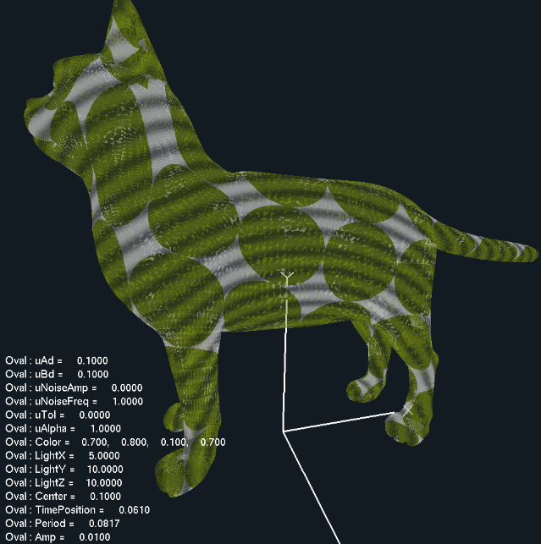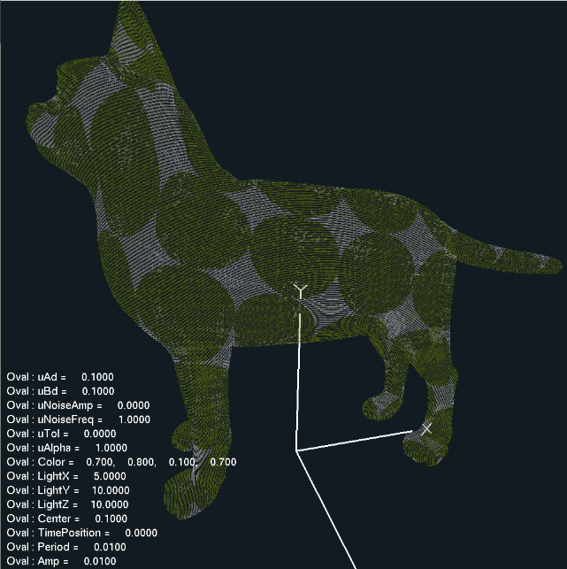

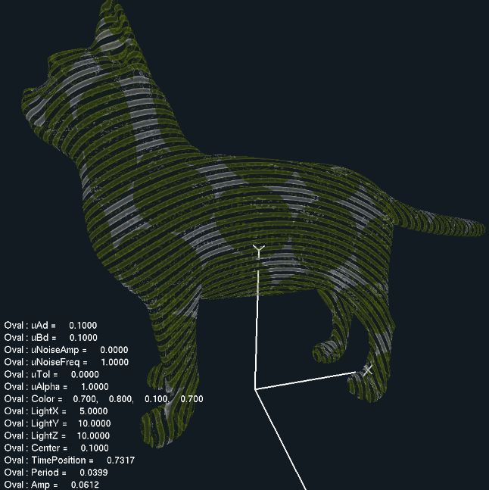

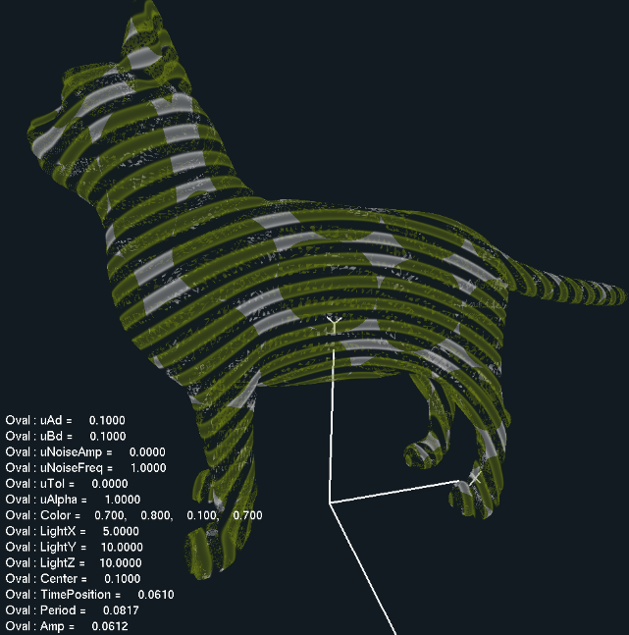

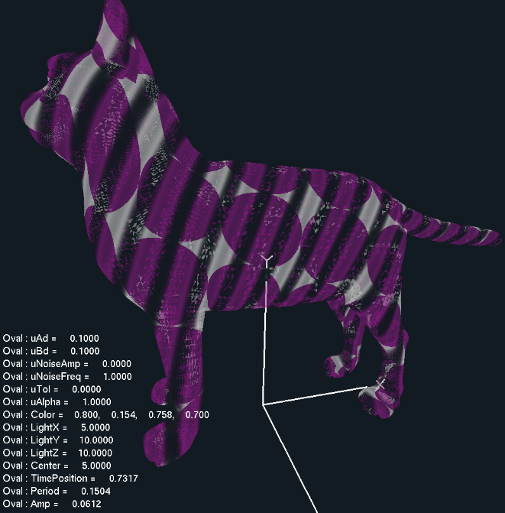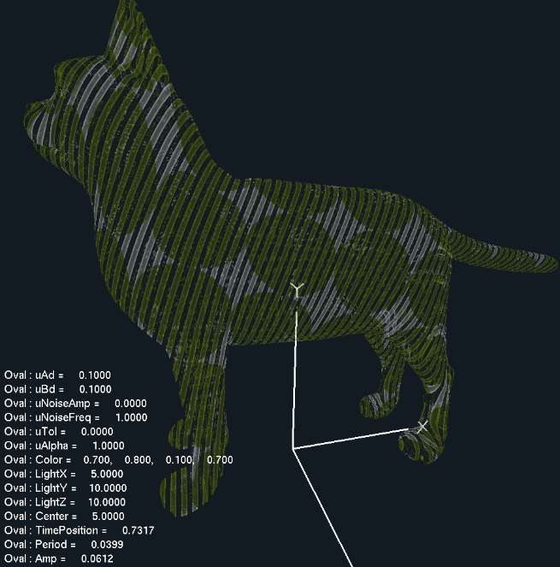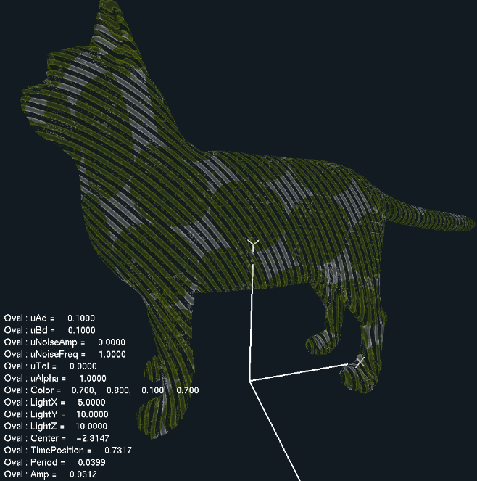

* Video Link: <https://youtu.be/Ed0Uz2DRqfk>