**CS 457/557 -- Winter Quarter 2021**

**Project #7**

**Geometry Shaders for Quantizing 3D Geometry: The Lego™ Project**

**Name: Chun-Yu Chen**

**E-mail:** [chench6@oregonstate.edu](mailto:chench6@oregonstate.edu)

* 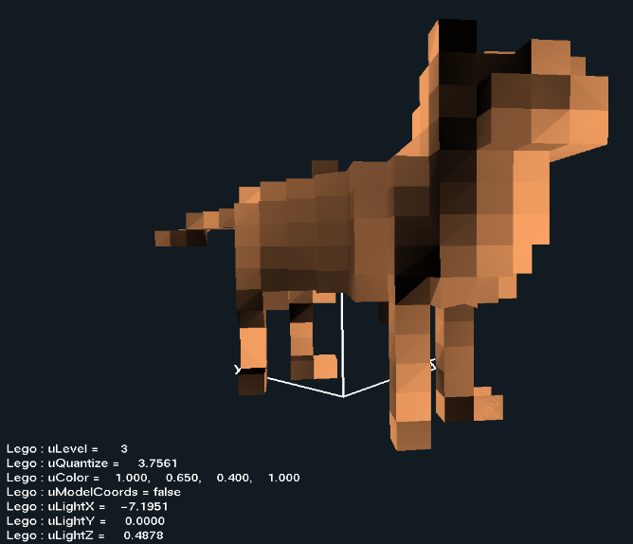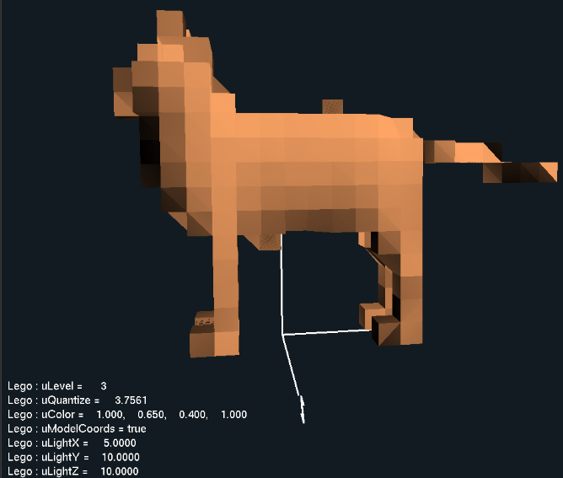Screen shots from program:

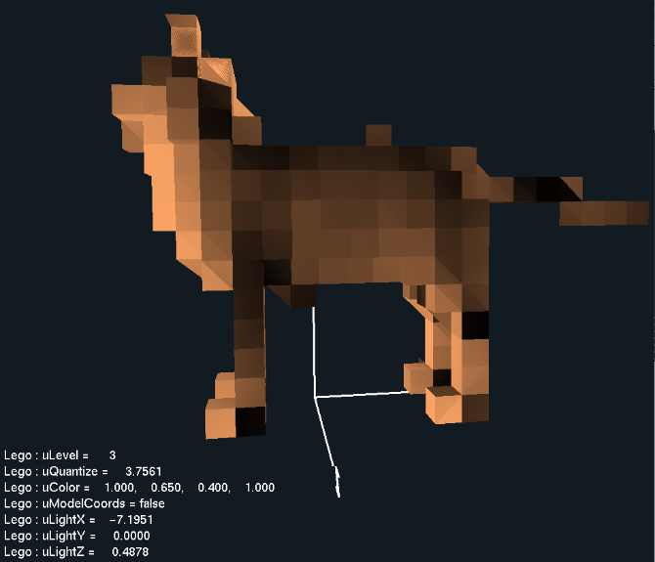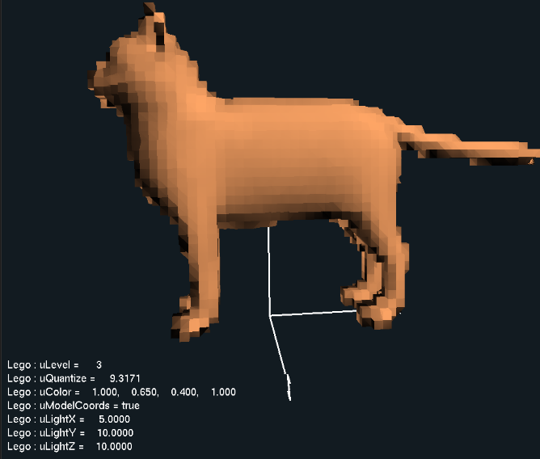

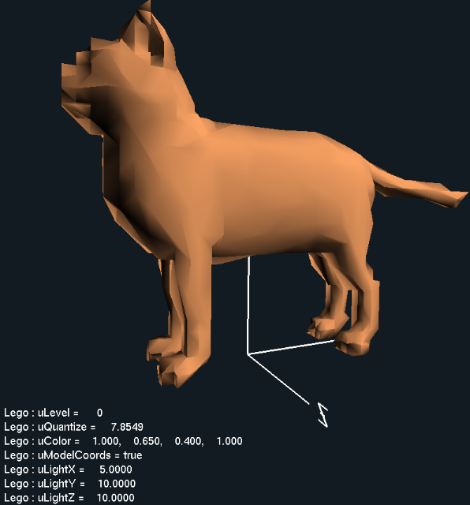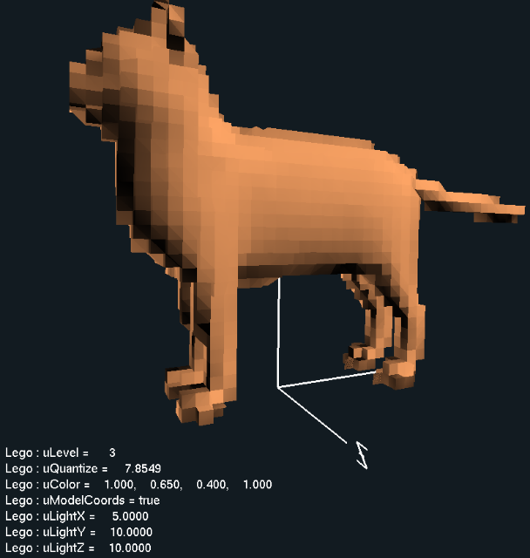

* Video Link: <https://youtu.be/mP8m7e1Q8Zo>