**CS 457/557 -- Winter Quarter 2021**

## Shaders Final Project

## RainbowCat

**Name: Chun-Yu Chen**

**E-mail:** [chench6@oregonstate.edu](mailto:chench6@oregonstate.edu)

* **Idea:**

I build the final project based on the idea of project6 and set 8 different colors to produce the colorful circle pattern. Then, I design a speed factor to present the flow situation of rainbow. In addition, the frequency and amplifier of noise are also added into the pattern generation. The value of alpha is designed to show the transparent effect when its value is 0.

* **Screen shots from program:**

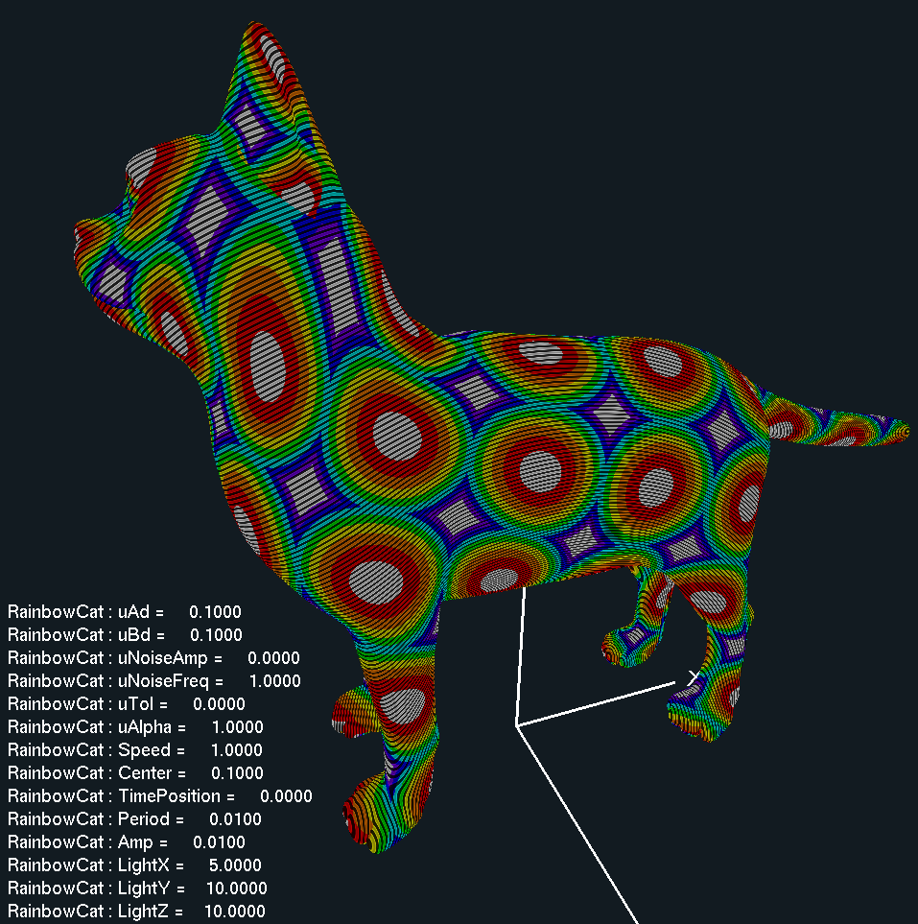 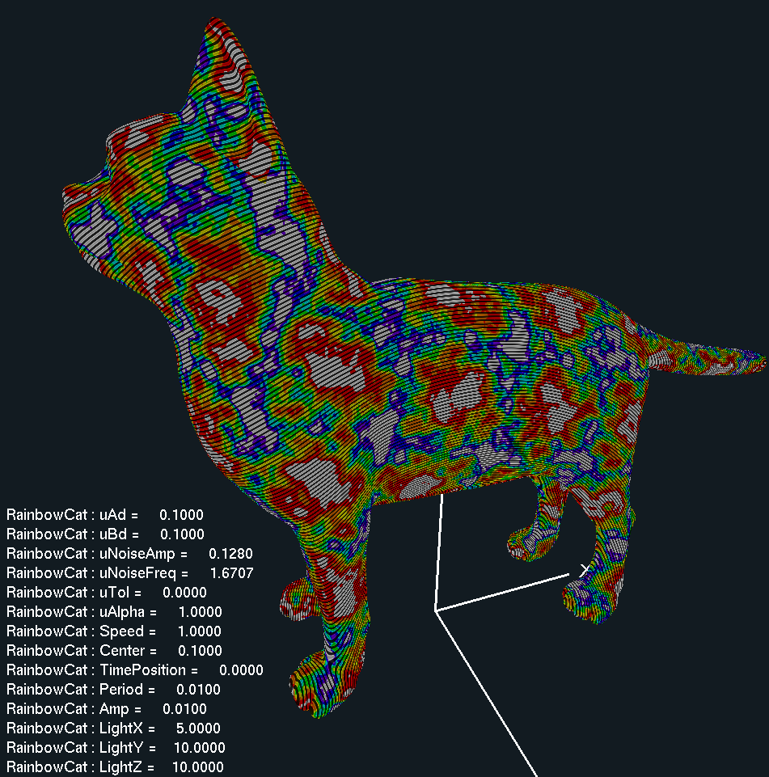

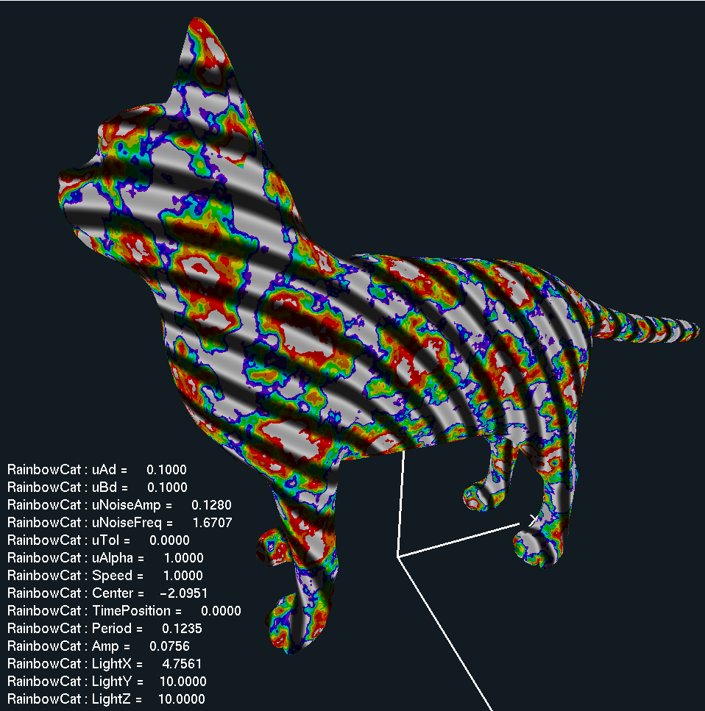 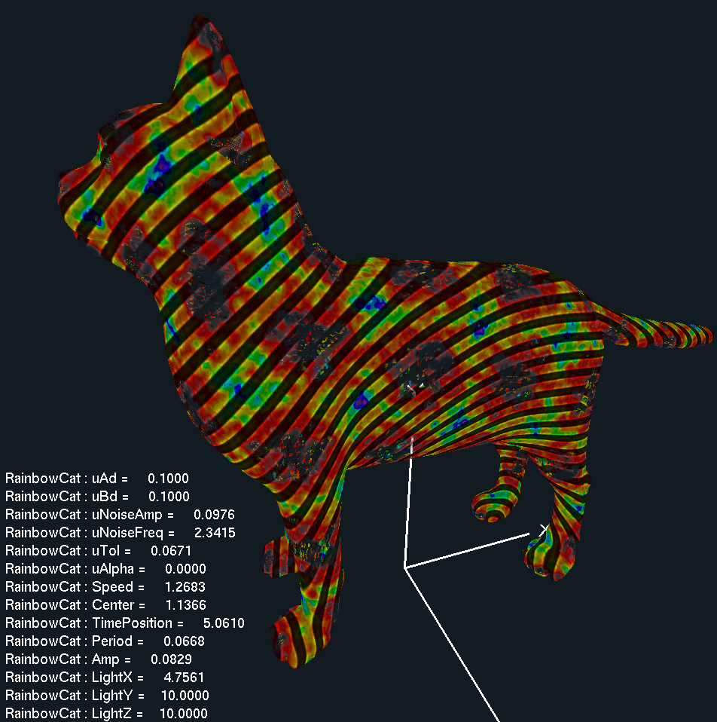

* **Video Link:**

[**https://youtu.be/VOq7dC_cO0Y**](https://youtu.be/VOq7dC_cO0Y)