**CS 475/575 -- Spring Quarter 2021**

**Project #4**

**Vectorized Array Multiplication/Reduction using SSE**

**Name: Chun-Yu, Chen**

**E-mail:** [**chench6@oregonstate.edu**](mailto:chench6@oregonstate.edu)

1. **What machine you ran this on:**

OSU Engineering Server: rabbit

1. **Show the table of performances for each array size and the corresponding speedups:**

|  |  |  |  |
| --- | --- | --- | --- |
| Array_size | MaxSIMDPerformance | MaxNonSIMDPerformance | SpeedUp |
| 1024 | 923.959 | 183.988 | 5.02185 |
| 2048 | 1780.59 | 348.002 | 5.1166 |
| 4096 | 1778.43 | 347.754 | 5.11403 |
| 8192 | 1787.1 | 347.644 | 5.14059 |
| 16384 | 1776.45 | 340.927 | 5.21064 |
| 32768 | 814.868 | 159.789 | 5.09966 |
| 65536 | 1615.48 | 332.546 | 4.85792 |
| 131072 | 1664.21 | 344.845 | 4.82597 |
| 262144 | 1608.26 | 332.695 | 4.83405 |
| 524288 | 1635.67 | 341.06 | 4.79583 |
| 1048576 | 1659.77 | 343.531 | 4.83152 |
| 2097152 | 1186.37 | 339.433 | 3.49514 |
| 4194304 | 942.282 | 338.39 | 2.7846 |
| 8388608 | 931.16 | 324.168 | 2.87246 |

1. **Show the graph of SIMD/non-SIMD speedup versus array size (one curve only):**

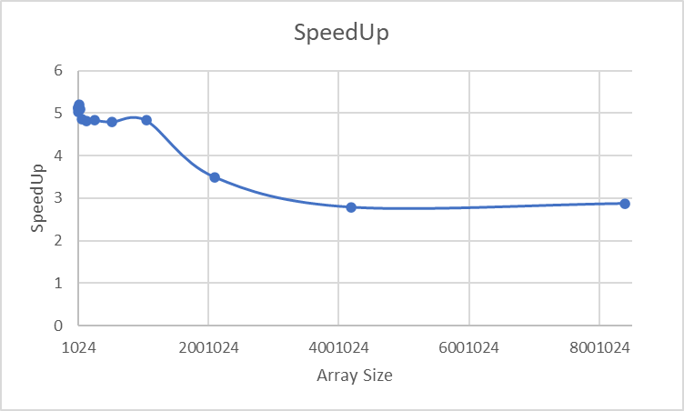

1. **What patterns are you seeing in the speedups?**

**Are they consistent across a variety of array sizes?**

**Why or why not, do you think?**

Based on the graph, we can find that the values of speedup are between 4 to 5 mostly. Basically, the pattern is linear and smooth. I think they are consistent across a variety of array sizes depending on the result. The result shows that the performance is quite stable (5.0 ± noise effect) before 2097152; however, it goes lower and lower after it. This is a issue which can be solved by using prefetching.

1. **Extra Credit:**
2. **Graph:**

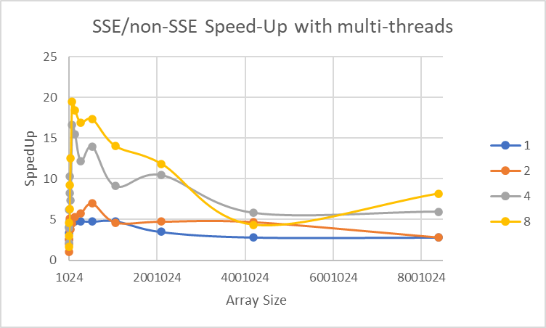

1. **Table:**

|  |  |  |  |  |
| --- | --- | --- | --- | --- |
| Threads  Size | 1 | 2 | 4 | 8 |
| 1024 | 2.528 | 1.05272 | 2.11704 | 1.66896 |
| 2048 | 3.3616 | 2.02445 | 3.94338 | 3.01752 |
| 4096 | 4.02039 | 2.52871 | 6.21117 | 4.5679 |
| 8192 | 4.50383 | 5.12277 | 8.2944 | 6.32741 |
| 16384 | 4.89862 | 3.66914 | 10.3162 | 9.22434 |
| 32768 | 4.76779 | 3.79904 | 7.39079 | 12.5187 |
| 65536 | 4.72209 | 4.53979 | 16.6001 | 19.4796 |
| 131072 | 4.74971 | 5.26489 | 15.5078 | 18.4612 |
| 262144 | 4.80944 | 5.71526 | 12.1798 | 16.9505 |
| 524288 | 4.75151 | 6.97479 | 13.9746 | 17.3597 |
| 1048576 | 4.81552 | 4.63439 | 9.10289 | 14.0525 |
| 2097152 | 3.48433 | 4.73862 | 10.4746 | 11.856 |
| 4194304 | 2.81571 | 4.67615 | 5.8207 | 4.35175 |
| 8388608 | 2.79849 | 2.79159 | 5.97783 | 8.19697 |

1. The result and table are similar to the slide which Professor provided. In addition, the most situation became stable after size 524288.