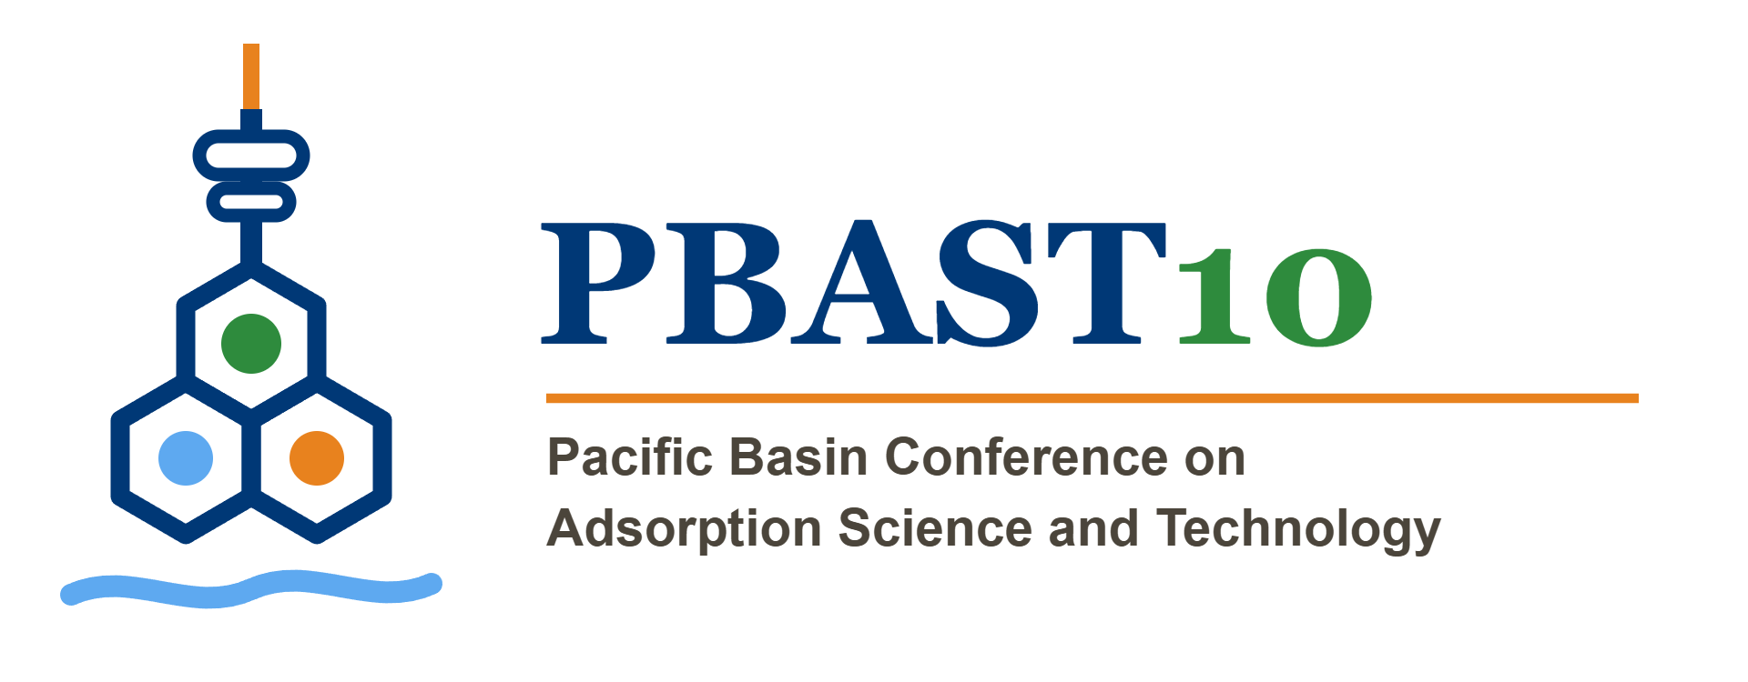 | 10th Pacific Basin Conference on Adsorption Science & Technology  May 31–June 3, 2027 · Yonsei University · Seoul, Republic of Korea

[ABSTRACT TITLE]
Family name, Given name¹*; Family name, Given name²; Family name, Given name¹
¹ Department, Institution, City, Country
² Department, Institution, City, Country
* Corresponding author: email@example.com
Template instructions: Replace all bracketed and sample text. Use Times New Roman throughout. Keep the completed abstract within one A4 page, including keywords and references. Export the final document as PDF before submission.
Abstract
[Replace this paragraph with the abstract text. Briefly state the background and purpose of the work, the methods or approach, the principal results, and the main conclusion. Define uncommon abbreviations at first use. Do not include confidential information. Use 11-point Times New Roman, justified alignment, and single line spacing. Delete these instructions before submission.]
Keywords: keyword 1; keyword 2; keyword 3; keyword 4
References (optional)
[1] A. Author and B. Author, Journal Name 00 (2026) 000–000.
[2] C. Author et al., Book or Proceedings Title, Publisher, City, 2025.
File for submission | PDF only (export this completed template as PDF)
Maximum upload size | 7.5 MB
Submission deadline | November 30, 2026, 11:59 PM KST

