Exercise 1

1. Create a web page, named Exercise1.jsp.
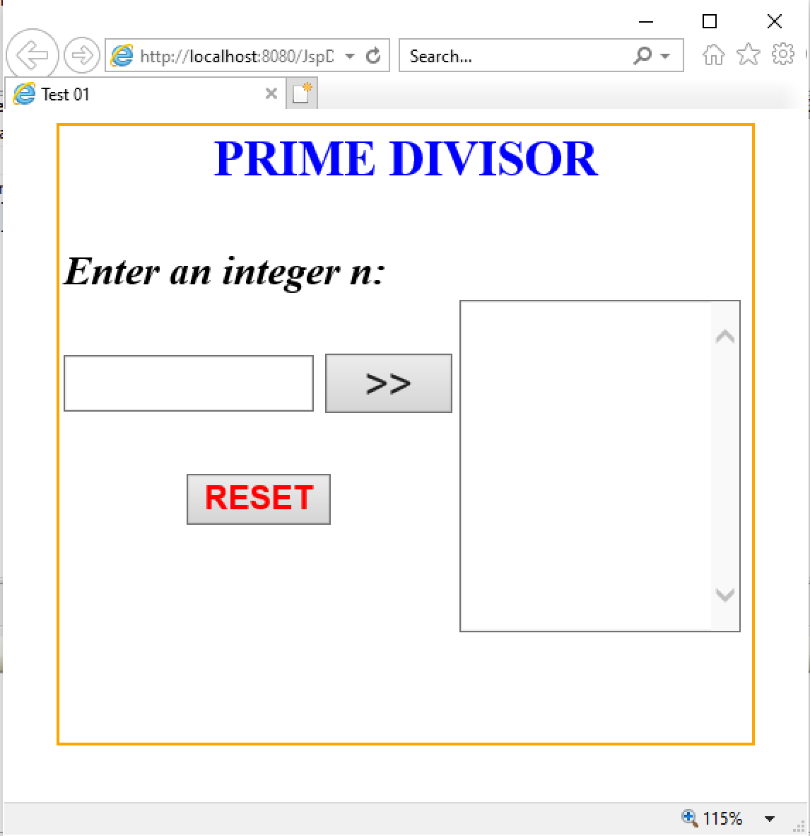

2. Requirement:
a. Click RESET button, set value of TextField and TextArea is empty.
b. Click “>>” button :
- Check input n is integer (n>0). If input fail, TextBox “Enter an integer n” is set empty and show error message to JSP.
- The prime divisor numbers < 10 of n will be added to the TextArea.

