Exercise 3

1. Create a web page, named Exercise3.jsp.
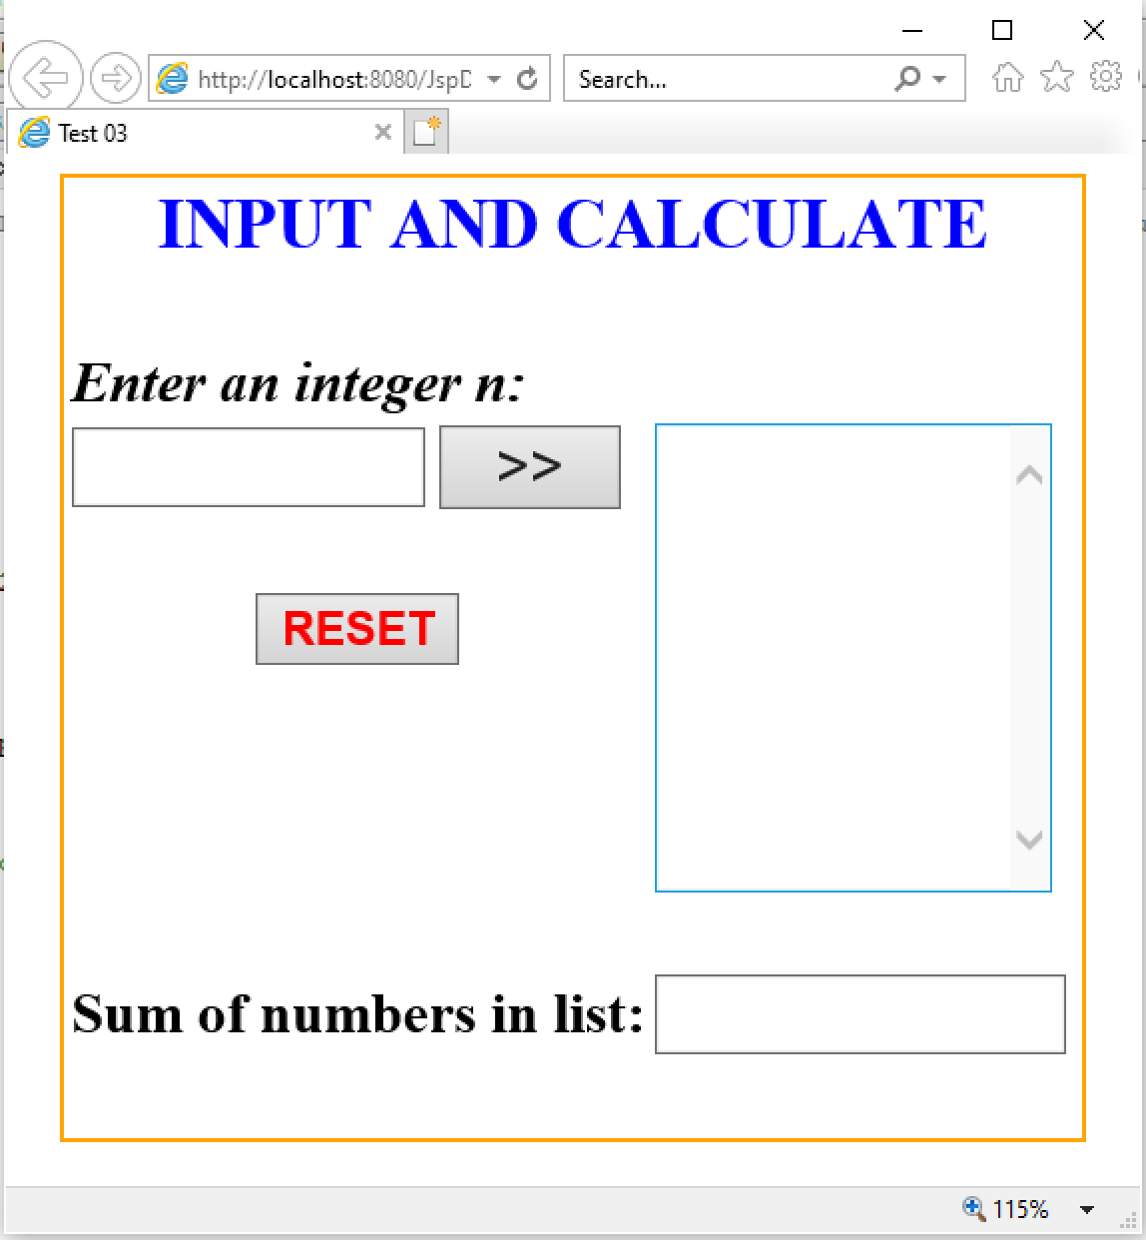

2. Requirement:
a. Click RESET button, set value of TextField and TextArea is empty.
b. Click button >>::
- Check input n is integer (n>3). If input fail, TextBox “Enter an integer n” is set empty and show error message to JSP.
- Otherwise:
b1. The even number < n will be added to the TextArea.
b2. The sum of number in the TextArea will be added to the TextField.

