Exercise 2

1. Create a web page, named Exercise2.jsp.
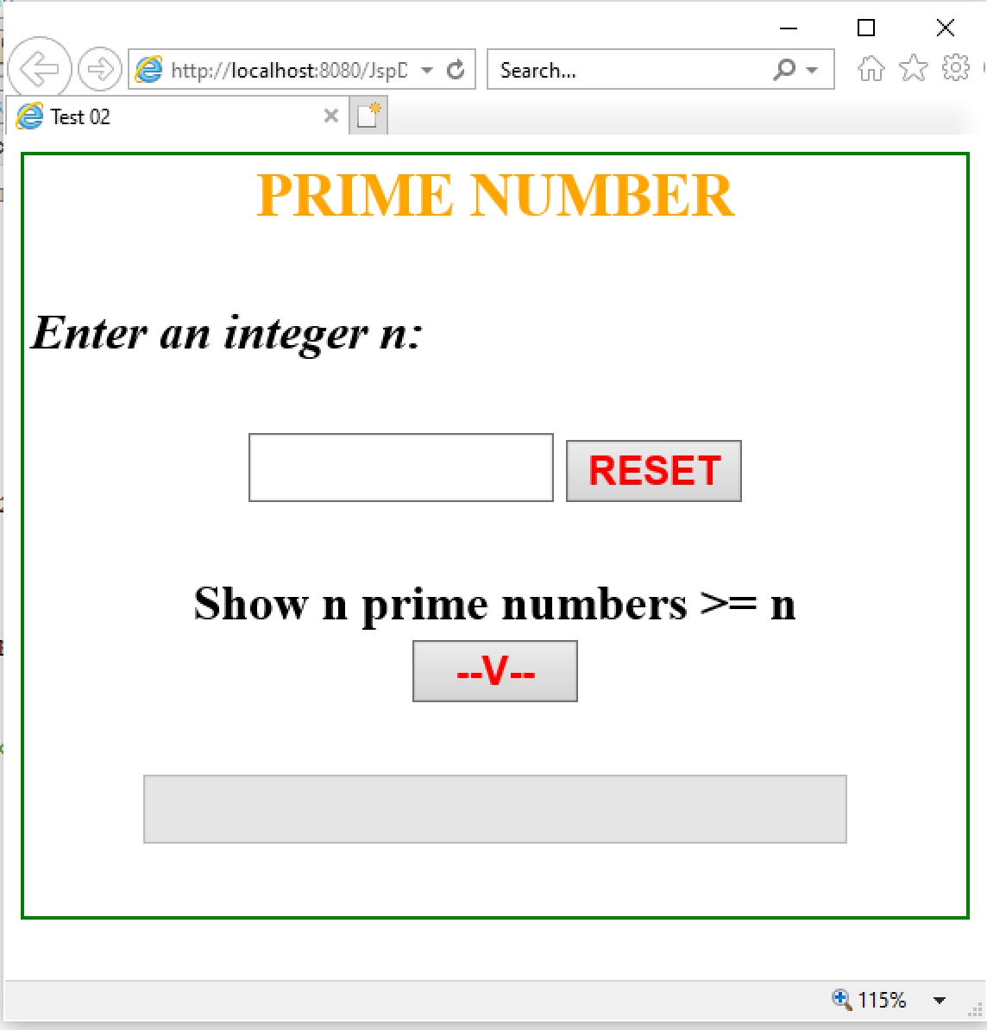

2. Requirement:
a. Click RESET button, set value of TextFields is empty.
b. . Click button V :
- Check input n is integer (n>2). If input fail, TextBox “Enter an integer n” is set empty and show error message to JSP.
- Add n prime numbers >n to TextField. If have no result, show message “No results.”

