NEW TOEFL for 2026 托福新改革細節解析
新托福改制內容
閱讀 (Reading)
1.1 詞彙完型填空 (Complete The Words)
1.2 日常生活閱讀 (Reading in Daily Life)
1.3 學術閱讀 (Reading on Academic Passage)
1.4 閱讀測驗改制與適性測驗 (Multistage Adaptive )
聽力 (Listening)
2.1 聆聽句子答題 (Listen and Choose a Response)
2.2 聆聽二人對話 (Listen to a Conversation)
2.3 聆聽公告 (Listen to an Announcement)
2.4 聆聽學術演講 (Listen to an Academic Talk)
2.5 聽力測驗改制與適性測驗 (Multistage Adaptive )
寫作 (Writing)
3.1 組織重組句子 (Build a Sentence)
3.2 電子郵件寫作 (Write an Email)
3.3 學術討論寫作 (Write for an Academic Discussion)
口說 (Speaking)
4.1 句子複誦 (Listen and Repeat)
4.2 模擬面試 (Take an Interview)

2026 NEW TOEFL托福新制正式上線，ETS在台灣更新考試題型與分數制度，閱讀／聽力引入適性測驗、分數對齊CEFR標準、口說與寫作題型大變革（含學術討論寫作）、出分時間縮短，讓你快速掌握新托福題型變動與應考策略。

NEW TOEFL將於2026年1月21日改制: 新制內容:
考試科目 | 題型 | 題數 | 考試時間
閱讀(二階段適性測驗) | 單詞填空  日常生活閱讀  學術閱讀 | 35-48題 | 約27分鐘
聽力(二階段適性測驗) | 句子答題  二人對話  學術講座  公告 | 35-45題 | 約27分鐘
寫作 | 組織重組句子  電子郵件寫作  學術討論寫作 | 10題  1題  1題 | 約23分鐘
口說 | 句子複誦  模擬面試 | 7題  4題 | 約8分鐘

題數變化：閱讀 Reading 與聽力 Listening 題目的數量將視考生是否被分配到加試試驗性題目而定。每位考生於正式考試中皆會有遇到閱讀或聽力其中一項加試之測試題目。
閱讀與聽力將採取 ”多階段自適應 Multistage Adaptive “ 設計
考試時間：標示之答題時間因其有無加試題型有所異動。

TOEFL Reading


Test Content for New TOEFL Reading
Test Section | Task Type | Number of Items | Estimated Timing
Reading | Complete the Words | 35-48 | About 18-27 minutes
 | Reading in Daily Life
 | Read an Academic Passage

NEW TOEFL – 2026
NEW TOEFL Reading

Module 1
1. Vocabulary 詞彙完形填空 (1/2 篇)
2. Real-life Reading 日常閱讀 (1/2 篇)
3. Academic Reading 學術閱讀 (1/2 篇)

Module 2 Upper Level
1. Vocabulary 詞彙完形填空 (1 篇)
2. Academic Reading 學術閱讀 (1篇)

Module 2 Lower Level
1. Vocabulary 詞彙完形填空 (1 篇)
2. Real-life Reading 日常閱讀 (1篇)

TOEFL Reading

閱讀題型一：單詞填空 (Complete The Words)
此題型主要是在評量考生理解短文的語意、文法句構，以及基礎詞彙的能力。此題型會出現一段長約 70 到 100 字的學術性短文。短文的第一句話都會是完整的句子給予學生內容的提示，接下來的句子每隔一個單字，其後的字就會被刪除後半部，考生透過語意線索、文法句構來填上缺少的部分。每段短文中共有 10 個單字(10題)需要補全。
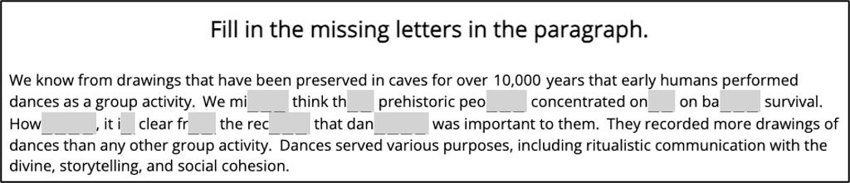
所謂「單詞填空」即是考生必須依據文章線索，補完空格成為正確合理之單字。 例如，看到第一個字「mi _ _ _」，這個字介於主詞we和動詞think之間，這個位置是助動詞或副詞的位置，能符合線索的就是助動詞“might”，因此你就要輸入ght，；接著第二挖空的字「th _ _」，它在動詞think後面，而其後又是一個子句結構，依據這些線索，這個字必須是連接詞，所以輸入at，使其成為連接詞“that”；第三個挖空的字「peo _ _ _」，依據短文第一句話 “We know from drawings that have been preserved in caves for over 10,000 years that early humans performed dances as a group activity.”，得知短文主題在討論早期人類(early humans)的行為，所以形容詞prehistoric (史前的)之後被挖空的字最合理的字就是名詞“people”，故輸入ple。

閱讀題型二：日常生活閱讀 (Reading in Daily Life)
此生活情境類閱讀為改革後之新題型。 基本上與多益(TOEIC) 之短篇閱讀題型極為相似，內容字數約為 15 到 150 字不等，依據篇幅會搭配兩至三題選擇題。




短閱讀之內容範疇：
海報 / 標示 / 公告 / 菜單 / 社群媒體貼文 / 網頁訊息 / 行程 / 電子郵件 /
簡訊對話 / 廣告 / 新聞文章 / 表單 / 發票 / 收據
閱讀題型三：學術閱讀 (Reading on Academic Passage)
接下來以後的學術閱讀和現行的托福學術閱讀一樣，只是篇幅更短了。 內容通常與高中或大學階段所閱讀的課堂材料相仿。此任務的設計理念是不要求考生具備任何背景知識，換句話說，考生可以只憑文章本身提供的資訊完成作答。
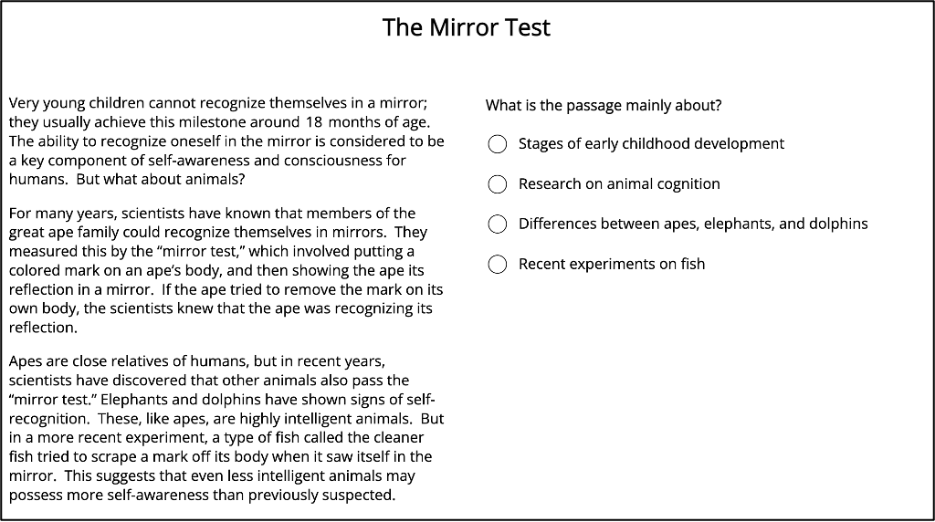
文章主題與現行托福閱讀一樣，涵蓋多個學科領域，例如：天文、地質、海洋、氣候、生命科學（如生物學）、物理科學（如物理、化學）、歷史、考古文明、藝術與音樂、商業與經濟、社會科學（如心理學、社會學）。 每篇文章長度大約 200 字，文章後會搭配 五題選擇題，問題類型包括：
文意主旨題：詢問作者寫這段話的目的或其在文章中扮演的功能。
事實訊息題：考查文章之具體內容或細節來形成正確事實內容判斷。
否定事實訊息題：考查考生對文中未提到或原文相矛盾否定細節之辨識。
語境詞彙題：測試考生是否能根據上下文判斷單字意義。
推論暗示題：根據文中直接陳述之內容進行推論演繹以理解觀點或含義。
修辭目的題 : 推斷出作者陳述事理背後之動機、目的或原因。
段落邏輯關係題：考查學生能否理解句子之間、段落之間的邏輯銜接。
Skills for Filling In The Missing Letters

 能力要求
 上下文線索搜尋 (語法 / 內容提示詞)
 語言直覺 (固定搭配 / 慣用語法)
 內容推斷 / 非語言直覺
 首句 / 末句與標題作用: 確認人數 / 確認時態 / 術語 / 確認指代詞 (this
/ that / these / those )

Skills：
1. 首先，通讀整篇文章以瞭解上下文，然後根據上下文選擇最合適的單詞。
2. 避免在任何單一空缺處停留太久，以更精確有效率管理時間。
3. 對可能成為考題之固定片語與避留心注意。
4. 填寫空白時注意動詞時態、單複數形式與正確的詞性。
5. 最後預留時間檢查答案的拼寫準確性、上下文一致性，以及是否包含任何指導性
詞語或短語。
6. 在備考時，積累常見搭配和介詞，並熟悉以特定字母組合開頭的單詞（例如，
st ——step，stop，star，store）以增強快速記憶。

Skills for Vocabulary 答題思路：
Step1: 根據的結構即句子的主動受結構以及固定搭配判斷所填詞彙的詞性。
Step2: 根據上下文判斷詞義。
Step3: 根據時態和具體空格數判斷是否需要變形。以題目為例，當看到關鍵字時，應立刻意識到其相關之固定搭配後面應該加動詞原形。接續，在腦海中搜索以該提示字母開頭、包含符合之字母數量的語詞，並找到描述相匹配之字詞，從而得出正確答案。

Tip：對於詞彙量不足且在聯繫上下文和語境理解能力上稍顯不足的考生來說，這種題型挑戰可能會比較大。尤其是這種一句話語境，並沒有特別充足的提示，如果對句子的關鍵字掌握不佳，解題的難度就會大大提高。

備考建議：擴大自己的詞彙量，可以嘗試將詞彙按照主題或詞性進行分類，然後進行記憶，並通過使用詞根詞綴記憶法、聯想記憶法等方法，提高背誦效率。還可以閱讀英文文章、看美劇、多和他人用英語溝通來積累詞彙、在語境中練習詞彙，熟能生巧。另外務必多做題多思考，培養答題之敏銳度，由數量積累提升底蘊。

Complete The Words
Fill in the missing letters in the paragraph.
(Questions 1-10)
There are a number of environments in which organisms are exposed to temperatures be __ __ __ 0 ℃ and thus the risk of freezing. In polar regions, terrestrial organisms are exposed to freezing temperatures for
m __ __ __ of the year. In more temperate regions, they may have to tolerate several months of winter, when subzero temperatures
pe __ __ __ __ __ for long p __ __ __ __ __ __ of time. High mountains are
an __ __ __ __ __ place where there is permanent s __ __ __ and ice, even at the equator. Ex __ __ __ __ __ __ to subzero temperatures may o __ __ __ __ on a daily and/or seasonal basis.

Fill in the missing letters in the paragraph.
(Questions 1-10)
Maps are tools that help us understand the world around us. They
sh__ __ the loca __ __ __ __ of pla __ __ __ like cit __ __ __ , rivers, a __ __
mountains. Th __ __ __ visual gu __ __ __ __ can al __ __ display different
ty __ __ __ of infor __ __ __ __ __ __ __ , such as climate or population.
There are many kinds, including physical, political, and thematic versions.
The study of maps and cartography, the process by which they are made,
can teach us about the geography of our planet and how people live in
different regions.

Reading in Daily Life
A History of Sports from Ancient Times to the Present
By Rebecca Jean Porter
Illustrated, 248 pp.
Oakview Press, Westport, CT $32.95
Rebecca Jean Porter, the author of Olympic Dreams, has attained another perfect score in this engaging and readable history. A History of Sports from Ancient Times to the Present covers everything from sporting events in ancient Rome to the origins of team sports in North America, and it includes a section on sports played on contemporary university campuses. I highly recommend the chapter with detailed instructions on how to play games that had previously been lost over time. Porter's comprehensive introduction and bibliography, as well as the time line of dates and events, make this a reference work that should be purchased by all public libraries. An online companion volume will be published next year.
-- Andrew Huff

1. What does Andrew Huff suggest about the book?
(A) It is not as good as Olympic Dreams.
(B) It does not cover previous centuries in detail.
(C) It is a well-written work.
(D) It is currently available online.

2. What is NOT mentioned as being included in the book?
(A) Names of reference sources
(B) A listing of historical dates
(C) A thorough opening section
(D) A schedule of local sporting events

3. For what group is the book particularly recommended?
(A) Community libraries
(B) University students
(C) Sports centers
(D) Sports players

Reading on Academic Passage
Milankovitch Cycles and Glaciation
Although the history of glaciation during the Pleistocene epoch (2 million to 10,000 years ago) is well established, we do not know with complete certainty why glaciation takes place. For over a century, geologists and climatologists have struggled with this problem, but it remains unsolved.
It is long known that Earth’s orbit around the Sun changes periodically, cyclically affecting the way solar radiation strikes the Earth, but the idea that these changes affect climate was first advanced by James Croll in the late 1800s. Later, Milutin Milankovitch elaborated the theory with calculations that convincingly argued that the cycles, now known as Milankovitch cycles, could cause climatic variations.

The Milankovitch cycles emerge from the way three cyclic changes in
Earth’s orbit combine. One characteristic of Earth’s orbit is its eccentricity, the degree to which the orbit is an ellipse rather than a circle. Changes in the eccentricity of Earth’s orbit occur in a cycle of about 96,000 years. The inclination, or tilt, of Earth’s axis also varies periodically, moving between 22 degrees and 24.5 degrees. The tilt of Earth’s axis, toward the Sun at some times of the year and away from the Sun at other times, is responsible for the annual cycle of seasons. The greater the tilt, the greater the contrast between summer and winter temperatures. Changes in the tilt occur in a cycle 41,000 years long. Also, Earth wobbles as it spins, like a slightly unsteady top. The wobble cycle is completed once every 21,700 years. Changes in eccentricity, tilt and wobble do not affect the total amount of solar radiation Earth receives in a year, but they do affect how evenly or unevenly this radiation is disturbed over the course of a year. According to the Milankovitch theory, about every 40,000 years the three separate cycles combine in such a way that the difference between summer and winter temperatures is at a minimum. At this point winter temperatures are milder but so too are summer temperatures. As a result, less ice is melted in the summer than is formed in the winter, so glaciers build up and a period of glaciation results.

Milankovitch worked out the ideas of climatic cycles in the 1920s and
1930s, but it was not until the 1970s that a detailed chronology of the Pleistocene temperature changes was determined that could test the predictions of this theory. A correspondence between Milankovitch cycles and climate fluctuations of the last 65 million years seems clear. Furthermore, studies or rock samples drilled from the deep-sea floor and the fossils contained in them indicate that the fluctuation of climate during the past few hundred thousand years is remarkably close to that predicted by Milankovitch.
A problem with Milankovitch’s explanation of glaciation arises from the fact that the variations in Earth’s orbit, and hence the Milankovitch cycles, have existed for billions of years. (A)■ Thus we might expect that glaciation would have been a cyclic event throughout geologic time. In fact, periods of glaciation are rare. (B)■ So there must be another factor acting together with the Milankovitch cycles that causes periods of glaciation. (C)■ Once this additional factor makes the temperature low enough, the cyclic variations of the Milankovitch cycles will force the planet into and out of glacial epochs with a fixed regularity. (D)■
Many hypotheses have been proposed for the additional cooling factor. Some suggest that variations in the Sun’s energy output could account for the ice ages. However, our present understanding of the Sun’s luminosity holds that it should have progressively increased, not decreased, over the course of Earth’s history. Still others argue that volcanic dust injected into the atmosphere shields Earth from the Sun’s rays and initiates an ice age. However, no correlation has been found between volcanic activity and the start of the last ice age. An increasingly attractive theory holds that decreases in atmospheric carbon dioxide starts the cooling trend that leads to glaciation. Carbon dioxide traps solar energy reflected from the Earth’s surface. If carbon dioxide levels decrease, less heat is trapped and Earth’s surface cools. Recent studies of the carbon dioxide content of gas bubbles preserved in the Greenland ice cap do in fact show that high carbon dioxide levels are associated with warm interglacial periods, and low levels with cold glacial periods.

Paragraph 2
It is long known that Earth’s orbit around the Sun changes periodically, cyclically affecting the way solar radiation strikes the Earth, but the idea that these changes affect climate was first advanced by James Croll in the late 1800s. Later, Milutin Milankovitch elaborated the theory with calculations that convincingly argued that the cycles, now known as Milankovitch cycles, could cause climatic variations.

1. The word ”elaborated” in the passage is closest in meaning to
(A) corrected
(B) defended
(C) studied
(D) developed

2. According to paragraph 2, Milankovitch was the first to do which of the
following?
(A) Introduce the idea that periodic changes in Earth’s orbit could
influence Earth’s climate.
(B) Show that periodic changes in Earth’s orbit could be mathematically
Calculated.
(C) Provide calculations to show that periodic changes in Earth’s orbit could affect Earth’s climate.
(D) Propose that Earth’s orbit is not fixed but undergoes periodic changes.

Paragraph 3
The Milankovitch cycles emerge from the way three cyclic changes in
Earth’s orbit combine. One characteristic of Earth’s orbit is its eccentricity, the degree to which the orbit is an ellipse rather than a circle. Changes in the eccentricity of Earth’s orbit occur in a cycle of about 96,000 years. The inclination, or tilt, of Earth’s axis also varies periodically, moving between 22 degrees and 24.5 degrees. The tilt of Earth’s axis, toward the Sun at some times of the year and away from the Sun at other times, is responsible for the annual cycle of seasons. The greater the tilt, the greater the contrast between summer and winter temperatures. Changes in the tilt occur in a cycle 41,000 years long. Also, Earth wobbles as it spins, like a slightly unsteady top. The wobble cycle is completed once every 21,700 years. Changes in eccentricity, tilt and wobble do not affect the total amount of solar radiation Earth receives in a year, but they do affect how evenly or unevenly this radiation is disturbed over the course of a year. According to the Milankovitch theory, about every 40,000 years the three separate cycles combine in such a way that the difference between summer and winter temperatures is at a minimum. At this point winter temperatures are milder but so too are summer temperatures. As a result, less ice is melted in the summer than is formed in the winter, so glaciers build up and a period of glaciation results.

3. According to paragraph 3, Milankovitch’s theory holds that periods of glaciation result from a particular combination of changes in all the following EXCEPT
(A) the shape of Earth’s orbit
(B) the inclination of Earth’s axis
(C) the wobble of Earth as it spins
(D) the amount of time required for Earth’s rotation around the Sun

4. According to paragraph 3, Milankovitch’s theory predicts that glaciers build up most when
(A) the least amount of solar heat is being delivered to Earth.
(B) winter temperatures are lowest.
(C) the difference between winter temperatures and summer temperatures is greatest.
(D) both winter temperatures and summer temperatures are relatively mild.

Paragraph 4
Milankovitch worked out the ideas of climatic cycles in the 1920s and
1930s, but it was not until the 1970s that a detailed chronology of the Pleistocene temperature changes was determined that could test the predictions of this theory. A correspondence between Milankovitch cycles and climate fluctuations of the last 65 million years seems clear. Furthermore, studies or rock samples drilled from the deep-sea floor and the fossils contained in them indicate that the fluctuation of climate during the past few hundred thousand years is remarkably close to that predicted by Milankovitch.

5. The word ”chronology” in the passage is closest in meaning to
(A) a study of past events
(B) a list that pairs past events with dates
(C) an explanation of why past events happened when they did
(D) an ordering of past events according to how long they lasted

6. Which of the following can be inferred from paragraph 4 about rock samples taken from the sea floor and the fossils they contain?
(A) There is a correspondence between the fossils in the samples and
climate fluctuations.
(B) Milankovitch’s theory predicts when the samples will contain fossils.
(C) It was not known until the 1970s that fossils were present in rocks taken from the sea floor.
(D) There is no fossil record in the samples older than a few hundred thousand years.

7. The phrase ”remarkably close” in the passage is closest in meaning to ○(A) sufficiently close
(B) relatively close
(C) extremely close
(D) frequently close

Paragraph 5
A problem with Milankovitch’s explanation of glaciation arises from the fact that the variations in Earth’s orbit, and hence the Milankovitch cycles, have existed for billions of years. Thus we might expect that glaciation would have been a cyclic event throughout geologic time. In fact, periods of glaciation are rare. So there must be another factor acting together with the Milankovitch cycles that causes periods of glaciation. Once this additional factor makes the temperature low enough, the cyclic variations of the Milankovitch cycles will force the planet into and out of glacial epochs with a fixed regularity.

8. According to paragraph 5, which of the following is a problem with Milankovitch’s theory?
(A) It assures that the astronomical cycles have been in existence for billions of years.
(B) It cannot explain why glaciation has been a relatively rare occurrence in Earth’s history.
(C) It cannot predict periods of glaciation in Earth’s distant past.
(D) It assures that astronomical cycles have an effect on Earth’s climate even during periods when there is no glaciation.

Paragraph 6
Many hypotheses have been proposed for the additional cooling factor. Some suggest that variations in the Sun’s energy output could account for the ice ages. However, our present understanding of the Sun’s luminosity holds that it should have progressively increased, not decreased, over the course of Earth’s history. Still others argue that volcanic dust injected into the atmosphere shields Earth from the Sun’s rays and initiates an ice age. However, no correlation has been found between volcanic activity and the start of the last ice age. An increasingly attractive theory holds that decreases in atmospheric carbon dioxide starts the cooling trend that leads to glaciation. Carbon dioxide traps solar energy reflected from the Earth’s surface. If carbon dioxide levels decrease, less heat is trapped and Earth’s surface cools. Recent studies of the carbon dioxide content of gas bubbles preserved in the Greenland ice cap do in fact show that high carbon dioxide levels are associated with warm interglacial periods, and low levels with cold glacial periods.

9. The author discusses “our present understanding of the Sun’s luminosity” in order to
(A) provide evidence that Milankovitch’s astronomical cycles cannot explain the occurrence of the ice ages
(B) present an objection to a proposed explanation of the cause of ice ages
(C) challenge the claim that long-term cooling can account for glaciation
(D) introduce a problem that none of the proposed hypotheses about the causes of glaciation can answer

10. The word ”initiates” in the passage is closest in meaning to
(A) begins
(B) accelerates
(C) extirpates
(D) shuns
11. According to paragraph 6, in addition to Milankovitch cycles, each of the following has been proposed as a contributing cause of ice ages EXCEPT
(A) variations in the composition of the Greenland ice cap
(B) variations in the Sun’s energy output
(C) volcanic dust injected into the atmosphere
(D) decreases in atmospheric carbon dioxide

12. It follows from the theory of the role of carbon dioxide discussed in paragraph 6, that
(A) the decrease in temperature during the last ice age caused a decrease in atmospheric carbon dioxide.
(B) the atmosphere had higher carbon dioxide content during the last ice age than it had during the warm period immediately before it.
(C) the cooling of temperatures that led to the last ice age was brought about by a decrease in atmospheric carbon dioxide.
(D) there was less carbon dioxide in the atmosphere toward the end of the last ice age than there was at the beginning.

