TOEFL READING
托福閱讀



READING ACHIEVEMENT GUIDE

Reading Section
_______________________________________
In the Reading Section, you will answer 35-50 questions to demonstrate how well you understand academic and non-academic texts in English. There are three types of tasks.

Type of Task | Description
Complete the Words | Fill in the missing letters in a paragraph.
Reading in Daily Life | Answer questions about everyday reading material.
Read an Academic Passage

Module 1
________________________________________________________________________
The clock will show how much time you have to complete Module 1.
You can use Next and Back to move to the next question or return to previous questions within the same module.
You WILL NOT be able to return to Module 1 once you have begun Module 2.

Vocabulary
Fill in the missing letters in the paragraph.
(Questions 1-10)
Early civilizations, including those in Mesopotamia, Egypt, the Indus
Valley, and China, emerged around river valleys, where fertile land and
water resources supported agriculture. Th __ __ developed
sophis __ __ __ __ __ __ __ social struc __ __ __ __ __, written
lang __ __ __ __ __ __ , and adva __ __ __ __technologies, wh __ __ __
allowed th __ __ to thr __ __ __ and esta __ __ __ __ __ cities, tr __ __ __
networks, and even empires. Just as important were their significant
contributions to fields like art, science, and law. There developments were
crucial in shaping the course of human history.

Real-Life Reading


Dear Jean,
I wanted to write you a note to thank you. I am sorry that you felt disappointed that your work responsibilities were not what you expected. I have enjoyed having your assistance with my projects.
Although the tasks we handled were not as varied as you would have liked, just think about what you and I have accomplished since September. We organized the annual small business conference, updated the association's web site, and answered scores of inquiries, many in great detail, from business owners who needed advice on a range of topics: loans, benefits, licensing, etc.
I feel the year has been very productive for both of us. You've been a congenial and conscientious assistant and all of us have the highest regard for your abilities. Please feel free to call upon me for a recommendation if you require one for future employment.
Best of luck,
Thomas

1. What can be inferred about Jean?
A She was unhappy in her job.
B She asked for a promotion.
C She started a new business.
D She lent money to Thomas.

2. What is NOT cited as part of Jean's work?
A Organizing conferences
B Processing business loans
C Corresponding with clients
D Maintaining a Web site

3. What does Thomas say about Jean?
A She is a skillful writer.
B She is a diligent worker.
C She is an excellent teacher.
D She is an experienced supervisor.

4. What does Thomas offer to do for Jean?
A Raise her salary
B Increase her hours
C Reduce her workload
D Recommend her for a job

(1) 考古真題

Attempts at Determining Earth’s Age
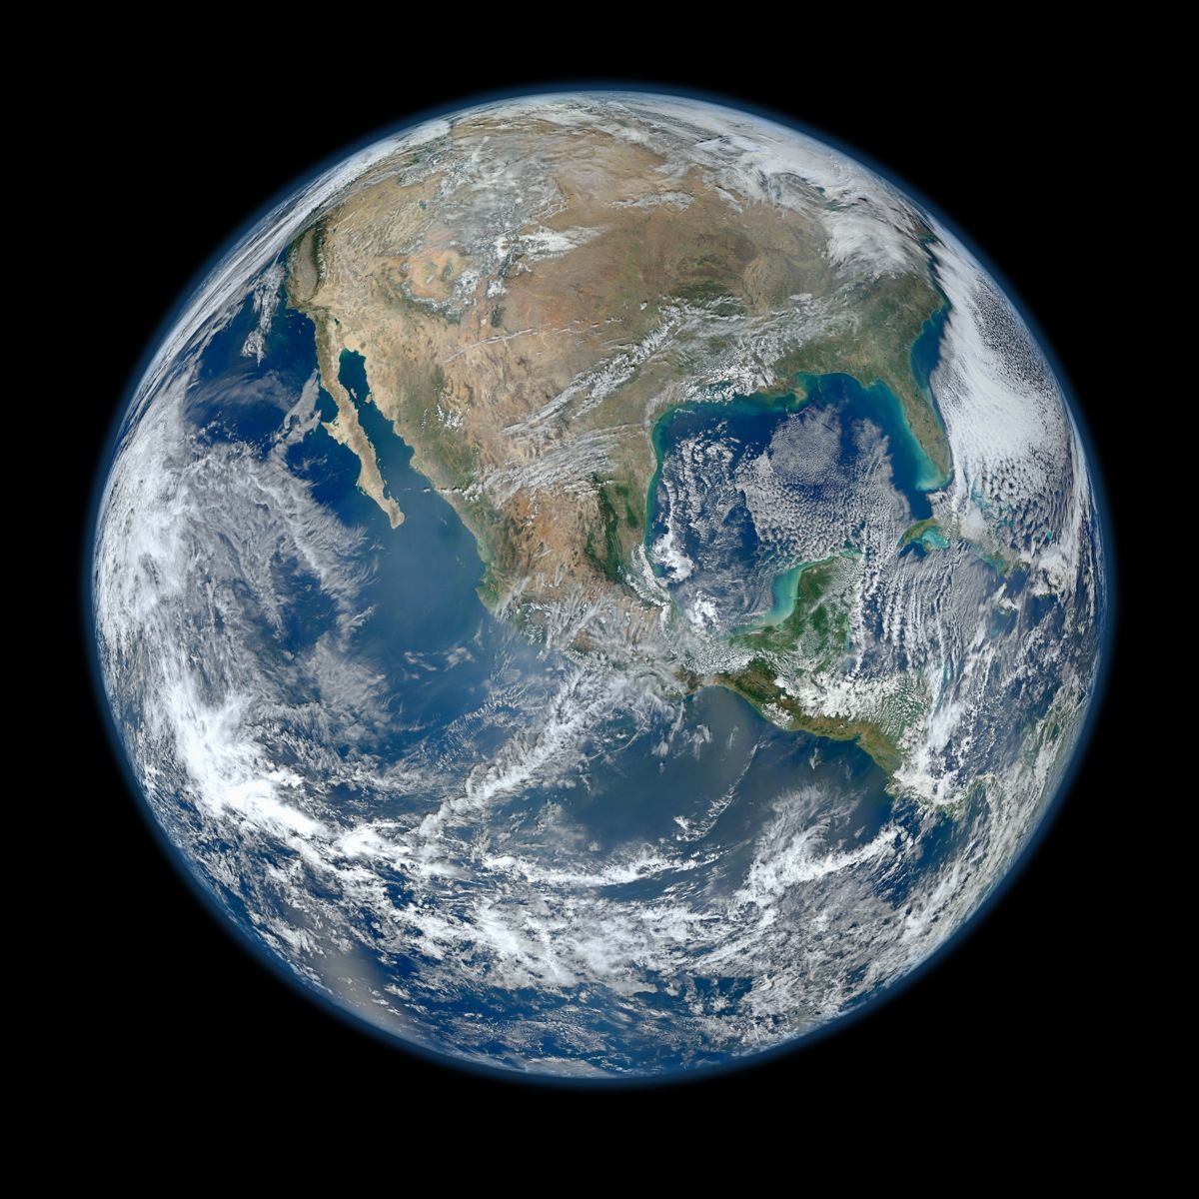
Since the dawn of civilization, people have been curious about the age of Earth. In addition, we have not been satisfied in being able to sate merely the relative geologic age of a rock or fossil. Human curiosity demands that we know actual age in years.

Geologists working during the nineteenth century understood rock bodies, they would have to concentrate on natural processes that continue at a constant rate and that also leave some sort of tangible record in the rocks. Evolution is one such process, and geologist Charles Lyell (1797-1875) recognized this. (A)■ By comparing the amount of evolution exhibited by marine mollusks then, Lyell estimated that 80 million years had elapsed since the beginning of the Tertiary Period. He came astonishingly close to the mark, since it was actually about 65 million years. (B)■ However, for older sequence of evolutionary development, estimates based on parts in the fossil record. (C)■ Rates of evolution for many orders of plants and animals were not well understood. (D)■

In another attempt, geologists reasoned that if rates of deposition could be determined for sedimentary rocks, they might be able to estimate the time required for deposition of a given thickness of strata, or rock layers. Similar reasoning suggested that one could estimate total elapsed geologic time by dividing the average thickness of sediment transported annually to the oceans into the total thickness of sedimentary rock that had ever been deposited in the past. Unfortunately, such estimates did not adequately account for past difference in rates of sedimentation or losses to the total section of strata during episodes of erosion. Also, some very ancient sediments were no longer recognizable, having been converted to igneous and metamorphic rocks in the course of mountain building. Estimates of Earth’s total age based on sedimentation rates ranged from as little as million to over a billion year.

Yet another scheme for approximating Earth’s age had been proposed in 1715 by Sir Edmund Halley (1656-1742), whose name we associate with the famous comet. Halley surmised that the ocean formed soon after the origin of the planet and therefore would be only slightly younger that the age of the solid Earth. He reasoned that the original ocean was not salty and that subsequently salt derived from the weathering of rocks was brought to the sea by streams. Thus, if one knew the total amount of salt dissolved in the ocean and the amount added each year, it might be possible to calculate the ocean’s age in 1899, Irish geologist John Joly (1857-1933) attempted the calculation. From information provided by gauges placed at the mouths of streams. Joly was able to estimate the annual increment of salt to the oceans. Then, knowing the salinity of ocean water and the approximate volume of water, he calculated the amount of salt already held in solution in the oceans. An estimate of the age of the ocean was obtained by diving the total salt in the ocean by the rate of salt added each year. Beginning with essentially non-saline oceans, it would have taken about 90 million years of the oceans to reach their present salinity, according to Joly. The figure, however, was off the currently accepted mark of 4.54 billion by a factor of 50, largely because there was no way to account accurately by recycled salt and salt incorporated into clay mineral deposited on the sea floors. Even though in error, Joly’s calculations clearly supported those geologists who insisted on an age for Earth far in excess of a few million years. The belief in Earth’s immense antiquity was also supported by Darwin, Huxley, and other evolutionary biologists, who saw the need for time in the hundreds of millions of years to accomplish the organic evolution apparent in the fossil record.

Paragraph 2
Geologists working during the nineteenth century understood rock bodies, they would have to concentrate on natural processes that continue at a constant rate and that also leave some sort of tangible record in the rocks. Evolution is one such process, and geologist Charles Lyell (1797-1875) recognized this. By comparing the amount of evolution exhibited by marine mollusks then, Lyell estimated that 80 million years had elapsed since the beginning of the Tertiary Period. He came astonishingly close to the mark, since it was actually about 65 million years. However, for older sequence of evolutionary development, estimates based on parts in the fossil record. Rates of evolution for many orders of plants and animals were not well understood.

1. The word “tangible” in the passage is closest in meaning to
(A) physical
(B) relevant
(C) tedious
(D) conducive

2. It can be inferred form paragraph 2 that Charles Lyell based his study of the marine mollusk fossils on which of the following assumptions?
(A) The Tertiary Period was separated into division of time that were equal in length.
(B) Mollusks lived under rocks in the sea during the Tertiary period.
(C) Evolution of mollusks proceeded at a uniform rate over time.
(D) Mollusks have evolved less rapidly with the passing of time

3. The word “sequence” in the passage is closest in meaning to
(A) observations
(B) domains
(C) series
(D) categories

4. According to paragraph 2, Lyell’s strategy for estimation geologic dates was not very accurate for periods before the Tertiary Period partly because
(A) marine mollusks did not evolve until the Tertiary Period
(B) fossil records of the very distant past are incomplete
(C) there was not much agreement about how to identify or categorize earlier eras
(D) the duration of previous geologic periods was difficult to determine

Paragraph 3
In another attempt, geologists reasoned that if rates of deposition could be determined for sedimentary rocks, they might be able to estimate the time required for deposition of a given thickness of strata, or rock layers. Similar reasoning suggested that one could estimate total elapsed geologic time by dividing the average thickness of sediment transported annually to the oceans into the total thickness of sedimentary rock that had ever been deposited in the past. Unfortunately, such estimates did not adequately account for past difference in rates of sedimentation or losses to the total section of strata during episodes of erosion. Also, some very ancient sediments were no longer recognizable, having been converted to igneous and metamorphic rocks in the course of mountain building. Estimates of Earth’s total age based on sedimentation rates ranged from as little as million to over a billion year.

5. The phrase “another attempt” in the passage refers to
(A) trying to understand the fossil record
(B) trying to determine the evolutionary rate of marine mollusks
(C) trying to understand natural processes
(D) trying to determine Earth’s actual age

7. According to paragraph 3, all of the following were problems with the calculation of Earth’s age using the study of sedimentary rocks EXCEPT
(A) the inconsistency of sedimentation rates over time
(B) the effect of geologic process on sedimentary rock
(C) the expansion of some sedimentary rocks due to Earth’s internal heat
(D) the loss of an unknown number of sedimentary layers due to erosion

Paragraph 4
Yet another scheme for approximating Earth’s age had been proposed in 1715 by Sir Edmund Halley (1656-1742), whose name we associate with the famous comet. Halley surmised that the ocean formed soon after the origin of the planet and therefore would be only slightly younger that the age of the solid Earth. He reasoned that the original ocean was not salty and that subsequently salt derived from the weathering of rocks was brought to the sea by streams. Thus, if one knew the total amount of salt dissolved in the ocean and the amount added each year, it might be possible to calculate the ocean’s age in 1899, Irish geologist John Joly (1857-1933) attempted the calculation. From information provided by gauges placed at the mouths of streams. Joly was able to estimate the annual increment of salt to the oceans. Then, knowing the salinity of ocean water and the approximate volume of water, he calculated the amount of salt already held in solution in the oceans. An estimate of the age of the ocean was obtained by diving the total salt in the ocean by the rate of salt added each year. Beginning with essentially non-saline oceans, it would have taken about 90 million years of the oceans to reach their present salinity, according to Joly. The figure, however, was off the currently accepted mark of 4.54 billion by a factor of 50, largely because there was no way to account accurately by recycled salt and salt incorporated into clay mineral deposited on the sea floors. Even though in error, Joly’s calculations clearly supported those geologists who insisted on an age for Earth far in excess of a few million years. The belief in Earth’s immense antiquity was also supported by Darwin, Huxley, and other evolutionary biologists, who saw the need for time in the hundreds of millions of years to accomplish the organic evolution apparent in the fossil record.

8. The word “approximating” in the passage is closest in meaning to
(A) arbitrating
(B) diffusing
(C) estimating
(D) demonstrating

9. The word “subsequently” in the passage is closest in meaning to
(A) later
(B) furthermore
(C) evidently
(D) inadvertently

10. According to paragraph 4, John Joly’s calculations were founded on all the following EXCEPT
(A) knowing how salty the ocean water is
(B) estimating how much salt enters the ocean each year
(C) accounting for the amount of salt that is recycled
(D) figuring the volume of water contained in the ocean

11. According to paragraph 4, in which of the following ways could Joly’s estimate of Earth’s age be considered significant?
(A) It proved that Halley’s idea about the age of the ocean was fairly accurate.
(B) It indicated that Earth was much older than some scientists had claimed.
(C) It was favored by the majority of scientists at the end of the nineteenth century.
(D) It was the basis for much modern research into the salinity of the ocean

12. The author mentions “Darwin, Huxley, and other evolutionary
biologists” in order to
(A) Provide evidence that Joly’s calculations inspired scientists working on other lines of scientific inquiry.
(B) Support the claim that all of the leading scientists of the time believed that Earth was just over 90 million years old.
(C) Argue that Joly’s calculations would have been more exact if he had collaborated with experts in other fields.
(D) Provide examples of scientists who believed the age of Earth to be greater than just a few million on year, like Joly, in order to account for their findings

Paragraph 2
Geologists working during the nineteenth century understood rock bodies, they would have to concentrate on natural processes that continue at a constant rate and that also leave some sort of tangible record in the rocks. Evolution is one such process, and geologist Charles Lyell (1797-1875) recognized this. (A)■ By comparing the amount of evolution exhibited by marine mollusks then, Lyell estimated that 80 million years had elapsed since the beginning of the Tertiary Period. He came astonishingly close to the mark, since it was actually about 65 million years. (B)■ However, for older sequence of evolutionary development, estimates based on parts in the fossil record. (C)■ Rates of evolution for many orders of plants and animals were not well understood. (D)■

13. Look at the four squares [■] that indicate where the following sentence could be added to the passage.

More fundamentally, Lyell’s evolutionary approach is intrinsically limited because Earth existed long before life and evolution began.

Where would the sentence best fit? Click on a square [■] to add the sentence to the passage.

TOEFL READING 解題技巧
Inference / Implication (推論及暗示題)

內容中之key word 為“ infer “ (推論) 或 “ imply “ (暗示) , 此類型題於文章中無直接或明顯之證據。 故而必須參照其文中所提供之撰述內容, 並分析判斷和猜測其正確答案。 一般而言, 可就文章所提供之細節, 觀點, 看法及引述例證來進行推理。
其中又細分為 ---

(1) 細節推論題
(2) 全文內容推論題
(3) 作者態度觀點推斷題

為精確推論上述題型, 文中所出現之相關輔助語詞亦不容忽視, 例如:
表時間之先後關係詞 --- before 、previously 、formerly 、afterward
thereafter 、presently 、shortly 、subsequently 、meanwhile
simultaneously 、used to、once.

表轉折對比關係詞 --- while 、nevertheless 、still 、yet 、nevertheless 、although 、even though / even if 、despite 、in spite of 、 by contrast 、on the contrary 、regardless of 、instead of 、 rather than

表極致詞 --- most、never 、merely 、only、 exclusively

表強調字詞 ---- even , in particular , especially

一、推理題之分類：共性推理題與無共性推理題。
所謂共性推理題意即為題幹中出現有與原文內容相同之關鍵字詞(key words / clues)。 根據關鍵字詞回溯原文定位, 然後進行推理。
一般來說, 大多數的推理題皆屬於此範疇。 反之, 至於無共性推理題, 即是於題幹中無任何線索, 此時之解題技巧則利用排除法 --- 即根據各個選項之關鍵字回原文定位, 運用比對排除法解答。

二、推理題的三個具體的解題思路：
1. 一般對比推理：根據兩個事情的對比特徵, 問其中一個事物的特徵，只要將與之形成對比的另外一個事情的特徵否定掉就可以。

2. 時間對比推理：基本上, 一般有兩個對比之時間序; 時間之前後形成反差對比;因此, 若題幹提問某個時間內之狀況或特徵時; 僅須將與相反時間段之敘述狀況特徵否定掉就可以了。

3. 集合概念推理 ：某個範圍內含兩個狀況之對比論述; 而兩者之間存在著互補性關係; 意即一個特徵為大/強; 則另一個則為小/弱; 或一邊豐富; 而另一個邊則貧乏。反之, 亦然。

解題原則:

1. 轉折語(however/ while / on the contrary/ by contrast / conversely / instead (of) / rather than / 否定詞)

2. 極致詞 (最高級/比較級)

3. 強調字(even / in particular / apparently / actually / undoubtedly / merely / definitely / in fact)

推論題/ 暗示題---主要測考之題型所指問的並非是文中那些明確陳述, 而是作者強烈暗示之部分。 與事實細節題差異在於事實細節題中所問的乃是篇章中直接陳述之內容; 而推論題則問的是需要對文中直接陳述的內容進行推論演繹方能得出的觀點或含義。

作者使用間接的方式進行闡述, 或不具體陳述之狀況下提出觀點。
推論題主要為測試推斷出作者僅是暗示的某一部分所意圖表達觀點的能力。
推論題/ 暗示題所指的並非文章中蘊含之生僻含義或暗示, 而是那些作者間接鋪陳之含義或者特別暗示。 回答此些問題, 務必進一步以超越作者陳述所表達的字面含義, 或者需要敏銳判讀作者陳述之對立面或者相對應另一面向, 或者需要辨別文中使用的一個象徵詞的意圖。 例如, 如若文章明確地細敘述一個結果, 其題目可能會要求推論出導致它的原因；再者, 假若文章描述此行動作為為了強化某事, 則必須推論於未行動前為弱化狀態; 倘若作者提出比較兩個現象, 可能要求推比較之基礎抑或根據；亦可能要求從一個明確敘述之新觀點的描述推論出舊思維之特徵。

因此, 當閱讀篇文章時, 應該不僅僅關注作者所明確表達之含義, 而且更要關注此些話所暗示的更為微妙之弦外之音。

TOEFL Reading Vocabulary 考古真題單詞集
2018/11/10

indeed = in fact 真正地; 確實

evolved = developed 進化; 發展

retain = keep 保留

promoted = encouraged 促進; 助長

ensured = guaranteed 保證; 擔保

prolonged = extended 延長

wholesale = complete 大批的; 全部的; 批發的

skeptical = doubtful 懷疑的

sought = looked for 尋找

sufficiently = adequately 充足地

be incorporated into = become part of 併入; 合併

hasten = speed up 加速

disguised = hidden 假裝; 掩飾

lethal = deadly 致命的

2018/11/11

feat = achievement 功績; 豐功偉業

bizarre = strange 怪異的

ingenious = comprehensive 足智多謀的; 有充分理解力的

prized = valued 重視; 視為有價值的

2018/11/17

adjacent = nearby 鄰近的

classic = typical 古典的; 傳統的

compensated = made up for 補償

exclusive = sole 獨有的

inviting = encouraging 吸引人的; 動人的

prevailing = dominant 盛行的

subsequently = one after another 後續地

refuged = protected 避難; 庇護

depletion = waste 消耗; 耗盡

put forth = introduce 提出

superlative = maximum 最高的; 最好的; 過度的

critically = dangerously 危急地; 嚴重地

diverse = varied 多樣的

vast = extensive 廣闊的

drawbacks = disadvantages 缺點

sequentially = one after another 連續地

just = fair 公平的

subtly = slightly 輕微地

activating = turning on 啟動

enable = allow 使能夠

restrict = limit 限制

excluded from = removed from 排除

steadily = at an unvarying rate 穩健地

concentrations = dense groupings 聚集物

reflect = indicate 反映; 指出

obscure = hide 使模糊; 遮蔽; 隱藏

monumental = enormous 巨大的

manipulated = skillfully used 巧妙地操控

pursue = practice 進行

subsistence = survival 生計; 維持

ongoing = continuing 持續的

corresponds to = matches 與..一致; 匹配

complexity = sophistication 複雜

allowing = making possible 允許; 使能夠

prompt = stimulate 促進; 助長

particular = specific 特別的

eventually = in the end 最終

recall = remember 回憶

accessible = available 可獲得的

accessible = comprehensible 易被理解的; 可接近的

ceaselessly 連續地; 不停地

