TOEFL READING
托福閱讀



READING ACHIEVEMENT GUIDE

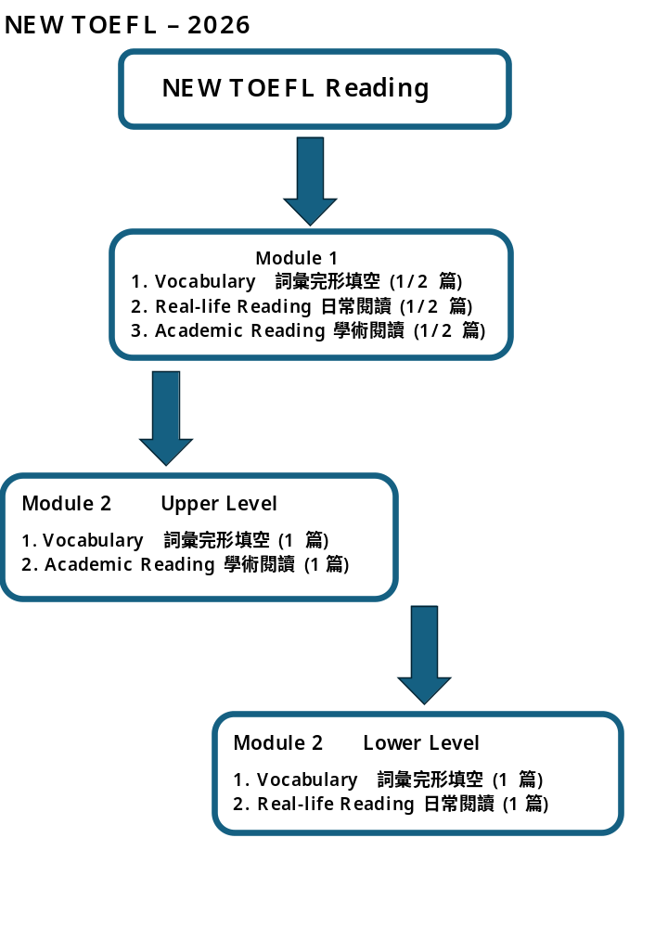

新式改革TOEFL Reading /Listening 皆為自適應考試 Multistage Adaptive

1. 第一階段Module One 題目為中等程度考題數量為 33題.
時間: 11分30秒
Module 1: 33題
1-10 題 – Vocabulary 詞彙完形填空
11-20題 – Vocabulary 詞彙完形填空
21-22題 – Real- Life Reading 日常閱讀 E-mail
23-25題 – Real-Life Reading 日常閱讀 E-mail
26-28題 – Real-Life Reading 日常閱讀 Text Message Chain
29-33題 – Academic Reading 學術閱讀

2. 第二階段Module Two題目將視第一階段之答題正確率決定第二階段之難易度
Lower Level – 一篇單詞填空, 一篇日常閱讀, 題目數量為15題
Upper Level – 一篇單詞填空與一篇學術閱讀, 題目數量為15題
時間: 9分
Module 2: 15 題
1-10 題 – Vocabulary 詞彙完形填空
Lower Level : 11-15題 – Daily-life Reading 生活類閱讀
Upper Level : 11-15 題 - Academic Reading 學術閱讀

3. 新TOEFL Reading 題目之難度相較舊式 TOEFL 文章之句子短, 內容維度難
度亦大幅降低, 惟最大挑戰在於時間之維度極為緊湊, 因此判讀理解之速度必須
精確迅速.

TOEFL IBT 閱讀題型:
主旨題: 考察考生對文章中心思想、主要觀點之掌握。
細節題: 考察考生對文章中具體信息的理解，例如人物、時間、地點、數據等。
推論題: 考察考生根據文章內容推斷出隱含信息的能力。
詞彙題: 考察考生對文章中關鍵詞彙的理解，包括同義詞、反義詞等。
句法題: 考察考生對句子結構、語法關係的理解。
修辭目的題: 考察考生對作者使用修辭手法(如比喻、對比等) 的目的的理解。
插入文本題: 考察考生將某一句子插入文章中合適位置的能力。

Complete the Words

Fill in the missing letters in the paragraph.
(Questions 1-10)
Psychology is the scientific study of behavior and mental processes, encompassing a wide range of topics such as perception, emotion, personality, and social interactions. Researchers
inves___ ___ ___ ___ ___ ___ how peo___ ___ ___ think, fe___ ___ and ac ___ in var___ ___ ___ ___ situations. It is esse___ ___ ___ ___ ___ to
coll___ ___ ___ data care___ ___ ___ ___ ___ and app___ ___ critical
thin___ ___ ___ ___ when interpreting findings. Understanding psychological concepts can help students make informed decisions in their daily lives. Moreover, studies in this field provide valuable insight into human development, learning, and emotions.

(1) 學術閱讀考古真題

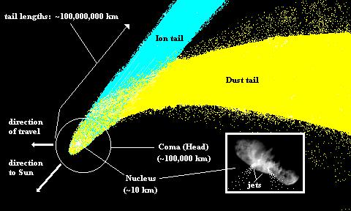
Comets
Comets are among the most interesting and unpredictable bodies in
the solar system. They are made of frozen gases (water vapor, ammonia,
methane, carbon dioxide, and carbon monoxide) that hold together small
pieces of rocky and metallic materials. Many comets travel in very
elongated orbits that carry them far beyond Pluto. These long-period
comets take hundreds of thousands of years to complete a single orbit
around the Sun. However, a few short-period comets (those having an
orbital period of less than 200 years), such as Halley' s Comet, make a
regular encounters with the inner solar system.

When a comet first becomes visible from Earth, it appears very small,
but as it approaches the Sun, solar energy begins to vaporize the frozen gases, producing a glowing head called the coma. The size of the coma varies greatly from one comet to another. Extremely rare ones surpass the size of the Sun, but most approximate the size of Jupiter. Within the coma, a small glowing nucleus with a diameter of only a few kilometers can sometimes be detected. As comets approach the Sun, some develop a tail that extends for millions of kilometers. Despite the enormous size of their tails and comas, comets are relatively small members of the solar system.

The observation that the tail of a comet points away from the Sun in a
slightly curved manner led early astronomers to propose that the Sun has a repulsive force that pushes the particles of the coma away, thereby forming the tail. Today, two solar forces are known to contribute to this formation. One, radiation pressure, pushes dust particles away from the coma. The second, known as solar wind, is responsible for moving the ionized gases, particularly carbon monoxide. Sometimes a single tail composed of both dust and ionized gases is produced, but often two tails— one of dust, the other, a blue streak of ionized gases — are observed.

As a comet moves away from the Sun, the gases forming the coma
recondense, the tail disappears, and the comet returns to distant space. Material that was blown from the coma to form the tail is lost from the comet forever. Consequently, it is believed that most comets cannot survive more than a few hundred close orbits of the Sun. Once all the gases are expelled, the remaining material—a swarm of tiny metallic and stony particles — continues the orbit without a coma or a tail.

Comets apparently originate in two regions of the outer solar system.
Most short-period comets are thought to orbit beyond Neptune in a region called the Kuiper belt, in honor of the astronomer Gerald Kuiper. During the past decade over a hundred of these icy bodies have been discovered. Most Kuiper belt comets move in nearly circular orbits that lie roughly in the same plane as the planets. A chance collision between two comets, or the gravitational influence of one of the Jovian planets— Jupiter, Saturn, Uranus, and Neptune—may occasionally alter the orbit of a comet in these regions enough to send it to the inner solar system and into our view.

Unlike short-period comets, long-period comets have elliptical orbits that are not confined to the plane of the solar system. These comets appear to be distributed in all directions from the Sun, forming a spherical shell around the solar system, called the Oort cloud, after the Dutch astronomer Jan Oort. Millions of comets are believed to orbit the Sun at distances greater than 10,000 times the Earth-Sun distance. The gravitational effect of a distant passing star is thought to send an occasional Oort cloud comet into a highly eccentric orbit that carries it toward the Sun. However, only a tiny portion of the Oort cloud comets have orbits that bring them into the inner solar system.

The most famous short-period comet is Halley' s Comet, named after English astronomer Edmond Halley. (A)■ Its orbital period averages 76 years, and every one of its 30 appearances since 240 B.C. has been recorded by Chinese astronomers. (B)■ When seen in 1910, Halley' s Comet had developed a tail nearly 1.6 million kilometers (1 million miles) long and was visible during daylight hours. (C)■ Its most recent approach occurred in 1986. (D)■

Paragraph 1
Comets are among the most interesting and unpredictable bodies in
the solar system. They are made of frozen gases (water vapor, ammonia,
methane, carbon dioxide, and carbon monoxide) that hold together small
pieces of rocky and metallic materials. Many comets travel in very
elongated orbits that carry them far beyond Pluto. These long-period
comets take hundreds of thousands of years to complete a single orbit
around the Sun. However, a few short-period comets (those having an
orbital period of less than 200 years), such as Halley' s Comet, make a
regular encounters with the inner solar system.

1. All of the following questions can be answered based on the facts presented in paragraph 1 EXCEPT:
(A) Do any comets travel to regions of space beyond our solar system?
(B) Do most short-period comets enter the inner solar system?
(C) What are comets composed of?
(D) Why are comets regarded as among the most unpredictable bodies in the solar system?

Paragraph 2
When a comet first becomes visible from Earth, it appears very small,
but as it approaches the Sun, solar energy begins to vaporize the frozen gases, producing a glowing head called the coma. The size of the coma varies greatly from one comet to another. Extremely rare ones surpass the size of the Sun, but most approximate the size of Jupiter. Within the coma, a small glowing nucleus with a diameter of only a few kilometers can sometimes be detected. As comets approach the Sun, some develop a tail that extends for millions of kilometers. Despite the enormous size of their tails and comas, comets are relatively small members of the solar system.

2. The word “surpass” in the passage is closet in meaning to
(A) allure
(B) conduce to
(C) approach
(D) go beyond

3. The word “detected” in the passage is closet in meaning to
(A) noticed
(B) implemented
(C) invoked
(D) dismantled

4. Paragraph 2 supports the idea that comets appear very small when they first become visible from Earth because
(A) the glow from the nucleus hides the rest of the comet from view
(B) they are still too far away from the Sun to have developed a coma or a tail
(C) their various gases have mostly become vaporized
(D) they are relatively small when compared to the visible planets

5. Paragraph 2 supports which of the following statements about comet size?
(A) The size of a comet is affected by the addition of gases absorbed as the comet passes the Sun.
(B) The size of a comet' s tail is less variable than the size of its coma.
(C) The coma of most comets is smaller than the Sun.
(D) The size of a comet cannot be accurately determined until it nears Earth.

Paragraph 3
The observation that the tail of a comet points away from the Sun in a
slightly curved manner led early astronomers to propose that the Sun has a repulsive force that pushes the particles of the coma away, thereby forming the tail. Today, two solar forces are known to contribute to this formation. One, radiation pressure, pushes dust particles away from the coma. The second, known as solar wind, is responsible for moving the ionized gases, particularly carbon monoxide. Sometimes a single tail composed of both dust and ionized gases is produced, but often two tails— one of dust, the other, a blue streak of ionized gases — are observed.

6. The word “propose” in the passage is closet in meaning to
(A) offer the theory
(B) prove
(C) abolish
(D) portend

7. According to paragraph 3, what is true about comets' tails?
(A) Their shape led early astronomers to draw false conclusions about the Sun.
(B) They consist mostly of ionized gases that had been blown out of the Sun.
(C) Radiation pressure and solar wind both play a role in their formation.
(D) Their dust content decreases as a comet nears the Sun.

Paragraph 4
As a comet moves away from the Sun, the gases forming the coma
recondense, the tail disappears, and the comet returns to distant space. Material that was blown from the coma to form the tail is lost from the comet forever. Consequently, it is believed that most comets cannot survive more than a few hundred close orbits of the Sun. Once all the gases are expelled, the remaining material—a swarm of tiny metallic and stony particles — continues the orbit without a coma or a tail.

8. Select TWO answer choices that according to paragraph 4 describe how a comet changes as it travels away from the Sun. To receive credit, you must select TWO answers.
(A) It loses its metallic and stony particles.
(B) It loses all the material that was in its tail.
(C) Its orbital period becomes shorter.
(D) The gases that were in its coma recondense.

Paragraph 5
Comets apparently originate in two regions of the outer solar system.
Most short-period comets are thought to orbit beyond Neptune in a region called the Kuiper belt, in honor of the astronomer Gerald Kuiper. During the past decade over a hundred of these icy bodies have been discovered. Most Kuiper belt comets move in nearly circular orbits that lie roughly in the same plane as the planets. A chance collision between two comets, or the gravitational influence of one of the Jovian planets— Jupiter, Saturn, Uranus, and Neptune—may occasionally alter the orbit of a comet in these regions enough to send it to the inner solar system and into our view.

9. The word “roughly” in the passage is closet in meaning to
(A) frequently
(B) approximately
(C) typically
(D) radically

Paragraph 6
Unlike short-period comets, long-period comets have elliptical orbits that are not confined to the plane of the solar system. These comets appear to be distributed in all directions from the Sun, forming a spherical shell around the solar system, called the Oort cloud, after the Dutch astronomer Jan Oort. Millions of comets are believed to orbit the Sun at distances greater than 10,000 times the Earth-Sun distance. The gravitational effect of a distant passing star is thought to send an occasional Oort cloud comet into a highly eccentric orbit that carries it toward the Sun. However, only a tiny portion of the Oort cloud comets have orbits that bring them into the inner solar system.

10. According to paragraphs 5 and 6, compared to the orbits of short-period comets, the orbits of long-period comets are
(A) more circular
(B) more likely to result in a comet' s entering the inner solar system
(C) more likely to be affected by a passing star
(D) more likely to lie in the same plane as the planets

11. According to paragraph 6, which of the following is true about the Oort cloud?
(A) It is almost 10,000 times the size of the Sun.
(B) It is formed by the orbits of long-period comets orbiting far from the Sun.
(C) It is produced by the gravitational effects of distant stars.
(D) It can disrupt the orbit of a comet enough to send it on a path toward the Sun.

Paragraph 7
The most famous short-period comet is Halley' s Comet, named after English astronomer Edmond Halley. Its orbital period averages 76 years, and every one of its 30 appearances since 240 B.C. has been recorded by Chinese astronomers. When seen in 1910, Halley' s Comet had developed a tail nearly 1.6 million kilometers (1 million miles) long and was visible during daylight hours. Its most recent approach occurred in 1986.

12. According to paragraph 7, all of the following are true of Halley' s Comet EXCEPT:
(A) On at least one appearance, it had a tail of well over a million kilometers in length.
(B) Each of its last 30 appearances has been recorded by astronomers in China.
(C) It is the only comet that can be observed during daylight hours.
(D) It averages 76 years between appearances in the inner solar system.

Paragraph 7
The most famous short-period comet is Halley' s Comet, named after English astronomer Edmond Halley. (A)■ Its orbital period averages 76 years, and every one of its 30 appearances since 240 B.C. has been recorded by Chinese astronomers. (B)■ When seen in 1910, Halley' s Comet had developed a tail nearly 1.6 million kilometers (1 million miles) long and was visible during daylight hours. (C)■ Its most recent approach occurred in 1986. (D)■

13. Look at the four squares [ ■ ] that indicate where the following sentence could be added to the passage.

It was not until 1705, however, that Halley determined that each of these appearances was actually a reappearance of the same object.

Where would the sentence best fit? Click on a square [■] to add the sentence to the passage.

14. Directions: An introductory sentence for a brief summary of the passage is provided below. Complete the summary by selecting the THREE answer choices that express the most important ideas in the passage. Some answer choices do not belong in the summary because they express ideas that are not presented in the passage or are minor ideas in the passage. This question is worth 2 points.

Drag your choices to the spaces where they belong. To review the passage, click on VIEW TEXT.

● ______________________________________________________________
● ______________________________________________________________
● ______________________________________________________________

Answer Choices:

(A) The size of a comet' s nucleus is determined by two solar forces, radiation pressure and solar wind.

(B) Comets accelerate as they move away from the Sun in part because they lose material from the coma each time they pass near the Sun.

(C) Comets are at times sent into the inner solar system as a result of a collision or a gravitational disturbance.

(D) Although a comet' s coma and tail may be quite large, these features do not develop until a comet is close enough to the Sun for solar energy to
vaporize its frozen gases.

(E) While short-period comets have circular orbits that lie close to the plane of the planets, long-period comets have more elliptical orbits that form a spherical shell around the solar system.

(F) Although studies of Halley' s Comet and other short-period comets provide some clues, astronomers do not yet fully understand how and when comets formed.

TOEFL READING 解題技巧
修辭目的題 (Rhetorical Purpose)
修飾目的題亦稱為例證題, 其主要考查考生藉由文句, 詞語表面特定意義之修辭方法, 而探究作者之敘述目的能力。 一般來說, 題幹詢問要求考生理解為什麼作者於文章中用某些單詞, 片語和句子。
1. 修辭目的題的兩種考察形式：
在TOEFL 閱讀考試中, 通常此類題目常出現有兩種考題模式
(1) 題幹提供文句修辭手段詢問其目的
(2) 題幹提供文句之修辭目的探詢問其手段

其常見的題目形式如下：

Why does the author mention …..?
Why does the author compare … to …?
Why does the author quote …?
What is the purpose of ……. Mentioned by the author?
Why does the author use …… … in discussing….. ?
The author uses …. as an example of…
The author provides the information about …. in order to …..
The author uses ….. as an example of…

修辭目的題乃為推斷出作者之陳述事理背後之動機、目的或原因。
作者舉證之句子、人物 、圖像 、數字、比較 、對照、狀態修飾所使用之特殊撰述手法或順序之含義或真正之目的為何。

2. 解題技巧
首先, 利用問題中所提及之關鍵字詞, 或根據問題所告知之段落相關訊息, 例如定義中所用的同位語—表達解釋或說明
描述事物大小、形狀的形容詞和名詞
表舉例用詞: for instance / for example / illustration / in other words
表因果用詞: because / since / be responsible for / due to / this is why
表肯定用詞: indeed / definitely
表訊息一致用詞: likewise / Similarly / equally important /
in the same manner

總之, 進行修辭目的題之步驟即是：分析問題題目搜尋關鍵詞, 原文關鍵詞定位, 根據定位所在句, 加以分析判讀, 理解上下文選擇答案。

A green iceberg that stranded just west of the Amery Ice Shelf
showed two distinct layers: bubbly blue-white ice and bubble-free green ice separated by a one meter-long ice layer containing sediments. The green ice portion was textured by seawater erosion. Where cracks were present, the color was light green because of light scattering; where no cracks were present, the color was dark green. No air bubbles were present in the green ice, suggesting that the ice was not formed from the compression of snow but instead from the freezing of seawater. Large concentrations of single-celled organisms with green pigments (coloring substances) occur along the edges of the ice shelves in this region, and the seawater is rich in their decomposing organic material. The green iceberg did not contain large amounts of particles from these organisms, but the ice had amassed dissolved organic matter from the seawater. It appears that unlike salt, dissolved organic substances are not excluded from the ice in the freezing process. Analysis shows that the dissolved organic material absorbs enough blue wavelengths from solar light to make the ice appear green.

Why does the author mention that “The green ice portion was textured
by seawater erosion”?
(A) To explain why cracks in the iceberg appeared light green instead of dark green
(B) To suggest that green ice is more easily eroded by seawater than white ice is
(C) To support the idea that the green ice had been the bottom layer before capsizing
(D) To explain how the air bubbles had been removed from the green ice

TOEFL Reading Vocabulary 考古真題單詞集
2018/11/24

proximity = closeness 接近

intense = strong 強烈的

pierced = broke through 刺穿; 穿透

rudimentary = primitive 初步的; 基礎的

motives = reasons 動機

anticipate = predict 預期

foundation = basis 基礎

exceed = be more than 超越; 凌駕

supplement = add to 補充

composes = makes up 組成

frigid = cold 寒冷的

detected = discovered 偵探; 發現

extensive = large 廣闊的; 龐大的

accounts for = explains 解釋

ties = connections 關係

2018/11/25

vicinity = region 附近地區

contribute to = add to 導致

exhaust = use up 耗盡

on balance = overall 總的來說

seldom = rarely 很少地; 幾乎沒有

pervasive = widespread 普遍的

hasty = hurried 匆忙的

emergence = appearance 出現

unprecedented = never before achieved 空前的; 前所未有的

initiation = action 行動

accelerated = faster 加速的

confirmed = proven 證明

ornamented = decorated 裝飾

stamina = endurance 耐力

peak = high point 頂峰; 最高點

stimulated = encouraged 激勵

surplus = excess 盈餘

lucrative = profitable 有利可圖的

elaborate = complex 複雜的

ruled out =excluded 排除

ideal = perfect 理想的; 完美的

periodically = at regular intervals of time 週期性地

recognized = accepted 認知的

simultaneously = at the same time 同時地

elevated = high 高的

install = put in place 安裝

hierarchy = system of ranking 階段制度; 等級制度

rudimentary = simple 初級的; 基本的

initiate = introduce 開始; 引進

2018/12/01

was repulsed = was driven back 被驅逐
vulnerable to = unprotected from 易受傷害的; 易受影響的
continuous = nonstop 持續的
perished = died 死亡; 消逝
constituent = component 組成物; 成份
gradual = slow 逐漸的
predominate = are in the majority 佔優勢
diffuse = spread 擴散; 散佈

perceive = see 察覺; 感知
scattered = spread apart 散佈
presumably = probably 可能地; 假設地
verifying = confirming 證實

ascend = go up 上升
converge on = meet at 匯聚; 輻合

vanishes = disappears 消失

primitive = original 原始的

contrary = opposing 相反的

insight = understanding 洞察力

critical = important 重要的

state of affairs = situation 情況

mutual = shared 相互的

indeed = in fact 確實; 實際上

slight = small 些微的; 微小的

capture = obtain 獲得
era = period 時代
precisely = accurately 精確地

progressively = increasingly 越加 ; 漸漸地
vital = critical 重要的
hazards = dangers 危險
severe = harsh 嚴厲的; 嚴酷的

