TOEFL READING
托福閱讀



READING ACHIEVEMENT GUIDE

閱讀題型三：學術閱讀 (Reading on Academic Passage)
學術閱讀與現行的托福學術閱讀一樣，惟篇幅更短了。 內容通常與高中或大學階段所閱讀的課堂材料相仿。此任務的設計理念是不要求考生具備任何背景知識，換句話說，考生可以只憑文章本身提供的資訊完成作答。

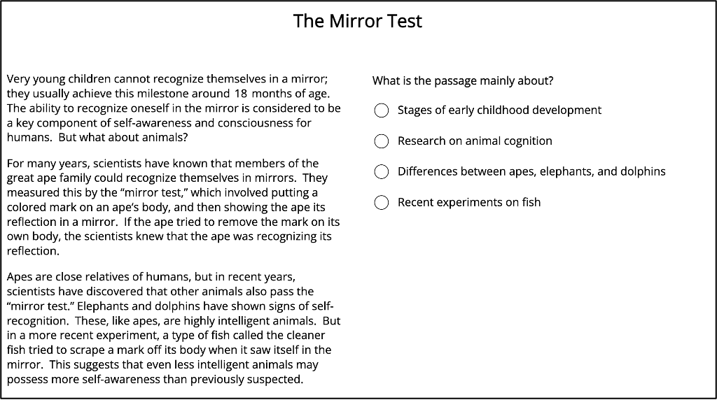

文章主題與現行托福閱讀一樣，涵蓋多個學科領域，例如：天文、地質、海洋、氣候、生命科學（如生物學）、物理科學（如物理、化學）、歷史、考古文明、藝術與音樂、商業與經濟、社會科學（如心理學、社會學）。 每篇文章長度大約 200 字，學術類文章搭配五題選擇題，問題類型包括：
文意主旨題：詢問作者寫這段話的目的或其在文章中扮演的功能。
事實訊息題：考查文章之具體內容或細節來形成正確事實內容判斷。
否定事實訊息題：考查考生對文中未提到或原文相矛盾否定細節之辨識。
語境詞彙題：測試考生是否能根據上下文判斷單字意義。
推論暗示題：根據文中直接陳述之內容進行推論演繹以理解觀點或含義。
修辭目的題 : 推斷出作者陳述事理背後之動機、目的或原因。
段落邏輯關係題：考查學生能否理解句子之間、段落之間的邏輯銜接。

考試變革：閱讀測驗改為適性測驗--”多階段自適應 Multistage Adaptive “.

 閱讀測驗變成兩個階段：
第一階段模組1 (Module 1)
第二階段模組2 (Module 2)，乃依據同學在第一階段作答的正確率而調整難度，成為Upper Level 或 Lower Level的題組。

 官方正式出題閱讀測驗總題數為35至50題

 考生可能會在閱讀或聽力碰上不計分的「加測試題」(官方並未公開說明測試題會出現在Module 1、Module 2、或者同時都有)。

 單詞填空題型增加了對單字拼寫之要求。

 改制後，「學術文本閱讀」以短篇、重點明確為特徵；一篇約 200 字、最多 5 題，強調在有限時間內抓取主旨與關鍵資訊，與舊制長文精讀相比，節奏更快速緊湊、題目更精煉。

CEFR 級分
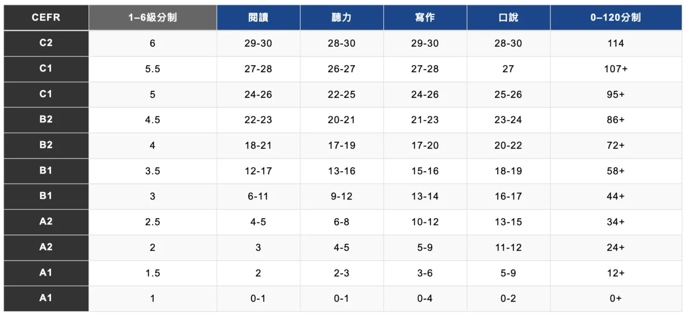

Complete the Words

Fill in the missing letters in the paragraph.
(Questions 1-10)
Consciousness is the state of being aware of and able to think about one’s own existence, thoughts, and surroundings. Wh __ __ you lo __ __ in a
mir __ __ __ and recognize your __ __ __ __, you exh __ __ __ __ self-awareness, wh __ __ __ is n __ __ unique t __ humans b __ __ is al __ __ found in dolphins and great apes. Consciousness is not to be confused with cognition. The latter refers to mental processed involved in gaining knowledge and solving problems, like thinking, judging, and remembering.

(1)

The Role of Diapause
If conditions within an organism environment occasionally or regularly
become harsh, it may be advantageous for an organism to have a resistant
stage built into the life cycle. In such a life history strategy, the organism
suspends any growth, reproduction, or other activities for a period of time
so that they may occur at a later, more hospitable time. This genetically
determined resting stage, characterized by the cessation of development
and protein synthesis and suppression of the metabolic rate, is called
diapause. Many other kinds of resting stages, with different levels of
suppression of physiological activities, are known. Some of these resistant
stages can be extremely long-lived. In one case, seeds of the arctic lupine, a member of the pea family recovered from ancient lemming burrows in the Arctic, germinated in three days even though they were carbon-dated at more than 10,000 years old!

Unfavorable conditions that are relatively predictable probably pose a
simpler problem for organisms than do unpredictable conditions.
Adaptations to the regular change of seasons in the temperate and polar
regions may be relatively simple. For example, many seeds require a
period of stratification, exposure to low temperatures for some minimum
period, before they will germinate. (A)■ This is a simple adaptation to
ensure that germination occurs following the winter conditions rather
than immediately prior to their onset. (B)■ In contrast, unfavorable
conditions that occur unpredictably pose considerable problems for
organisms. (C)■ In fact, unpredictability is probably a greater problem
than is the severity of the unfavorable period. (D)■ How can organisms
cope with the unpredictable onset of good or poor conditions?

Many adaptations to this general problem are based on a resting stage
that awaits favorable conditions. We will consider two examples from the vertebrates. The first is the red kangaroo. This marsupial inhabits the deserts of central Australia where the onset of rains and the resulting sudden growth of vegetation are extremely unpredictable. Obviously, it is advantageous for a kangaroo female to produce young at a time when plant productivity is sufficient to support her offspring. For such a relatively large mammal, however, gestation (the period of development during pregnancy) is so long that if a female waited to mate and carry the young until after the rains came, the favorable period might be past. The kangaroo’s life history adaptation to this problem involves the use of embryonic diapause during gestation (development in the uterus).

After a 31-day gestation period, the female gives birth to a tiny helpless young typical of marsupials. The newborn crawls into the mother’s pouch and attaches to a teat where it continues to grow and develop. After 235 days it leaves the pouch but remains with the mother and obtains milk from her. Two days after giving birth, the female mates again. The fertilized egg enters a 204-day period of embryonic diapause during which it remains in the uterus but does not attach. It then implants, and 31 days later, birth of the second young occurs. Note that the first young leaves the pouch at just this time. Again, the female mates, fertilization occurs, and another diapause follows. The eventual result is that at any one time, the female has three young at various stages of development: one in diapause, one in the pouch, and one outside the pouch. Among other benefits, this allows her to freeze the development of an embryo during times of drought and food shortage until the offspring in the pouch is able to leave.

A similar strategy accelerated development combined with a resting stage as also allowed amphibians to inhabit deserts. The spadefoot toads, such as Couch spadefoot toad, inhabit some of the most severe deserts in North America. Adults of this species burrow deeply into the substrate where it is cooler and perhaps more moist. Here they enter into a resting state in which they are covered with a protective layer of dead skin. When it rains, the adults emerge and congregate to mate at temporary ponds. Development is greatly accelerated: the eggs hatch within 48 hours, and the tadpoles change into toads at 16-18 days. Consequently, they can complete the life cycle during the brief window of favorable conditions, then return to the resistant resting stage to await the next rainfall. Resting stages thus comprise a series of adaptations that allow the species to avoid the most difficult conditions for life.

Paragraph 1
If conditions within an organism environment occasionally or regularly
become harsh, it may be advantageous for an organism to have a resistant
stage built into the life cycle. In such a life history strategy, the organism
suspends any growth, reproduction, or other activities for a period of time
so that they may occur at a later, more hospitable time. This genetically
determined resting stage, characterized by the cessation of development
and protein synthesis and suppression of the metabolic rate, is called
diapause. Many other kinds of resting stages, with different levels of
suppression of physiological activities, are known. Some of these resistant
stages can be extremely long-lived. In one case, seeds of the arctic lupine, a member of the pea family recovered from ancient lemming burrows in the Arctic, germinated in three days even though they were carbon-dated at more than 10,000 years old!

1. According to paragraph 1, why do some organisms have a resting stage during their life cycle?
(A) To recover from injuries suffered during harsh conditions
(B) To devote all of their energy to a period of growth and reproduction
(C) To wait for local conditions to become favorable for important life events
(D) To prepare to move to a different environment if conditions become harsh

2. Why does the author mention “seeds of the arctic lupine”?
(A) To argue that members of the pea family are extremely resistant to cold temperatures.
(B) To provide information about what ancient lemmings ate during their long resting periods
(C) To provide an example of an organism with a resting stage that has many different levels of suppression of physiological activities
(D) To support the claim that some resting stages last an extremely long time

Paragraph 2
Unfavorable conditions that are relatively predictable probably pose a
simpler problem for organisms than do unpredictable conditions.
Adaptations to the regular change of seasons in the temperate and polar
regions may be relatively simple. For example, many seeds require a
period of stratification, exposure to low temperatures for some minimum
period, before they will germinate. (A)■ This is a simple adaptation to
ensure that germination occurs following the winter conditions rather
than immediately prior to their onset. (B)■ In contrast, unfavorable
conditions that occur unpredictably pose considerable problems for
organisms. (C)■ In fact, unpredictability is probably a greater problem
than is the severity of the unfavorable period. (D)■ How can organisms
cope with the unpredictable onset of good or poor conditions?

3. According to paragraph 2, why do many seeds require a period of stratification?
(A) To slowly build up a tolerance for lower and lower temperatures
(B) To guarantee that the seeds grow after and not before unfavorable weather
(C) To make sure that the seeds can deal with unpredictable conditions
(D) To give the seeds enough time to germinate before winter begins

4. The word “severity” in the passage is closest in meaning to
(A) cohesiveness
(B) harshness
(C) unexpectedness
(D) completeness

Paragraph 4
After a 31-day gestation period, the female gives birth to a tiny helpless young typical of marsupials. The newborn crawls into the mother’s pouch and attaches to a teat where it continues to grow and develop. After 235 days it leaves the pouch but remains with the mother and obtains milk from her. Two days after giving birth, the female mates again. The fertilized egg enters a 204-day period of embryonic diapause during which it remains in the uterus but does not attach. It then implants, and 31 days later, birth of the second young occurs. Note that the first young leaves the pouch at just this time. Again, the female mates, fertilization occurs, and another diapause follows. The eventual result is that at any one time, the female has three young at various stages of development: one in diapause, one in the pouch, and one outside the pouch. Among other benefits, this allows her to freeze the development of an embryo during times of drought and food shortage until the offspring in the pouch is able to leave.

5. According to paragraph 4, all of the following statements are true about the young offspring of the red kangaroo EXCEPT
(A) After birth, a newborn crawls into the mother’s pouch where it grows and develops.
(B) After a young kangaroo leaves its mother’s pouch, it still needs its mother’s milk.
(C) A mother usually gives birth to three baby kangaroos at the same time.
(D) A baby kangaroo spends 235 days in the mother’s pouch after its birth.

6. Paragraph 4 supports all of the following statements about the red kangaroo of central Australia EXCEPT
(A) A female kangaroo mates again shortly after her newborn enters her pouch.
(B) During diapause, a young kangaroo stays in the female's pouch and growth of a second fertilized egg inside the uterus is delayed.
(C) A female kangaroo can freeze the development of her young at each stage of their development.
(D) The adaptation of diapause enables female kangaroos to ensure the survival of their young during periods of environmental stress.

7. What is the main purpose of paragraph 4 in the passage?
(A) To give the details of an adaptation mentioned in paragraph 3
(B) To describe an adaptation different from the one explained in paragraph 3
(C) To introduce an adaptation that is described in detail in paragraph 5
(D) To discuss an adaptation that is not as successful as the one discussed in paragraph 5

Paragraph 5
A similar strategy accelerated development combined with a resting stage as also allowed amphibians to inhabit deserts. The spadefoot toads, such as Couch spadefoot toad, inhabit some of the most severe deserts in North America. Adults of this species burrow deeply into the substrate where it is cooler and perhaps more moist. Here they enter into a resting state in which they are covered with a protective layer of dead skin. When it rains, the adults emerge and congregate to mate at temporary ponds. Development is greatly accelerated: the eggs hatch within 48 hours, and the tadpoles change into toads at 16-18 days. Consequently, they can complete the life cycle during the brief window of favorable conditions, then return to the resistant resting stage to await the next rainfall. Resting stages thus comprise a series of adaptations that allow the species to avoid the most difficult conditions for life.

8. According to paragraph 5, how do amphibians such as spadefoot toads survive the severe heat conditions in the North American deserts?
(A) They dig down into the ground and go into a resistant resting state.
(B) They remain in the ponds that develop after it has rained.
(C) They lose their outer layer of skin.
(D) Their eggs live dormant until the desert air becomes cooler and more moist.

9. The word “congregate” in the passage is closest in meaning to
(A) expunge
(B) gather
(C) preclude
(D) expect

10. According to paragraph 5, which of the following occurs during the life cycle of the spadefoot toad?
(A) The female’s eggs hatch under the surface of the desert.
(B) The adults mate during the dry period.
(C) The newborn grows into an adult before unfavorable conditions return.
(D) The newborn enters a resting stage before it becomes an adult.

11. The word “Consequently” in the passage is closest in meaning to
(A) Suddenly
(B) In addition
(C) As a result
(D) However

12. The word “comprise” in the passage is closest in meaning to
(A) consist of
(B) bring about
(C) conduce to
(D) take the place of

Paragraph 2
Unfavorable conditions that are relatively predictable probably pose a
simpler problem for organisms than do unpredictable conditions.
Adaptations to the regular change of seasons in the temperate and polar
regions may be relatively simple. For example, many seeds require a
period of stratification, exposure to low temperatures for some minimum
period, before they will germinate. (A)■ This is a simple adaptation to
ensure that germination occurs following the winter conditions rather
than immediately prior to their onset. (B)■ In contrast, unfavorable
conditions that occur unpredictably pose considerable problems for
organisms. (C)■ In fact, unpredictability is probably a greater problem
than is the severity of the unfavorable period. (D)■ How can organisms
cope with the unpredictable onset of good or poor conditions?

13. Look at the four squares [■] that indicate where the following sentence could be added to the passage.

Such adaptations to predictable conditions can also be made by animals, such as by hibernating during the coldest months.

Where would the sentence best fit? Click on a square [■] to insert the sentence in the passage.

14. Directions: An introductory sentence for a brief summary of the passage is provided below. Complete the summary by selecting the THREE answer choices that express the most important ideas in the passage. Some answer choices do not belong in the summary because they express ideas that are not presented in the passage or are minor ideas in the passage. This question is worth 2 points.

Drag your answer choices to the spaces where they belong. To remove an answer choice, click on it. To review the passage, click VIEW TEXT.

Some organisms adapt to periodic harsh conditions by building a
resistant stage, a diapause, into their life cycle.

● ______________________________________________________________
● ______________________________________________________________
● ______________________________________________________________

Answer Choices:

(A) The diapause stage evolved very early and is most common in species that first appeared more than 10,000 years ago.

(B) Unpredictable conditions are more problematic for organisms than are fairly predictable changes such as the seasons.

(C) Some seeds may germinate in three days even if they have been exposed to very low temperatures for a long time.

(D) Some marsupials can care for three newborns in their pouch at the same time, allowing the young to leave the pouch only when conditions are favorable for their growth.

(E) The female red kangaroo adapts to unfavorable conditions by delaying the development of the embryo in the uterus.

(F) Some amphibians adapt to arid environments by combining accelerated development with resting stages deep underground.

TOEFL READING 解題技巧
Detailed Factual Information (事實細節判斷題)
原文中明確陳述的觀點, 引用論證之事實, 用以支持作者觀點論據的細枝末節, 抑或為用來支持或闡述篇章中心思想之描述性細節。
事實判斷題型要求確定對主題做出闡述單獨句子或段落之涵義。 解題時必須將之歸納文章之某部分核心思想。

1. According to paragraph…, which of the following is true about … ?

2. According to paragraph…, how / what/ why…?

3. Paragraph… / The passage supports which of the following statements
about ….?

注意: (1) 此題型屬於細節類題型, 因此於題幹中即出現某個明確之細節定位詞。
(2) 該題型乃對於原文細節資訊之正面提問 (題幹一般出現有true / support);因此, 此題型之方向與否定事實資訊題相反。
(3) 此題型疑問部分一般由特殊疑問詞：which / how / what / why… 引導, 因而該題型大致上就某細節資訊之具體“ 特性、原因、方式等” 出題。

該些題型在文中會出現關鍵字詞所提及之事實訊息, 此時, 則運用key words 並加入出現之段落進行文章中所列之相對應內容, 包含舉例 、原因、條件、 數據、說明、成份、及描述等針對文章之具體內容或細節來形成正確事實內容判斷。
1. 審視題幹
2. 尋找關鍵字詞 key words
若定位詞非原文原詞, 則在定位過程中必須對思考其在原文中的同義替換詞
3. 原文定位
4. 分析判讀

閱讀題幹之敘述

尋找關鍵字詞 key words

原文段落定位 positioning

審慎完整句子閱讀與分析判讀選項

TOEFL Reading Vocabulary 考古真題單詞集
2019/01/05

relatively = comparatively 相對地

episode = occurrence 事件

amplify = strengthen 放大; 增強

uniform = the same 相同的; 一致的

magnitude = size 大小; 強度; 重大

readily = easily 容易地

collide = mix together 碰撞; 衝突; 抵觸

implausible = unlikely 不合理的
advocate = supporter 支持者
simultaneous extinctions = extinctions that took place at the same time
同時發生的滅絕事件
detrimental = harmful 有害的

sparsely = is widely scattered 稀疏地
traumatic = upsetting 令人苦惱的; 創傷的
incentive = motivation 動機

constituent = component 組成物
gradual = slow 逐漸的
predominate = are in the majority 佔優勢的
diffuse = spread 散佈; 擴散

severity = harshness 嚴重性
congregate = gather 聚集
consequently = as a result 因此
comprise = consist of 組成

collapsed = fell inward 崩潰; 瓦解
intense = extreme 強烈的
in retrospect = in reconsidering the past 回顧
scenario = version of events 情境; 情節

Presumably = It is reasonable to assume 假設
pertinent = relevant 相關的
subdue = defeat 征服; 戰勝
coincides with = occurs at the same time as 同時發生

elaborately = with great details 詳細地
abandoned = no longer occupied 捨棄
entirely = completely 完全地
intermittently = periodically 間歇地

2019/01/12

pertinent = relevant 相關的

ceases = stops 停止

integrated = combined 整合

typically = usually 典型地

thus = as a result 因此

pursuits = efforts 追趕; 努力

intricate = complex 複雜的

exploit = take advantage of 利用

impetus = push 衝力; 刺激

fiscal = financial 財政上的

overlooked = ignored 忽略

prerequisite = requirement 先決條件

proper = appropriate 合適的

besides = in addition to 此外

coupled with = combined with 結合

autonomy = independence 自主

relentless = without pause 不懈怠的

encountered = came into contact with 遭遇

mobilize = put into action 動員

remarkable = impressive 引人注目的; 明顯的

constituent = component 組成物

gradual = slow 逐漸的

predominate = are in the majority 佔優勢

diffuse = spread 擴散

adequate = rich 充足的

compelling = persuasive 令人信服力的

ultimately = eventually 最終地

virtually = nearly 幾乎

suspended = floating 懸浮的

replenished = restored 補充; 使恢復

striking = dramatic 劇烈的

a good candidate for past life = originally had some Earth-like forms of life
本身具備生命痕跡

assess = evaluate 評估; 評價

preoccupation = concern 全神貫注; 專注

explicit = clearly stated 明確的

integration = unity 整合

suspicion = distrust 懷疑

lucrative = payable 有利可圖的

