TOEFL READING
托福閱讀



READING ACHIEVEMENT GUIDE

TOEFL Reading
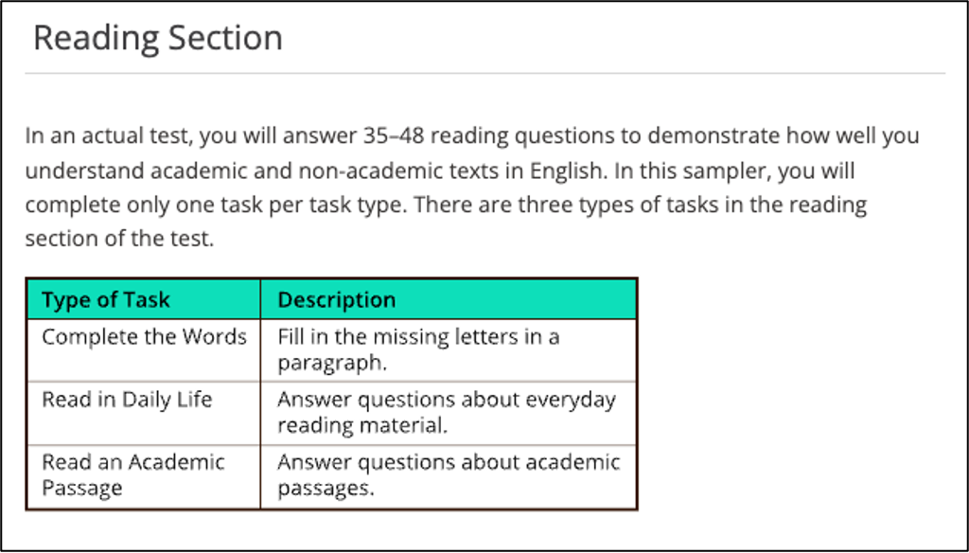

Test Content for New TOEFL Reading
Test Section | Task Type | Number of Items | Estimated Timing
Reading | Complete the Words | 35-50 | About 18-30 minutes
Reading | Reading in Daily Life | 35-50 | About 18-30 minutes
Reading | Read an Academic Passage | 35-50 | About 18-30 minutes

New TOEFL Reading
Skills for Completing the Words 答題思路：

Step1: 根據的結構即句子的主動受結構以及固定搭配判斷所填詞彙的詞性。
Step2: 根據上下文判斷詞義。
Step3: 根據時態和具體空格數判斷是否需要變形。以題目為例，當看到關鍵字時，應立刻意識到其相關之固定搭配後面應該加動詞原形。接續，在腦海中搜索以該提示字母開頭、包含符合之字母數量的語詞，並找到描述相匹配之字詞，從而得出正確答案。

Tip：對於詞彙量不足且在聯繫上下文和語境理解能力上稍顯不足的考生來說，這種題型挑戰可能會比較大。尤其是這種一句話語境，並沒有特別充足的提示，如果對句子的關鍵字掌握不佳，解題的難度就會大大提高。

備考建議：擴大自己的詞彙量，可以嘗試將詞彙按照主題或詞性進行分類，然後進行記憶，並通過使用詞根詞綴記憶法、聯想記憶法等方法，提高背誦效率。還可以閱讀英文文章、看美劇、多和他人用英語溝通來積累詞彙、在語境中練習詞彙，熟能生巧。另外務必多做題多思考，培養答題之敏銳度，由數量積累提升底蘊。

Test Content for New TOEFL Reading
Test Section | Task Type | Number of Items | Estimated Timing
Reading | Complete the Words | 35-50 | About 18-30 minutes
Reading | Reading in Daily Life | 35-50 | About 18-30 minutes
Reading | Read an Academic Passage | 35-50 | About 18-30 minutes

New TOEFL Reading Task Arrangement
Section | Task Type
Section | Task Type | Stage 1 | Stage 2  Lower | Stage 2  Upper | Easy Path | Hard Path
 | Complete the Words | 10 | 10 | 10 | 20 | 20
 | Daily Life  Reading | 5 | 5 | 0 | 10 | 5
 | Academic Passage | 5 | 0 | 5 | 5 | 10
 | Total | 20 | 15 | 15 | 35 | 35

CEFR 級分
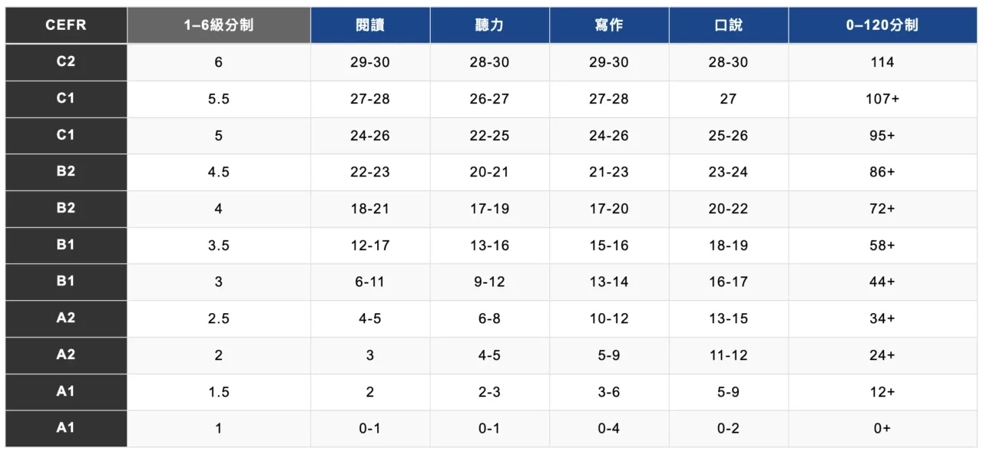

Complete the Words

Fill in the missing letters in the paragraph.
(Questions 1-10)
To understand most of the processes at work on Earth, it is useful to envisage interactions within the Earth system as a se __ __ __ __ of interrelated cycles. One of these is the energy cycle, wh __ __ __ encompasses the great ―engines —the ex __ __ __ __ __ __ and internal energy so __ __ __ __ __ —that dr __ __ __ the Earth system and all its cycles. We can think of Earth’s energy cycle as a budget: energy may be
a __ __ __ __ to or subtracted fr __ __ the budget and may be transferred from one storage place to another, but o __ __ __ __ __ __ the additions and subtractions and transfers must ba __ __ __ __ __ each other. If a balance did not exist, Earth would e __ __ __ __ __ heat up or cool down until a balance was reached.

Real-Life Reading – E-Mail

13870 Nares Road
Bangkok
Thailand 10500
June 30
Dear Ms. Baharn,
I'd like to thank you for the time you spent with me discussing the marketing researcher position at Amarin, Ltd. After interviewing with you and touring the facility, I feel strongly that this company would be an ideal place for me to work.
I now understand why Amarin, Ltd., is considered the premier publisher of travel and tourism books in the region. I am impressed by the fact that it has been listed as one of Thailand's ten most successful businesses since it was founded six years ago. The company's reputation for quality is also reflected in its outstanding record of employee retention.
I wanted to emphasize the fact that I attended a three-week intensive seminar on MarkTrends, the foremost marketing research software package. I know the job description mentions the ability to use MarkTrends, and I wanted to let you know that I am very comfortable using this software.
Again, thank you for your time and consideration. I hope to hear from you soon concerning your hiring decision.
Yours truly,
Anusak Arinchai Anusak Arinchai

1. What kind of business is Amarin, Ltd.?
A A marketing firm
B A trading company
C A research institute
D A publishing company

2. What is stated in the letter about Amarin, Ltd.?
A It was started six years ago.
B It plans to expand its operations to other countries.
C It will be hiring several marketing researchers.
D It has been successful because of its marketing strategies.

3. What did the writer want to emphasize about his background?
A His degree in marketing
B His overseas travel experience
C His familiarity with a software program
D His presentations at professional seminars

4. What does the letter indicate is a sign that Amarin, Ltd., is doing very well?
A Its large number of employees
B Its international reputation
C Its use of up-to-date computer technology
D Its high ranking on a list of successful businesses

Academic Reading
(1)
Colonial House-Building
Seventeenth-century colonial houses were simple, functional structures reflecting medieval traditions. In the first half of the eighteenth century a shift toward greater elegance occurred as rising prosperity enabled colonists to build finer dwellings. Because architecture was not yet a profession in the colonies, designs were often produced by informed amateurs or by carpenters consulting English architectural manuals; surviving library inventories show many such handbooks, and their influence appears in period houses. Yet builders adapted rules freely, producing a wide divergence of tastes.

Regional materials shaped construction. New England generally favored wood, though brick became common in Boston and other towns where the danger of fire encouraged more durable material. Stone was used widely only in Pennsylvania and adjacent areas. Virginia and Maryland saw increased brick use in houses and outbuildings, but many wealthy owners still built in wood. In the Carolinas, even crowded Charleston, wooden houses predominated over brick.

Interiors improved markedly: windows grew larger and shutters were removed as small leaded panes gave way to larger clear glass; doorways became more decorative and fireplaces assumed ornamented roles. Walls were often plastered or elaborately paneled in wood. Color schemes shifted toward white paint instead of earlier blues, yellows, and greens, and after about 1730 colonial newspapers began advertising scenic patterned wallpapers – evidence of growing taste for refined interior decoration.

Paragraph 1
Seventeenth-century colonial houses were simple, functional structures
reflecting medieval traditions. In the first half of the eighteenth century a
shift toward greater elegance occurred as rising prosperity enabled colonists to build finer dwellings. Because architecture was not yet a profession in the colonies, designs were often produced by informed amateurs or by carpenters consulting English architectural manuals; surviving library inventories show many such handbooks, and their influence appears in period houses. Yet builders adapted rules freely, producing a wide divergence of tastes.

1. What was one of the main reasons for the change in architectural style in eighteenth century North America?
(A) More architects arrived in the colonies.
(B) The colonists developed an interest in classical architecture.
(C) Bricks were more readily available.
(D) The colonists had more money to spend on housing.

2. The word “divergence” in the passage is closest in meaning to
(A) description
(B) development
(C) difference
(D) display

Paragraph 2
Regional materials shaped construction. New England generally favored wood, though brick became common in Boston and other towns where the danger of fire encouraged more durable material. Stone was used widely only in Pennsylvania and adjacent areas. Virginia and Maryland saw increased brick use in houses and outbuildings, but many wealthy owners still built in wood. In the Carolinas, even crowded Charleston, wooden houses predominated over brick.

3. Click on the sentence in paragraph 2 that identifies a reason why brick was the preferred material for houses in some urban areas.

Paragraph 3
Interiors improved markedly: windows grew larger and shutters were removed as small leaded panes gave way to larger clear glass; doorways became more decorative and fireplaces assumed ornamented roles. Walls were often plastered or elaborately paneled in wood. Color schemes shifted toward white paint instead of earlier blues, yellows, and greens, and after about 1730 colonial newspapers began advertising scenic patterned wallpapers – evidence of growing taste for refined interior decoration.

4. Why does the author mention “ elaborately paneled walls” in the passage?
(A) as an example of how the interior design of colonial houses was improved.
(B) as an example of why walls were made of wood or plaster.
(C) as an example of how walls were made stronger in the eighteenth century.
(D) as an example of what kind of wood was used for walls after 1730.

5. What does the author imply about the use of wallpaper before 1730?
(A) Wallpaper samples appeared in the architectural manuals.
(B) Wallpaper was the same color as the wall paints used
(C) Patterned wallpaper was not widely used.
(D) Wallpaper was not used in stone houses.
TOEFL READING 解題技巧
Detailed Factual Information (事實細節判斷題)
原文中明確陳述的觀點, 引用論證之事實, 用以支持作者觀點論據的細枝末節, 抑或為用來支持或闡述篇章中心思想之描述性細節。
事實判斷題型要求確定對主題做出闡述單獨句子或段落之涵義。 解題時必須將之歸納文章之某部分核心思想。

1. According to paragraph…, which of the following is true about … ?

2. According to paragraph…, how / what/ why…?

3. Paragraph… / The passage supports which of the following statements
about ….?

注意: (1) 此題型屬於細節類題型, 因此於題幹中即出現某個明確之細節定位詞。
(2) 該題型乃對於原文細節資訊之正面提問 (題幹一般出現有true / support);因此, 此題型之方向與否定事實資訊題相反。
(3) 此題型疑問部分一般由特殊疑問詞：which / how / what / why… 引導, 因而該題型大致上就某細節資訊之具體“ 特性、原因、方式等” 出題。

該些題型在文中會出現關鍵字詞所提及之事實訊息, 此時, 則運用key words 並加入出現之段落進行文章中所列之相對應內容, 包含舉例 、原因、條件、 數據、說明、成份、及描述等針對文章之具體內容或細節來形成正確事實內容判斷。
1. 審視題幹
2. 尋找關鍵字詞 key words
若定位詞非原文原詞, 則在定位過程中必須對思考其在原文中的同義替換詞
3. 原文定位
4. 分析判讀

閱讀題幹之敘述

尋找關鍵字詞 key words

原文段落定位 positioning

審慎完整句子閱讀與分析判讀選項

TOEFL Reading Vocabulary 考古真題單詞集
2019/01/13

capacity = used to its full agricultural potential 能力

parameters = factors 因素; 參數

theoretically = in principle 理論上

roughly = approximately 大約

in essence = basically 本質上

feasible = practical 可行的

scale = size 規模; 大小

advocated = promoted 提倡; 鼓勵

fostered= encouraged 促進; 鼓勵

ideally = perfectly 完美的; 理想的

coupled with = added to 結合

consumption = use of products and services 消費

prosperous = wealthy 繁榮的

tangible = physical 可觸知的; 有形的; 實體的

sequences = series 順序; 系列

converted = changed 轉變

approximating = estimating 近似; 估計

subsequently = later 後來

launched = started 開始

methodically = systematically 有條理地

accelerated = speeded up 加速

perfected = improved 使完美

diminishing = reducing 減少; 降低

rudimentary = primitive 基本的; 早期的

controversial = debated 有爭議的

hence = thus 因此

outbreak = sudden increase 爆發

accompany = occur along with 伴隨發生

converge = come together 聚集

severity = seriousness 嚴重性

vigorous = energetic 有活力的

trait = feature 特性

scatter = spread out 散佈

scrutinize = close observation 仔細檢查

scarce = lacking 缺乏

recollections = memories 回憶

modest = small 不太大的; 適度的

severely = very seriously 嚴重地

exploiting = making use of 利用

readily = easily 容易地

adequate = rich 充足的

compelling = persuasive 令人信服力的

a good candidate for past life = originally had some Earthlike forms of life
本身具備生命痕跡

assess = evaluate 評估; 評價

constituent = component 組成物

gradual = slow 逐漸的

predominate = are in the majority 佔優勢

diffuse = spread 擴散

2019/01/26

presumably = most likely 可能地; 假設地

were persistently viewed = continue to be viewed 被長期認為是

hence = therefore 因此

inviting = encouraging 鼓勵; 促進

continuous = uninterrupted 持續的

ideally = perfectly 理想的; 完美的

dismissed = rejected 拒絕; 否定

flee = run away 逃跑

systematically = methodically 系統性地

reflected = shown 表現; 反映

flourishes = does very well 興盛

autonomy = self-rule 自治

pervasive = widespread 普遍的; 瀰漫的

accommodated = allowed 給..方便; 通融; 容納

detected = noticed 偵察; 注意

debate = argue about 爭論

unfavorable = negative 不利的

more permeable = had more places where crossings could occur 更易滲透的

pursue = engage in 追求; 從事

comparable = similar 可比較的; 比得上的

signifying = indicating 表明; 示意

ceased = stopped 停止

dispersed = scattered 散佈
function = purpose 目的; 功能

exclusively = solely 獨有的

supplement = add to 補充

autonomous = independent 獨立自主的

erased = eliminated 消除; 塗掉

