TOEFL Writing
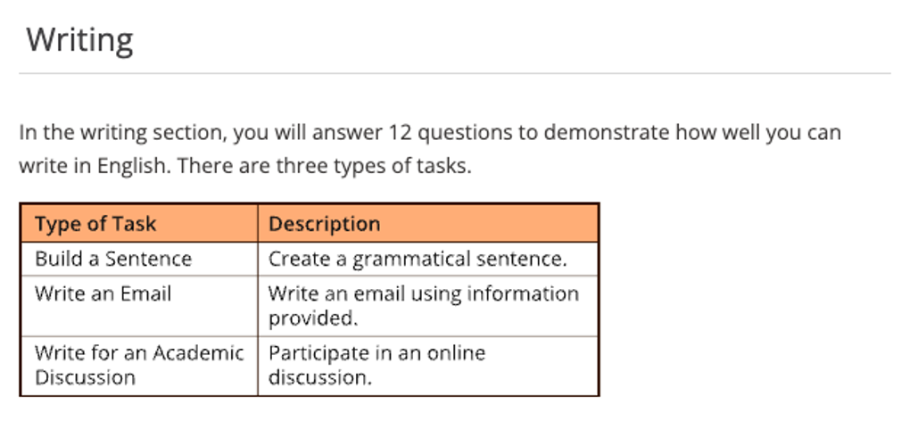

Test Content for New TOEFL Writing
Test Section | Task Type | Number of  Items | Estimated  Timing
Writing | Build a Sentence | 10 | 6 minutes
 | Write an Email | 1 | 7 minutes
 | Write for an Academic Discussion | 1 | 10 minutes
 |  | 12 | About 23  minutes

寫作題型一：組織重組句子 (Build a Sentence)
考生會看到一個完整的句子，接著是一個詞序錯亂的句子。這兩個句子構成一段對話。考生需將第二句中打亂順序的字詞重新排列，組成一個在語境中合適且語法正確的句子，作為對前一句的回應。
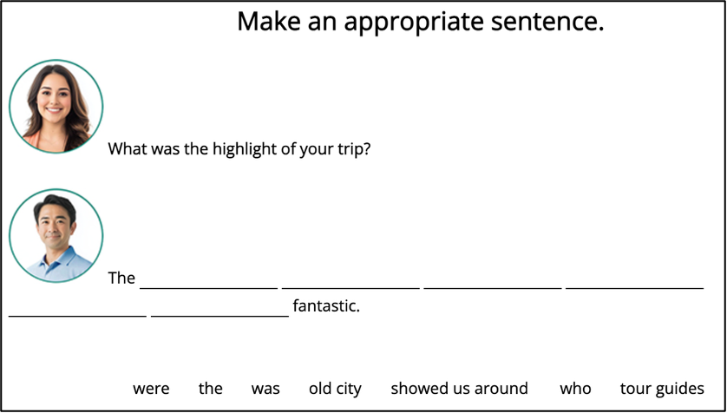
本題型考察考生是否能理解語境，並以正確的句型結構做出自然回應。換句話說，考生必須能理解情境，再將詞語組合成符合英文正確語法語與語序的句子。此題型務必強化其文法和句構之觀念。

寫作題型二：撰寫電子郵件（Write an Email）
題目會提供考生一段描述某個學術或社交情境的提示文字，考生需要根據這個情境撰寫一封電子郵件。題目會明確告知考生撰寫信件的目的，而此這目的通常很具體，例如：提出建議、發出邀請，或是針對問題提出解決方案。考生需要在7分鐘內完成撰寫電子郵件。

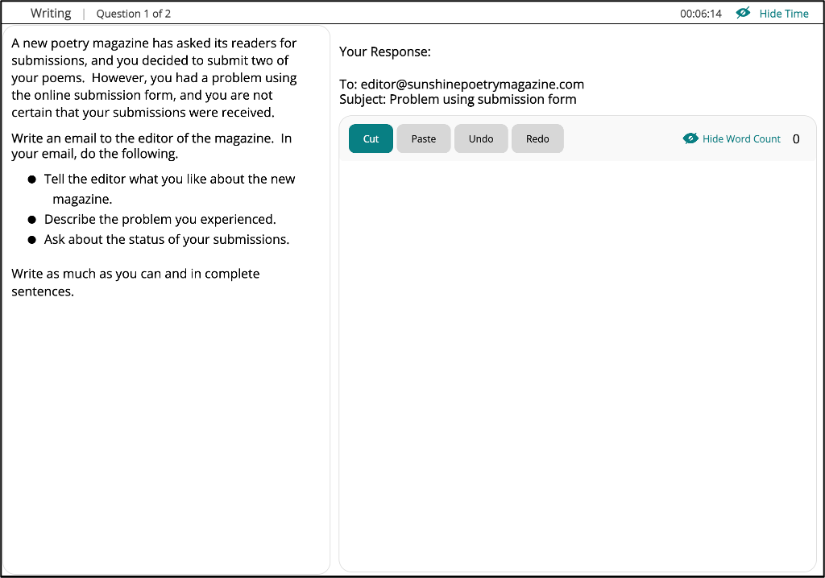

寫作題型三：學術討論（Write for an Academic Discussion）
系統會模擬線上課程的討論區：先由教授的貼文簡要介紹主題並提出一個待討論之核心問題，接著呈現兩位學生對該議題簡短回應的不同立場。考生必須在線上課堂討論區的情境下，發表一則回覆貼文：表達並支持一項個人立場，明確表達自己的立場，直接回應教授的問題，並以推理、經驗或知識提供充足的支持論點（可適度引用同學觀點進行呼應或反駁）。測驗重點在觀點清晰度、論證與邏輯連貫性、語言準確度與是否切題；篇幅不必冗長，但結構宜清晰（立場→理由→例證／說明→結論）。 考生有 10 分鐘 的時間字數最少100字來完成這項寫作任務。
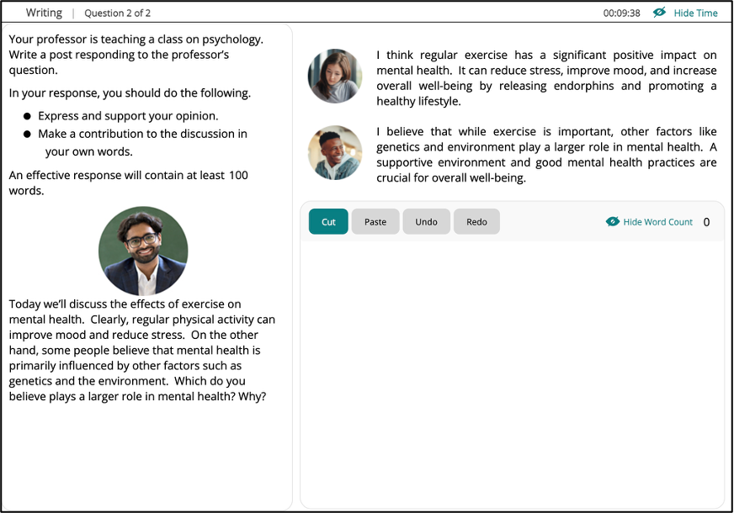
此題型主要測驗考生撰寫多句式英文短文的能力，並需符合下列標準：
- 能夠清楚闡述自己的觀點，並對他人觀點做出回應，或使用題目提供的資訊加
以佐證
 內容有充分支持、清楚且具邏輯連貫性
- 正確且適切地使用各種文法結構與詞彙
- 遵守英文書寫的基本格式規則（例如：拼字、標點符號與大小寫等）

Build a Sentence
Move the words in the boxes to create grammatical sentences.
A clock will show you how much time you have to complete this task.

Make an appropriate sentence.

1.
What did Andrew ask you at the party?
 ________ _______ _______ ________ ________.
wanted / does / he / ended / when / to know / it
2.
 Why was the meeting rescheduled?
________ _______ ________ ________ ________ ________ ________ .
was moved / to / it / a time / when / everyone / could attend

Write an Email

Example:
Hi Editor,
I hope you are well! I wanted to say that I really love the new Sunshine Poetry Magazine. It's refreshing to see such a diverse range of voices, and the layout is very engaging. However, I had some trouble with the online submission form when I tried to submit two of my poems. After I uploaded the files and hit submit, the page just kept loading and loading, and eventually, I wasn't sure if my poems can successfully be sent. Could you please confirm if you received my submissions? I'm really excited to be a part of your magazine and would appreciate any help you can provide to fix this issue. Looking forward to your response.
Best regards.
諮詢信
1. 諮詢結構
諮詢信一般分為三部分：第一部分自我介紹，說明寫信目的(詢問某方面情況)，指明你所需要的資訊;第二部分提供相關背景資訊，指出你為什麼需要這些資訊。詢問具體相關事宜。指明你什麼時候需要這些資訊;第三部分表達請求説明的願望，預先感謝對方的幫助，並表示希望早日得到答覆。
2. 常用句型
1) I would be much obliged to you if you could let me know the procedures I have to go through.
2) Your prompt and favorable attention to my inquiry would be highly appreciated.
3) I am looking forward to a favorable reply/response at your earliest convenience.
4) Would you provide me with some valuable advice?
5) Your kind reply will be highly appreciated.
6) It would be greatly appreciated if you could furnish me with relevant booklets on the above-mentioned aspects.
7) I am writing to enquire whether I may become a member of your club.
8) I would be grateful if you could let me know your annual fee charges and any other information which would be useful.
9) Please let me know as soon as possible how you propose to settle this matter.
10) Although at this time of year you will have more work to deal with than usual, I would appreciate a reply in the future.

道歉信
1. 書信結構
道歉信通常有四個主要部分。第一部分自我介紹，說明寫信目的，為自己做錯的事表示歉意。第二部分說明當時情況並解釋原因，提出有力的觀點，側重事實，避免歸咎其他人。第三部分提出補救方案，表達自己想改過或者補救的希望，注意考慮收信人的情緒。最後一部分再次道歉，首尾呼應，表達不會再犯同樣錯誤的願望，建立彼此信任度。

2. 常用句型
1) I just wanted to write you a quick note to apologize for not being able to keep our appointment tomorrow.
2) In deference to your valuable time，I would like to get straight to the point and admit that I was wrong.
3) I really hope that you will be able to accept my apology.
4) Please accept my apologies for…
5) Please accept my sincere apology for missing the interview scheduled for…
6) Please accept my apology for the delay and thank you for your understanding.

邀請信
1. 書信結構
寫邀請信時，書信主體應該至少寫到三個部分。第一部分自我介紹，大概描述活動或計畫的內容並指定被邀請參加的人。第二部分指定日期、位址和時間。提出邀請，希望對方參加。如果恰當的話，清楚指明出席活動所需要做的準備，例如著裝要求等。第三部分設定要求對方回復的日期，並表達感謝。

2. 常用句型
1) I would like to invite you to dinner and be our guest.
2) I would like to invite you to join us and attend this meeting.
3) I am glad to invite you to participate in my graduation ceremony.
4) I am honored to invite you to our wedding, as I understand that you only come to visit on special occasions.
5) Your presence is immediately requested.

投訴信
1. 書信結構
投訴信是雅思考試中最常見的一種，寫信時應該重點包括三個部分。第一部分為自我介紹、投訴事由、自己的感受等;第二部分為投訴的事實與理由，具體描述當時的情形，如人物、時間、地點和原因等。指出具體問題及其所產生的後果; 第三部分可分為提出個人要求或者建議，清晰說明讀信人可以做的補救措施，希望有關部門和人士做出相應的改進，以及提出願望，希望早日得到答覆。

2. 常用句型
1) I am writing to express my dissatisfaction with .
2) There are some problems with that I wish to bring to your attention.
3) I regret to inform you that .
4) You can imagine my disappointment when I discovered that _.
5) You can imagine my feelings when I realized that this would mean .
6) Even though I telephoned you about , .
7) I hope that the authorities concerned will consider my suggestions and improve the situation as best as they can.
8) We trust that you will now consider this matter seriously and make an effort to prevent the recurrence of this kind.
9) We will appreciate your willingness to make up for the loss.

建議信
1. 書信結構
寫建議信，主要有三個部分。第一部分自我介紹，指出存在的問題，簡要指出其可能的不良後果。第二部分具體介紹情況：表示對存在問題有興趣，分析其產生原因，並提出合理建議。將最重要的建議放在首尾。強調所有重要的事項。第三部分期望對方對該問題重視，早日解決問題並表達自己願意提供進一步的幫助。

2. 常用句型
1) If I can be of any assistance in any way, please do not hesitate to call me.
2) I am available at …………….., if you require any further information.
3) I am happy to supply any further information you may require and I look forward to hearing from you shortly.
4) Please contact me if I can be of any assistance.

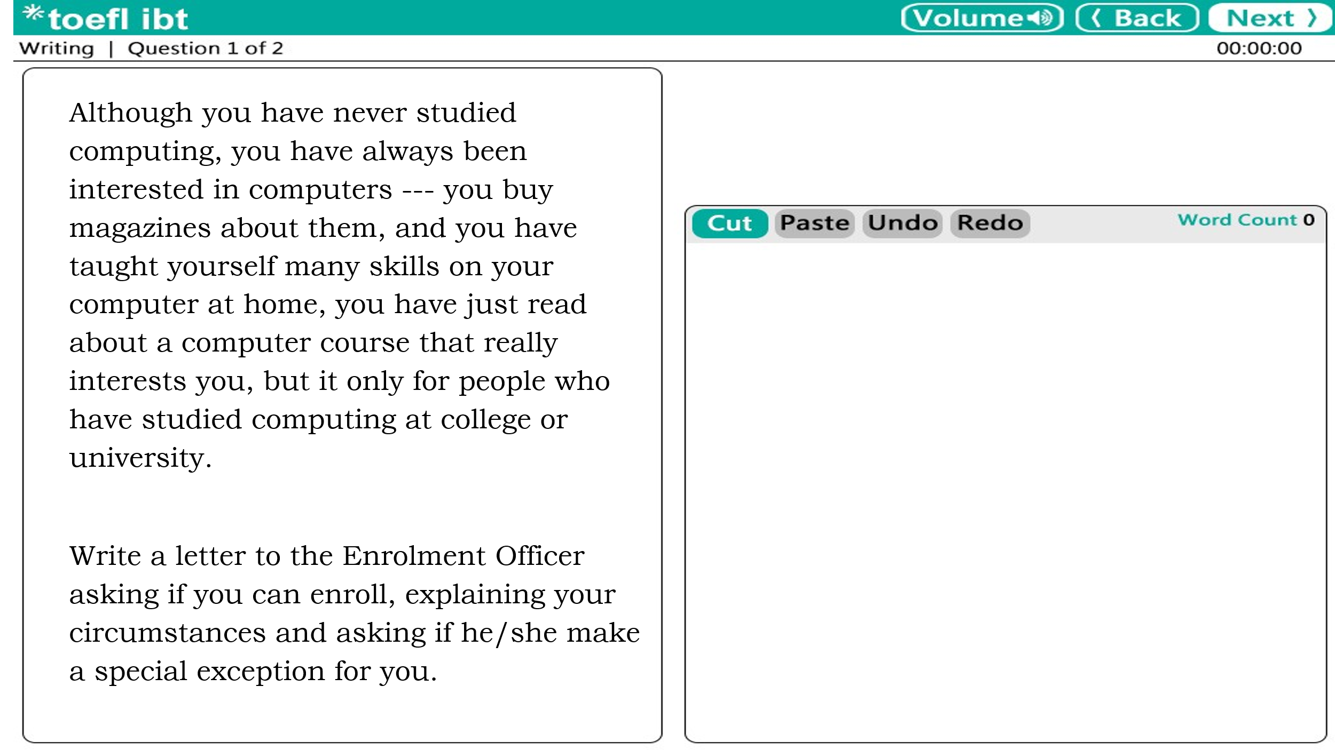

Sample Response
Dear Enrolment Officer,

I am writing to inquire the course you are offering in computer programming. I would like to enroll in the course.

I haven not studied computers at college or university, but I have taught myself a great deal about them. I read computer magazines and conform to the instructions in them. I also utilized self-help computer books to train myself to use most of the programs that are mentioned in your course. I deem that it is fair to say that I am computer literate, and I am certainly very enthusiastic about learning more. I have been able to instruct myself a lot, so I am explicit I would learn very swiftly and efficiently from your course. May I please join the course even though I have not studied computers formally? I am sure that I could learn a great deal from the course and it would be very stunning for me to eventually acquire some formal computer training.

I look forward to your reply.
Yours sincerely

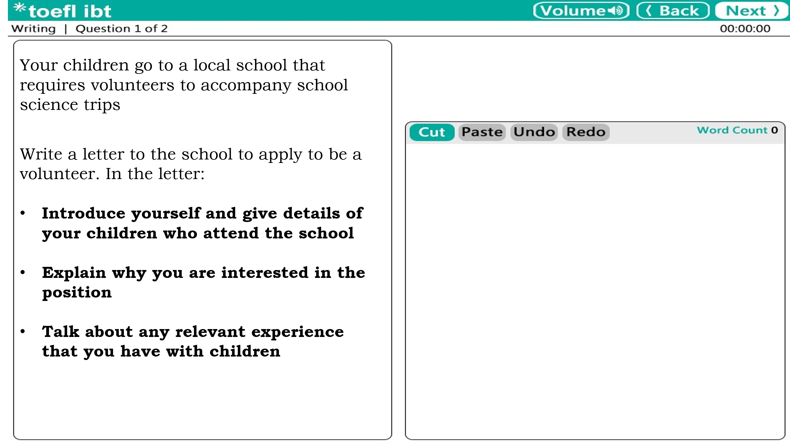

Sample Response
Dear Sir or Madam,
My son attends your school, and has recently informed me that you are looking for long-term volunteers to attend school outing. I am the mother of Saffron Monsoon; he is in the fourth year, in Mr. Bonham-Carter’s class.
I reckon that since I have such a long relationship with the school I would put myself forward. I think I might be better prepared than most as I was a primary school teacher for over four years before having my son and leaving my career.
I work from home the vast majority of the time and so I am questing for opportunities to participate in community events to warrant that I can interact with other people, thereby expanding my interpersonal connections. I could not help but think that I would be eligible enough to be an optimal candidate of volunteer for the science trips.
Do give me a call provided that there are any places still available.

Best Regards

Writing Skills :

Writing Section

TOEFL Writing --- Academic Discussion
2023/09/03 真題
Your professor is teaching a class on education. Write a post responding to the professor’s question. In your response, you should do the following.

- express and support your personal opinion
- make a contribution to the discussion in your own words
An effective response will contain at least 100 words. You have ten minutes to write.

 Doctor Diaz
This week, we'll examine issues in education reform. For example, some educators think that by focusing mainly on foundational knowledge in subjects like reading, math, and science, schools are not fully preparing students for success in the workplace. These educators argue that soft skills-nonacademic skills such as being empathetic or having a strong work ethic-should be part of the curriculum, with classroom time dedicated to developing these skills. Do you agree? Why or why not?

 Andrew:
I agree. While students need a strong foundation in academic subjects, soft skills are important because they affect how well students do their work. If classroom time is set aside for these skills, students will take them seriously and their academic work will benefit. Teachers could design lessons so that students learn about a skill and then do role-playing activities with classmates.

 Claire:
Soft skills are important, but I don't agree with using classroom time to work on them. I'm not sure how teachers would measure students' progress in developing these skills. If students' progress can't be measured on something taught, I'm not sure if there's any point to teaching.

Sample Response
立場表明 – 回應學生觀點 – 理由陳述 – 自我觀點 – 解釋理由 – 例證說明
In my perspective, I concur with the educators who advocate for the inclusion of nonacademic skills in the curriculum. As technology and the economy advance, society becomes increasingly complex. Students possessing only professional skills may not be adequately prepared to thrive in the workplace after graduating from college. In other words, as suggested by an MIT professor, students who solely focus on STEM subjects in college may struggle to meet their working requirements. To remain competitive in their respective fields, most students acknowledge the necessity of mastering soft skills such as effective communication, empathy, and patience when dealing with clients.

Moreover, I support Claire's assertion that soft skills are essential because they can enhance students' academic performance. Allocating classroom time for soft skill development can provide a much-needed break from rigorous academic studies. Consequently, students may become more productive and efficient when they return to their subject-specific coursework.

Writing Skills :

In addition, while I acknowledge the importance of academic knowledge, I respectfully disagree with Andrew's argument that soft skills should not be taught in class due to difficulties in measuring their acquisition. Admittedly, evaluating soft skills may not be as straightforward as assessing academic abilities through traditional methods like exams or written assignments. However, teachers can invest more time observing students' daily interactions and behaviors to better gauge their proficiency in these essential nonacademic competencies.

In conclusion, incorporating soft skill development into classroom instruction is crucial for preparing students for future success in their workplaces. By recognizing and addressing this need within our educational system, we can foster well-rounded individuals capable of navigating an increasingly complex world.

Writing Practice
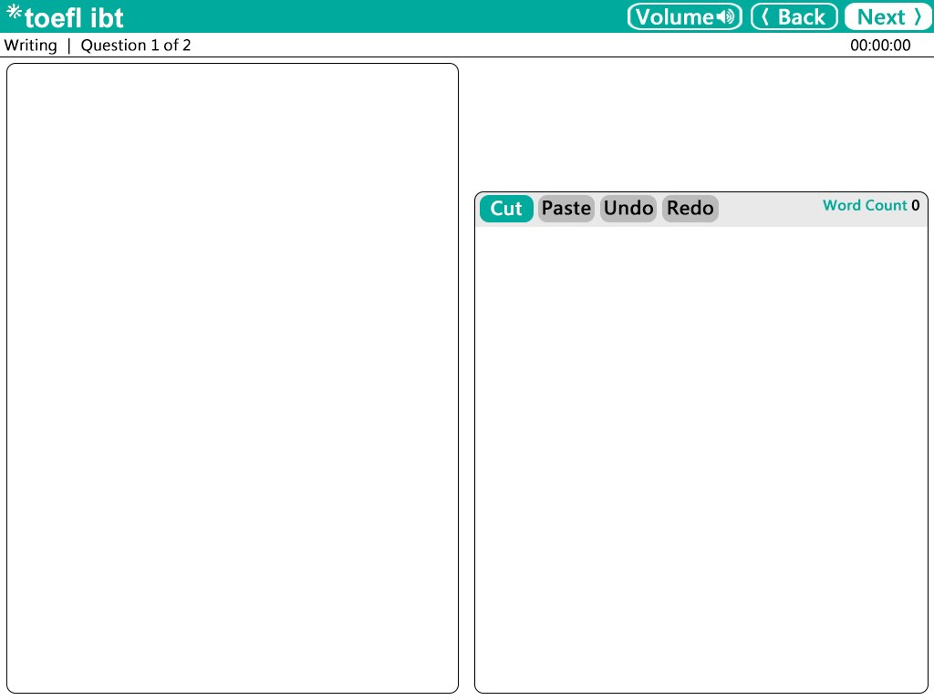
You recently took a trip with a taxi company. The driver behaved in an unacceptable way and you had a lot of problems. You complained to the company but no-one has replied to your complaint.
Write a letter to the taxi company. In your letter
- say why you are writing and how you feel
- explain what happened
- tell them what you would like them to do.

