TOEFL WRITING
托福寫作



WRITING ACHIEVEMENT GUIDE

TOEFL Writing
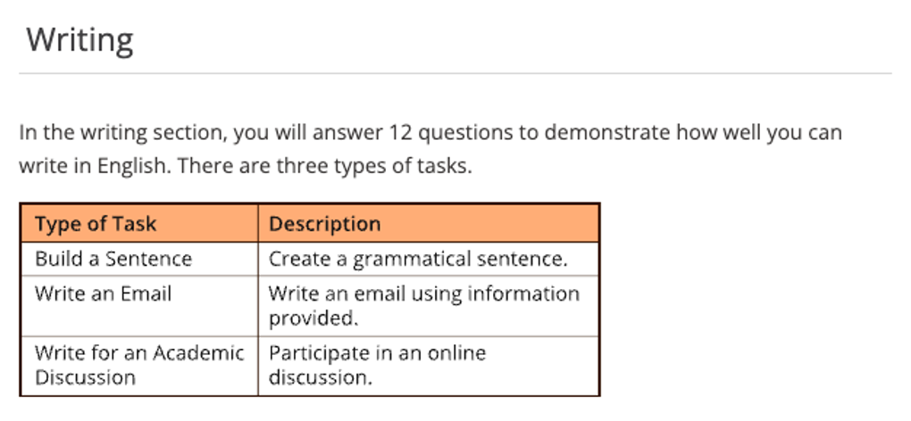

Test Content for New TOEFL Writing
Test Section | Task Type | Number of  Items | Estimated  Timing
Writing | Build a Sentence | 10 | 6 minutes
Writing | Write an Email | 1 | 7 minutes
Writing | Write for an Academic Discussion | 1 | 10 minutes
 |  | 12 | About 23  minutes

TOEFL Writing Academic Discussion
Academic Discussion 學術討論寫作回應要點:
針對上述官方提供之寫作方向說明，即學術討論寫作時應該注意之重點。 確實於討論中加入自己的觀點，而非僅僅是重複對方已經談論之論點。
字數至少 100 個字。 可選擇同意他人觀點，但必須增添自己的支持內容。
自己的立場看法亦可以採取折衷觀點—在某些情況下支持A方，在其他情況下支持B方。 學術討論問題並無「正確」答案。
必須陳述自己的觀點, 並提供合理、相關的支持, 以便對討論做出有意義的貢獻。
在規定的時間內盡可能地充分表達自己的觀點。
完善的回應將包含明確適當的理由、例子和細節。
句型結構和詞彙的品質與準確性極為重要, 亦是評分標準之一, 雖是討論議題, 然切勿以非正式的文句或詞彙進行寫作。
論述時仍應遵循標準的語法規則。 若不同意其他學生之意見時, 務必以尊重的方式表達自己的不同意見。

Skills: 論點提出、論述方式、支持內容、句型詞彙
TOEFL Writing --- 議論文寫作技巧:
基本上, TOEFL 論文寫作滿分標準：

(1) Effectively addresses the topic and task.
(2) Is well-organized and well-developed
(3) Using clear appropriate explanation, exemplification, and/or details.
(4) Display unity, progression, and coherence.
(5) Display consistent facility in the use of language, demonstrating syntactic variety, appropriate word choice, and idioms, though it may have minor lexical or grammatical errors.
簡言之即是:
(1) 切題, 有效地描述主題; 切勿離題
(2) 組織結構嚴謹, 擴展得宜
(3) 清晰適度理由解釋說明, 例證充分
(4) 論證一致, 層層遞進與連貫
(5) 用字遣詞貼切, 句法多元變化; 允許少量的拼寫和語法錯誤。

議論文寫作之段落結構：

1. Introduction: Background, 引入話題;
Statement of the issue, 針對議題大眾之看法如何
Thesis Statement, 自我立場與觀點

2. Body Paragraphs:
Topic Sentence.
Supporting Sentence
Supporting Sentence
Supporting Sentence
Illustration / Examples
Concession / Transition

3. Conclusion:
Rewrite the thesis statement. Restate the ideas. Prediction.

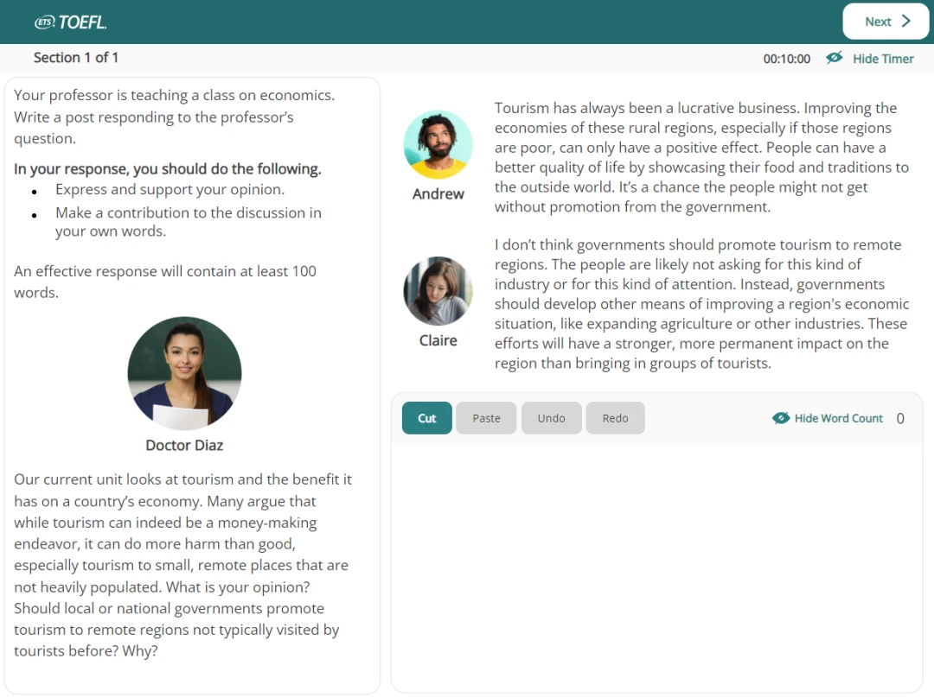

TOEFL Writing --- Academic Discussion

Your professor is teaching a class on Education. Write a post responding to the professor’s question. In your response, you should do the following.

- express and support your personal opinion
- make a contribution to the discussion in your own words
An effective response will contain at least 100 words. You have ten minutes to write.

 Doctor Diaz:
In today's context, there's a growing consensus that education should extend beyond high school and college, encompassing lifelong learning. Imagine you're a student engaging with this topic. Your input is sought on which specific field adults should focus on for ongoing education. Given this perspective, the question to you is: Considering the shift towards lifelong education, which field of study do you believe adults should prioritize for their continuous learning journey?

 Andrew
In my opinion, it's important for adults to have the opportunity to take foreign language classes as part of their lifelong education. Learning a new language can open doors to different cultures, enhance communication skills, and boost career prospects. Plus, it's a way to keep our minds active and engaged throughout our lives. So, I believe offering foreign language courses to adults is a valuable way to support their continuous learning journey.

 Claire
I think art classes should definitely be available to adults as part of lifelong education. Engaging in art allows us to express ourselves, relieve stress, and tap into our creativity. Even if someone didn't have the chance to explore art when they were younger, providing these classes to adults can offer them a way to discover new talents, develop new hobbies, and continue growing personally, no matter their age.

Response
立場表明 – 回應學生觀點 – 理由陳述 – 自我觀點 – 解釋理由 – 例證說明

TOEFL Writing Word Bank：
Education
scope of knowledge 知識面
comprehensive knowledge 廣博的知識
distance education 遠端教育
multimedia teaching 多媒體教學
solid professional working experience 紮實的職業工作經驗
vocational education 職業教育
aptitude = endowment 資質
intelligent quotient (IQ) 智商
an unrealistic dream 一個不切實際的夢想
comprehensive knowledge 全面的知識
face-to-face communication 面對面交流
the cultural diversity 文化的多元性
vocational guidance 職業指導
vocational training 職業訓練
exam-oriented education 以考試為導向的教育
education for all-round development 全面發展教育
diplomas 文憑
compulsory education 義務教育
quality education 素質教育
rote learning 死記硬背
student-oriented education 以學生為主體的教育
hone one’s hands-on skills 磨練實作技術
bias of culture 文化偏見
cradle of culture 文化搖籃
mainstream culture 主流文化
system of education 教育體制
schooling education 學校教育
parenting = upbringing 家庭教育
distance education = distance learning 遠端教育
quality-oriented education 素質教育
primary / secondary / tertiary education 小/中/大學教育
co-education 男女同校
acquire knowledge 獲取知識
impart / inculcate knowledge 傳授/ 灌輸知識
instill high moral values 灌輸高尚的道德觀
teaching method 教學方法
academic performance 學習成績
well-educated 受過良好教育
discipline 學科
expertise 專業知識
learn things by rote 死記硬背
creativity / innovation 創造力
shape(mold) one’s character 塑造性格
students’ feedback 學生的回饋
evaluate / assess ….. performance 評估表現
theoretical knowledge / sophistication 理論知識
intellectual development 智力發展
thinking capacity 思考能力
universal language 世界語
linguistic studies 語言學研究
a means of communication 一種交流工具
mechanical translation 機械翻譯
verbal communication 口頭交流
grammatical rules 語法規則
an intricate progress 一個複雜過程
artificial intelligence (AI) 人工智慧
easy accessibility 易於操作
speedy communication 快速的交流
language acquisition 語言習得
precious gift 寶貴的禮物
stress-related illness 與壓力有關的疾病
formidable task 艱鉅的任務

CEFR 級分制
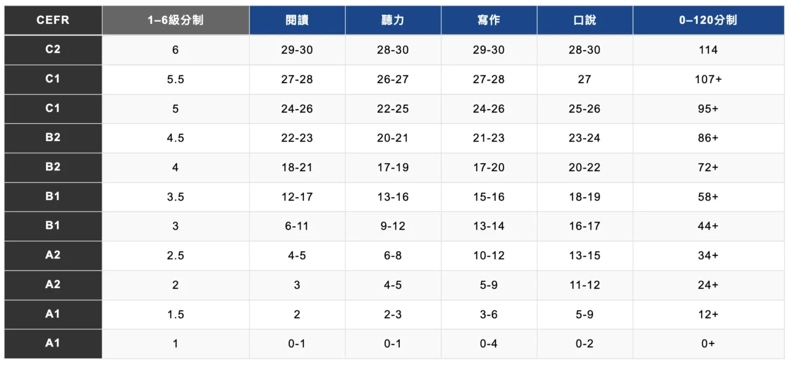

TOEFL寫作級分換算表

Writing  Rating Average | Scaled Score | Writing  Rating Average | Scaled Score
5.00  4.75  4.50  4.25  4.00  3.75  3.50  3.25  3.00 | 30  29  28  27  25  24  22  21  20 | 2.75  2.50  2.25  2.00  1.75  1.50  1.25  1.00 | 18  17  15  14  12  11  10  8

TOEFL寫作5分作文：文章切題，闡述充分，文章說服力強; 段落組織結構緊湊，過渡自然，能展示考試出色的邏輯性; 段落內句子連接順暢，句法使用嫻熟靈活;用詞準確。文章可能有個別語法拼寫錯誤，但不影響整體理解。
TOEFL寫作4分作文：文章切題，闡述基本充分，在某些地方有小漏洞。段落組織結構緊湊，過渡自然，能展示考生較強的語言邏輯性強; 段落內句子連接順暢，句法使用較恰當; 用詞基本準確。文章中有少量用詞不當和語法錯誤。
TOEFL寫作3分作文：文章切題，闡述尚可，略顯空洞。段落組織結構緊湊，過渡自然，能展示考生的語言邏輯性; 段落內句子連接基本順暢; 有部分句法使用不當；用詞尚可，有時不準確。語法及拼寫等有若干錯誤。
TOEFL寫作2分作文：文章切題，段落組織基本合理，能看出考生的邏輯性，但僅僅體現在語義層面，語言表達上有較大缺陷; 句法基本成立，但文章有不少語法錯誤，句間聯繫鬆散，詞不達意，表述生硬，拼寫錯誤多。
TOEFL寫作1分作文：文章切題。然而闡述空洞，三言兩語泛泛而談; 段落組織混亂，作文不分段; 句子間雖有一定的邏輯關係，但結構與語法錯誤較多;用詞不恰當，拼寫錯誤多。
TOEFL寫作0分作文：文章無論在結構還是語言都有嚴重錯誤。考試寫作能力及其欠缺，英語水準極低，達不到一分標準，只能給最低分。

Writing Section

TOEFL Writing --- Academic Discussion
2023/09/03 真題
Your professor is teaching a class on education. Write a post responding to the professor’s question. In your response, you should do the following.

- express and support your personal opinion
- make a contribution to the discussion in your own words
An effective response will contain at least 100 words. You have ten minutes to write.

INCLUDEPICTURE "https://img.kmf.com/kaomanfen/img/toefl/b29652cb792145613cfb35bc216c47f0.png" \* MERGEFORMATINET INCLUDEPICTURE "https://img.kmf.com/kaomanfen/img/toefl/b29652cb792145613cfb35bc216c47f0.png" \* MERGEFORMATINET Doctor Diaz
This week, we'll examine issues in education reform. For example, some educators think that by focusing mainly on foundational knowledge in subjects like reading, math, and science, schools are not fully preparing students for success in the workplace. These educators argue that soft skills-nonacademic skills such as being empathetic or having a strong work ethic-should be part of the curriculum, with classroom time dedicated to developing these skills. Do you agree? Why or why not?

Andrew:
I agree. While students need a strong foundation in academic subjects, soft skills are important because they affect how well students do their work. If classroom time is set aside for these skills, students will take them seriously and their academic work will benefit. Teachers could design lessons so that students learn about a skill and then do role-playing activities with classmates.

Claire:
Soft skills are important, but I don't agree with using classroom time to work on them. I'm not sure how teachers would measure students' progress in developing these skills. If students' progress can't be measured on something taught, I'm not sure if there's any point to teaching.

Sample Response
立場表明 – 回應學生觀點 – 理由陳述 – 自我觀點 – 解釋理由 – 例證說明

Undoubtedly while rudimentary core academic subjects lay the groundwork for academic proficiency, from my perspective, a portion of classroom time should be committed to cultivating soft skills as these are pivotal in helping students adapt to an ever-changing job market. I espouse Andrew’s opinion. Explicitly, the inclusion of soft skills in the curriculum is imperative for holistic student development. The classroom serves as the microcosm of the broader world, abounding with plenty of people with disparate attributes, personalities, and backgrounds, and challenges, making it the optimal surroundings to nurture nonacademic techniques. To illustrate, the very nature of group projects prompts critical thinking, communication, collaboration, teamwork, mutual esteem, conflict resolution, adaptability and problem-solving capabilities. These are not just abstract concepts but tangible skills.

Moreover, soft skills and academic knowledge are not mutually exclusive; rather, they complement each other. Proficient communication abilities allow students to establish a study rapport with their peers and professors, fostering the surroundings conducive to learning. When encountering impediments to academic attainment, students can seek assistance from their classmates and instructors more efficaciously. Furthermore, strong collaboration skills facilitate cohesive problem-
solving efforts, enabling students to approach issues from various perspectives and garner both theoretical knowledge and real-life techniques in tandem. With these soft skills inculcated one can overshadow other rivals, ultimately boosting their competitiveness in the future capricious work settings.

Writing Skills :

Take a moment to reflect on leaders like Barack Obama or Oprah Winfrey. Albeit they are undoubtedly informative as well as erudite in their distinctive domains, it is their phenomenal communication and interpersonal skills that set them apart as well as distinguished. Hence, by seamlessly blending soft skill development into the curriculum through activities like group discussions or debates, we can help students not just accomplish attain academic accomplishment but, more importantly, be equipped with competence to tide over a myriad of life’s challenges and break through predicaments.

In this manner, I hold the notion that soft skills should be incorporated into a school curriculum due to the fact that this can be beneficial for preparing students for the complexities and demands of a rapidly evolving job market.
Writing Skills :

Sample Response
立場表明 – 回應學生觀點 – 理由陳述 – 自我觀點 – 解釋理由 – 例證說明

In my perspective, I champion Andrew's assertion that soft skills are essential because they can enhance students' academic performance. Additionally, I consent to the educators who advocate for the inclusion of nonacademic skills in the curriculum. As technology advances and
economy flourishes, thew society also becomes increasingly sophisticated. Students possessing only professional skills may not be adequately prepared to thrive in the workplace after graduating from college. In other words, students who focus solely on professional disciplines in universities may struggle to meet their working requirements. To possess competitive edge in their respective realms, most students acknowledge the necessity of mastering soft skills such as effective communication, empathy, collaboration, and patience when mingling with colleagues, superintendents, or clients. Allocating classroom time for soft skill development can provide a much-needed break from rigorous academic studies. Consequently, students may become more productive and efficient when they return to their subject-specific coursework.

Meanwhile, while I acknowledge the significance of academic knowledge, I steadfastly express my dissent concerning Claire’s argument that soft skills should not be taught in class due to difficulties in measuring their acquisition. Admittedly, evaluating soft skills may not be as straightforward as assessing academic abilities through conventional methods like exams or written assignments. Nonetheless, instructors can invest more time observing students' daily interactions and conduct to better appraise their proficiency in these essential nonacademic competencies.

In conclusion, incorporating soft skill development into classroom instruction is crucial for preparing students for future success in their career. By recognizing and addressing this need within our educational system, we can foster well-rounded individuals capable of navigating an increasingly intricate world.

Writing Skills :
Writing Practice

Your professor is teaching a class on education. Write a post responding to the professor’s question. In your response, you should do the following.

- express and support your personal opinion
- make a contribution to the discussion in your own words
An effective response will contain at least 100 words. You have ten minutes to write.

 Doctor Achebe
As we enter a new school year, there is an ongoing debate about school start times. Research shows that teens naturally stay up later and wake up later due to changing sleep patterns during adolescence. Some argue that starting school later would allow teens to get more sleep and be better rested for learning. Given this background, I'd like you to consider whether schools should change the start time to 8:30 a.m. rather than the current 7:30 a.m.

 Paul
Getting up early with insufficient sleep seriously affects classroom quality. I often struggle with early morning classes, feeling groggy and unable to concentrate. Research backs this up, showing that teens have naturally shifted sleep patterns. Starting school at 8:30 a.m. instead of 7:30 a.m. would allow us to get more rest, leading to improved focus, better grades, and overall well-being. It's time to prioritize our sleep and academic success.

 Kelly
The lack of sleep often results from staying up too late, and it indicates a broader issue with the family's daily routines. Children are part of families where schedules can get hectic, affecting their sleep patterns. To address this problem, it's crucial for families to establish consistent sleep schedules and prioritize healthy bedtime routines. This way, we can all ensure that we get the rest we need to succeed in our daily activities, including school.

