TOEFL WRITING
托福寫作



WRITING ACHIEVEMENT GUIDE

Test Content for New TOEFL Writing

Test Section | Task Type | Number  of Items | Estimated  Timing
Writing | Build a Sentence | 10 | 6 minutes
Writing | Write an Email | 1 | 7 minutes
Writing | Write for an Academic Discussion | 1 | 10 minutes
 |  | 12 | About 23  minutes

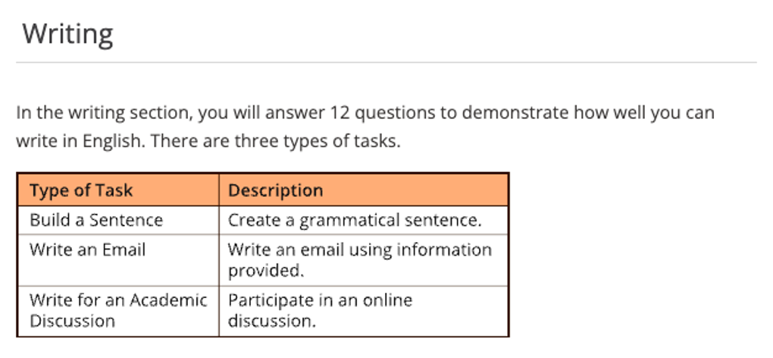

TOEFL Writing Academic Discussion
Writing 2 --- Academic Discussion Writing (學術討論寫作)

題綱要點 Sentence Patterns
1. 直截論述認可同學觀點 I espouse the argument of ….
2. 增添額外新支持理由 Additionally, in my perspective
3. 解釋陳述 Indeed,
4. 例證細節 For instance
5. 總結觀點 On balance / Overall

審題歸納---掌握關鍵核心
論述題綱---直截論述認可或駁斥同學觀點
立場觀點---提出自我觀點之論點
解釋陳述---增添額外新支持理由
例證細節---舉例說明強化論證

TOEFL Writing --- 寫作步驟技巧:
1. 學術討論寫作首要重點切題。 論述內容與觀點必須符合題目之要求。

2. 審題- TOEFL 論文寫作通常只會有一個核心Keyword，無論是觀點設計或邏輯推導，都圍繞著Keyword進行分析演繹。此時, 切記，對於issue 之焦點必須用同義之轉換使其文字變化層次豐富，藉此以維持切題性與展現自己之詞彙底蘊與文詞運用能力。

3. 時間性- 能限時寫完作文，為了能從容完成文章撰寫，同學得於考前做大量的構思和寫作練習。若於練習時苦惱時間比較緊迫導致考場時間掌握不切實，建議可以採取寫兩個比較豐富之的主體段(主論點)，然後輔以概論之讓步段(敘述對立論點之利基)；或者將二個主體段的字數視情況進行比例節縮，俾使其得以於10分鐘內完成。

4. 長短句互補- 若對於寫長句無能力駕馭，只是用簡單之短句進行拼接或套句，句子中間使用逗號連接甚至什麼都不加。 此時, 長句寧可切分成短句，或者有適當地增添邏輯聯結詞與從句。

5. 例證必要性- 論文寫作是使用生活中例子支撐觀點的，意即同學家可以根據情況編寫例子。然而，不建議在缺乏誇大情況下編寫調查報告與科學原理，一些常識性的錯誤往往易造成失分應必避免。

6. 邏輯論述- TOEFL論文寫作對於邏輯之重視程度逐年增加，開頭段和主體段務必要有呼應關係，主體段內部各個句子務求前後有聯結，善用遞進關係與因果關係以連接句構。若無法熟練則每段皆可如下論述： 觀點-解釋-例子-分析-總結 之流程順序描述。

7. 讓步段- 例證之後優先要掌握之技巧為寫出讓步段，然而，寫好一個讓步段並非易事，尤其是要寫出一個字數達標，邏輯完整之讓步段乃須具有較強之思辨能力。支持對立點是適當之切入點。 再者，反駁必須以理服人，不要拖泥帶水，以論據強化自我立場。

8. 主體段落之論點豐富性- 如果時間足夠建議至少二個論點以滿足其內容豐富多元。 文字駕馭能力不僅體現在能寫長，亦要可短。

9. 結論- TOEFL 論文寫作務必於尾段綜整前面各段支正反立論, 重述議題, 最後再重申立場觀點, 意即將所支持之論點再次概述下截結論。

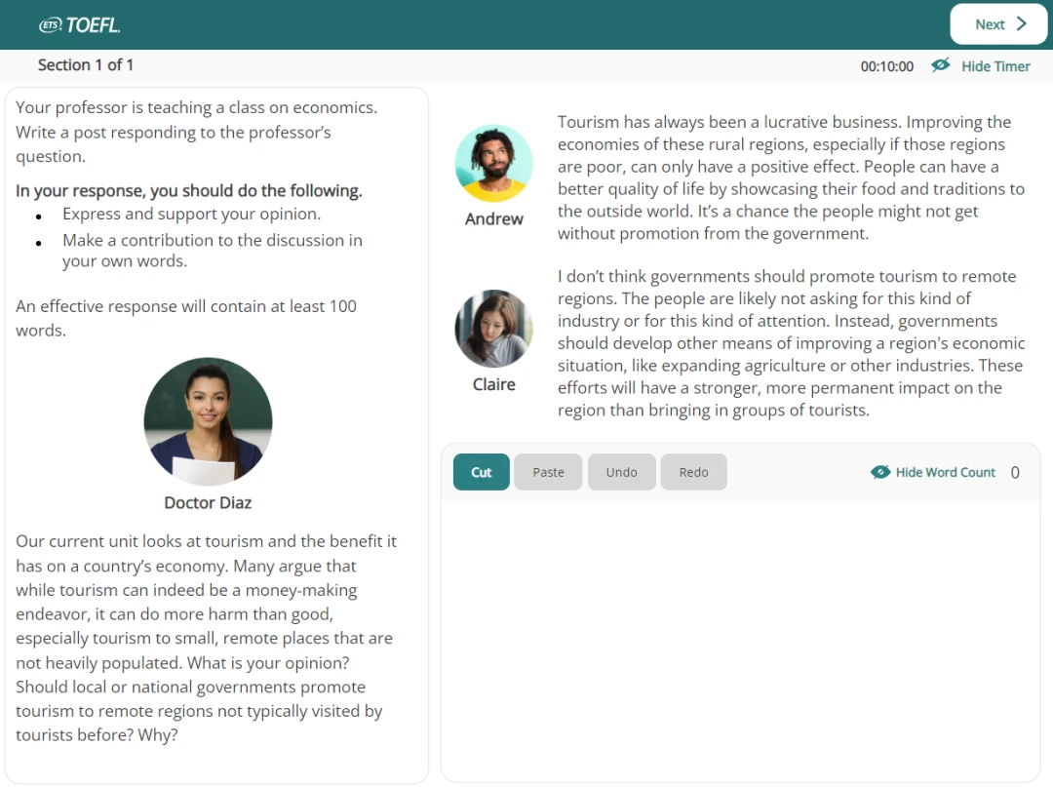

TOEFL Writing --- Academic Discussion
考古真題
Your professor is teaching a class on sociology. Write a post responding to the professor’s question. In your response, you should do the following.

- express and support your personal opinion
- make a contribution to the discussion in your own words
An effective response will contain at least 100 words. You have ten minutes to write.

 Doctor Diaz:

Next week we’ll be talking about factors that contribute to human happiness. Surveys reveal that career satisfaction and the quality of personal relationships, such as with family and friends, are frequently identified as two important factors for happiness. Which of these two factors- career or relationships do you think most people would say has the greater impact on their overall happiness, and why?

 Claire
I would say career satisfaction impacts overall happiness more. Having a fulfilling job gives you a sense of purpose and achievement that’s hard to replicate elsewhere. It’s a core part of your identity and self-worth. Relationships are vital too, but work dominates so much of our waking lives that its role in our well-being can’t be overstated.

 Paul
Relationships are more impactful for happiness than career. We’re social beings, so having strong bonds with family and friends fulfills a core need. Quality time with loved ones boost positive emotions and provides a support system during tough times. That’s why relationships trump career when it comes to overall well-being.

Your Personal Viewpoints :
TOEFL Writing Word Bank：
Society
1. urbanization 城市化
2. centralization 集中化
3. imbalance 不平衡
4. in the long run 從長遠角度而言
5. infrastructure 基礎設施
6. booming 繁榮發展的
7. tertiary industry 第三產業
8. tranquility 寧靜
9. revenue 稅收
10. commercialization 商業化
11. traffic congestion 交通擁擠
12. water scarcity 水短缺
13. the environmental pollution 環境污染
14. over-industrialization 過度工業化
15. over-crowdedness 過度擁擠
16. unemployment 失業
17. wealth distribution 財富分配
18. wealth divide 貧富差距
19. offer more job opportunities 提供更多的就業機會
20. social instability 社會動盪
21. urban construction 城市建設
22. population explosion 人口激增
23. a rising crime rate 犯罪率上升
24. drain of energy and resources 能源和資源消耗
25. a rapid pace of life 快節奏生活
26. stress-related illnesses 與壓力有關的疾病
27. class polarization 階級兩極分化
28. high cost of living 高額生活費用
29. pastoral life 田園生活
30. social welfare 社會福利
31. give special care to … 給予…特殊關照
32. urban sprawl 城市擴張
33. convenient transportation means 便捷的交通工具
34. better medical services 更好的醫療服務
35. pressure of modern life in city 城市生活壓力
36. be vulnerable to … / be susceptible to …. 易遭受到…
37. melting pot 熔爐
38. on the brink of … / on the border of / on the verge of 瀕臨…邊緣
39. contaminant / pollutant 污染性物質
40. waste disposal 廢物處理
41. put the blame on … 歸咎於…
42. attribute to .. / ascribe to .. / accredit to … 歸因為…
43. ways of consumption 消費方式
44. suffer enormous losses 遭受重大損失
45. citizen 公民
46. inhabitant = dweller / resident 居民
47. be confronted with… 面臨著…
48. breed crimes 滋生犯罪
49. juvenile delinquency 青少年犯罪
50. vicious cycle 惡性循環
51. a feasible measure 一種可行的措施
52. give priority to … 優先考慮…
53. take sanctions against 對…制裁
54. culprit 元凶 ; 罪犯
55. impose restrictions on … 對.. 加以限制
56. lift restrictions on …. 解除… 限制

TOEFL寫作級分換算表

Writing  Rating Average | Scaled Score | Writing  Rating Average | Scaled Score
5.00  4.75  4.50  4.25  4.00  3.75  3.50  3.25  3.00 | 30  29  28  27  25  24  22  21  20 | 2.75  2.50  2.25  2.00  1.75  1.50  1.25  1.00 | 18  17  15  14  12  11  10  8

TOEFL寫作5分作文：文章切題，闡述充分，文章說服力強; 段落組織結構緊湊，過渡自然，能展示考試出色的邏輯性; 段落內句子連接順暢，句法使用嫻熟靈活;用詞準確。文章可能有個別語法拼寫錯誤，但不影響整體理解。
TOEFL寫作4分作文：文章切題，闡述基本充分，在某些地方有小漏洞。段落組織結構緊湊，過渡自然，能展示考生較強的語言邏輯性強; 段落內句子連接順暢，句法使用較恰當; 用詞基本準確。文章中有少量用詞不當和語法錯誤。
TOEFL寫作3分作文：文章切題，闡述尚可，略顯空洞。段落組織結構緊湊，過渡自然，能展示考生的語言邏輯性; 段落內句子連接基本順暢; 有部分句法使用不當；用詞尚可，有時不準確。語法及拼寫等有若干錯誤。
TOEFL寫作2分作文：文章切題，段落組織基本合理，能看出考生的邏輯性，但僅僅體現在語義層面，語言表達上有較大缺陷; 句法基本成立，但文章有不少語法錯誤，句間聯繫鬆散，詞不達意，表述生硬，拼寫錯誤多。
TOEFL寫作1分作文：文章切題。然而闡述空洞，三言兩語泛泛而談; 段落組織混亂，作文不分段; 句子間雖有一定的邏輯關係，但結構與語法錯誤較多;用詞不恰當，拼寫錯誤多。
TOEFL寫作0分作文：文章無論在結構還是語言都有嚴重錯誤。考試寫作能力及其欠缺，英語水準極低，達不到一分標準，只能給最低分。

Writing Section

TOEFL Writing --- Academic Discussion
2024/09/01 2023/09/09 真題

Your professor is teaching a class on sociology. Write a post responding to the professor’s question. In your response, you should do the following.

- express and support your personal opinion
- make a contribution to the discussion in your own words
An effective response will contain at least 100 words. You have ten minutes to write.

Dr. Achebe:
Local governments have limited budgets to spend on enriching residents' lives. Supporting arts programs like concerts and museums offers cultural engagement, while funding recreational activities like hiking trails and parks promotes healthy lifestyles. As students who appreciate culture and wellness, let's discuss whether local funding should support arts programs or recreational activities more. Which do you think better serves the community and why?

 Kelly:
I think local governments should prioritize spending on outdoor trails and parks rather than arts programs like museums and concerts. More people would use and benefit from improved recreation spaces than arts venues. If fewer residents are interested in the arts, they won't attend museums or concerts even if government funds them.

 Andrew:
I believe local governments should actually prioritize spending on arts programs like museums and concerts rather than recreation. Precisely because fewer residents are inherently interested in the arts, public funding is essential to sustain these cultural institutions for the minority who appreciate them. Without support, access to the arts will decline and society will lose these enriching, enduring outlets for creative expression.

Perspectives

Governmental funds for recreational facilities:

Reason 1: 娛樂設施如公園和戶外步道能有效緩解城市壓力，戶外空間提供了戶外運動和鍛煉的機會，增強了身體的耐力、力量與靈活性，降低了罹患慢性疾病的風險。也為居民提供釋放壓力的綠色空間，有助於心理健康之維護。

Reason 2: 此外，公園與步道還提供了情感出口與舒緩壓力的途徑，充當放鬆和減壓的環境。促進民眾交流與互動，強化了社交關係和社區歸屬感，從而提高了居民的整體生活品質。促進社區的和諧發展。

Governmental funds for arts and cultural programs：

Reason1：藝術活動能激發創新思維，培養居民審美，對社會整體文化素質提升有深遠影響，在全球化背景下，文化交流日益頻繁，支持藝術項目有助於提升城市形象，吸引國際關注，促進社區蓬勃發展。

Reason 2: 藝術與商業的結合為市場注入了新的活力和商業價值，藝術與文化的結合在城鄉各地煥發出新的生命力。此外，藝術項目可以吸引旅遊和投資，促進當地商業活動，創造就業機會，從而促進經濟發展。

Reason 3: 對藝術專案的支持有助於發現和培養藝術人才。為有藝術天賦的學生與愛好者提供展示和學習的平台，鼓勵他們追求藝術夢想，有助於培養出更多專業的藝術家和藝術從業者，為文化事業的發展注入新的活力。

Sample Response
立場表明 – 回應學生觀點 – 理由陳述 – 自我觀點 – 解釋理由 – 例證說明

Deciding on the allocation of restricted local government budgets is indeed a sophisticated issue. Nonetheless, I get on board with Kelly’s idea that the government should prioritize funding for recreational facilities since plenty of residents and the community as a whole would will reap benefits from enhanced recreational spaces. Apart from this, I contend that these amenities can substantially conduce to individuals’ physical well-being. Evidently, the principal reason is that in currently fast-paced society, citizens often confront immense stress arising from various financial obligations, such as medical expenses, housing costs, and educational fees. Consequently, they may struggle relentlessly to secure augmentation of salary while insisting on prolonged sedentary habits and inadvertently become vulnerable to stress-induced health issues, namely triggering ailments, such as anxiety, gastric ulcer, hypertension. By providing accessible recreational spaces public funded, local governments can incentivize city inhabitants to engage in physical activities after work, thereby fostering mitigation of stress as well as relaxation and curtailing the risk of illnesses. For instance, office workers or the elderly can engage in a variety of activities, including jogging and playing tennis, by virtue of the recreational facilities, like hiking trails or newly constructed park every morning, extirpating chronic diseases, like arthritis or hypertension.

Writing Skills :

In contrast, provided that governments spend a modest outlay on recreational facilities, the overall fitness of residents will not be enhanced considerably, owing to the fact that people may neglect the outdoor activities, so they are more prone to a sedentary lifestyle, which will contribute to their suffering of health problems such as obesity and diabetes.
Hence, it seems advisable to allocate a larger portion of funds towards recreational facilities, which will exert a positive impact on the fortification of residents’ life expectancy and amelioration of individuals’ health and community well-being.
Writing Skills :

Sample Response
立場表明 – 回應學生觀點 – 理由陳述 – 自我觀點 – 解釋理由 – 例證說明

反論
My stance aligns with Andrew’s opinion that local governments should prioritize spending on arts programs like museums and concerts and I would advocate the highlight arts and cultural initiatives. While it is true that outdoor facilities like hiking trails and parks prompt individuals’ physical fitness and community engagement, the significance of arts programs should not be underestimated since they play a crucial role in enriching our society and preserving our cultural heritage.

Explicitly, arts offer a disparate sort of enrichment that transcends physical well-being. Arts programs provide unique opportunities for people to delve into their creativity and express themselves and they can boost dwellers’ intellectual and emotional growth, foster innovation, and reinforce diversity of thought. Moreover, it is not just about catering to the majority. A vibrant society values and highlights its cultural diversity, including those who have a profound appreciation for the arts. Public funding for cultural events, museums, or concerts will warrant accessibility to all residents, irrespective of their economic status. These institutions serve as hubs for communal interaction, sparking dialogue and a sense of belonging. By nurturing the arts, local governments invest funds in fortifying the long-term vitality of their communities, facilitating a unique identity and enchanting visitors and businesses alike. Therefore, albeit both outdoor activities and arts programs hold their merits, investing in the arts enriches the community in ways that extend far beyond physical health and immediate gratification.

Writing Skills :
Sample Response
Additionally, funding for arts and culture can provide a platform for artists to showcase their talents and inspire others. Museums, for example, not only house valuable works of art but also educate visitors about various cultures and histories. Concerts bring people together to appreciate music and create a sense of community. Meanwhile, arts programs contribute to the economy by attracting tourists and generating revenue. They can also have a conducive impact on mental well-being, providing a gateway to alleviating stress and a source of inspiration for individuals. While recreational activities are vital for promoting a healthy lifestyle, I deem that a well-rounded community should support both the arts and recreation. Nevertheless, given stringent budgets, it is prudent to prioritize funding for arts programs to ensure their accessibility and sustainability for future generations.

Writing Skills :
Writing Practice

Your professor is teaching a class on Sociology. Write a post responding to the professor’s question. In your response, you should do the following.

- express and support your personal opinion
- make a contribution to the discussion in your own words
An effective response will contain at least 100 words. You have ten minutes to write.

Doctor Achebe
People travel for many reasons. Traveling allows people to practice a different language, explore and admire new landscapes, and encounter other cultures. In the past, physical travel was the only practical way to experience the pleasures and benefits of traveling. Today, television and the Internet allow people to experience many aspects of distant places without leaving their homes. Do you believe that exploring other places through technology offers many of the same benefits as in-person travel? Why or why not?

Claire
Absolutely, virtual travel offers many benefits of physical travel. Through the internet and TV, we can immerse ourselves in the sceneries, different cultures, and even pick up languages–all from home. It's eco-friendly, cost-effective, and allows us to better prepare for an actual trip.

Andrew
I don't believe exploring places through technology offers the same benefits as in-person travel. While virtual tours and online content give us a glimpse into different cultures, they fail to fully capture the sights, smells, sounds and feel of being there physically. It's only a shallow substitute for the real thing.

