TOEFL Writing
Test Content for New TOEFL Writing
Test Section | Task Type | Number of  Items | Estimated  Timing
Writing | Build a Sentence | 10 | 6 minutes
 | Write an Email | 1 | 7 minutes
 | Write for an Academic Discussion | 1 | 10 minutes
 |  | 12 | About 23  minutes
新托福寫作題型
- 題型：句子重組 Build a Sentence
- 撰寫電子郵件 Write an Email
- 學術討論寫作 Write for an Academic Discussion
- 題量與時間：12 題，約 23 分鐘
- 重點：延續「學術討論寫作」，新增短型任務鍛鍊句構與實務書寫。
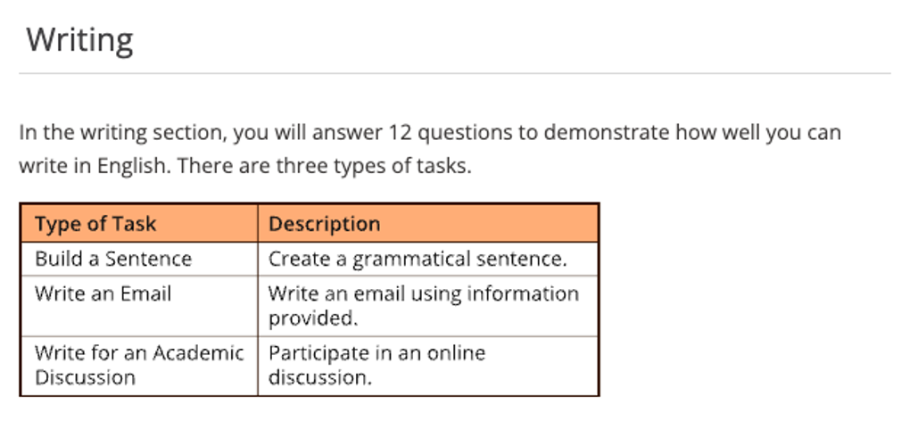
寫作題型一：組織句子(Build a Sentence)
此任務會同時呈現兩個句子：第一句為完整句，用來提供對話情境；第二句則為詞／片語詞序錯亂的句子。考生需依據第一句的語境，將第二句打亂順序的字詞重新排列，組成一個在語境中合適且文法正確、語意通順且情境恰當的回應句。
本題型考察考生是否能理解語境，並以正確的句型結構做出自然回應。換句話說，考生要能理解情境，利用文法和句構觀念再把詞語組合成符合英文語序的句子。
此題型重點在檢核考生對句型結構、語序與語用判斷的掌握能力，這是有效溝通的重要語言技能。

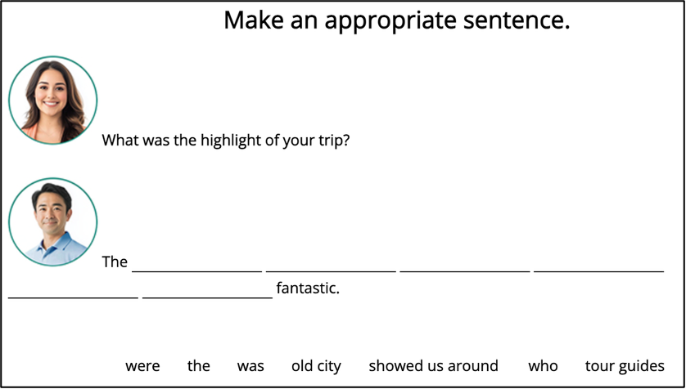

You will read some information and use the information to write an email.
You will have 7 minutes to write the email.

Writing Skills
-  語法運用語意整合力
-  訊息擷取與應用力
-  學術思辨與表達能力

TOEFL Writing Word Bank：

1. Alarmingly, many modern people, especially youngsters, have been suffering from unwholesome eating habits.
令人擔憂的是，很多現代人，尤其是年輕人，一直受到不健康飲食的困擾。

2. Contradictory ideas clash in whether or not the advertisement is the root cause of people’s unhealthy dietary habits.
關於廣告是不是人們不健康飲食的根源，人們的觀點是矛盾的。

Key point：unhealthy dietary habit = unwholesome eating habit

3. In addition to the subtle influence of ads, there are still many other reasons that contribute to people’s undesirable eating habits.
除了廣告的微妙影響，還有很多的原因導致了人們的不良飲食習慣。

contribute to = give rise to = lead to

4. So fierce is the competition and so fast is the tempo of modern life that the vast majority of people nearly have no time available to prepare the meals.
現代社會，競爭激勵，生活節奏快，現代人幾乎沒有時間準備餐食。

5. Eating too much fast food is health-threatening, for fast food contains too much fat, sugar and calorie.
吃了太多的速食有害健康，因為不少的速食含有太多的脂肪，糖分和熱量。

6. To be more specific = to be more precise = more precisely 更具體來說

7. a variety of = various kinds of = manifold 各種各樣的

8. carbonated beverage = carbonated drinks 碳酸飲料

9. be detrimental to health
be physically detrimental
= be health-threatening
= undermine one’s health 有害身體健康

10. obesity or over-nutrition 肥胖或營養過剩

11. nutrient = nutriment 營養品

12. tonic 補品

13. exert a subtle influence on 對於……有微妙的影響

14. … is inevitably health- threatening …… 無可避免地威脅健康

13. food preference or engorgement are still contributing factors of people’s sub-health.
偏食和暴飲暴食同樣是人們亞健康的原因

14. fail to maintain well-balanced diet 無法保持均衡的飲食

15. A profusion of young ladies are pursing slender figure nowadays, many of them tend to believe that cutting food intake is the best method. Unfortunately, the cost of beautiful look is the malnutrition.
很多年輕女孩喜歡追求苗條身材，很多人認為節食是最後的方法，但是，美麗的代價就是營養不良。

論文句型結構寫作(Composition --- Sentence Making)
UNIT 1
1. 人們相信一場新的經濟危機可能再次席捲全球; 然而, 所幸通貨膨脹的下
降無疑地是長期經濟衰退中的一線轉機。 _________________________________________________________________
_________________________________________________________________
2. 在環境的變遷與物質的改變中，網路與電子產品貼近我們的生活，我們經
常在空閒時間使用網路資源娛樂或學習額外的知識。
_________________________________________________________________
_________________________________________________________________
_________________________________________________________________
_________________________________________________________________
3. 眾所周知, 維護治安人人有責. 社會的穩定與和諧與繁榮之經濟息息相關(As is known to all, …).
_________________________________________________________________
_________________________________________________________________
________________________________________________________________
4. 事實上, 用英文表達自己的意思對於母語不是英文的人來說是相當困難.
_________________________________________________________________
_________________________________________________________________
_________________________________________________________________
5. 一般來說, 空氣及水在我們的日常生活是不可或缺的. 因此, 環境污染對人類的生存構成極大的威脅.
_________________________________________________________________
_________________________________________________________________
_________________________________________________________________
6. 毫無疑問地, 大海的無垠，可以開闊博大的胸襟；浪濤的洶湧，可以塑造頑強的性格.
_________________________________________________________________
_________________________________________________________________
7. 不可諱言, 知道是一回事, 做又是另一回事.
_________________________________________________________________
_________________________________________________________________

8. 不消說, 保護瀕臨絕種的動物與維持生物多樣性之永續已刻不容緩.
_________________________________________________________________
_________________________________________________________________
- 不須説 , 把握契機是好方法, 製造契機是更好的方法.
_________________________________________________________________
_________________________________________________________________
10. 依我之見, 藝術品是宇宙的精華, 也是世界的縮影.
_________________________________________________________________
_________________________________________________________________
11. 正如許多社會批評家所指出的那樣, 廣告目前的發展趨勢對年輕人的思想正在施加一種腐化的影響, 因為現代的廣告中總充斥著大量的思想不健康和低級下流的內容.
_________________________________________________________________
_________________________________________________________________
_________________________________________________________________
_________________________________________________________________
_________________________________________________________________

UNIT 2
1. 說來奇怪, 為了健康, 人們就是無法培養規律運動習慣. (Odd to say..)
_________________________________________________________________
_________________________________________________________________
2. 說來遺憾, 社會弊端叢生,違法情事屢見不鮮; 因此灌輸學生守法之觀念是當務之急.
_________________________________________________________________
_________________________________________________________________
3. 說來可悲, 近年來國內外企業舞弊案件層出不窮, 嚴重影響國內經濟發展
與金融穩定.
__________________________________________________________________
__________________________________________________________________
__________________________________________________________________
4. 沒有人可以否認, 健康勝於財富. 真正健康在於豁達的人生觀與開朗心靈與強健的體魄. (No one can deny that …)
_________________________________________________________________
_________________________________________________________________
5. 不可否認的沒有人是沒有缺點的.
_________________________________________________________________
_________________________________________________________________
6. 有人或許說智慧與勇氣最明顯的象徵就是臨危不懼. _________________________________________________________________
_________________________________________________________________
7. 不可否認, 真正的友誼在於互信, 互助, 及互諒.
_________________________________________________________________
_________________________________________________________________
8. 有人或許會說種族隔離政策是對種族的偏見及歧視.
_________________________________________________________________
_________________________________________________________________
9. 毫無疑問, 出自人類的貪婪, 無數多動物的棲息地遭受破壞, 與生態系統的瓦解, 因此他們瀕臨絕種.
_________________________________________________________________
_________________________________________________________________
_________________________________________________________________
10. 無疑地, 遇到志同道合的朋友是不容易的.
_________________________________________________________________
_________________________________________________________________
11. 毫無疑問地, 空氣污染及垃圾處理是大都市所面臨最大的問題.
_________________________________________________________________
_________________________________________________________________
12. 坦言之, 品格比學問重要. 良好的品格是人性的最高表現。好的品性不
僅是社會的良心，而且是國家的原動力；因為世界主要是被德性統治.。
_________________________________________________________________
_________________________________________________________________

13. 不可否認, 眼睛為靈魂之窗. 孩童近視的問題必須加以重視.
_________________________________________________________________
_________________________________________________________________

14. 人們經常認為, 隨著現代科技和大眾傳播媒體的廣泛普及, 那些不利的報導已經對人們的家庭生活和社區的共同感產生嚴重的威脅.
________________________________________________________________
________________________________________________________________
________________________________________________________________
________________________________________________________________

寫作題型二：撰寫電子郵件（Write an Email）
題目會提供考生一段描述某個學術或社交情境的提示文字，考生需要根據這個情境撰寫一封電子郵件。題目會明確告知考生撰寫信件的目的，而此這目的通常很具體，例如：提出建議、發出邀請，或是針對問題提出解決方案。考生需要在7分鐘內完成撰寫電子郵件。

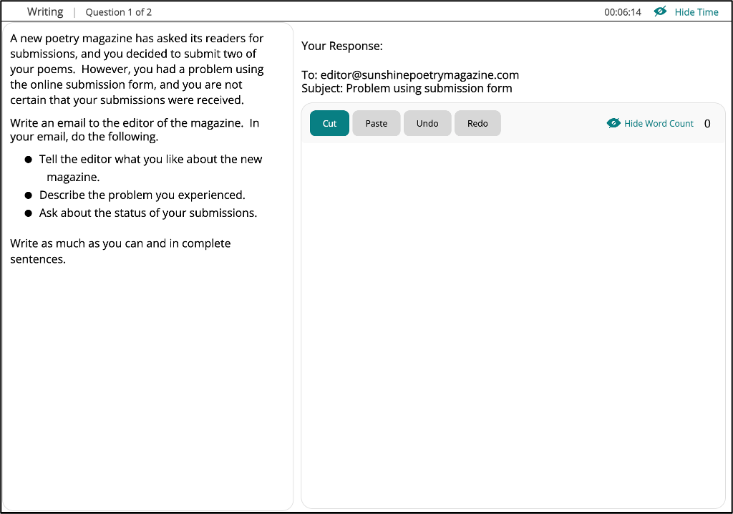

Email/ 書信 必備詞彙、短語和句型 - 請求/求助信
(1) 主體段
- seek/ ask for one’s assistance/ help in sth.
- turn to sb.
- formally request sb. to do sth.
- look after/ take care of sb./ sth. during one’s absence
- Would you be so kind to …?
- I wonder if you could spare some time to attend to my home while I
am away for my annual paid holiday.
- I would appreciate it if you could …

(2) 主體段
- drop in (on)/ by sb.
- take the trouble to do sth.
- the operation instructions/ guidebook
- every other day/ every two days
- lose (lost) sth. somewhere
- check sp. to see if it is possible to find sth. for sb.
- Your timely help is of great significance to me.
- Sth. if of great value to me because it is a gift from sb. who …
- I am sure that I have left sth. in sp./ somewhere but I cannot
remember/ recall the exact time and place now.

(3) 結尾段
- I would be greatly grateful/ thankful to you if you could lend me a
hand at such a critical time and I am looking forward to hearing from you.
- If you have any information/ Should you have any information, please
feel free to email me or call me anytime.
- Should anything happen, please call me, and I would be available all the time.
- A favorable reply at your earliest convenience is highly appreciated.
- Thank you for your attention to these requests.
- I shall remain grateful to you for the great help.

Writing Section
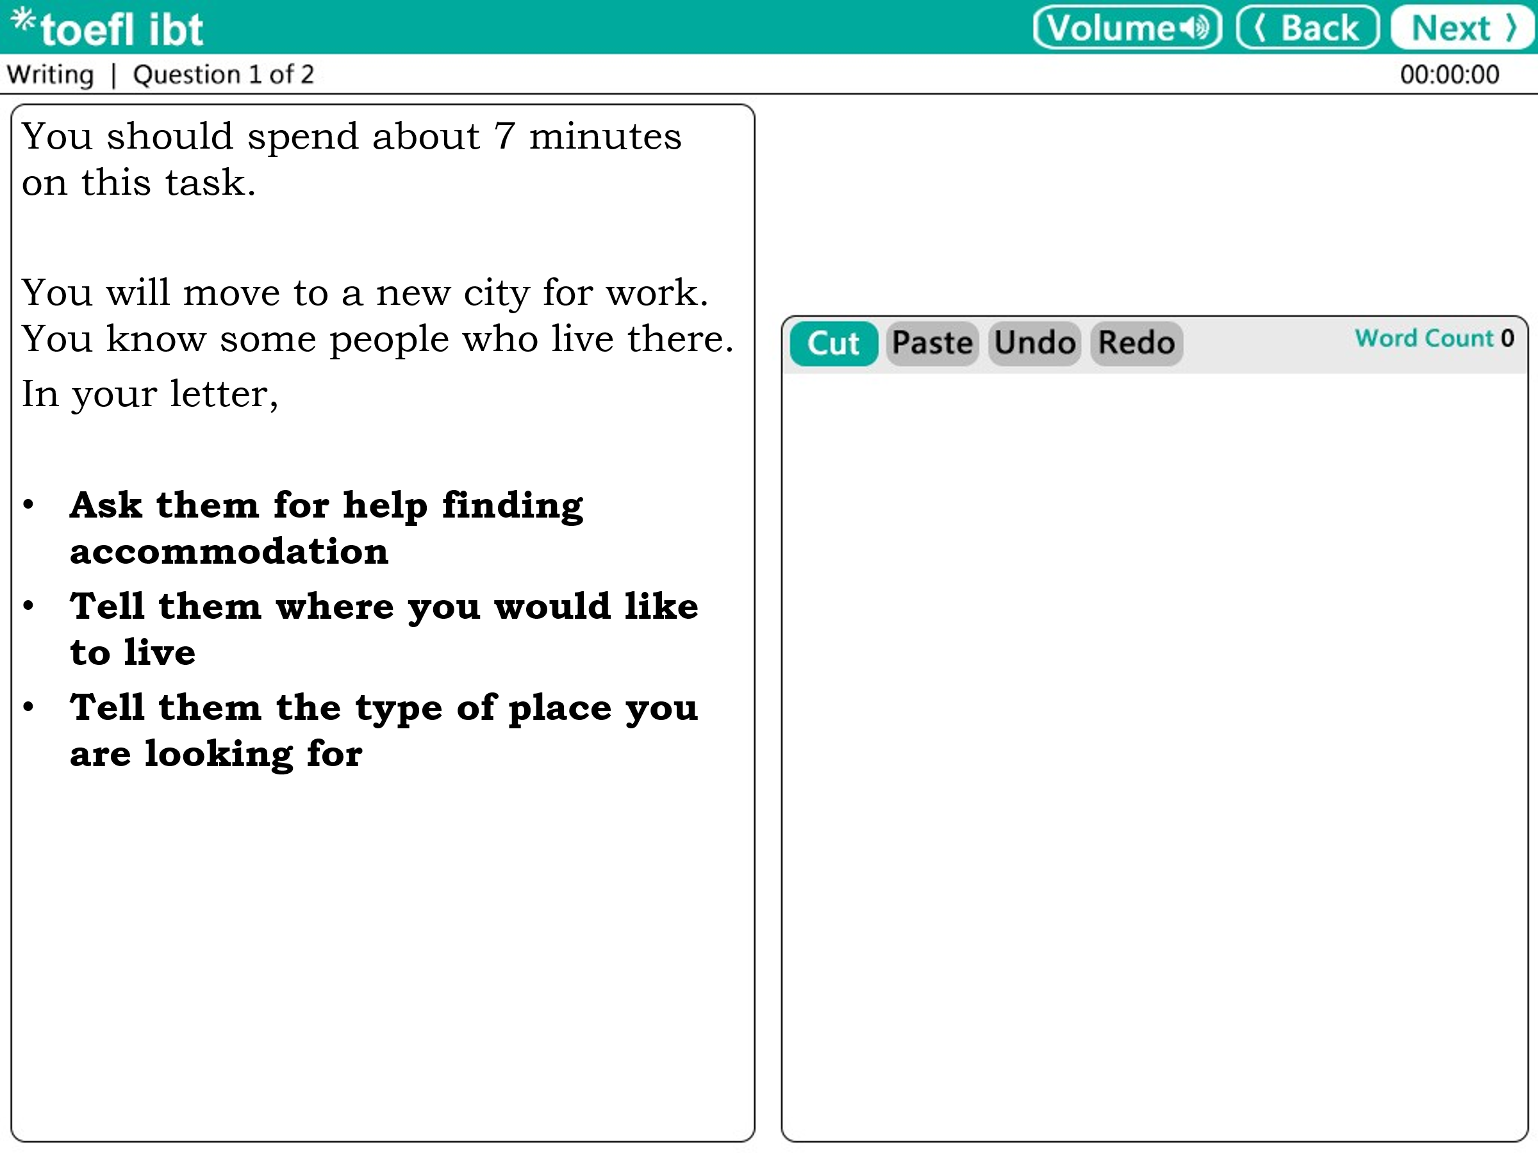
You should spend about 20 minutes on this task.
You will move to a new city for work. You know some people who live there.
In your letter,
- Ask them for help finding accommodation
- Tell them where you would like to live
- Tell them the type of place you are looking for

Sample Response
Dear Sir /Madam,
It has been a while since our last discourse. How are you doing? I have some good news: in the near future, my family and I will be moving to the city where you dwell, and we could meet more frequently. I would like to ask for your assistance with the relocation. Acquiring sufficient and exhaustive advice with respect to the optimal places to inhabit with a family would be crucial. The accommodation I am questing for should be equipped with three bedrooms and be well-lit. I enjoy spacious and bright homes with a large kitchen.
Ideally, I would like to live in the vicinity of where I am going to be working, or in the downtown district. The location with ample amenities is my priority. If possible, there should be some shops nearby, like a supermarket; meanwhile, some recreational facilities, such as parks or gyms enhancing quality of life cannot be neglected.
Additionally, I have always dreamed of having a large balcony or yard to plant a variety of beautiful flowers. Nonetheless despite accessible transport, a private parking lot is a must-have for us. Moreover, the education system in the area plays an essential role in choosing a place to live since we have a child. I know your advice is always helpful; therefore, I hope this time, relying on your opinion, we will find a gorgeous place for our family.
We appreciate your kindness

Faithfully yours
Kenny

Writing Skills :

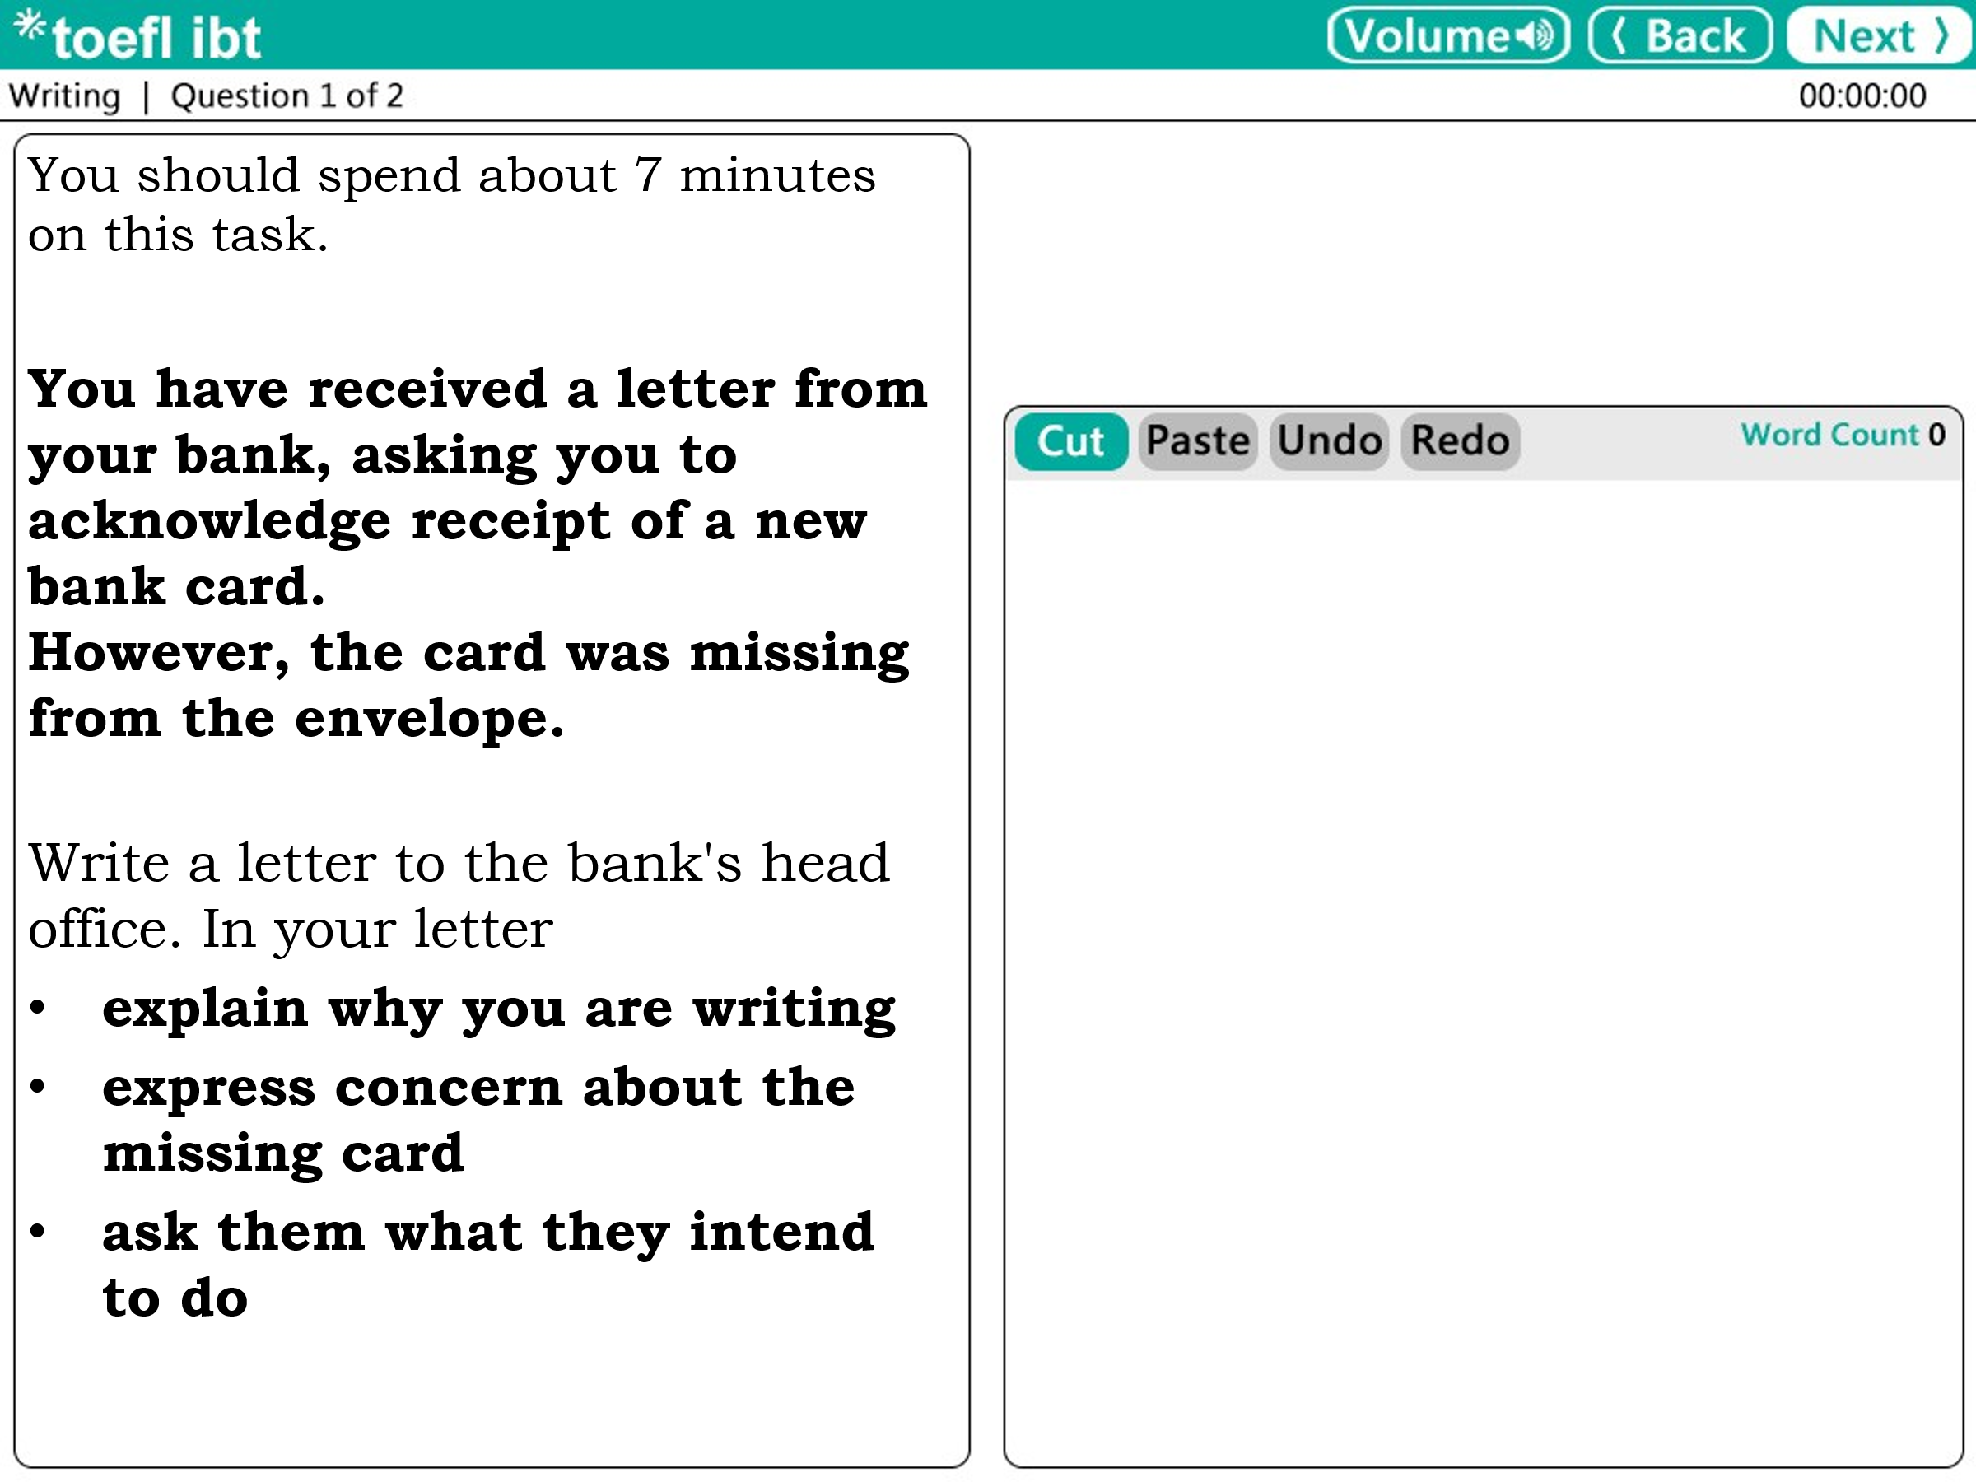

Writing Skills :

Writing Practice
