TOEFL WRITING
托福寫作



WRITING ACHIEVEMENT GUIDE

TOEFL Writing
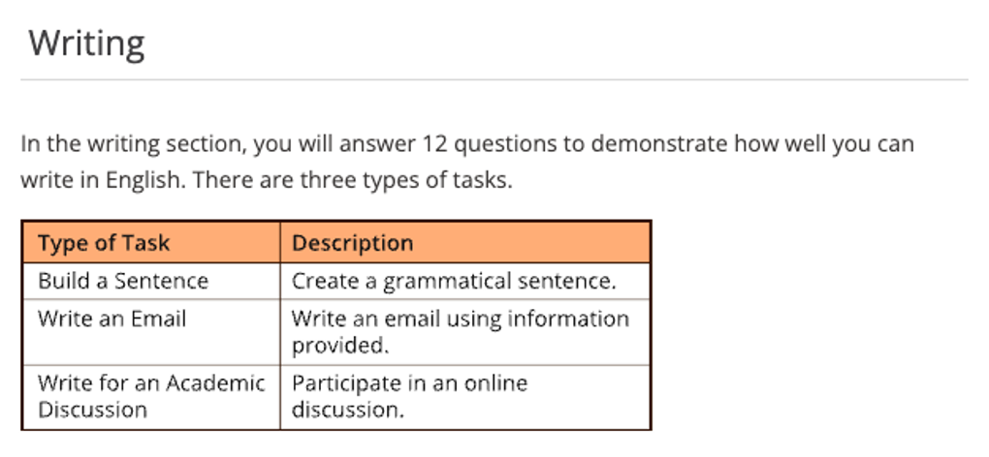

Test Content for New TOEFL Writing
Test Section | Task Type | Number of  Items | Estimated  Timing
Writing | Build a Sentence | 10 | 6 minutes
Writing | Write an Email | 1 | 7 minutes
Writing | Write for an Academic Discussion | 1 | 10 minutes
 |  | 12 | About 23  minutes

TOEFL Writing Academic Discussion
Academic Discussion 學術討論寫作回應要點:
針對上述官方提供之寫作方向說明，即學術討論寫作時應該注意之重點。 確實於討論中加入自己的觀點，而非僅僅是重複對方已經談論之論點。
字數至少 100 個字。 可選擇同意他人觀點，但必須增添自己的支持內容。
自己的立場看法亦可以採取折衷觀點—在某些情況下支持A方，在其他情況下支持B方。 學術討論問題並無「正確」答案。
必須陳述自己的觀點, 並提供合理、相關的支持, 以便對討論做出有意義的貢獻。
在規定的時間內盡可能地充分表達自己的觀點。
完善的回應將包含明確適當的理由、例子和細節。
句型結構和詞彙的品質與準確性極為重要, 亦是評分標準之一, 雖是討論議題, 然切勿以非正式的文句或詞彙進行寫作。
論述時仍應遵循標準的語法規則。 若不同意其他學生之意見時, 務必以尊重的方式表達自己的不同意見。

Skills: 論點提出、論述方式、支持內容、句型詞彙
TOEFL Writing --- 議論文寫作技巧:
基本上, TOEFL 論文寫作滿分標準：

(1) Effectively addresses the topic and task.
(2) Is well-organized and well-developed
(3) Using clear appropriate explanation, exemplification, and/or details.
(4) Display unity, progression, and coherence.
(5) Display consistent facility in the use of language, demonstrating syntactic variety, appropriate word choice, and idioms, though it may have minor lexical or grammatical errors.
簡言之即是:
(1) 切題, 有效地描述主題; 切勿離題
(2) 組織結構嚴謹, 擴展得宜
(3) 清晰適度理由解釋說明, 例證充分
(4) 論證一致, 層層遞進與連貫
(5) 用字遣詞貼切, 句法多元變化; 允許少量的拼寫和語法錯誤。

Academic Discussion 學術討論寫作技巧
Steps | Detailed Skills
1. 審題歸納 | 掌握關鍵核心
2. 論述題綱 | 直論型 / 讓步型
3. 立場觀點 | 自我立論觀點
4. 支持理由 | 解釋細節理由
5. 論據例證 | 強化舉證提例
6. 檢查排錯 | 審查語法與拼寫

Academic Discussion 學術討論題型
學術討論題目分為三個部分：
1. Instructions (指引)
2. Question (問題)
3. Discussion (討論)

Your professor is teaching a class on political science. Write a post responding to the professor’s question.
In your response, you should do the following:
- express and support your opinion
- make a contribution to the discussion
An effective response will contain at least 100 words.
You will have 10 minutes to write it.

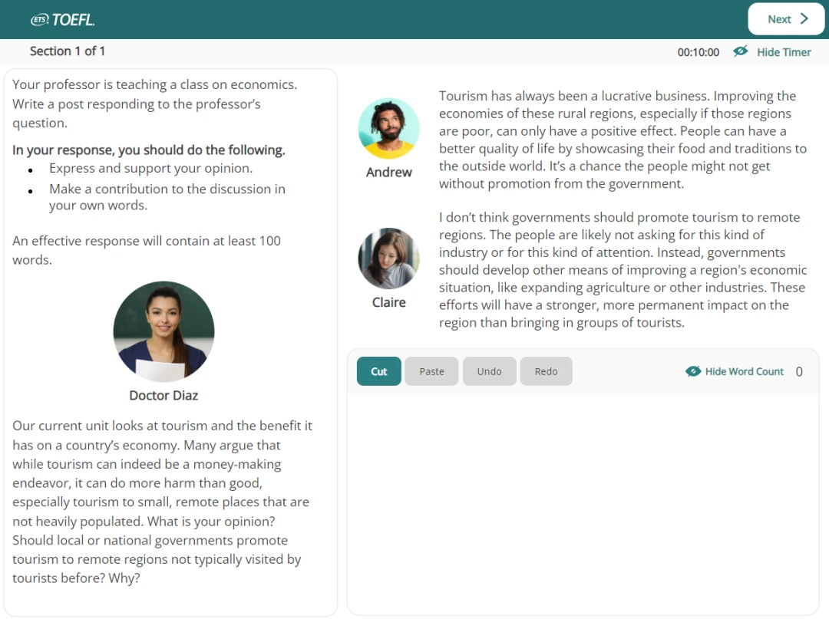

TOEFL Writing --- Academic Discussion

Your professor is teaching a class on Sociology. Write a post responding to the professor’s question. In your response, you should do the following.

- express and support your personal opinion
- make a contribution to the discussion in your own words
An effective response will contain at least 100 words. You have ten minutes to write.

 Doctor Diaz:
As environmental protection develops, more people have come to realize that everybody should play a part in preserving the planet we live on. These years, many people want to protect and improve the natural environment. In terms of what individuals in their daily lives could do if they want to protect the environment, some put forward walking or bicycling instead of driving a car to work or school, while others recommend buying locally grown organic foods grown without pesticides, and which one do you think would work better?

 Claire
I think walking or cycling instead of driving works better in reducing carbon emissions. Everybody needs to commute, and a lot of people drive every day. If they can switch to walking or riding bicycles, the outcome of such a collective effort would be considerable.

 Andrew
Buying locally grown organic foods is more effective, I think. Growing crops organically means giving up pesticides to get rid of pests, which significantly reduces pollutants that pose great threats to soil and water. Therefore, the food chain could be less contaminated.

Response
立場表明 – 回應學生觀點 – 理由陳述 – 自我觀點 – 解釋理由 – 例證說明

TOEFL Writing Word Bank： Technology
1. cutting-edge technology = state-of-the-art technology 尖端科技
2. scientific invention 科學發明
3. exert a far-reaching impact on… 對…產生一種深遠的影響
4. double-edged sword 雙面刃
5. earth-shaking changes 翻天覆地的改變
6. pave the way for the future development 為未來之發展鋪路
7. lay a solid foundation for… 為…奠下穩固之根基
8. energy crisis 能源危機
9. depletion of resources 資源耗竭
10. milestone 里程碑
11. sophisticated equipment 尖端設備
12. technical innovation 科技創新
13. expediency 權宜之計
14. be antithetical to 與…背道而馳的
15. over-commercialized 過渡商業化的
16. a heated discussion 熱烈的討論
17. exhaust gas 廢氣
18. disastrous = catastrophic 災難性的
19. overshadow = dwarf = outshine 使…相形見絀
20. compared to/with… 與…相比
21. usher in 引領
22. speedy and comfortable 既快捷又舒適
23. downsides 不利一面
24. a fatal breakdown 致命故障
25. potential hazards 潛在危險
26. pose a threat to… 對…構成威脅
27. promote relative industries 促進相關產業發展
28. accelerate 加速…
29. means of transportation 交通工具
30. exploration of the frontiers 探索新領域
31. social status 社會地位
32. environmentally-friendly resources 環保能源
33. make people’s life easier 使人們生活更方便
34. alternative fuel 可替代燃料
35. sustainable development 可持續性發展
36. scientific exploration 科學探索
37. air travel 航空旅行
38. ridiculous = ludicrous 可笑的
39. absurd = preposterous 荒唐的
40. supersede = supplant = substitute = replace 取代
41. tide over difficulties = overcome difficulties 克服困難
42. make a stride = make progress 取得進步
43. a sense of national pride 民族自豪感
44. unprecedented 空前的; 前所未有的
45. soaring = escalating 不斷上升的
46. give a great push to the economic growth 極大地推動了經濟發展
47. see dramatic breakthroughs 取得突破性進展
48. aggravate = exasperate = worsen 使惡化
49. optimize 優化
50. cure-all solution 萬能良藥

CEFR 級分制


TOEFL寫作級分換算表

Writing  Rating Average | Scaled Score | Writing  Rating Average | Scaled Score
5.00  4.75  4.50  4.25  4.00  3.75  3.50  3.25  3.00 | 30  29  28  27  25  24  22  21  20 | 2.75  2.50  2.25  2.00  1.75  1.50  1.25  1.00 | 18  17  15  14  12  11  10  8

TOEFL寫作5分作文：文章切題，闡述充分，文章說服力強; 段落組織結構緊湊，過渡自然，能展示考試出色的邏輯性; 段落內句子連接順暢，句法使用嫻熟靈活;用詞準確。文章可能有個別語法拼寫錯誤，但不影響整體理解。
TOEFL寫作4分作文：文章切題，闡述基本充分，在某些地方有小漏洞。段落組織結構緊湊，過渡自然，能展示考生較強的語言邏輯性強; 段落內句子連接順暢，句法使用較恰當; 用詞基本準確。文章中有少量用詞不當和語法錯誤。
TOEFL寫作3分作文：文章切題，闡述尚可，略顯空洞。段落組織結構緊湊，過渡自然，能展示考生的語言邏輯性; 段落內句子連接基本順暢; 有部分句法使用不當；用詞尚可，有時不準確。語法及拼寫等有若干錯誤。
TOEFL寫作2分作文：文章切題，段落組織基本合理，能看出考生的邏輯性，但僅僅體現在語義層面，語言表達上有較大缺陷; 句法基本成立，但文章有不少語法錯誤，句間聯繫鬆散，詞不達意，表述生硬，拼寫錯誤多。
TOEFL寫作1分作文：文章切題。然而闡述空洞，三言兩語泛泛而談; 段落組織混亂，作文不分段; 句子間雖有一定的邏輯關係，但結構與語法錯誤較多;用詞不恰當，拼寫錯誤多。
TOEFL寫作0分作文：文章無論在結構還是語言都有嚴重錯誤。考試寫作能力及其欠缺，英語水準極低，達不到一分標準，只能給最低分。

Writing Section

TOEFL Writing --- Academic Discussion
考古真題
Your professor is teaching a class on technology. Write a post responding to the professor’s question. In your response, you should do the following.

- express and support your personal opinion
- make a contribution to the discussion in your own words
An effective response will contain at least 100 words. You have ten minutes to write.

 Doctor Achebe:
A new story about Artificial Intelligence (AI) is in the news almost every day. And, of course, companies are spending an enormous amount of money to develop new technologies related to AI. Before next class, I want you to consider the following question: Is AI a dangerous technology that, overall, will be harmful to society, or is it a powerful tool that will improve the lives of people?

Claire:
Personally, I think AI is a threat. As AI advances, many jobs may become automated, leaving people without work. That will certainly increase income inequality. Additionally, there’s the risk that AI systems could be programmed with biases or used to discriminate against certain groups. We need to be careful and ensure that AI is developed in an ethical and responsible way. Since we can’t guarantee that right now, I think it is best to slow down.

Alex:
I disagree with Claire. I’m of the opinion that AI has the potential to solve many of the world’s problems, from climate change to disease. Additionally, AI can help us make better decisions by analyzing vast amounts of data and identifying patterns that humans may miss. That said, I agree with Claire that we must ensure that AI is developed and used in a responsible way that benefits society as a whole.

立場表明 – 回應學生觀點 – 理由陳述 – 自我觀點 – 解釋理由 – 例證說明

In my perspective, the incessant breakthrough of advancement of artificial intelligence of technology will bring some conspicuous benefits.
Artificial Intelligence (AI) is exceedingly helpful and will ameliorate our lives over time. I strongly advocate Alex’s opinion that AI will help us grapple with plenty of knotty problems currently influencing the society. On top of that, I also deem that Artificial Intelligence (AI) is lucidly able to outperform humans in a profusion of jobs, and can significantly dwindle errors and boost accuracy and precision, thereby fortifying work proficiency and productivity. Also, the decisions made by AI in every step is decided by information previously gathered and a certain set of algorithms programmed properly. For instance, robotic surgery systems, which can perform sophisticated procedures precisely, diminishing the risk of human error and ameliorating patients’ safety in healthcare. Moreover, AI has already been utilized to make driving safer and substantially curtail incidence of accidents, so we already have some proof that AI is assisting people around the world. According to statistics conducted by the department of transportation, self-driving cars equipped with the intelligent program get in accidents 85% less frequently than vehicles driven by humans. Evidently, this innovative technology is a marvelous merit to all the people. On balance, artificial intelligence or intelligent machines will no doubt improve our lives in multifarious manners.

In contrast, Claire raises the relevant point that AI could deprive people of the chances of certain jobs, whereas she neglects the fact that AI is creating new jobs simultaneously. For instance, when new products are invented by virtue of artificial intelligent techniques, they still have to be manufactured, which means that new factory jobs are created. Apart from this, AI learning tools can help people enhance their techniques and make themselves more attractive employees for various companies.
Overall, I would contend that AI will improve our lives in a variety of aspects.

Writing Skills :

Sample Essay
People seem to be either thrilled or anxious about the future impacts of artificial intelligence, meaning there are tons of advantages and defects it gives rise to. Personally, I can grasp the two opposing points of view; I am both fascinated by the development in artificial intelligence and apprehensive about its potential as well as negative impacts.

支持立場
Explicitly, the incessant breakthrough of advancement of artificial intelligence of technology will bring some conspicuous benefits.
Unlike humans, Artificial Intelligence (AI) is programmed to work persistently without getting fatigued or distracted. They can also handle tedious and monotonous jobs easily with the help of AI algorithms.
AI is lucidly able to do a myriad of jobs better than humans, and can significantly retrench errors and increase accuracy and precision. The decisions made by AI in every step is decided by information previously gathered and a certain set of algorithms programmed properly. For instance, robotic surgery systems, which can perform intricate procedures precisely, will allow medical professionals to assess the patients and their health risks promptly with AI to mitigate the jeopardy of human error and ameliorate patients’ safety in healthcare. Additionally, nowadays people have already had automobiles that utilize ancillary sensors and cameras to drive themselves. Such technologies can undoubtedly ameliorate safety by curtailing the likelihood of human errors. Evidently, AI can revolutionize a variety of aspects of our daily lives, and will steadily improve our quality of life.

反對立場
On the contrary, with the tremendous concerns concomitant with the merits, people contend that artificial intelligence (AI) may bring detriment to humans and the society as a whole if we are not meticulous enough. In the short term, in all likelihood, the prominent rise in unemployment rate can be witnessed as workers in various industries are superseded by machines or software programs. To illustrate, robots are frequently utilized to supersede human resources in manufacturing industries in some more technologically advanced nations in order to increase efficiency. Meanwhile, self-driving vehicles are expected to contribute to redundancies in driving jobs, such as lorry drivers, taxi drivers and bus drivers. Furthermore, ethics and morality are crucial human features that can be difficult to incorporate into artificial intelligence. The swift progress of AI has raised a number of concerns, which AI will grow uncontrollably, and eventually wipe out humanity to be the phase of AI singularity. If intelligent technologies gradually take jobs away from humans, we may find that people become deskilled, incompetent, and lose their sense of purpose in life. Moreover, prolonged fear or the vast demerit of artificial intelligence is the paucity of creativity, meaning that it cannot learn to think outside the box. AI is capable of learning over time with pre-fed data and past experiences, but cannot be innovative or creative in its approach.

On the whole, while artificial intelligence and intelligent machines will no doubt improve our lives in multifarious manners, the latent and potential hazards of such technologies should not be ignored.

Writing Skills :

Advantages of Artificial Intelligence
In real-world applications, AI is revolutionizing various industries through many advantages it has to offer in the following ways:

1. By Reducing Human Error
It is likely for humans to make mistakes in tedious and monotonous tasks, but computers can avoid such errors if programmed correctly.
AI models make predictions by applying algorithms to the compiled data, thereby reducing errors and improving accuracy.
Hence, achieving better results and fewer mistakes is possible. This can save both time and resources. So, organizations tend to increase their investments in AI for leveraging big data.

2. Allows Automating Repetitive Tasks
Repetitive tasks and processes continue to be a significant aspect of many occupations today.
This does not allow using the full potential of human employees.
AI enables automation of routine monotonous tasks in different areas of data collection and entry, email responses, customer support through chatbots, factory operations such as visual quality inspection, software testing, invoice generation, and many more.
This can undoubtedly free up the employees' time to focus on creativity or other areas that require distinctively human abilities.

3. Easily Handles Big Data
AI can process and make sense of big data in very less time.
It can quickly capture data and extract relevant data for analysis. However, that's not all, as AI can also further process this data through interpretation and transformation.

4. Faster Decision-Making with Consistent Availability
Organizations are always keen on faster decision-making to respond to today's dynamic markets.
But for faster decision-making, it is essential to have reliable insights available at a faster pace.
AI, along with various technologies, enables machines to bring consolidated information and predictions to assist in faster decision-making.
Additionally, AI also improves the process every time with previous predictions. Besides, AI systems can be continuously available, ensuring continual availability 24/7 with breaks (other than planned maintenance activities). This significantly impacts the company's productivity.

5. AI-powered Digital Assistants
Many businesses today have implemented digital assistants (chatbots) for customer interactions.
A chatbot can significantly reduce the need for excessive customer service staff for routine and simple customer queries.
Chatbots can smartly interact with the customer and provide relevant information on demand.
Voice assistants like Alexa and Siri are examples of voice bots that respond to voice commands and assist users with queries and personal management tasks.

6. Mitigates Risks
A highly notable advantage of AI application is in areas that are hazardous to humans.
AI systems can minimize the risks involved for humans in such tasks. For example, AI-enabled robots can undertake risky tasks such as coal mining, marine life exploration, assisting in rescue operations during natural disasters, and so on.

7. Pattern Identification
AI outperforms human talents when spotting patterns in words, figures, or images.
AI effectively discovers trends and patterns in a dataset and, as a result, can generate more accurate predictions faster.
This is crucial for companies as they can visualize the bigger picture for better decision-making.
For example, with such trends and patterns, AI can improve the marketing analytics capabilities of any organization.

8. Improving Processes and Workflows
Companies strive to find ways to work more efficiently, increase productivity, and boost revenues.
An important part of this includes developing better human workflows. It might be possible to achieve higher efficiency by designing workflows that reduce error and rework by humans.

9. Medical Applications and Treatments
The best thing that has ever happened to humans is AI being involved in medical applications and treatments.
Doctors can assess their patients and their health risks quickly with AI. The growing applications of AI used in medical science also help educate the machines regarding the side effects of various medicines.
Nowadays, medical professionals are trained with artificial surgery stimulators that help monitor and detect neurological disorders and stimulate brain functions.

Many studies have been conducted, and it has been proved that humans are productive only for three to four hours a day.
They demand breaks and time off to maintain a healthy work-life balance. This is where artificial intelligence (AI) enters the picture.

Disadvantages of Artificial Intelligence
Although AI offers several advantages, it still has a few disadvantages mentioned below:

1. More Likely to Increase Human Laziness
Automation in tasks and increased availability of digital assistants tend to increase machine dependency, which can likely increase human laziness.
Too much relying on AI for simple tasks such as small calculations or remembering numbers or addresses can affect humans in their day-to-day activities, which require memorization or analysis.
Conscious use of AI is crucial to avoid negative effects on future generations.

2. AI is Expensive to Implement
Initial set-up for AI requires a high investment as companies have to invest in AI frameworks, including the latest hardware and software.
Additional costs are incurred on training teams to learn how to utilize the AI systems. All this makes implementing and maintaining AI systems expensive.

3. Can Increase Unemployment
Although AI can replace repetitive tasks and other types of manual work, which is beneficial for organizations, this also has a negative impact on employment.
Conventional jobs will likely be completely replaced by AI in the future, leading to the unemployment of individuals who perform them.

4. Lacks Creativeness
Since AI systems make predictions based on a set of algorithms, these can lack creativity, especially in the content marketing field.
As AI systems improve over time from inputs and experience, they cannot think outside the box or generate creative approaches to a project.

5. Cannot Understand Emotions
AI systems can work faster and without a break, but they cannot evaluate emotions before making decisions.
These systems always remain highly rational and practical. This is why AI systems find it challenging to bring in emotions while interacting with customers, as emotions play a key role in sales and marketing while convincing a customer to make a purchase.

6. Difficult to Implement Ethics
Finally, AI systems cannot process human emotions and feel them. It is highly challenging to incorporate ethics and morality into these systems.
Advanced versions of AI like the theory of mind and Self-awareness, when achieved, can only implement ethical behaviour in AI systems.
Currently, these systems are on paper and only partly achieved; it looks a long way to think about implementing ethics in AI systems.

Writing Practice

Your professor is teaching a class on education. Write a post responding to the professor’s question. In your response, you should do the following.

- express and support your personal opinion
- make a contribution to the discussion in your own words
An effective response will contain at least 100 words. You have ten minutes to write.

Doctor Achebe
Let's explore the concept of retail and its variations. In the world of retail, there's a unique type where a wide array of products are housed under one roof, allowing for wholesale purchases. This brings us to the idea of super stores. On the other end, we have small stores catering to specific needs. Now, considering these options, which one do you think holds more advantages for people? Would the convenience of super stores outweigh the personal touch of small stores?

Andrew
In my view, small stores outweigh super stores, mainly due to the emphasis on personalized service and repairs. The direct assistance and expertise offered by small stores are invaluable, especially when it comes to electronics or gadgets that might need fixing. While super stores provide convenience, the hands-on support and tailored solutions from small stores align better with my college experience and budget considerations.

Claire
In my opinion, super stores hold an edge over small stores due to their wide ranging product choices, extended hours, and cost-saving options. As a student juggling classes and activities, the convenience of finding everything under one roof and the potential for bulk discounts make superstores a practical choice. While small stores offer a personal touch, the efficiency and budget-friendly nature of super stores align better with my busy college lifestyle.

