TOEFL Writing
Test Content for New TOEFL Writing
Test Section | Task Type | Number of  Items | Estimated  Timing
Writing | Build a Sentence | 10 | 6 minutes
 | Write an Email | 1 | 7 minutes
 | Write for an Academic Discussion | 1 | 10 minutes
 |  | 12 | About 23  minutes

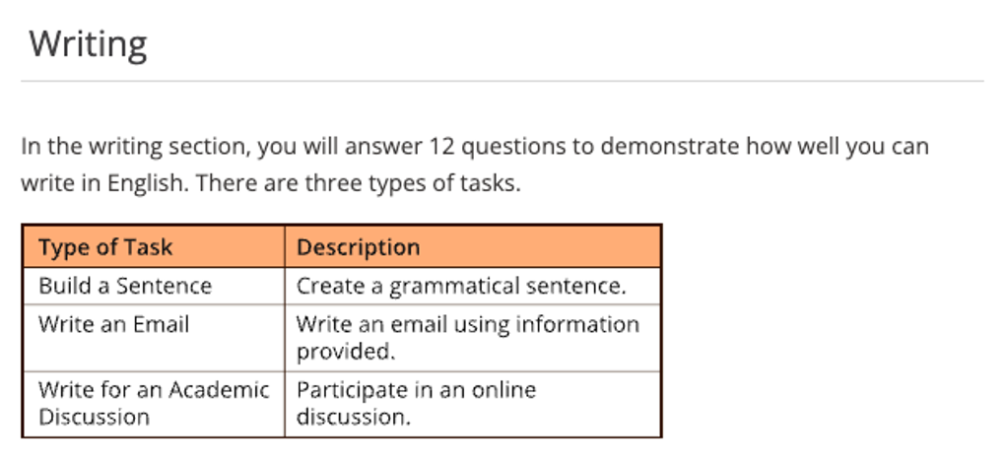

寫作題型二：撰寫電子郵件（Write an Email）
題目會提供考生一段描述某個學術或社交情境的提示文字，考生需要根據這個情境撰寫一封電子郵件。題目會明確告知考生撰寫信件的目的，而此這目的通常很具體，例如：提出建議、發出邀請，或是針對問題提出解決方案。考生需要在7分鐘內完成撰寫電子郵件。

E-Mail Writing 寫作技巧
1. 提出建議 – Making a Recommendation
2. 發出邀請 – Extending an Invitation
3. 說明情況或請求協助 – Sharing Information / Proposing a Solution)

E-Mail Writing 技巧

1. 稱呼敬語 (Dear ….. )
2. 開頭表明目的 (I am wiring regarding ………)
3. 陳述問題 (What happened…….)
4. 提出請求 (Would you please …….)
5. 結尾禮貌致意 (Thanks for ……)

Task Requirement
1. Communicative Goal: 是否完成溝通目的, 語氣得體有禮
2. Organization & Cohesion: 是否組織清晰邏輯連接, 句子銜接自然
3. Lexical Resources : 詞彙是否精確, 自然, 多元變化
4. Grammatical Range & Accuracy: 語法範圍精確
5. Mechanics: 拼寫, 標點, 格式是否符合規範

How to Write E-mail
1. 首先敬語稱呼
2. 開頭禮貌問候
3. 說明目的
4. 展開問題
5. 提出請求
6. 結尾禮貌致意

Email/ 書信 必備詞彙、短語和句型 - 請求/求助信
(1) 主體段
- seek/ ask for one’s assistance/ help in sth.
- turn to sb.
- formally request sb. to do sth.
- look after/ take care of sb./ sth. during one’s absence
- Would you be so kind to …?
- I wonder if you could spare some time to attend to my home while I
am away for my annual paid holiday.
- I would appreciate it if you could …

(2) 主體段
- drop in (on)/ by sb.
- take the trouble to do sth.
- the operation instructions/ guidebook
- every other day/ every two days
- lose (lost) sth. somewhere
- check sp. to see if it is possible to find sth. for sb.
- Your timely help is of great significance to me.
- Sth. if of great value to me because it is a gift from sb. who …
- I am sure that I have left sth. in sp./ somewhere but I cannot
remember/ recall the exact time and place now.

(3) 結尾段
- I would be greatly grateful/ thankful to you if you could lend me a
hand at such a critical time and I am looking forward to hearing from you.
- If you have any information/ Should you have any information, please
feel free to email me or call me anytime.
- Should anything happen, please call me, and I would be available all the time.
- A favorable reply at your earliest convenience is highly appreciated.
- Thank you for your attention to these requests.
- I shall remain grateful to you for the great help.

TOEFL WRITING --- 重要句型-5

1. ….. cannot emphasize the importance of …. too much
(再怎麼強調...的重要性也不為過。)
Ex. We cannot emphasize the importance of protecting the natural environment against being devastated too much.
(我們再怎麼強調保護自然環境免於破壞也不為過。)

2. Nothing is + …. than to + V
Nothing is + more + 形容詞 + than to + V
Ex. For parents, nothing is more important than to educate children in a proper manner.
(對父母而言, 沒有比以一種正確方式教育孩子更重要的事情了。)

3. …. the + 最高級+ 名詞 + (that) + 主詞 + have ever + seen (known/heard/had/read )

…. the most + 形容詞 + 名詞 + (that) + 主詞 + have ever + seen
(known/heard/had/read)

Ex. A paucity of interpersonal skills is one of the most serious defects that we have ever known about today’s college students.
(缺乏人際交往技能是我們迄今所知的當今大學生的最大缺陷。)

4. There is no denying that + S + V ... (無可否認的...)
Ex. There is no denying that the practicality of our tertiary education
has gone from bad to worse.
(無可否認的, 我們高等教育的實用性已經每況愈下。)

5. It is universally acknowledged that + S + V (全世界都知道...)
Ex. It is universally acknowledged that it is the doctor’s duty and obligation to heal the wounded and rescue the dying.
(全世界都知道救死扶傷是醫生的天職。)

6. There is no doubt that + S + V … (毫無疑問的...)
Ex. There is no doubt that the Internet is far more convenient and efficient than the written words or other conventional means of conveying meaning.
(毫無疑問網際網路比書面文字更方便、快捷。)

7. An advantage of …. is that + S+ V (... 的優點是...)
Ex. An advantage of children’s participation in some paid work is that this practice can cultivate their independence, self-determination and sense of responsibility.
(孩子參加有償勞動的一個優點是這種實踐可以培養小孩的獨立性、自主性和責任感。)

8. The reason why + S + V …. is that + S+ V (... 的原因是...)
Ex. The reason why a large number of customs have altered substantially is that most of them are associated with some superstitious beliefs, and they are incompatible with this world with highly-developed technology.
(許多舊風俗習慣都產生了巨大的改變的原因是它們大多與封建迷信有關, 與現代高度發展的科技社會格格不入。)

9. So + 形容詞 + be + S + that + S + V (如此...以致於...)
Ex. So pervasive are advertisements that no one can avoid being influenced by them.
(廣告是如此盛行, 每個人都難免不受它們的影響。)

10. Adj. + as + S + be, S + V …. (雖然...)
Ex. Useful and convenient as cellphones are, it is by no means appropriate for adolescents / teenagers to indulge in them.
(雖然手機很有用與方便, 然而對青少年而言沉迷其他是絲毫不妥的。)
Ex. Lovely as pets are, it is by no means appropriate for city dwellers to keep them in their houses.
by no means = in no way = on no account (一點也不…)
(雖然寵物很可愛, 然而市民在家中飼養是絲毫不妥的。)

11. The + 比較級+ S + V, the + 比較級+ S + V ….
The + more + Adj. + S + V, the + more + Adj. + S + V (愈...愈...)
Ex. The more children are encouraged to get in touch with various aspects of society, the more comprehensive their knowledge will be.
(越鼓勵孩子接觸社會的各個方面, 他們學習的知識會更全面。)

12. By +Ving, …. Can … (藉由..., .. 能夠..)
Ex. By putting the responsibility into the government’s hand, citizens can enjoy a higher level of assurance in quality.
(藉由將這種職責放在政府手中, 市民在品質上能夠享有更高程度的保障。)

13. ~~~ enable + O + to + V (..使..能夠..)
Ex. Community service programs enable the government to assuage the strain on its limited budget.
(社區服務計畫有助於減輕政府財政負擔。)

14. On no account can we + V …. (我們絕對不能...)
Ex. On no account can we ignore the significance of education.
(我們絕對不能忽略教育的重要性。)

15. It is high / right time + S + 過去式 (該是...的時候了)
Ex. It is high / right time we evaluated the roles that modern technology plays in our life from more balanced and objective perspectives.
(該是我們從更加公正和客觀的角度來評價現代科技在我們的生活中所發揮的作用的時候了。)

Writing Section
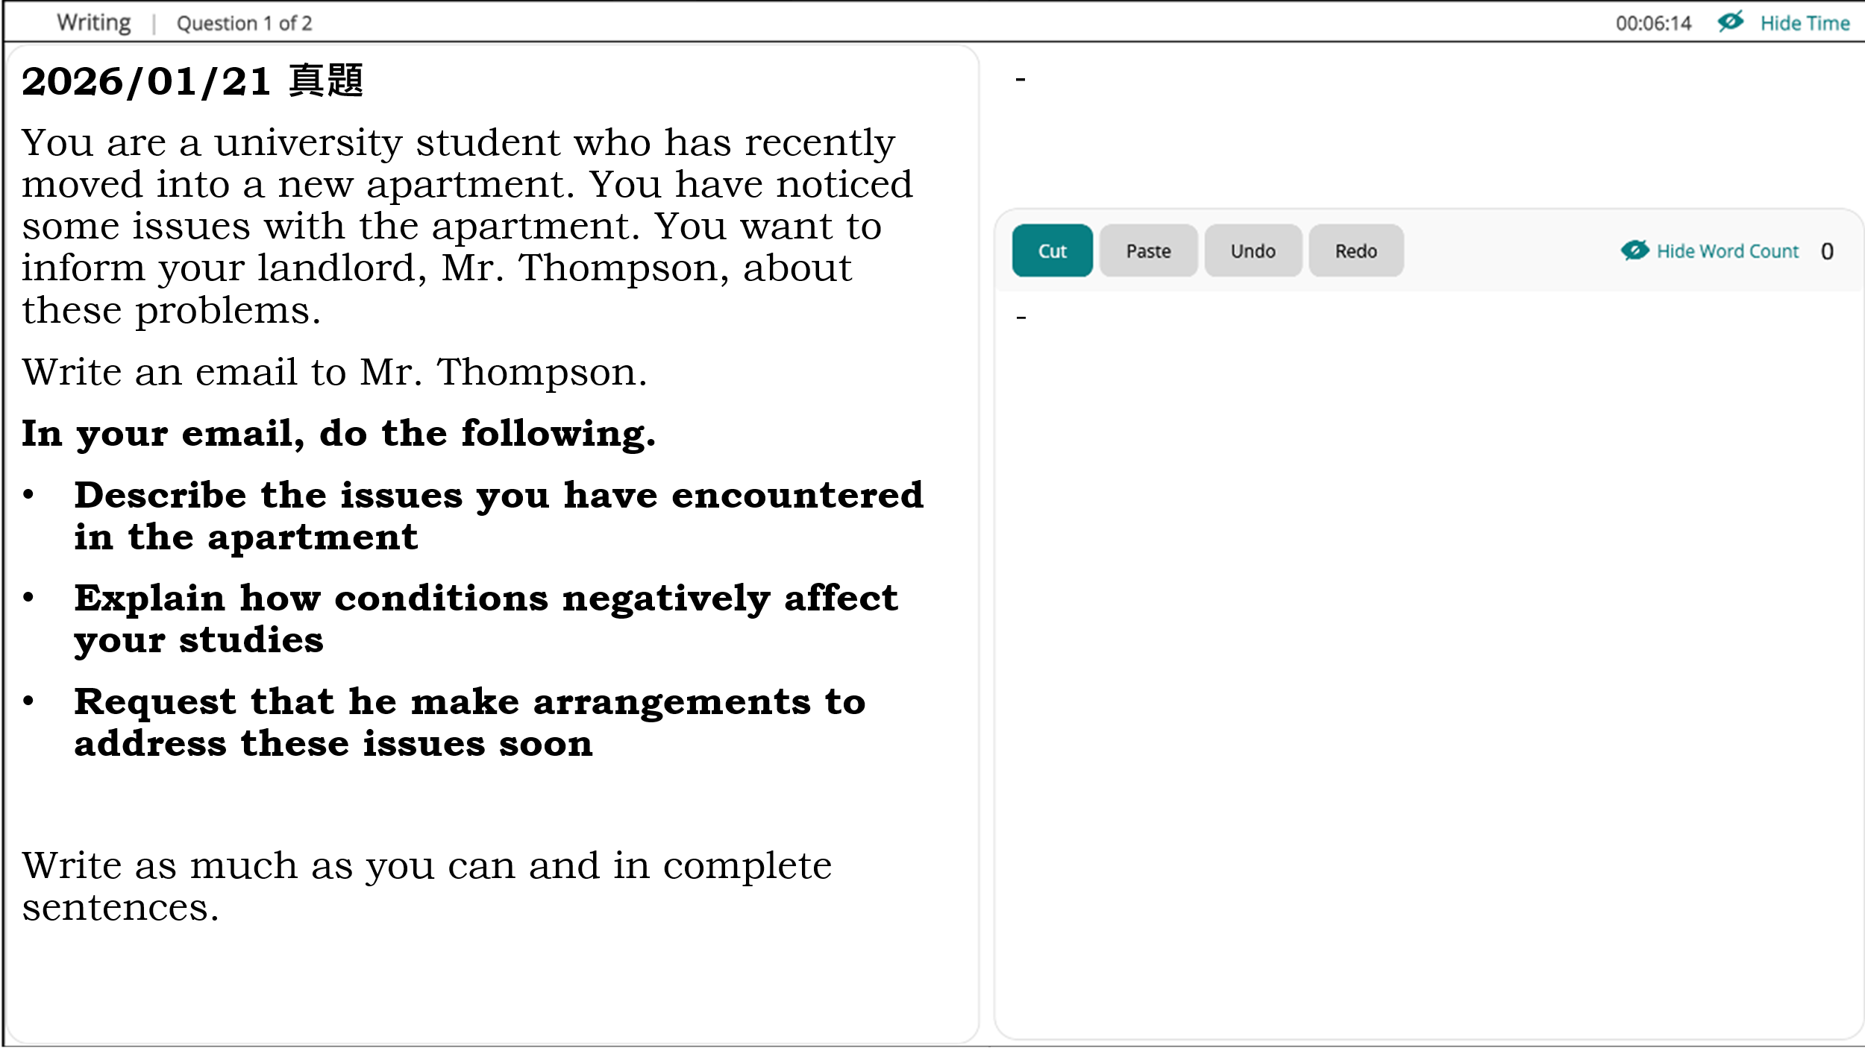

Sample Response
To: Mr. Thompson
Subject: Request for apartment repairs

Dear Mr. Thompson
I hope this message finds you well. I am writing to inform you about several problems I have encountered since moving into the apartment.

First, the heating system is not functioning properly and often stops working, which makes the apartment exceedingly freezing, particularly at night. Furthermore, there are cracks in the roof, and during rainy days, water leaks into the room.

These issues have substantially influenced my concentration on my studies. On account of the cold temperature as well as the noise and water dripping from the ceiling, I find it annoying and difficult to be immersed in my schoolwork. Actually, this situation has become so unbearable that I had to stay overnight at my friend’s house.

I would greatly appreciate it if you could swiftly make arrangements to address these problems thoroughly since I enjoy dwelling in this area and hope these hassles could be eradicated and make it more hospitable.
Thank you a million for your consideration and care.
Yours Faithfully
Andrew
Writing Skills :

諮詢信
1. 諮詢結構
諮詢信一般分為三部分：第一部分自我介紹，說明寫信目的(詢問某方面情況)，指明你所需要的資訊;第二部分提供相關背景資訊，指出你為什麼需要這些資訊。詢問具體相關事宜。指明你什麼時候需要這些資訊;第三部分表達請求説明的願望，預先感謝對方的幫助，並表示希望早日得到答覆。
2. 常用句型
1) I would be much obliged to you if you could let me know the procedures I have to go through.
2) Your prompt and favorable attention to my inquiry would be highly appreciated.
3) I am looking forward to a favorable reply/response at your earliest convenience.
4) Would you provide me with some valuable advice?
5) Your kind reply will be highly appreciated.
6) It would be greatly appreciated if you could furnish me with relevant booklets on the above-mentioned aspects.
7) I am writing to enquire whether I may become a member of your club.
8) I would be grateful if you could let me know your annual fee charges and any other information which would be useful.
9) Please let me know as soon as possible how you propose to settle this matter.
10) Although at this time of year you will have more work to deal with than usual, I would appreciate a reply in the future.

投訴信
1. 書信結構
投訴信是雅思考試中最常見的一種，寫信時應該重點包括三個部分。第一部分為自我介紹、投訴事由、自己的感受等;第二部分為投訴的事實與理由，具體描述當時的情形，如人物、時間、地點和原因等。指出具體問題及其所產生的後果; 第三部分可分為提出個人要求或者建議，清晰說明讀信人可以做的補救措施，希望有關部門和人士做出相應的改進，以及提出願望，希望早日得到答覆。

2. 常用句型
1) I am writing to express my dissatisfaction with .
2) There are some problems with that I wish to bring to your attention.
3) I regret to inform you that .
4) You can imagine my disappointment when I discovered that _.
5) You can imagine my feelings when I realized that this would mean .
6) Even though I telephoned you about , .
7) I hope that the authorities concerned will consider my suggestions and improve the situation as best as they can.
8) We trust that you will now consider this matter seriously and make an effort to prevent the recurrence of this kind.
9) We will appreciate your willingness to make up for the loss.

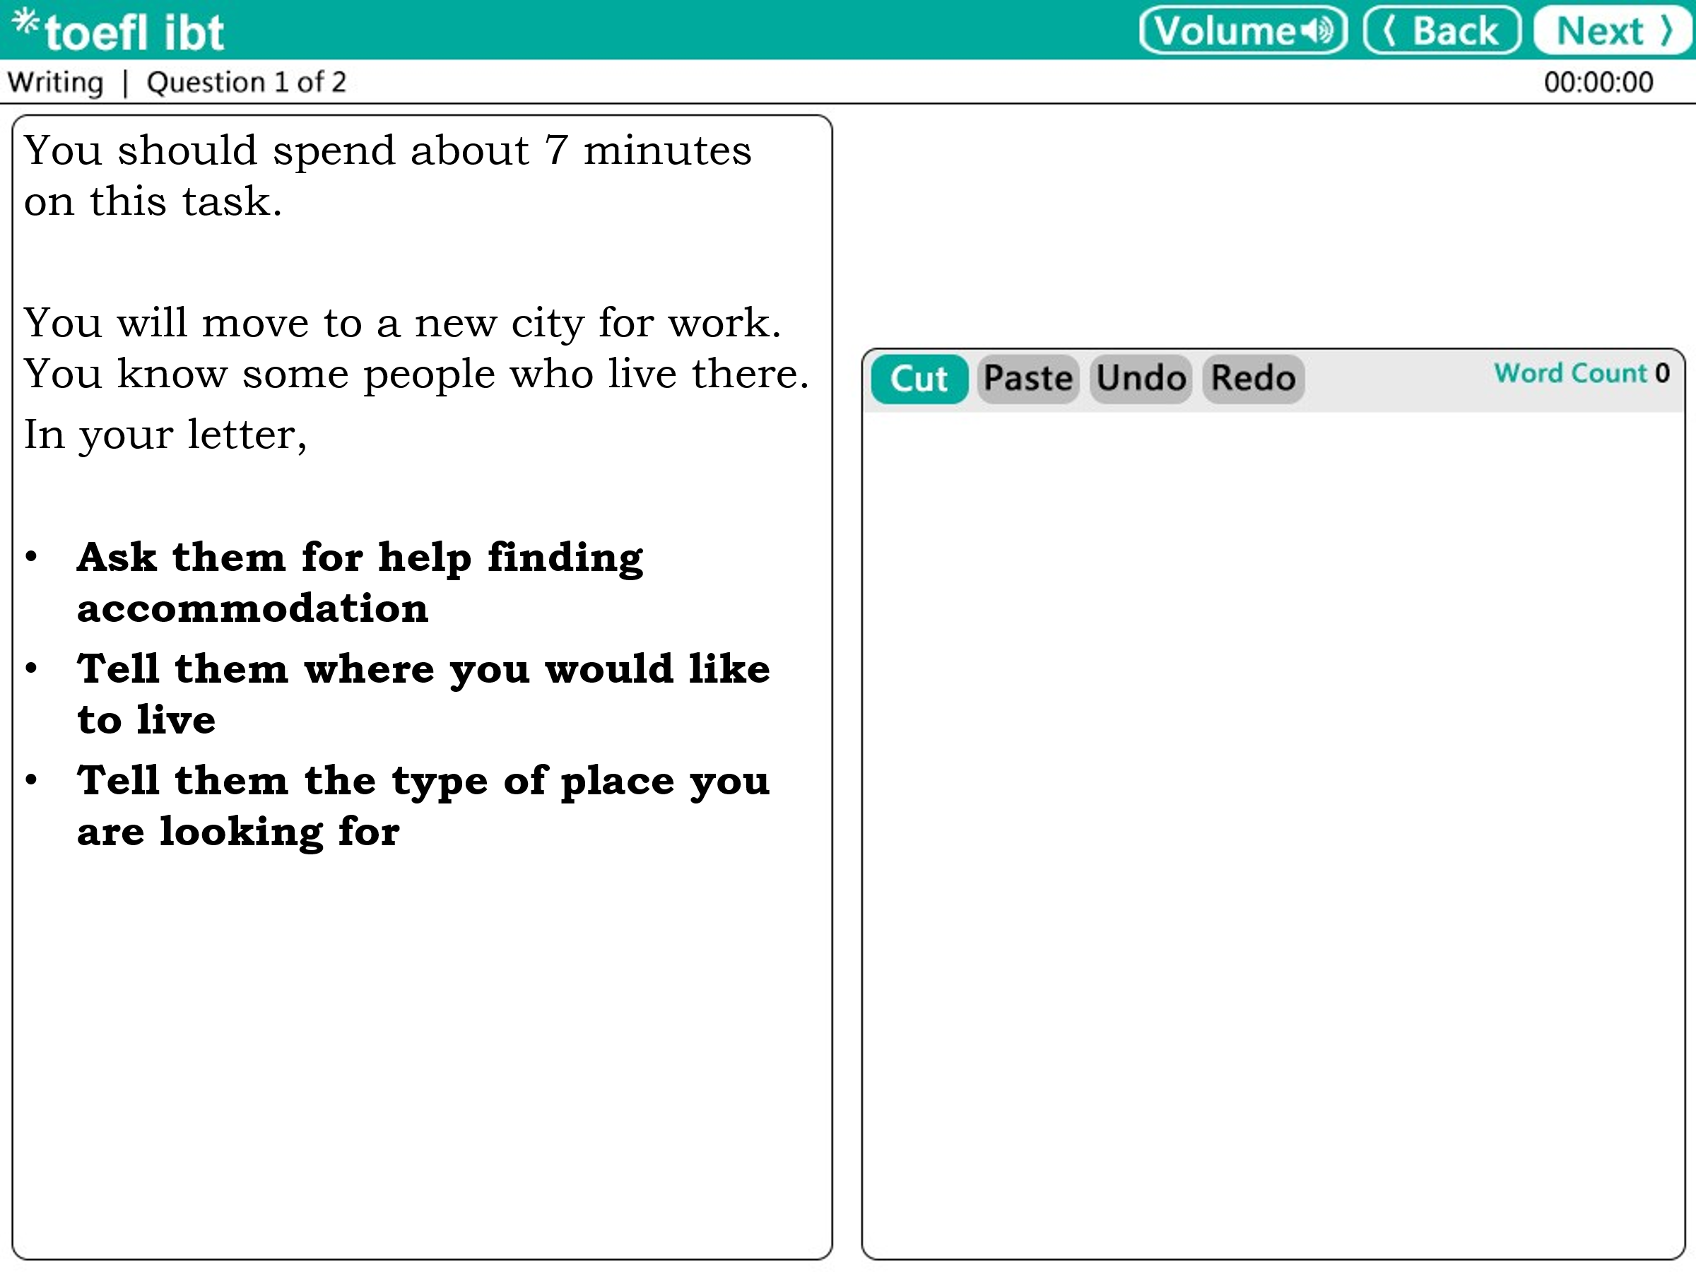

Sample Response
Dear Sir,
It has been a while since our last discourse. How are you doing? I have some good news: in the near future, my family and I will be moving to the city where you dwell, and we could meet more frequently. I would like to ask for your assistance with the relocation. Acquiring sufficient and exhaustive advice with respect to the optimal places to inhabit with a family would be crucial. The accommodation I am questing for should be equipped with three bedrooms and be well-lit. I enjoy spacious and bright homes with a large kitchen.
Ideally, I would like to live in the vicinity of where I am going to be working, or in the downtown district. The location with ample amenities is my priority. If possible, there should be some shops nearby, like a supermarket; meanwhile, some recreational facilities, such as parks or gyms enhancing quality of life cannot be neglected.
Additionally, I have always dreamed of having a large balcony or yard to plant a variety of beautiful flowers. Nonetheless despite accessible transport, a private parking lot is a must-have for us. Moreover, the education system in the area plays an essential role in choosing a place to live since we have a child. I know your advice is always helpful; therefore, I hope this time, relying on your opinion, we will find a gorgeous place for our family.
We appreciate your kindness.

Sincerely Yours
Kenny

Writing Skills :

Writing Practice
