10710EECS204001  
Data Structures Homework 4

Due date: 2018/11/27 23:59

Submit to OJ: #12063

Upload code to iLMS

Submission

* Please **1)** submit your code to OJ (OJ: #12063),   
  and **2)** upload the zipped file (source codes) to iLMs.   
  **Both should be done before the due date.**
* Scores will be given based on your OJ results, and the uploaded zipped file (the source codes) should be identical to those submitted to OJ. TAs will examine your uploaded codes.

Description

In this homework, you need to implement the basic graph data structure and four commands.

1. addEdge

Input: three integers, representing two labels of the terminal nodes and the edge weight. E.g., *add 0 1 4*

Please note that this command has no output.

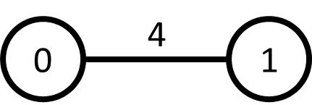

The following is an example of a sequence of edge additions.

------------------------------------------------------------

*add 0 1 4*

*add 0 2 8*

*add 1 2 11*

*add 1 3 8*

*add 2 4 7*

*add 3 4 2*

*add 2 5 1*

*add 4 5 6*

*add 3 6 4*

*add 5 6 2*

*add 3 7 7*

*add 6 7 14*

*add 7 8 9*

*add 6 8 10*

------------------------------------------------------------

After those edges are added, the graph is shown as follows.

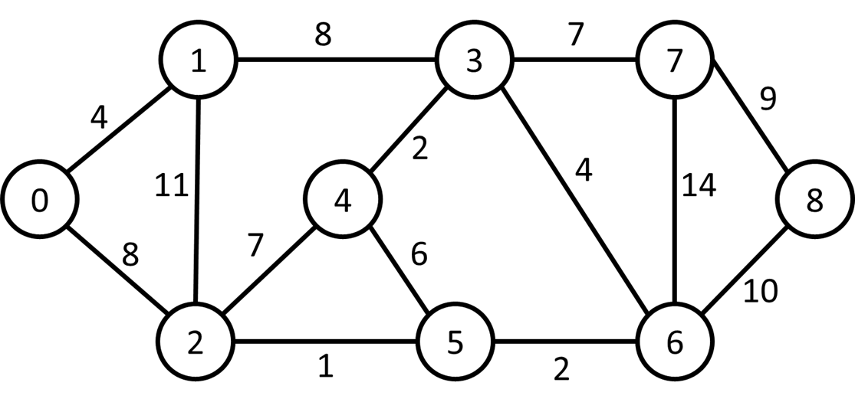

Fig 1.

2. shortest_path

Output the shortest path length between the given two nodes.

E.g., *shortest_path 0 3*

Take Fig. 1 as an example, “*shortest_path 0 3”* outputs **12**.

3. mst_weight (minimum spanning tree weight)

Compute the sum of weights of the minimum spanning tree of the given graph. Take Fig. 1 as an example, calling *mst_weight* outputs **37**. The edges selected are marked in blue as follows.

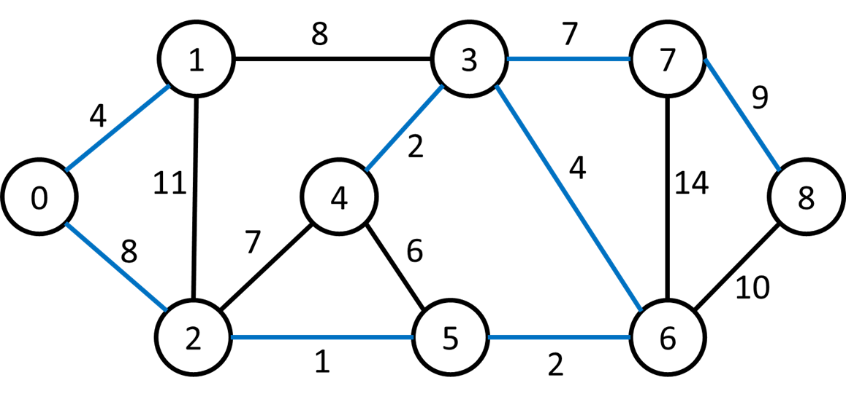

4. two_color

Check if the given graph can be colored with two colors such that any two adjacent nodes are not colored with the same color. If yes, output “*two-colorable”*. If no, output “*not two-colorable”*.

The following example is a proper two-coloring.



We cannot find a proper two-coloring for the following graph.

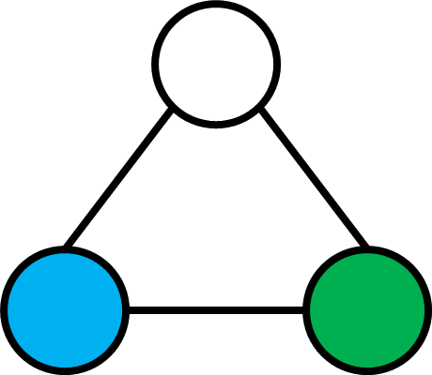

Input

Input starts with an integer ***n*** indicating the number of nodes in the graph, $0≤n≤$**2500.** Then, a set of ***m*** edges, $0≤m≤950000$**,** and ***k*** command, $0≤k≤30$, are given. The following four commands might appear multiple times (even interleaving) *add*, *shortest_path*, *mst_weight*, *two_colorable*. All edge weight is larger than 1.

Output

Print the outputs of the given commands.

Sample Input

9

add 0 1 4

add 0 2 8

add 1 2 11

add 1 3 8

add 2 4 7

add 3 4 2

add 2 5 1

add 4 5 6

add 3 6 4

add 5 6 2

add 3 7 7

add 6 7 14

add 7 8 9

add 6 8 10

shortest_path 0 3

shortest_path 0 4

shortest_path 2 7

mst_weight

two_color

Sample output

12

14

14

37

not two-colorable