Problem1:

5/4 data

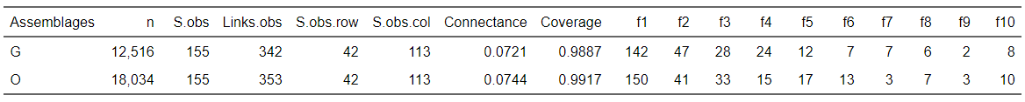

1/25 data

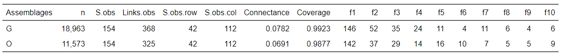

Problem2:

"Anobium_fulvicorne" "Cryphalus_abietis"

"Dasytes_cyaneus" "Grammoptera_variegata"

"Molorchus_umbellatarum" "Nemosoma_elongatum"

"Phyllodrepa_ioptera" "Phymatodes_alni"

"Phymatodes_pusillus" "Rhaphitropis_machicus"

"Rhopalopus_femoratus" "Xyleborus_dispar"

"Xyleborus_germanus" "Xyleborus_saxesenii"

"Xyloterus_signatus"