### Datainfo

| Plot | Treatment | n | S.obs | Links.obs | S.obs.row | S.obs.col | Connectance | Coverage | f1 | f2 | f3 | f4 | f5 | f6 |
| --- | --- | --- | --- | --- | --- | --- | --- | --- | --- | --- | --- | --- | --- | --- |
| A | G | 3,012 | 140 | 132 | 42 | 98 | 0.0321 | 0.9794 | 62 | 12 | 11 | 8 | 6 | 2 |
| A | O | 3,555 | 140 | 151 | 42 | 98 | 0.0367 | 0.9781 | 78 | 17 | 10 | 9 | 1 | 4 |
| B | G | 5,508 | 140 | 122 | 42 | 98 | 0.0296 | 0.9907 | 51 | 15 | 14 | 13 | 2 | 2 |
| B | O | 5,286 | 140 | 115 | 42 | 98 | 0.0279 | 0.9907 | 49 | 16 | 10 | 3 | 4 | 6 |
| C | G | 2,627 | 140 | 104 | 42 | 98 | 0.0253 | 0.9829 | 45 | 13 | 6 | 7 | 6 | 2 |
| C | O | 8,825 | 140 | 127 | 42 | 98 | 0.0309 | 0.9943 | 50 | 17 | 13 | 6 | 4 | 2 |

| Assemblages | n | S.obs | Links.obs | S.obs.row | S.obs.col | Connectance | Coverage | f1 | f2 | f3 | f4 | f5 | f6 |
| --- | --- | --- | --- | --- | --- | --- | --- | --- | --- | --- | --- | --- | --- |
| G | 11,147 | 140 | 267 | 42 | 98 | 0.0649 | 0.9896 | 116 | 28 | 20 | 19 | 10 | 5 |
| O | 17,666 | 140 | 290 | 42 | 98 | 0.0705 | 0.9928 | 127 | 35 | 25 | 7 | 15 | 9 |

### Summary

對於4steps分析, 我使用給定treatment G,O下pool起來的資料直接比較, 可以整理結果如下

#### Asymptotic / Empirical diversity

**Taxonomic Phylogenetic**

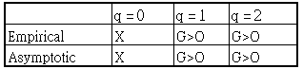 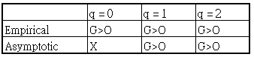

#### Rarefaction/ Extrapolation

**Taxonomic Phylogenetic**

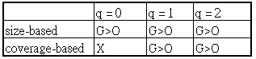 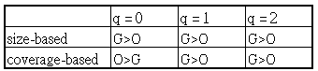

Note: X表示差距不顯著, 或是有交叉, 難以下結論

而Beta分析則可以考慮三種dissimilarity (使用三種不同資料結構來計算)

a. 整個區域中, G和O間的相異程度

b. Plot-wise: 給定不同的Plot(A,B,C)下, treatment G和O間的相異程度

c. Treatment-wise: 給定不同的Treatment(G,O)下, plot A,B,C間的相異程度

## Taxonomic:

### 1.Sample completeness

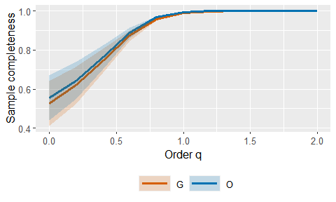

### 2.Asymptotic/ Empirical diversity

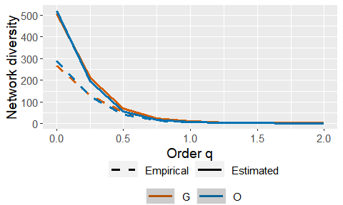

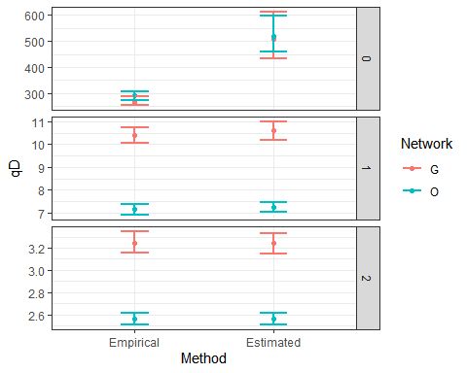

| Order.q | qD | qD.LCL | qD.UCL | Network | Method |
| --- | --- | --- | --- | --- | --- |
| 0 | 507.264158 | 431.877495 | 613.653269 | G | Estimated |
| 0 | 520.401243 | 459.753303 | 595.497955 | O | Estimated |
| 1 | 10.626041 | 10.200157 | 10.999398 | G | Estimated |
| 1 | 7.260913 | 7.030795 | 7.481015 | O | Estimated |
| 2 | 3.244067 | 3.149643 | 3.327412 | G | Estimated |
| 2 | 2.565628 | 2.508271 | 2.610181 | O | Estimated |

### 3.Rarefaction / Extrapolation

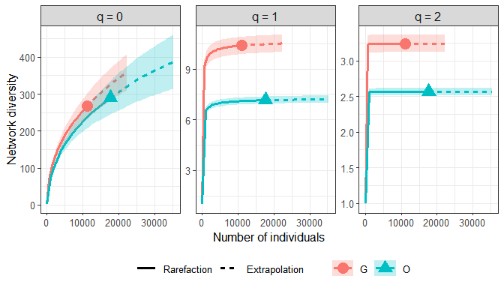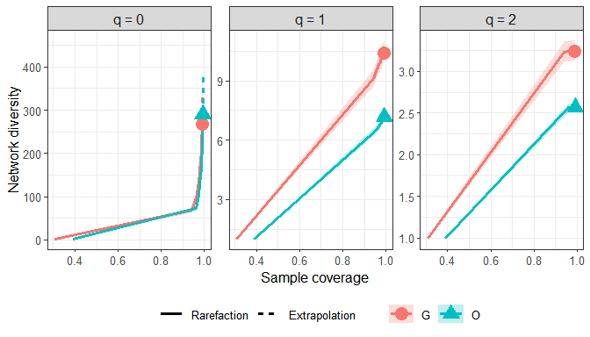

### Closer look at q = 0

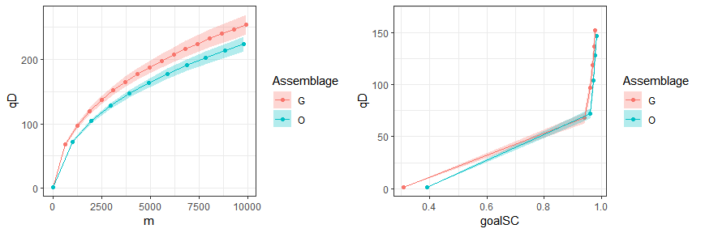

### 4.Specialization

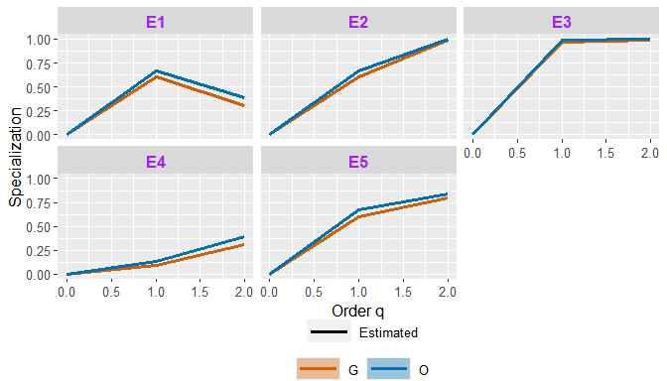

### 5.Dissimilarity

考慮三種dissimilarity

a. 整個區域中, G和O間的相異程度

b. Plot-wise: 給定不同的Plot(A,B,C)下, treatment G和O間的相異程度

c. Treatment-wise: 給定不同的Treatment(G,0)下, plot A,B,C間的相異程度

#### Compare treatment G and O with pooled abundance

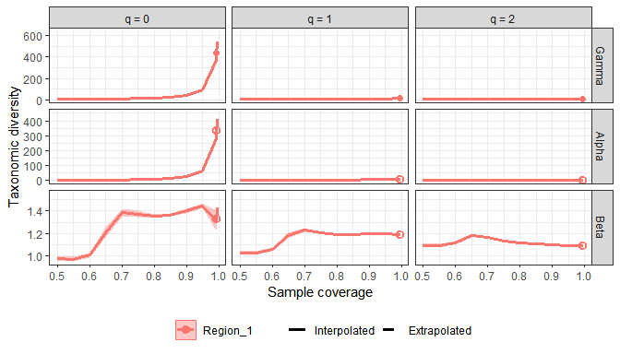

#### Plot-wise comparison

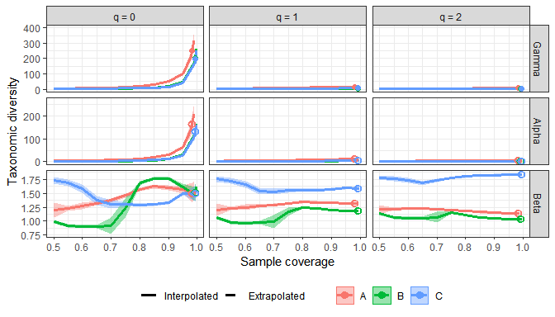

### Take a closer look (individually scaling)

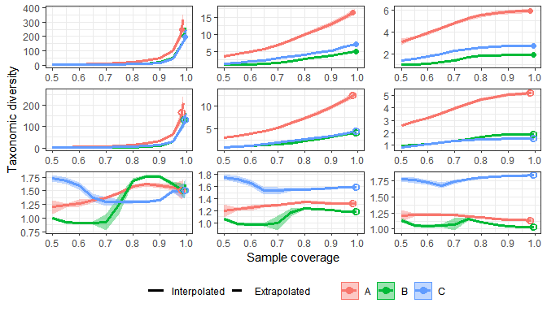

#### Treatment-wise comparison

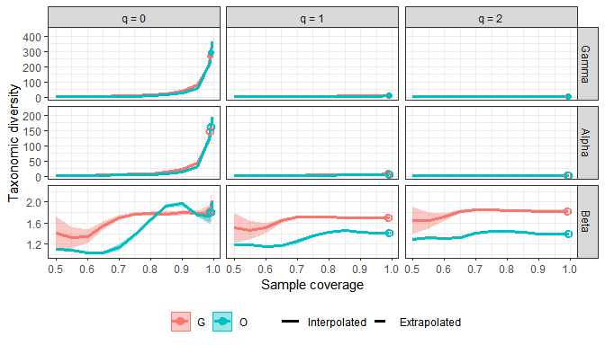

### Take a closer look (individually scaling)

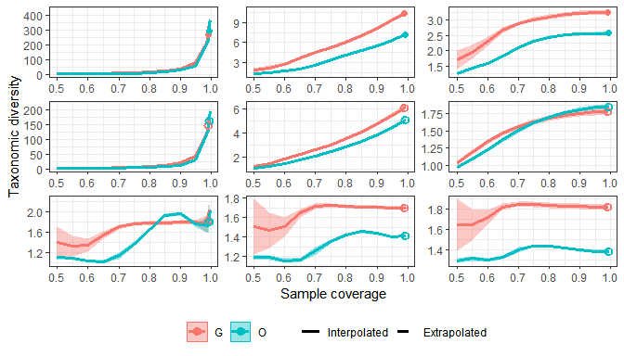

## Phylogenetic:

## 1.Asymptotic/ Empirical diversity

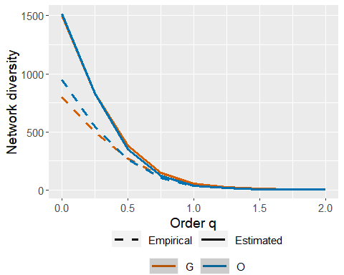

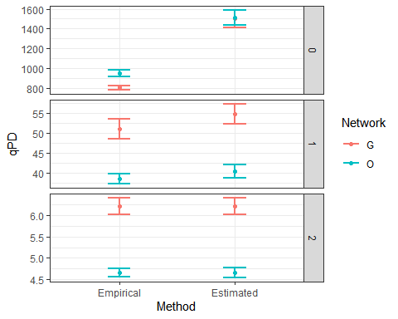

| Order.q | qD | qD.LCL | qD.UCL | Network | Method |
| --- | --- | --- | --- | --- | --- |
| 0 | 507.264158 | 431.877495 | 613.653269 | G | Estimated |
| 0 | 520.401243 | 459.753303 | 595.497955 | O | Estimated |
| 1 | 10.626041 | 10.200157 | 10.999398 | G | Estimated |
| 1 | 7.260913 | 7.030795 | 7.481015 | O | Estimated |
| 2 | 3.244067 | 3.149643 | 3.327412 | G | Estimated |
| 2 | 2.565628 | 2.508271 | 2.610181 | O | Estimated |

### 2.Rarefaction / Extrapolation

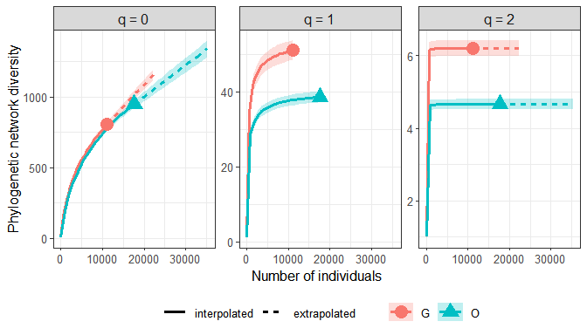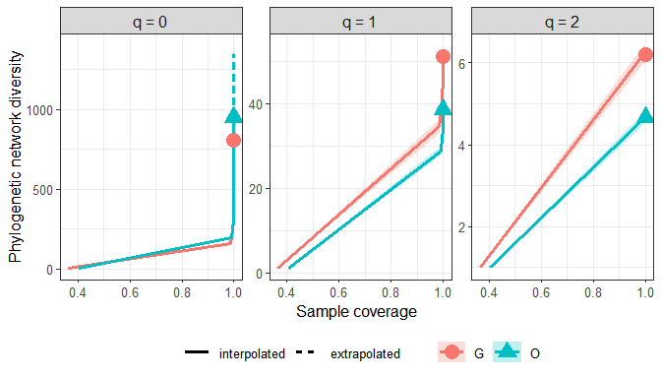

### Closer look at q = 0

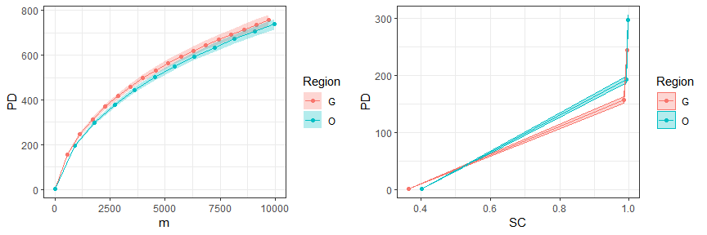

### 3.Dissimilarity

#### Compare treatment G and O with pooled abundance

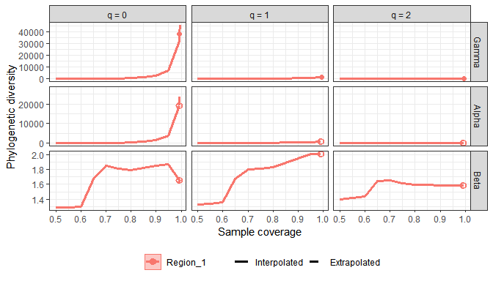

#### Plot-wise comparison

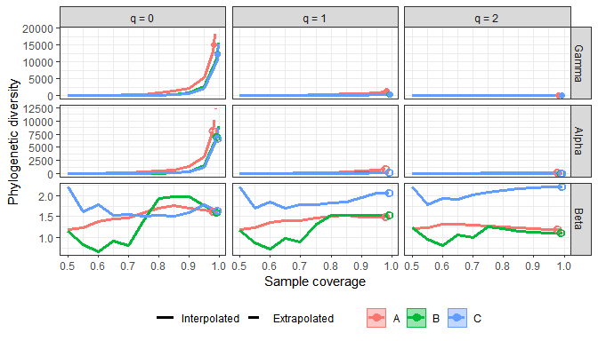

### Take a closer look (individual scaling)

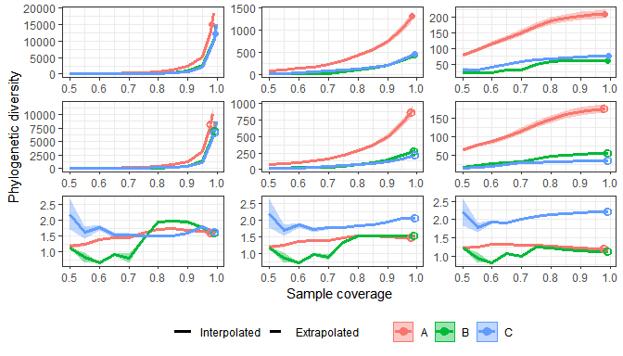

#### Treatment-wise comparison

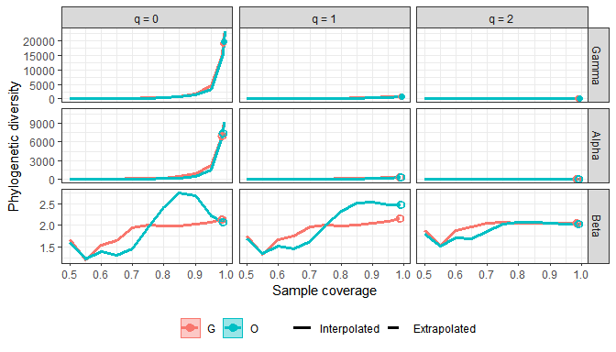

### Take a closer look (individually scaling)

