Structure of the system

Supermarket(Main), CheckoutRegister, Product_Class, SupermarketDao(database)

Supermarket – Supermarket Class working as the main. They show the list of the poducts including(Barcode, name, desc, price ).

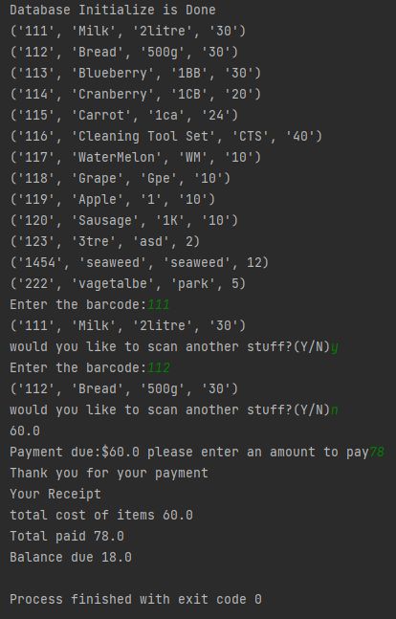

Get the payment process from CheckoutRegister with ‘total cost of items, total paid, balance due’.

CheckoutRegister – provide all methods related to payment and total calculation.

Transaction, Product_Class – provide the objects to the class.

.